A Software Design Document:
Backup/Restore Utility

Member Name RollNo Email

Shravan R Patel B14225 b14225@students.iitmandi.ac.in
Umang Agarwal B14137 b14137@students.iitmandi.ac.in
Sumant Garg B14134 b14134@students.iitmandi.ac.in
Rohit Kumar Verma B14125 b14125@students.iitmandi.ac.in

1st May 2017

The Backup/Restore Utility
Design Document
Revision History

Version | Date | Author(s) | Description
v1.0 | 01/05/17 | Umang,Shravan,Sumant,Rohit | Initial version

Table of Contents
1Introduction 2
1.1Design Overview 2
1.2Intended Audience 2
1.3References 3
2Detailed Design 3
2.1Architecture 4
Components 4
Interfaces 4
2.2Algorithms and Data Structures 4
2.3External Data 4
Databases 4
Files 4
2.4Performance 4
2.5Test Scripts 5

Introduction

Design Overview

Backup/Restore system is based on rsync utility which is commonly found on UNIX like system. It helps in efficiently transferring and synchronizing files across a network. Clients would be able to backup their files/folders by assigning low/high priority to them. A global node which handles the request from different clients for backup/restore would save high number of copies for a file with a high priority across multiple servers available as backup disks. This would guarantee high availability and reliability to clients during restore phase.

Intended Audience
This document is intended for software managers and designers, network administrator and also general tech enthusiastic peoples.

References
[1] https://en.wikipedia.org/wiki/Rsync
[2] https://unix.stackexchange.com/questions/211595/linux-dump-which-folders-files-are-excluded-from-first-backup
[3] https://unix.stackexchange.com/questions/183504/how-to-rsync-files-between-two-remotes

Detailed Design
Backup/Restore utility can be used to backup data every minute. Cron a time based scheduler would be running a job on global node which would fetch conf file from all the clients every minute. Global node would extract the path, priority, backup/restore flag from the conf file and then tunnel the data from client to backup disks using rsync utility accordingly. If a client wants to backup a new folder, the global node will assign a backup disk with most available space to that file/folder. Global node would maintain a database which will contain client name, path, disk id in tabular form. Each storage device will have a separate directory for every client and in each of those client directories there would be many directories to store data of that client with name as path name as shown in fig 1. During restoration phase, global node will restore the data from one of the active disks to the client.
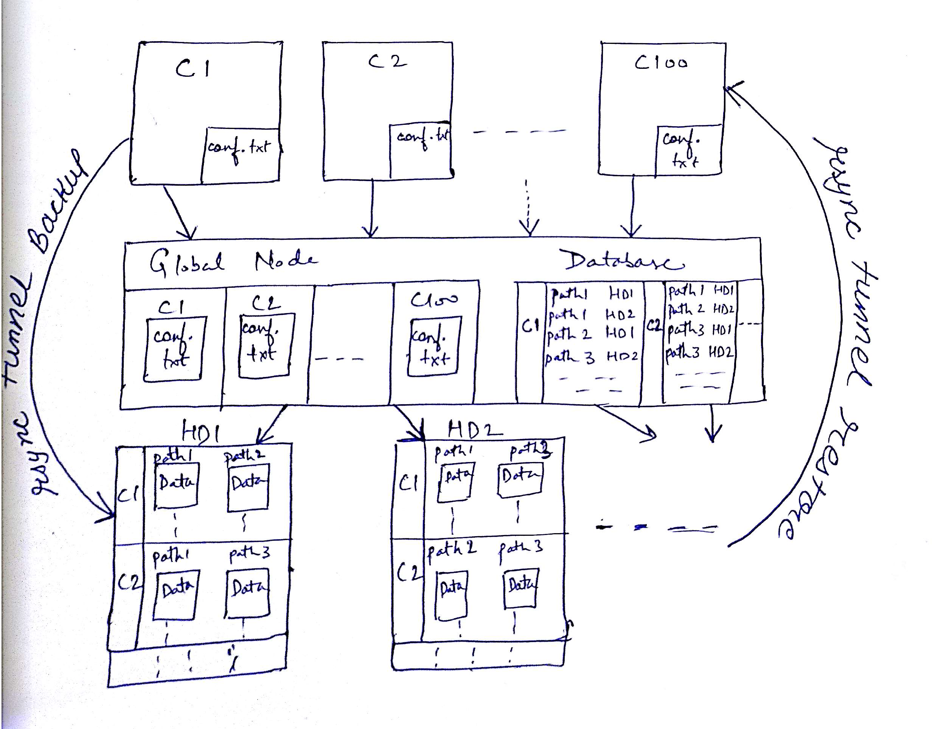

Fig. 1: Backup-Restore Utility Architecture

Architecture
Backup/Restore utility has a skeleton which looks exactly as described in fig 1. At the top of the figure, the rectangular blocks represents clients namely C1,C2 upto C100 who wants to use the backup/restore utility. In the centre resides a global node which acts as a tunnel in storing/restoring data between clients and disks across a network.

Components

Client is a machine which contains config file in the home directory.
Global Node is a machine which has crontab utility and MySQL database installed.
Storage Disks are servers which are used to backup data from client machines.
All the components need to have openssh server and rsync utility installed.

Interfaces

The interface between all pairs of components are CLI over ssh.

Algorithms and Data Structures

Global node will check in the database whether a folder is already backed up or not. If it is already backed up, global node would do rsync to the disks on which it is stored. If it is a new folder, global node will assign some disks according to available space. If priority of a folder is changed from high to low, global node will delete the folder from some disks. If priority of a folder is changed from low to high, global node will store that folder to some more disks.

External Data

Databases
Backup/Restore utility uses database to store Id and password of each client. It also use a database which contain client name, path, disk id.

Files
Backup/Restore utility uses the config file stored on clients machine. Config file contains id, password, path of folder/file, priority and backup/restore flag.

Performance

The utility will be bechmarked on differnt volume of data over different clients.

Test Scripts

ChangeConfig.pl : It would be running on each client machine. Script would automatically create/modify a folder on the client machine and add that path along with relevent priority to the config file.
Also we could manually switch off some servers and then show difference in restoration of some high and low priority files already backed up.

