Design of Backup/Restore Utility

MemberName RollNo Email

Shravan R Patel B14225 b14225@students.iitmandi.ac.in
Umang Agarwal B14137 b14137@students.iitmandi.ac.in
Sumant Garg B14134 b14134@students.iitmandi.ac.in
Rohit Kumar Verma B14125 b14125@students.iitmandi.ac.in

23 April 2017

Requirements Document

Table of Contents
1Introduction 3
1.1Need and Purpose 3
1.2High Level Description 3
1.3Intended Audience 3
1.4References 3
2Description 4
2.1Features and Functions 4
Features 4
Functions 4
2.2Users 4
2.3Operating Environment 4
2.3.1Hardware 4
2.3.2Software 4
3Specific Requirements 4
3.1Performance Requirements 4
3.2Additional Comments 5
4 Mini Project Plan 5

Introduction

Need and Purpose
With the wide-spread availability of PCs, laptops, data storage and its safety has became a critical issue nowadays. Precious data can be lost anytime due to hardware/software failures in big industry or organisation. Even the frequent changes in data has to be taken into account for ensuring complete safety. Organisations have their own private network and most of them wants to store their data on a remote host.
Backup/Restore Utility fills this need. It allows members of the organisation and other end users of PC to automatically or manually update the changes made in the data on a remote host.

High Level Description
We are making a backup and restore utility similar to the Linux backup/restore. Using it, we can back up our files in the remote host. We are using rsync for this project.
Rsync is typically used for synchronizing files and directories between two different systems. Rsync command is similar to scp command. For example, the command shown below will use SSH to connect as user to remote-host.

rsync localFile user@remoteIP:remoteFile

Once connected, it will invoke the remote host's rsync and then the two programs will determine what parts of the file need to be transferred over the connection. Rsync splits the file into different chunks. Only modified chunks get transferred via rsync.

Intended Audience

This document is intended for software managers and designers, network administrator and also general tech enthusiastic peoples.

References

[1] https://en.wikipedia.org/wiki/Rsync
[2] https://unix.stackexchange.com/questions/211595/linux-dump-which-folders-files-are-excluded-from-first-backup

Description

Features and Functions

Features
Backup/restore utility will work across network. It will backup level 0 and level 1 dump. It will allow selective restore of a given file or directory.

Functions
- Backup in remote host connected to local host via network.
- Backup and Restore only those part of files which are modified since the level 0 backup.
- Various errors such as failure of the network during backup and backup disk partition full will be handled.
- Scripts will allow selective restore of a given file or directory and show the available backups (by date/time) for the file or directory.
- Savings in disk space compared to doing a full back up every time.

Users
- Big companies
- The general public

Operating Environment

Hardware
- Local PC whose files will be backed up
- Remote Server that stores Backup Files
- Network connection between this two PCs

Software
This Backup/Restore Utility can run on any recent version of Linux, such as Ubuntu, Debian, Fedora Core, Redhat Enterprise, etc.

Specific Requirements

Performance Requirements
On an entry-level PC acting as server, the maximum response time for any online request must be less than 2 secs.

Additional Comments
This document describes a fictitious software product purely for academic purposes. It is not related in any way to a particular existing or proposed real product.

Mini-Project Plan
The version 1 till 2 May 2017 in this we will be implementing the backup in the single server.
The version 2 till 9 May 2017 in this we will increase the backup server from single system to distribute systems and may include the backup with priorities.
The final submission 14 May 2017 in this we will include the load balancing on top of the distributed backup.
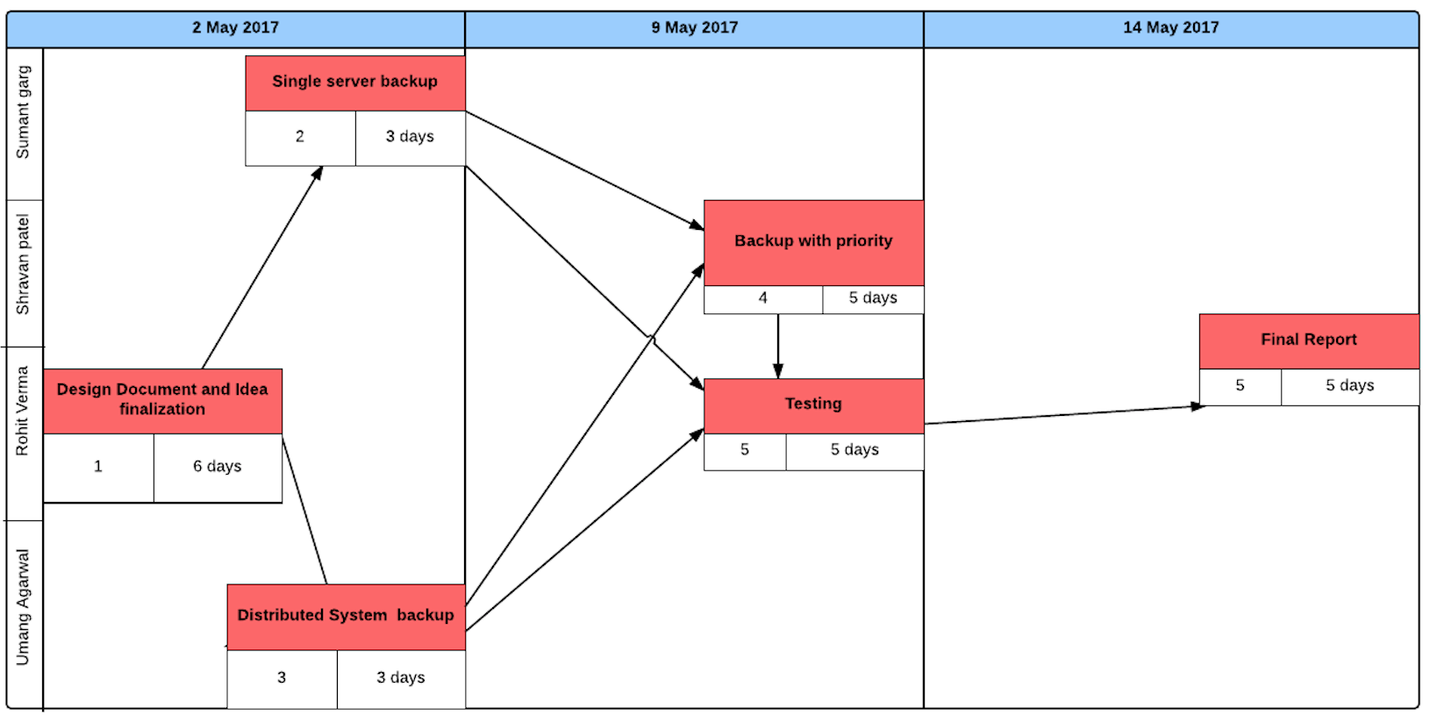
Fig. Pert Chart

