ExpensePro
Income & Expense Manager
Personal Finance Management Progressive Web App

PHP 8+ | PDO | MySQL (InnoDB, utf8mb4) | Vanilla JavaScript | Apache/XAMPP

Rohit Vadher, BCA Sem-5 | Version 1.0 | 2026

Table of Contents

Right-click the table above and choose Update Field in Microsoft Word to populate page numbers.

1. Project Abstract
ExpensePro is a PHP and MySQL based personal finance management Progressive Web App designed to manage income, expenses, categories, budgets, analytics, reports, notifications and financial data import/export through a modular web architecture. Guests start on a public landing page; registered users sign in to a dashboard summarizing the current month. The system runs on Apache/XAMPP with PDO access to MySQL (InnoDB, utf8mb4), needs no build step, installs as a PWA and degrades gracefully offline.

2. Project Objectives
- Record income and expense entries in seconds with validation at every step.
- Organize spending with private income/expense categories.
- Stay within weekly, monthly or yearly budgets with live progress.
- Visualize twelve-month trends and category breakdowns.
- Produce CSV and PDF records filtered exactly like on-screen reports.
- Import history from CSV with per-row validation feedback.
- Keep every byte of one user’s data invisible to every other user.

3. Problem Statement
Household spending spreads across cash, cards and apps, so monthly totals surprise their owners. Spreadsheets demand discipline and offer no budgets, alerts or mobile entry. ExpensePro answers with a private, mobile-first ledger: fast entry, automatic totals, budget guardrails and one-click exports, self-hosted on XAMPP with MySQL.

4. System Overview
A front controller routes whitelisted pages to server-rendered shells. Page controllers call a single JSON API client; endpoints enforce authentication, CSRF, validation and ownership, then delegate to services and repositories. MySQL stores exact decimals; one finance module computes every total shown anywhere.
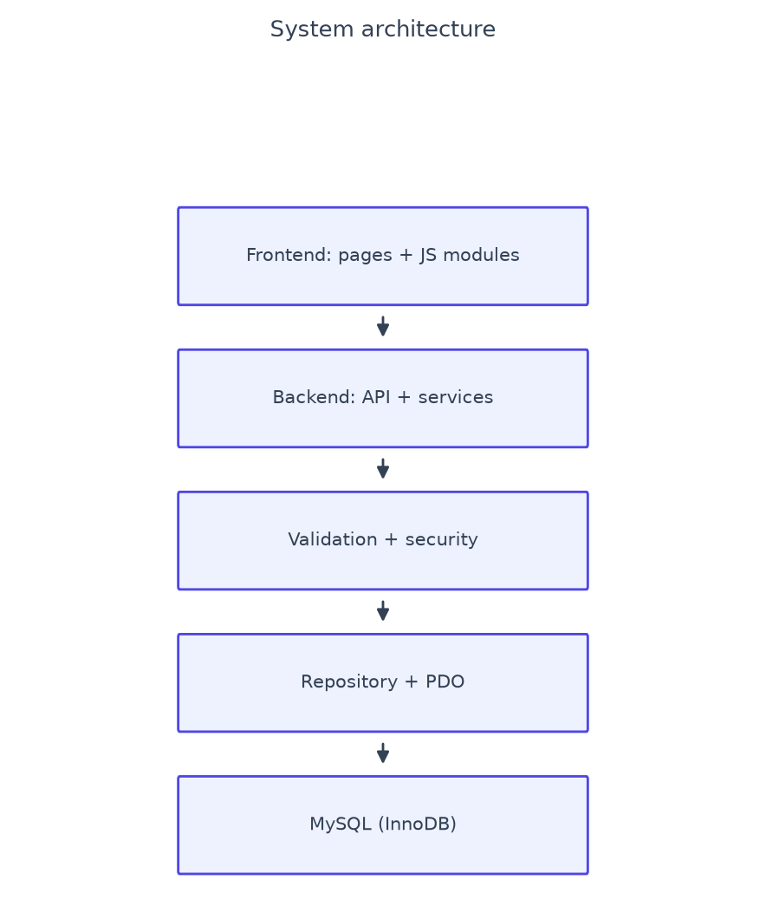
Figure 1 — System architecture layers.

5. Functional Scope
Registration, login, logout, remember-me sessions, dashboard, transactions (CRUD, search, filters, pagination), categories, budgets, analytics, reports, CSV import/export, PDF/print export, notifications, quick templates, profile, password change, command palette, mobile navigation, help, offline page and PWA install/update flows.

6. Technology Stack
Layer | Technology
Backend | PHP 8+
Database | MySQL
Database Engine | InnoDB
Database Access | PDO
Frontend | Vanilla JavaScript
CSS | Tailwind CSS
Charts | ApexCharts 3.44.0 (lazy-loaded)
Icons | Lucide 1.47.0 where used, local SVG set
Date Tools | Flatpickr 4.6.13 pickers, Day.js 1.11.23 math (lazy-loaded)
PDF | html2pdf.js 0.10.2 client engine plus server printable report
PWA | Service Worker + Web App Manifest
Server | Apache/XAMPP

7. System, Folder, Frontend, Backend and API Architecture
Controllers handle HTTP method, auth, CSRF, validation and responses only; services hold workflows; repositories hold user-scoped PDO SQL. Frontend page controllers share one API client, error handler, validation layer, finance previews and button state machine, with one modal controller, one toast system and one lazy vendor loader. Every endpoint returns {success, message, data, errors} with correct HTTP codes (200/201/400/401/403/404/409/422/429/500).

8. Database Architecture
MySQL 8+, InnoDB, utf8mb4. Money is exact DECIMAL(12,2). All user data cascades from users; transaction categories are delete-restricted; budget and template categories null out safely. Ownership plus performance indexes cover auth, filtering, reporting and cleanup.

8.1 Database Tables

Table: budgets — Spending limits per period
Column | Type | Null | Key | Default
id | int(11) | NO | PRI | NULL
user_id | int(11) | NO | MUL | NULL
category_id | int(11) | YES | MUL | NULL
amount | decimal(12,2) | NO | - | NULL
period | enum('weekly','monthly','yearly') | YES | - | monthly
start_date | date | NO | - | NULL
end_date | date | NO | - | NULL
created_at | timestamp | NO | - | current_timestamp()
updated_at | timestamp | NO | - | current_timestamp()

Indexes: PRIMARY(id); category_id(category_id); idx_user_period(user_id+start_date+end_date); idx_user_period_category(user_id+period+category_id); idx_user_created(user_id+created_at).
Foreign keys: user_id references users(id) ON DELETE CASCADE; category_id references categories(id) ON DELETE SET.

Table: categories — Per-user income/expense groups
Column | Type | Null | Key | Default
id | int(11) | NO | PRI | NULL
user_id | int(11) | NO | MUL | NULL
name | varchar(100) | NO | - | NULL
type | enum('income','expense') | NO | - | NULL
icon | varchar(50) | NO | - | NULL
color | varchar(7) | NO | - | NULL
created_at | timestamp | NO | MUL | current_timestamp()

Indexes: PRIMARY(id); uq_user_name_type(user_id+name+type); idx_user_type(user_id+type); idx_created_at(created_at).
Foreign keys: user_id references users(id) ON DELETE CASCADE.

Table: csv_imports — Import history and error logs
Column | Type | Null | Key | Default
id | int(11) | NO | PRI | NULL
user_id | int(11) | NO | MUL | NULL
filename | varchar(255) | NO | - | NULL
row_count | int(11) | YES | - | 0
success_count | int(11) | YES | - | 0
error_count | int(11) | YES | - | 0
errors_log | longtext | YES | - | NULL
status | enum('completed','partial','failed') | YES | - | completed
created_at | timestamp | NO | - | current_timestamp()

Indexes: PRIMARY(id); idx_user_imports(user_id+created_at).
Foreign keys: user_id references users(id) ON DELETE CASCADE.

Table: login_attempts — Brute-force guard
Column | Type | Null | Key | Default
id | int(11) | NO | PRI | NULL
email | varchar(255) | NO | MUL | NULL
ip | varchar(45) | NO | - | NULL
attempted_at | timestamp | NO | MUL | current_timestamp()

Indexes: PRIMARY(id); idx_email_ip_time(email+ip+attempted_at); idx_attempted_at(attempted_at).

Table: notifications — Budget and login alerts
Column | Type | Null | Key | Default
id | int(11) | NO | PRI | NULL
user_id | int(11) | NO | MUL | NULL
type | enum('over_budget','info','login') | NO | - | info
title | varchar(200) | NO | - | NULL
message | text | NO | - | NULL
link | varchar(255) | YES | - | NULL
is_read | tinyint(1) | YES | - | 0
created_at | timestamp | NO | - | current_timestamp()

Indexes: PRIMARY(id); idx_user_read(user_id+is_read+created_at); idx_user_type_title_created(user_id+type+title+created_at).
Foreign keys: user_id references users(id) ON DELETE CASCADE.

Table: quick_templates — One-tap entry presets
Column | Type | Null | Key | Default
id | int(11) | NO | PRI | NULL
user_id | int(11) | NO | MUL | NULL
name | varchar(100) | NO | - | NULL
category_id | int(11) | YES | MUL | NULL
type | enum('income','expense') | NO | - | NULL
amount | decimal(12,2) | YES | - | NULL
description | text | YES | - | NULL
usage_count | int(11) | YES | - | 0
created_at | timestamp | NO | MUL | current_timestamp()
updated_at | timestamp | NO | - | current_timestamp()

Indexes: PRIMARY(id); category_id(category_id); idx_user_usage(user_id+usage_count); idx_created_at(created_at).
Foreign keys: user_id references users(id) ON DELETE CASCADE; category_id references categories(id) ON DELETE SET.

Table: rate_limits — Generic API buckets
Column | Type | Null | Key | Default
id | int(11) | NO | PRI | NULL
rate_key | varchar(191) | NO | MUL | NULL
ip | varchar(45) | NO | - | NULL
attempted_at | timestamp | NO | MUL | current_timestamp()

Indexes: PRIMARY(id); idx_key_time(rate_key+attempted_at); idx_attempted_at(attempted_at).

Table: transactions — Every income/expense entry
Column | Type | Null | Key | Default
id | int(11) | NO | PRI | NULL
user_id | int(11) | NO | MUL | NULL
category_id | int(11) | NO | MUL | NULL
type | enum('income','expense') | NO | - | NULL
amount | decimal(12,2) | NO | - | NULL
description | text | YES | - | NULL
date | date | NO | MUL | NULL
created_at | timestamp | NO | - | current_timestamp()
updated_at | timestamp | NO | - | current_timestamp()

Indexes: PRIMARY(id); category_id(category_id); idx_user_date(user_id+date); idx_user_type_date(user_id+type+date); idx_user_category(user_id+category_id); idx_date(date).
Foreign keys: user_id references users(id) ON DELETE CASCADE; category_id references categories(id).

Table: users — Registered accounts
Column | Type | Null | Key | Default
id | int(11) | NO | PRI | NULL
name | varchar(100) | NO | - | NULL
email | varchar(255) | NO | UNI | NULL
password | varchar(255) | NO | - | NULL
role | enum('user','admin') | YES | - | user
currency | varchar(10) | YES | - | INR
monthly_budget | decimal(12,2) | YES | - | NULL
remember_token | varchar(255) | YES | MUL | NULL
created_at | timestamp | NO | MUL | current_timestamp()
updated_at | timestamp | NO | - | current_timestamp()

Indexes: PRIMARY(id); email(email); idx_created_at(created_at); idx_remember_token(remember_token).

8.2 Database Relationships
users 1—N categories, transactions, budgets, quick_templates, csv_imports, notifications. categories 1—N transactions (ON DELETE RESTRICT); budgets and quick_templates reference categories with ON DELETE SET NULL. login_attempts and rate_limits are standalone guard tables.

9. Authentication Workflow
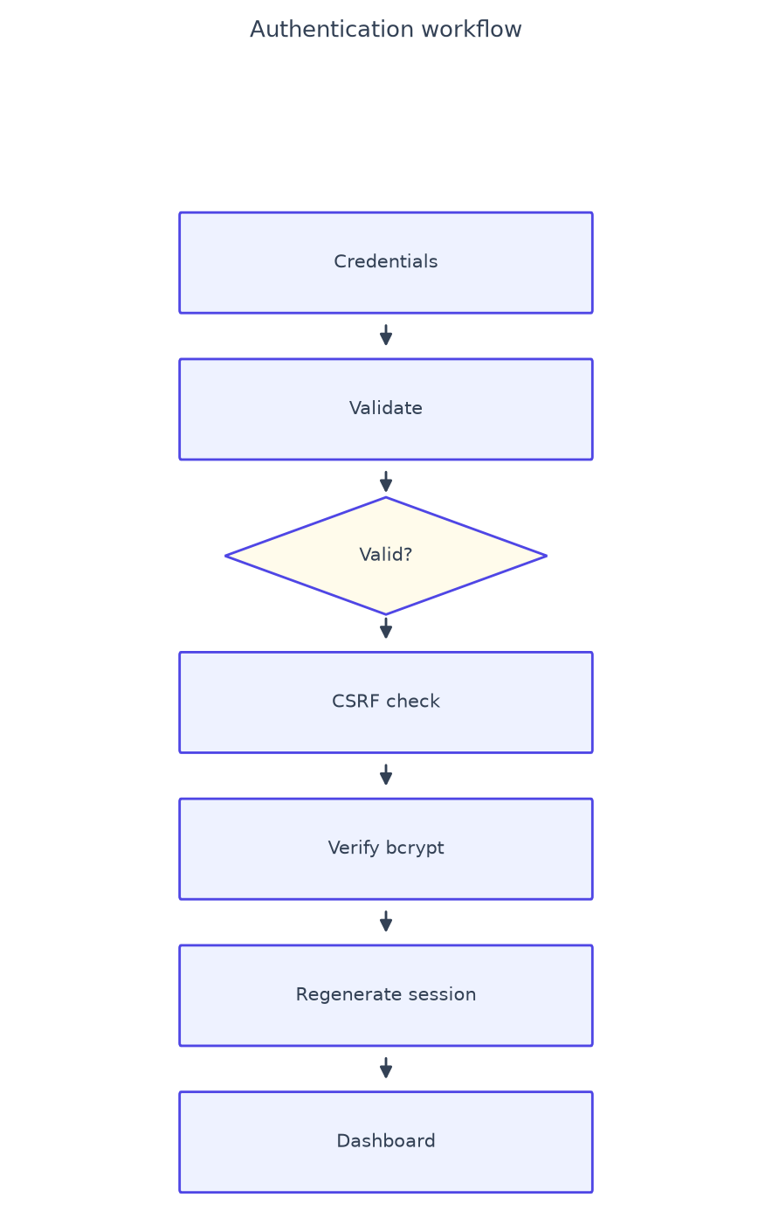
Figure 2 — Login flow.
Registration validates input, rejects duplicate emails (409) and seeds default categories in one transaction. Login rate-limits failures (5 per 15 minutes per email and IP), rehashes outdated bcrypt hashes and optionally sets a 30-day rotated remember-me token. Sessions regenerate IDs and expire after 24 idle hours. Logout revokes tokens; password change requires the current password and revokes remembered devices.

10. User, Transaction, Category and Budget Workflows
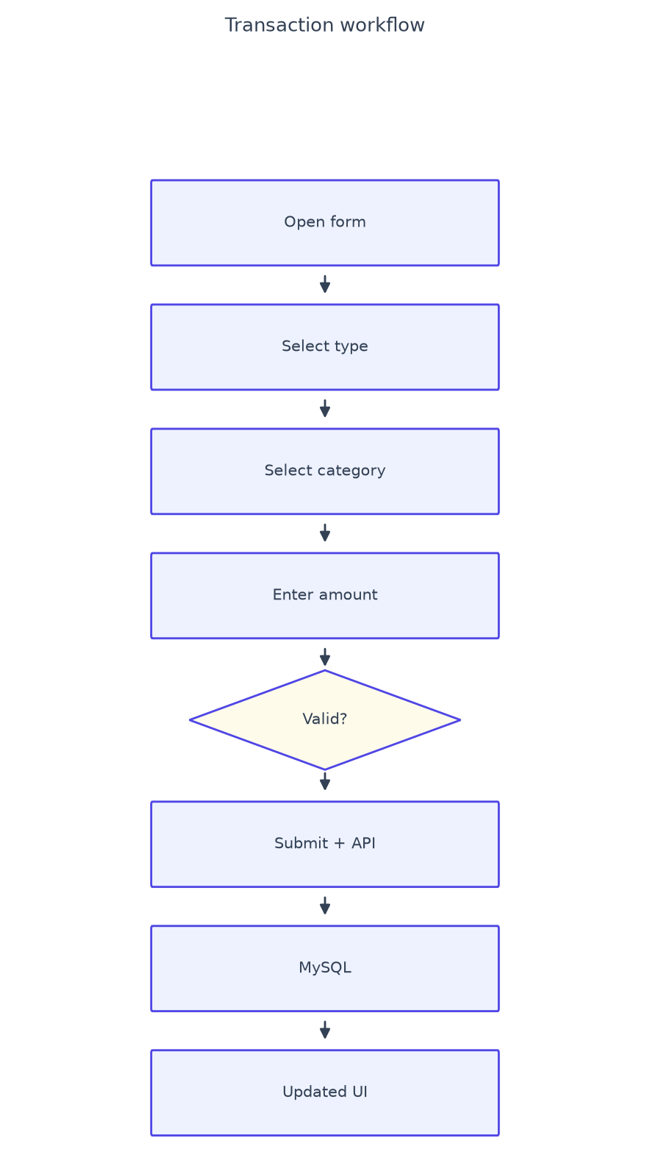
Figure 3 — Transaction lifecycle.
Guest landing, register or login, dashboard, daily entry, budgets, analytics, reports, exports, profile upkeep. Categories support safe delete with reassignment. Budgets track weekly, monthly or yearly periods with progress and over-budget flags computed by the shared finance module.

11. Analytics, Report, Import and Export Workflows
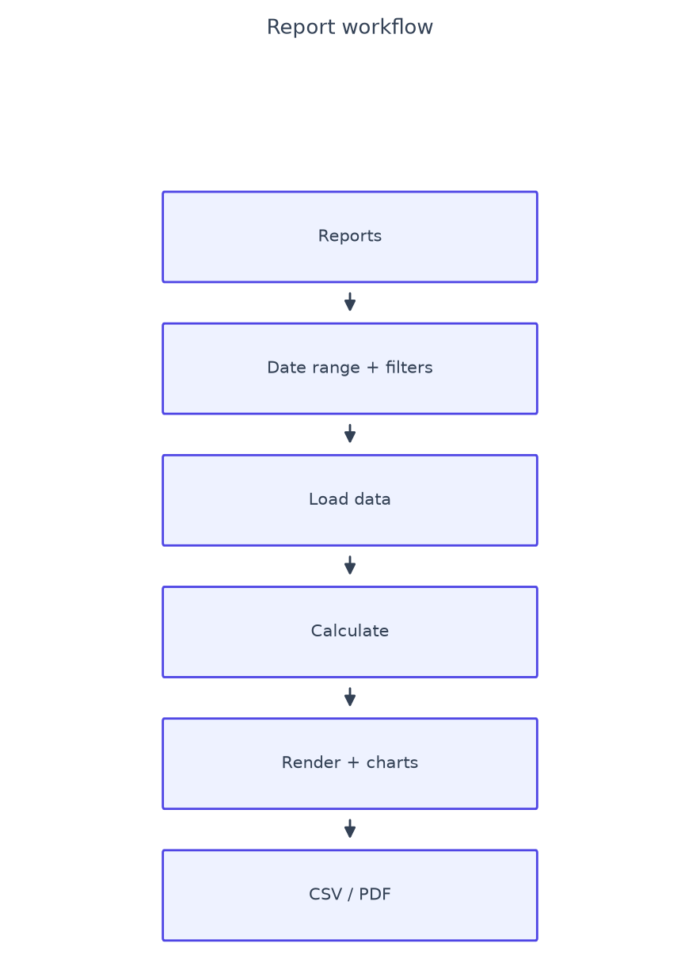
Figure 4 — Report pipeline.
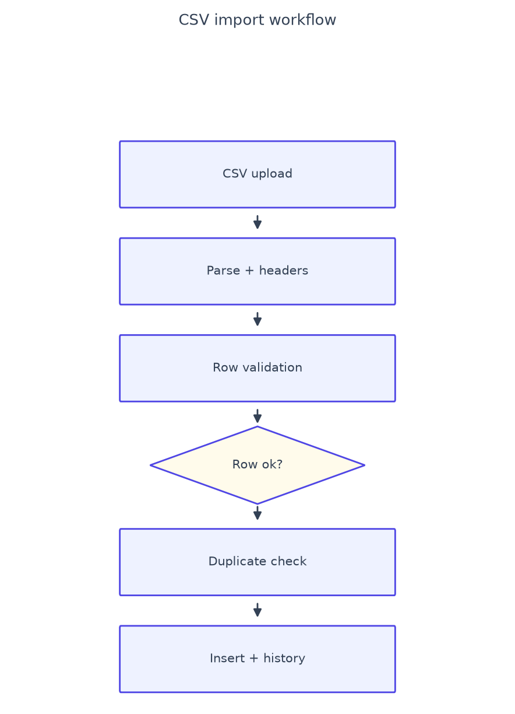
Figure 5 — CSV import pipeline (5 MB cap, MIME sniffing, 5000 rows, per-row errors).
Analytics renders twelve-month series with cancellable refresh. Reports reuse page filters for server-authoritative CSV and PDF output. Exports carry correct filenames and content types.

12. Notification, Profile and Validation Workflows
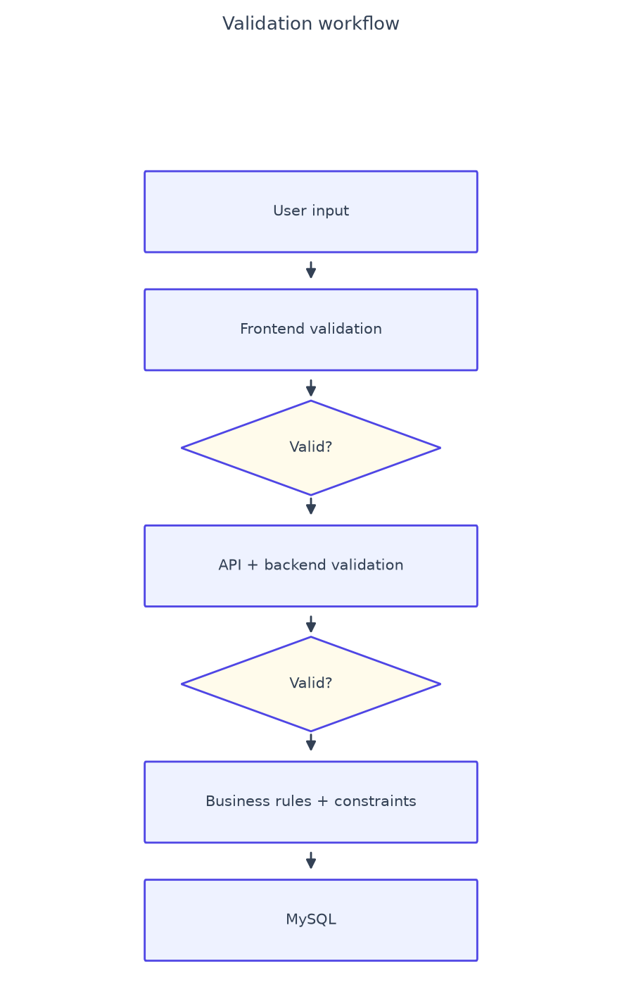
Figure 6 — Two-layer validation.
Budget alerts regenerate at most every 30 minutes with same-day deduplication; login notices deduplicate within 15 minutes; newest 30 per user retained. Profile edits and password changes require the current password and rotate session plus CSRF. Rules: email format, 8+ character alphanumeric passwords, positive two-decimal capped amounts, YYYY-MM-DD dates, owned type-matched categories, 2–100 character names, hex colors, icon allowlists, duplicates rejected.

13. Security Workflow
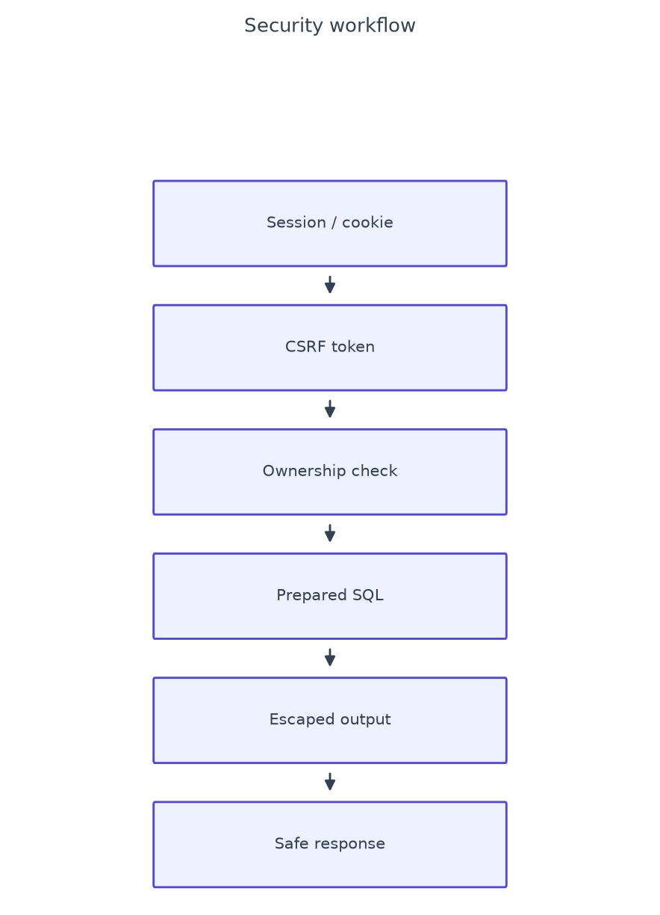
Figure 7 — Defense in depth per request.
Bcrypt with rehash, regenerated sessions, HttpOnly SameSite=Lax cookies, 30-minute CSRF rotation with constant-time compare, per-user query scoping, prepared statements, output escaping, allowlisted links/icons, self-cleaning rate limits, generic errors, CSP/nosniff/framing/referrer headers and denied direct access to code, data and log paths.

14. Financial Calculation Workflow
Balance = Income − Expense. Savings rate = (Income − Expense)/Income × 100. Remaining = max(0, Limit − Spent); over-budget when Spent > Limit. Rounding to paise, one module serves every screen, Indian digit grouping for display.

15. Error Handling, Assets, CDN, PWA and Performance
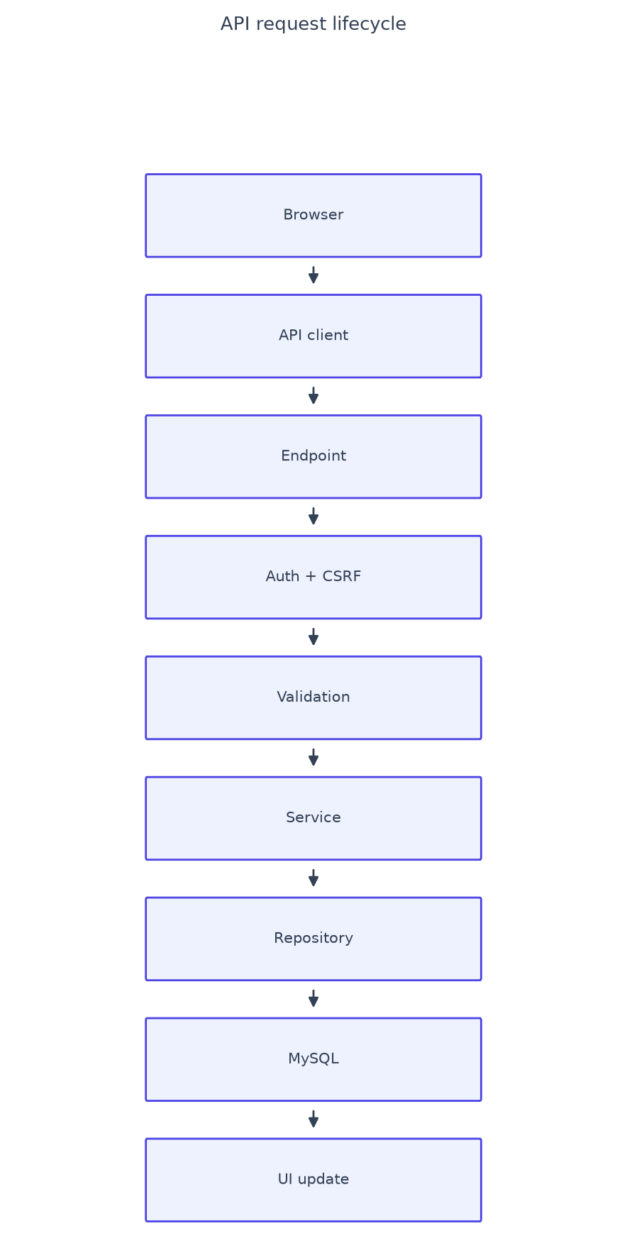
Figure 8 — API request lifecycle.
Global JSON handlers plus classified client errors; loaders always resolve to content, empty, error-with-retry or offline states. Page-scoped modules, one lazy SRI-pinned vendor registry, AbortController with sequence guards, event delegation, indexed paginated queries, immutable versioned-asset caching, gzip and a versioned service worker (network-only APIs with offline JSON, network-first navigation with offline page).

16. Responsive Design and UI/UX System
Light theme with system typography, white cards, indigo primary actions and semantic status colors. Desktop sidebar plus top bar from 768px; mobile header, bottom navigation, bottom sheets and safe-area padding below. Deterministic button states, focus-trapped modals, toasts plus persistent notifications, and empty/loading/error/validation states on every data screen.

17. API Endpoint Reference
Endpoint | Methods | Auth | Purpose
api/login.php | POST | public + CSRF | Sign in, remember-me, login notice
api/register.php | POST | public + CSRF | Create account + default categories
api/logout.php | POST | session + CSRF | Revoke tokens, destroy session
api/version.php | GET | public | Build check for update banner
api/dashboard.php | GET | session | Month KPIs, recent, trend, budget
api/transactions.php | GET/POST/PUT/DELETE | session (+CSRF write) | CRUD, filters, pagination
api/categories.php | GET/POST/PUT/DELETE | session (+CSRF write) | CRUD, safe delete
api/budgets.php | GET/POST/PUT/DELETE | session (+CSRF write) | Period budgets, progress
api/reports.php | GET | session | Summary, categories, trend, rows
api/export.php | GET | session | CSV download / printable report
api/import.php | GET/POST | session (+CSRF write) | CSV upload, preview, history
api/profile.php | GET/PUT | session (+CSRF write) | Profile, password change
api/quick-templates.php | GET/POST/PUT/DELETE | session (+CSRF write) | Entry presets
api/notifications.php | GET/POST | session (+CSRF write) | Alerts, mark read

18. Security Controls and Data Flow
Sessions, cookies, CSRF, authentication, authorization, ownership checks, prepared statements, input validation, output escaping, password hashing, rate limiting, secure responses, HTTP security headers, direct-file protection and safe error handling. UI state feeds validated requests; services coordinate repositories; MySQL persists; responses refresh exactly the state that changed; stale responses never win.

19. Deployment, XAMPP, MySQL, Configuration, Browsers
Copy the folder to htdocs, import database/schema.sql into MySQL (utf8mb4_unicode_ci), set EXPENSEPRO_DB_* credentials, open the app. Requires Apache mod_rewrite/mod_headers and PHP pdo-mysql/mbstring/fileinfo. Base URL auto-detects with override; Asia/Kolkata timezone; production-safe errors. Verified on Chrome/Edge, Firefox and iOS Safari; desktop 1366–1920px and mobile 390–412px viewports.

20. Project Statistics
Metric | Count (measured)
Total source files | 127
PHP files | 59
JavaScript modules | 24
CSS modules | 26
API endpoints | 14
Pages | 14
Backend modules | 18
Database tables | 9
Major features | 16

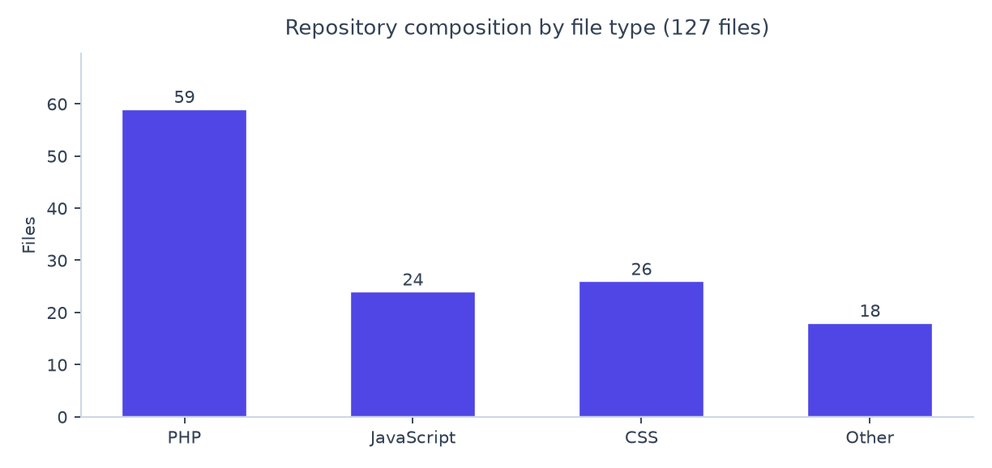
Figure 9 — Repository composition (measured).
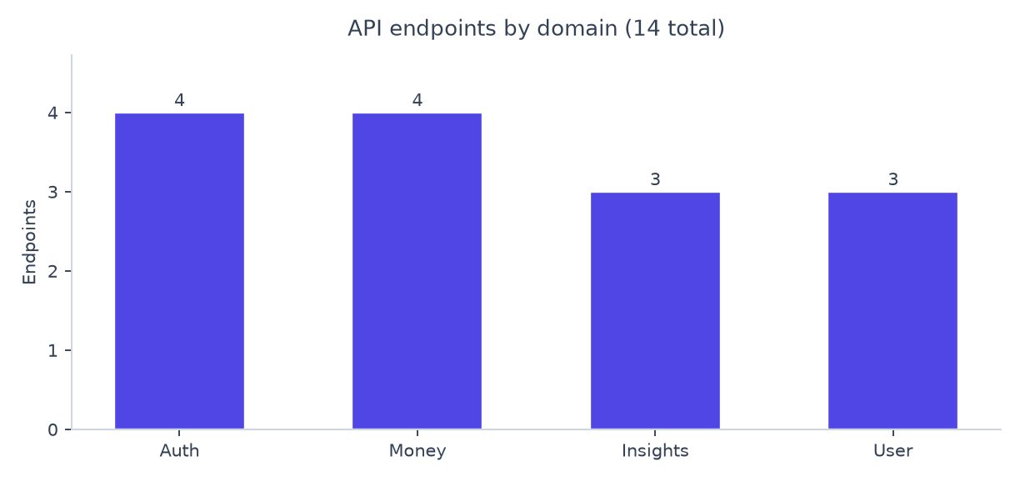
Figure 10 — API endpoints by domain (measured).
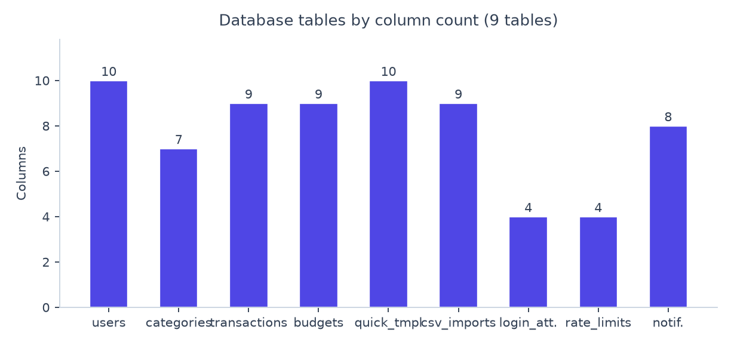
Figure 11 — Database tables by column count (measured).

21. Screenshots
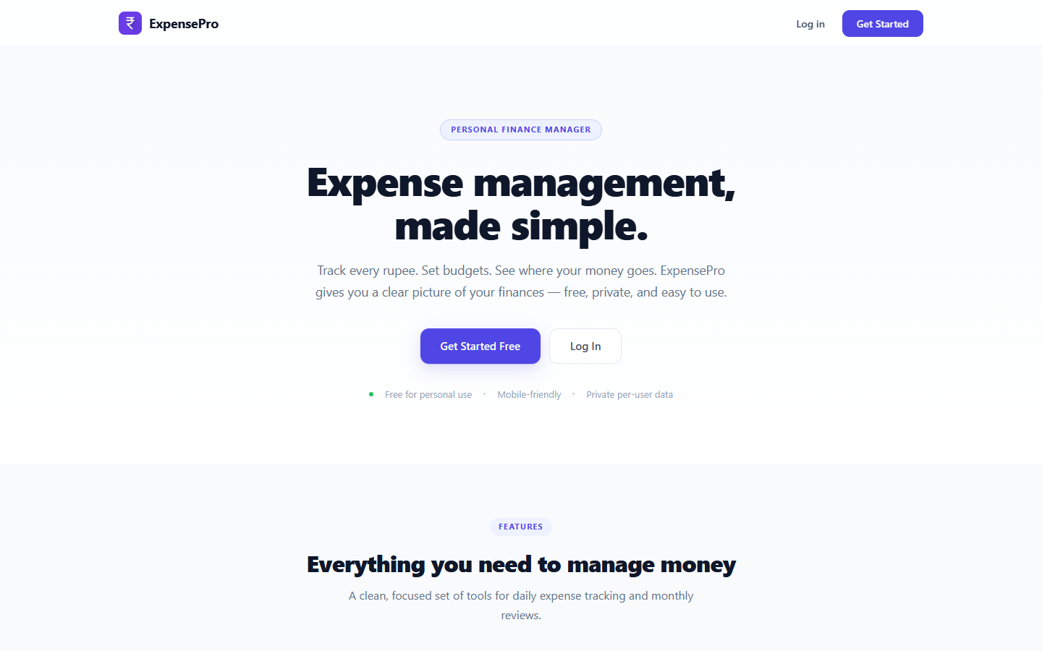
Figure — ExpensePro Desktop landing page.
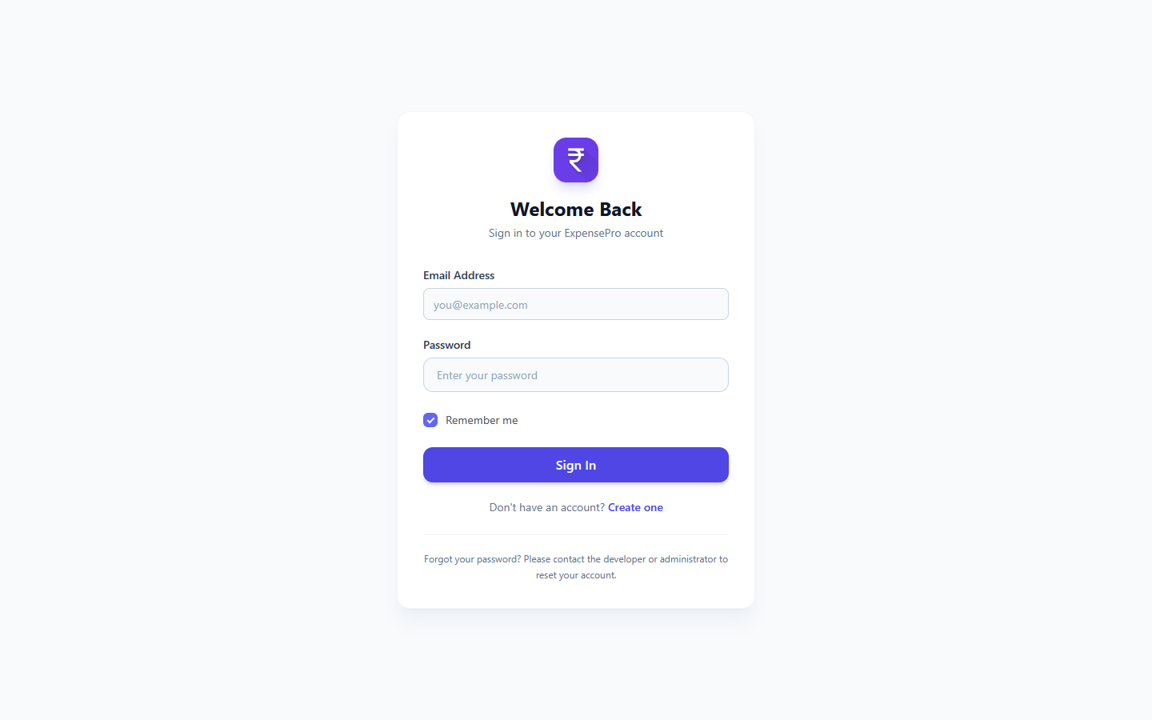
Figure — ExpensePro Desktop login.
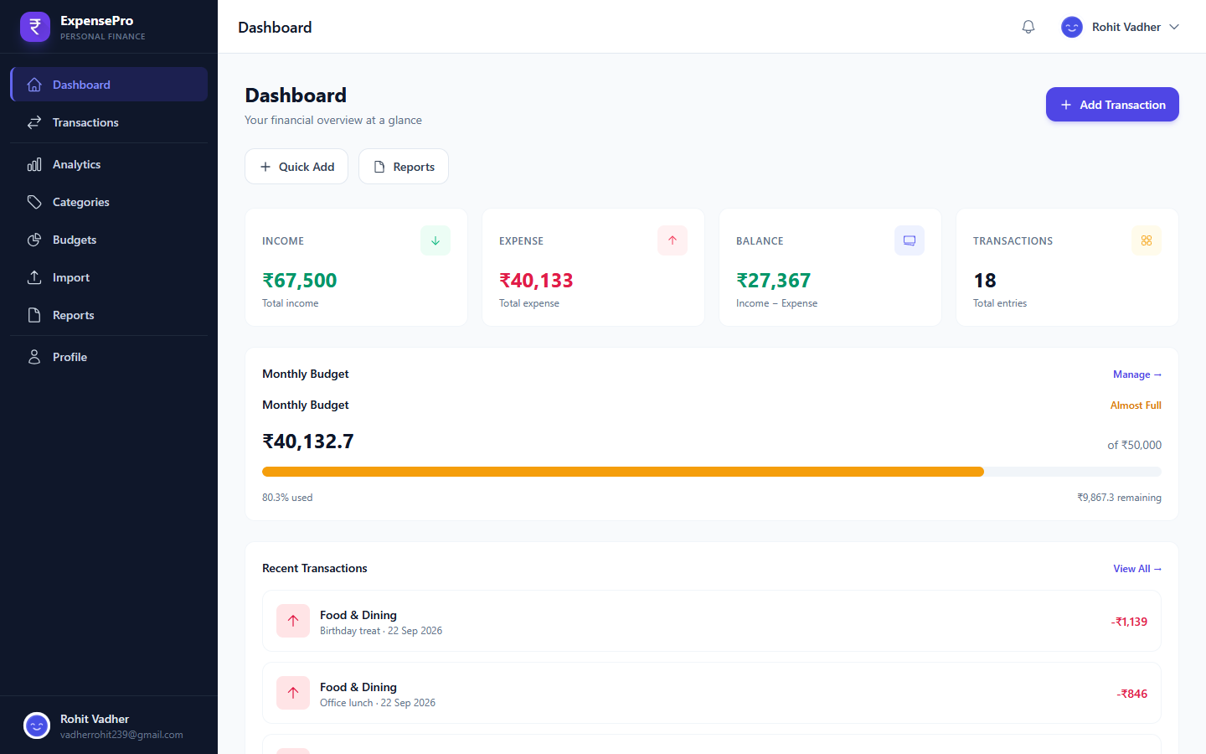
Figure — ExpensePro Desktop dashboard with monthly KPIs.
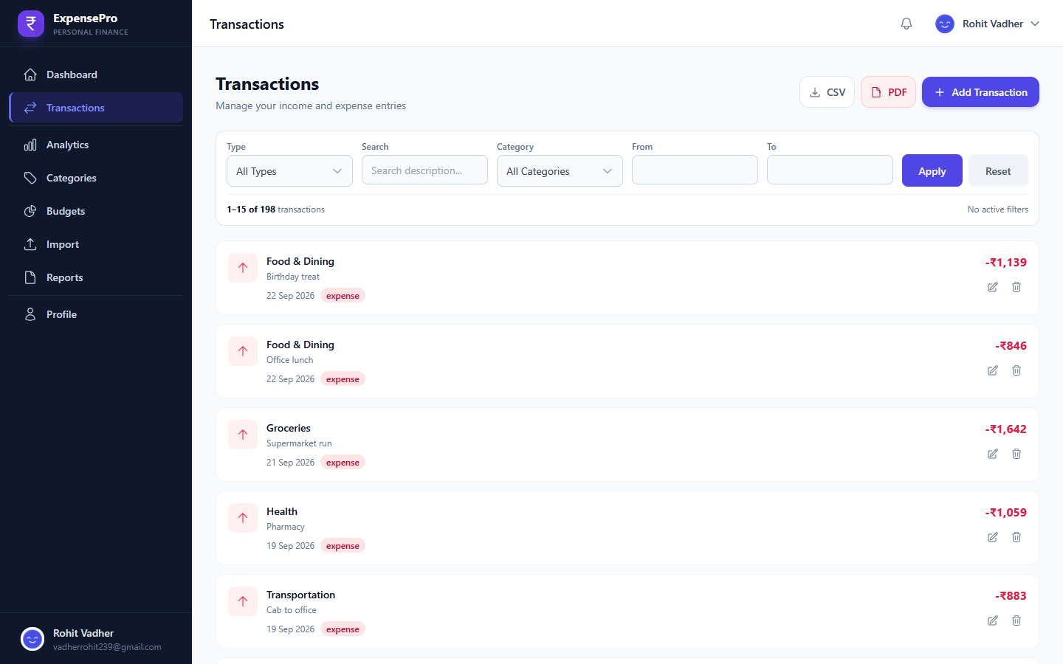
Figure — ExpensePro Desktop transactions with filters.
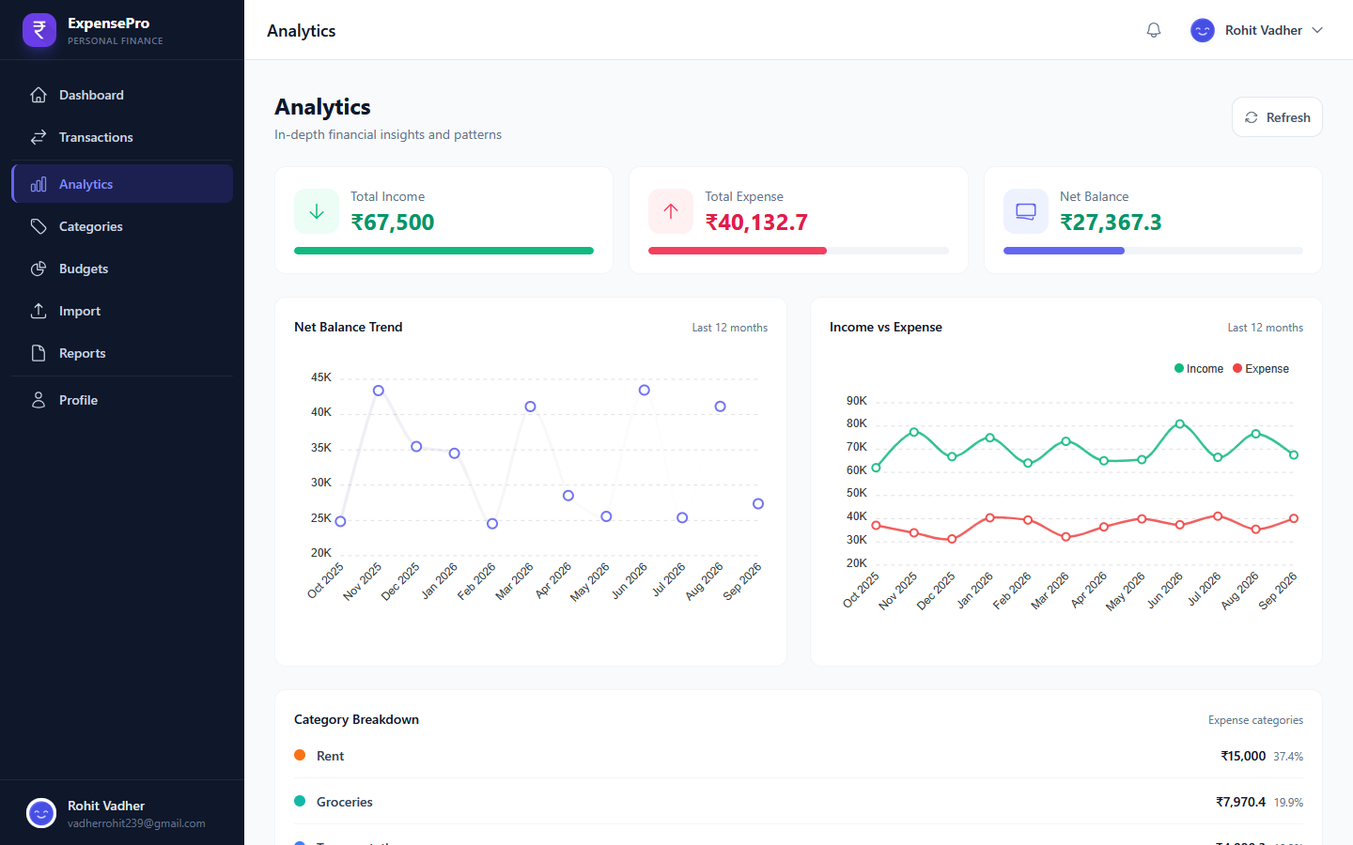
Figure — ExpensePro Desktop analytics with twelve-month charts.
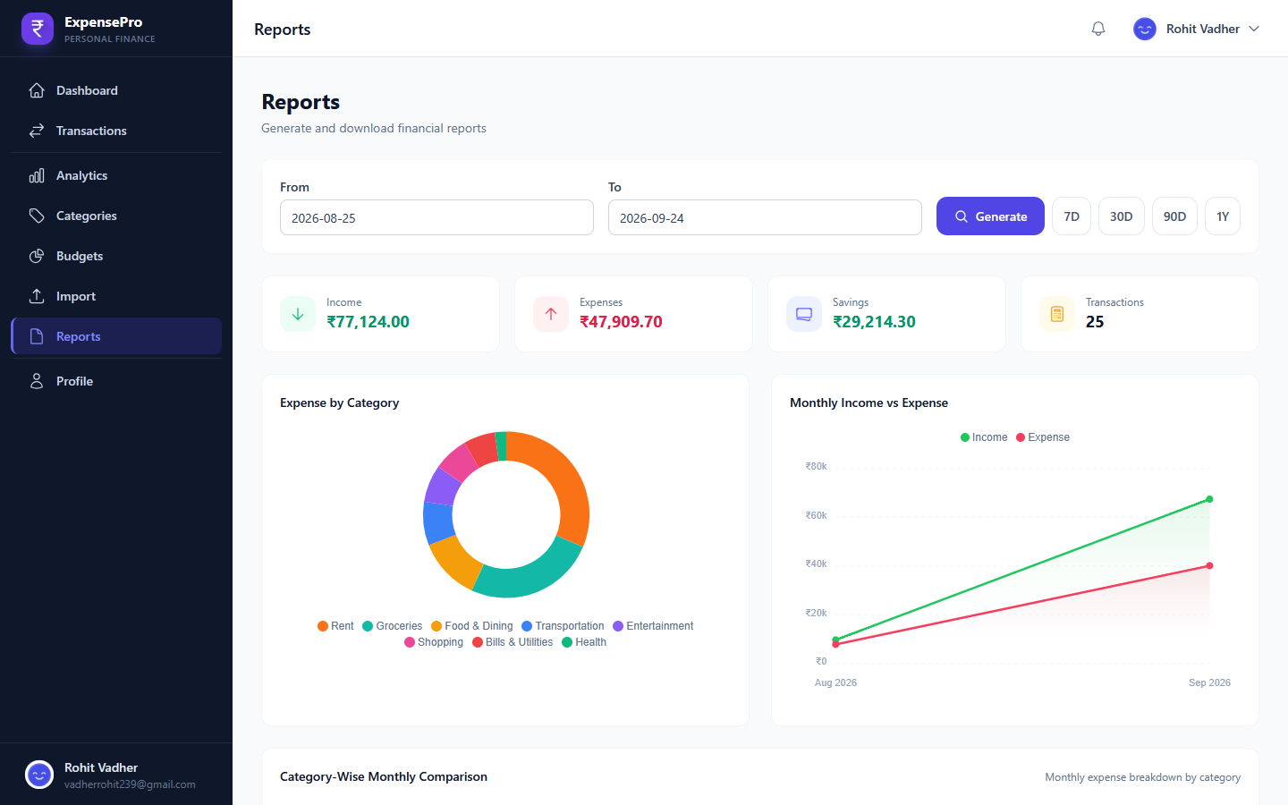
Figure — ExpensePro Desktop reports with exports.
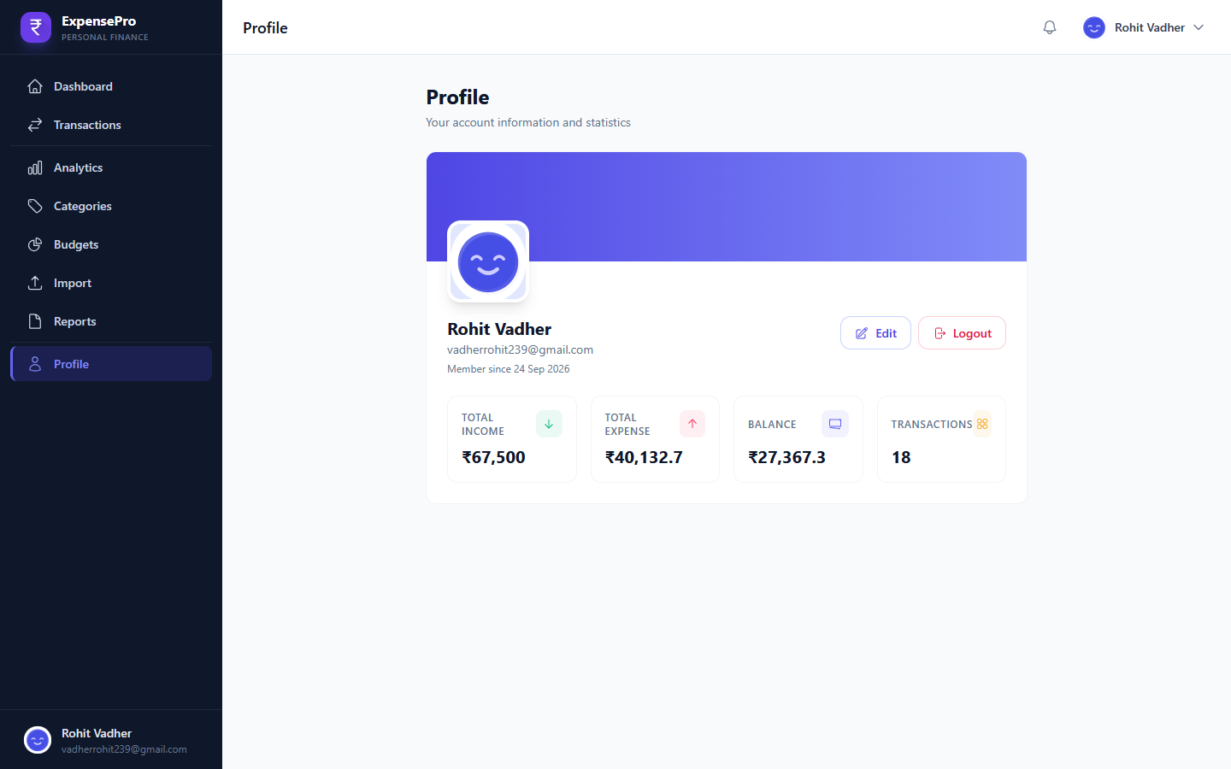
Figure — ExpensePro Desktop profile and stats.
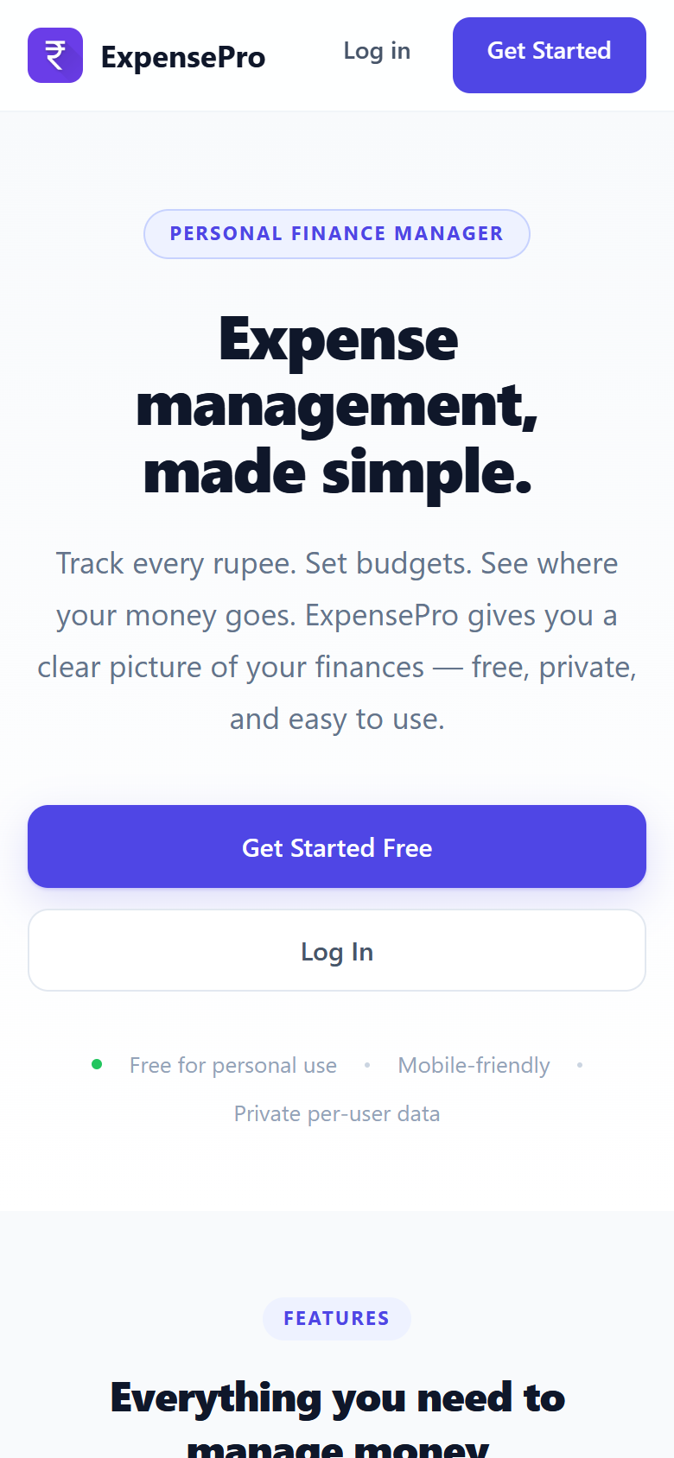
Figure — ExpensePro Mobile landing.
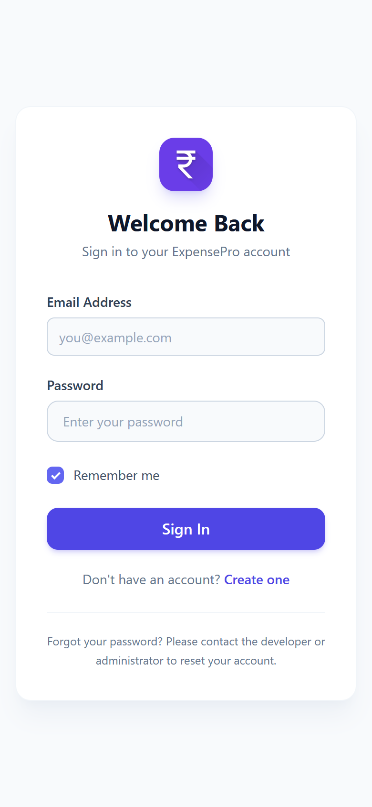
Figure — ExpensePro Mobile login.
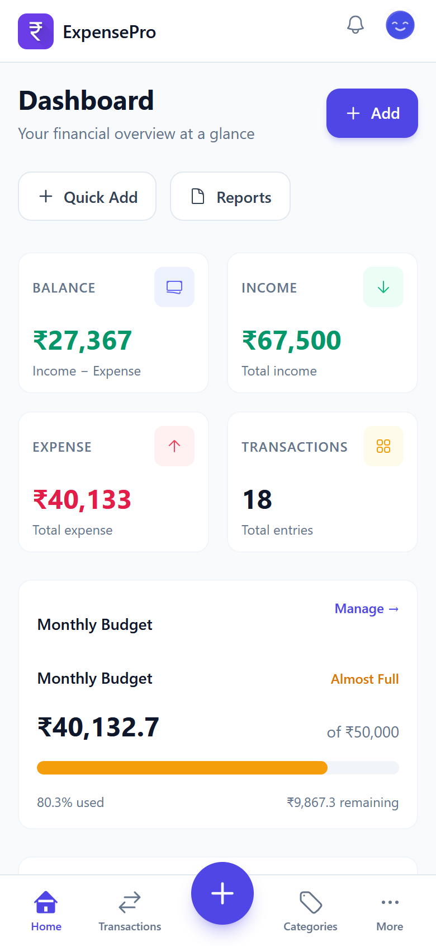
Figure — ExpensePro Mobile dashboard.
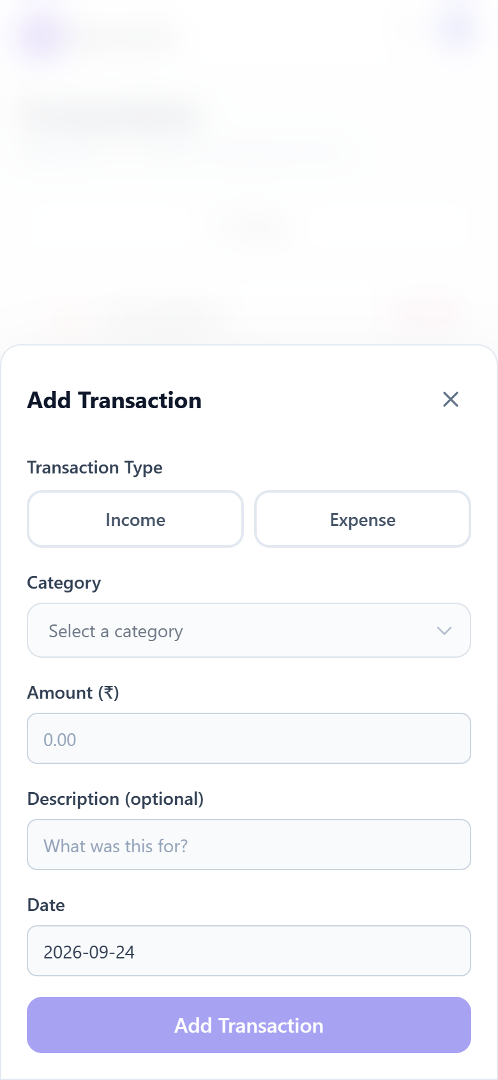
Figure — ExpensePro Mobile transaction bottom sheet.
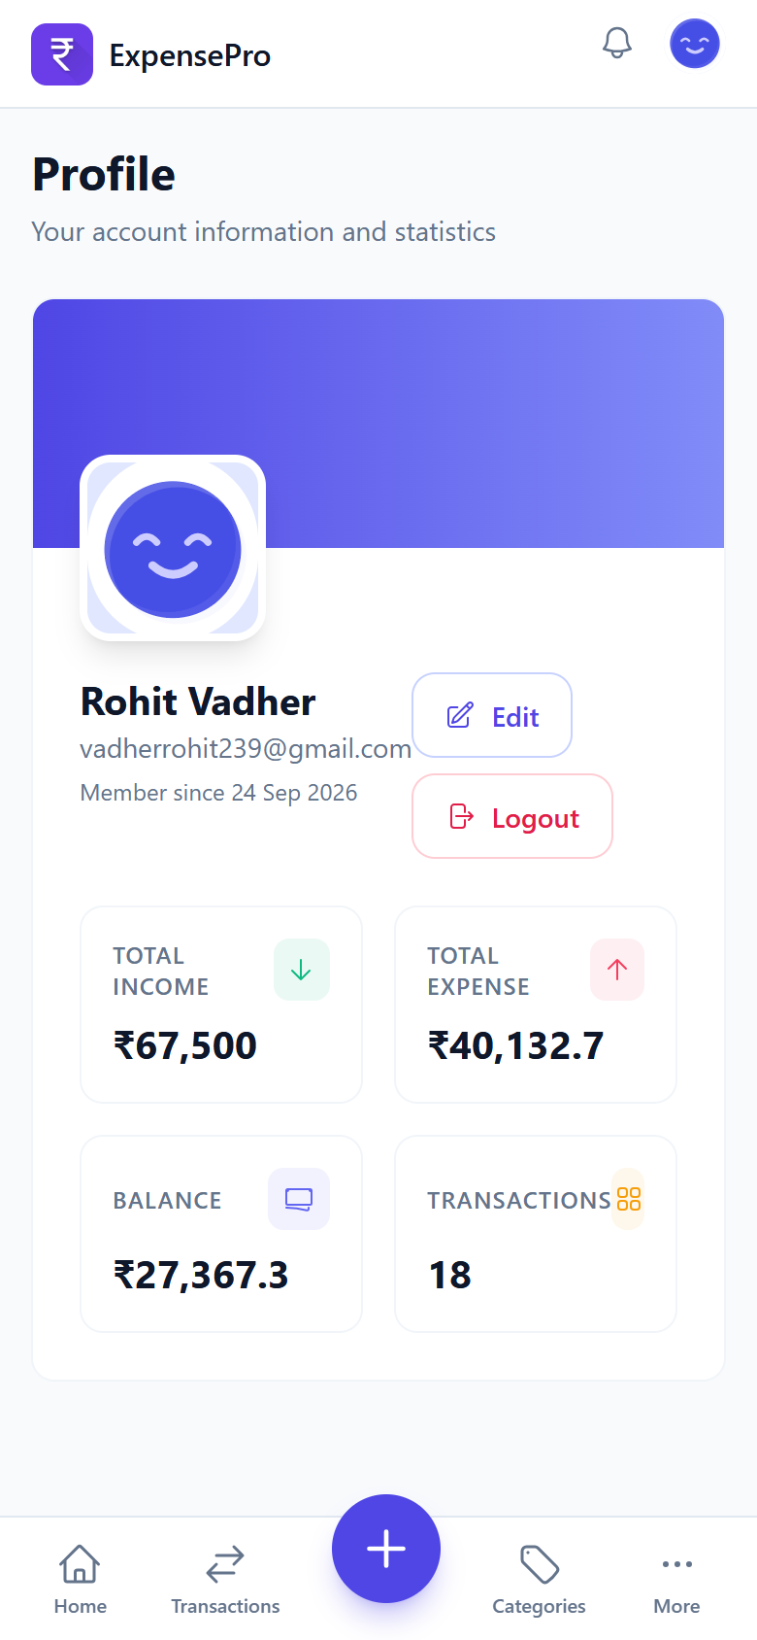
Figure — ExpensePro Mobile profile.

22. Project Structure and Responsibilities
api (HTTP boundary), pages/layouts (shells), assets/js (core, services, components, features, pages), assets/css (tokens through pages), backend (rules, services, repositories), includes (bootstrap), database (schema plus migrations), docs (this pack), offline (offline page).

23. Limitations
- PDF history pages use printer-safe Rs. amounts (PDF standard fonts lack the rupee glyph).
- Quick templates are API-complete.
- Charts and the PDF engine need their CDN on first use; offline fallbacks apply.
- Dashboard KPI cards round to whole rupees by design.

24. Maintenance Notes
Logs are disabled by design; errors surface as safe UI messages with correct HTTP codes. Add tables via guarded schema statements plus a migration file; keep every new query user-scoped and prepared; mirror validation rules on both sides; never expose internals in responses.

25. Conclusion
ExpensePro delivers a complete private finance workflow on ordinary shared-friendly hosting: PHP, PDO and MySQL on the server, vanilla JavaScript in the browser, one validation and calculation model everywhere, and installable offline-capable clients.

26. Student Information
Rohit Vadher, BCA Sem-5. ExpensePro v1.0, 2026. Stack: PHP 8+, PDO, MySQL (InnoDB, utf8mb4), vanilla JavaScript, Tailwind CSS, Apache/XAMPP.

