VivaahFlow — Wedding Services Management System
Project Documentation — September 2026
The visible product name is VivaahFlow. The wedding_planner database name and project folder name are intentionally retained for compatibility. Brand colour #8B0A72, currency INR, timezone Asia/Kolkata.

1. Overview
End-to-end wedding planning platform: public website enquiry, lead follow-up and quotation, confirmed booking with events, staff, payments, invoices, and moderated reviews, plus reporting, notifications, activity audit, and role-based permissions. Three surfaces share one backend through /api/v1/index.php; page files are thin shells with no SQL.

2. Key Features — Public Website
Branded hero with live stats, categories, featured services, featured package, gallery showcase, active offer, testimonials. Searchable/filterable catalogue, service detail with gallery/reviews/similar services, package detail with conditional discount rows, and a tracked enquiry form with reference numbers.

3. Key Features — Customer Portal
Gated /account area with dashboard stats, quotations (accept/decline, expiry-aware), bookings with schedules and staff, payment history, printable invoices, review submission with moderation status, and profile management.

4. Key Features — Admin Panel
Role-aware CRUD across customers, categories, services, packages, offers, quotations, bookings, events, staff, payments, invoices, users; enquiry-to-booking conversion; scheduling and assignments; payment protection and reversal; invoice lifecycle; review moderation; ApexCharts reports; notifications; settings with logo upload; audit log.

5. Tech Stack
PHP 8.2, MySQL/MariaDB (PDO prepared statements), Apache or PHP built-in server, custom JSON router (PATH_INFO with ?route= fallback), Tailwind CDN + Flowbite 2.5.1 + vanilla JS, ApexCharts, Lucide, Inter + Playfair Display, Flatpickr, Swiper 11.

6. System Requirements
PHP 8.2+ (pdo_mysql, mbstring, fileinfo, session, json, bcmath recommended, curl optional; gd not required), MySQL 5.7+/MariaDB 10.4+, Apache with mod_rewrite or built-in server, modern browser, internet for CDNs.

7. Folder Structure
frontend/customer, frontend/portal, frontend/admin (shells + routers, no SQL); frontend/assets (css, js/admin|customer|portal|core, images/brand/logo.svg, icons); api/v1/index.php; backend (bootstrap, Calculations, Controllers, Core, Database, Helpers, Middleware, Repositories, Services, Validators); config/config.php; database/schema.sql (29 tables) + seed.php; storage/logs; uploads/services (23 WebP) + uploads/packages (3 WebP); docs.

8. Backend Architecture
Front controller loads bootstrap then Router; App\ maps to backend/; Container autowires via reflection; Routes::register() declares 144 routes; middleware EnsurePanelUser/EnsureCustomer/CsrfGuard; BaseController + Validator + standardized JSON; Services throw BusinessException; Repositories hold all SQL; CalculationEngine centralises money math. Envelope {success, message, data}; 422 carries an errors map.

9. Frontend Architecture
Shared foundation (app.config/api/loader/alerts/ui/tables/workflow/upload) then page modules. API resolves with payload.data and normalized ApiError. Single Loader system, toasts + promise confirms, declarative tables, central FrontendRoutes map (url_for()/APP.route()). Admin/portal shells set APP.currentUser, apply permissions, dispatch app:ready.

10. Design System and Theming
Brand scale --brand-50..900 on --brand-600 #8B0A72, ink scale, semantic colours, radii/shadows, Inter + Playfair Display. core/components/layout/utilities/site/help CSS. Light only, desktop-first, responsive.

11. CDN and Third-Party Libraries
Tailwind CDN, Flowbite 2.5.1, Lucide, ApexCharts, Flatpickr (lazy), Swiper 11 (lazy), Google Fonts. Registered in AssetManager::LIBRARIES, per-page via $extraLibraries.

12. Database Overview
wedding_planner, utf8mb4, 29 tables, InnoDB. Money DECIMAL(12,2), integer cents in PHP. Reference numbers PREFIX-YYYY-NNN. created_at/updated_at on mutable records. Status enums as short strings.

13. Database Tables Reference
See table below (29 tables, DDL in database/schema.sql).

14. Entity Relationships
users 1:1 customers; customers 1:N enquiries 1:N enquiry_services; enquiries 1:0..1 quotations 1:N quotation_items; quotations 1:0..1 bookings 1:N booking_services; bookings 1:N events 1:N staff_assignments N:1 staff; bookings 1:N payments/invoices/reviews; categories 1:N services 1:N service_images; packages N:M services; offers N:M services/packages; roles 1:N users; leads 1:N lead_followups.

15. Installation (XAMPP)
Place project in C:\xampp\htdocs\Wedding Planner, start Apache+MySQL, create wedding_planner (utf8mb4), import schema, run seed.php with XAMPP PHP, verify config, open / (site) and /manage/login (admin).

16. Configuration Reference
app_name VivaahFlow; timezone Asia/Kolkata; debug false; session vivaahflow_sess, 7200s, Lax, non-secure; login_max_attempts 5 / lock 15 min; uploads 3MB, jpg/jpeg/png/webp; pagination 10; currency INR; api_base /api/v1.

17. Database Setup and Seeding
Fresh schema import then seed.php (roles, users, catalogue, CRM, finance, reporting demo data; prints demo credentials).

18. Default Credentials
admin@example.com/Admin@123, manager@example.com/Manager@123, staff@example.com/Staff@123, customer@example.com/Customer@123. Change all passwords before real use.

19. Running with Apache
Root .htaccess clean URLs to frontend routers; API at /api/v1/index.php/<route> via PATH_INFO; /assets from frontend/assets; /uploads public; listings off; backend/config/database/storage/direct frontend blocked (403); .env/.sql/.log/README/.bak/.tmp/dotfiles denied. Missing assets fall through to the customer router (homepage HTML 200), so referenced asset files must exist.

20. Running with the PHP Built-in Server
php -S 127.0.0.1:8100 with docroot at project root; no /Wedding Planner prefix, no .htaccess; routers accept ?route=.

21. Page and URL Map — Public
/ (home), /services + /services/{slug}, /packages + /packages/{slug}, /gallery, /offers, /reviews, /contact, /login, /register.

22. Page and URL Map — Portal and Admin
Portal: /account, enquiries, quotations/{id}, bookings/{id}, payments, invoices/{id}, reviews, profile. Admin: /manage dashboard, customers/{id}, enquiries, leads, categories, services, packages, offers, quotations/{id}, bookings/{id}, events, staff, payments, invoices/{id}, reviews, reports, notifications, users, settings, activity, profile, help, login.

23. Authentication Flow
POST /auth/login (rate-limit checked, bcrypt verified) regenerates session; AuthService::user() caches user+role+customer; GET /auth/me shapes user; POST /auth/logout clears. Admin footer sets APP.currentUser; portal guarded by EnsureCustomer + portal_guard(). Login needs prior GET /auth/csrf.

24. Session Management
vivaahflow_sess, 7200s, SameSite=Lax, secure off (enable on HTTPS). Started in bootstrap, regenerated at login, CSRF token in meta.

25. CSRF Protection
CsrfGuard on mutating requests; token in meta + APP.csrfToken; app.api.js attaches X-CSRF-Token; refresh via GET /auth/csrf.

26. Security and Rate Limiting
Bcrypt, login_attempts logging, 5 failures/15min lockout (429), prepared statements, upload size/extension validation with generated names, escaped output, server-side role checks, errors to php-error.log only.

27. Roles Overview
admin: full. manager: all but settings/users/roles/activity and selected deletes/reversals. staff: operational subset. customer: own portal data.

28. Permissions Matrix
See matrix table below.

29. Full Permission Reference
dashboard.view; customers/services/categories/packages/enquiries/quotations/bookings/events/staff/payments/invoices/reviews/offers/leads/reports/notifications/settings/users/roles/activity tokens as documented; managers exclude customers.delete, invoices.delete/create, reviews.delete, payments.reverse, settings.*, users.*, roles.*, activity.read.

30. Admin Panel Overview
bootstrap/sidebar/header/footer partials; per-page $pageTitle/$pageDesc/$activeNav/$pageScript plus optional CSS/libraries/area scripts.

31. Dashboard Module
KPI cards, revenue trend, booking distribution, upcoming events, follow-ups, shortcuts (GET /reports/dashboard, GET /dashboard).

32. Customers Module
Searchable/filtered/paginated list + aggregated detail; gated delete.

33. Enquiries and Leads Modules
Enquiry statuses and quotation/lead conversion; lead pipeline with assignment and follow-up history.

34. Catalogue Modules
Categories; services with cover image + gallery sub-resource (primary/ordering); packages with quantities and percent/fixed discounts; time-bound offers scoped to all/services/packages.

35. Quotations Module
From enquiries, editable items, draft/sent/accepted/rejected/expired with 409-guarded transitions; portal accept/reject; expiry enforced.

36. Bookings Module
From accepted quotations with snapshotted items; full lifecycle; schedule/payment modals; derived payment_status.

37. Events and Staff Assignments Module
Per-booking events with day schedule panel; assign/complete/remove staff.

38. Staff Module
Directory with optional linked login; active-staff endpoint for pickers.

39. Payments and Invoices Modules
Server-authoritative amounts, over-payment blocked, gated reversal; invoice lifecycle with derived paid/partial/overdue and print view.

40. Reviews Module
Moderation queue with visibility + business replies; public shows approved/visible only.

41. Reports and Analytics Module
KPI snapshot, revenue/booking/funnel/performance charts, date-ranged revenue and bookings reports, top customers, recent activity.

42. Notifications, Settings, Users, Activity, Profile
Inbox with unread indicator; business settings + logo upload; user/role management with self-protection; audit trail; profile + password change.

43. Public Website
Home hides empty sections; services search/chips + detail; packages with conditional discounts; gallery with empty state; active offers; reviews with distribution; contact enquiry with prefill + reference; auth honours registration_open. See screenshots below.

44. Customer Portal
Gated /account with dashboard, read-only enquiries, quotation accept/decline, bookings with schedules/staff, payments, printable invoices, reviews, profile. API under /portal/*.

45. Booking and Status Lifecycles
Enquiry new>contacted>quotation_pending>quotation_sent>converted (or closed). Quotation draft>sent>accepted/rejected/expired (409 guards skips). Booking pending>confirmed>scheduled>in_progress>completed (or cancelled). Event scheduled>in_progress>completed. Payment recorded>reversed. Invoice draft>issued>partial>paid (or overdue/cancelled). Review pending>approved/rejected. Lead new>contacted>follow_up>converted (or lost).

46. Calculation Engine and Money Handling
Integer cents via Money; CalculationEngine discounts; PackageService hydration; server-side totals with formatted fields; derived payment status.

47. File Uploads and Media Handling
3MB + extension validation, generated names, ImageEngine reference counting, upload_url() links. No blank boxes: Lucide icon fallbacks + empty states everywhere; canonical brand mark logo.png (192x192) in headers/sidebar/login/hero/favicon; icon favicons in assets/icons.

48. Media Integration Pass (September 2026)
23 raw PNGs (56.2 MB) converted to 26 WebP (5.4 MB): 23 service images + 3 package covers. Applied: 13 services.image, 23 service_images rows, 3 packages.cover_image; leftover package id 4 deleted. Verified: services 13/13 image_url, gallery 23, packages 3/3 covers, 0 orphans. Mapping: docs/image-inventory.json/.md.

49. REST API Reference
144 routes in 24 groups (see table). Errors: 401/403/404/409/422/429. Verified: health 200x3, csrf ok, unauth /customers 401, unknown route 404.

50. Validation and QA Evidence
See QA table below. Toolchain: XAMPP Apache :80, MySQL 3306, PHP 8.2.12, Node 24, Chrome playwright-core.

51. Real-Browser Repair Pass (September 2026)
Sixteen headed Chrome sessions exercised every critical workflow end to end (QA_REAL_BROWSER_REPORT.md; fixes in MASTER_FIX_REPORT.md). Five genuine runtime defects found, fixed, retested to PASS with DB proof: (1) permission race hiding row actions — two-way applyPermissions + app:ready re-apply (forced-race 30/30 x3); (2) package create with services always 422 — service_ids normalized before validation; (3) settings logo upload never sent (API.upload arg order) — now POST 200 verified; (4) checkbox wipe on slow loads — checked state preserved; (5) overflow at 768px (+32) and contact at 1024px (+89) — grid/detail-row guards. Lifecycles verified: profile edit, services/packages/offers/reviews/gallery/customers CRUD (zero residue), logout, registration, guest enquiry, auth matrix, 20 admin pages with 0 console errors, mobile drawer. A second full role/CRUD visible pass (admin/manager/staff/customer + QA user lifecycle) fixed four more defects and retested them: password-change and admin-profile 401s (routes lacked user resolution), enquiry-to-lead 500 (wrong data keys), unlinked logged-in enquiries, stale names after rename. Responsive 45/45 across 9 viewports; sidebar 21/21 verified.

52. Troubleshooting, Error Handling and Deployment
Port conflicts; missing-asset fallback; 401/403/422/409/429 handling; never CSS-hide image bugs; pre-deploy: rotate passwords, debug false, secure cookies, restrict dirs, back up DB+uploads, re-run QA.

53. Release Checklist
Media integrated, zero broken/blank images, logo everywhere, lint clean, browser QA green, API+DB verified, log clean, no temp residue, PDF+DOCX built, README rewritten.

Appendix A — Database Tables (29)
# | Table | Purpose
1 | roles | Roles (admin, manager, staff, customer)
2 | users | Login accounts
3 | customers | Customer profiles
4 | service_categories | Catalogue categories
5 | services | Bookable services + image
6 | service_images | Per-service gallery
7 | packages | Bundles + cover image
8 | package_services | Package-service links
9 | offers | Promotions
10 | offer_services | Offer-service links
11 | offer_packages | Offer-package links
12 | enquiries | Enquiries
13 | enquiry_services | Enquiry items
14 | quotations | Quotations
15 | quotation_items | Quotation items
16 | bookings | Bookings
17 | booking_services | Booking items
18 | events | Scheduled events
19 | staff | Staff
20 | staff_assignments | Assignments
21 | payments | Payments
22 | invoices | Invoices
23 | reviews | Reviews
24 | leads | Leads
25 | lead_followups | Follow-ups
26 | notifications | Notifications
27 | activity_logs | Audit trail
28 | settings | Business settings
29 | login_attempts | Rate-limit tracking

Appendix B — QA Evidence (September 2026)
Check | Result
php -l (project) | 156/156 OK
node --check (project JS) | 58/58 OK
Image audit pages @200 | 9/9, 0 broken, 0 blank, 0 empty-src
home / services / gallery imgs | 15 / 14 / 24, logo present
service-detail / packages / package-detail | 4 / 4 / 2
offers / reviews / contact | 1 / 1 / 1
Viewports 5x6 routes | 30/30, 0 overflow, 0 errors
Pages + assets HEAD | 20/20 status 200
API health GET x3 forms | 3/3 status 200 JSON
API services image_url | 13/13
API gallery items | 23
API packages with cover | 3/3
DB counts + orphans | 13 / 23 / 3, 0 orphans
Auth journeys (baseline) | 20/20
API regression 409/422/403/401/404 | 8/8
Interactions | 6/6
php-error.log | no PHP errors logged (directory empty)
Temp residue | 0

Appendix C — Screenshots (public pages, no credentials)
Public homepage
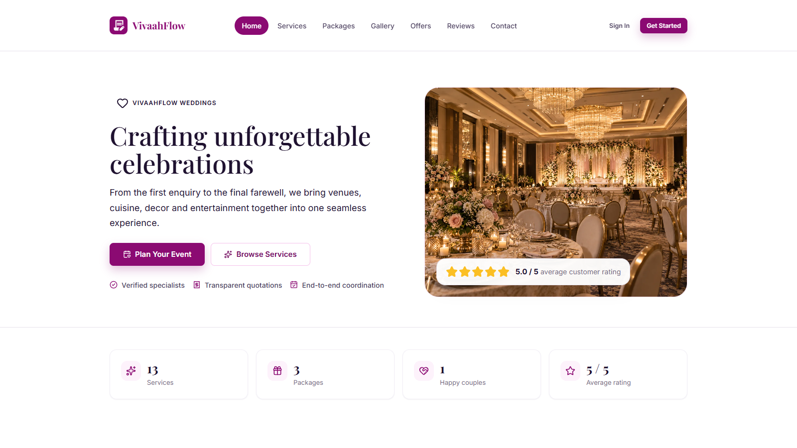
Service catalogue
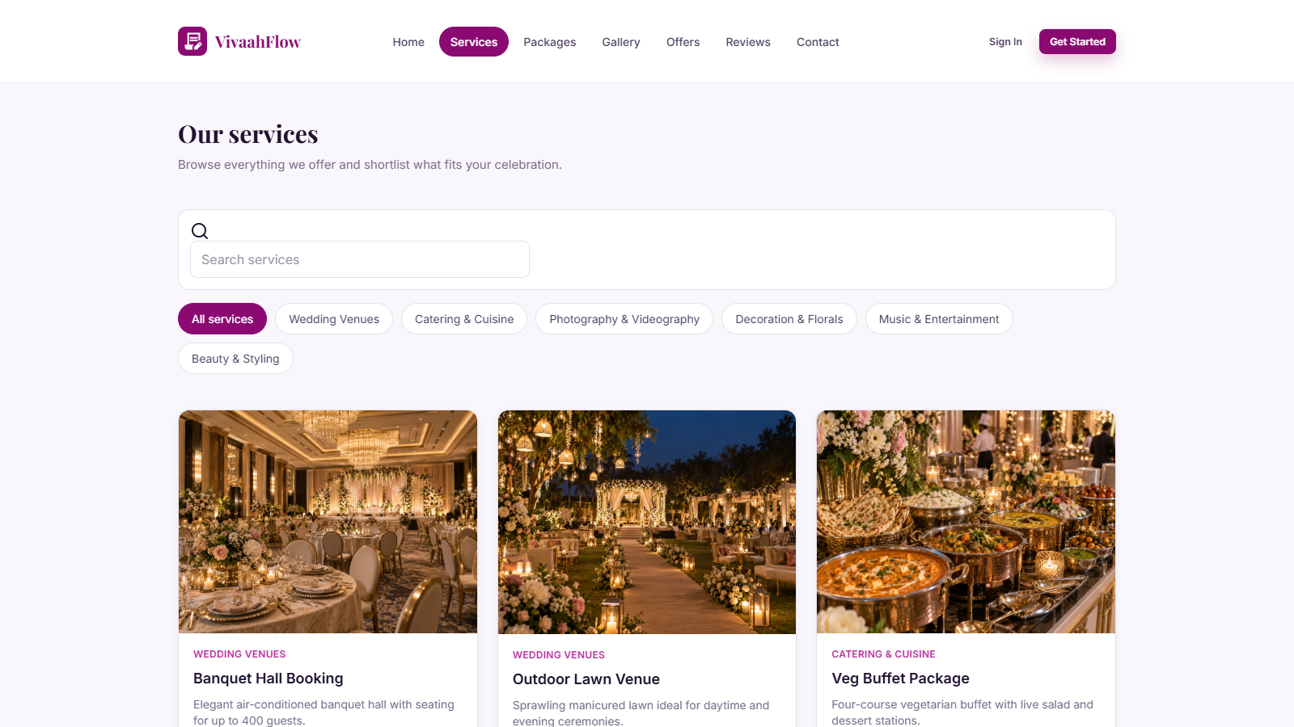
Gallery showcase
