Sudoku Solver
- Team 9

Team Members:
1. Chinmai Kulkarni
2. Nitasha Gupta
3. Rohit Vasudevan
4. Saumya Arora
5. Srividhya Manjunath

Introduction

Sudoku is a logic-based combinatorial number-placement puzzle. The grid is divided into 9 boxes where a box consists of 3 rows and 3 columns. Every new puzzle starts out with an arbitrary number of given integers placed in the grid. Every such integer is called a clue. The goal of the puzzle is to fill the remaining cells in the grid with integers such that every integer appears uniquely.

Algorithms Used:
1. Brute Force Search
2. DFS with backtracking

1. Brute Force Search
Brute-force search computes every possible solution to a problem and then selects one that fulfills the requirement.
Backtracking is an extension to Brute Force Search in which the implicit constraints are evaluated after every choice.

2. Backtracking Depth First Search (DFS)
At each node, before looking at its children, we check to make sure to populate grid cells comply with the Sudoku constraints. This way, we only continue down a search path until we’re sure it won’t lead us to a solution. This can significantly reduce the amount of time spent traversing the tree. Every time we try writing the right number down in a cell, or make a choice on a solution path, we’ve effectively reduced our problem size.

Steps Followed during Image Processing:
- Preprocessing the image
- Extracting the Sudoku and perform Perspective Transformation
- Extracting the cells of the Sudoku
- Recognizing the digits (OCR)
- Solve the Sudoku

1. Preprocessing the Image
Convert the original image into grayscale image by using cv2.cvtColor()

2. Extracting the Sudoku and perform Perspective Transformation
Steps:
- Apply Thresholding
Using Adaptive Gaussian Thresholding (cv2.adaptiveThreshold()).
2. Find Edge Detection
Using Canny Edge Detection (cv2.Canny()).
3. Find Contours
Contours is the curve joining all the continuous points. Done using cv2.findContours().
4. Find Largest Connected Component
Largest Connected Component – Sort by Area. Find a component which is a square by using cv2.approxPolyDP().
5. Apply Transformation
Warp Perspective Transformation is done by using cv2.getPerspectiveTransform() and cv2.WarpPerspective().

3. Extracting the cells of the Sudoku
This step is performed to correctly identify the location of each cell from the grid. We do rough estimates of cell location. To achieve this, we rely on the concepts of structuring elements. This is done by placing them at the centers of the partitions of an even 9x9 partitioning. Then for each cell, we will refine its cell center position vertically, then horizontally.
When a structuring element is centered at (x,y), its response is defined to be the sum of the values of the pixels within the four orange rectangles. SE A is used to refine the cell center vertically and SE B is used to refine the cell center horizontally.
To vertically refine a cell center, the basic idea is that we center SE A at the current cell center estimate and slide it up and down within some predefined range and place it where the highest number of foreground pixels will fall within the orange areas.
To Horizontally refine a cell center, we slide SE B left and right within a fixed range of the cell center estimate provided by vertical refinement and move the cell center horizontally to the location of highest response.
Why have this gap in between the orange areas? The answer is that this configuration reduces the effect that the number in the cell (or in adjacent cells) will have on the responses of the SEs.

4. Recognizing the digits (OCR)
Optical character recognition is the mechanical or electronic conversion of images of typed, handwritten or printed text into machine-encoded text, whether from a scanned document, a photo of a document, a scene photo. Here, we are recognizing digits using K-nearest neighbor algorithm (KNN). We analyze each cell whether or not it is empty. If it contains a digit, then remove 5 pixels from each direction to isolate the digit and pixel value is used as a feature.

5. Solve the Sudoku

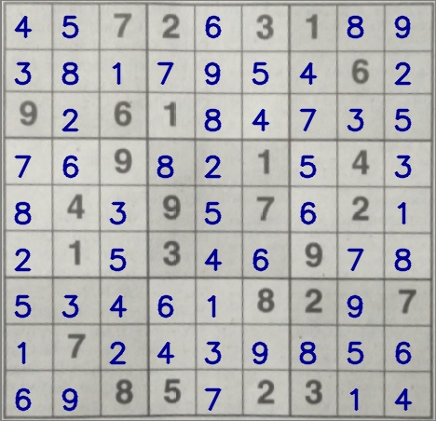

Image of the solved Sudoku

Environment Setup

We need to have Python 2.7 installed. IDE used is PyCharm CE.
Packages installed are OpenCV-python, Numpy, matplotlib.

Demo

Our Sudoku Solver project consists of solving a Sudoku with and without using image processing.
1. Under the General_Sudoku directory, it consists of two programs, Brute_Force.py and DFS_Backtracking.py.

Brute_Force.py performs brute force approach for solving the Sudoku by entering the Sudoku as a text input in the program.
DFS_Backtracking.py performs Sudoku solving using Backtracking Depth First Search by entering the Sudoku as a text input.

2. For Image Processing, it consists of three programs, general_operations.py, image_process.py, solve_sudoku.py.
general_operations.py performs the basic image processing functions like recognition of the image, resizing the image, trying to find the four corners of an image, ordering the coordinates of an image.

image_process.py analyzes each cell of an image, checks if a cell contains a digit or not, find the contours and edges, does the warp perspective, etc.

solve_sudoku.py is the main program of the project. To execute the project, we have to run the solve_sudoku.py program.

3. The responses.data and samples.data consists of training data for the OCR to recognize the digits in the cell during image processing.

4. train_OCR.py consists of the code to extract the digits from the Sudoku using the training data as input.

5. Sample Sudokus folder consists of the Sudoku images.

Running the code

To solve the Sudoku using Image Processing:

python solve_sudoku.py -i “path-to-input-image”

For OCR Training

python train_OCR.py -i “path-to-input-image”

To solve the Sudoku without Image Processing:

python DFS_Backtracking.py
python Brute_Force.py

Input Images are under SampleSudokus folder.

Output obtained after running the code is the Original Image, Solved Sudoku, Warp Perspective and Thresholding Image.

Output obtained after running train_OCR.py is the extraction of each digit, and upon pressing enter we can extract each digit of the Sudoku.

References

https://github.com/rupeshwar/Sudoku-Solver

https://www.academia.edu/4840328/A_Synopsis_Report_On_SMART_SUDOKU_SOLVER_USING_IMAGE_PROCESSING

https://web.stanford.edu/class/ee368/Project_Spring_1415/Reports/Wang.pdf

