Codexa OS Knowledge Graph: A Token-Reduction Proof

Rohit V K | CODE & FULL WRITE-UP: https://github.com/rohitvijayakumar45/Codexa | https://github.com/rohitvijayakumar45

85.8x  fewer context tokens | 98.8%  token reduction | 174  code symbols tested | 5  real repositories
PROBLEM STATEMENT
LLM coding agents that answer from raw source files suffer four compounding failures: hallucination, context bloat, runaway token usage (hard questions can make an agent fail to converge; single runs we tested reached 300K–1.9M tokens with no answer), and sycophancy (a confidently-worded wrong answer talks a correct peer agent out of its own). Codexa's structural graph and persistent memory address all four: claims are checked against the graph instead of self-reported, stale payloads are evicted by graph distance instead of a flat timer, the graph replaces raw-file reading, and disagreement is resolved by verifying claims before any free-text debate.
METHODOLOGY
Pipeline: each repository is parsed with real tree-sitter grammars (Python, JS, TS, TSX) into an event-sourced structural knowledge graph — nodes for files/functions/classes, edges for imports/calls/dependencies — built from the real parse tree, not regex. An LLM annotation pass then writes a one-line semantic description per symbol, cached by content hash. These, plus three other memory types (semantic, episodic, procedural, organizational), persist in a shared store. Measurement: a deterministic, model-free comparison (tiktoken cl100k_base) isolates the graph as the only variable — graph retrieval resolves a symbol's definition and callers in one lookup; raw retrieval opens every file needed for the same facts. An earlier agentic benchmark across 3 LLMs was abandoned once every arm thrashed without converging.
RESULTS & INSIGHTS
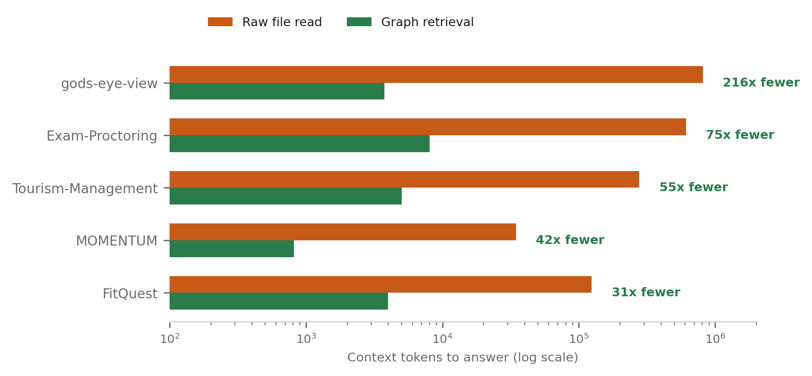
Repository | Raw tokens | Graph tokens | Reduction
gods-eye-view | 813,852 | 3,764 | 216x
Exam-Proctoring | 609,888 | 8,081 | 75x
Tourism-Management | 278,000 | 5,026 | 55x
MOMENTUM | 34,620 | 816 | 42x
FitQuest | 124,443 | 3,997 | 31x
All (aggregate) | 1,860,803 | 21,684 | 85.8x

At $0.25/1M input tokens, these 174 lookups cost $0.465 raw vs. $0.005 via the graph — scaled to 100K lookups, roughly $267 vs. $3. Raw agentic runs on the same questions reach 300K–1.9M tokens without even converging, so the true gap is larger than shown.
NOVELTY
- Four memory types: semantic, episodic, procedural, organizational — shared across every active model.
- Symbol annotations: an LLM's one-line semantic gloss on top of tree-sitter's structural parse, cached by content hash.
- Graph: an event-sourced structural graph that answers navigation queries directly and prevents context bloat by evicting stale payloads via graph-distance, not a fixed round-count.
- Blast radius: reverse-dependency traversal of the graph surfacing every downstream node an edit could break, before the change is made.
- Quorum: agents answer independently and are checked against the graph before seeing a peer's answer; ties debate only via structured, verified belief cards — closing the sycophancy vector.
Codexa OS — engineering-intelligence platform (FastAPI + Next.js, event-sourced knowledge graph, LLM build/chat agents).

