**CHAT BOT IN FOOD INDUSTRY**

Rohit Vishwakarma, Varnika Prasad, Kunal Hadkar,

BE-EXTC, BE-EXTC, BE-EXTC,

SIES GST, SIES GST, SIES GST,

Nerul, Navi Mumbai. Nerul, Navi Mumbai. Nerul, Navi Mumbai.

UNDER THE GUIDANCE OF

Dr. Preeti Hemnani,

Head of Department, EXTC Branch,

SIES GST,

Nerul, Navi Mumbai.

***Abstract*—** Some programs respond intelligently like a human or similar to a human. Such a program is called as a Chatbot.Chatbots are widely popular now-a-days and catching speed as an application of computer communication. There are generally two types of chatbots- a rule-based bot which works on keywords using ‘Natural Language Processing’ or NLP, which is a subset of Artificial Intelligence or AI, and the other is a complete ‘Machine Learning and Deep Learning’ based bot. This paper addresses the design and implementation of an NLP and AI developed Chatbot system in the food industry i.e. a bot in a restaurant which will perform the complete task of taking up orders and bringing it back at your table saving up your waiting time and cutting costs required for manpower. This system is so designed that it can also take up online orders since the system website developed can be accessed by users on a global platform. The project is more efficient than current restaurant systems because of the following factors- a) to reduce the waiting time for customers to order; b) to cut costs for manpower and thus yielding more profit for restaurant owners; c) adding a new technological aspect in any traditional system becomes a trend quickly which helps gaining popularity and thereby helps in business growth. d) better accuracy of service, especially during busy hours when human service might end up doing mistakes more often.

***Keywords—*** Chatbot; Food Industry; Natural Language Processing; AI.

# I. INTRODUCTION

Customer satisfaction with a company’s services is often seen as the key to success and long-term competitiveness for a company. In today’s world, we find ourselves now in a digital economy of expectation, one where we don’t want to stand in a queue to order food or even wait for the waiter to do so. On a personal level basis, we have observed the same and that’s where we thought of implementation of our idea, and this is where the idea of a ‘Chatbot’ came into picture. A chatbot is a program designed to counterfeit a smart communication on a text or spoken ground. Put simply, chatbots can mimic human conversations. By encouraging customers to place an order with the bot, thereby reducing the waiting period, it can increase sales and also attract the younger technology-driven audience. It will also help in reducing manpower required by restaurants, thus cutting costs with increasing efficiency.

A chatbot is basically a software that resides on a messaging platform and is developed with the purpose of having lifelike interactions with humans through text or audio.  
But how can these bots contribute to restaurants, you ask?  
Suppose you feel like having your favorite pizza but your order is taking up too much time at the pizza joint. Wouldn’t it be great if someone magically delivered your pizza? Well, we don’t have pizza delivering robots as of now, but we have the next best thing – bots.

This paper is based on a ‘Food request accepting chatbot.’ A system at the table, with the restaurant webpage opened, serves as the communication medium. A customer at the table can have a conversation with our bot, check the menu, etc. via the webpage and can decide and order his/her favorite dish. The restaurant staff gets notified of the order immediately. Once the order is received, the hardware part of the bot takes care of delivering your favorite food item right at your table. A person sitting at home can also order online using the website and his/her favorite food-item will be at the doorstep. The system also deals with online payments, where a user can either pay via cash on delivery or using his/her credit/debit card. Customer payment records are also maintained in this system.

# II. LITERATURE SURVEY

[1] In a paper by Joseph Weizenbaum of MIT- ‘Computational Linguistics’, insights of the first ever rule-based chatbot ‘ELIZA’ is given. ELIZA was not very definitive with its responses however it paved the way for more powerful bots to be developed in the future using Artificial Intelligence.

[2] In an article by Riya Savjani, she has mentioned the 5 most common restaurant industry challenges and how chatbots can tackle these. The article emphasizes more on restaurant management issues and gives a brief idea about how important AI and NLP developed bots can prove to be a boon in the food industry.

[3] In an article by Deena Zaidi, she has given us the insights of the ‘Barista Bot’ developed by the Seattle based global chain Starbucks. Starbucks introduced the Barista Bot on their app, allowing customers to quickly pre-order and pay for their drinks and skip the queue in-store.

[4] In an article by John Brandon, he explains about the U.S. supermarket Whole Foods launched ‘Recipe bot’, which helps customers decide their shopping list and recipes for the week. By using emojis instead of words, the bot speeds up interactions with customers and creates a unique experience with the customers online.

[5] In a blog by Nikki Gilliland, we get to know about one of the best-known influencers of AI in food industry- Domino’s, who created their pizza-loving chatbot ‘Dom’ in 2014. Today Domino’s conducts more than 65% of its sales in the U.S. via numerous digital platforms including using Dom.

[6] According to an article by Bloomberg News, fried chicken giants KFC opened their AI-only staff driven KFC outlet in Shanghai, China. The bot named ‘Du Mi’, not only serves the customers but also helps them with selecting music and other exciting stuff.

# III. PROPOSED METHODOLOGY

The designing and development of this system can be divided into three major domains-

1. Web development.

2. Natural Language Processing based software development.

3. Hardware model using IoT.

The first domain refers to a website/webpage developed for the UI (User Interface). The second domain refers to the actual bot program required to train the bot for appropriate responses. A python program provided with a pre-requisite restaurant dataset/database, to train the bot based on NLTK (Natural Language tool kit), is linked to the webpage using ‘Flask’ framework of python which is used to link python programs to webpages to display results on them and vice-versa. This framework was chosen by us over the more popular and preferred ‘Django’ framework, simply because of its easier syntax and lesser complexity. The third domain refers to the connectivity to the ‘Hardware bot’ which works on the principles of IoT (Internet of Things). The bot, on receiving an order, follows a path up to the kitchen, waits for a certain interval of time and then brings the order back at the customer’s table.

The following facts are kept in mind during designing and development process:

## A. Selection of OS

Windows is used for this project because it is user friendly. It is also robust.

## B. Selection of Software

‘Brackets text editor’ software is used for creating python programming as well as web development, because it is open source with a basic workspace and lesser complexity.

## C. Creating a Chatbot

For creating a Chatbot, a program has to be written. Python programming language is used for programming. The Chatbot is created in such a way to help the user, improve the communication and amuse the user.

## D. Creating a Chat

The chat is created using a pattern that is known to the user and could be easy to understand. This chat is stored as a text file and serves as the database on which the chatbot is trained.

## E. Pattern Matching

It is a technique of artificial intelligence and NLP used in the designing process. The user input is matched with the inputs saved in the database and corresponding response is returned.

## F. Complexity

The design of the bot is very simple. It just answers to the questions asked by the user, if similarities are found in the database.

## G. Conversational and Entertaining

The Chatbot responses are a way known to the user. The conversation follows a Basic English language and interacts in an easy to read manner. The conversation between the user and the Bot is entertaining. It is like talking to another person.

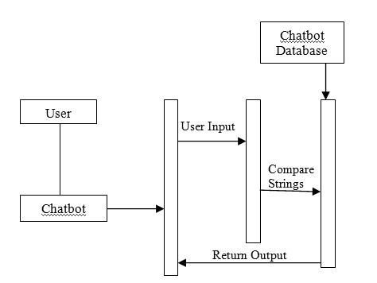

Fig. 1: Sequence Diagram Representing Design of the Chatbot.

**IV. SYSTEM ARCHITECTURE AND IMPLEMENTATION**

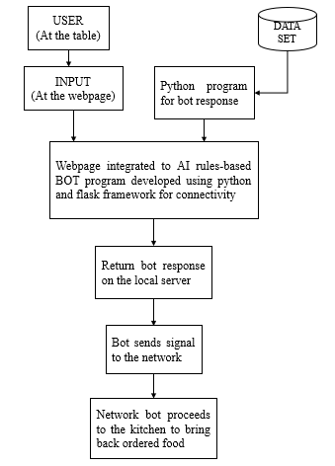

Fig. 2: System Architecture

The first and foremost process was collecting data/creating a database. We researched about various cuisines and food items/dishes and also the conversations taking place at a restaurant. Then, the entire data was stored in a.txt file. After data collection, the program to implement the bot response was written in python. Python offers a number of libraries and frameworks free of cost to use and implement as per our needs. The two major modules used here are- NLTK and scikit learn or sklearn. Using NLTK, we performed tokenization and lemmatization while sklearn helped to performed Tf-idf vectorization and cosine similarity analysis. Tokenization is nothing but converting the entire dataset into a list of sentences or words whereas to lemmatize is to derive root words from the list of word tokens. Tf-idf vectorizer determines the frequency of word(s) in the dataset. More information on Tf-idf is shared in an article by Cory Maklin, a Data Scientist at Interset [7].

After generating responses on python platform, it was time to develop a UI where the user input and corresponding bot response will be displayed. For this, we used ‘Flask’ framework of python. The framework uses ‘routing’ method i.e. result to be displayed on a particular webpage is provided with the name of the web file along with the route to be accessed (example: for accessing the home page, route- ‘/home’ would be provided, likewise for ‘About’ page, ‘/about’ route would be provided). The framework is imported and accessed in the same python file and the user input and bot-response logic is implemented within the ‘routing to our page’ portion of the program. On executing the program without errors and bugs, the page is displayed on the ‘localhost’ server having a port number (generally 5000, but one can change it if required). Another important thing to note here is that we can route as many pages we want for a website using this framework, and so, we have ‘Menu’, ‘Card Payment’, ‘Cash on Delivery Payment’ pages and an ‘Instructional guide’ page too.

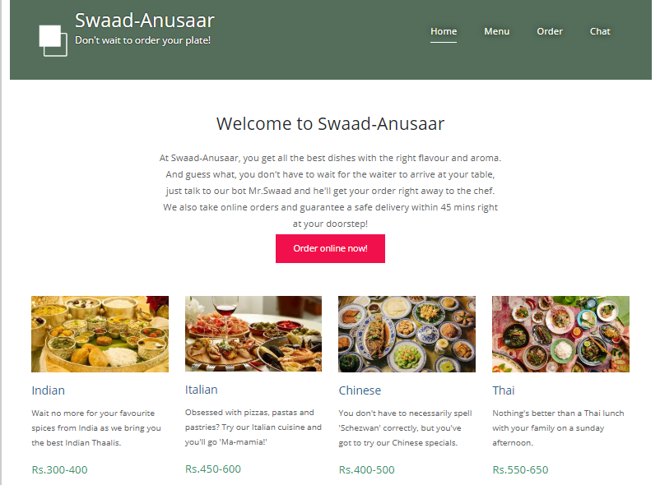

Fig. 3: Restaurant webpage.

The homepage has a section for chatting with the bot. A user can input anything he/she wishes to and will get an immediate response from the bot which is displayed on the same page. If the user input is well understood by the bot, it returns an appropriate response, although when not understood it returns with a ‘I’m sorry, I can’t understand you’ statement. With our dataset, we have tried to make the bot return with satisfactory responses as much as possible.

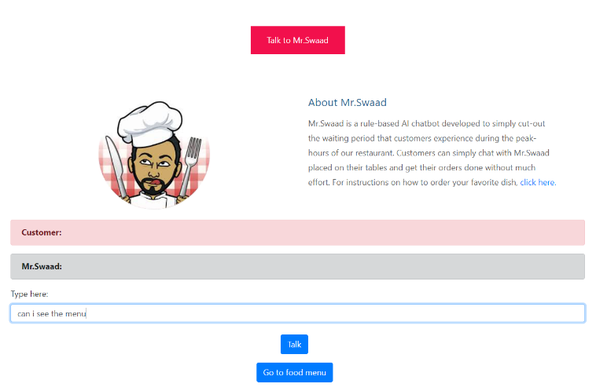

Fig. 4: User input/query.

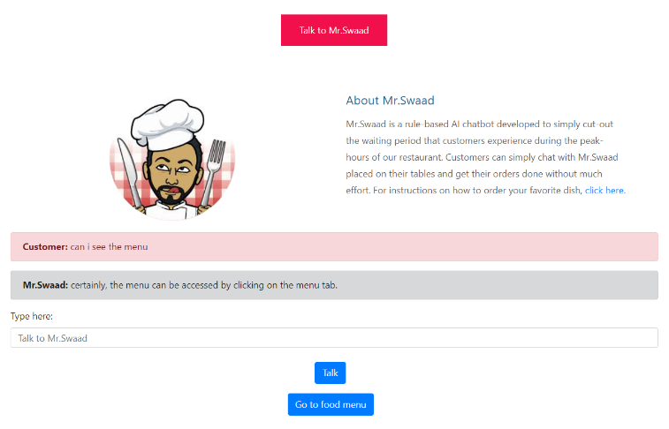

Fig. 5: Bot response.

As soon as the order is made, the bot can send the signal to the built hardware model. Once a customer is satisfied after talking to the bot, he/she can finalize the order by mentioning what they wish to order in the ‘Confirm order’ section of the page.

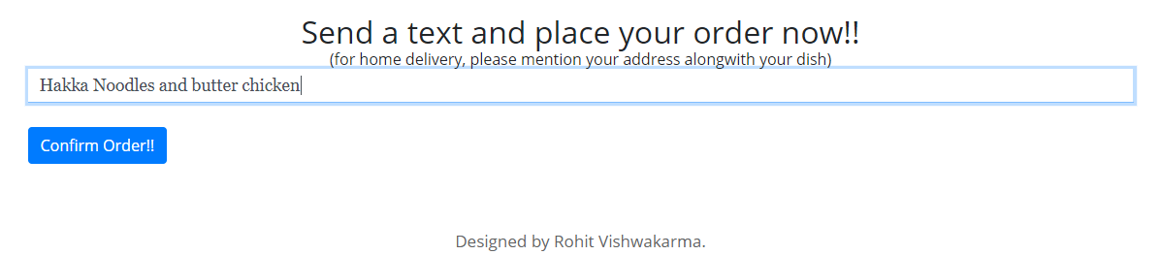

Fig. 6: Confirming order.

A text message to the chef is immediately sent onclick with an ‘order confirmation’ dialog box popping up on the customer system. This was done using ‘nexmo’ library of python which enables us to send/receive messages via any app or webpage. Nexmo allows users to create a free account and a person can send/receive messages, mails, etc. upto a limited allowable amount. For demonstration purposes, one of us has entered their contact number and created a free nexmo account. Then as soon as a customer clicks on the ‘Confirm Order’ button as shown in the image above, a text message is received as shown in the following image. This notifies the chef with a time stamp about the received orders. If someone wishes to order online, we have made the website live for the same. For this we have used ‘pythonanywhere’ platform. This website allows us to have a free non-customized domain name for our website.

Visit- <http://rohitvish14.pythonanywhere.com/>

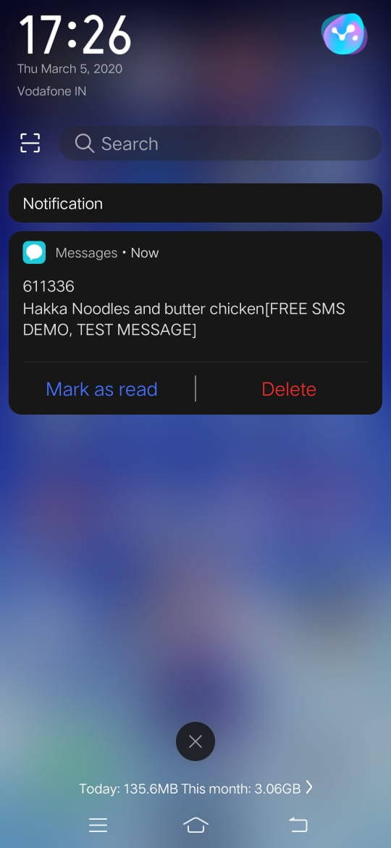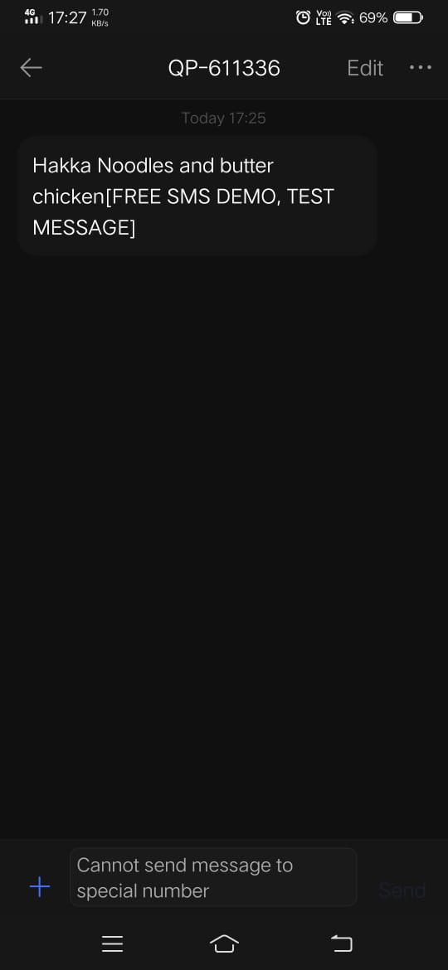

Fig. 7: Order notification message on chef’s mobile phone.

The homepage also consists of a ‘Payment’ section at the bottom which enables the user to know his/her total bill after ordering. To calculate and display results on the webpage, once again flask framework helped a lot. Once the total calculated bill is displayed, the user can proceed to pay via his/her credit/debit card or pay it to the restaurant itself. To validate customer card details, ‘jQuery mask-plugin’ is used in the script section of the code. For home delivery orders, ‘Cash on Delivery’ option is also provided. A user can choose one these options to pay and a ‘transactional details’ form appears on the screen asking for user details. On successful check out, required customer details are sent to a Google sheet with timestamps. This sheet acts as a database of customers for the restaurant which is a good practice for a number of reasons including keeping customer history and knowing the business growth. Simultaneously, an email to the specified email address (say the manager’s or the chef’s) is sent which has the same details as that in the Google sheet.

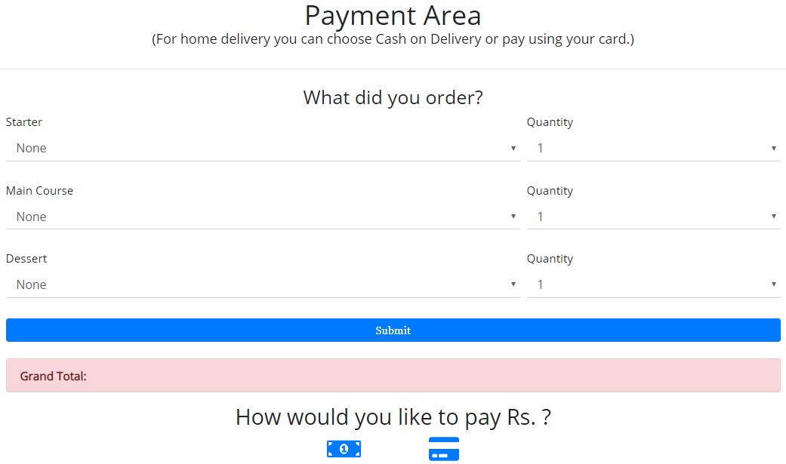

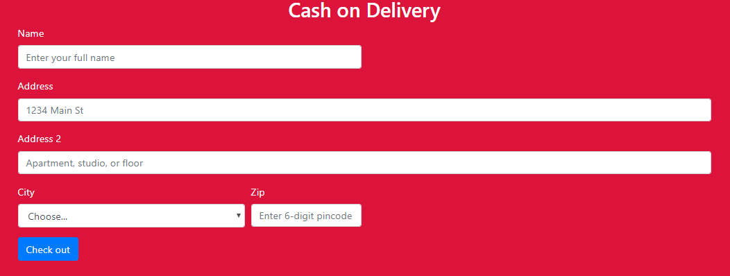

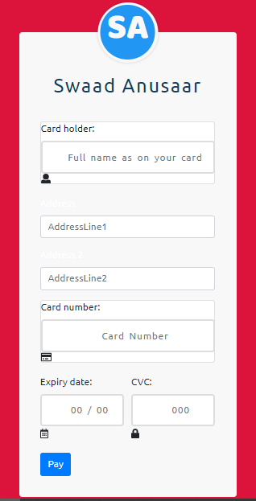

Fig 9: Payment options after calculation of the total bill amount.

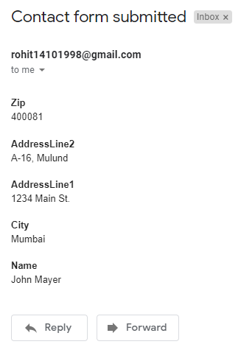

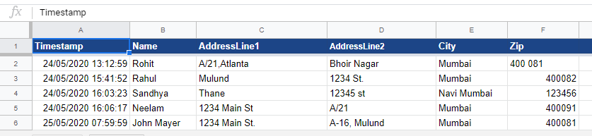

Fig 10: An email with the same details as that in the 6th row of the google sheet as shown here is send as ‘Customer Cash on Delivery’ details.

The hardware bot, built using IoT technology, is basically a wireless car with IR (infrared sensors) at the front to detect the path to follow. The core of the hardware is an Arduino Uno board connected to a motor shield to control movements and programmed in such a way that it follows a specific path up to the kitchen area. For sending response from the webpage to the hardware bot, ESP8266 Wi-Fi module is used. On receiving a signal, the hardware bot follows the path built up to the kitchen area, waits for a certain time interval and returns to the customer’s table with the order.

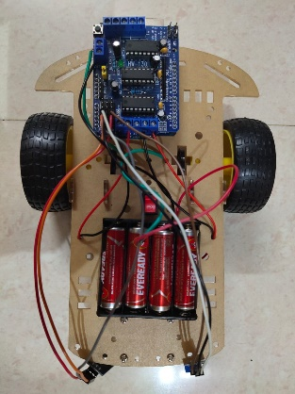

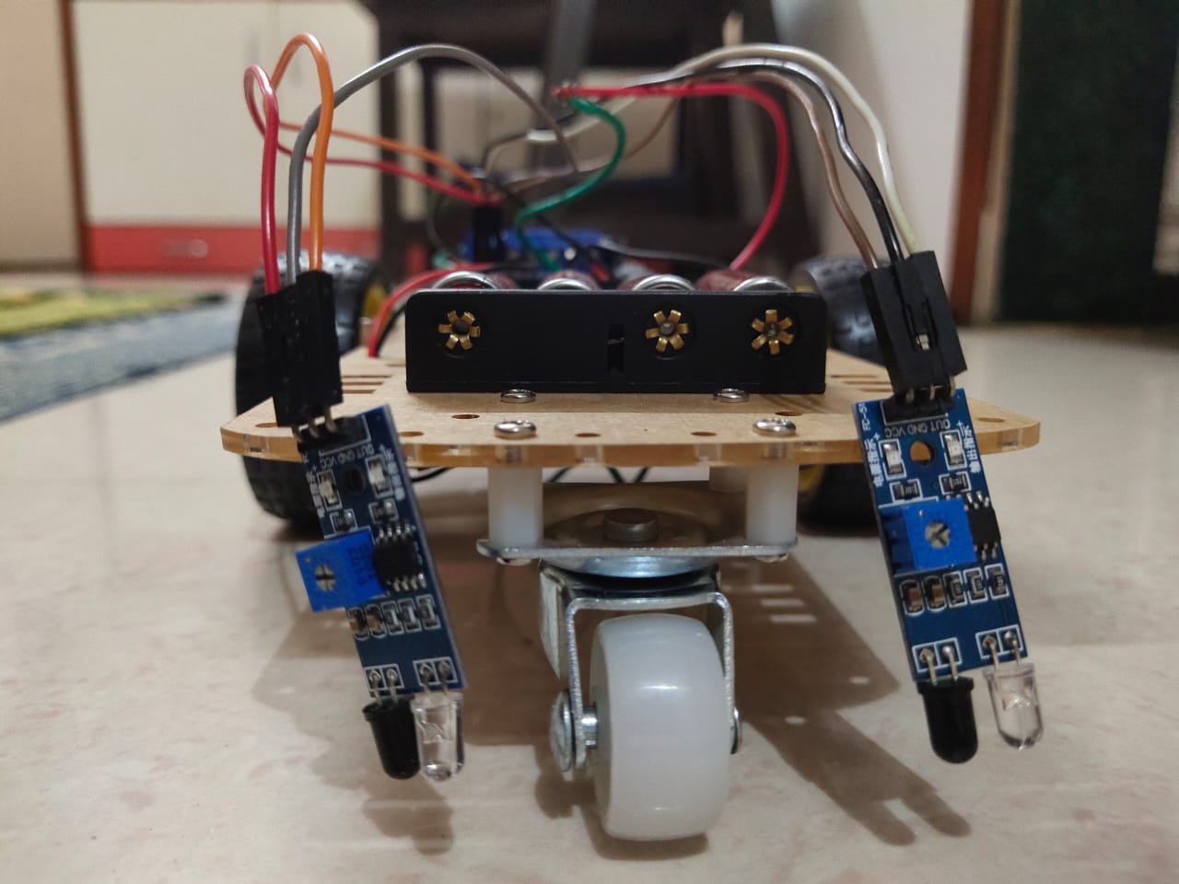

Fig. 8: Path-follower hardware bot prototype.

# V. CONCLUSION

In this paper, information about the design and implementation of a chatbot in food industry has been presented. The proposed system will not only be helpful to reduce the waiting period in restaurants, but will also cut costs required for manpower for food industries and restaurant owners. With technological advent, it is also an innovative method to attract younger audience thereby increasing sales.

# VI. ACKNOWLEDGEMENT

Our sincere thanks to our project guide and mentor Dr. Preeti Hemnani, who contributed greatly towards the development of the project.

# VII. REFERENCES

[1] ‘Computational Linguistics’: ELIZA- A Computer Program for the study of Natural Language Communication between Man and Machine *- Joseph Weizenbaum, published in January, 1966.*

[2] ‘How bots can solve the 5 most common restaurant industry challenges’ – *Riya Savjani, published on September 29, 2016.*

[3] ‘Starbucks Bot Steps Up the Coffee Experience’ *– Deena Zaidi, published on October 13, 2017.*

[4] ‘Whole Foods just launched a Messenger chatbot for finding recipes with emojis’ *– John Brandon, published on July 12, 2016.*

[5] ‘Domino’s introduces ‘Dom the Pizza Bot’ for Facebook Messenger’ *– Nikki Gilliland, published on August 12, 2016.*

[6] ‘KFC aims to keep its China edge with AI Menu, Robot Ice cream Maker’ *– Bloomberg News, published on March 21, 2019.*

[7] ‘TFIDF | TFIDF Python Example’ *– Cory Maklin, published on May 5, 2019.*