# Business Case – Cloud Kitchen

**Organization and department**

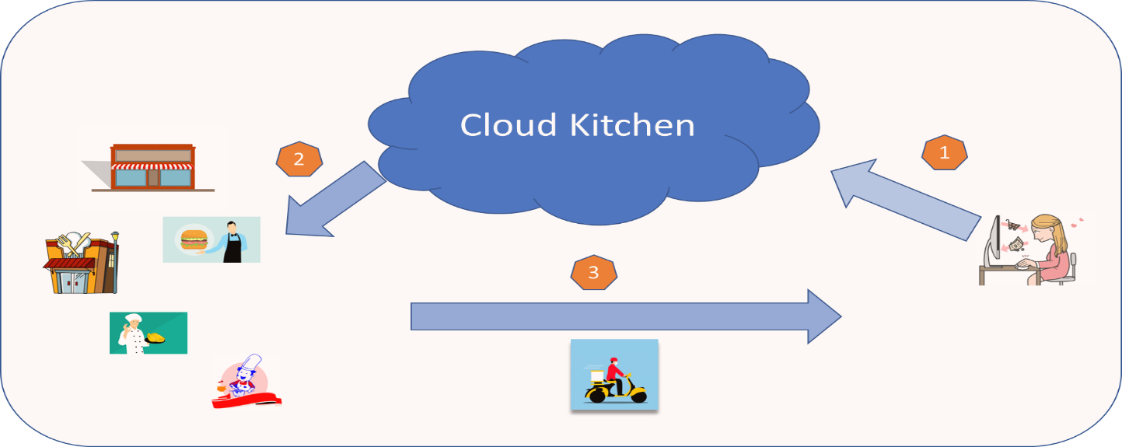

Many newcomers/Students travel to Canada every year and find themselves in foreign land away from their home, culture, language, and food. Out of the four food is something that that connects immediately with the soul and bring back sweet memories from back home. Unfortunately access to tasty food is not pocket friendly and there are no subscription-based models for food. Secondly small vendors – who run business from home kitchens, can’t afford to be on online portals for their business. What about a ‘Cloud Kitchen’ model where both customers and Vendors can meet, search for their preference of food (type, price, distance, and delivery model), pay online and get food delivered to their doorsteps. Also, the model provides minimal delivery prices to the customers to be pocket friendly for a newcomer. ‘Cloud Kitchen’ can be accessed through Web as well as phone apps both for customers and the vendors thus making it easy functional and usable for the user.

## Requirements and Justification

This online portal and mobile app will provide newcomers to Canada with a more comprehensive one-stop solution to food-related problems. Furthermore, it will help people who want to start restaurants but lack the resources. Therefore, we will provide a platform for individuals to set up their own virtual kitchen and start delivering food from home only. On the other hand, newcomers lack a platform to view all vendors offering tiffin services and to see what their prices, availability, and reviews are. Using our platform, they can compare the tiffin services offered by different vendors, so they can choose and customize based on their needs. In this business, the vendor will sign-up for a vendor account, where they can add their menu items, prices, and availability, whereas the newcomer will create a customer account, where they will see the prices and menu of all vendors.

**Functional Requirements**

* For vendors and customers, the platform must have two separate registration and login pages where they can register themselves and log in with their passwords.
* There should be an active database to store the information related to vendors and customers.
* A receipt generation function should be included that displays payment details and the meal plan the user has subscribed, which would then automatically be emailed to the customer and vendor.

The vendor account should contain:

* A function by which they can add, update, and delete menu options and their prices.
* A function by which they can see how many active customers they have.
* A function by which they can provide deals and discount to their customers.
* A description section that describes the vendor.

The customer account should contain:

* A function to add, update, and delete items in their cart.
* A section on the cart page where customers can leave a note or comment for the vendor.
* A mechanism that will allow customers to customize their meal plan with different vendors.
* A function that will allow customers to give reviews & feedback to vendors.
* A subscription section where customers can manage and view their active subscriptions with different vendors.

**Non-Functional Requirements**

* The mobile application and the web portal both should be accessible smoothly around-the-clock / daytime so that users can access the services from any browser on any mobile device for both customer and vendor.
* As there will be certain personal and confidential information of customer or vendor both applications must be secured via Secured Socket Layer for every transaction.
* The customer and items databases will be handled by a commercial database.
* With traffic on both the applications there must be a backup mechanism
* There should be a fixed length of session if inactive over certain time for both customers and vendors.
* The web application must be optimized for any of browser and device.

**Cost Estimate and Solution:**

|  |  |
| --- | --- |
| **New Service Cost:** | **$57,000** |
| Mobile App & Desktop Website | $25,000 |
| Product Testing | $10,000 |
| Product Launch | $10,000 |
| Other Expenses | $12,000 |
|  |  |
| **Technology Cost:** | **$80,000** |
| Hardware Installation | $15,000 |
| Software | $15,000 |
| Database | $20,000 |
| Server Installation | $25,000 |
| Unknown Cost | $5,000 |
|  |  |
| **Marketing Cost** | **$33,000** |
| Social Media and Direct Marketing | $18,000 |
| Discount Offers | $10,000 |
| Unknown Cost | $5,000 |
|  |  |
| **Other Known Expenses** | **$50,000** |
| Staff Salary | $30,000 |
| Customer Care Salary | $20,000 |
|  |  |
| **TOTAL ESTIMATED EXPENSES** | **$220,000** |

**Solution**:

The food industry is transforming with online food ordering apps. To bridge this gap and fulfill the need of customers, we have developed this online food ordering app ‘Cloud Kitchen’ which will help the consumer choose between a variety of restaurants and the kind of delicacy they want to have.

Our motto is to provide a cost-effective solution to both our vendors and buyers by staying connected with them. ***A cost-effective solution saves or makes money in comparison with its costs.***

Solution and benefits of Online Food Ordering System includes:

1. **Improved customer experience**- Having an easy ordering process increases the likelihood that the customer will complete their order.
2. **Best discount and offers-**Since we have a price match feature, our app offers the best discount and offers for the customers based on their orders.
3. **More time to browse the menu-**Online menus not only provide more information about food options, but also allow customers to browse at their own pace.
4. **Subscription based model-**For Six months as a new user signup we offer free delivery to our consumers.
5. **Product information is available in detail-**Our algorithm works in such a way that it provides the top trending food for a particular day with best combos and mixtures.
6. **Motivation**: Cost efficient way for students and busy people who don’t have much time to cook this app provides affordable solution