GLA UNIVERSITY

Institute of Engineering & Technology


Life Style Store
Mid-Term Report

By

Rohit kumar yadav(191599016)
Km. Sonam(191599018)
Khushboo(191599007)

Supervised By

Mr. Akash Kumar Choudhary
(Asst. Professor)

Department of Computer Engineering & Applications

DECLARATION

We certify that the work contained in this report is original and has been done by us under the guidance of my supervisor(s).
- The work has not been submitted to any other Institute for any degree or diploma.
- We have followed the guidelines provided by the Institute in preparing the report.
- We have conformed to the norms and guidelines given in the Ethical Code of Conduct of the Institute.
- Whenever we have used materials (data, theoretical analysis, figures, and text) from other sources, we have given due credit to them by citing them in the text of the report and giving their details in the references.

Name and Signature of Project Team Members:

Sr.  No. | University No. | Name of students | Signature of  students
1. | 191599016 | Rohit kumar yadav
2. | 191599018 | Km. Sonam
3. | 191599007 | Khushboo

GLA University, MATHURA

CERTIFICATE

Certified that the project report entitled, “Life Style Store
” is a bonafide work done under my guidance by Rohit kumar yadav, Km. Sonam, Khushboo.

Date: / / Sign. Of Mentor
LIST OF FIGURES ACKNOWLEDGEMENT

We have immense pleasure in expressing our sincerest and deepest sense of gratitude towards our Mentor Mr. Akash Kumar Chaudhary for the assistance, valuable guidance and co- operation in carrying out this Project successfully. We have developed this project with the help of Faculty members of our institute and we are extremely grateful to all of them. We also take this opportunity to thank Head of the Department Prof. Shailendra Kumar Mishra, and Dean of Chameli Devi Group of Institutions, Dr. K.S. Jairaj , for providing the required facilities in completing this project. We are greatly thankful to our parents, friends and faculty members for their motivation, guidance and help whenever needed.

Name and signature of team Members:
- Rohit kumar yadav
- Km. Sonam
- khushboo

CONTENTS | Page No.
Title Page | I
Declaration | II
Certificate by the Supervisor | III
Acknowledgement | IV
Chapter-1
Introduction of the Project Life Style Store | 1
1.1. Abstract of the Project……………………………………………………………...... | 2
1.2 Scope of the Project…………………………………………………………………...  ... | 3
1.3 Reports of the E- Learning………………………………………………………...... | 4
1.4 Modules of the E- Learning………………………………………………………...... | 4
1.5  Objective…………………….…………………………………………  …………………...... | 6
Chapter-2
Requirement Engineering | 7
2.1 Software Requirement Specification  …………………………………………… | 7
2.2 Requirements of the Project………………………………..…………………...... | 7
Chapter-3
Analysis & Design | 8
3.1 System Design of E-learning  …………………………………………… | 8
3.2 General task involved in the design process  ……………………………...... | 8
3.3 Project Category………………………..………………………………………  …………. | 9
3.4 Project Planning…………………………………………………………………  …………. | 10
3.5 Steps for successful software project………………………………………….. | 11

INTRODUCTION

INTRODUCTION:
The Shopping cart is mainly useful for who haven’t time to go to shopping, those are just entered into this website and bought whatever they want.
The aim of this project is on the online shopping application it is developed
using HTML, JAVA script, CSS, PHP. The application is very
useful where the buyer can directly buy the products from home via internet on mobile or system.
Even it is night or morning they entered into this site, and chosen different items like shoes, books, mobiles etc..
‘Customer is our god’ mainly this website is based on this formula. After chosen items he bought into Pay pal process like VISA or MASTER credit cards or any Debit cards are accepted in this website. Customer is happily shopping at his rest place.

PROJECT OVERVIEW:
Once customer entered with his own username and password, at that time automatically one shopping cart will be created, once user select an item it will add to cart. In case user thinks the selected item is not useful for me, then deleted that item from shopping cart.
Customer selected some items, but in his credit or debit cart haven’t that much balance, then he was logout from the website, the selected items are stored at cart with specific users with his allotted carts, after some days he bought those items then automatically deleted from the cart.

System Specifications
Hardware Requirements:-

- Dual Core (Processor).
- RAM 4GB
- Window 10 Professional (64 Bit)

Software Requirements: -

Technology Implemented : Apache Server
Language Used : PHP 5.62 (Developed in Core PHP)
Database : My SQL
User Interface Design : HTML, CSS, JAVASCRIPT, BOOTSTRAP
Web Browser : Mozilla, Google Chrome, OPERA
Software : XAMPP Server

OVERVIEW OF TECHNOLOGIES USED

Front End Technology (HTML, CSS, JAVASCRIPT, BOOTSTRAP, PHP)

Introduction to HTML
The hypertext markup language (HTML) is a simple markup language. Used to create a hypertext documents that are portable from one platform to another HTML documents are SGML (Standard generalized mark up language) documents with generic semantics that are appropriate for representing information from a wide range of applications. This specification defines HTML version 3.2. HTML 3.2 aims to capture recommended practice as of early ’96 and as such a replacement for HTML2.0 (RFC 1866).
A set of instructions embedded in a document is called mark up language. These instructions describe what the document text means and how it should look like in a display. Hyper Text Mark Up language (HTML) is the language used to encode World Wide Web documents.

WHY TO USE HTML?

Website is a collection of pages, publications, and documents that reside on web server. While these pages publications and a document as a formatted in a single format, you should use HTML for home page and all primary pages in the site. This will enable the millions of web users can easily access and to take advantage of your website.

HTML is considered first for formatting any new material you plan to publish on the web. HTML documents are platform independent, meaning that they don’t confirm to any standard. If they are created properly you can move home page to any server platform or you can access them with any complaint www browser.

STRUCTURE OF HTML

HTML elements perform a defined task. HTML uses two types of elements
. Empty Tags
. Container Tags
These tags differ because of what they represent. Empty tags represent formatting constricts such as line breaks and horizontal rules. Container tags define a section of text, formats and dot all of the selected text. A container tag has both a beginning and an ending.

HTML LAYOUT:
An HTML document consists of text, which comprises the content of the document and tags, which, defines the structure, and appearance of the document. The structure of an HTML document is simple, consists of outer.
<HTML>tag enclosing the document header and body
<HTML>
<HEAD>
<TITLE>the title of HTML document</TITLE>
</HEAD>
<BODY>
This is where the actual HTML documents
Text lies, which is displayed in the browser
</BODY>
</HTML>

Each document has a head and body delimited by the <HEAD> and <BODY> tag. The head is where you give your HTML document a title and where you indicate other parameters the browser may use when displaying the document. This includes the text for displaying the text. Tag also references special and indicates the hot spots that link your document to other documents.

HTML FORMS:

Creating a form usually involves two independent steps: Creating the layout for the form itself and then writing a script program on the server side to process the formation you get back from a form.
To create a form, You use the <FORM> tag. Inside the opening and closing FORM tags are each of the individual form elements plus any other HTML content to create a layout for that form.
The opening tag of the FORM element usually includes the attributes: METHOD and ACTION. The METHOD attributes can be either GET or POST which determines how your form data is sent to the script to process it.
The ACTION attribute is a pointer to the script that processes the form on the server side. The ACTION can be included by a relative path or by a full URL to a script on your server or somewhere else. For example, the following <FORM> tag would call a script called form-name in cgi-bin directory on server www.myservser.com

<FORM Method= post action=http://www.mytservser.com/cgi-bin/form-name.pl>
……………….
</FORM>

INTRODUCTION TO HTML4.0

What is the World Wide Web?
The World Wide Web is a network of information resources. The Web relies on three mechanisms to make these resources readily available to the widest possible audience.

- A uniform naming scheme for locating resources on the Web (e.g. URLs)
- Protocols, for access to named resources over the Web (e.g. HTTP)
- Hypertext, for easy navigation among resources (e.g.HTML)

The ties between the three mechanisms are apparent throughout this specification

What is HTML?
To publish information for global distribution, one needs a universally understood language, a kind of publishing mother tongue that all computers may potentially understand. The publishing language used by the World Wide Web is HTML (from Hyper Text Markup Language). HTML gives authors the means to
- Publish online documents with headings, text, tables, lists, photos, etc.
- Retrieve online information via hypertext links, at the click of a button
- Design forms for conducting transactions with remote services, for use in searching for information, making reservations, ordering products etc.
- Include spread - sheets, video clips, sound clips, and other applications directly in their documents.

A brief history of HTML:
HTML was originally developed by Tim Berners-Lee while at CERN, and popularized by the Mosaic browser developed at NCSA. During the course of the 1990s it has blossomed with the explosive growth of the Web during this time. HTML has been extended in a number of ways. The Web depends on Web page authors and vendors sharing the same conventions for HTML. This has motivated joint work on specifications for HTML.
HTML 2.0 (November 1995) was developed under the aegis of the Internet Engineering Task Force (IETF) to codify common practice in late 1994. HTML (1993) and ([HTML.30]) (1995) proposed much richer versions of HTML, despite never receiving consensus in standards discussions, these drafts led to the adoption of a range new features. The efforts of the World Wide Web Consortium’s HTML working group to codify common in 1996 resulted in HTML 3.2 (January 1997). Most people agree that HTML documents should work well across different browsers and platforms. Achieving interoperability lowers costs to content providers since they must develop only one version of a document. If the effort is not made, there is much greater risk that the Web will devolve into a proprietary world of incompatible formats, ultimately reducing the Web’s commercial potential for all participants.

HTML CODE:

<html>
<head>
<h4 class="">sign in</h4>
<p class="">Hello, Welcome to your account.</p>
<form class="register-form outer-top-xs" method="post">
<div class="form-group">
<label class="info-title" for="exampleInputEmail1">Email Address <span>*</span></label>
<input type="email" name="email" class="form-control unicase-form-control text-input" id="exampleInputEmail1" >
</div>
<div class="form-group">
<label class="info-title" for="exampleInputPassword1">Password <span>*</span></label>
<input type="password" name="password" class="form-control unicase-form-control text-input" id="exampleInputPassword1" >
</div>
<div class="radio outer-xs">
<a href="forgot-password.php" class="forgot-password pull-right">Forgot your Password?</a>
</div>
<button type="submit" class="btn-upper btn btn-primary checkout-page-button" name="login">Login</button>
</form>
</div> </body>
</html>

CSS:
WHAT IS CSS:

- CSS stands for cascading style sheets
- CSS describes how HTML element are to be displayed on screen ,
paper, or in other media.
- CSS saves a lot of work. It can control the layout of multiple web pages all at once.
- External style sheet are stored in CSS files.

Advantages of CSS:

CSS saves time: You can write CSS once and then reuse the same sheet in multiple HTML pages. You can define a style for each HTML element and apply it to as many web pages as you want.
Pages load faster - If you are using CSS, you do not need to write HTML tag attributes every time. Just write one CSS rule of a tag and apply it to all the occurrences of that tag. So, less code means faster download times.
Easy maintenance - To make a global change, simply change the style, and all the elements in all the web pages will be updated automatically.
Superior styles to HTML - CSS has a much wider array of attributes than HTML, so you can give a far better look to your HTML page in comparison to HTML attributes.
Multiple Device Compatibility - Style sheets allow content to be optimized for more than one type of device. By using the same HTML document, different versions of a website can be presented for handheld devices such as PDAs and cellphones or for printing.

CSS Syntax:
A CSS rule set contains a selector and a declaration block.
Selector: Selector indicates the HTML element you want to style. It could be any tag like <h1>, <title> etc.
Declaration Block: The declaration block can contain one or more declarations separated by a semicolon. For the above example, there are two declarations:
- color: yellow;
- font-size: 11 px;
Each declaration contains a property name and value, separated by a colon.
Property: A Property is a type of attribute of HTML element. It could be color, border etc.
Value: Values are assigned to CSS properties. In the above example, value "yellow" is assigned to color property.
Selector{Property1: value1; Property2: value2; ..........;}

Example:

P {
Color: red;
Text-align: center;
}

CSS Selector: CSS selectors are used to select the content you want to style. Selectors are the part of CSS rule set. CSS selectors select HTML elements according to its id, class, type, attribute etc.

There are several different types of selectors in CSS.

- CSS Element Selector
- CSS Id Selector
- CSS Class Selector
- CSS Universal Selector
- CSS Group Selector
Element selector: The element selector selects the HTML element by name.
Id selector: The id selector selects the id attribute of an HTML element to select a specific element. An id is always unique within the page so it is chosen to select a single, unique element. It is written with the hash character (#), followed by the id of the element.
Example:<html>
<head>
<style>
#para1 {
text-align: center;
color: blue;
}
</style>
</head>
<body>
<p id="para1">Hello </p>
<p>This paragraph will not be affected.</p>
</body>
</html>
Class selector: The class selector selects HTML elements with a specific class attribute. It is used with a period character . (full stop symbol)

Universal selector: The universal selector is used as a wildcard character(*). It selects all the elements on the pages.

Group selector: The grouping selector is used to select all the elements with the same style definitions. Grouping selector is used to minimize the code. Commas are used to separate each selector in grouping.

Type of CSS:
There are three types of css
- Inline CSS
- Internal CSS
- External CSS
Inline CSS: Inline CSS is used to apply CSS on a single line or element. If we want to use inline CSS, we should use the style attribute to the relevant tag.
Syntax:
<body style=”background: blue”>
<p style=”background: yellow”> this is a paragraph </p>
</body>
Internal CSS: It helps in declaring of CSS property with in the HTML document which should be provided in <head> part of html. By using <style> </style> tag.
Syntax: <style>
Body { background: cyan}
</style>
External CSS: It is use to attach the CSS file ending width. CSS extension with in the HTML document by the helps of link tag.
Synatx: <head>
<link href=”first.css” rel=”style sheet” types=’text/css”>
<head>

CSS File: First.css
body {
background-color: lightblue;
}
h1 {
color: navy;
margin-left: 20px;
}
BOOTSTARP:

WHAT IS BOOTSTARP:
Bootstrap is a front-end framework used for easier and faster web development. Bootstrap is the most popular HTML, CSS and JavaScript framework for developing a responsive, mobile first projects on the web.
History of Bootstrap:

Bootstrap was developed by Mark Otto and Jacob Thornton at Twitter. It was released as an open source product in August 2011 on Git Hub.
In June 2014 Bootstrap was the No.1 project on Git Hub.
One Framework, Every Device:
Bootstrap is promoted as being One framework, every device, This is because websites built with Bootstrap will automatically scale between devices – whether the device is a mobile phone , tablet, laptop, desktop computer, screen reader,etc.
Bootstrap Components:
Bootstrap includes components such as buttons, navbars, dropdown menus, alert boxes, and more. In most cases, you can make use of a components simply by using the appropriate class name.
We’ll be looking at these components throughout this tutorial. We’ve got plenty of interactive examples that enable you too see exactly how these components work.

Client-side Script(JAVASCRIPT):-

JavaScript:
JavaScript is a new scripting language for WebPages. Scripts written with java script can be embedded into your HTML pages. With java script you have many possibilities for enhancing your HTML page with interesting elements. For example you are able to respond to user-initiated events quite easily. Some effects that are now possible with java script were some time ago only possible with CGI. So you can create really sophisticated pages with the helps of java script on the Internet.

Difference between java and Java Script

Although the names are almost the same Java is not the same as Java Script. These are two different techniques for Internet programming. Java is programming language. JavaScript is a scripting language as the name implies. The difference is that we can create real programs with java. But java script in not real programming. Java Script is meant to be easy to understand and easy to use. JavaScript authors should not have to care too much about programming. We could say that Java Script is rather an extension to HTML than a separate computer language. Of course this is not the official definition but it makes it easier to understand the difference between java and java script.

How can Java Script scripts run?
The first browser to support java script was the Netscape Navigator 2.0 of course the higher versions do have java script as well. You might know that java does not run on all Netscape Navigators 2.0 (or higher versions) versions. But this is not true for java script -although there are some problems with the different versions.
The Mac version for example seems to have many bugs. In the near future there are going to be some other browsers, which support java script. The Microsoft Internet explorer 3.0 is going to support java script. JavaScript enabled browsers are going to spread soon - it is worth learning this new technique now. You might realize that is really easy to write Java Script scripts. We have to know is some basic techniques and some work-around for problems you might encounter. Of course we need a basic. Understanding HTML before reading this tutorial you can find many really good online resources about HTML. Best you make an online search about ‘html’ at yahoo if you want to get informed about HTML. Now I want to show some small scripts so you can learn how they are implemented into HTML-documents and to show which possibilities you have with the new scripting language. The following is a very small script, which will only print a text into an HTML document.
<html>
<head>
My first JavaScript
</head>
<body><br>
This is a normal HTML document
<br>
<script language=”JavaScript”>
Document.write (“this is a java script”)
</script><b r>
Backing HTML again
</body>
</html>
If you are using a java script enabled-browser at the moment then you will have the possibility to see this script working. If your browser doesn’t support Java Script then this output might be some kind of strange…
This is a normal HTML document
This is java script!
Back in HTML again.

Functions
Functions are bet declared between the <Head> tag of HTML page. Functions are called by user-initiated events. Seems reasonable to keep the functions between the <Head> tags. They are loaded first before a user can do anything that might call a function. Scripts can be placed between inside comment fields to ensure that older browser do not display the script itself.
<html>
<head>
<script language=”JavaScript”>
function pushbutton (){
alert (“Hello!”);
}
</script>
</head>
<body>
<form>
<input type=”button” name=”Button1” value=”push me” onclick=”pushbutton ()”>
</form>
</body>
</html>

If we want to test this one immediately and you are using a Java Script enabled browser then please go ahead and push the button.
This script will create a button and when you press it a window will pop up saying “hello!”. In fact we have a lot of possibilities just by adding functions to our scripts.
The common browsers transmit the form information by either method: here’s the complete tag including the GET transmission method attribute for the previous form
Example
<Form method =GET action=http://www.mycompany.com/ upfdate.php>
………
</form>

Input elements:
Use the <input> tag to define any one of a number of common form elements including text fields multiple choice lists click able images and submission buttons. There are many attributers for this tag only that types and name attributes are required for each element, each type of input element uses only a subset of the followed attributes. Additional <input> attributes may be required based upon which type of the form element you specify.
Submit button:
The submit button (<input type=submit> ) does what its name implies, settings in motion the form’s submission to the server from the browser. We many have more than submit buttons will be added to the parameter list the browser sends along to the server.

Example
< Input type =”submit”>
<Input type=”submit” value=”submit” name=”name”>

Reset button:
The reset button if firm <input> button is nearly self- explanatory; it lets the user reset erase or set to some default value all elements in the form. By default the browser displays a reset button worth the label “reset”. We can change that by specifying a value attribute with tour own button label.

METHOD ATTRIBUTE:
The other required attribute for the <form> tag sets the methods by which the browser form’s data to the server for processing. There are two ways: the POST method and GET method. With POST method, the browser sends the data in two steps: the browser first contacts the form-processing server specified in the action attributes, and once contact is made, sends the data.

PHP (PHP: Hypertext preprocessor):

PHP is a server-side scripting language designed specifically for the web. Within an HTML page, you can embed PHP code that will be executed each time the page is visited. Your PHP code is interpreted at the web server and generates HTML or other output that the visitor will see.
PHP was introduced in 1994. As of November 2007, it was installed on more than 21 million domains worldwide, and this number is growing rapidly. You can see the current number at http://www.php.net/usage.php
PHP is an Open Source project. PHP originally stood for Personal Home Page and now stands for PHP Hypertext Preprocessor.

Unique Features
If you are familiar with other server side language like ASP.NET or JSP you might be wondering what makes PHP so special, or so different from these competing alternatives well, here are some reasons:
- Performance
- Portability(Platform Independent)
- Ease Of Use
- Open Source
- Third-Party Application Support
- Community Support

Performance
Scripts written in PHP executives faster than those written in other scripting language, with numerous independent benchmarks, putting the language ahead of competing alternatives like JSP,ASP.NET and PERL.The PHP 5.0 engine was completely redesigned with an optimized memory manager to improve performance, and is noticeable faster than previous versions.In addition, third party accelerators are available to further improve performance and response time.
Portability
PHP is available for UNIX, MICROSOFT WINDOWS, MAC OS, and OS/2.PHP Programs are portable between platforms. As a result, a PHP application developed on, say, Windows will typically run on UNIX without any significant issues.This ability to easily undertake cross-platform development is a valuable one, especially when operating in a multi platform corporate environment or when trying to address multiple market segments.
Ease Of Use
“Simplicity is the ultimate sophistication”, Said Leonardo da Vinci, and by that measure, PHP is an extremely sophisticated programming language. Its syntax is clear and consistent, and it comes with exhaustive documentation for the 5000+ functions included with the core distributions.This significantly reduces the learning curve for both novice and experienced programmers, and it’s one of the reasons that PHP is favored as a rapid prototyping tool for Web-based applications.

Open Source
PHP is an open source project – the language is developed by a worldwide team of volunteers who make its source code freely available on the Web, and it may be used without payment of licensing fees or investments in expensive hardware or software .This reduces software development costs without affecting either flexibility or reliabilityThe open-source nature of the code further means that any developer, anywhere , can inspect the code tree, spit errors, and suggest possible fixes, this produces a stable, robust product wherein bugs, once discovered, are rapidly resolved – sometimes within a few hours of discovery !.

Third-Party Application Support

One of PHP’s Strengths has historically been its support for a wide range of different databases, including MySQL, PostgreSQL, Oracle, and Microsoft SQL Server. PHP 5.3 Supports more than fifteen different database engines, and it includes a common API for database access. XML support makes it easy to read and write XML documents though they were native PHP data structures, access XML node collections using Xpath, and transform XML into other formats with XSLT style sheets.

Community Support
One of the nice things about a community-supported language like PHP is the access it offers to the creativity and imagination of hundreds of developers across the world.Within the PHP community, the fruits of this creativity may be found in PEAR, the PHP Extension and Application Repository and PECL, the PHP Extension Community Library, which contains hundreds of ready-,made widgets and extensions that developers can use to painlessly and new functionality to PHP.Using these widgets is often a more time-and cost-efficient alternative to rolling your own code.

PHP Server
The PHP Community Provides Some types of Software Server solution under The GNU (General Public License).
These are the following:
- WAMP Server
- LAMP Server
- MAMP Server
- XAMPP Server
All these types of software automatic configure inside operating system after installation it having PHP, MySQL, Apache and operating system base configuration file, it doesn’t need to configure manually.
WAMP----- Microsoft window o/s,Apache Mysql PHP
LAMP---- Linux Operating System Apache Mysql PHP
MAMP---- Mac os Apache Mysql PHP
XAMPP---- x-os(cross operating system) Apache Mysql PHP Perl
BACK END TECHNOLOGY:
MYSQL
There are a large number of database management systems currently available, some commercial and some free.
Some of them : Oracle, Microsoft Access, Mysql and PostgreSQL.
These database systems are powerful, feature-rich software, capable of organizing and searching millions of records at very high speeds.

Understanding Databases, Records, and Primary Keys
Every Database is composed of one or more tables.
These Tables, which structure data into rows and columns, Impose organization on the data.
The records in a table(below) are not arranged in any particular order.

SQL, statements fall into one of three categories.(Types of SQL)
Data Definition Language(DDL) : DDL Consists of statements that define the structure and relationships of a database and its table.
These Statements are used to Create, drop and modify databases and tables.
Data Manipulation Language(DML) : DML statements are related to altering and extracting data from a database.
These statements are used to add records to, update records in, and delete records from, a database; perform queries; retrieve table records matching one or more user specified criteria; and join tables together using their common fields.
Data Control Language(DCL) : DCL statements are sued to define access levels and security privileges for a database.
You would use these statements to grant or deny user privileges; assign roles; change passwords; view permissions; and create rulesets to protect access to data.
The Syntax of SQL is quite intuitive. every SQL statement begins with an “action word”, like DELETE, INSERT,ALTER etc.
it ends with a semicolon. whitespace, tabs, carriage returns are ignored.
Some example of valid SQL statements :
CREATE DATABASE employee;
SELECT name FROM users where email =”anuj.lpu1@gmail.com”;
DELETE FROM cars WHERE year of manufacture < 1980;

PHP Mysql connectivity
Use the mysql connect( ) function to established connection to the MySQL server.
To access the database functionality we have to make a connection to database using Php.
mysql_connect() function is used to establish the connection to mysql server.
four arguments need to be passed to mysql_connect() function.
hostname : if you are working on local system , you can use localhost or you can also provide ip address or server name.
username : if there is a existing user , you can provide username. default username is ‘root’.
password : by default password is blank or null.
dbname : it is a optional field . it is basically a name of the database that need to be connected.
mysql_connect(host, username, password, dbname);
host(Server name)---- Either a host name(server name) or an IP address
username---- The MySQL user name
password---- The password to log in with
dbname---- Optional. The database to be used when performing queries

Note : There are more available parameters, but the ones listed above are the most important.
In the following example we store the connection in a variable ($con) for later use in the script.
<?php

// Create connection
$con=mysql_connect("localhost","root","") or die(mysql_error());

?>
Here localhost is server name. root is MySQL default user name. default password is blank and database name is my_db. mysql_error( ) function provides mysql connectivity error message.

MySQL Close Connection
<?php
// Create connection
$con=mysql_connect("localhost","root","","my_db") or die(mysql_error());
//code to be executed.
// Close connection
mysql_close($con);
?>
after work with the database is done we have to close the connection using mysql_close() function
in which the connection to the database is passed.

DATABASE MODELS

Single Tier

In a single tier the server and client are the same in the sense that a client program that needs information (client) and the source of this type of architecture is also possible in java, in case flat files are used to store the data. However this is useful only in case of small applications. The advantage with this is the simplicity and portability of the application developed.

Server and client

Database

Two Tier (client-server)
In two tier architecture the database resides in one machine and client in different machine they are connected through the network. In this type of architecture a database management takes control of the database and provides access to clients in a network. This software bundle is also called as the server. Software in different machines, requesting for information are called as the clients

Server

Client

Client

Database

Three Tier and N-Tier

In the three-tier architecture, any number servers can access the database that resides on server. Which in turn serve clients in a network. For example, you want to access the database using java applets, the applet running in some other machine, can send request only to the server from which it is down loaded. For this reason we will need to have a intermediate server which will accept the requests from applets and them to the actual database server. This intermediate server acts as a two-way communication channel also. This is the information or data from the database is passed on to the applet that is requesting it. This can be extended to make n tiers of servers, each server carrying to specific type of request from clients, however in practice only 3 tiers architecture is popular.

FEASIBILITY STUDY:

Feasibility study is conducted once the problem is clearly understood. Feasibility study is a high level capsule version of the entire system analysis and design process. The objective is to determine quickly at a minimum expense how to solve a problem. The purpose of feasibility is not to solve the problem but to determine if the problem is worth solving.

The system has been tested for feasibility in the following points.
1. Technical Feasibility
2. Economical Feasibility
3. Operational Feasibility.

1. Technical Feasibility
The project entitles "Courier Service System” is technically feasibility because of the below mentioned feature. The project was developed in Java which Graphical User Interface.
It provides the high level of reliability, availability and compatibility. All these make Java an appropriate language for this project. Thus the existing software Java is a powerful language.

2. Economical Feasibility

The computerized system will help in automate the selection leading the profits and details of the organization. With this software, the machine and manpower utilization are expected to go up by 80-90% approximately. The costs incurred of not creating the system are set to be great, because precious time can be wanted by manually.

3. Operational Feasibility

In this project, the management will know the details of each project where he may be presented and the data will be maintained as decentralized and if any inquires for that particular contract can be known as per their requirements and necessaries.

Implementation:

Implementation is the stage where the theoretical design is turned into a working system. The most crucial stage in achieving a new successful system and in giving confidence on the new system for the users that it will work efficiently and effectively.

The system can be implemented only after thorough testing is done and if it is found to work according to the specification.

It involves careful planning, investigation of the current system and its constraints on implementation, design of methods to achieve the change over and an evaluation of change over methods a part from planning. Two major tasks of preparing the implementation are education and training of the users and testing of the system.

The more complex the system being implemented, the more involved will be the systems analysis and design effort required just for implementation.

The implementation phase comprises of several activities. The required hardware and software acquisition is carried out. The system may require some software to be developed. For this, programs are written and tested. The user then changes over to his new fully tested system and the old system is discontinued.

DESIGN

INTRODUCTION:

Design is the first step in the development phase for any techniques and principles for the purpose of defining a device, a process or system in sufficient detail to permit its physical realization.

Once the software requirements have been analyzed and specified the software design involves three technical activities - design, coding, implementation and testing that are required to build and verify the software.

The design activities are of main importance in this phase, because in this activity, decisions ultimately affecting the success of the software implementation and its ease of maintenance are made. These decisions have the final bearing upon reliability and maintainability of the system. Design is the only way to accurately translate the customer’s requirements into finished software or a system.

Design is the place where quality is fostered in development. Software design is a process through which requirements are translated into a representation of software. Software design is conducted in two steps. Preliminary design is concerned with the transformation of requirements into data.
CLASS:
A description of set of objects that share the same attributes, operations, relationships, and semantics

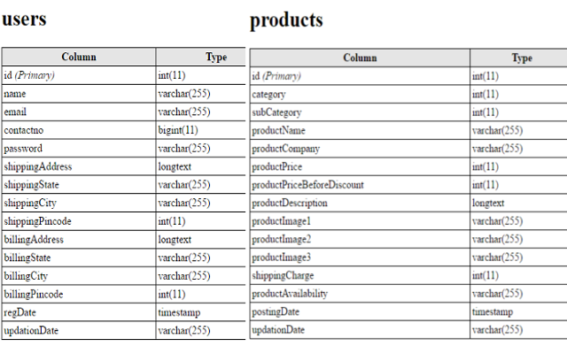

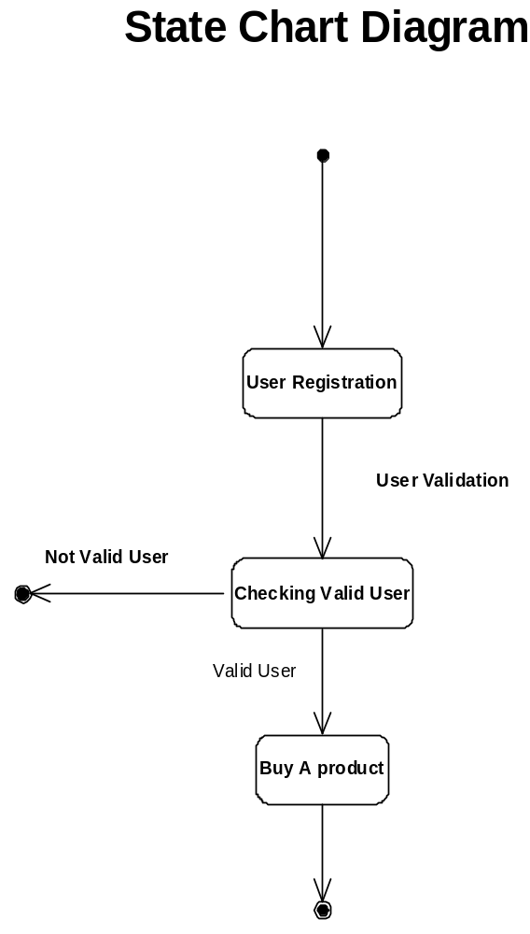

DATA FLOW DIAGRAMS:

The DFD takes an input-process-output view of a system i.e. data objects flow into the software, are transformed by processing elements, and resultant data objects flow out of the software.

Data objects represented by labeled arrows and transformation are represented by circles also called as bubbles. DFD is presented in a hierarchical fashion i.e. the first data flow model represents the system as a whole. Subsequent DFD refine the context diagram (level 0 DFD), providing increasing details with each subsequent level.

The DFD enables the software engineer to develop models of the information domain & functional domain at the same time. As the DFD is refined into greater levels of details, the analyst perform an implicit functional decomposition of the system. At the same time, the DFD refinement results in a corresponding refinement of the data as it moves through the process that embody the applications.

A context-level DFD for the system the primary external entities produce information for use by the system and consume information generated by the system. The labeled arrow represents data objects or object hierarchy.

RULES FOR DFD:

- Fix the scope of the system by means of context diagrams.

- Organize the DFD so that the main sequence of the actions

- Reads left to right and top to bottom.

- Identify all inputs and outputs.

- Identify and label each process internal to the system with Rounded circles.

- A process is required for all the data transformation and Transfers. Therefore, never connect a data store to a data Source or the destinations or another data store with just a Data flow arrow.

- Do not indicate hardware and ignore control information.

- Make sure the names of the processes accurately convey everything the process is done.

- There must not be unnamed process.

- Indicate external sources and destinations of the data, with Squares.

- Number each occurrence of repeated external entities.

- Identify all data flows for each process step, except simple Record retrievals.

- Label data flow on each arrow.

- Use details flow on each arrow.

- Use the details flow arrow to indicate data movements.

DATAFLOW DIAGRAMS:

Database:
User registration

Buying Product

User registration
Shopping
Cart
Database

User details

User registration

Register user
Update user details
Search for user details
Order History
view user details

Buying Product

User details

Buy product

Buy product car
Add to Cart
Make Payment
Delete Cart
view products

DATAFLOW DIAGRAM FULL

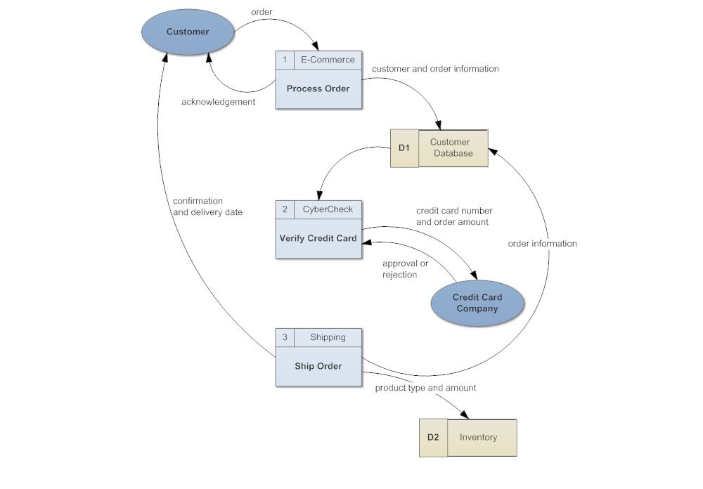

MODULES

PROJECT MODULES

MODULES : This project contains 3 modules, those are

- Admin
- Products
- User

MODULES DESCRIPTION:

Admin:-

When admin login, he saw the customer’s database, means how many users are authenticated to this website and how many users are transact everyday, and newly items are inserting into products.

Products:-

This module contains product name, and related image, and cost of its. Like shoes, books, furniture, gold items, etc.. Whatever customer wants from the shopping cart.

User:-

User entered into with his username and password, when he entered into this, he saw what items are available today, this facility is available for this site. Chosen different items from website get those through door delivery.

Database Tables and their relations:

ABOUT INTERNET AND INTRANET

Technologically, the Internet is network of computers. Not just a few special Computers, but over nine million of all kinds of computers. Similarly it is not just a network, but a network of networks hence the name and using TCP/IP (transmission control protocol and internet protocol).

Internet is the name for a vast, worldwide system consisting of people, information and computers. Internet is global communication system of diverse, INTER connected computer NETWORK for the exchange of information of virtually every conceivable topic known to man.
Internet is not just one thing. It is a lot of things to lot of people. In today’s world it is one of the most important commodity of life. The Internet is more important in what it enables than what it is, more of a phenomenon than fact.
Intranet

The classical definition of Intranet is the application of the Internet technologies to the internal business applications media most refer to the Intranet in terms of applying web technologies to information systems in the organization.

Coding Pattern of Project(login.php):
<?php
session_start();
error_reporting(0);
include('includes/config.php');
// Code user Registration
if(isset($_POST['submit']))
{
$name=$_POST['fullname'];
$email=$_POST['emailid'];
$contactno=$_POST['contactno'];
$password=md5($_POST['password']);
$query=mysql_query("insert into users(name,email,contactno,password) values('$name','$email','$contactno','$password')");
if($query)
{
echo "<script>alert('You are successfully register');</script>";
}
else{
echo "<script>alert('Not register something went worng');</script>";
}
}// Code for User login
if(isset($_POST['login']))
{
$email=$_POST['email'];
$password=md5($_POST['password']);
$query=mysql_query("SELECT * FROM users WHERE email='$email' and password='$password'");
$num=mysql_fetch_array($query);
if($num>0)
{
$extra="my-cart.php";
$_SESSION['login']=$_POST['email'];
$_SESSION['id']=$num['id'];
$_SESSION['username']=$num['name'];
$uip=$_SERVER['REMOTE_ADDR'];
$status=1;
$log=mysql_query("insert into userlog(userEmail,userip,status) values('".$_SESSION['login']."','$uip','$status')");
$host=$_SERVER['HTTP_HOST'];
$uri=rtrim(dirname($_SERVER['PHP_SELF']),'/\\');
header("location:http://$host$uri/$extra");
exit();
}
else
{
$extra="login.php";
$email=$_POST['email'];
$uip=$_SERVER['REMOTE_ADDR'];
$status=0;
$log=mysql_query("insert into userlog(userEmail,userip,status) values('$email','$uip','$status')");
$host = $_SERVER['HTTP_HOST'];
$uri = rtrim(dirname($_SERVER['PHP_SELF']),'/\\');
header("location:http://$host$uri/$extra");
$_SESSION['errmsg']="Invalid email id or Password";
exit();
}
}

?>
<!DOCTYPE html>
<html lang="en">
<head>
<!-- Meta -->
<meta charset="utf-8">
<meta http-equiv="Content-Type" content="text/html; charset=UTF-8">
<meta name="viewport" content="width=device-width, initial-scale=1.0, user-scalable=no">
<meta name="description" content="">
<meta name="author" content="">
<meta name="keywords" content="MediaCenter, Template, eCommerce">
<meta name="robots" content="all">
<title>Shopping Portal | Signi-in | Signup</title>
<!-- Bootstrap Core CSS -->
<link rel="stylesheet" href="assets/css/bootstrap.min.css">
<!-- Customizable CSS -->
<link rel="stylesheet" href="assets/css/main.css">
<link rel="stylesheet" href="assets/css/green.css">
<link rel="stylesheet" href="assets/css/owl.carousel.css">
<link rel="stylesheet" href="assets/css/owl.transitions.css">
<!--<link rel="stylesheet" href="assets/css/owl.theme.css">-->
<link href="assets/css/lightbox.css" rel="stylesheet">
<link rel="stylesheet" href="assets/css/animate.min.css">
<link rel="stylesheet" href="assets/css/rateit.css">
<link rel="stylesheet" href="assets/css/bootstrap-select.min.css">

<!-- Demo Purpose Only. Should be removed in production -->
<link rel="stylesheet" href="assets/css/config.css">

<link href="assets/css/green.css" rel="alternate stylesheet" title="Green color">
<link href="assets/css/blue.css" rel="alternate stylesheet" title="Blue color">
<link href="assets/css/red.css" rel="alternate stylesheet" title="Red color">
<link href="assets/css/orange.css" rel="alternate stylesheet" title="Orange color">
<link href="assets/css/dark-green.css" rel="alternate stylesheet" title="Darkgreen color">
<!-- Demo Purpose Only. Should be removed in production : END -->

<!-- Icons/Glyphs -->
<link rel="stylesheet" href="assets/css/font-awesome.min.css">

<!-- Fonts -->
<link href='http://fonts.googleapis.com/css?family=Roboto:300,400,500,700' rel='stylesheet' type='text/css'>

<!-- Favicon -->
<link rel="shortcut icon" href="assets/images/favicon.ico">
<script type="text/javascript">
function valid()
{
if(document.register.password.value!= document.register.confirmpassword.value)
{
alert("Password and Confirm Password Field do not match !!");
document.register.confirmpassword.focus();
return false;
}
return true;
}
</script>
</head>
<body class="cnt-home">

<!-- ============================================== HEADER ============================================== -->
<header class="header-style-1">

<!-- ============================================== TOP MENU ============================================== -->
<?php include('includes/top-header.php');?>
<!-- ============================================== TOP MENU : END ============================================== -->
<?php include('includes/main-header.php');?>
<!-- ============================================== NAVBAR ============================================== -->
<?php include('includes/menu-bar.php');?>
<!-- ============================================== NAVBAR : END ============================================== -->

</header>

<!-- ============================================== HEADER : END ============================================== -->
<div class="breadcrumb">
<div class="container">
<div class="breadcrumb-inner">
<ul class="list-inline list-unstyled">
<li><a href="home.html">Home</a></li>
<li class='active'>Authentication</li>
</ul>
</div><!-- /.breadcrumb-inner -->
</div><!-- /.container -->
</div><!-- /.breadcrumb -->

<div class="body-content outer-top-bd">
<div class="container">
<div class="sign-in-page inner-bottom-sm">
<div class="row">
<!-- Sign-in -->
<div class="col-md-6 col-sm-6 sign-in">
<h4 class="">sign in</h4>
<p class="">Hello, Welcome to your account.</p>
<form class="register-form outer-top-xs" method="post">
<span style="color:red;" >
<?php
echo htmlentities($_SESSION['errmsg']);
?>
<?php
echo htmlentities($_SESSION['errmsg']="");
?>
</span>
<div class="form-group">
<label class="info-title" for="exampleInputEmail1">Email Address <span>*</span></label>
<input type="email" name="email" class="form-control unicase-form-control text-input" id="exampleInputEmail1" >
</div>
<div class="form-group">
<label class="info-title" for="exampleInputPassword1">Password <span>*</span></label>
<input type="password" name="password" class="form-control unicase-form-control text-input" id="exampleInputPassword1" >
</div>
<div class="radio outer-xs">
<a href="forgot-password.php" class="forgot-password pull-right">Forgot your Password?</a>
</div>
<button type="submit" class="btn-upper btn btn-primary checkout-page-button" name="login">Login</button>
</form>
</div>
<!-- Sign-in -->

<!-- create a new account -->
<div class="col-md-6 col-sm-6 create-new-account">
<h4 class="checkout-subtitle">create a new account</h4>
<p class="text title-tag-line">Create your own Shopping account.</p>
<form class="register-form outer-top-xs" role="form" method="post" name="register" onSubmit="return valid();">
<div class="form-group">
<label class="info-title" for="fullname">Full Name <span>*</span></label>
<input type="text" class="form-control unicase-form-control text-input" id="fullname" name="fullname" required="required">
</div>

<div class="form-group">
<label class="info-title" for="exampleInputEmail2">Email Address <span>*</span></label>
<input type="email" class="form-control unicase-form-control text-input" id="exampleInputEmail2" name="emailid" required >
</div>

<div class="form-group">
<label class="info-title" for="contactno">Contact No. <span>*</span></label>
<input type="text" class="form-control unicase-form-control text-input" id="contactno" name="contactno" maxlength="10" required >
</div>

<div class="form-group">
<label class="info-title" for="password">Password. <span>*</span></label>
<input type="password" class="form-control unicase-form-control text-input" id="password" name="password" required >
</div>

<div class="form-group">
<label class="info-title" for="confirmpassword">Confirm Password. <span>*</span></label>
<input type="password" class="form-control unicase-form-control text-input" id="confirmpassword" name="confirmpassword" required >
</div>

<button type="submit" name="submit" class="btn-upper btn btn-primary checkout-page-button">Sign Up</button>
</form>
<span class="checkout-subtitle outer-top-xs">Sign Up Today And You'll Be Able To : </span>
<div class="checkbox">
<label class="checkbox">
Speed your way through the checkout.
</label>
<label class="checkbox">
Track your orders easily.
</label>
<label class="checkbox">
Keep a record of all your purchases.
</label>
</div>
</div>
<!-- create a new account --> </div><!-- /.row -->
</div>
<?php include('includes/brands-slider.php');?>
</div>
</div>
<?php include('includes/footer.php');?>
<script src="assets/js/jquery-1.11.1.min.js"></script>

<script src="assets/js/bootstrap.min.js"></script>

<script src="assets/js/bootstrap-hover-dropdown.min.js"></script>
<script src="assets/js/owl.carousel.min.js"></script>

<script src="assets/js/echo.min.js"></script>
<script src="assets/js/jquery.easing-1.3.min.js"></script>
<script src="assets/js/bootstrap-slider.min.js"></script>
<script src="assets/js/jquery.rateit.min.js"></script>
<script type="text/javascript" src="assets/js/lightbox.min.js"></script>
<script src="assets/js/bootstrap-select.min.js"></script>
<script src="assets/js/wow.min.js"></script>
<script src="assets/js/scripts.js"></script>
<script src="switchstylesheet/switchstylesheet.js"></script>
<script>
$(document).ready(function(){
$(".changecolor").switchstylesheet( { seperator:"color"} );
$('.show-theme-options').click(function(){
$(this).parent().toggleClass('open');
return false;
});
});

$(window).bind("load", function() {
$('.show-theme-options').delay(2000).trigger('click');
});
</script>

</body>
</html>

CONCLUSION

CONCLUSION:

The package was designed in such a way that future modifications can be done easily. The following conclusions can be deduced from the development of the project.

  - Automation of the entire system improves the efficiency
  - It provides a friendly graphical user interface which proves to be better when compared to the existing system.
  - It gives appropriate access to the authorized users depending on their permissions.
  - It effectively overcomes the delay in communications.
  - Updating of information becomes so easier.
  - System security, data security and reliability are the striking features.
  - The System has adequate scope for modification in future if it is necessary.

s

ADVANTAGES:

Speed up the buying process and save time for customers.

- The convenience of shopping at home.

- Get detailed information about the product.

Able to provide detailed information to the customer.

- Easy price comparisons.

- We can compare various models/brands.

- The mall is open on 365 x 24 x 7. So, time does not act as a barrier, wherever the vendor and buyers are.

- Online consumers can track the order status and delivery status tracking of shipping is also available.

OUTPUT SCREEN

Home Page:
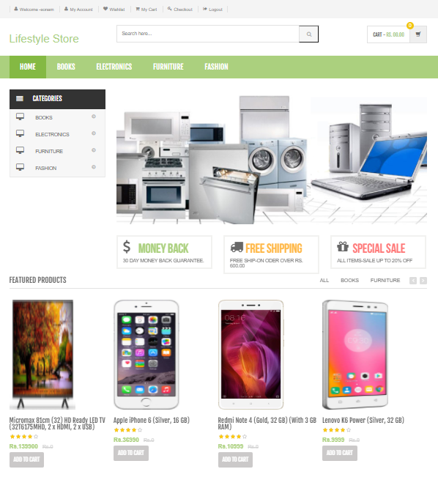
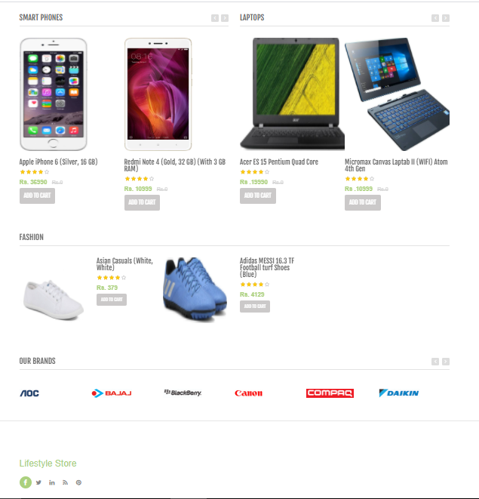
Product:
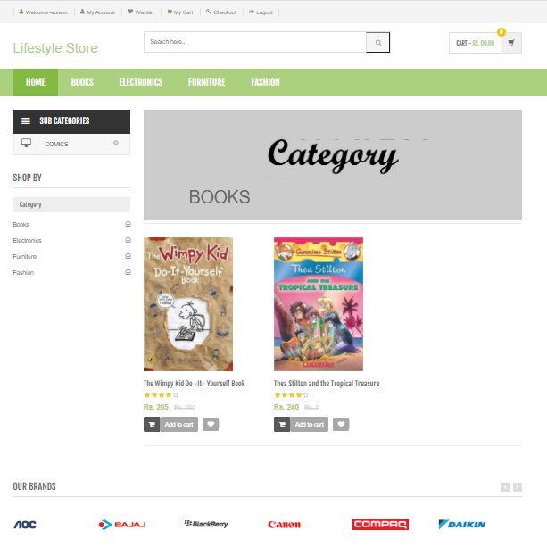
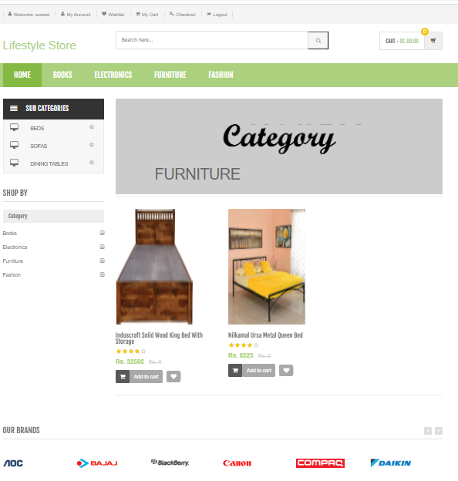
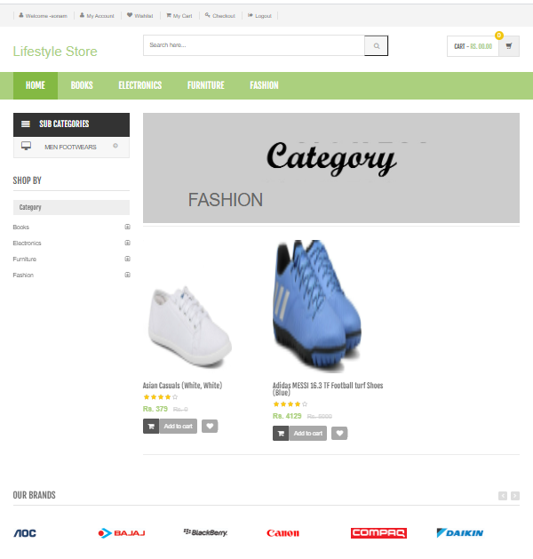
Login page:
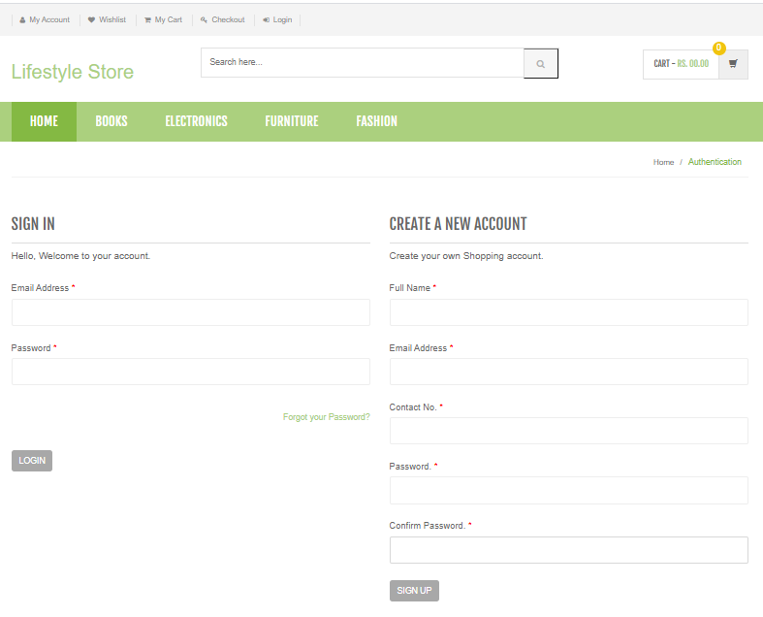
Add to cart:
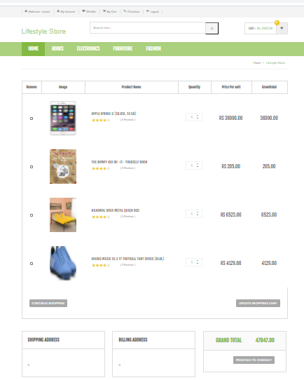

Wishlist:
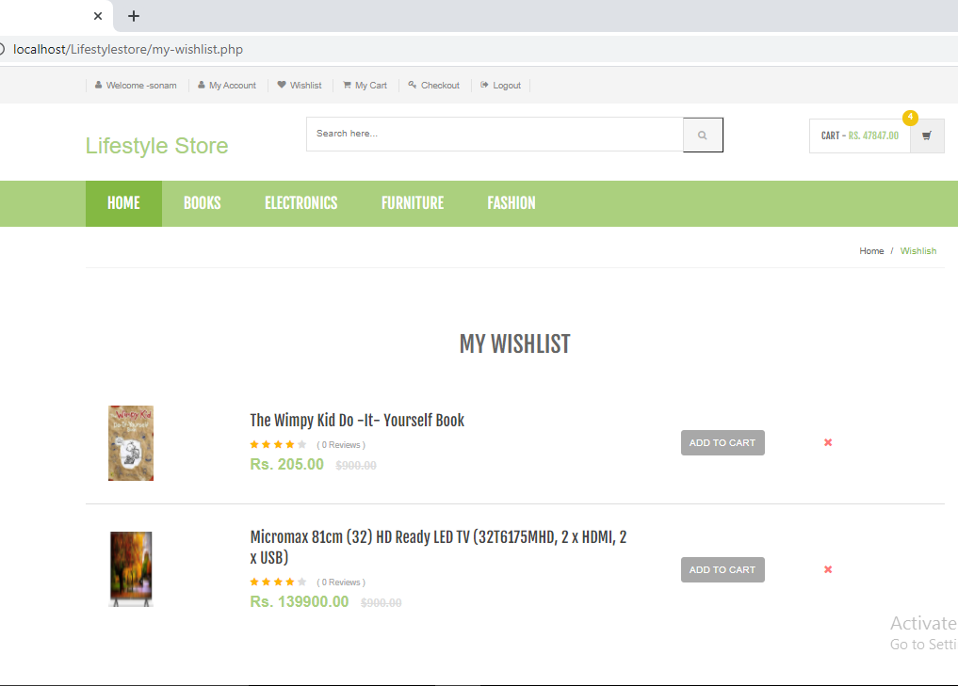

Shipping/Billing Address:

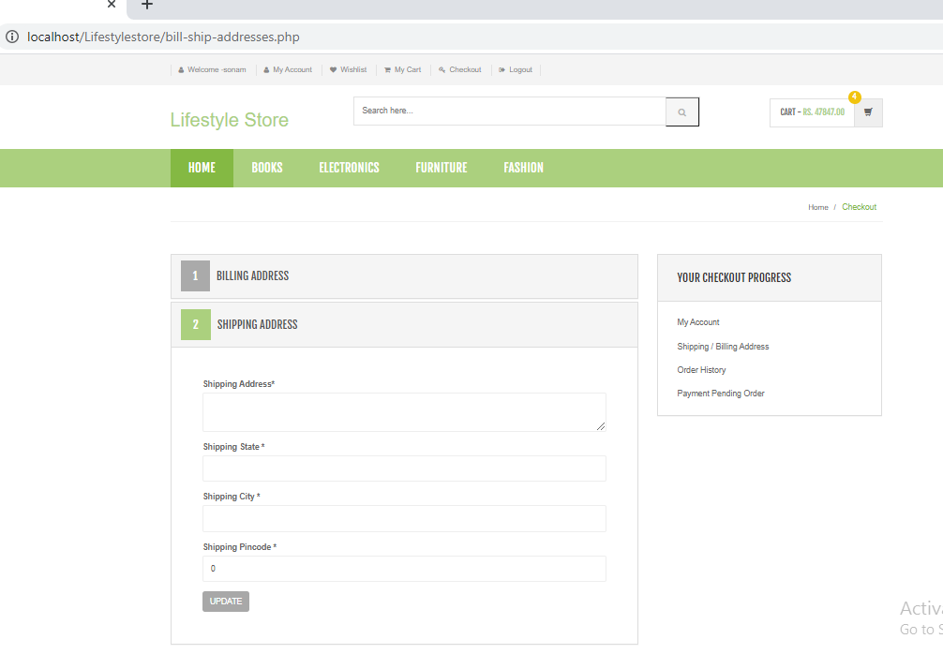

Setting page:

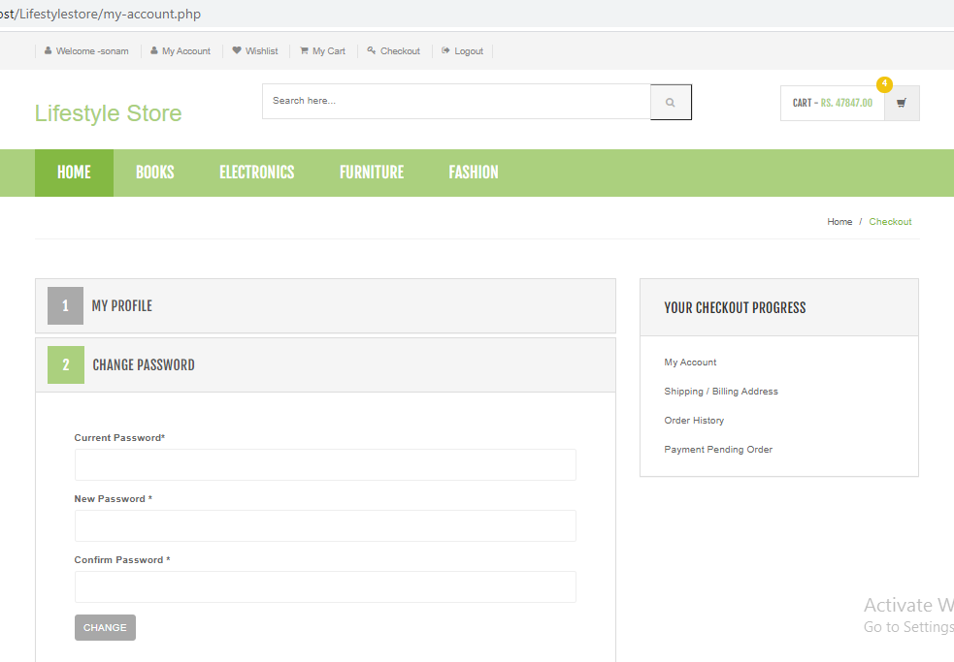

Product Detail:
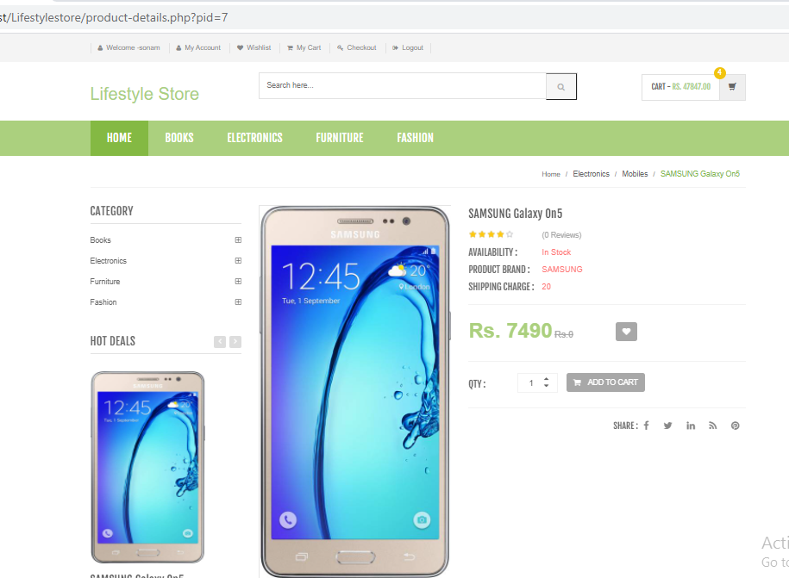

Payment:

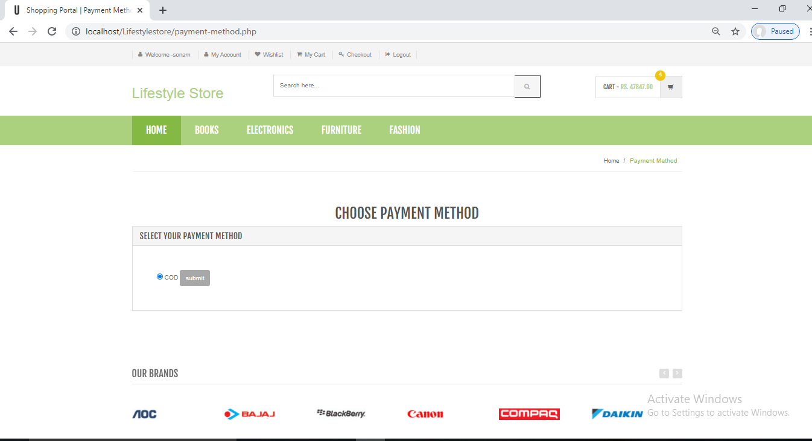

REFERENCE

REFERENCE

The following books were referred during the analysis and execution phase of the project

PHP and MySQL Web Development
Book by Luke Welling

Head First PHP & MySQL
Book by Lynn Beighley and Michael Morrison

PHP & MySQL for Dummies
Book by Janet Valade

WEBSITES:
- www.w3schools.com
- www.tutorialspoint.php
- http://stackoverflow.com

Github Link:-
- https://github.com/rohityadavcs19/LifeStyleStore

