Universal Wireshark Log Reader — Easy User Manual
Welcome! This program takes network recordings (or live network traffic) and turns the raw numbers inside them into a neat Excel spreadsheet that you can read and analyse.
This manual is written for complete beginners. You do not need to be a programmer or a networking expert. Every technical word is explained the first time it appears, and there is a plain-English [Glossary](#23-glossary-every-word-explained) at the end. Take it one section at a time — there is a 5-minute Quick Start below that gets you a real result fast.
About the pictures: every screenshot in this manual was taken from the real program after building it on Windows. What you see here is exactly what you will see on your screen.

Table of contents
The basics
1. What this program does (in plain English)
2. Starting the program & a tour of the main window
3. Light and dark themes
4. The big idea: 3 simple steps
Quick start
5. 5-minute Quick Start (from recording to Excel)
Doing it yourself, step by step
6. Step 1 — Choose where the packets come from
7. Step 2 — Choose which packets you want (Port or Header)
8. Step 3 — Describe a message
9. Step 4 — Describe the fields inside a message
10. Data types — the list of "kinds of number"
11. Resolution — turning raw numbers into real units
12. Step 5 — Export and read your Excel file
Advanced decoding
13. Bitfield decoders (splitting one number into flags)
14. Conditional bitfield decoders
15. Compare Options (checking the data is correct)
16. NMEA messages (GPS-style text sentences)
Big time-savers
17. Import a Word ICD (.docx) — define everything automatically
18. Import / export field tables (CSV & JSON)
19. Save and reload your work (projects)
Live network capture
20. Live Mode — read packets straight off the network
Reference
21. Keyboard shortcuts
22. Troubleshooting (when something looks wrong)
23. Glossary — every word explained

1. What this program does (in plain English)
Imagine the network is like a postal system. Computers and devices send each other tiny parcels of data called packets. This program is good at one specific job:
It opens a recording of those parcels, finds the ones you care about, opens them up, reads the numbers inside, labels each number, and writes everything into an Excel spreadsheet.
A few words you'll meet again and again (don't worry, there's a full glossary at the end):
Word | What it means, simply
Packet | One small parcel of data sent over the network.
UDP | One common way of sending packets. This program reads UDP packets.
Port | A numbered "mailbox" on a computer. Packets are addressed to a port number (e.g. 5000).
Payload | The actual contents inside a packet — the bytes you want to read.
Byte | The smallest chunk of data, a number from 0 to 255. A payload is just a row of bytes.
Offset | The *position* of a byte inside the payload. The first byte is position 1.
Field | One meaningful value inside the payload (e.g. "Latitude"), made of one or more bytes.
Message | A named kind of packet (e.g. "Track Report") with a known size and a known set of fields.
ICD | "Interface Control Document" — a Word document that describes the messages and fields.

You can use this program in two ways:
- File Mode — open a recording file (a .pcap or .pcapng file, the kind Wireshark makes) and export it to Excel.
- Live Mode — listen to packets arriving on the network *right now* and write them to Excel as they come in.

2. Starting the program & a tour of the main window
Double-click `UniversalWiresharkLogReader.exe` to start. The main window opens like this:
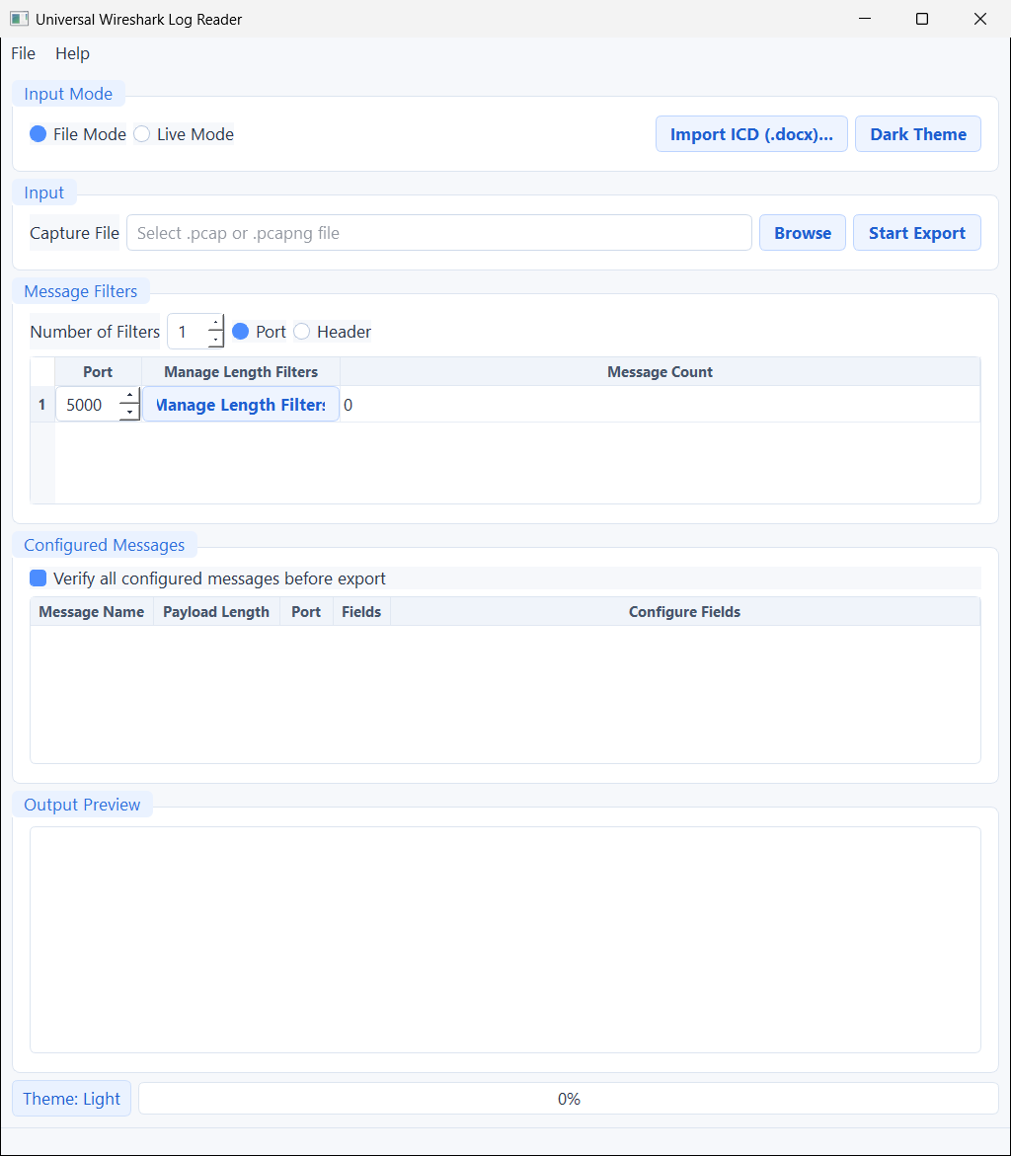
The main window in File Mode
From top to bottom, here is what every area is for:
Area | What it's for
Menu bar (File, Help) | Save/open your work, import a Word ICD, and view keyboard shortcuts.
Input Mode | Switch between File Mode and Live Mode. Also holds the Import ICD (.docx)… button and the theme button (top-right).
Input | The recording file you want to read, a Browse button to pick it, and a Start Export button to run the job.
Message Filters | How the program decides which packets to look at: by Port number or by a Header signature, and how many filter rows you want.
Configured Messages | The list of messages you've described for the selected filter, each with a Configure Fields button.
Output Preview | A live preview table that fills up with sample rows while a job runs.
Status bar (bottom) | A short message telling you what's happening, plus a progress bar.

Tip: The window is tall. If the bottom is cut off on a small screen, make the window taller or scroll — every control still works.

3. Light and dark themes
The program comes in a bright Light theme (the default, friendly for most people) and a Dark theme (easier on the eyes in a dark room).
- The button in the top-right of the Input Mode area switches themes.
- The button shows the theme you will switch to. So when it says "Dark Theme", you are currently in Light; click it to go dark.
- You can also press Ctrl + T at any time.
- Your choice is remembered the next time you open the program.
Here is the same window in the Dark theme:
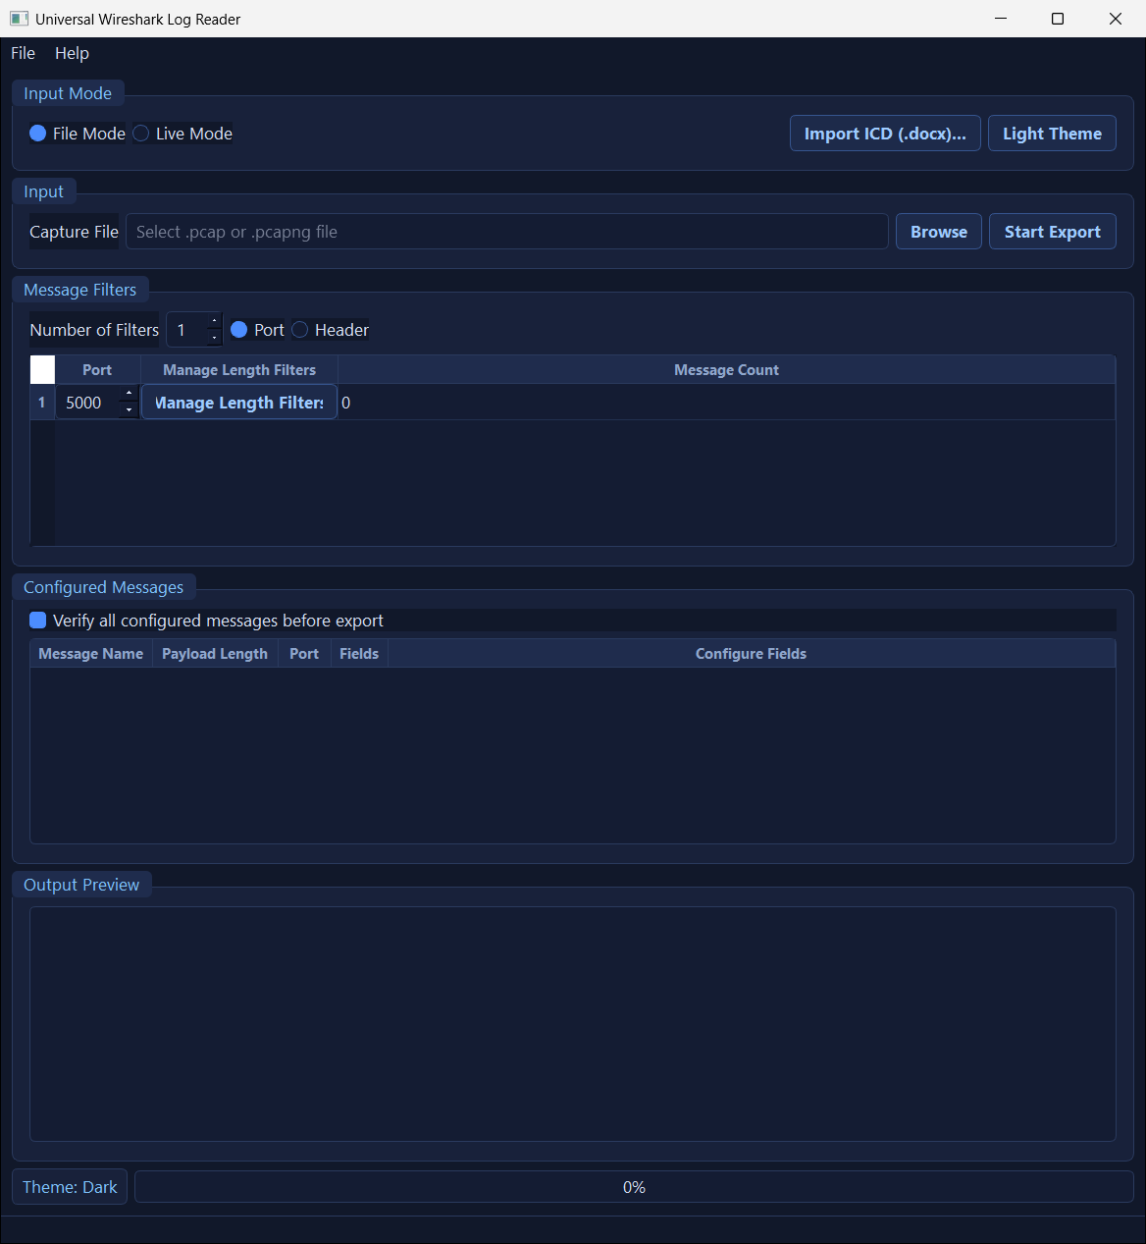
The main window in the Dark theme
Use whichever you prefer — it changes only the colours, never how anything works.

4. The big idea: 3 simple steps
No matter which mode you use, the job is always the same three questions:
┌─ 1. WHERE do the packets come from? ─────────────┐
│ • File Mode: a .pcap / .pcapng recording file │
│ • Live Mode: a live network port │
└──────────────────────────────────────────────────┘
│
┌─ 2. WHICH packets do I want? ────────────────────┐
│ • Match by Port number + payload size │
│ (and, optionally, a "header" signature) │
│ • or by NMEA sentence type (GPS-style text) │
└──────────────────────────────────────────────────┘
│
┌─ 3. HOW are the bytes read? ─────────────────────┐
│ • Fields: position, kind of number, size, scale│
│ • plus optional flag-decoders and checks │
└──────────────────────────────────────────────────┘
│
▶ Excel spreadsheet
(one file per message)

You can fill in steps 2 and 3 by hand (the dialogs below), or have the program fill them in automatically by reading a Word ICD (see Section 17) or a CSV/JSON table (see Section 18).

5. 5-minute Quick Start (from recording to Excel)
Let's do a complete job from start to finish so you can see how it all fits together. (This example uses a recording with packets on port 5000 that are 32 bytes long.)
1) Make sure you are in File Mode. The File Mode button (top-left) should be filled in.
2) Pick your recording. Click Browse, find your .pcap/.pcapng file, and open it. Its path now appears in the Capture File box.
3) Set the port. In Message Filters, leave the matching style on Port and type the port your packets use (e.g. 5000) in the Port box of row 1.
4) Describe a message. Click Manage Length Filters on that row. In the window that opens, click Add Length Filter, give the message a name and its exact payload length in bytes, then click Save.
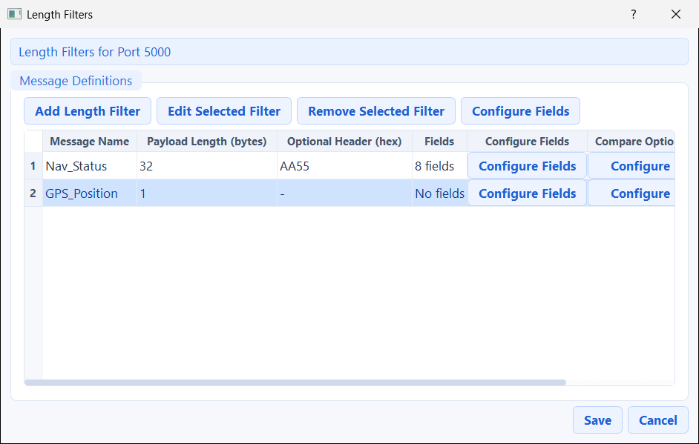
The "Length Filters" window listing your messages
5) Describe the fields. Click Configure Fields on the message row, then add your fields (name, position, kind of number, length, scale). In the picture below, eight fields have been defined for a "Nav_Status" message:
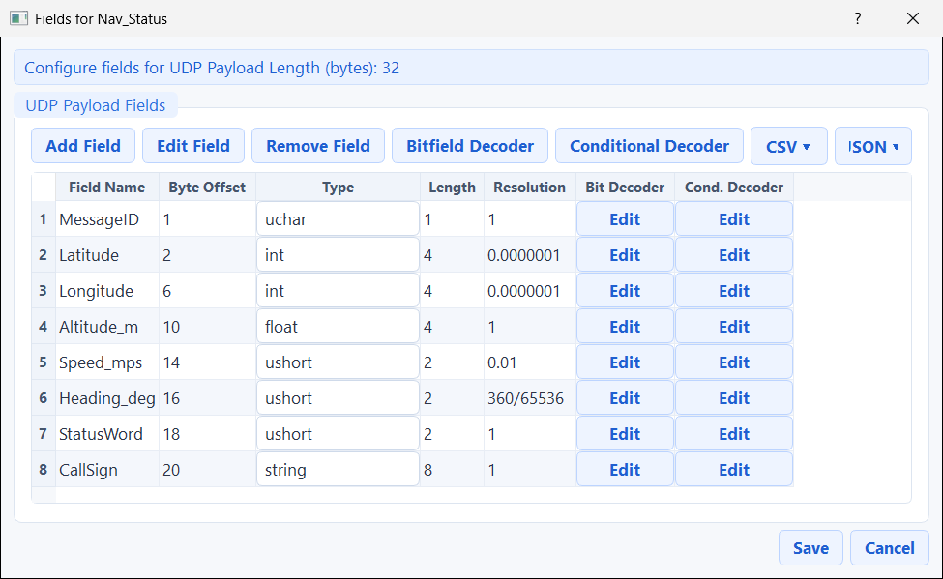
The field editor, filled with eight fields
Click Save to close the field editor, then Save again to close the Length Filters window.
6) Export! Back on the main window, click Start Export. The program asks you to choose a folder for the Excel files, then it runs. When it finishes, you get a summary:
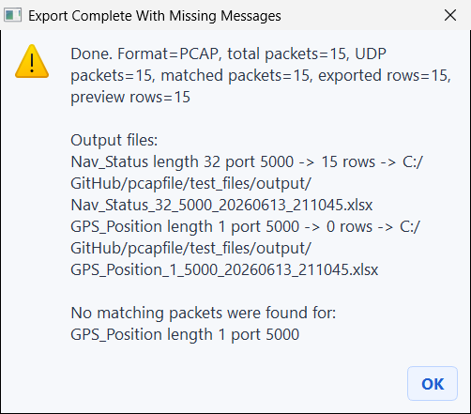
The "Export complete" summary
This summary tells you how many packets were read, how many matched your message, how many rows were written, and exactly where each Excel file was saved.
7) Look at the result. The Output Preview on the main window fills with the rows it wrote:
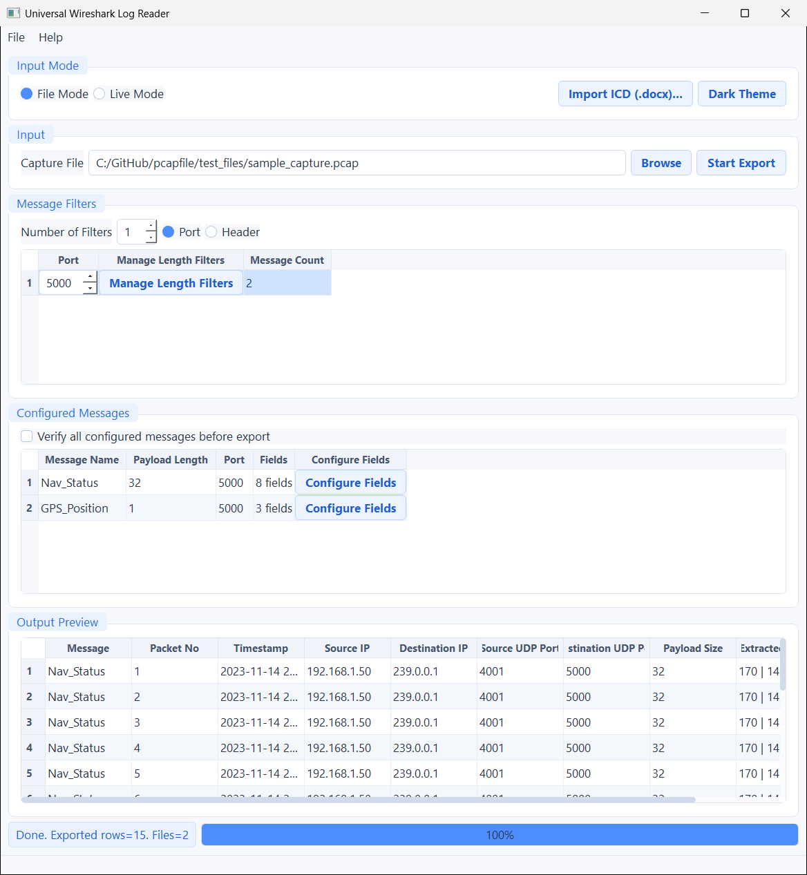
The Output Preview filled with rows
And here is the actual Excel file it created — one tidy column per field, one row per packet:
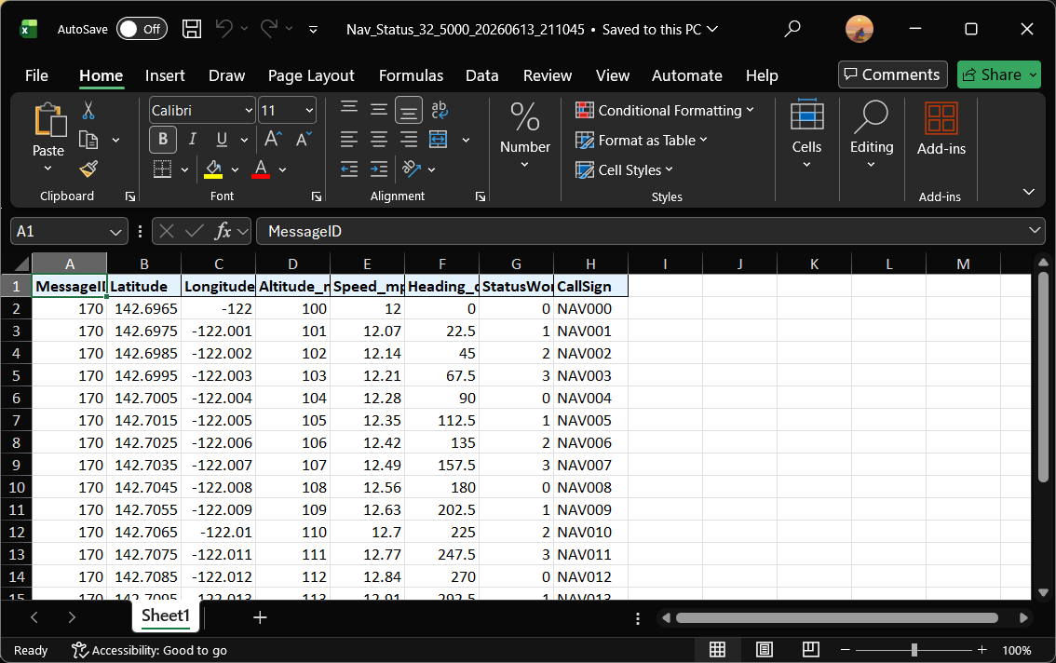
The exported Excel spreadsheet
That's the whole idea! The rest of this manual explains each step in detail and shows you the more powerful features.

6. Step 1 — Choose where the packets come from
At the very top, the Input Mode area has two choices:
- File Mode — read a recording file that already exists on your computer. This is the most common choice and is what most of this manual uses. *(Shortcut: Ctrl + 1.)*
- Live Mode — listen to packets arriving on the network in real time. See Section 20. *(Shortcut: Ctrl + 2.)*
In File Mode, the Input area shows a Capture File box. Click Browse to pick a .pcap or .pcapng file. *(Shortcut: Ctrl + B.)*
What's a .pcap file? It's a recording of network traffic, usually made by a tool called Wireshark. .pcap and the newer .pcapng are both supported.
Tip: If you saved your settings for this recording before (see Section 19), the program offers to restore them automatically when you browse to the file. Say Yes to pick up where you left off.

7. Step 2 — Choose which packets you want (Port or Header)
The Message Filters area decides which packets the program will look at. Use Number of Filters to create one or more independent filter rows, and pick a matching style with the Port / Header buttons.

Port mode (the usual choice)
Each row is a port number. The program looks only at packets sent to that port, and then matches them to the messages you describe (by their size, and an optional header signature). This is the default and the most common way to work.

Header mode
Click the Header button to switch styles:
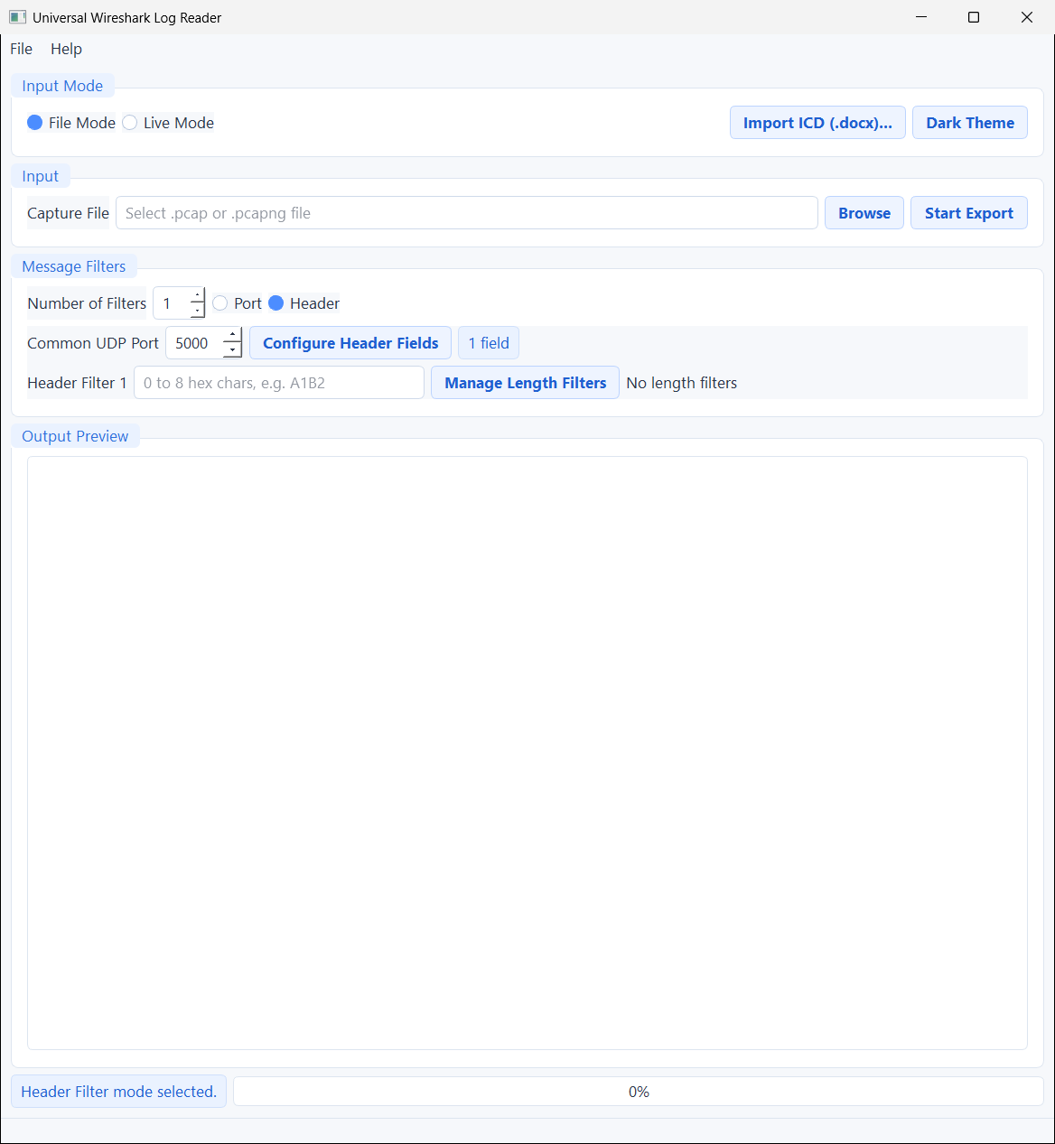
The main window in Header filter mode
In Header mode, all rows share one Common UDP Port, and each row carries a short header signature written in hex (for example A1B2). A packet matches a row when its payload starts with those bytes. This is useful when many different messages arrive on the same port and you tell them apart by their opening bytes.
- Configure Header Fields defines the fields for packets matched this way.
- Manage Length Filters lets you also attach size-based messages to a header row.
What's "hex"? Hex (hexadecimal) is a way of writing byte values using the digits 0–9 and letters A–F. Each pair of hex characters is one byte. For example A1B2 means two bytes: A1 and B2. See the Glossary.

8. Step 3 — Describe a message
A message is a named kind of packet with a known size. To manage the messages on a port, click Manage Length Filters on that filter row. The Length Filters window opens:

The Length Filters window with two messages
It lists every message on that port. The columns are:
Column | Meaning
Message Name | A friendly name you choose (it becomes part of the Excel file name).
Payload Length (bytes) | The exact payload size that identifies this message.
Optional Header (hex) | A signature so two same-size messages can be told apart (see below).
Fields | How many fields you've defined so far.
Configure Fields | Opens the field editor for this message.
Compare Options | Opens the optional verification checks (see Section 15).

Buttons: Add Length Filter (new message), Edit Selected Filter, Remove Selected Filter, and Configure Fields.

The message editor
Click Add Length Filter (or Edit Selected Filter) to open the editor:
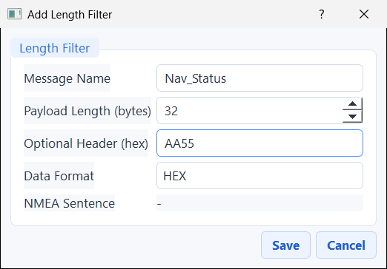
The message editor
Box | What to put in it
Message Name | A unique, friendly name, e.g. Nav_Status.
Payload Length (bytes) | The exact number of bytes in this message's payload.
Optional Header (hex) | *(Optional)* 0–8 hex characters. When set, the payload's first bytes must match this — handy when two messages on one port have the same size but different opening bytes. Leave it blank if you don't need it.
Data Format | HEX (read by byte positions — the normal choice) or NMEA (read a GPS-style text sentence — see Section 16).
NMEA Sentence | Only used when Data Format is NMEA.

The Data Format box is a dropdown with two choices:
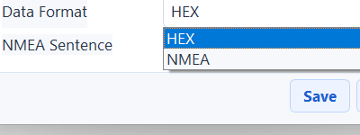
The Data Format dropdown: HEX or NMEA
Click Save to add the message to the list.

9. Step 4 — Describe the fields inside a message
This is where you tell the program how to read the bytes. Open the field editor with Configure Fields:

The field editor with eight fields defined
Each row is one field — one column in your final spreadsheet. The columns are:
Column | What to put in it
Field Name | The column heading in Excel (must be unique within the message).
Byte Offset | The position of the field's first byte. The first byte of the payload is position 1.
Type | The kind of number (see Section 10). It's a dropdown inside the cell.
Length | How many bytes the field uses. Fixed for most number types; you choose it for Raw Unsigned BE and string.
Resolution | A scale applied to the raw number (see Section 11).
Bit Decoder | An Edit button to split this number into named flags (see Section 13).
Cond. Decoder | An Edit button for advanced flag decoding that depends on another field (see Section 14).

The buttons across the top:
- Add Field / Edit Field / Remove Field — manage the rows. *(Keyboard: Insert adds a row, Ctrl + E edits, Ctrl + Delete removes.)*
- Bitfield Decoder / Conditional Decoder — open a decoder for the selected field.
- CSV ▾ — import, export, or download a template field table as a CSV file.
- JSON ▾ — import or export the whole field list (decoders included) as JSON.
The Type cell is a dropdown listing every available kind of number:
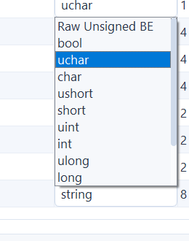
The Type dropdown listing the data types
Tip: You can also drag and drop a .csv or .json field file straight onto this window to load it. See Section 18.
When you close the editors, the main window's Configured Messages area lists everything you've set up — here, two messages on port 5000, ready to export:
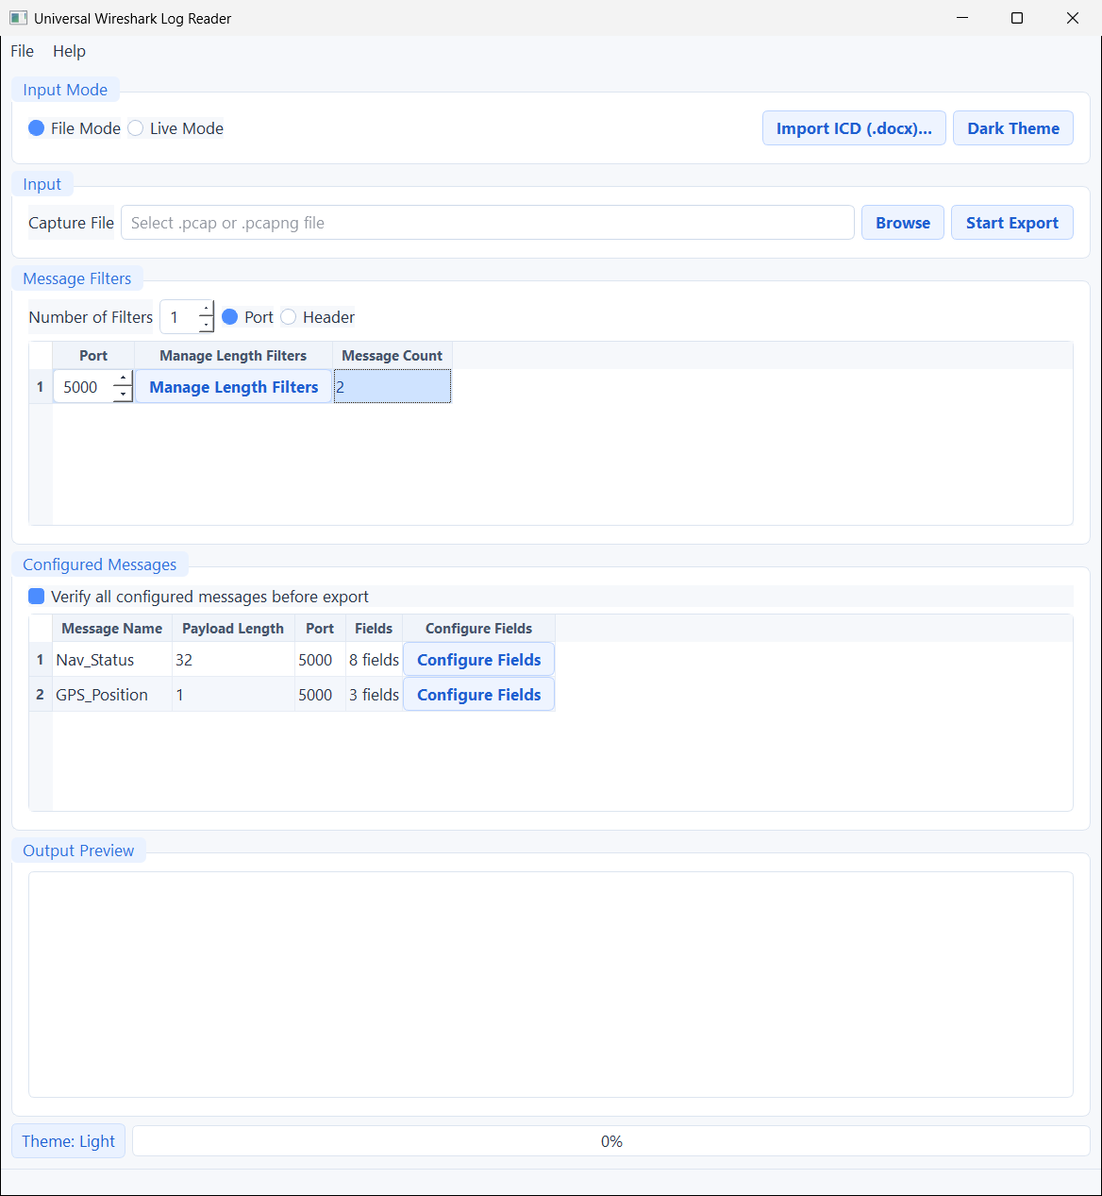
The main window listing two configured messages

10. Data types — the list of "kinds of number"
The Type dropdown offers 13 kinds of value. "Kind of number" mostly means *how many bytes* the value uses and *whether it can be negative or have decimals*.
Type (label) | Size (bytes) | What it is
Raw Unsigned BE | you choose (1–8) | A plain whole number, never negative, of any width up to 8 bytes.
uchar (Uint8) | 1 | A whole number 0–255.
char (Int8) | 1 | A whole number −128…127.
ushort (Uint16) | 2 | A whole number 0–65 535.
short (Int16) | 2 | A whole number −32 768…32 767.
uint (Uint32) | 4 | A larger whole number, never negative.
int (Int32) | 4 | A larger whole number that can be negative.
ulong (Uint64) | 8 | A very large whole number, never negative.
long (Int64) | 8 | A very large whole number that can be negative.
float (Float32) | 4 | A number with decimals (single precision).
double (Float64) | 8 | A number with decimals (double precision).
bool | 1–8 | True/False. Zero becomes false; anything else becomes true.
string / text | you choose | Plain text. The program reads that many bytes as text. Text can be longer than 8 bytes (numbers can't).

A few helpful notes:
- "BE" / big-endian" just means the most important byte comes first — the normal order for most equipment. You don't have to do anything; the program reads numbers this way.
- If a field's position and length run past the end of the payload, that cell shows N/A.
- Only number types can have bit decoders. Text (string) cannot.

11. Resolution — turning raw numbers into real units
Equipment often sends numbers as plain integers to save space. For example, a speed of 12.34 metres per second might be sent as the whole number 1234. Resolution is how you turn that raw number back into the real value.
The rule: final value = raw number × Resolution
You type the Resolution as a number or a small formula:
- A plain number, e.g. 0.01 (so 1234 becomes 12.34).
- A fraction or formula, e.g. 360/65536 (useful for angles), 1/1000, or 2*pi.
- It understands + - * / ( ) and the constants `pi` and `e`.
- Use 1 (the default) when you want the raw number unchanged.
Important: the Resolution is only a scale factor — it is *not* a formula about the byte value. Don't write things like raw*0.01; just write the scale itself, e.g. 0.01. There is no raw keyword.
In the field editor above, the Heading_deg field uses 360/65536, which neatly converts a 2-byte angle into degrees. You can see the effect in the exported Excel file (Heading steps 0, 22.5, 45, 67.5, 90 …):

Excel output showing scaled values

12. Step 5 — Export and read your Excel file
When your messages and fields are ready:
1. *(Optional but recommended)* In Configured Messages, tick "Verify all configured messages before export". The program first scans the recording and warns you if any message you described never actually appears — a great way to catch a wrong port or size before you wait for a big export. (Untick it for the fastest possible single pass on very large files.)
2. Click Start Export (or press F5).
3. The program asks you to choose a folder. It writes one Excel file per message into that folder.
4. A summary box reports the totals and the exact file paths:

Export summary
While the job runs, the Output Preview table fills with sample rows and the status bar shows a progress bar:

Output Preview during/after export

About the Excel files
- You get one `.xlsx` file per message, named like MessageName_Length_Port_Date_Time.xlsx (e.g. Nav_Status_32_5000_20260613_211045.xlsx).
- Each file has a bold heading row with your field names, then one row per matching packet:

The Excel output
- If you turned on any Compare Options (Section 15), extra checking columns are added after your fields.
- The on-screen Output Preview also shows packet details (packet number, time, addresses, ports, size). The saved Excel file contains your field columns.
Heads-up about Excel files: the spreadsheet is written all at once when the job finishes. Two things to remember: (1) don't close the program in the middle of a long live capture, or the unfinished file is lost; and (2) close the file in Excel before re-exporting to the same name, or saving will fail because the file is locked.

13. Bitfield decoders (splitting one number into flags)
Sometimes a single number is really a bundle of small flags packed together — a "status word" where bit 0 means one thing, bits 1–2 mean another, and so on. A bitfield decoder unpacks that number into separate, named, human-readable columns.
What's a "bit"? A byte is made of 8 bits, each either 0 or 1. Bits are numbered starting at 0. A "2-byte" number has bits 0–15.
Open it with the Edit button in the Bit Decoder column (or select a field and click Bitfield Decoder). Here it is for a 2-byte "StatusWord" field:
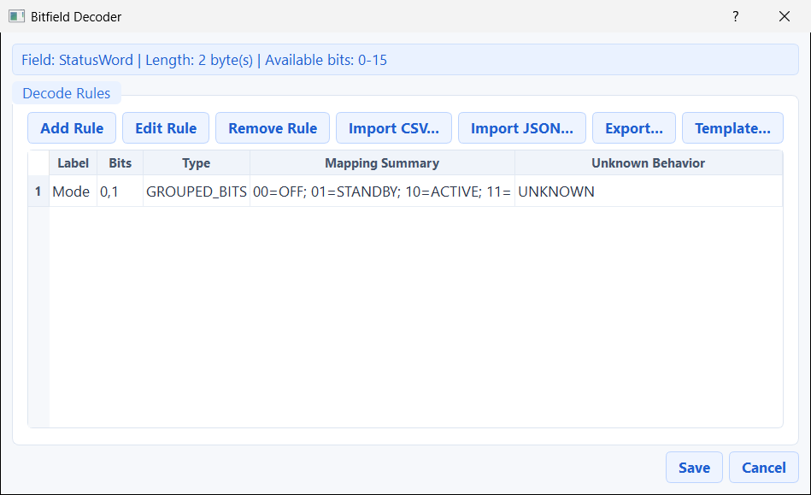
The bitfield decoder window
The heading reminds you which field you're decoding and which bit numbers are available (0–15 for 2 bytes). Each rule becomes one new column in Excel. Use Add / Edit / Remove Rule, or the bulk Import / Export / Template buttons.

Editing one rule
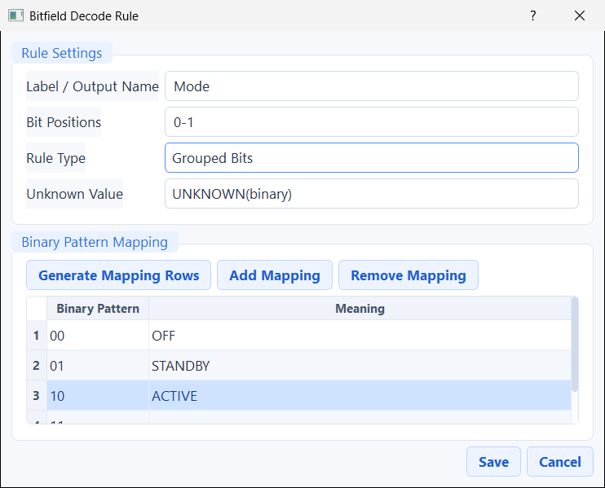
The rule editor
Setting | What it does
Label / Output Name | The name of the new Excel column (e.g. Mode).
Bit Positions | Which bits this rule reads — one bit (5), a list (1,3,5), or a range (0-1).
Rule Type | Single Bit (exactly one bit) or Grouped Bits (several bits read together). Choose Grouped Bits when you list more than one bit.
Unknown Value | What to write when a value has no meaning in your table (show UNKNOWN, leave blank, or show the raw binary).
Binary Pattern Mapping | The lookup table: each bit pattern → a meaning. In the picture, 00 → OFF, 01 → STANDBY, 10 → ACTIVE. The Generate Mapping Rows button fills in every possible pattern for the bits you chose, so you only have to type the meanings.

Tip: If you pick more than one bit but leave Rule Type on "Single Bit", the program reminds you to switch it to Grouped Bits.

14. Conditional bitfield decoders
This is an advanced version of the bit decoder. A conditional decoder chooses which set of rules to apply based on the value of *another* field — called the controller. This is for messages where one byte changes the meaning of the rest (for example, a "message subtype" byte).
Open it with the Edit button in the Cond. Decoder column:
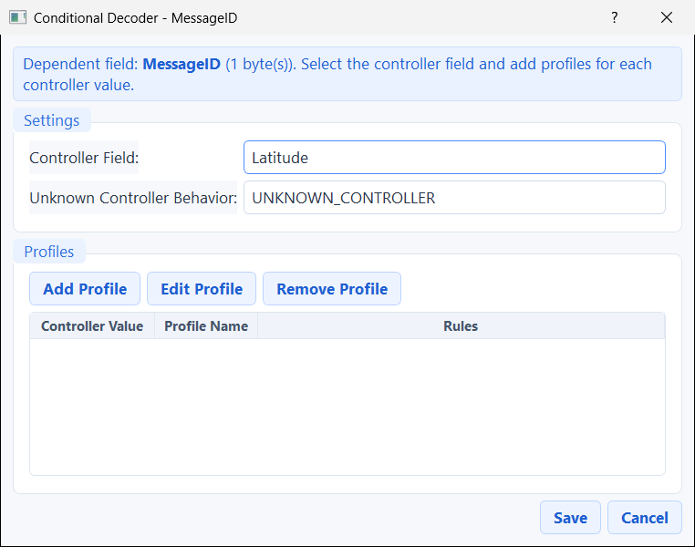
The conditional decoder window
- Controller Field — the field whose value decides which rules to use.
- Unknown Controller Behavior — what to do when the controller's value matches none of your profiles.
- Profiles — each profile is "when the controller equals *this* value, use *these* bit rules". Add, edit, or remove profiles here. Each profile has its own little bit-decoder table just like Section 13.
If this sounds complicated, you probably don't need it — most messages only need plain fields and ordinary bit decoders.

15. Compare Options (checking the data is correct)
Compare Options add checking columns to your Excel file so you can confirm the packets are framed and read correctly. Open them with the Configure button in the Compare Options column of the Length Filters window:
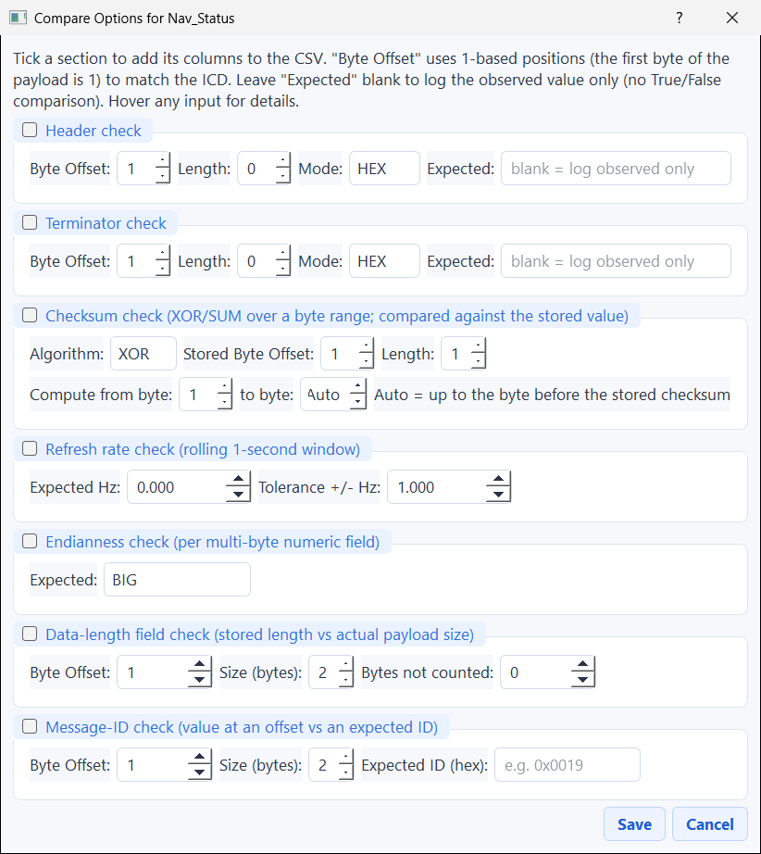
The Compare Options window with all seven checks
Tick a section to switch its check on. If you leave the Expected value blank, the program just records what it *observed* (no pass/fail). Every Byte Offset here also starts at 1.
Section | What it checks | Columns it adds
Header check | The opening bytes match an expected hex value. | HeaderObserved (+ Expected/OK)
Terminator check | The closing bytes match an expected value. | TerminatorObserved (+ Expected/OK)
Checksum check | A maths total (XOR or SUM) over a range of bytes matches the stored checksum. | ChecksumComputed, ChecksumStoredInPayload, ChecksumOK
Refresh rate check | How often the message arrives (per second) is close to an expected rate. | RefreshRateObservedHz (+ Expected/OK)
Endianness check | Shows each multi-byte number read both byte-orders so you can eyeball which is right. | <field>_BE, <field>_LE (+ OK)
Data-length field check | A "length" value inside the payload matches the real payload size. | DataLenStored, DataLenComputed, DataLenOK
Message-ID check | A value at a chosen position matches an expected ID (typed in hex). | MsgIdObserved, MsgIdExpected, MsgIdOK

What's a checksum? A small number stored in the packet that is calculated from the other bytes. If you recalculate it and get the same number, the data probably wasn't corrupted.
The last two checks (Data-length and Message-ID) are off by default and are handy for catching mistakes when you've set up a message from a generic ICD.

16. NMEA messages (GPS-style text sentences)
Some equipment (especially GPS and marine gear) doesn't send raw bytes — it sends short lines of text called NMEA 0183 sentences, like:
$GPGGA,123519,4807.038,N,01131.000,E,1,08,0.9,545.4,M,...*47

These are comma-separated. To read one, set a message's Data Format to NMEA. The program then shows a sentence picker:
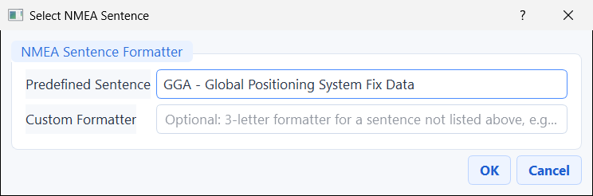
The NMEA sentence picker
- Predefined Sentence — choose from a built-in list of 87 standard NMEA sentence types (GGA, RMC, and many more). You can type the 3-letter code to jump to it.
- Custom Formatter — or type your own 3-letter code for a sentence not in the list.
After you pick one, the message editor shows it:
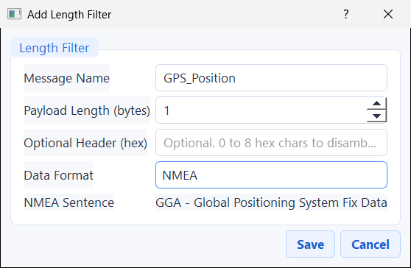
An NMEA message in the editor
NMEA messages are matched by their sentence type (the port still applies, but exact byte size and header don't). When you click Configure Fields, you get the NMEA field editor instead of the byte editor:
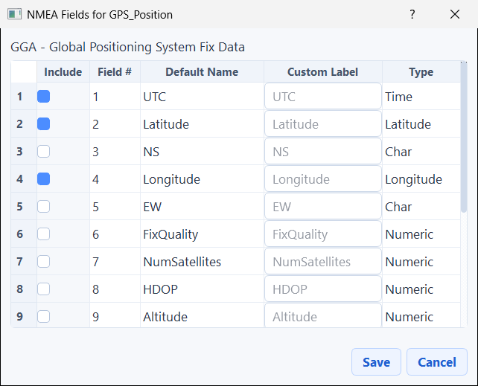
The NMEA field editor for a GGA sentence
Here, fields are picked by their position between commas (the "Field #" column) instead of byte offsets. For a known sentence the program already knows the fields: just tick Include for the ones you want, optionally type a friendlier Custom Label, and the Type (Time, Latitude, Numeric, Text…) is filled in for you. One Excel row is written per sentence.

17. Import a Word ICD (.docx) — define everything automatically
This is the biggest time-saver. If you have an ICD — a Microsoft Word document that describes your messages in tables — the program can read those tables and create the messages and fields for you, instead of typing them all by hand.
Start it with File → Import ICD (.docx)… (or Ctrl + I, or the Import ICD (.docx)… button). Pick your .docx file, and this window opens:
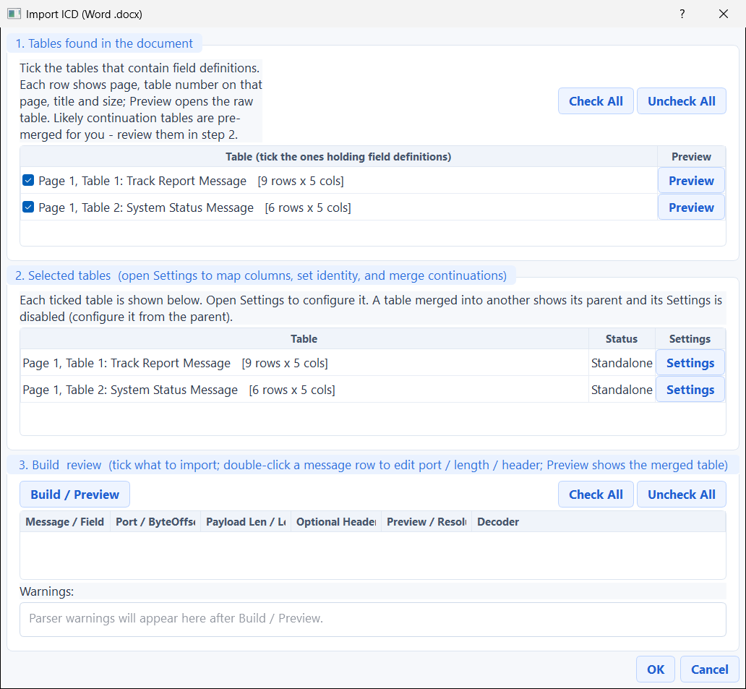
The ICD import window
The window works in three numbered boxes, top to bottom:

Box 1 — Tables found in the document
Every table the program found is listed, with its page, title, and size. Tick the tables that hold field definitions. Use Check All / Uncheck All to select quickly, and Preview to peek at any table's raw contents before deciding.

Box 2 — Selected tables (open Settings to map columns)
Each ticked table appears here. Click its Settings button to tell the program which column is which:
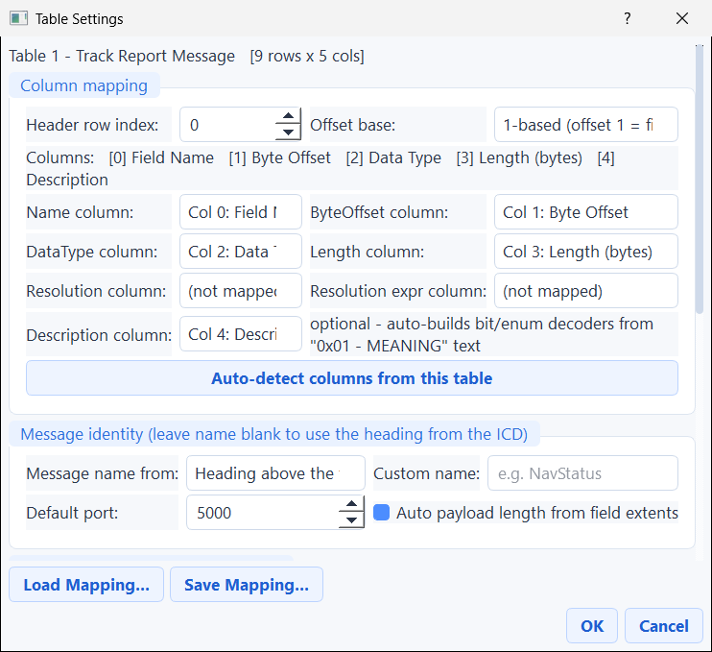
The table Settings window
- Column mapping — choose the header row, whether offsets start at 0 or 1, and which columns are the Name / Byte Offset / Data Type / Length / Resolution. The Description column can even build flag-decoders automatically from text like 0x01 - MEANING.
- Auto-detect columns from this table — the program *guesses* the mapping for you (it reads the content; there's no AI and nothing is sent anywhere). In the picture it correctly found all five columns. You can always override its guess.
- Message identity — the message name (blank uses the Word heading) and a default port.
- Load / Save Mapping — reuse a mapping you set up earlier on a similar document.

Box 3 — Build & review
Click Build / Preview to assemble everything into a checkable tree of messages and fields:
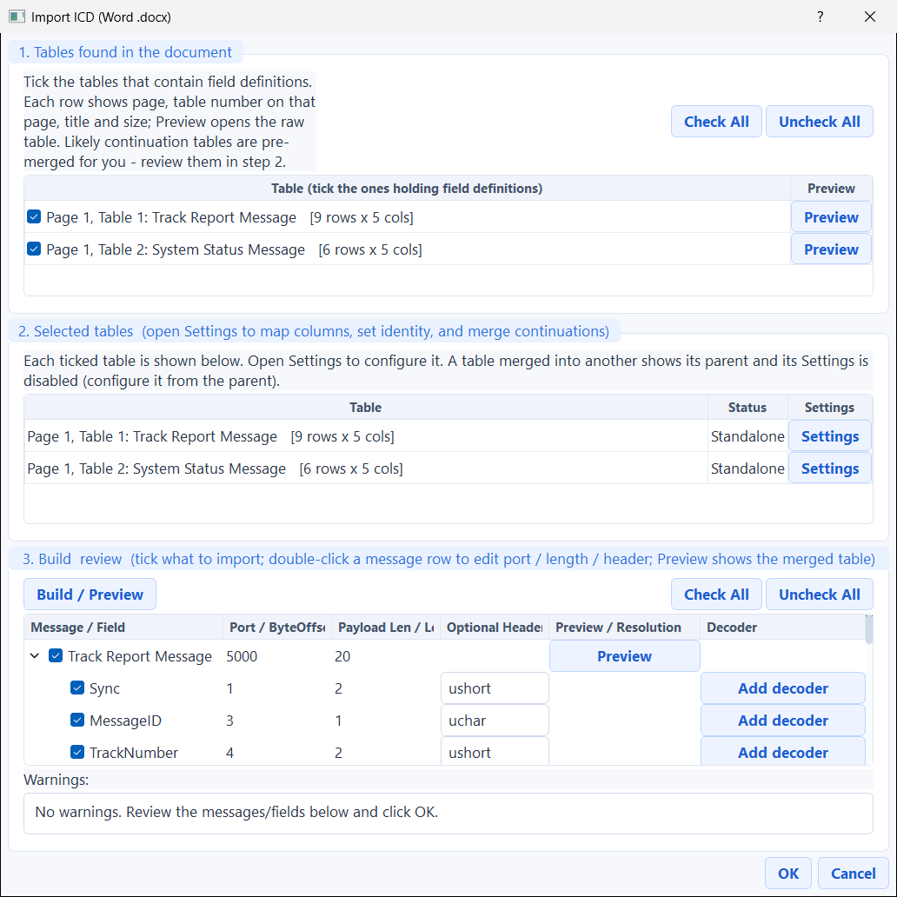
The build & review tree
- Every message and field has a tick box — untick anything you don't want.
- Anything the program was unsure about is left blank for you to fix, never silently dropped, and is explained in the Warnings box at the bottom ("No warnings" here means a clean read).
- The Data Type of each field is a dropdown you can correct.
- The Preview button on a message shows the exact rows it read from the Word table:
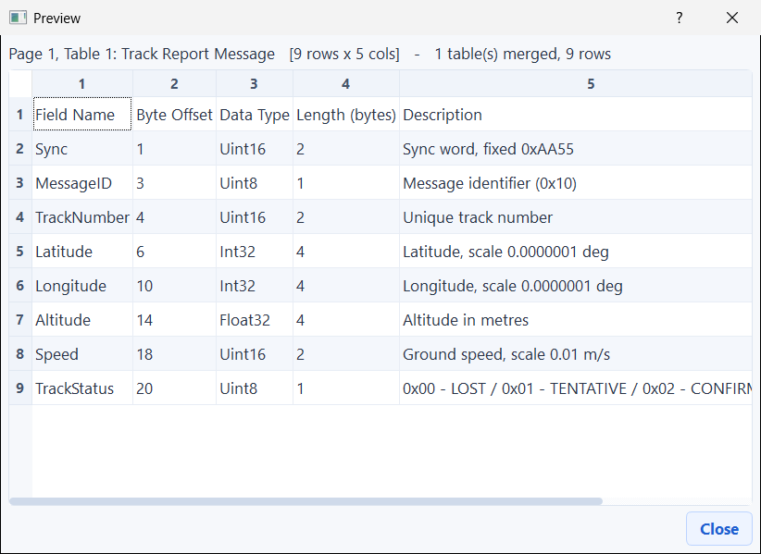
Previewing the parsed table
Click OK to finish. The messages drop straight into your current mode (the selected port, header, or Live list) — exactly as if you'd typed them by hand — and they save with your project like anything else.

18. Import / export field tables (CSV & JSON)
If you'd rather prepare your fields in a spreadsheet or a text file, the field editor can read and write them.
In the field editor, the CSV ▾ button has three choices:
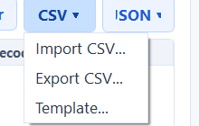
The CSV menu: Import / Export / Template
- Template… writes an empty CSV with the right column headings so you know the format.
- Export CSV… saves your current fields to a CSV.
- Import CSV… loads fields from a CSV. The columns are Name, ByteOffset, DataType, Length, Resolution, ResolutionExpression. Heading order doesn't matter, capitalisation doesn't matter, and blank or # lines are ignored.
When you import, the program tells you how many fields it found and asks whether to Replace your current list or Append to it:
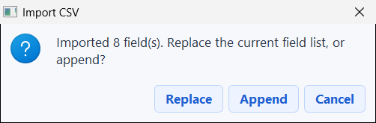
The import Replace / Append prompt
- JSON ▾ does the same but in JSON format, and JSON also keeps your bit decoders (CSV does not). JSON is the best choice if you want to back up everything including decoders.
- If anything in the file is wrong, the program shows all the problems in one message and leaves your current table untouched — so a bad import never damages your work.
Tip: You can drag a .csv or .json file from Windows Explorer straight onto the field editor to import it.

19. Save and reload your work (projects)
Setting up ports, messages, and fields takes effort — so save it! The File menu has:
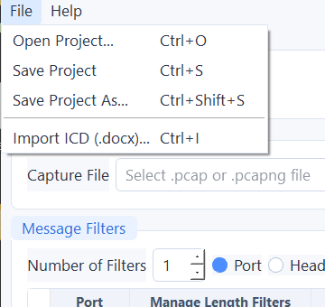
The File menu
- Open Project… (Ctrl + O), Save Project (Ctrl + S), Save Project As… (Ctrl + Shift + S).
- A project remembers your entire setup: input mode, filters, every message and field (with decoders and Compare Options), live settings — everything.
- The project is saved as a small .pcproj.json file next to your recording. When you later browse to that recording, the program offers to restore the project automatically.
- Your work is also auto-saved when you close the program, so you rarely lose anything.
- You can drag a `.pcproj.json` file onto the main window to open it.

20. Live Mode — read packets straight off the network
Instead of a recording, Live Mode listens to packets arriving right now. Click Live Mode (or press Ctrl + 2):
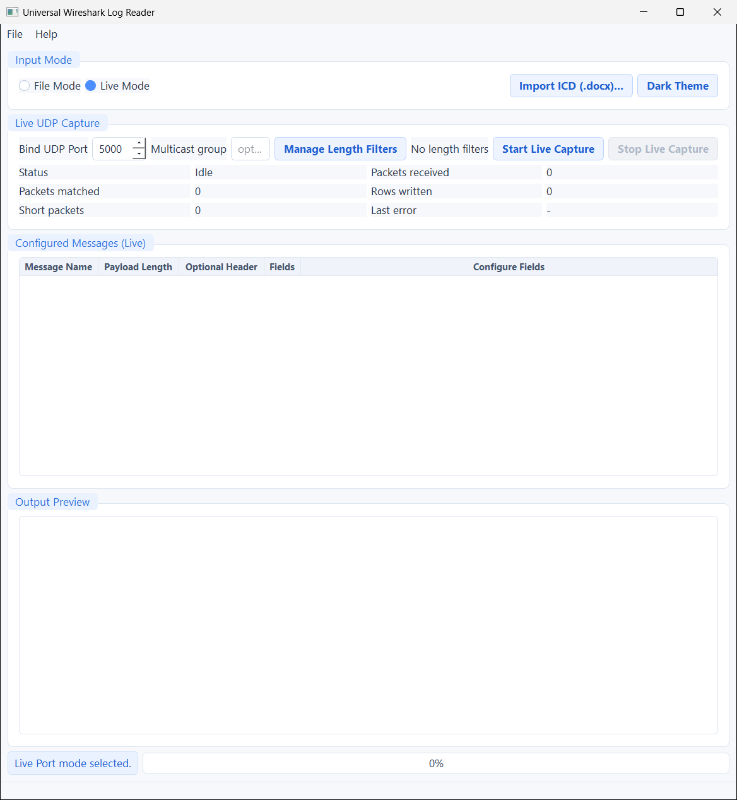
The main window in Live Mode
Control | What it does
Bind UDP Port | The port number to listen on.
Multicast group | *(Optional)* a multicast address like 239.1.1.1 to join. Leave it blank for normal traffic.
Manage Length Filters | Describe the messages to capture — exactly like Section 8. You need at least one before you can start.
Start / Stop Live Capture | Begin or end listening. When you start, you choose an output folder; one Excel file per message is written and kept up to date.
Status grid | Live counters: status, packets received, packets matched, rows written, short packets, and the last error.
Configured Messages (Live) | Your live message list, each with a Configure Fields button.

Important for multicast: if your packets go to an address like 239.x.x.x, you must type it into Multicast group. A normal listen won't receive multicast traffic on its own.
Everything else — fields, bit decoders, NMEA, Compare Options — works in Live Mode exactly as in File Mode.

21. Keyboard shortcuts
Press F1 at any time — or use Help → Keyboard Shortcuts — to see this list inside the program:
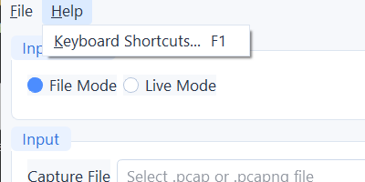
The Help menu
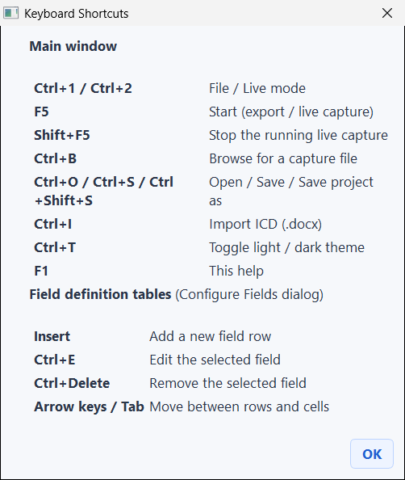
The keyboard shortcuts window
Main window
Keys | Action
Ctrl + 1 / Ctrl + 2 | Switch to File / Live mode
F5 | Start (export, or live capture)
Shift + F5 | Stop a running live capture
Ctrl + B | Browse for a recording file
Ctrl + O / Ctrl + S / Ctrl + Shift + S | Open / Save / Save Project As
Ctrl + I | Import an ICD (.docx)
Ctrl + T | Switch light / dark theme
F1 | Show this help

Inside the field editor
Keys | Action
Insert | Add a new field row
Ctrl + E | Edit the selected field
Ctrl + Delete | Remove the selected field
Arrow keys / Tab | Move between rows and cells

In any dialog, Enter usually means OK/Save and Esc means Cancel.

22. Troubleshooting (when something looks wrong)
What you see | What it usually means / how to fix it
No rows came out / 0 packets matched | The message's payload length (or NMEA type) doesn't match any packet, or the port is wrong. Tick "Verify all configured messages before export" to check before a full run.
A cell shows `N/A` | The field's position + length runs past the end of the payload, or a number's length doesn't match its type. Remember Byte Offset starts at 1.
Two different messages on one port get mixed up | Give each one a different Optional Header (hex) signature so the program can tell them apart.
Live capture receives nothing on a 239.x.x.x address | Type that address into Multicast group so the program joins the group.
Saving the Excel file failed | The file is probably open in Excel. Close it, then export again.
The ICD import "dropped" a field | It didn't — unsure fields are kept blank for review and listed under Warnings. Fix the column mapping in Settings, correct the Data Type dropdown in the review tree, then Build / Preview again.
My change to the program didn't appear | If you rebuilt the program but launched an old copy from a different folder, you'll see the old one. Make sure you're running the freshly built UniversalWiresharkLogReader.exe.

23. Glossary — every word explained
- Big-endian (BE) — a way of ordering the bytes of a number so the most important byte comes first. Most equipment uses this; the program reads numbers this way by default.
- Bit — the smallest piece of data: a single 0 or 1. Eight bits make one byte. Bits are numbered from 0.
- Bitfield / flags — a single number used as a bundle of separate yes/no or small values, one per bit or group of bits.
- Byte — a chunk of data holding a number from 0 to 255. A payload is a row of bytes.
- Capture file — a recording of network traffic; here a .pcap or .pcapng file.
- Checksum — a small number stored in a packet, calculated from the other bytes, used to check the data wasn't corrupted.
- CSV — "Comma-Separated Values", a simple table format that opens in Excel or any text editor.
- Endianness — the order in which the bytes of a multi-byte number are stored (big-endian or little-endian).
- Field — one meaningful value inside a payload (e.g. "Latitude"), made of one or more bytes.
- Header — the first bytes of a payload, often a fixed signature identifying the message.
- Hex (hexadecimal) — writing byte values using 0–9 and A–F. Each two hex characters are one byte (e.g. AA = 170).
- ICD (Interface Control Document) — a document (often Word) that describes the messages and fields a system uses.
- JSON — a structured text format the program uses to save settings and field lists.
- Message — a named kind of packet with a known size and a known set of fields.
- Multicast — a way of sending one packet to many listeners at once, using special addresses (often starting with 239.). You must "join the group" to receive them.
- NMEA 0183 — a text format for GPS and marine data, made of comma-separated "sentences".
- Offset — the position of a byte inside the payload. In this program the first byte is position 1.
- Packet — one small parcel of data sent over the network.
- Payload — the actual contents inside a packet — the bytes you want to read.
- pcap / pcapng — file formats for recorded network traffic (made by tools like Wireshark).
- Port — a numbered "mailbox" on a computer that packets are addressed to (e.g. 5000).
- Project — a saved copy of your whole setup (.pcproj.json).
- Resolution — a number you multiply the raw value by to get the real, scaled value.
- UDP — one common method of sending packets over a network. This program reads UDP packets.
- Wireshark — a popular free tool for recording and viewing network traffic; it makes the .pcap / .pcapng files this program reads.

*This manual and its screenshots were generated from the live program built with Qt 5.10.1. If you are a developer, see CLAUDE.md and PROJECT_MINDMAP.md for the code-level details.*

