Universal Wireshark Log Reader — User Manual
Universal Wireshark Log Reader is an offline desktop tool that reads and decodes UDP data — from a captured `.pcap` / `.pcapng` file or a live UDP stream — into engineering values, and exports the result to CSV or Excel. It is the receiver/parser companion to *Universal Data Simulator* (the sender).
Tip: press F1 any time to open this manual, and use the search box at the top to jump straight to a Common function or a Troubleshooting entry.

Using this manual
This manual is built into the app (Help → User Manual, or F1). The list on the left is a clickable table of contents; the box at the top searches the whole manual — type a word like troubleshooting, live mode or bitfield and press Enter (or Next/Prev) to step through every match. The same content is also provided as parser_manual.docx.
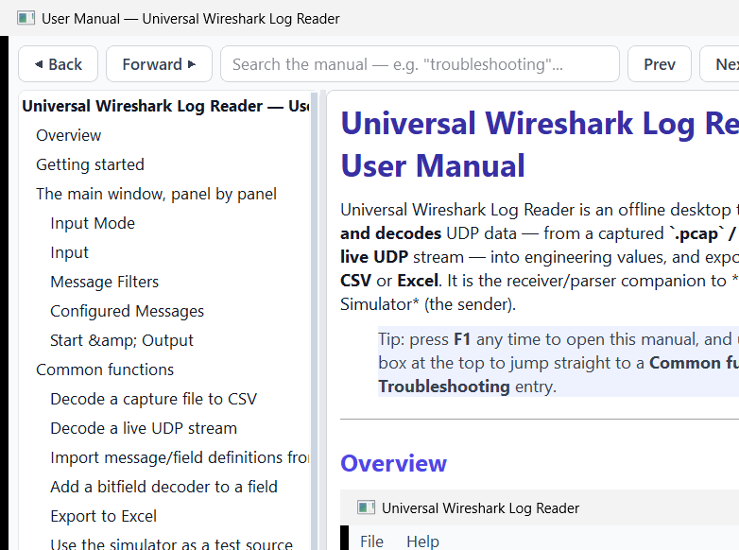
The searchable in-app manual viewer

Overview
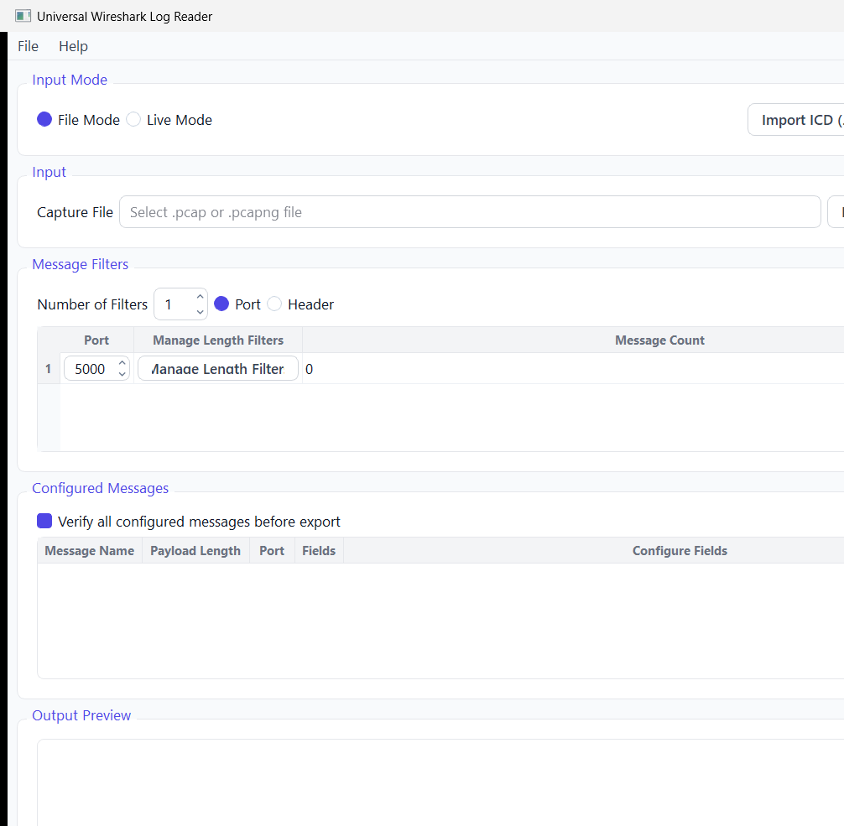
Universal Wireshark Log Reader — main window (Modern Light theme)
The window flows top to bottom:
1. Input Mode — *File Mode* (a saved capture) or *Live Mode* (listen to UDP now). Plus Import ICD….
2. Input — choose the capture file (File Mode) or the listen settings (Live Mode).
3. Message Filters — by Port and/or Header, with per-message Length filters.
4. Configured Messages — the message/field definitions that drive decoding.
5. Start — parse/decode and write the output.
6. Output Preview — a preview of the decoded rows.
The same window in the Slate Dark theme (toggle with Ctrl+T):
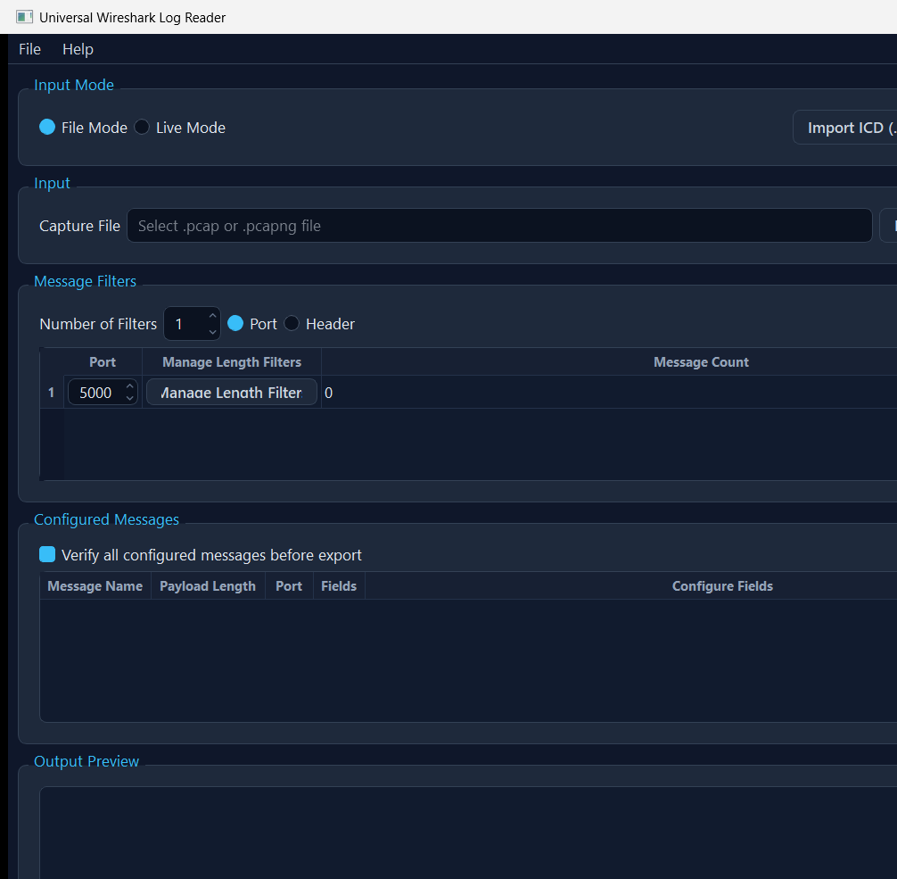
Main window (Slate Dark theme)

Getting started
1. Choose File Mode (Ctrl+1) and Browse to a .pcap/.pcapng file — or Live Mode (Ctrl+2) and set the listen port.
2. Set a Message Filter (e.g. Port 5000) so only the traffic you care about is decoded.
3. Define one or more messages and their fields (name, byte offset, type, length, resolution), or Import ICD… to generate them from a Word document.
4. Press Start (F5). The Output Preview fills in and a CSV/Excel file is written.

The main window, panel by panel

Input Mode
- File Mode (Ctrl+1) — decode a saved .pcap/.pcapng capture.
- Live Mode (Ctrl+2) — bind a UDP port and decode datagrams as they arrive, writing per-message CSV files to a chosen folder.
- Import ICD… — build message/field definitions from a Word .docx ICD.

Input
*File Mode:* Browse to the capture file. *Live Mode:* set the listen port (and per-message length filters) before Start Live.

Message Filters
Select Port or Header filtering and set the number of filters. Each filter row has a port and a Manage Length Filters button (route messages by payload length) with a live message count. Header filtering lets you tell apart same-length messages by a leading signature.

Configured Messages
The list of messages to decode. Each has a name, payload length, port and fields. Configure Fields opens the field editor (name, 1-based byte offset, data type, length, resolution / resolution expression). Fields can carry bitfield decoders and conditional bitfield decoders that expand a byte/word into named bit meanings. Tick Verify all configured messages before export to validate everything first.

Start & Output
Start (F5) parses the input, applies the filters, decodes each message's fields and writes the output (CSV, or Excel via the export options). The Output Preview shows a sample of the decoded rows. In Live Mode, Stop (Shift+F5) ends the capture.

Common functions

Decode a capture file to CSV
1. File Mode (Ctrl+1) → Browse to the .pcap/.pcapng.
2. Add a Port filter (e.g. 5000) and define the message + fields (or Import ICD…).
3. Start (F5). The decoded rows appear in the preview and a CSV is written.

Decode a live UDP stream
1. Live Mode (Ctrl+2) → set the listen port.
2. Define messages/fields and (optionally) per-message length filters.
3. Start Live, pick an output folder; one CSV per message is written as datagrams arrive. Stop when done.

Import message/field definitions from a Word ICD
Import ICD… → pick the .docx → tick the tables that hold field definitions → Build / Preview → review (the column mapping and offset base are auto-detected and editable) → OK. The drafted messages appear in *Configured Messages*.

Add a bitfield decoder to a field
In Configure Fields, open the field's decoder and define bit ranges → names/meanings. On export, the field expands into readable per-bit columns. Conditional decoders switch the bit meanings based on a controller field's value.

Export to Excel
Use the export options to write .xlsx instead of CSV (one sheet per message). See the Excel export notes for carrying the bundled library to another PC.

Use the simulator as a test source
Run *Universal Data Simulator*, point it at this app's Live Mode port, and stream a message — a quick way to validate your field definitions end to end.

Troubleshooting
Symptom | Likely cause | Fix
"Please select a PCAP or PCAPNG file" | No/invalid capture chosen in File Mode | Browse to a real .pcap/.pcapng file.
No rows decoded | Filters exclude everything, or the wrong port | Check the Port/length filters match the traffic; widen or remove a filter to confirm.
Live Mode shows 0 messages | Nothing arriving on that port, or firewall | Confirm a sender is transmitting to this PC's IP and the listen port; allow the app through the firewall.
Values look wrong / scaled oddly | Resolution or data type mismatch | Re-check each field's Type, Length and Resolution; confirm the byte offset (1-based).
Fields shifted by a byte | Wrong byte offset base or payload length | Byte Offset is 1-based; verify the message Payload Length and each field's offset.
ICD import offsets look shifted by one | Offset base (0- vs 1-based) mis-detected | In the import's Table Settings, flip the Offset base; review offsets are editable.
Export fails / no file written | Output path not writable, or verify failed | Pick a writable folder; fix any issues from Verify all configured messages.
Two messages of equal length collide | Same length on the same port | Add a Header filter / optional-header signature to tell them apart.
App opened with mixed light/dark panels | One-time startup repaint (now auto-fixed) | If seen on older builds, toggle the theme (Ctrl+T) once; current builds re-apply on launch.

Keyboard shortcuts
Shortcut | Action
F1 | Open this user manual
Shift+F1 | Keyboard shortcuts box
Ctrl+1 / Ctrl+2 | File Mode / Live Mode
F5 / Shift+F5 | Start / Stop
Ctrl+T | Toggle Light/Dark theme
Ctrl+O / Ctrl+S / Ctrl+Shift+S | Open / Save / Save-As project
Ctrl+I | Import ICD (.docx)

Glossary
- PCAP / PCAPNG — packet-capture file formats (e.g. from Wireshark/tcpdump).
- UDP payload — the application bytes of a UDP datagram, after the IP/UDP headers.
- Message filter — a rule (by port, header signature and/or payload length) selecting which datagrams map to which message definition.
- Byte offset — 1-based position of a field's first byte within the payload.
- Resolution — scale factor; the decoded engineering value is raw × resolution.
- Bitfield decoder — expands a numeric field into named per-bit meanings.
- ICD — Interface Control Document; here, a Word .docx describing message/field layouts.

