Universal Data Simulator — User Manual
Universal Data Simulator is an offline desktop tool that transmits user-defined binary (HEX) and NMEA 0183 messages over UDP (Ethernet) or a serial COM port. It is the sender-side companion to *Universal Wireshark Log Reader* (the receiver/parser). Use it to feed a system under test with exactly the bytes you choose, at the rate you choose.
Tip: press F1 any time to open this manual, and use the search box at the top to jump straight to a Common function or a Troubleshooting entry.

Using this manual
This manual is built into the app (Help → User Manual, or F1). The list on the left is a clickable table of contents; the box at the top searches the whole manual — type a word like troubleshooting, endian or checksum and press Enter (or Next/Prev) to step through every match. The same content is also provided as simulator_manual.docx.
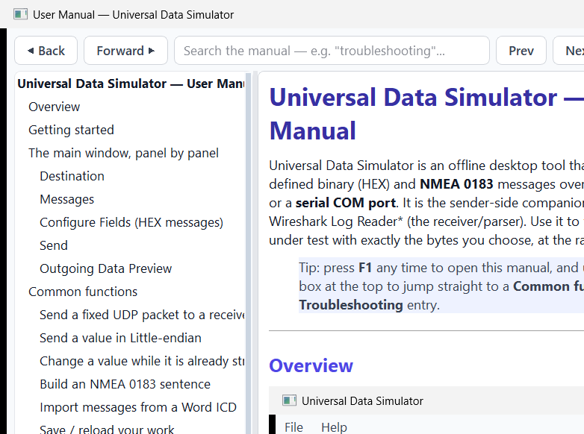
The searchable in-app manual viewer

Overview
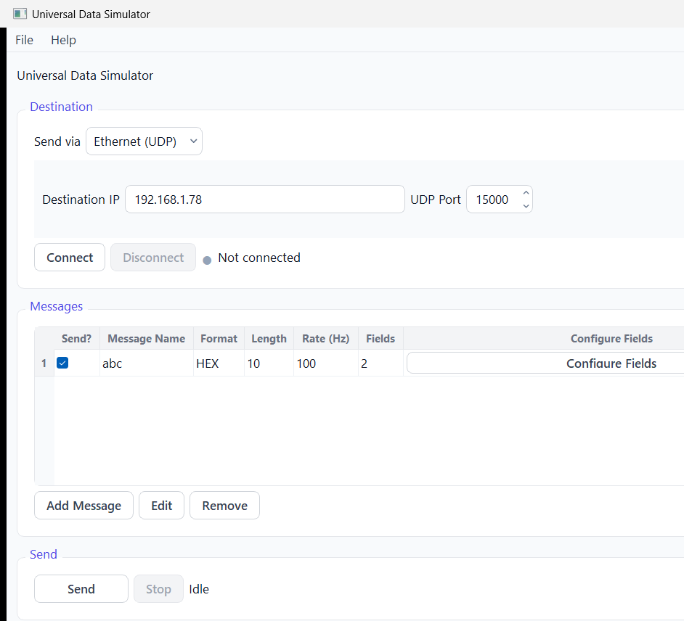
Universal Data Simulator — main window (Modern Light theme)
The window is a single top-to-bottom flow:
1. Destination — choose Ethernet (UDP) or a serial COM port and press Connect.
2. Messages — define one or more messages, each with its own fields, values and send rate.
3. Send — verify everything and stream every ticked message at its own rate until Stop.
4. Outgoing Data Preview — the last 5 payloads handed to the link, in hex.
The same window in the Slate Dark theme (toggle with Ctrl+T):
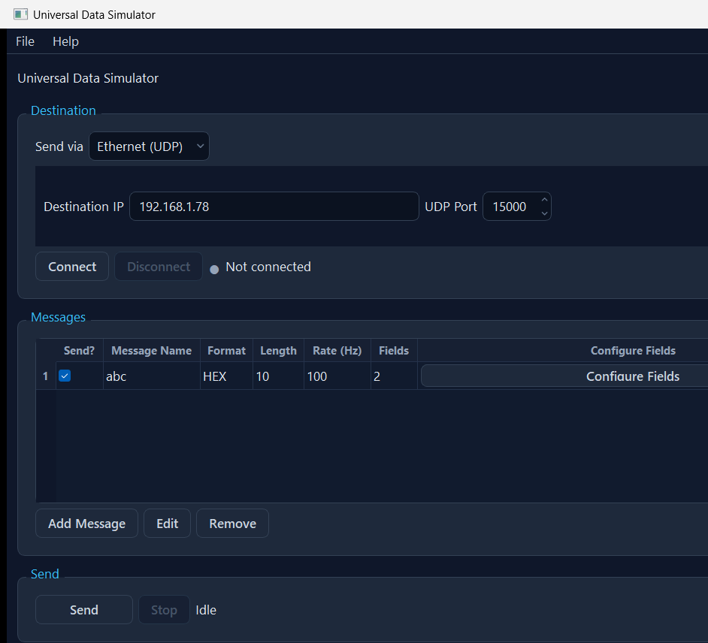
Main window (Slate Dark theme)

Getting started
1. Pick a destination at the top — *Ethernet (UDP)* (type the destination IP + port) or *Serial Port* (pick the COM port, baud rate, data bits, parity, stop bits).
2. Press Connect. The dot turns green when the link opened and a health-check message was transmitted, red (with a reason + solution) if it failed.
3. Press Add Message, give it a name, payload length and send rate, then Configure Fields.
4. Type a Value for each field — the Hex (auto) column shows the exact bytes in real time.
5. Tick the message's Send? box and press Send (F5). Watch the preview at the bottom.

The main window, panel by panel

Destination
Pick Ethernet (UDP) for an IP + port, or Serial Port for a COM port with baud / data bits / parity / stop bits. Press Refresh to re-scan the serial ports on this PC. Connect opens the link and sends a short health-check message; for UDP a green dot means "handed to the network" (UDP cannot confirm a listener). Disconnect closes the link.

Messages
Each row is a message: Send? tick, Name, Format (HEX or NMEA), payload Length, Rate (Hz), field count and a Configure Fields button.
- Add Message / Edit / Remove manage the list.
- Import ICD… reads a Word .docx ICD and turns its tables into ready-to-send messages.

Configure Fields (HEX messages)
Columns: Field Name · Byte Offset · Type · Length · Endian · Resolution · Value · Hex (auto) · Bits.
- The Value is typed in the field's own type; the read-only Hex (auto) cell shows the exact bytes that will be sent and updates as you type (it turns red with a reason if the value does not fit).
- Endian sets Big-endian (default) or Little-endian per field (numeric fields only).
- Bits… opens a two-way bit editor — type a value or toggle individual bits.
- Select several rows (Ctrl/Shift-click) to delete them at once; drag a row to reorder it (Alt+Up / Alt+Down also work).

Send
Send (F5) verifies everything first — connection, ticked messages, and that every field encodes and fits — and reports all problems in one dialog, each with a reason and a solution. It then streams every ticked message at its own rate until Stop (Shift+F5). You can edit values, rates or the Send? tick while streaming — the affected stream updates in place without a gap.

Outgoing Data Preview
The bottom box shows the last 5 payloads handed to the link, newest at the bottom, in hex.

Common functions

Send a fixed UDP packet to a receiver
1. Destination → Ethernet (UDP); type the receiver IP and port; Connect (dot green).
2. Add Message (e.g. name TEST, length 4, rate 1 Hz) → Configure Fields.
3. Add a field (type uint, length 4), type a Value, Save.
4. Tick Send?, press Send. The preview shows the bytes leaving.

Send a value in Little-endian
In Configure Fields, set that field's Endian column to Little-endian. A uint32 value of 1 becomes 01 00 00 00 on the wire instead of 00 00 00 01. String fields are never reversed.

Change a value while it is already streaming
With Send running, open Configure Fields, change the Value, Save. The live stream picks up the new bytes immediately — no Stop/Start needed. Changing the Rate retunes the cadence live; toggling Send? starts or stops just that one message.

Build an NMEA 0183 sentence
Add a message and set its Format to NMEA; pick the sentence (e.g. GGA) and talker (e.g. GP). In Configure Fields, type each field's token value; the simulator builds $GPGGA,...*HH<CR><LF> with a correct XOR checksum.

Import messages from a Word ICD
File → Import ICD… (Ctrl+I) → pick the .docx → tick the tables that hold field definitions → Build / Preview → review → OK. Each table becomes a message with its byte offsets, lengths and types filled in; type the values and send. Names that clash with existing ones are auto-renamed (ttd → ttd_1) with a warning.

Save / reload your work
File → Save Setup writes the whole setup (destination + messages + fields + values + rates) to a JSON file; Open Setup loads one. The setup is also auto-saved on close and restored on next launch.

Troubleshooting
Symptom | Likely cause | Fix
Red dot after Connect (UDP) | Bad IP, or no route to the destination | Re-check the IP/port; confirm the network route. The warning box states the exact reason.
Red dot after Connect (Serial) | COM port busy, missing, or wrong settings | Close other apps using the port; press Refresh; check baud/data/parity/stop bits.
"Cannot Send" dialog lists problems | Not connected, no message ticked, or a field value doesn't fit | Fix each listed item (each has a solution). Connect first; tick at least one message; correct out-of-range values.
Hex (auto) cell shows — in red | The Value can't be encoded in that type/length | Hover the cell for the reason; widen the Length, change the Type, or enter a value in range.
Value too big for the field | Value exceeds the type/length range | Use a wider type or larger Length, raise the Resolution, or send a smaller value.
Bytes arrive byte-swapped at the receiver | Endianness mismatch | Set the field's Endian to match the receiver (Big vs Little).
Nothing received over UDP | Green dot only means "sent to the OS" | Confirm the receiver is listening on that exact IP/port; check firewalls; try the parser app's Live mode as a receiver.
NMEA sentence rejected by the receiver | Bad talker/formatter or a token contains , * $ ! | Use a valid 2-char talker + 3-char formatter; remove delimiter characters from token values.
ICD import offsets look shifted by one | The ICD's offset base (0- vs 1-based) was mis-detected | In the import's Table Settings, flip the Offset base; every review offset is also editable.
Send rate seems capped | The timer fires at most once per millisecond | Rates above ~1000 Hz are clamped; use 0.001–1000 Hz.

Keyboard shortcuts
Shortcut | Action
F1 | Open this user manual
Shift+F1 | Keyboard shortcuts box
Ctrl+O / Ctrl+S / Ctrl+Shift+S | Open / Save / Save-As setup
Ctrl+I | Import ICD (.docx)
F5 / Shift+F5 | Send / Stop
Ctrl+T | Toggle Light/Dark theme
Ctrl+Q | Quit
Insert / Ctrl+E / Ctrl+Delete | (Field dialog) Add / Edit / Remove field(s)
Alt+Up / Alt+Down | (Field dialog) Move the selected field

Glossary
- Payload — the bytes of one message, excluding any transport headers.
- Byte offset — 1-based position of a field's first byte within the payload.
- Resolution — scale factor; the transmitted raw value is round(value ÷ resolution).
- Endianness — byte order on the wire: Big-endian (most-significant byte first) or Little-endian.
- NMEA 0183 — an ASCII sentence format ($TALKER+FORMATTER,fields*CHECKSUM).
- ICD — Interface Control Document; here, a Word .docx describing message/field layouts.

