भारत सरकार — रक्षा मंत्रालय / GOVERNMENT OF INDIA — MINISTRY OF DEFENCE
WEAPONS AND ELECTRONICS SYSTEMS ENGINEERING ESTABLISHMENT
( W E S E E )
An Autonomous Organisation under the Ministry of Defence • Indian Navy

INDUSTRIAL TRAINING REPORT
Design and Development of an Offline Protocol-Data Toolset for
Network Capture Decoding and Interface-Data Simulation

Universal Wireshark Log Reader • Universal Data Simulator

SUBMITTED BY  Rohit Yaduvanshi  Industrial Trainee | SUBMITTED TO  Weapons and Electronics Systems  Engineering Establishment (WESEE)

Training Period: 23 April 2026 – 23 June 2026
Report Date: June 2026

TABLE OF CONTENTS
…
(If the contents below appear blank, select all and press F9, or right-click → Update Field, to populate the page numbers.)

Abstract
This report documents the design and development of two complementary offline desktop software applications engineered during the industrial training period at the Weapons and Electronics Systems Engineering Establishment (WESEE). Modern naval combat-management, sensor and communication subsystems exchange large volumes of interface data over Ethernet (UDP) and serial buses, the layouts of which are governed by Interface Control Documents (ICDs). Two recurring engineering needs arise during integration and testing: first, the ability to capture such traffic and decode raw payload bytes into meaningful engineering values for verification; and second, the ability to generate and transmit controlled test traffic when the real sensor or subsystem is not available on the bench.
To address these needs, two purpose-built tools were developed. The first, the “Universal Wireshark Log Reader”, is a receive-and-analyse application that reads Wireshark packet-capture logs (.pcap / .pcapng) and live UDP and TCP streams, parses Ethernet II / IPv4 / UDP frames, decodes user-defined payload fields and NMEA 0183 marine sentences into engineering values, and exports the results to Microsoft Excel. The second, the “Universal Data Simulator”, is a transmit-and-test application that encodes user-defined binary (HEX) and NMEA messages and streams them over UDP, TCP, or a serial COM port at configurable rates. The encode logic of the simulator is the exact mathematical inverse of the reader’s decode logic, so the two together form a closed-loop, self-validating test harness.
Both applications are written in C++11 on the Qt 5.10 framework under a strict engineering mandate: fully offline operation, no external software dependencies, and smooth behaviour on low-specification hardware. In total the work spans approximately 29,100 lines of C++ across 121 source and header files and 26 user-interface forms, of which a shared core of about 7,200 lines is compiled into both applications. The report covers the objectives, the technology stack, the architecture and data model of each application, the encoding/decoding contract that binds them, the complete feature set, the engineering and validation practices adopted, and the outcomes achieved.

1. Introduction

1.1 Background and Context
WESEE is the nodal design authority of the Indian Navy for combat-management systems, networks, and software-intensive electronic systems. Such systems are inherently distributed: radars, navigation aids, weapon consoles, data-fusion processors and communication gateways continuously exchange structured data messages with one another. On naval platforms a large fraction of this exchange happens over Ethernet using the UDP transport protocol, and over point-to-point serial links for legacy and navigation equipment. The precise byte-level layout of each message — the offset, length, data type, scaling (resolution) and meaning of every field — is specified in an Interface Control Document.
During development, integration and acceptance testing, engineers repeatedly face two practical problems. When a subsystem is connected, its traffic must be captured (typically with Wireshark) and the raw payload bytes decoded back into engineering units to confirm that the data is correct. Conversely, when a subsystem is absent from the test bench, its messages must be simulated so that the equipment under test still receives realistic, well-formed input. General-purpose commercial tools for these tasks are frequently online, heavyweight, licence-bound, or unable to apply ICD-specific field definitions and scaling. A pair of lightweight, offline, dependency-free tools tailored to ICD-defined payloads — and to the NMEA 0183 standard widely used by marine navigation equipment — was therefore required.

1.2 Problem Statement
The task was to engineer two offline Windows desktop applications, driven entirely by user- or ICD-supplied field definitions, that together cover both directions of interface-data handling on the test bench — while operating without any internet connection, external library or specialised hardware, and running reliably on low-specification computers. The two complementary requirements were:
(a) Decoding — to read captured (.pcap / .pcapng) files and live UDP streams, parse the Ethernet / IPv4 / UDP layers, and decode the payload into engineering values that can be previewed and exported for analysis.
(b) Generation — to encode equivalent payloads from user-defined values and transmit them over UDP and serial links, so that the equipment under test receives realistic, well-formed input even when the real subsystem is absent from the bench.

1.3 Objectives
- Develop a tool to read Wireshark .pcap and .pcapng capture files and to manually parse Ethernet II, IPv4 and UDP layers without any packet-capture library.
- Allow the user to define payload fields (offset, length, data type, resolution) and decode them into engineering values, with support for thirteen data types.
- Support decoding of NMEA 0183 marine navigation sentences as an alternative to raw byte extraction, covering the full set of approved sentence formatters.
- Provide a live capture mode over UDP and TCP (including multicast, and several simultaneous connections bound to different adapters/ports) that streams the same decoding to an output file in real time.
- Enable bulk definition of messages and fields by importing ICD tables directly from Microsoft Word (.docx) documents and from CSV / JSON field lists.
- Export all decoded results to native Microsoft Excel (.xlsx) workbooks.
- Develop a companion tool that transmits user-defined binary (HEX) and NMEA messages over UDP, TCP or a serial COM port at configurable per-message rates, to one or more destinations at once.
- Guarantee that the simulator’s encoding is the exact inverse of the reader’s decoding, so that values round-trip exactly and the two tools validate each other.
- Enforce throughout an offline, no-external-dependency, low-resource design, with every user-facing error message stating both a reason and a suggested solution.

1.4 Scope and Constraints
The following hard constraints were fixed at the outset and observed across the entire development of both applications:
Constraint | Decision adopted
Framework | Qt 5.10 (verified on Qt 5.10.1) with the Qt Widgets UI toolkit
Language | C++11 — no use of newer language or Qt 6 APIs
Build system | qmake project files (.pro); MinGW 5.3 (32-bit) toolchain
Dependencies | Qt modules only; a single vendored, source-compiled Excel writer (QXlsx) is the lone, explicitly-approved exception
Connectivity | Fully offline — no internet, database, or cloud service
Hardware | Must run smoothly on low-specification office computers
Robustness | Malformed input rejected safely; every error gives a reason and a solution

2. Development Environment and Technology Stack
Both applications share a deliberately minimal and portable technology stack, chosen so that the tools can be built and run on an isolated, offline engineering workstation with nothing more than a Qt installation.
Area | Technology / Tooling | Notes
Language | C++11 | Standard-library and Qt containers only
UI framework | Qt 5.10 Widgets | Cross-platform; native look on Windows
Qt modules | core, gui, widgets, network, serialport | network for UDP/TCP; serialport for serial COM links (simulator)
Build | qmake + MinGW 5.3 (32-bit) | Shadow builds via Qt Creator
UI design | Qt Designer (.ui forms) | 26 forms; styling applied at runtime
Excel output | QXlsx 1.4.10 (vendored, MIT) | Compiled from source; produces native .xlsx (both applications)
Persistence | JSON (QJsonDocument), CSV | Project files, field lists, auto-save sidecars
Document import | QXmlStreamReader + QZip (.docx) | ICD table extraction from Word documents (both applications)
Version control | Git | Incremental, feature-scoped commit history
A guiding principle of the stack is self-containment: apart from the single vendored Excel writer, every capability — packet parsing, JSON and CSV handling, Word-document reading, theming and serial I/O — is built on facilities already present in the Qt framework. This keeps deployment to a simple file copy and avoids any installer, runtime download or licence server.

3. Project I — Universal Wireshark Log Reader
The Universal Wireshark Log Reader (developed under the working name PcapUdpExtractor and later renamed) is the receive-and-analyse half of the toolset. It reads packet-capture logs and live network streams, decodes the UDP payloads inside them according to user-defined field definitions, and exports the decoded engineering values to Excel for further analysis.

3.1 Purpose and Workflow
The operator selects a .pcap or .pcapng capture file (or switches to live capture), enters the UDP port of interest, defines the message and field layout — either by hand or by importing an ICD — and starts extraction. The application reads packets sequentially, keeps only Ethernet / IPv4 / UDP datagrams on the chosen port, extracts each defined field from the payload, previews the result in a table, and writes every decoded row to an Excel workbook. Because a single UDP port may carry several different message layouts, the tool organises work as a hierarchy: a port owns one or more length filters, each length filter defines one message, and each message owns its own field list — keeping dissimilar payloads from being mixed.
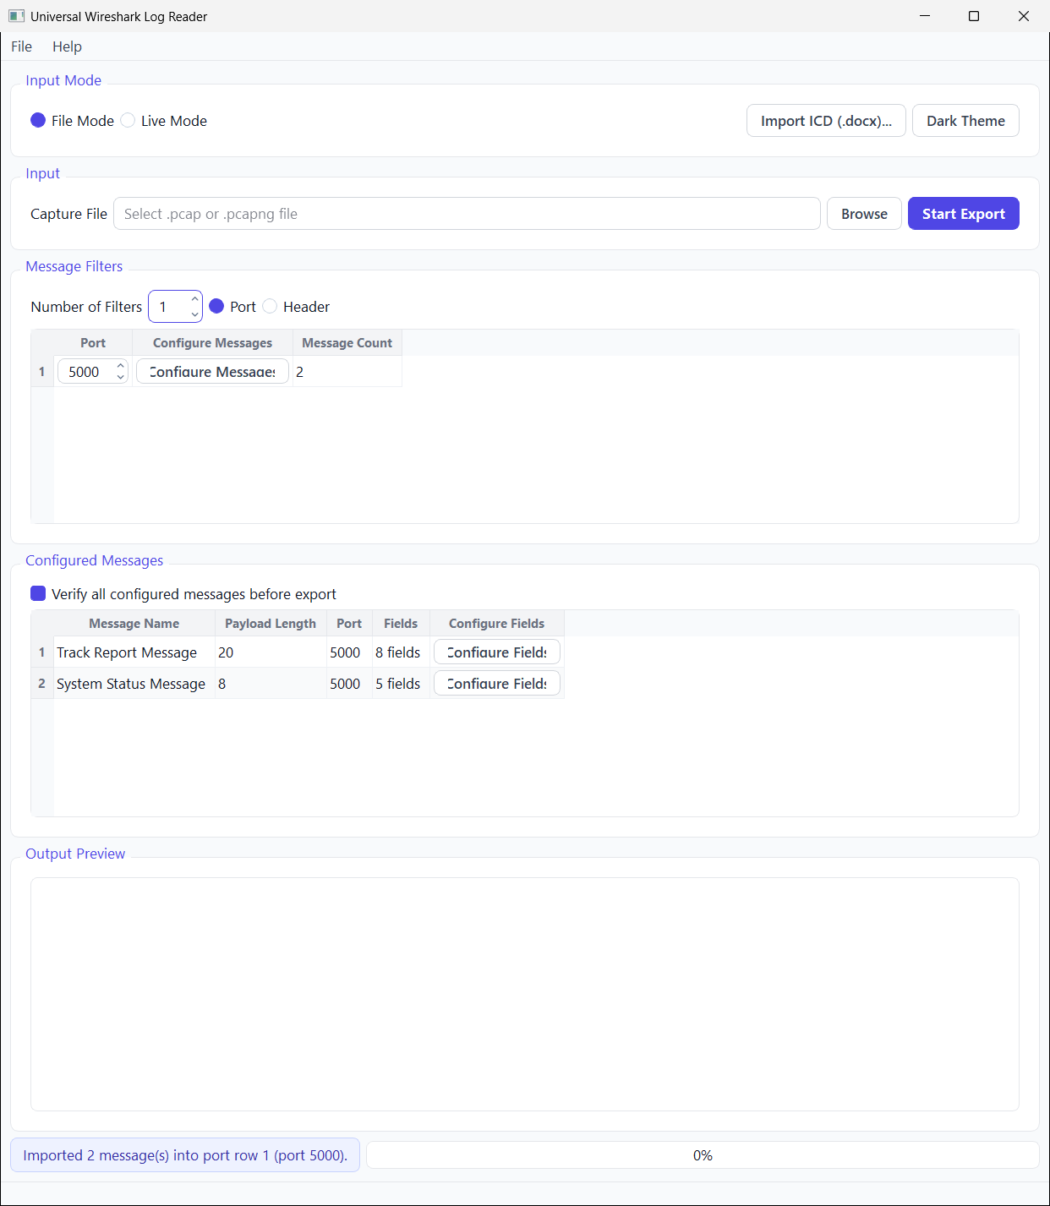
Figure 3.1. Main window of the Universal Wireshark Log Reader — the input mode, the port/message filters, the configured messages (here imported from an ICD), and the output-preview area.

3.2 Software Architecture
The application follows a clear separation between file/network input, protocol parsing, the extraction engine, and the user interface. The principal modules are summarised below.
Module | Responsibility
PcapFileReader | Manually reads .pcap and .pcapng container formats (packet records, enhanced/simple packet blocks) from disk.
UdpPacketParser | Parses Ethernet II, IPv4 and UDP headers; validates boundaries; rejects malformed frames safely.
LiveUdpReceiver / LiveTcpReceiver | Binds a UDP socket (optionally joining a multicast group) or frames an incoming TCP stream, feeding live data into the same extraction path; one receiver runs per configured connection.
ExtractionEngine | Applies field definitions to each payload, computing engineering values from raw bytes and resolution.
NmeaDecoder / NmeaSentenceRegistry | Decodes NMEA 0183 sentences using a registry of approved formatters and validates the checksum.
BitfieldDecoder / ConditionalBitfieldDecoder | Decode individual bit groups into labelled values, optionally conditioned on a controller field.
IcdDocxImporter / IcdReviewDraftBuilder | Extract message and field tables from Word (.docx) ICDs into an editable review before import.
ExcelExporter / ExcelStreamWriter | Write decoded rows to native .xlsx workbooks via the vendored QXlsx writer.
CompareOptionsEngine | Optional per-message verification (header, terminator, checksum, refresh rate, endianness).
ProjectFile | Saves and restores the entire project (filters, messages, fields, decoders) as JSON with silent auto-save; whole message sets and field lists also interchange as JSON, CSV and Excel, shared with the simulator.
MainWindow + dialogs | Qt Widgets UI: file/live controls, the connection manager, message and field editors, ICD import, themes and keyboard shortcuts.

3.3 Data Model and Extraction Logic
A field is the atomic unit of decoding. Each field carries a name, a 1-based byte offset (stored alongside a 0-based internal index), a length in bytes, a data type, and a resolution (numeric scale). For the common unsigned integer case, the decoded value is obtained by the relation:
Engineering Value = Raw Big-Endian Integer × Resolution
Thirteen data types are supported, allowing the same engine to decode raw byte blocks, fixed-width signed and unsigned integers, IEEE-754 floating point, booleans and text. Where a defined field falls outside the available payload, the engine writes a safe “N/A” rather than reading out of bounds.
Category | Data types
Raw / unsigned | Raw Unsigned (Big-Endian), Uint8, Uint16, Uint32, Uint64
Signed integer | Int8, Int16, Int32, Int64 (two’s complement)
Floating point | Float32 (4 bytes), Float64 (8 bytes), IEEE-754
Logical / text | Bool, String (UTF-8, user-defined length)
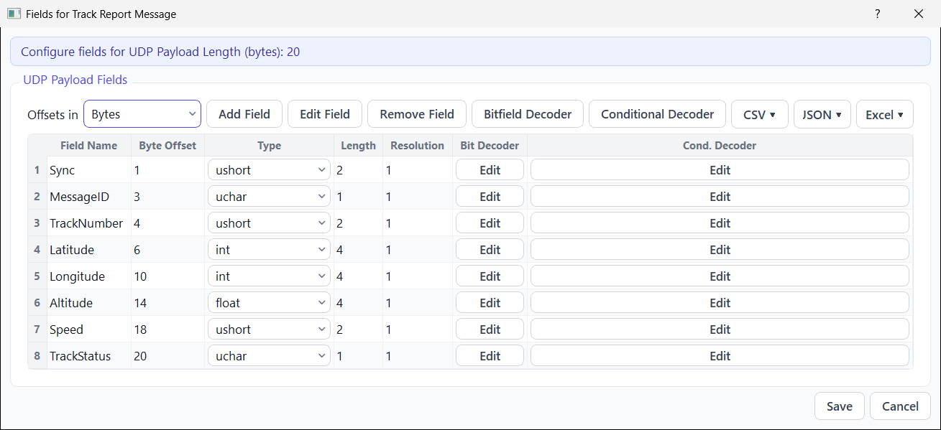
Figure 3.2. Field-definition dialog — each field is given a name, byte offset, data type, length and resolution (offsets shown in bytes or 2-byte words, with optional per-field bitfield/conditional decoders); example message “Track Report Message”.
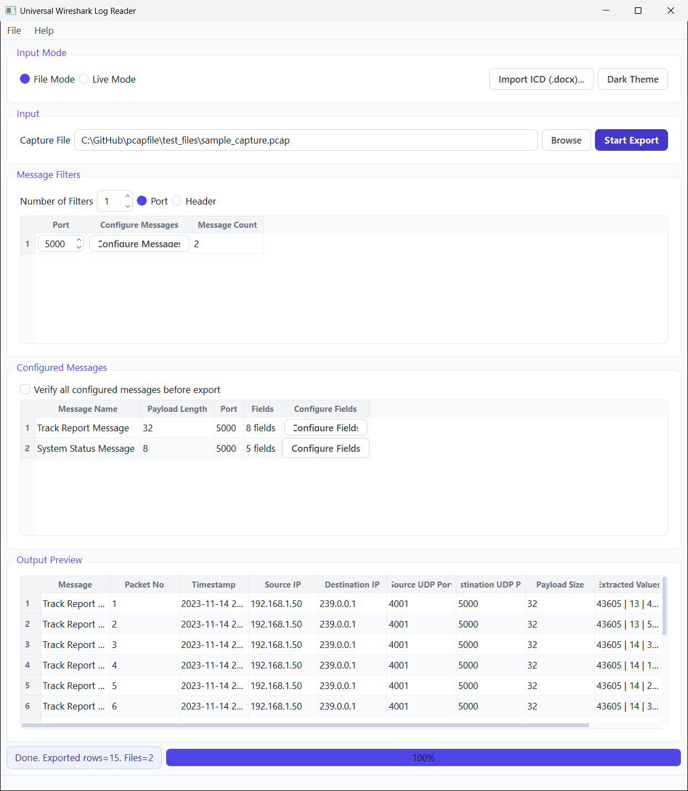
Figure 3.3. Output preview — each 32-byte captured payload is decoded, using the field definitions of Figure 3.2, into engineering values: packet metadata followed by the extracted field columns.

3.4 Key Features
- Capture-file decoding — manual reading of .pcap and .pcapng files with Ethernet II / IPv4 / UDP parsing, requiring no libpcap or Npcap.
- Live UDP / TCP capture — listens on a UDP socket (optionally joining a multicast group) or frames an incoming TCP stream, and streams extraction to file in real time, optionally across several simultaneous connections.
- Port and message filtering — per-port length filters, each defining one message, with an optional header to disambiguate same-length layouts.
- NMEA 0183 decoding — decodes ASCII marine sentences by formatter; all 87 approved parametric formatters (AAM…ZTG) are available, plus user-defined custom/proprietary sentences, with XOR checksum validation.
- Bitfield and conditional decoders — split a field into labelled bit groups, optionally selecting the decode profile from a controller field’s value.
- ICD (.docx) import — reads Interface Control Documents directly from Word, lists the tables with page numbers and a preview, and bulk-creates messages and fields through a tolerant, editable review stage.
- Excel (.xlsx) export — every extraction is written to a native Excel workbook; one workbook/sheet set per message definition.
- Compare-Options verification — optional per-message checks for header, terminator, checksum (with a configurable compute range such as “byte 4 to byte 16”), refresh rate and endianness.
- Resolution expressions — the scale of a field may be entered as a formula (e.g. 1/100) and is evaluated to a numeric resolution.
- Project persistence — the full project saves to JSON and auto-restores; field lists import/export as CSV and JSON.
- Multi-connection live capture — several receive connections (each an adapter + port, UDP or TCP) can run at once, with every message decoded only on the connection it is bound to, so traffic from different sources is never mixed.
- Whole-message JSON interchange — entire message and field sets (including decoders, compare options and offset units) export and import as a single JSON file, shared losslessly with the simulator.
- Flexible offsets and wide fields — field offsets display and accept either bytes or 2-byte words, and numeric fields wider than 8 bytes are decoded to exact decimal values.
- Usability and safety — light/dark themes, keyboard shortcuts, an in-app help screen, a preview-row cap to protect low-spec machines, and formula-injection-safe exports.
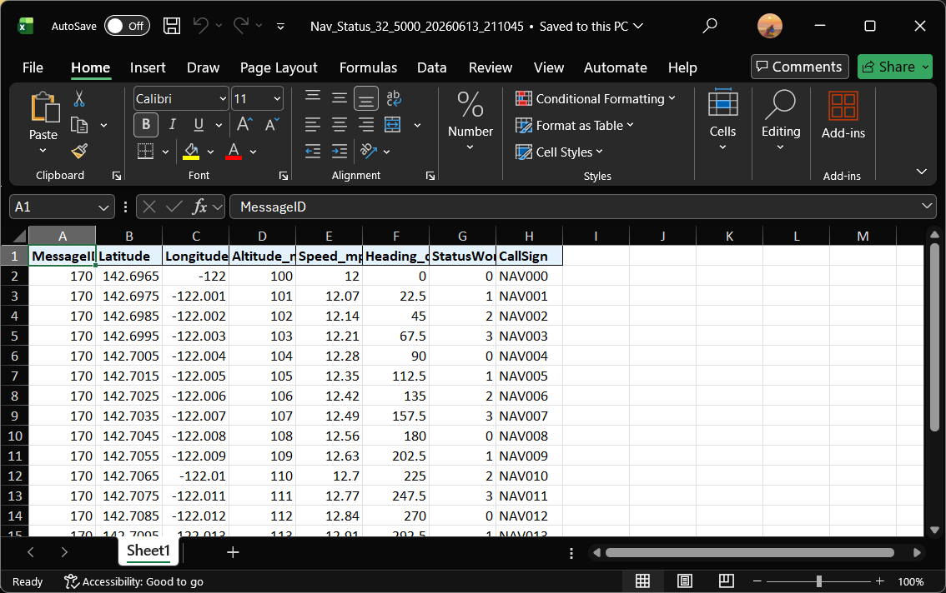
Figure 3.4. Decoded output written to a native Microsoft Excel (.xlsx) workbook — one worksheet per message definition.
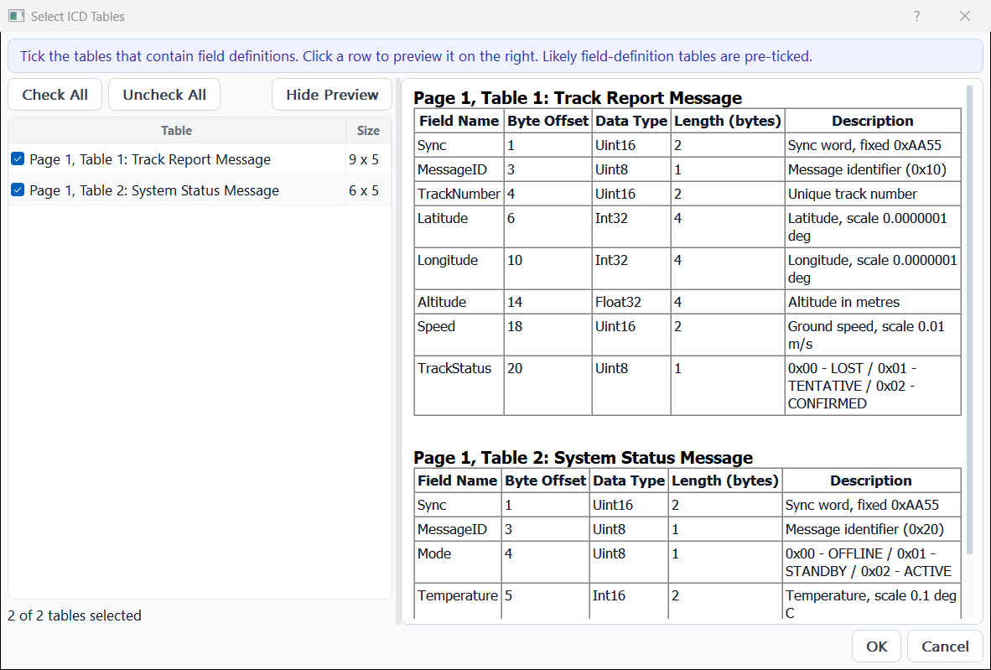
Figure 3.5. ICD table picker — selecting which Word tables hold field definitions, with a live preview of each table on the right; the chosen tables are bulk-imported as messages and fields.

4. Project II — Universal Data Simulator
The Universal Data Simulator is the transmit-and-test half of the toolset. Where the reader decodes received data, the simulator generates it: the user defines messages and field values, and the application encodes them into wire format and streams them over UDP, TCP or a serial port at controlled rates. It is the natural test source for the reader, and for any equipment that expects ICD-defined or NMEA traffic on the bench.

4.1 Purpose and Workflow
The operator first defines one or more destinations (connections) — a UDP endpoint (IP address and port), a TCP endpoint (host, port and Server/Client role), or a serial COM port (with selectable baud rate, data bits, parity and stop bits). A Test Connection opens the link and transmits a short health-check message; a coloured status indicator (green / red / grey) reports the link state, and any failure is explained with both a reason and a remedy. The user then defines one or more messages, each with its fields and the value to transmit for every field, binds each message to the connection it is sent on, ticks the messages to be sent, and presses Send. After a full pre-flight verification, every ticked message is streamed at its own configured rate until Stop is pressed; the transmitted payloads are shown in hexadecimal in a rolling outgoing-data history.
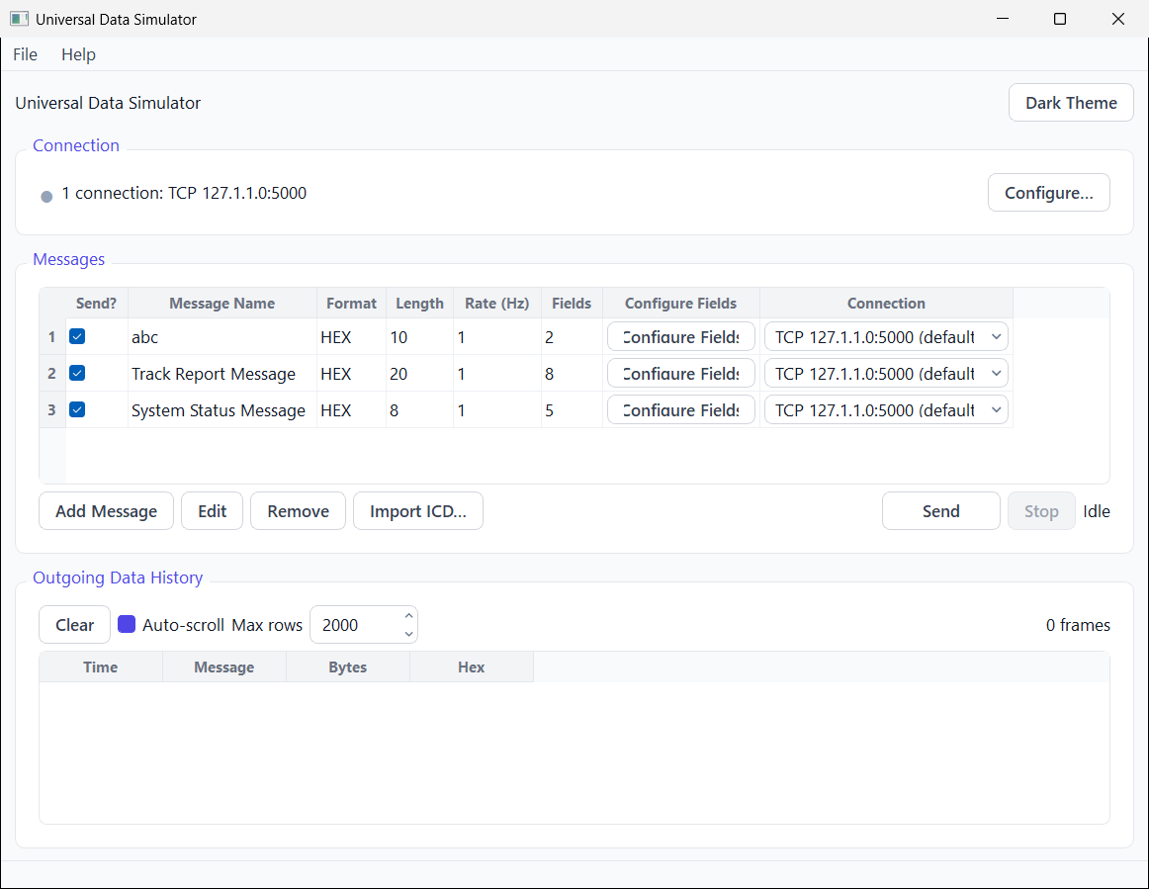
Figure 4.1. Main window of the Universal Data Simulator — the connection bar and link status (here a TCP destination), the messages table (per-message format, send rate, Send? tick and bound connection), the send controls, and the outgoing-data history.

4.2 Software Architecture
Module | Responsibility
DataSender (base) | Abstract link interface: open, send, close, status, and an error signal carrying a human-readable reason.
UdpDataSender / TcpDataSender | Transmit datagrams to a UDP IP/port or write framed bytes to a TCP host/port (Server or Client); validate the address/port, enforce size limits, and report routing or connection errors.
SerialDataSender | Configures and opens a serial port (baud, data bits, parity, stop bits) and writes message bytes to it.
PayloadBuilder | The encoding core: converts each typed field value into raw big-endian bytes, builds HEX payloads and NMEA sentences, and produces the live hex preview.
SimulatorWindow | Main UI: connection bar and manager, message table, the rate-driven send engine, verification, outgoing-data history, menus and themes.
MessageDefinitionDialog | Editor for a message (name, length, HEX/NMEA format, talker, send rate).
SimFieldConfigurationDialog | Field editor with a live hex column and a two-way bit editor.
BitValueEditorDialog | Bit grid that maps a typed value to individual bits and back, live.
IcdImportDialog / IcdDocxImporter | Imports messages and their fields from a Word (.docx) ICD through a staged, editable review.
SimSetupFile | Saves/opens the entire setup as JSON with atomic writes and silent auto-restore; field lists and whole message sets interchange as CSV, JSON and Excel.

4.3 The Encoding Contract
The defining engineering property of the simulator is that its encoding is the exact mathematical inverse of the reader’s decoding. Whatever the reader computes when receiving a payload, the simulator reverses when producing one. This guarantees that a value typed into the simulator is received and decoded as the identical value by the reader — the basis of round-trip testing.
Aspect | Reader — decode | Simulator — encode
Integer scaling | value = raw (big-endian) × resolution | raw = round(value ÷ resolution), big-endian
Signed values | sign-extend at length × 8 bits | two’s complement at length × 8 bits
Floating point | Float32 = 4 bytes, Float64 = 8 bytes | same fixed lengths; error otherwise
Text | UTF-8, trailing NULs trimmed | UTF-8, NUL-padded to length
NMEA sentence | validate XOR checksum between $ and * | compute XOR checksum between $ and *

4.4 Key Features
- Multiple transmission links — send over UDP, TCP (Ethernet) or a serial COM port, with all serial parameters selectable from drop-downs and re-scannable ports; several destinations can be defined and each message bound to its own.
- Health-check connection — Connect transmits a probe message and shows a green / red / grey link indicator; failures state the reason and the solution.
- Typed field values — each field’s value is entered in its own data type (thirteen types), validated and encoded big-endian on transmit.
- Real-time hex cell — a read-only column converts each typed value to its exact hexadecimal wire bytes as the user types, turning red with a tooltip reason when a value cannot be encoded.
- Two-way bit editor — for integer and boolean fields, a bit grid lets the user type a value to see its bits, or toggle any individual bit and watch the value, raw integer and hex update live.
- Per-message send rates — every message streams at its own configurable rate (in hertz) using independent precise timers; the engine pre-builds and freezes payloads before streaming.
- NMEA sentence building — constructs valid NMEA 0183 sentences ($ + talker + formatter + comma-separated tokens + XOR checksum + CRLF) for any of the predefined or custom formatters.
- Verification before sending — a single pre-flight check collects every problem (no connection, nothing ticked, a value that will not encode or fit, an out-of-range rate, an over-size datagram) into one dialog, each line giving a reason and a solution; nothing is sent unless all checks pass.
- Rolling outgoing-data history — transmitted payloads are displayed in hexadecimal (time, message, byte count and bytes), buffered and flushed on a timer so that high send rates never stall the interface.
- ICD (.docx) import — bulk-defines messages and their fields by importing an Interface Control Document directly from Microsoft Word; the user selects which tables hold field definitions through a staged, editable review, and each becomes a ready-to-send message (the same import facility as the reader).
- Multiple destinations (connections) — UDP, TCP and serial links can be defined together, and each message routed to the connection it is transmitted on, so two messages can stream to two different places at once.
- Flexible offsets — field offsets display and accept either bytes or 2-byte words, matching the reader.
- Persistence and interchange — the whole setup saves/opens as JSON and auto-restores on next launch; field lists import/export as CSV, JSON and Excel (.xlsx), entire message sets round-trip as a single shared JSON file, and field lists exported by the reader application import directly.
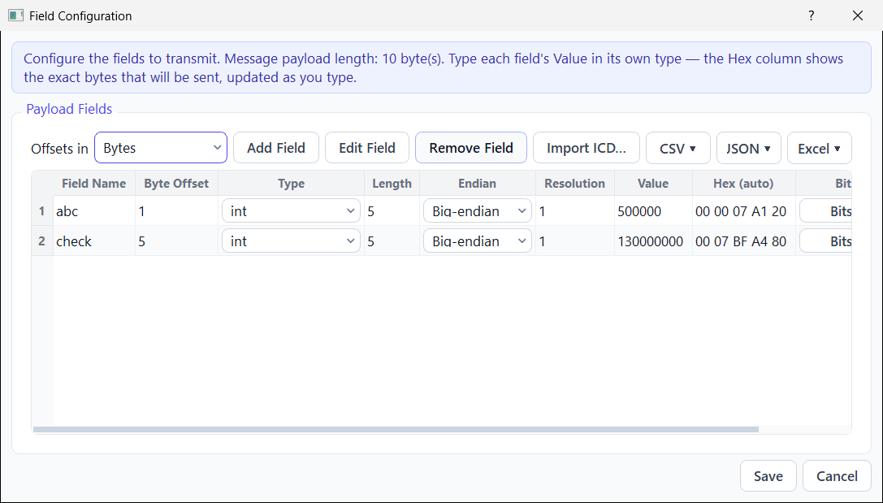
Figure 4.2. Field configuration in the simulator — each value is typed in its own data type and the read-only Hex (auto) column shows the exact wire bytes in real time; per-field endianness, byte/word offsets and a two-way bit editor are available.

5. Inter-Project Relationship and Closed-Loop Verification
Although the two applications are fully independent products — separate build files, separate user interfaces, and no runtime link between them — they were designed deliberately as a complementary transmit/receive pair. Because the simulator’s encoding is the exact inverse of the reader’s decoding, and because both share the same field-definition model, the same NMEA registry, and the same Word (.docx) ICD-import facility, they form a closed-loop test harness in which each tool validates the other.
A representative end-to-end test proceeds as follows:
- The reader is launched in Live UDP mode and bound to a chosen local port.
- The simulator is pointed at the same address and port; Connect shows a green indicator and the reader registers the health-check packet.
- The same message and field layout is defined in both tools; values are typed into the simulator and transmitted.
- The reader’s Excel output is checked to confirm it shows exactly the values typed into the simulator — with identical offsets, types and resolutions — and, for NMEA messages, a valid checksum.
This mutual-validation property is valuable in a test environment: a single engineer can generate controlled, repeatable traffic on one tool and confirm its correct interpretation on the other, without needing the real subsystem, an external traffic generator, or a network connection.
The shared NMEA 0183 capability is particularly relevant to naval navigation equipment, which exchanges position, heading, speed, depth and wind data as NMEA sentences. The simulator can synthesise such sentences with correct checksums, and the reader can decode and verify them, providing a practical bench facility for navigation-data interfaces.

6. Engineering Practices and Quality
A consistent set of engineering practices was applied across both applications to keep the code maintainable, the behaviour predictable, and the user experience dependable on modest hardware.
- Reason-and-solution diagnostics — every user-facing failure states both what went wrong and what to do about it; multiple problems are gathered into a single dialog rather than a stream of pop-ups.
- Defensive input handling — file types and sizes, port numbers, field definitions and packet boundaries are all validated; malformed input is rejected safely instead of crashing.
- Responsive UI under load — high-volume operations (live capture, high-rate sending) never write to the interface per packet; previews are buffered and flushed on a timer to keep the window responsive.
- Deterministic numeric handling — numbers are parsed in the C locale so that the decimal point is unambiguous, and resolutions may be supplied as evaluated expressions.
- Safe persistence — project and setup files are written atomically (write to a temporary file, then rename, keeping a backup) so an interrupted save can never corrupt the user’s work; silent auto-save and auto-restore protect against accidental loss.
- Additive, low-risk evolution — features were added as new modules and code paths rather than by rewriting working behaviour, keeping each change easy to review and to revert if required.
- Disciplined framework use — the code stays strictly within Qt 5.10 and C++11, avoiding any newer API, so the tools build reliably on the verified offline toolchain.
- Documentation — the design and behaviour of each significant feature were captured in dedicated reference notes alongside user manuals, so the work is transferable and maintainable.

7. Results and Outcomes
Both applications were completed, build cleanly on the verified Qt 5.10.1 / MinGW toolchain, and run as intended. The reader decodes capture files and live streams and exports them to Excel; the simulator transmits encoded HEX and NMEA messages over UDP and serial links; and the two interoperate to form a closed-loop test setup. The quantitative scope of the work is summarised below.
Metric | Universal Wireshark Log Reader | Universal Data Simulator
Role | Receive / decode / export | Encode / transmit / test
Lines of C++ (sources + headers, incl. shared core) | ≈ 21,600 | ≈ 14,700
C++ source & header files (incl. shared core) | 91 | 66
User-interface forms (incl. shared core) | 18 | 12
Transmission / capture links | Capture file + live UDP/TCP (multicast; multiple connections) | UDP, TCP + serial COM port (multiple connections)
Supported field data types | 13 | 13
NMEA 0183 formatters | 87 predefined + custom | 87 predefined + custom
Excel (.xlsx) export | Yes (native, vendored writer) | Yes (field import/export)
ICD (.docx) import | Yes | Yes
Design / reference documents | 24 | Working-notes reference
Taken together, the two applications comprise approximately 29,100 lines of C++ across 121 distinct source and header files and 26 user-interface forms — including a shared core of about 7,200 lines (36 files, 4 forms) compiled into both applications — developed during the training period from 23 April to 23 June 2026. The deliverables provide WESEE with a self-contained, offline facility for both interpreting and generating ICD-defined and NMEA interface data on the test bench.

8. Challenges and Future Scope

8.1 Engineering Challenges Addressed
- Parsing .pcap and .pcapng container formats by hand — including enhanced and simple packet blocks — without any packet-capture library.
- Guaranteeing that the simulator’s encoding is the bit-exact inverse of the reader’s decoding across all thirteen data types, signed ranges and scaling.
- Keeping the interface responsive while sending many messages at high rates and while capturing live traffic, by pre-building payloads and buffering previews.
- Importing real-world ICD tables from Word documents, which vary widely in layout, through a tolerant review stage that accepts incomplete rows.
- Producing native Excel output offline, by vendoring and compiling a small open-source writer from source rather than depending on installed software.

8.2 Possible Future Enhancements
- Extend protocol parsing in the reader to IPv6 and to NMEA encapsulation (e.g. AIS) sentences (live TCP capture and multi-connection support are already implemented).
- Add scripted / scheduled send sequences and replay of captured traffic in the simulator for scenario-based testing.
- Introduce multi-threaded parsing for very large capture files.
- Provide a combined launcher and shared field-library so message definitions are authored once and used by both tools.

9. Conclusion
The industrial training resulted in two complete, complementary desktop applications that together address a recurring need in naval systems engineering: the interpretation and the generation of structured interface data exchanged over UDP and serial links. The Universal Wireshark Log Reader turns captured and live UDP traffic — including NMEA 0183 navigation data — into engineering values and Excel reports, and can bootstrap its definitions directly from ICD documents. The Universal Data Simulator performs the inverse task, encoding user-defined values into wire-format messages and transmitting them at controlled rates, making it a precise, repeatable test source.
Both tools were built to a strict offline, dependency-free, low-resource mandate, and the encode/decode symmetry between them yields a self-validating closed-loop test harness that requires neither external instruments nor a network connection. The work provided practical, in-depth exposure to network protocol parsing, data-format engineering, the Qt application framework, and the disciplined development practices expected of dependable defence-grade software, and it leaves WESEE with reusable, maintainable, and well-documented engineering tools.

Appendix A — Field Data Types
# | Data type | Length | Description
1 | Raw Unsigned (BE) | user | Unsigned big-endian integer of any length
2 | Uint8 | 1 | Unsigned 8-bit integer
3 | Int8 | 1 | Signed 8-bit integer (two’s complement)
4 | Uint16 | 2 | Unsigned 16-bit integer
5 | Int16 | 2 | Signed 16-bit integer
6 | Uint32 | 4 | Unsigned 32-bit integer
7 | Int32 | 4 | Signed 32-bit integer
8 | Uint64 | 8 | Unsigned 64-bit integer
9 | Int64 | 8 | Signed 64-bit integer
10 | Float32 | 4 | IEEE-754 single-precision float
11 | Float64 | 8 | IEEE-754 double-precision float
12 | Bool | 1 | Boolean (0/1, true/false)
13 | String | user | UTF-8 text, NUL-padded to length

Appendix B — Representative NMEA 0183 Sentence
The applications build and validate NMEA 0183 sentences such as the GGA (Global Positioning System fix) sentence shown below. The simulator computes the two-digit XOR checksum following the asterisk; the reader validates it on receipt, which makes the checksum an effective end-to-end correctness check.
$GPGGA,123519,4807.038,N,01131.000,E,1,08,0.9,545.4,M,46.9,M,,*47
Structure: “$” start • GP talker • GGA formatter • comma-separated positional fields (time, latitude, N/S, longitude, E/W, fix quality, satellites, …) • “*” • XOR checksum • carriage-return/line-feed terminator.

Appendix C — Abbreviations
Term | Expansion
WESEE | Weapons and Electronics Systems Engineering Establishment
ICD | Interface Control Document
UDP | User Datagram Protocol
NMEA | National Marine Electronics Association (0183 data standard)
PCAP / PCAPNG | Packet Capture file formats
IEEE-754 | Standard for floating-point arithmetic
UTF-8 | 8-bit Unicode Transformation Format (text encoding)
GUI | Graphical User Interface
CSV / JSON | Comma-Separated Values / JavaScript Object Notation

