|  |  |
| --- | --- |
| Rohit Kumar B | Receiver with solid fill+91 8197721473  Envelope with solid fill rohitkumar.birakayala@gmail.com  Exploring LinkedIn Icons: A Visual Guide - Blog - smarticons.co https://www.linkedin.com/in/rohit-kumar-birakayala-56a743257/  GitHub Logos and Usage · GitHub https://github.com/rohk30 |

# ABOUT

I’m a 2nd Computer Science student from VIT Vellore. I am a person with diverse interests, always on the lookout to learn new things and make myself more proficient in these fields. Competitive coding and robotics are some of the fields that intrigue me.

|  |  |  |  |  |  |  |  |  |  |  |  |  |  |
| --- | --- | --- | --- | --- | --- | --- | --- | --- | --- | --- | --- | --- | --- |
| **Academic Achievements**  * Maintaining a CGPA of 9.76 in my college * Received a merit certificate for being the branch topper in 1st year * 93% in 12th CBSE in 2022 * 98% in 10th ICSE in 2020 | **Educational Qualifications**   |  |  |  | | --- | --- | --- | | Field of Education | School/ University | Years Studied | | * B.Tech in Computer Science | * VIT Vellore | * 2022 - present | | * 11th and 12th grade | * Geetanjali Olympiad School, Bangalore | * 2020 - 2022 | | * Nursery – 10th grade | * New Horizon Public School, Bangalore | * 2007 - 2020 | |

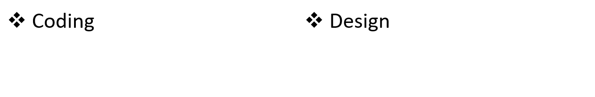Skills

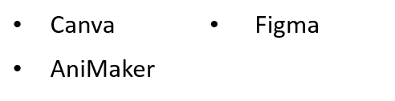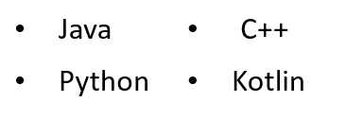

* Well versed with the basics of data structures and algorithms
* Certified in the Supervised Machine Learning: Regression and Classification Coursera course by Andrew NG

Projects

* In 2023, took part in a VIT hackathon where we won “Best Fresher Award”.
  + Designed a website that would read pdf’s/ YouTube videos/ general links to give you a summary of the information and answer any related questions
* Developed an airplane management system using C++, where I was responsible for design coding. Also, created a video and animated presentation along with my project team (2023)
* Designed a calculator app using Android Studio which performs all basic operations
* Developed a Tic-Tac-Toe game using Java and its graphics from scratch (2023)
* Built from scratch a remote-controlled robot that is used to transfer objects from one place to another. Coded on Arduino IDE to control the various drivers and sensors that were used (2018)
* In 10th grade, represented my school in a robotic competition where we won 2nd prize. I was responsible for building the logic and structural framework of the robot.   
  We were given 3 tasks:
  + Match speed of your robot with the given robot and find its speed
  + Line following robot while picking up and dropping an object midway
  + Find volume of 3 cubes while moving parallel to their edges

Volunteering

* IEEE Robotics and Automation: Sept-2023

Organised the RoboEscape event by IEEE-RAS club  
Was instrumental in the modelling of the electronic components which included the programming and hardware construction of a box handle using arduino.

Also helped in the general management of the event along with other student volunteers

* Juvenile Care NGO VIT: March 2023 - Present  
  I am an active member of VIT NGO club, with a sincere attempt to make the lives of children better. We do this by conducting fun filled events in orphanages, cancer care centres.

Hobbies and Awards

* Interested in many sports, especially Tennis and Cricket
* Won over 20 medals and 4 Individual Trophies in school athletics
* Competed in club cricket matches
* Came 4th in U-16 state school level 200m sprint