Name: Rohma Shakeel

Class: BESE - 5A

Reg No: 32398

CMS ID: 111139

Course: Formal Methods

Title: Assignment 3

Github Link: https://github.com/rohmashakeel/FM-Assignment-3

**Introduction**

In this assignment, we prepare and enhance the example “Mutual Exclusion Protocol” in Uppal. Mutual exclusion is a form of synchronization to avoid simultaneous use of a shared resource. Uppaal is a model checking, simulation, validation and verification tool.

**Task 1: Mutual Exclusion Protocol**

We model Peterson’s Solution which is an algorithm for mutual exclusion allowing concurrency in programming.

We have two processes namely mutex 01 and mutex 02. Mutex 01 can only enter critical section CS when turn == 1 and req2 == 0. While, Mutex 02 can only enter critical section CS when turn == 2 and req1 == 0. This is presented below.

The blue text are assignments to variables executed when the corresponding transition is taken. The green text are guards that *should* be true for the corresponding transition to be enabled.

*Declarations*

// Place global declarations here.

int[0, 1] req1, req2;

int[1, 2] turn;

// Place template instantiations here.

Mutex01 = Mutex1(1, req1, req2);

Mutex02 = Mutex2(2, req2, req1);

// List one or more processes to be composed into a system.

system Mutex01, Mutex02;

*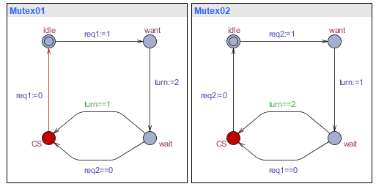Simulation*

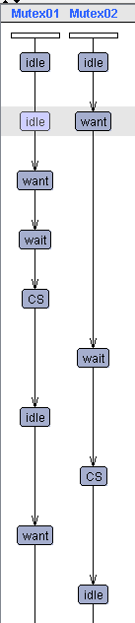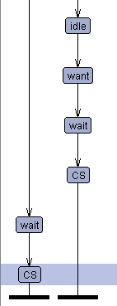

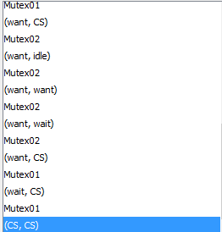

*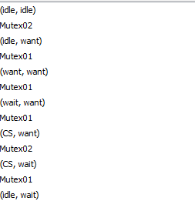Traces*

**Task 2: Light Automaton**

We model a light with 3 modes off, low and bright light. User pressing button once, transitions to low light, again instantly (less than y=5), transitions to bright light, if with some wait(y>=5), transitions back to off. Pressing button twice quickly (y<5) transitions from off directly to bright light and then, again, transitions to off. This is presented below.

*Declarations*

// Place global declarations here.

int y;

chan press;

// Place template instantiations here.

L1 = Light();

U1 = User();

// List one or more processes to be composed into a system.

system L1, U1;

*Simulation*

