

A PROJECT REPORT

On

Indian Government Schools Analysis

Submitted by

Rhythm Balooni

169105144
Rohan Chopra
169105152

Department of Computer Science and Engineering

School of Computing and Information Technology

Manipal University Jaipur

Rajasthan, INDIA

November, 2019
Indian Government Schools Analysis Dr. Yogesh Gupta

Table of Contents

Table of Contents ……………………………………………………………………... 2

Abstract ………………………………………………………………………………... 3

Acknowledgements …………………………………………………………………...... 4

- Introduction ………………………………………………………………….......... 5

  - Motivation and Overview ………………………………………………….. 5

  - Objective …………………………………………………………………..... 5

- Software Requirement Analysis ………………………………………………….. 6

  - Problem Definition …………………………………………………………. 6

- Implementation & Plots …………………………………………………………... 6

- Bibliography …………………………………………………………………........ 10

Dept. of CSE, SCIT, MUJ 2

Indian Government Schools Analysis Dr. Yogesh Gupta

Abstract

We know children are future of any country. But, future is bleak for them if they do not get safe drinking water, sanitation & hygiene in school. Girls in India, drop out of school for a number of reasons. But in many cases, these reasons are directly related to lack of sanitation and personal hygiene and unhygienic toilets at their schools. As girls enter into adolescence appropriate bathroom facilities and clean water become even more critical to stay in school. Why do girls drop out of school? Is the rate of dropouts of girls is more than that of boys? If toilets are in place but are not working or are not single sex? Schools are deemed to be failing to offer even a basic standard of hygiene and sanitation? The Indian government has taken the initiative of ensuring that every school must have at least one toilet. This project is an attempt to observe the correlation between absence of hygienic facilities and school dropouts. The dataset used in this project has been taken from https://data.gov.in/ provided by the Indian government.

Dept. of CSE, SCIT, MUJ 3

Indian Government Schools Analysis Dr. Yogesh Gupta

Acknowledgements

We are overwhelmed in all humbleness and gratefulness to acknowledge our debt to all those who have helped us to put these ideas, well above the level of simplicity and into something concrete.

We would like to express our special thanks of gratitude to our project guide Dr. Yogesh Gupta, who gave us the golden opportunity to do this wonderful project on the topic Indian Government Schools Analysis, which also helped us in doing a lot of research and we came to know about so many new things. We are really thankful to them.
Any attempt at any level can 't be satisfactorily completed without the support and guidance of our parents and friends.
We would like to thank our parents who helped us a lot in gathering different information, collecting data and guiding us from time to time in making this project, despite of their busy schedules. They gave us different ideas in making this project unique. Thanking you,

Rhythm Balooni & Rohan Chopra

CSE–C

Dept. of CSE, SCIT, MUJ 4

Indian Government Schools Analysis Dr. Yogesh Gupta

1. Introduction

1.1 Motivation and Overview

The motivation behind this project lies in the thought of working on a project with a real-life application. As we thought of topics to work on, we had the novel idea of working on this project – a problem being faced by whole country where children leave schools due to unavailability of hygienic conditions in schools.

This project aims to solve all these questions by finding trends as well as possible states having schools with toilets installed. It aims to understand the underlying cause of dropouts among the children in government schools.

1.2 Objective

This project has the following objectives:

- Analyse number of students enrolled in each class in each state

- Analyse rate of dropouts as education level increases

- Analyse number of schools in each state with toilets

- Rate of dropout of Girls

- Correlation between girls retained and toilet facilities

s

Dept. of CSE, SCIT, MUJ 5

Indian Government Schools Analysis Dr. Yogesh Gupta

2. Software Requirement Analysis

2.1 Problem Definition

In India, a lot of children enroll in primary classes. Nevertheless, as their education level increases, the enrolled students start to drop out of schools due to lack of hygienic facilities. This project aims to find the reasons of dropouts by finding the correlation of students enrolled and facilities available in schools. The positive correlations found between various facilities will further help us to know where significant improvements can be done to ensure least dropouts of children.

3. Implementation and Plots

No. of boys and girls enrolled in each class in each state
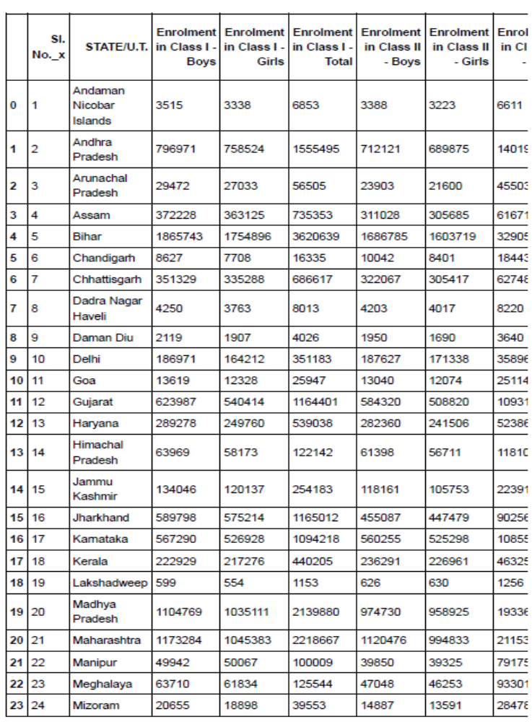

Dept. of CSE, SCIT, MUJ 6

Indian Government Schools Analysis Dr. Yogesh Gupta

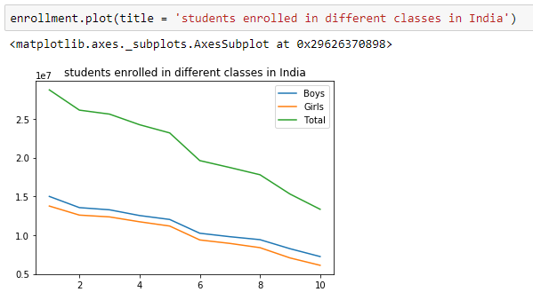

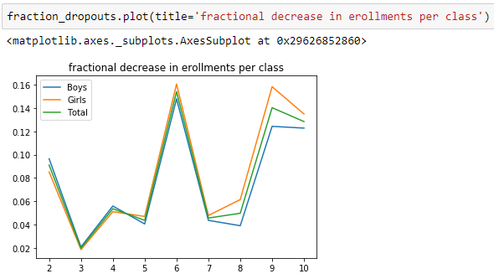

Dept. of CSE, SCIT, MUJ 7

Indian Government Schools Analysis Dr. Yogesh Gupta

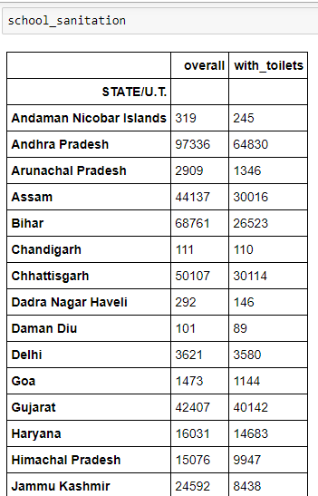
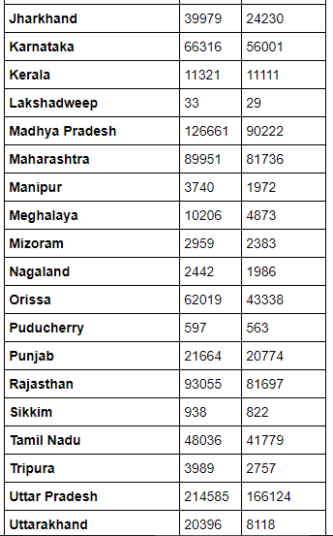

Dept. of CSE, SCIT, MUJ 8
Indian Government Schools Analysis Dr. Yogesh Gupta

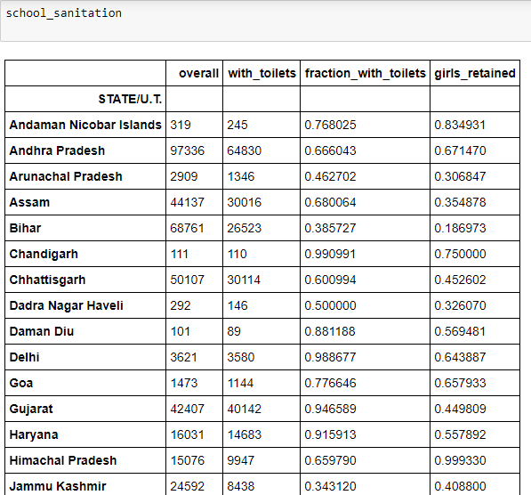

Correlation found between toilets available and girls retained in government schools
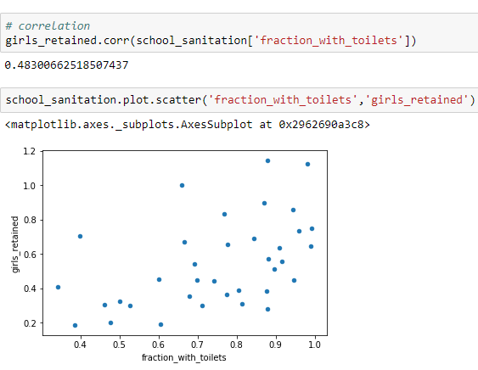

Dept. of CSE, SCIT, MUJ 9

Indian Government Schools Analysis Dr. Yogesh Gupta

  - Bibliography

- https://data.gov.in

- http://localhost:8888/notebooks/BDA%20Project/ArrangeSchoolData.ipynb

- https://matplotlib.org/3.1.1/contents.html

Dept. of CSE, SCIT, MUJ 10

