FE Return Label
Here is what the email looks like that the customer receives:
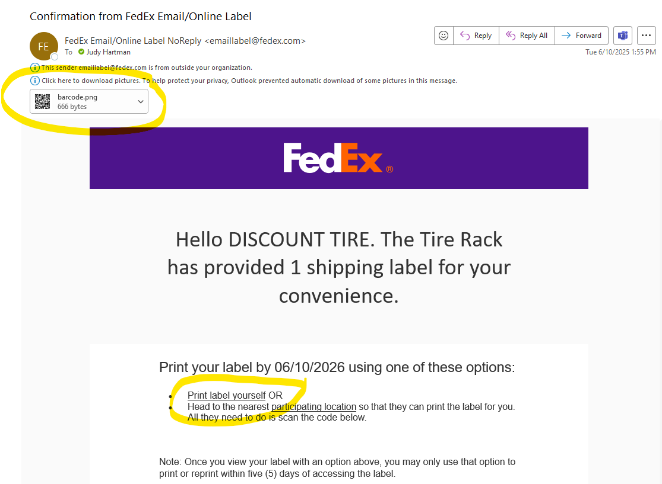

Once they click the link “Print Label Yourself” this is the screen they will see. They should hit “Print Label” in the bottom right corner .. Note, once they click this, they will no longer have the option to have the label printed at a Fedex location (no QR code).
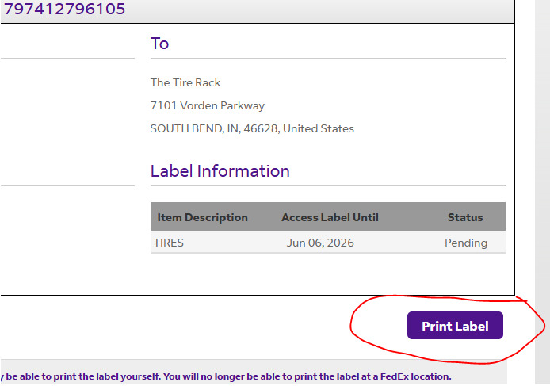
The next screen will show them the options for return (located in the blue box).
If proceeding to have Fedex pickup on their next visit to their location, just hit “Print Label”. Labels should be printed and attached to product being returned.
If returning to a Fedex location or wanting to schedule an appointment, they should click one of the options listed in the blue box below.

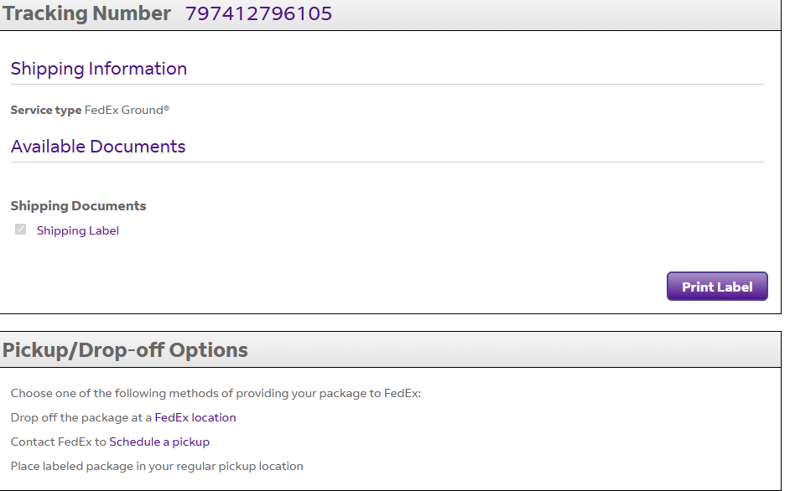
If customers want to schedule a pickup, once they click on the option above, they will be directed to this screen:
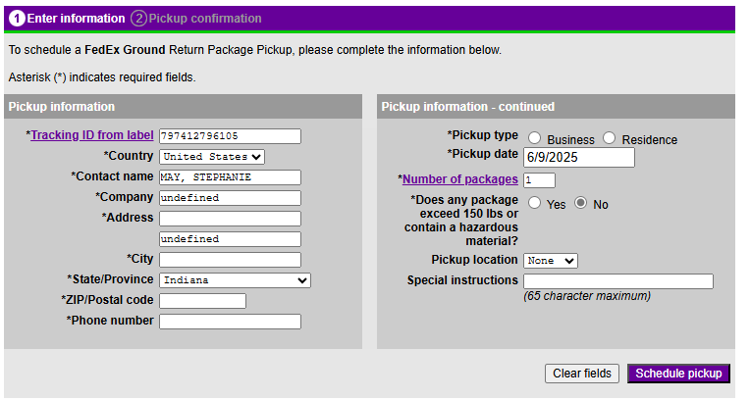
After completing the above, they will need to go back and click “Print Label”.

