**Data Section**

The following data is considered in the analysis of the subject area.

1. **Cities and Counties data**

The list of cities and counties in Georgia state has been found from the link in Wikipedia as <https://en.wikipedia.org/wiki/List_of_municipalities_in_Georgia_(U.S._state)>

I will be scrapping the data from the wiki link, then further clean the data and then reduce it to be used in creating the choropleth map.

Below shown is the screenshot of the data to be used.

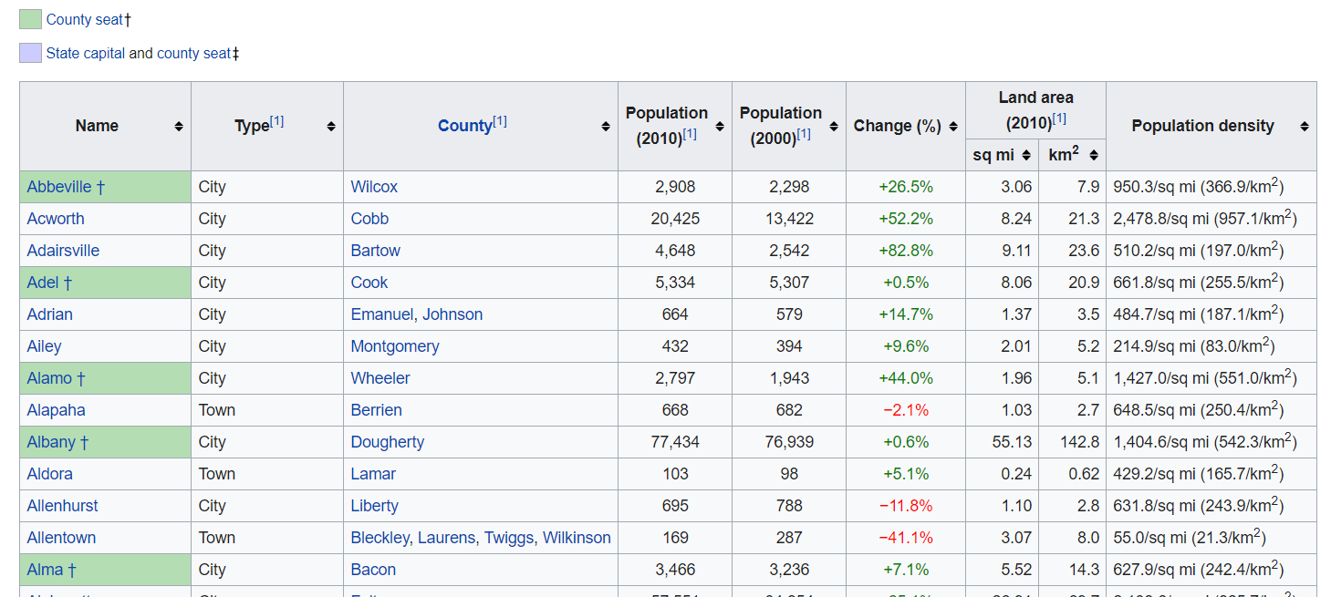



1. **Coordinates for Georgia cities**

I created own table with Coordinates (Latitude and Longitude) using Google Maps. That info will be merged with data from Cities and Counties. [2]

In this case, since the Geocoder is not allowing to retrieve information related coordinates, we will create extract coordinates directly using Google Map.

The following example will show how will be the dataset to use.



1. **Foursquare API Data**

We will use “Foursquare API” to extract data from the most common venues of each city in Atlanta. It will help us to provide the options in the comparative analysis.

In this case we will use the credentials already created to consume the venues.

Below an example of the credentials to be used:

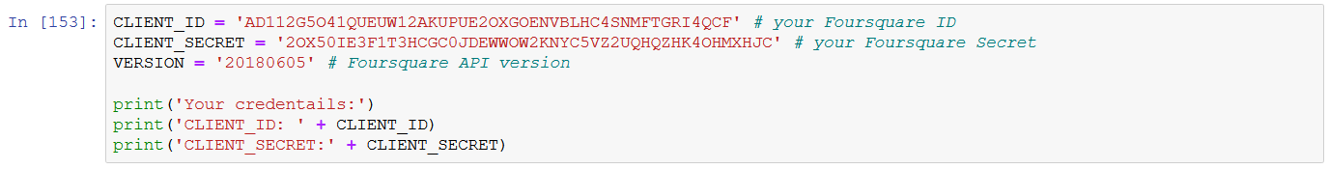

1. **Schools, Colleges, Universities ranking and price of house rental data**

I will create own tables for School, Colleges, University Ranking extracting from different websites It will help us to provide ranking analysis. [4]

There are not too many public data related to Education and rental prices of apartments. Therefore, I will create own tables to collect that information for our analysis.

Here an example of the data.







**References:**

• [1] Georgia — Wikipedia : https://en.wikipedia.org/wiki/Georgia_(U.S._state)

• [2] Google Map : https://www.google.com/maps

• [3] Forsquare API : https://developer.foursquare.com/

• [4] Schools, University, Rental Houses websites :

- https://www.schooldigger.com/go/GA/schoolrank.aspx?level=3#

- https://www.rentcafe.com/blog/rental-market/local-rent-reports/georgia-rent-report-october-2019/

- https://www.4icu.org/us/georgia