第一二次实验报告

专业班级：软件工程2301班

学号：8209230122

姓名：李雨菲

实验1-1

#include <iostream>

using namespace std;

int main() {

int k=2 , i = k + 1;

cout << i++ << endl;

i = 1;

cout << i++ << endl;

cout << "Welcome to C++" << endl;

return 0;

}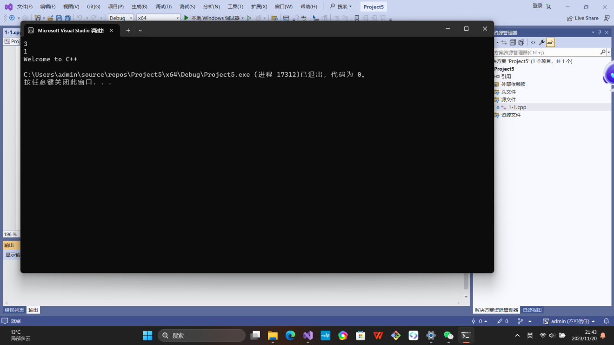

实验1-2

#include<iostream>

using namespace std;

#define pai 3.14

int main() {

double V,r,h;

cout << "圆锥的半径，锥高是：";

cin >> r >> h;

V = r * r * h * pai / 3;

cout << "圆锥的体积是：";

cout << V << endl;

return 0;

}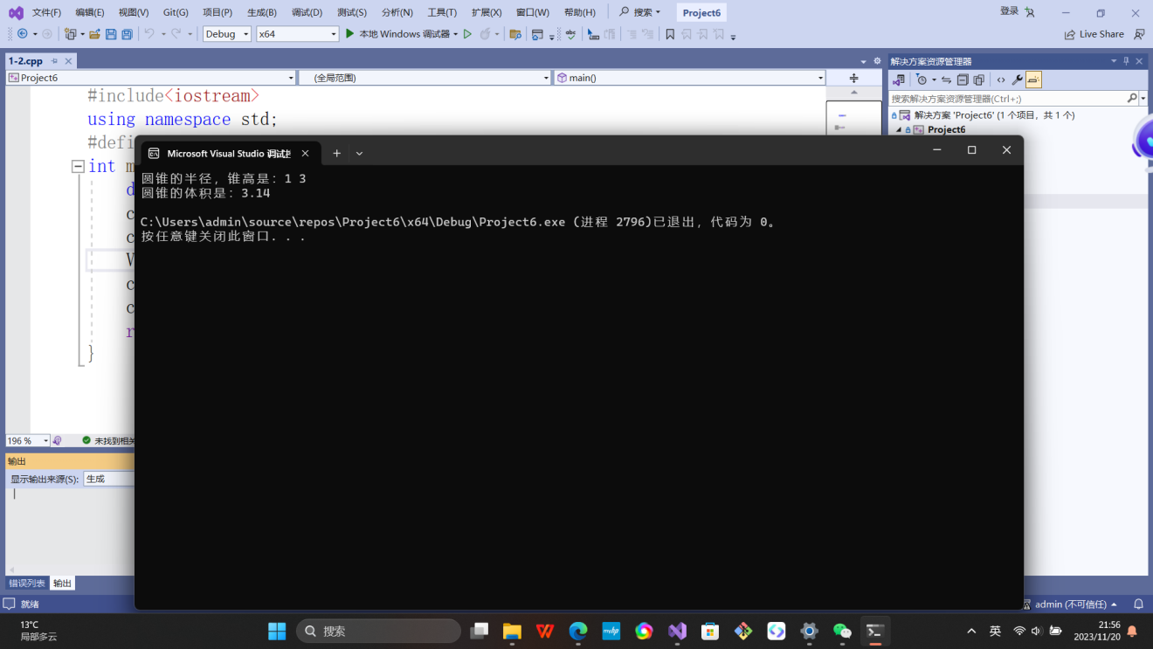

实验1-3

#include<iostream>

using namespace std;

int main() {

cout << "bool length:" <<sizeof(bool)<< endl;

cout << "char length:" << sizeof(char) << endl;

cout << "unsigned char length:" << sizeof(unsigned char) << endl;

cout << "wchar_t length:" << sizeof(wchar_t) << endl;

cout << "int length:" << sizeof(int) << endl;

cout << "signed length:" << sizeof(signed) << endl;

cout << "unsigned length:" << sizeof(unsigned) << endl;

cout << "short length:" << sizeof(short) << endl;

cout << "long length:" << sizeof(long) << endl;

cout << "unsigned short length:" << sizeof(unsigned short) << endl;

cout << "unsigned long length:" << sizeof(unsigned long) << endl;

cout << "float length:" << sizeof(float) << endl;

cout << "double length:" << sizeof(double) << endl;

cout << "long double length:" << sizeof(long double) << endl;

return 0;

}

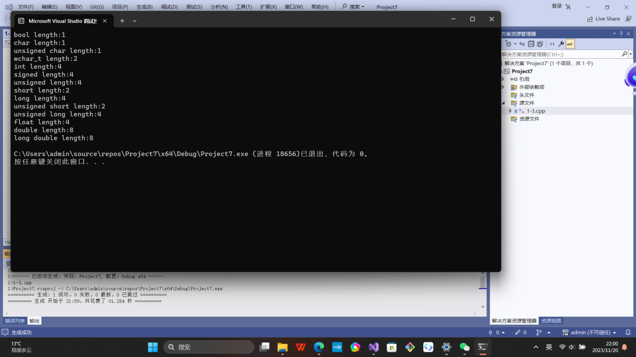

实验1-4

#include<iostream>

#include<iomanip>

using namespace std;

int main() {

unsigned int testUnint = 65534;

float a = 1.25;

cout << "output in Oct unsigned int type:" << oct << testUnint << endl;

cout << "output in int type:" << static_cast<int>(a) << endl;

system("pause");

return 0；}

结果为-2的原因：数据溢出

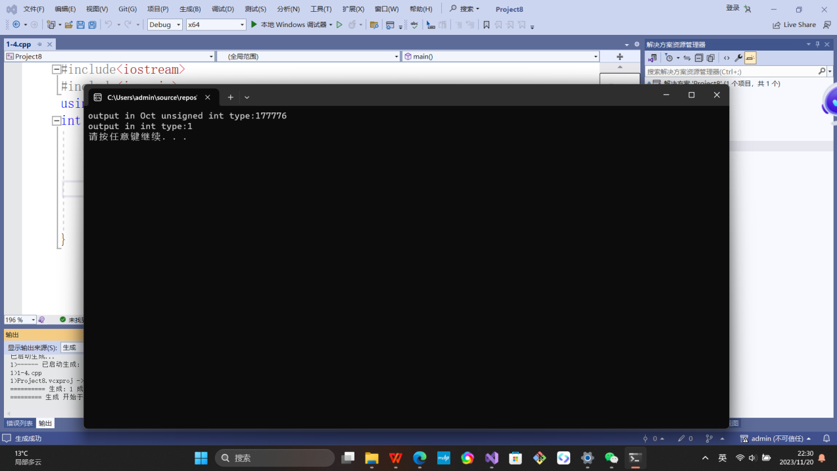

实验1-5

#include<iostream>

#include<iomanip>

using namespace std;

int main() {

float f, c;

cout << "华氏温度是：";

cin >> f;

c = 5.0/9*(f-32);

cout << fixed << setprecision(2);

cout << "对应的摄氏温度是：" << c << endl;

return 0;

}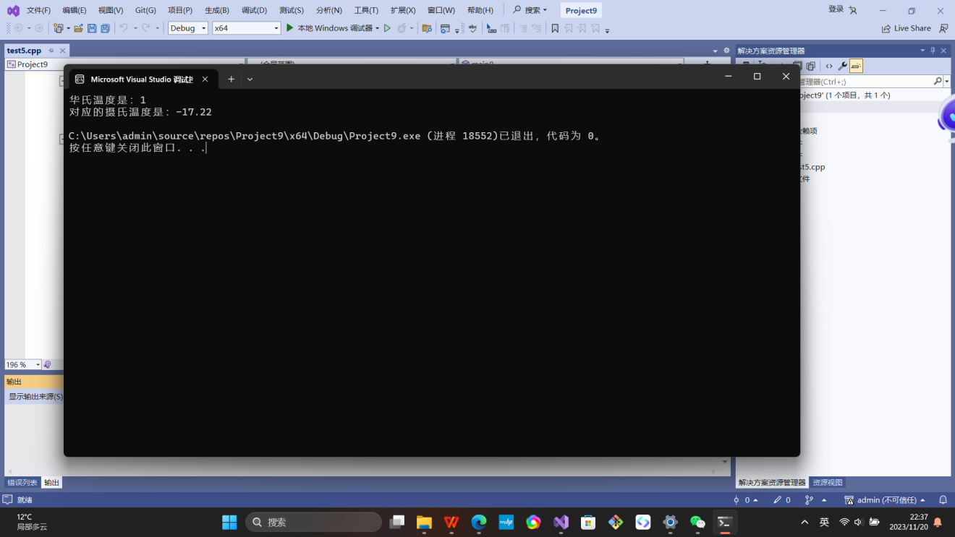遇到的问题和解决办法：

问题：不清楚实验1-5怎么保留两位小数 解决方法：上网搜查。

体会：

对于不清楚的没掌握的要查漏补缺。

实验2-1

#include<iostream>

using namespace std;

int main() {

char a;

cout << "输入一个字符：";

cin >> a;

cout << endl;

int i ;

i = static_cast<int>(a);

if (i >= 97 && i <= 122)

{

int j = i - 32;

char b ;

b = static_cast<char>(j);

cout << b;

}

else cout << i;

return 0;

}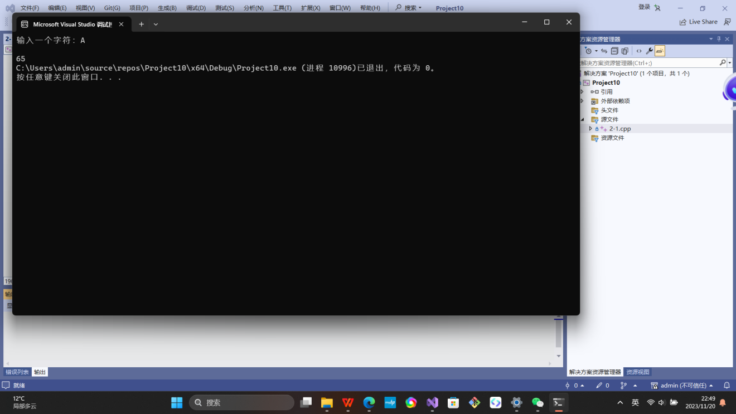

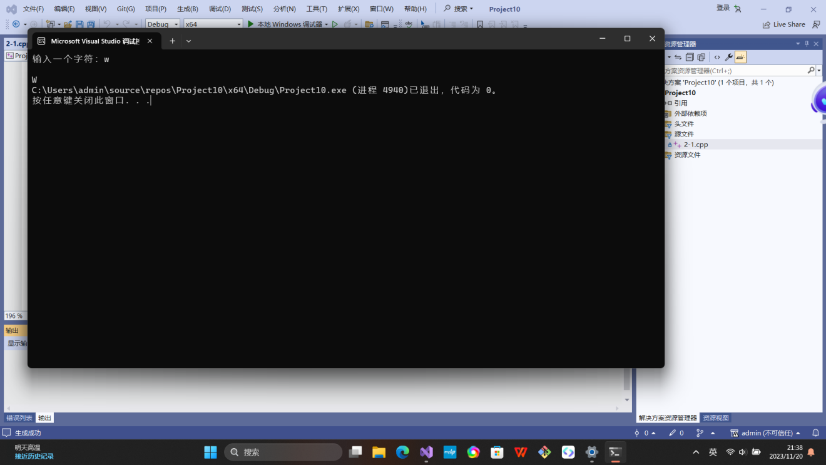

实验2-2

#include<iostream>

using namespace std;

int main() {

float x, y;

cout << "x的值是：";

cin >> x;

cout << endl;

if (x > 0 && x < 10)

{

if (x < 5)

{

if (x < 1)

{

y = 3 - 2 * x;

}

else y = 1 + 2 / (4 * x);

}

else y = x * x;

cout << y;

}

return 0;

}

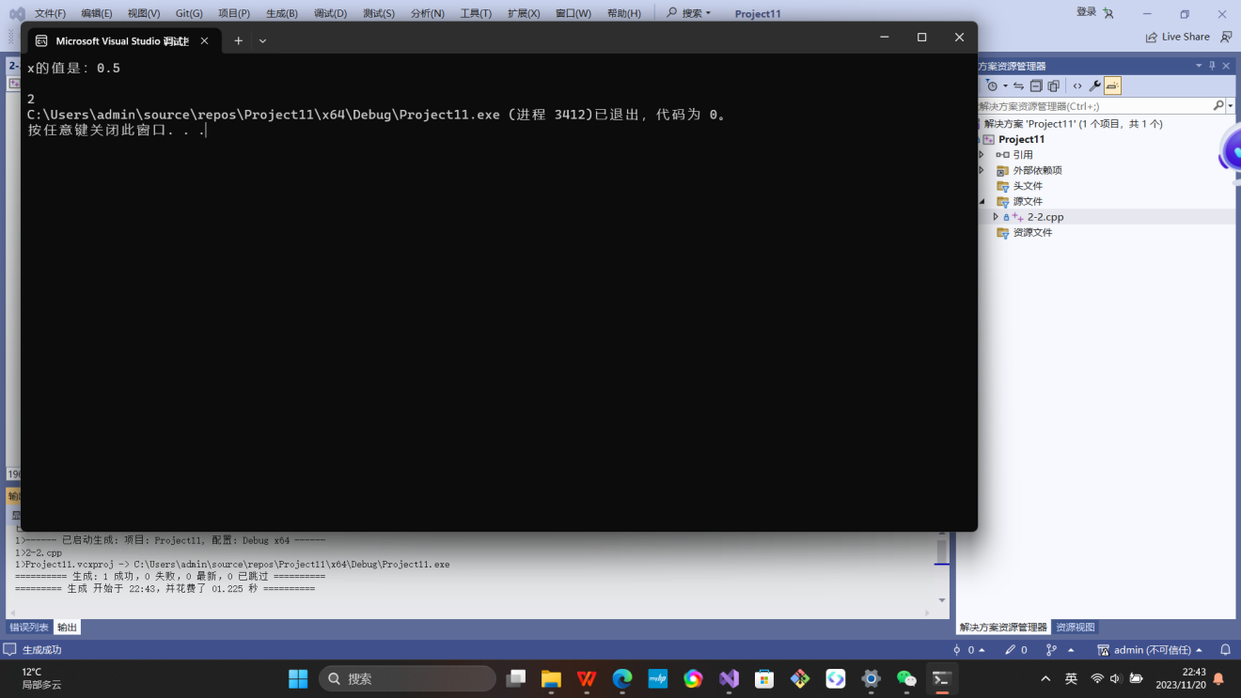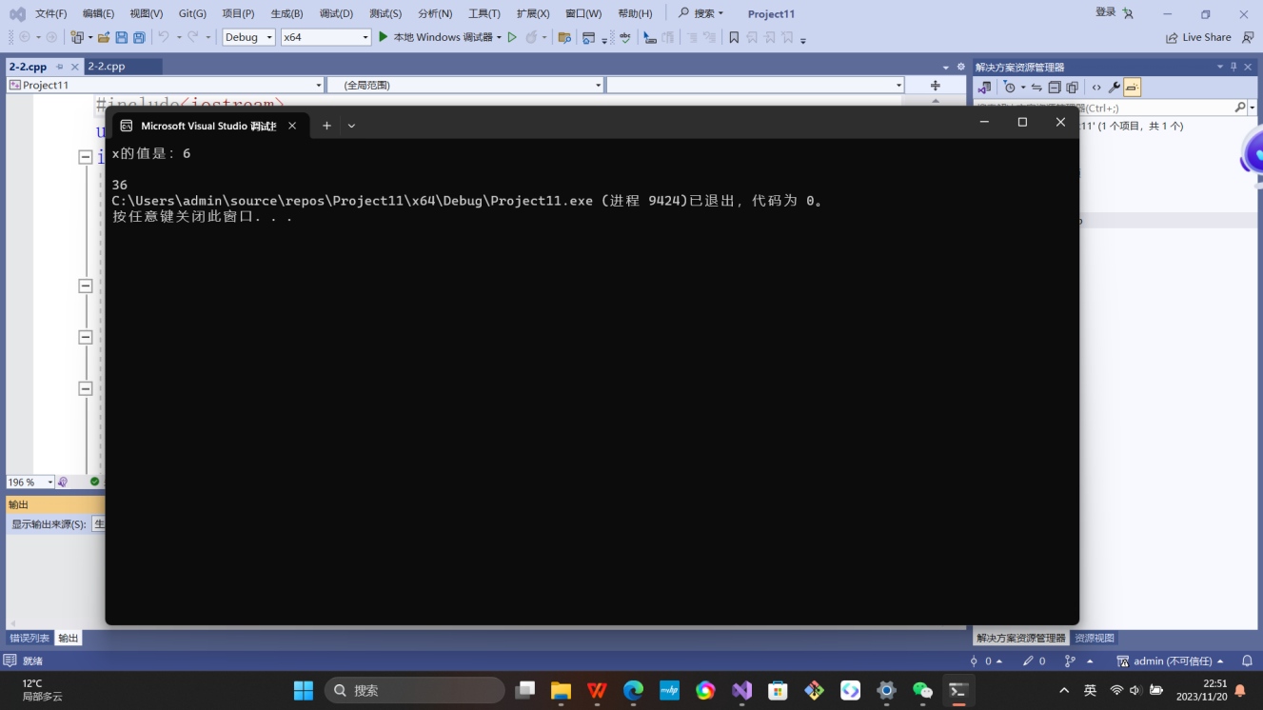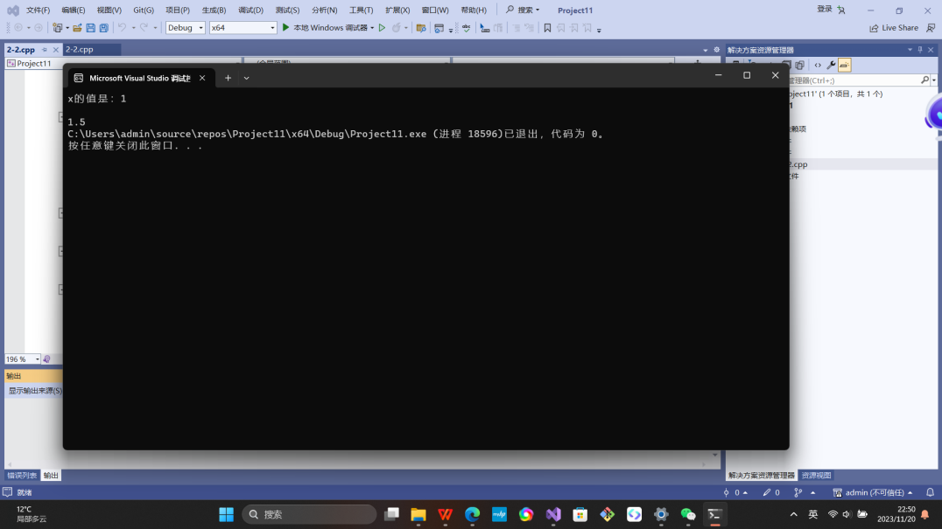

实验2-3

#include<iostream>

using namespace std;

int main() {

double a, b, c;

cout << "三角形的三条边长：";

cin >> a >> b >> c;

if ((a + b > c) && (b + c > a) && (a + c > b))

{

cout << "三角形周长：" << a + b + c << endl;

if (a == b || b == c || a == c)

{

cout << "三角形是等腰三角形" << endl;

}

else

cout << "三角形不是等腰三角形" << endl;

}

else

cout << "不能构成三角形" << endl;

return 0;

}

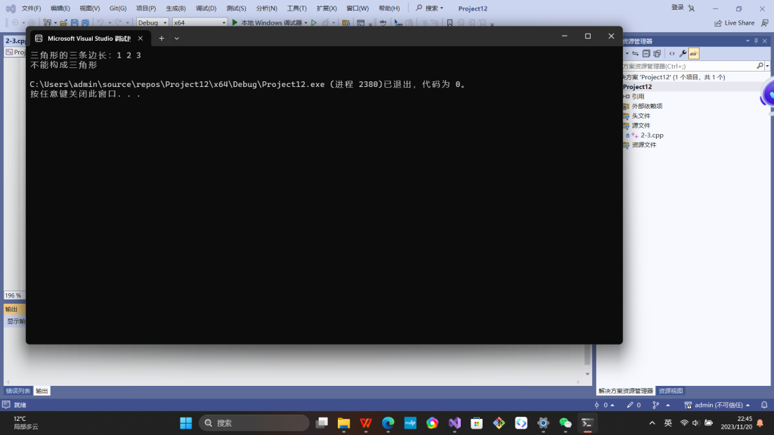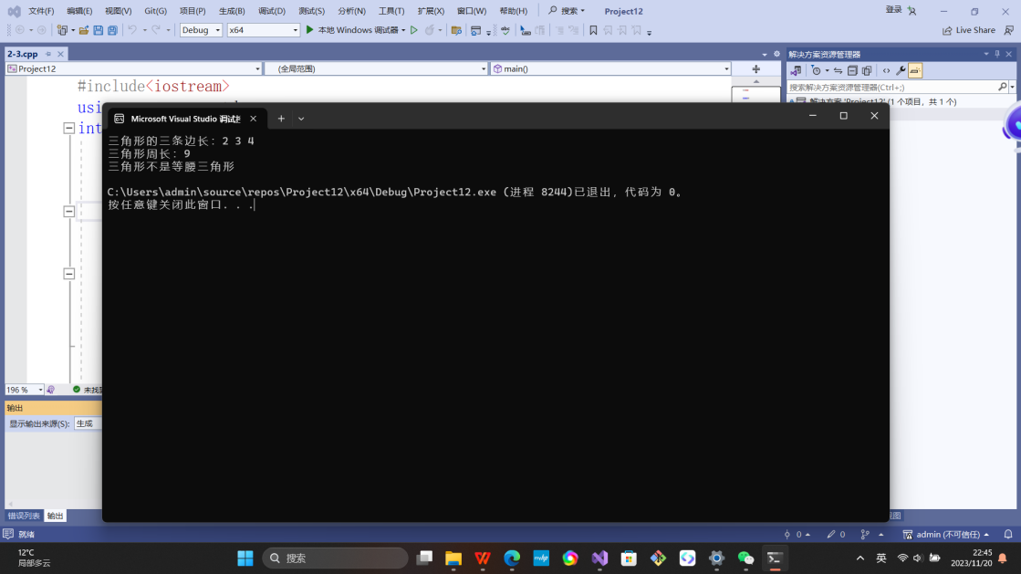

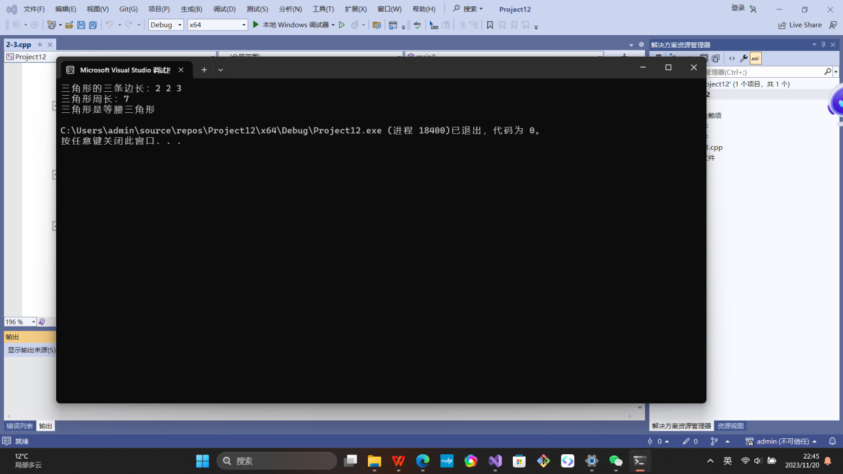

实验2-4

#include<iostream>

using namespace std;

int main() {

char am;

float j, k;

cout << "输入运算符：";

cin >> am;

cout << "输入两个数：";

cin >> j >> k;

switch (am)

{

case'+':

cout<< j + k;

break;

case'-':

cout << j - k;

break;

case'*':

cout << j * k;

break;

case'/':

if (k == 0) {

cout << "除数是0无法计算";

break;

}

else {

cout << j / k;

break;

}

case'%':

{int i = static_cast<int>(j), d = static_cast<int>(k);

cout << i % d;

break;

}

default:

cout << "运算符非法";

break;

}

return 0；

}

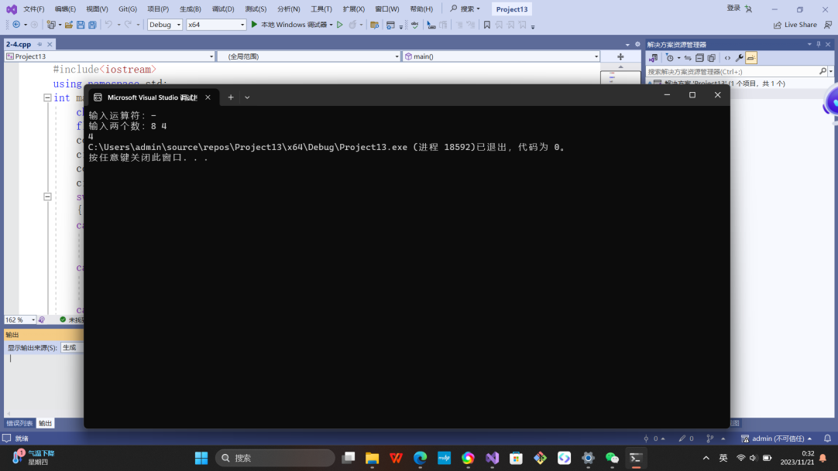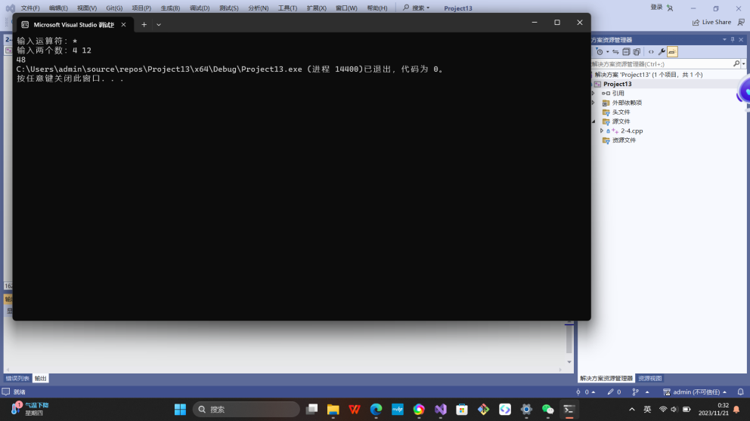

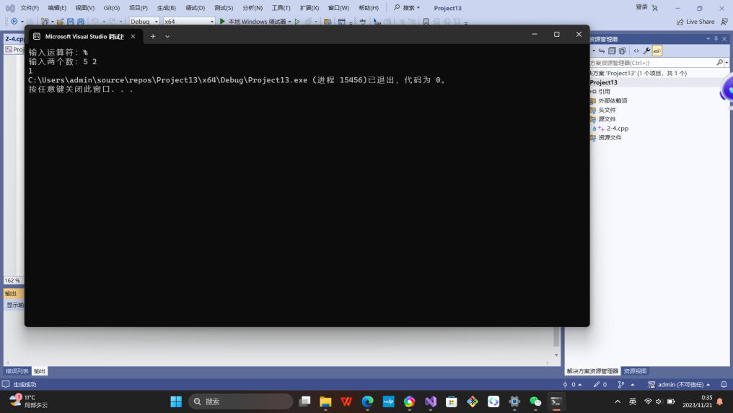

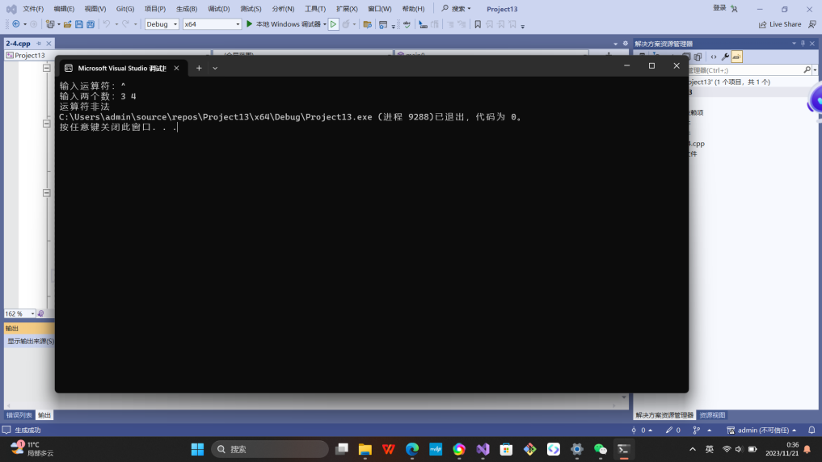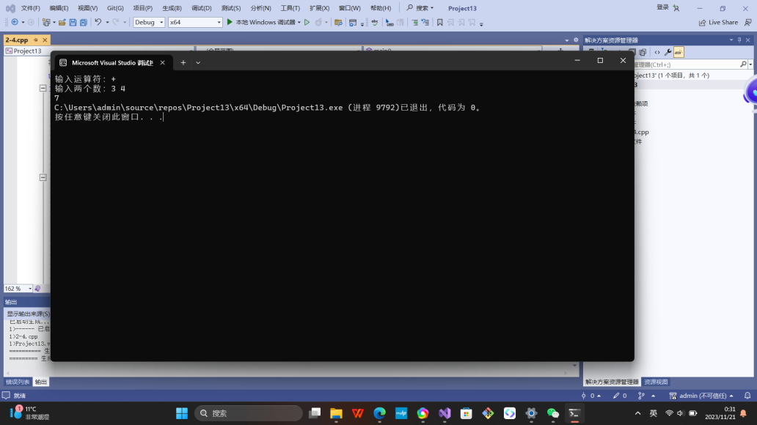

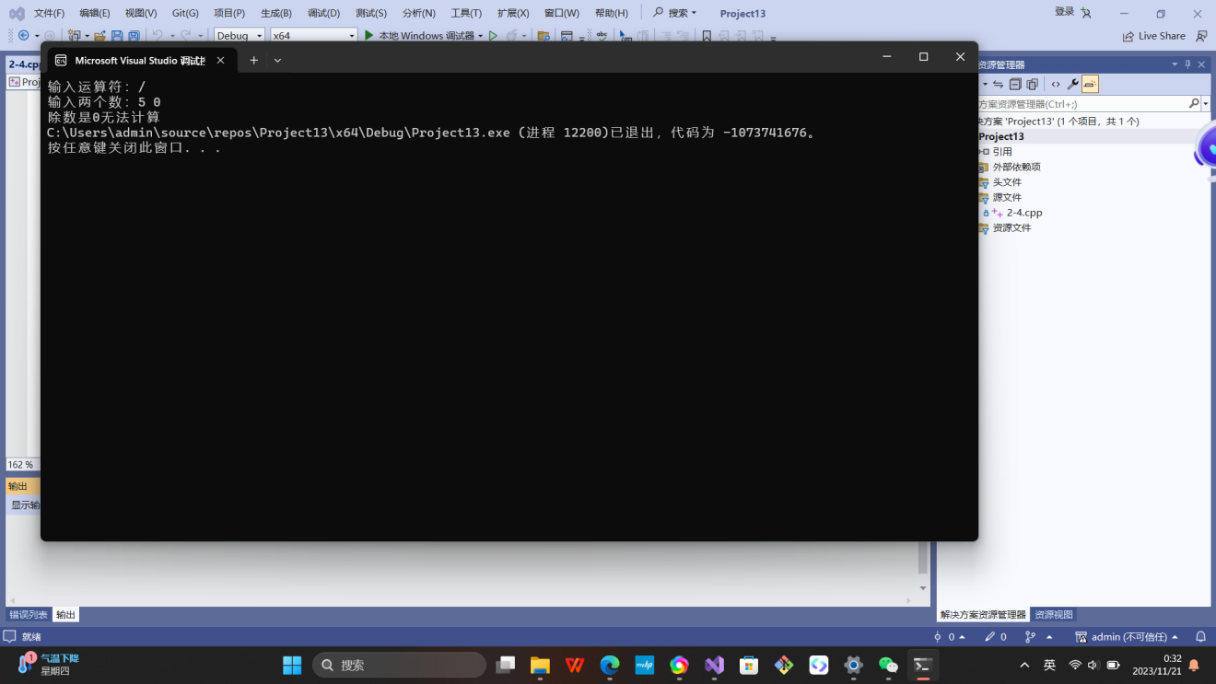

实验2-5

#include<iostream>

#include<string>

using namespace std;

int main() {

string input;

cout << "请输入一行字符：";

getline(cin, input);

int letters = 0,space = 0,digit = 0,other = 0;

for (char c : input)

{

if (isalpha(c))

{

letters++;

}

else if (isspace(c))

{

space++;

}

else if (isdigit(c))

{

digit++;

}

else

{

other++;

}

}

cout << "字母个数：" << letters << endl;

cout << "空格个数：" << space << endl;

cout << "数字个数" << digit << endl;

cout << "其它字符个数：" << other << endl;

return 0;

}

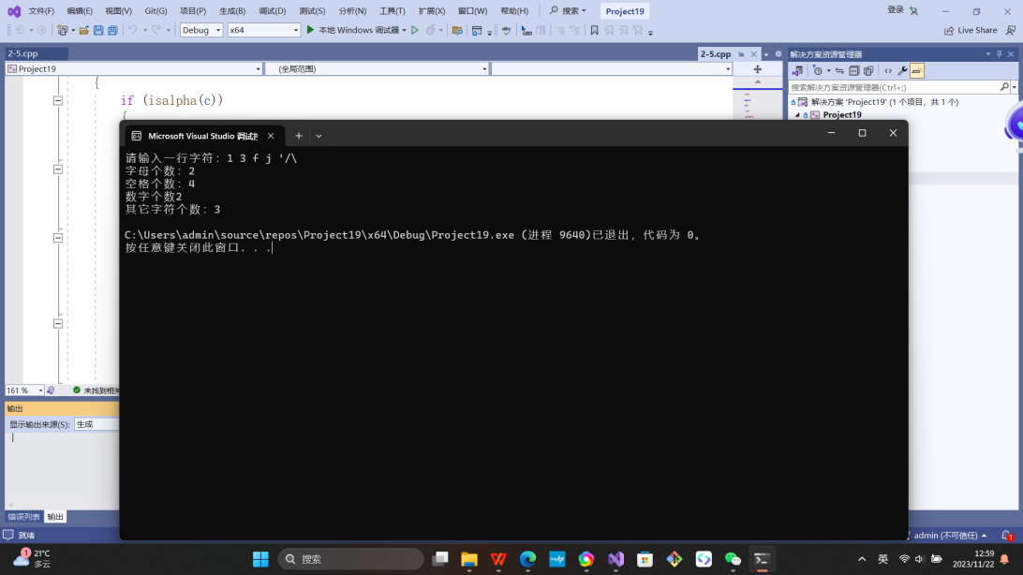

实验2-6

#include<iostream>

using namespace std;

int main() {

int a, b,i,j,k;

cout << "输入两个正整数：";

cin >> a >> b;

for (i = 1;i <= a;i++)

{

if (a % i == 0 && b % i == 0)

{

j = i;

}

}

cout << "最大公约数是：";

cout << j;

for (i = a * b;i >= a;i--)

{

if (i % a == 0 && i % b == 0)

{

k = i;

}

}

cout << "最小公倍数是：";

cout << k;

return 0;

}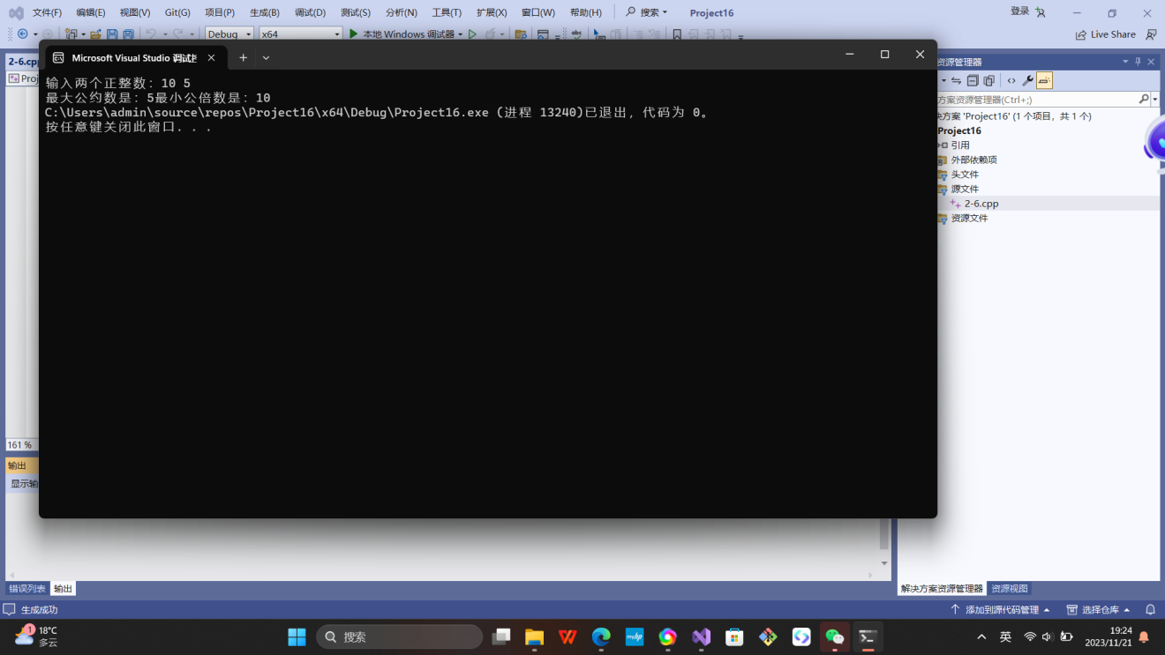

实验2-7

#include<iostream>

using namespace std;

int main() {

int i, j;

for (i = 1;i <= 5;++i) {

for (j = 1;j <= i;++j)

cout << "*";

cout<< endl;

}

return 0;

}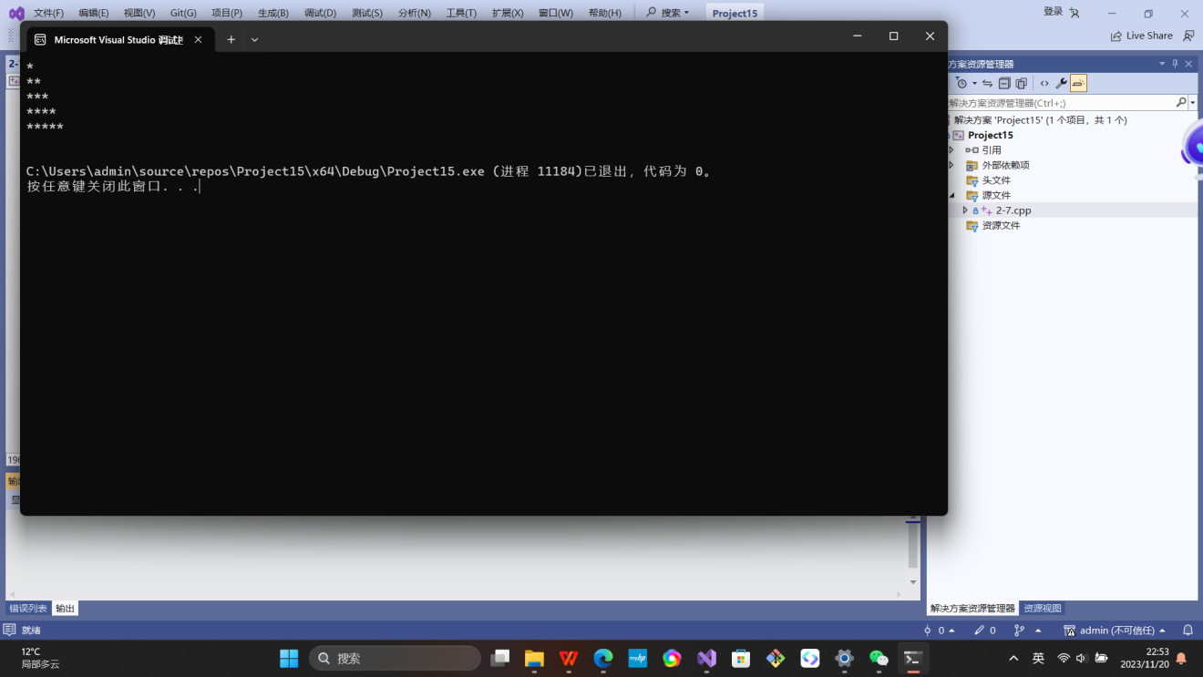

实验2-8

#include<iostream>

using namespace std;

int main() {

double a, j, k;

cin >> a;

k = a, j = k / 2 + a / (2 * k);

if (a > 0)

{

if (j - k > 0)

{

while (j - k >= 1e-5)

{

k = j;

j = k / 2 + a / (2 * k);

}

}

else

{

while (k - j >= 1e-5)

{

k = j;

j = k / 2 + a / (2 * k);

}

}

cout << "平方根是：" << j;

}

if (a < 0) {

cout << "a<0平方根不存在";

}

if(a==0){

cout << "平方根是0";

}

return 0;

}

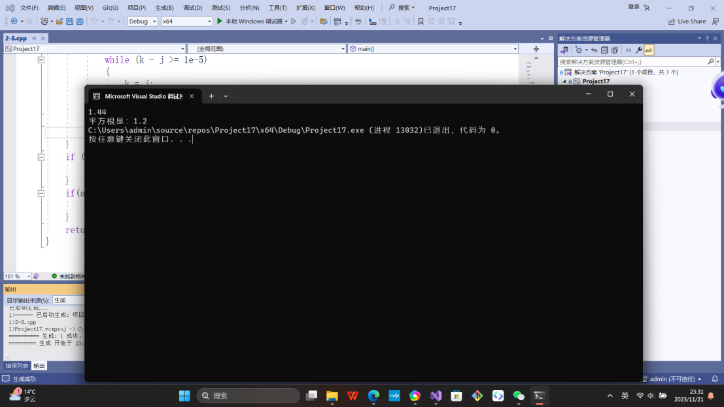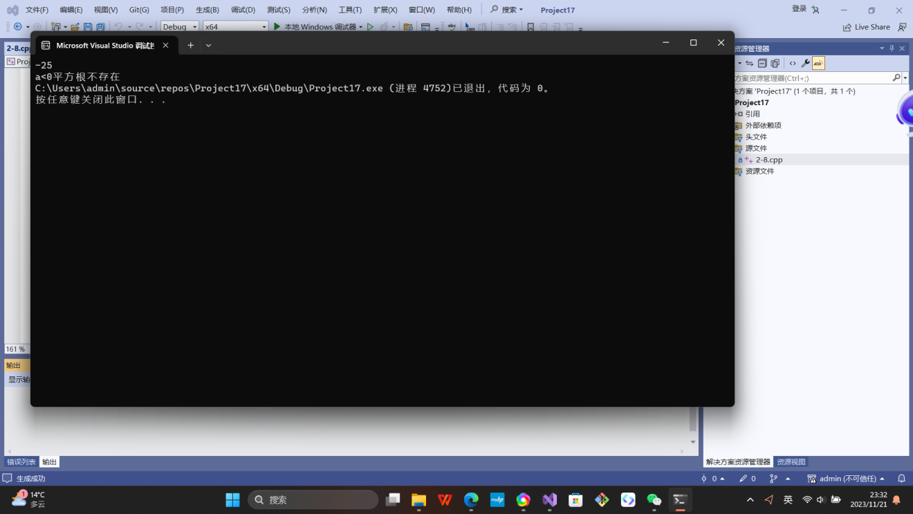

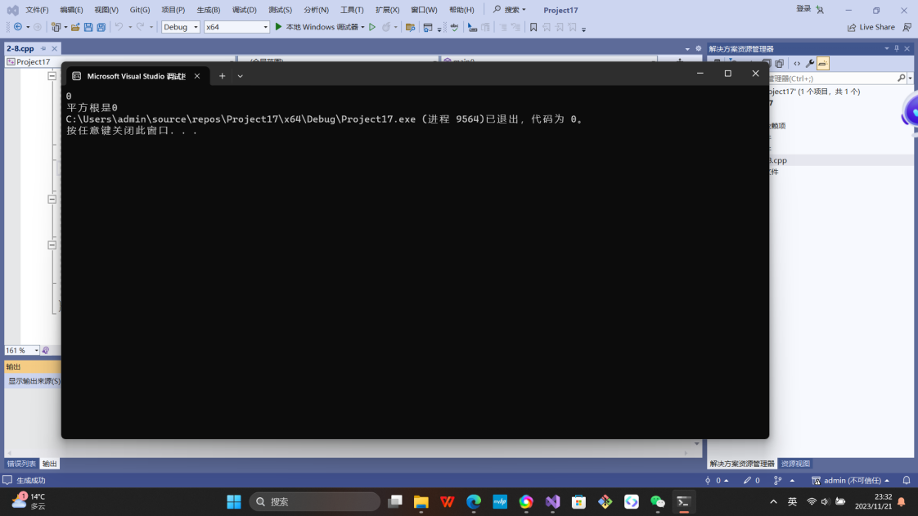

思考：1.无回应2.能。

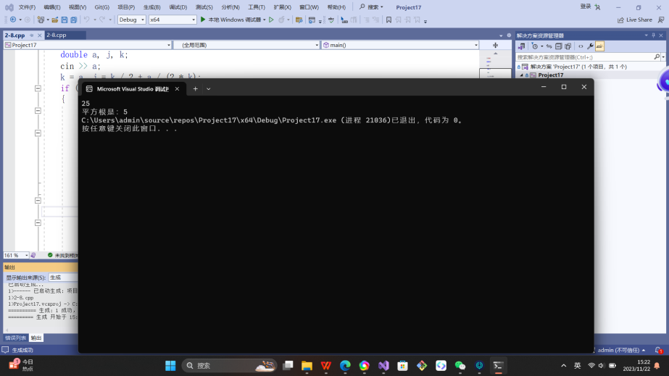

实验2-9

#include<iostream>

using namespace std;

int main()

{

const float a = 0.8;

int j=0,i;

float k = 0;

for (i = 2;i <= 100;i*=2)

{

k=k+i*a;

j++;

}

float b = k / j;

cout << "每天平均：" << b;

return 0;

}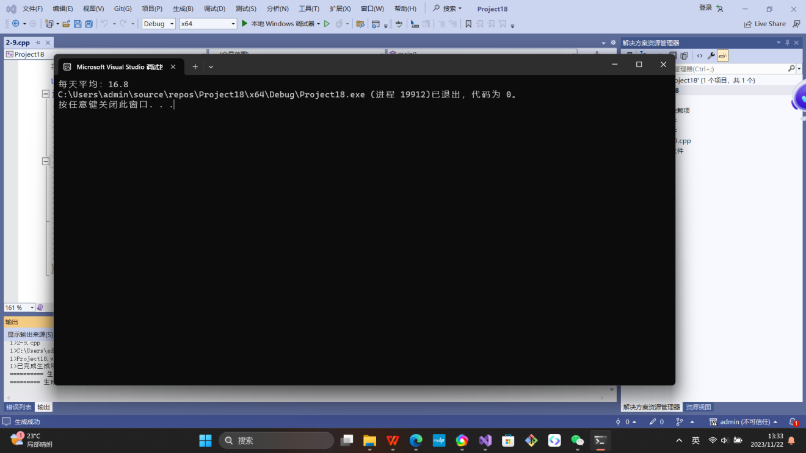

遇到的问题和解决方法：

实验2-1通过查阅书后的表格明白大小写字母的ASCII码范围和转换。

实验2-5不能判断变量是什么字符，通过查找网上资料知道字符判断函数的使用。

体会：

要多加练习增强逻辑思维表达的能力以及获取新知识的能力，自主动手实践和应用。