OSSP Skill Programs

Program 1: Command-Line Tokenizer
Aim
To write a C program that splits a shell-style input line into whitespace-separated tokens, as a reusable building block for a shell.
Algorithm
Step 1: Read a line of input from the user.
Step 2: Use strtok() with delimiters (space, tab, newline) to repeatedly extract tokens from the line.
Step 3: Store each token pointer in an array until no tokens remain or the array is full.
Step 4: Print the number of tokens found and each token.
Program (tokenizer.c)
#include <stdio.h>
#include <stdlib.h>
#include <string.h>

#define MAX_TOKENS 64
#define DELIMS " \t\r\n"

char **tokenize(char *line, int *count) {
char **tokens = malloc(MAX_TOKENS * sizeof(char *));
int n = 0;

char *tok = strtok(line, DELIMS);
while (tok != NULL && n < MAX_TOKENS - 1) {
tokens[n++] = tok;
tok = strtok(NULL, DELIMS);
}
tokens[n] = NULL;
*count = n;
return tokens;
}

int main(void) {
char line[1024];

printf("Enter a line to tokenize: ");
if (fgets(line, sizeof(line), stdin) == NULL)
return 0;

int count;
char **tokens = tokenize(line, &count);

printf("Token count: %d\n", count);
for (int i = 0; i < count; i++)
printf(" [%d] \"%s\"\n", i, tokens[i]);

free(tokens);
return 0;
}

Output
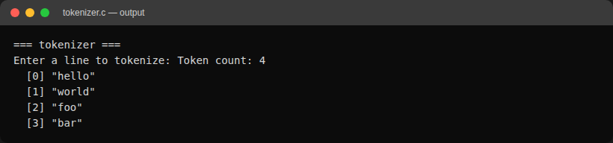

Program 2: Simple Shell Command Loop
Aim
To write a C program implementing a basic shell: a read-tokenize-fork-exec loop that runs external commands, with 'cd' and 'exit' as built-ins.
Algorithm
Step 1: Print a prompt and read a command line from the user.
Step 2: Tokenize the line into a command and its arguments.
Step 3: If the command is 'exit', terminate the loop.
Step 4: If the command is 'cd', call chdir() directly in the shell process (a child cannot change the parent's working directory).
Step 5: Otherwise, fork a child process; in the child, use execvp() to run the command; the parent waits for the child to finish.
Step 6: Repeat until the user exits or end-of-input is reached.
Program (simple_shell.c)
#include <stdio.h>
#include <stdlib.h>
#include <string.h>
#include <unistd.h>
#include <sys/wait.h>

#define MAX_TOKENS 64
#define DELIMS " \t\r\n"

static int tokenize(char *line, char **tokens) {
int n = 0;
char *tok = strtok(line, DELIMS);
while (tok != NULL && n < MAX_TOKENS - 1) {
tokens[n++] = tok;
tok = strtok(NULL, DELIMS);
}
tokens[n] = NULL;
return n;
}

int main(void) {
char line[1024];
char *tokens[MAX_TOKENS];

while (1) {
printf("myshell> ");
fflush(stdout);

if (fgets(line, sizeof(line), stdin) == NULL) {
printf("\n");
break;
}

int n = tokenize(line, tokens);
if (n == 0)
continue;

if (strcmp(tokens[0], "exit") == 0)
break;

if (strcmp(tokens[0], "cd") == 0) {
if (n < 2 || chdir(tokens[1]) != 0)
fprintf(stderr, "cd: could not change directory\n");
continue;
}

pid_t pid = fork();
if (pid < 0) {
perror("fork");
continue;
}

if (pid == 0) {
execvp(tokens[0], tokens);
perror("exec");
exit(EXIT_FAILURE);
} else {
int status;
waitpid(pid, &status, 0);
}
}

return 0;
}

Output
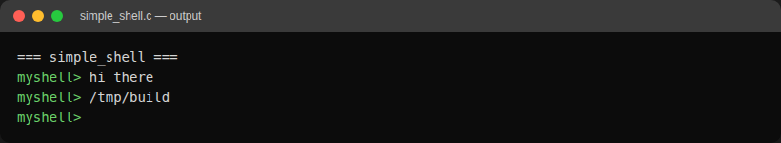

Program 3: Shell with Command History
Aim
To extend the simple shell with a command history feature: every command is stored, 'history' lists them, and '!n' re-executes history entry n.
Algorithm
Step 1: On each loop iteration, read a command line as in the simple shell.
Step 2: If the line is 'history', print all stored commands with their index.
Step 3: If the line starts with '!', parse the number n, look up history entry n, echo it, add it to history again, tokenize it and execute it.
Step 4: Otherwise, store the raw line in the history buffer, then tokenize and execute it via fork/exec (or handle 'cd' as a built-in) as in the simple shell.
Step 5: On 'exit' or end-of-input, free the history buffer and terminate.
Program (shell_history.c)
#include <stdio.h>
#include <stdlib.h>
#include <string.h>
#include <unistd.h>
#include <sys/wait.h>

#define MAX_TOKENS 64
#define MAX_HISTORY 100
#define DELIMS " \t\r\n"

static char *history[MAX_HISTORY];
static int history_count = 0;

static int tokenize(char *line, char **tokens) {
int n = 0;
char *tok = strtok(line, DELIMS);
while (tok != NULL && n < MAX_TOKENS - 1) {
tokens[n++] = tok;
tok = strtok(NULL, DELIMS);
}
tokens[n] = NULL;
return n;
}

static void add_history(const char *line) {
if (history_count < MAX_HISTORY) {
history[history_count++] = strdup(line);
} else {
free(history[0]);
memmove(history, history + 1, (MAX_HISTORY - 1) * sizeof(char *));
history[MAX_HISTORY - 1] = strdup(line);
}
}

static void print_history(void) {
for (int i = 0; i < history_count; i++)
printf("%4d %s", i + 1, history[i]);
}

static void execute_tokens(char **tokens, int n) {
if (n == 0)
return;

if (strcmp(tokens[0], "cd") == 0) {
if (n < 2 || chdir(tokens[1]) != 0)
fprintf(stderr, "cd: could not change directory\n");
return;
}

pid_t pid = fork();
if (pid < 0) {
perror("fork");
return;
}

if (pid == 0) {
execvp(tokens[0], tokens);
perror("exec");
exit(EXIT_FAILURE);
} else {
int status;
waitpid(pid, &status, 0);
}
}

int main(void) {
char line[1024];
char *tokens[MAX_TOKENS];

while (1) {
printf("myshell> ");
fflush(stdout);

if (fgets(line, sizeof(line), stdin) == NULL) {
printf("\n");
break;
}

if (line[0] == '\n')
continue;

if (strcmp(line, "exit\n") == 0)
break;

if (strcmp(line, "history\n") == 0) {
print_history();
continue;
}

if (line[0] == '!') {
int idx = atoi(line + 1);
if (idx < 1 || idx > history_count) {
fprintf(stderr, "history: no such entry\n");
continue;
}
char entry_copy[1024];
strncpy(entry_copy, history[idx - 1], sizeof(entry_copy) - 1);
entry_copy[sizeof(entry_copy) - 1] = '\0';
printf("%s", entry_copy);
fflush(stdout);
add_history(entry_copy);
char exec_copy[1024];
strncpy(exec_copy, entry_copy, sizeof(exec_copy) - 1);
exec_copy[sizeof(exec_copy) - 1] = '\0';
int n = tokenize(exec_copy, tokens);
execute_tokens(tokens, n);
continue;
}

add_history(line);

char copy[1024];
strncpy(copy, line, sizeof(copy) - 1);
copy[sizeof(copy) - 1] = '\0';
int n = tokenize(copy, tokens);
execute_tokens(tokens, n);
}

for (int i = 0; i < history_count; i++)
free(history[i]);

return 0;
}

Output
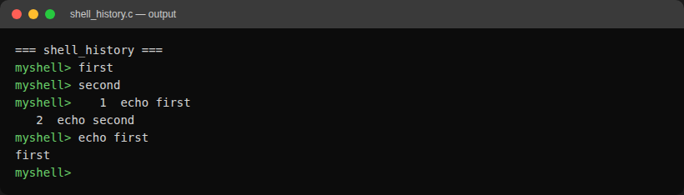
Errors Encountered & Fix
1. Compiler warning: unused function
While building the history-recall path, a leftover helper function (run_command) was left in the file after its logic was inlined directly into main(). Compiling with -Wall -Wextra flagged it:
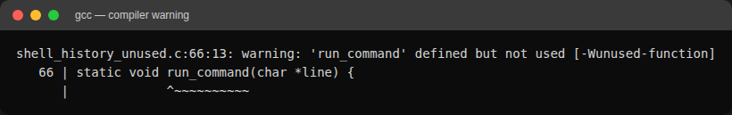
Fix: removed the unused run_command function (and its now-unnecessary forward declaration) since its body had already been folded into main(). Recompiling produced no warnings.
2. Output appearing in the wrong order for the '!n' history recall
The '!n' command is supposed to first echo the recalled command line, then run it. Testing '!1' after running 'echo first' showed the child process's output ("first") printed BEFORE the echoed command line ("echo first"), which is backwards:
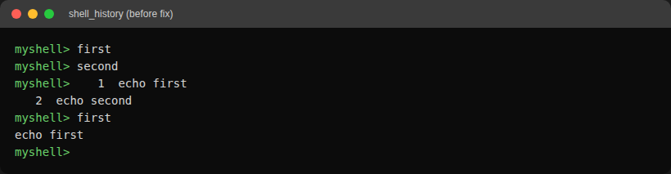
Cause: printf() output to stdout is fully buffered when not connected to an interactive terminal, so the parent's printf("%s", entry_copy) call was sitting in libc's buffer while the forked child (running via execvp) wrote its own output straight through. The child's write reached the screen first even though the parent's printf executed first in program order.
Fix: added fflush(stdout) right after printing the recalled command, forcing it out before the child process runs. The corrected order is visible in the Output section above ("echo first" is printed before "first").

