Introduction
This project will build off of and enhance the Ivy Tech Chatbot. The project will include multiple major improvements that will bring immense value to the already impressive tool. The goal of these features combined are to better support our Ivy Tech students and staff so they can get the information needed in a timely manner without having to interact with a human if not needed. These features mainly consist of building off the chatbot fundamentals making it a more useful and robust tool. Features that will be included in the scope of this project include adding context to the chatbot so the bot can keep track of conversation history and better support our Ivy Tech students, improving the dataset to include more topics, including but not limited to graduation and next steps support. Lastly, the project will improve the input recognition engine to accept and understand a broader range of input. Adding a manually coded translator, which, as of now, only covers the Filipino language. The Filipino Inquiries controller will actively monitor user inputs to determine if they are written in Filipino. Once the controller identifies a Filipino input, the chatbot will respond in the same language, ensuring a smooth, coherent conversation flow. This feature aims to improve user experience by allowing Filipino users to interact with the chatbot more comfortably and effectively.

Entity Relationship Diagram (ERD)
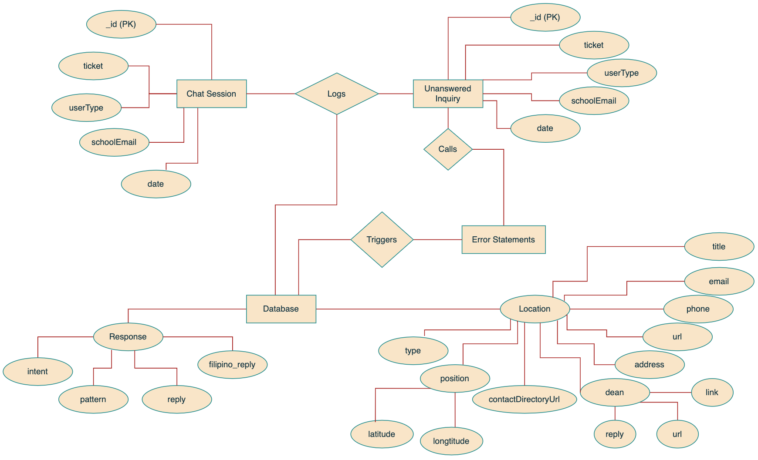

Sequence Diagrams
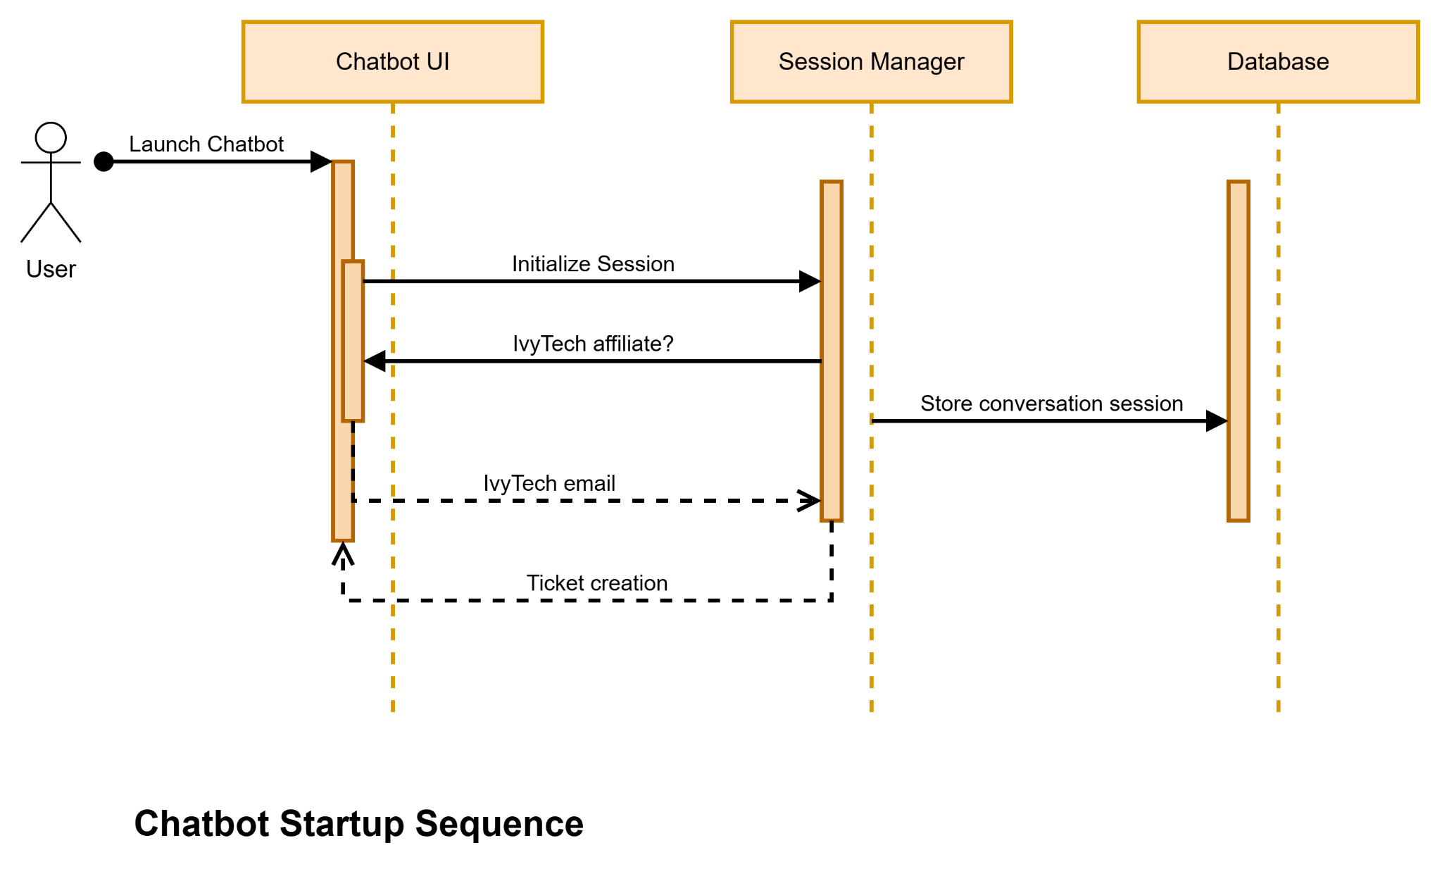
The sequence diagrams illustrate the interaction between the user, the chatbot, and the system components throughout startup and inquiry handling. They show how sessions are initiated, how messages are processed, and how responses are generated or logged. These diagrams demonstrate communication flow, along with the chatbot’s ability to manage context and user intent.

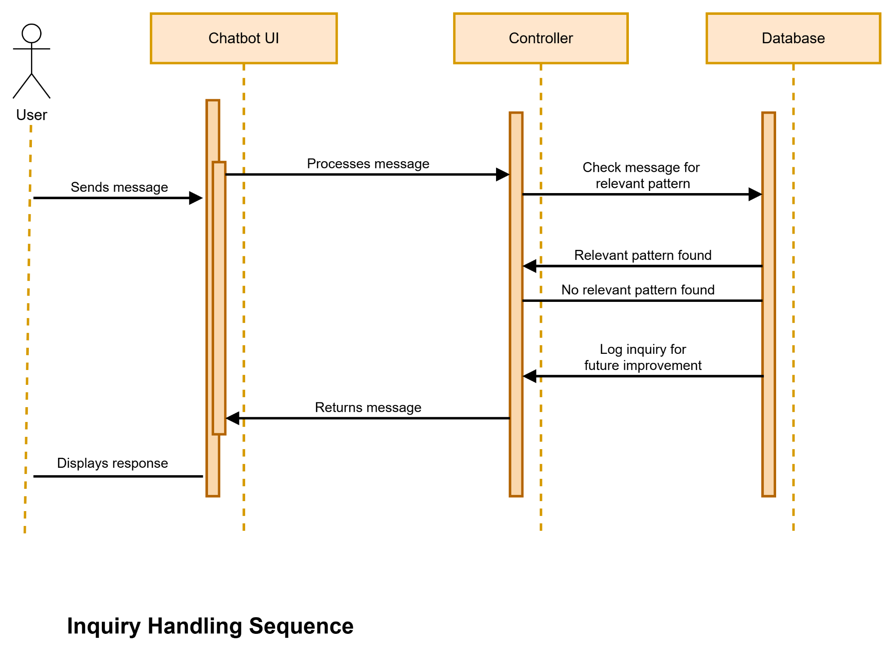

Architecture Design Diagram

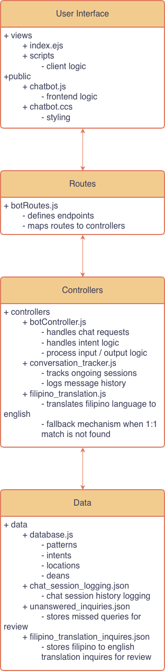 | Layered MVC Hybrid Architecture  The application is a Node.js web application that encompasses a layered software architecture with clear layers of separation with Model-View-Controller inspired design patterns.  Each layer maintains clear separation of concerns from user interaction and routing, business logic and data management. While not strictly MVC implementation since models are not directly bound to the frontend, the architecture and design patterns promote modularity, scalability and maintainability by isolating responsibilities across views, controllers and data layers.

Class Diagram
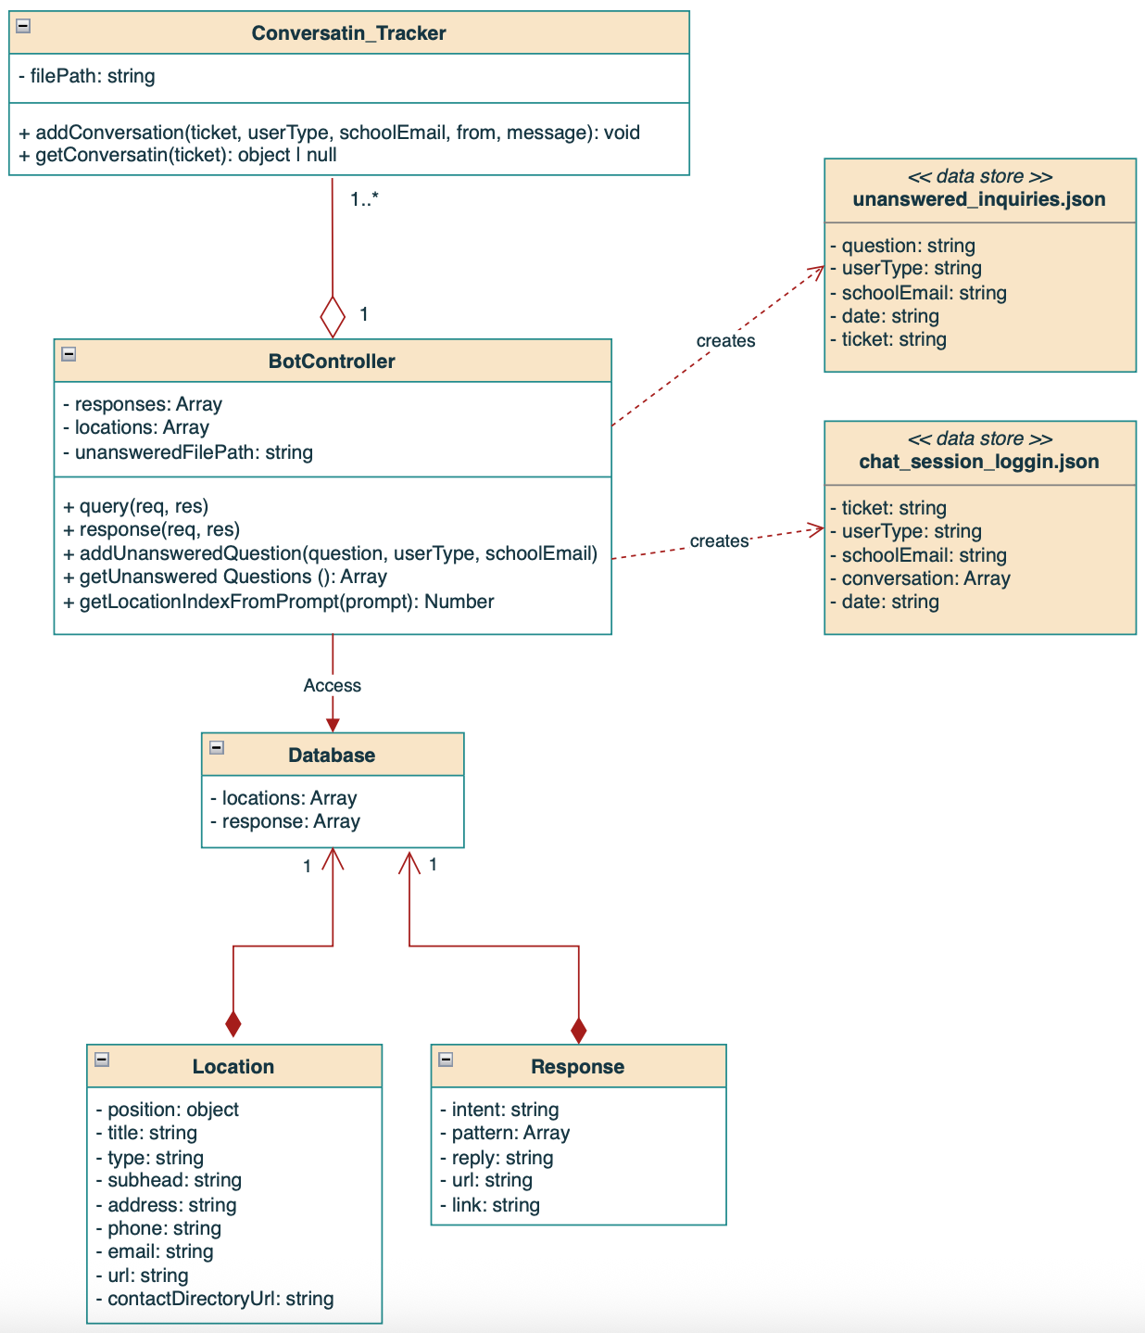

Database Design
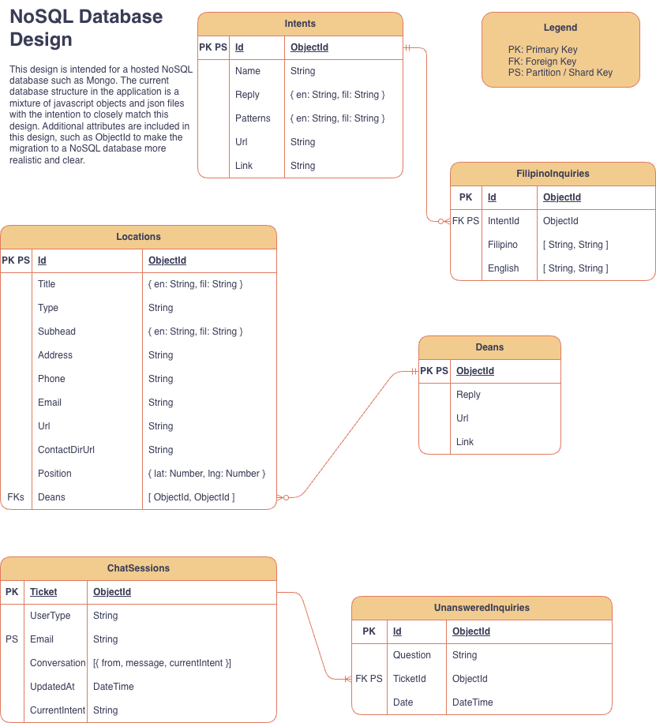

Interface Design
We decided that the interface design would resemble the FA24 Blue Team’s version, with some revisions to the fonts, Ivy Tech logos, and added icons for simplicity. Hershey used Figma to revise the design and used icons from Bootstrap.

Desktop Concept

Landing Page
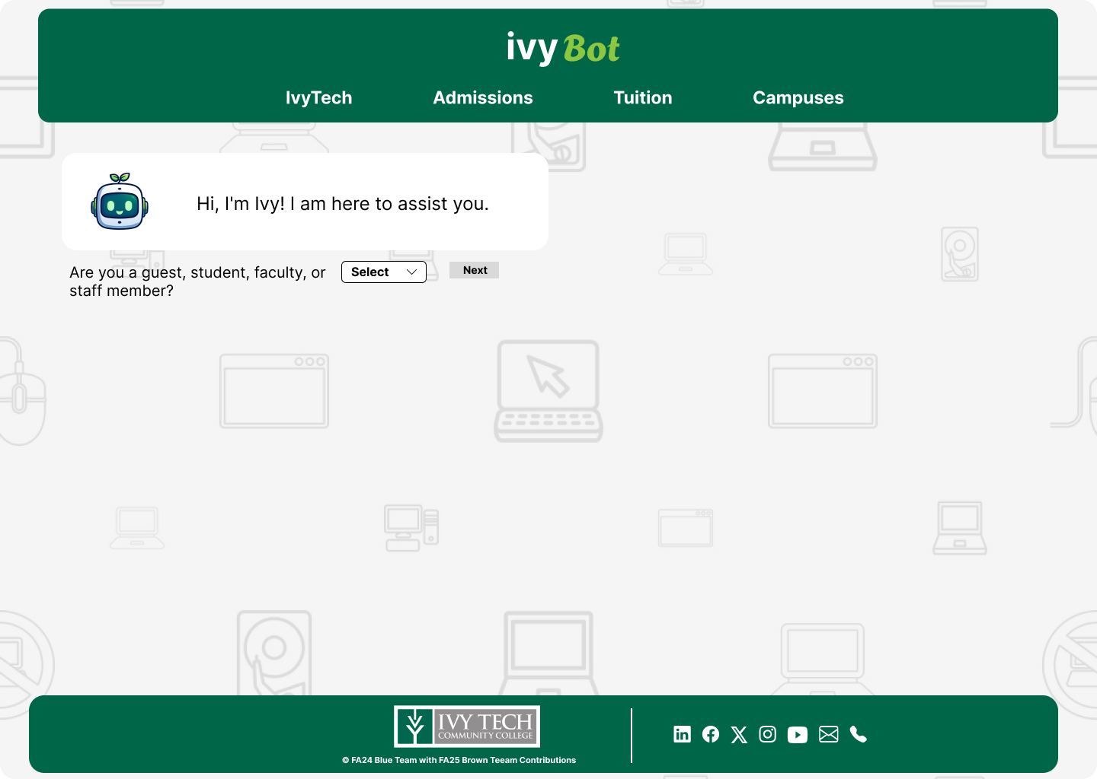

If the userType == ‘Student’ || ‘Faculty’ || ‘Staff Member’
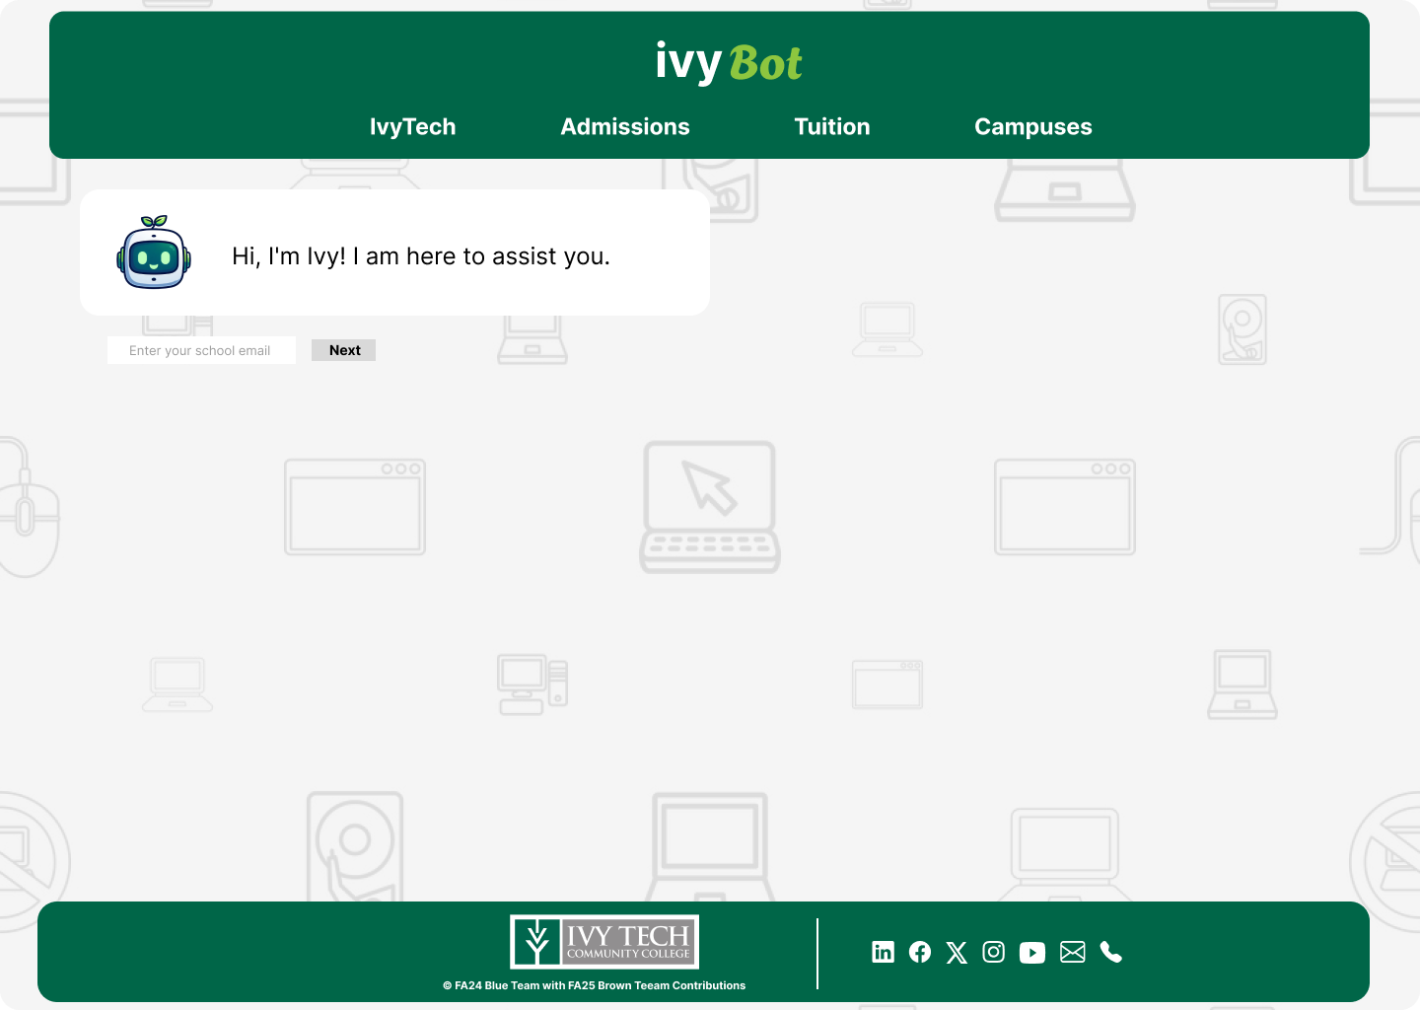

Example Prompt (GUEST)
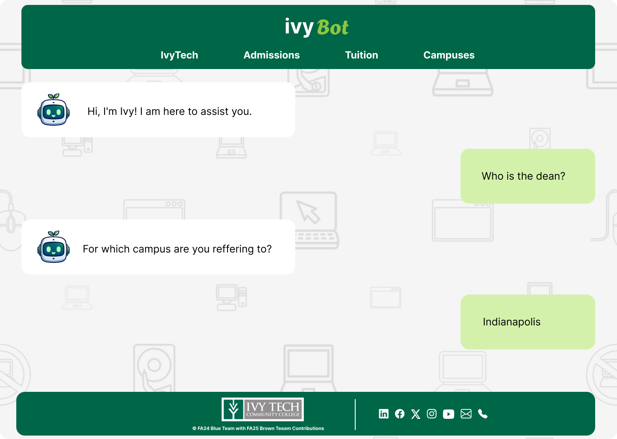
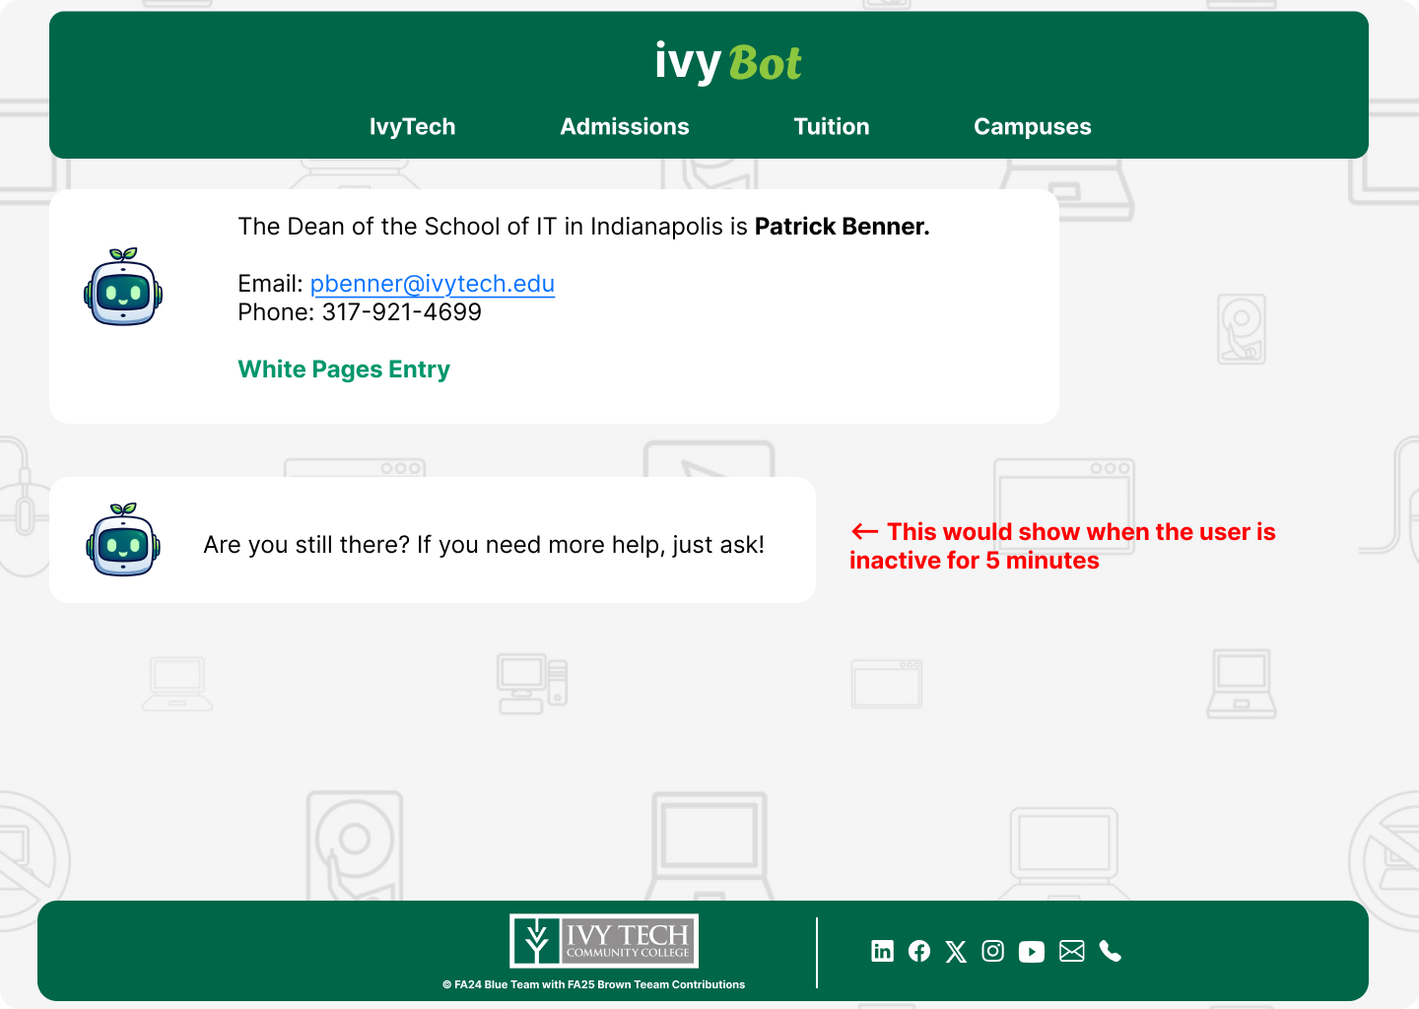

Mobile Devices or Ipad Sizes (Portrait) Concept
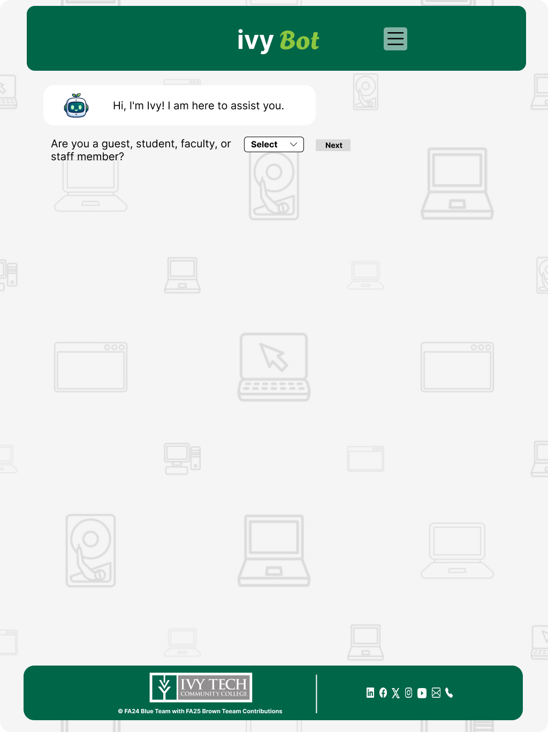

Use Cases
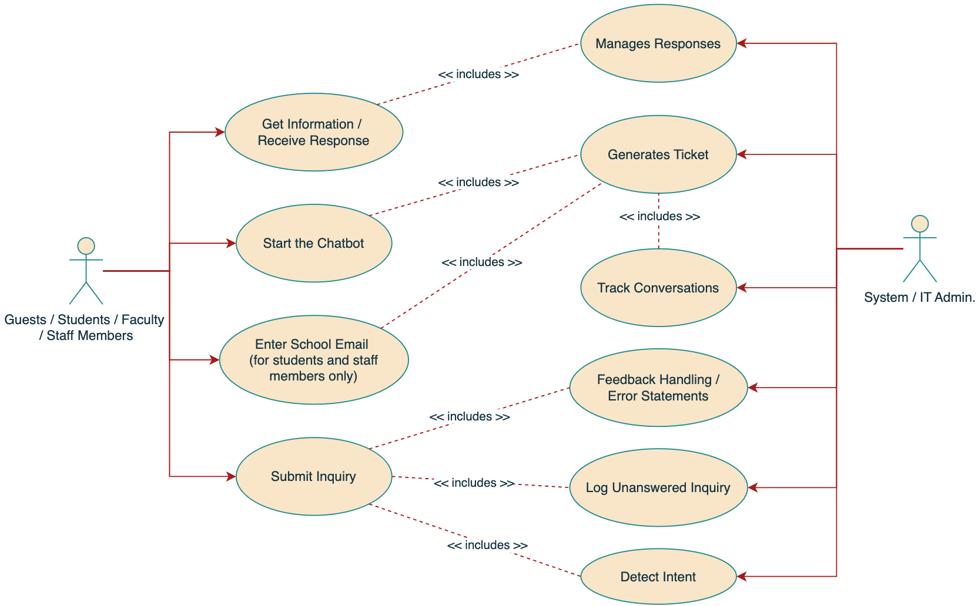

Test Cases
Chatbot Startup

- Navigate to Ivy Chatbot
- Start up chatbot
- If student or faculty, enter school email address
- Chatbot is available and functional on various internet browsers and operating systems

Initial Setup

- When a new conversation is started (ie. chatbot starts up), a ticket should be generated that tracks the conversation
- User submits messages and inquiries
- Chatbot should receive the user’s response and process it accordingly

Runtime

- Chatbot manages responses to user inquiries
- Based on given database, chatbot should provide relevant information
- Log unanswered inquiry and search database for relevant responses
- Chatbot should detect user’s intended inquiries and manage response
- Minor typos and misspellings from user are interpreted and handled
- Error messages are displayed if chatbot is unable to process user’s prompts
- Comprehensive database allows chatbot to answer questions and inquiries related to Ivy Tech Community College and the School of Information Technology
- Chatbot supports, interprets, and processes essential inquiries written in Filipino
- Unfulfilled inquiries or inquiries that chatbot is unable to sufficiently answer are recorded for future reference on database improvements

Requirement | Test Case Description | Expected Result
When the user opens a new conversation with chatbot, the system records log session details. | If the user has an IvyTech email, the system generates a ticket to track the conversation. Verify that session data is correctly tracked and recorded. | Sessions logs are recorded and filed, retaining correct and relevant data. Session log should include email, ticket number, data/time of conversation, and conversation details.
The chatbot should keep track of conversation history to provide contextually relevant responses. | Chatbot should be running and connected to the database. If the user asks ambiguous questions such as “What is the address?” or “ What programs are offered?” the chatbot should be able to ask for further details on the user’s question and provide a response. | Chat responds correctly and maintains context throughout the conversation.
Chatbot must handle typos, misspellings, and incomplete sentences. | Fuzzball library should provide some leeway for user mistypes, detect intended inquiry, and provide a response. | Chatbot successfully and accurately interprets informal or misspelled input and provides relevant information about the user’s inquiry.
Expanded dataset includes graduation information and potential next steps. | Incorporate and confirm new topics are included in the database. | Chatbot provides more detailed programing and advising information, and provides correct and complete information to the user.
Chatbot must support essential, manually coded Filipino inquiries. | Include and verify chatbot responses to questions received in Filipino language. | Chatbot identifies inquiries sent in Filipino and provides appropriate responses.
Unrecognized topics and unfulfilled inquiries are logged for future dataset improvement. | The chatbot is configured to properly store new or unknown inquiries if relevant to SoIT. | New/ unknown and relevant inquiries from the user are stored for future improvements.
Chatbot runs smoothly on internet browsers and operating systems. | The system is hosted through the IvyTech website. Validate interface and functionality across supported browsers and systems. | Chatbot UI and responses function consistently across different browsers, and no errors or inconsistencies are observed.

Summary
The Brown Team enhances the SoIT Chatbot to provide faster, more relevant, and more detailed support for students, staff, and visitors. The system integrates advanced language processing to handle typos, recognize conversational context, and support multiple languages. The chatbot connects to a NoSQL database for scalable data storage and continuous improvement. Through improved datasets, user-friendly interfaces, and thorough testing, the project delivers a reliable, efficient, and accessible digital assistant that strengthens communication and student success across Ivy Tech Community College’s School of Information Technology.

