SoIT Chatbot: User Documentation
SDEV 265 FALL 2025 Brown Team
Members: Richard O'Connor, Amanda Rivera, & Hershey Beatrice Marbeda

Table of Contents

Introduction 3
Installation and Launching 4
Interaction with IvyBot 8
Initial User Guidelines from SDEV 265 FA24 Blue Team 8
Language Selection 9
Input Validation 12
System Structure 15
System Structure: Folder Information 16
More Breakdown of Information 16
Important Notes For the Filipino Language 17
Summary 18
Resources Used 19
Example of Interaction 20

Introduction
This document provides instructions for interacting with the School of Information Technology (SoIT) Chatbot, named ‘Ivy.’ The chatbot was initially created by the SDEV 265 FA24 Blue Team. The SDEV 265 FA25 Brown Team later made improvements to enhance its context awareness, user experience, and added Filipino translations. The chatbot can be launched using any integrated development environment (IDE) that supports JavaScript, HTML, and CSS. The SDEV 265 FA25 recommends Visual Studio (VS) Code.

The SoIT Chatbot: User Documentation contains the following information:
- Instructions for installing and launching the application
- Guidelines for interacting with the chatbot
  - Initial User Guidelines From the Original Creators
  - Language Selection
  - Input Validation
  - System Structure
- Summarization of this document
- Resources used in improving the chatbot
- Screenshots of sample interaction

Installation and Launching
First, you should have an IDE installed on your desktop or laptop that supports JavaScript. Examples of compatible IDEs include Visual Studio (VS) Code, WebStorm, NetBeans, and Eclipse. The Brown Team recommends VS Code, which the team used for improving the application. For more instructions on installing and using VS Code might find them here: https://code.visualstudio.com/docs.
* Please note that these instructions are based on a local installation and interacting with the chatbot. Also, the terminal commands are used on macOS.
Follow the instructions below to install and launch the SoIT Chatbot:
- Go to your Desired Directory: Open your VS Code’s terminal and use the command below to change the directory where you want to clone the repository.
  - cd your-directory
  - your-directory -> replace it with your actual directory name and stay in that directory
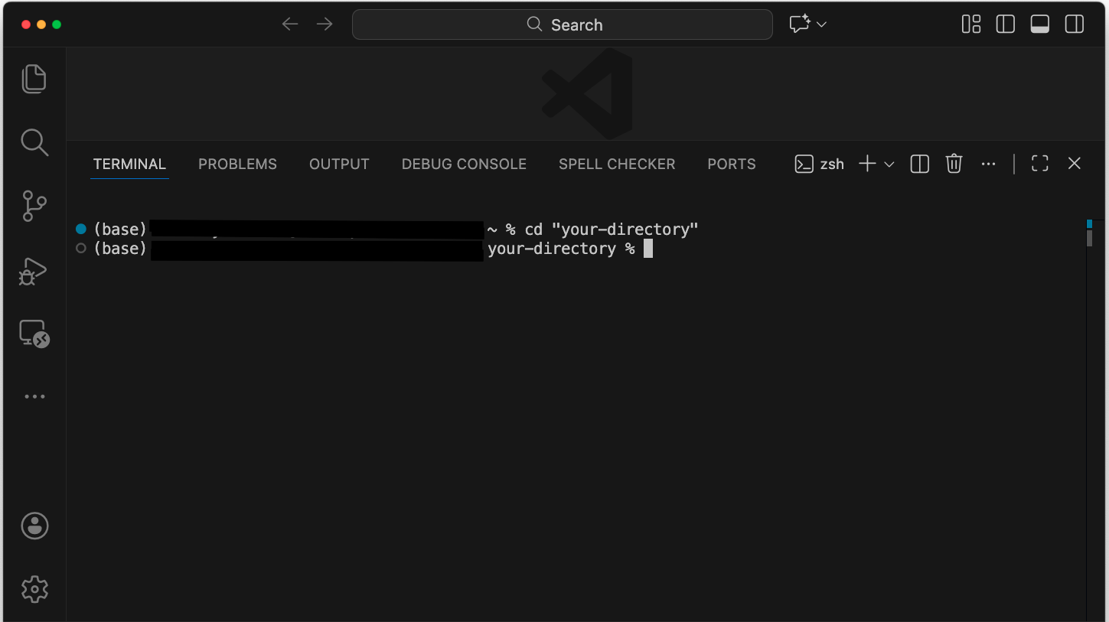
- Clone the repository: Use the command below to clone the repository:
  - git clone https://github.com/rohydro93/SoIT_ChatBot_BrownTeam.git your-repository-name
    - your-repository-name -> replace it with your actual repository name
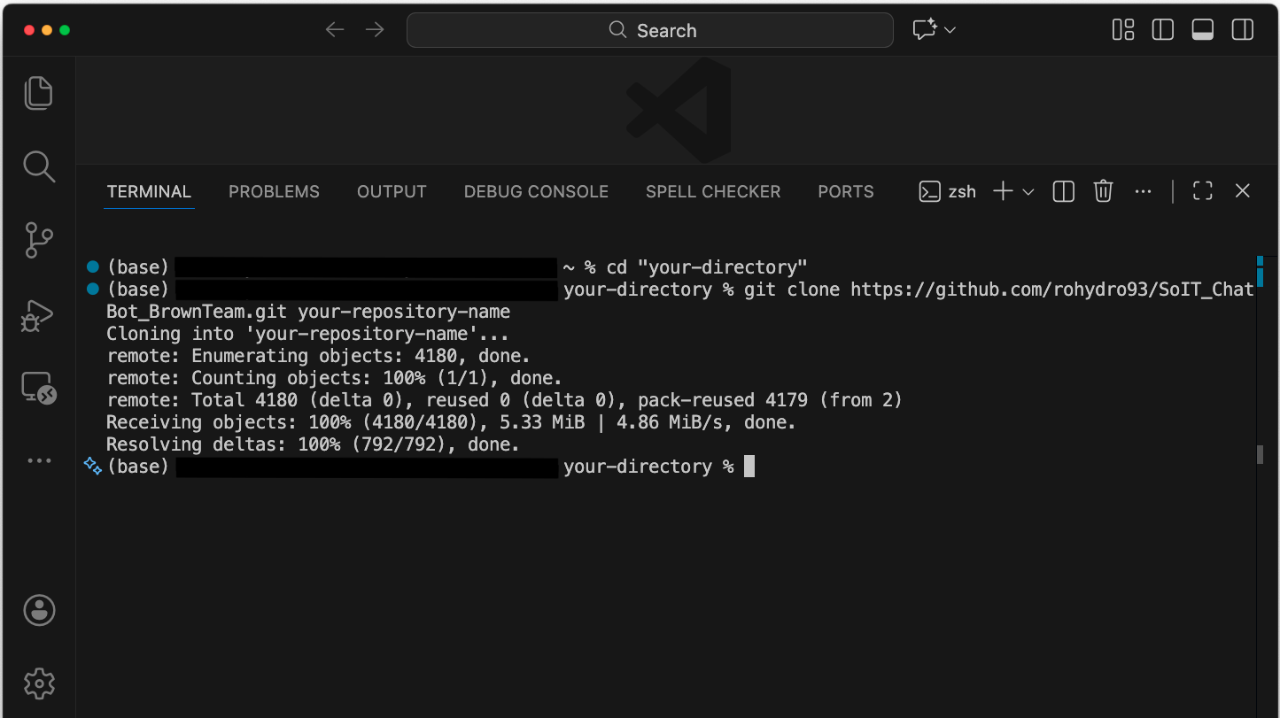
- Navigate to Cloned Project Folder
  - cd your-repository-name
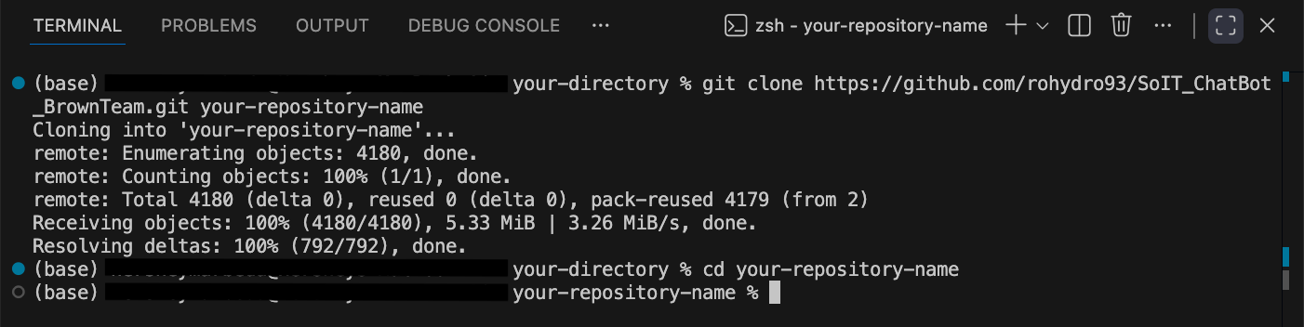
- Install Necessary Dependencies: Node.js would need to install required packages. Use the command to install those dependencies.
  - npm install
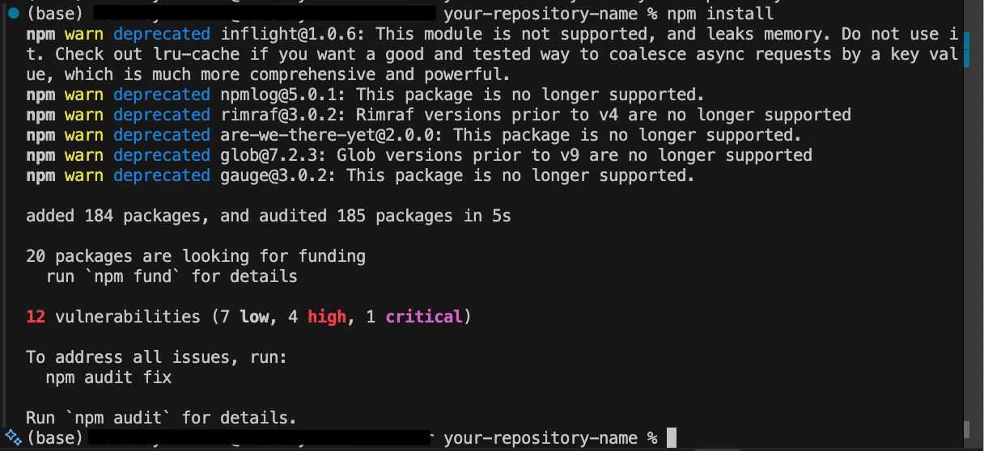
- Start the Server: The port would be 3030. Replace ‘3030’ if you have an ongoing application on that port.
  - npm start
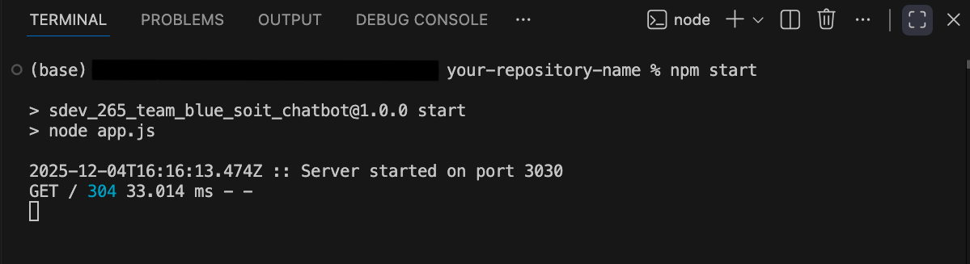

- Open Any Browser: Copy and paste the link below to run and interact with the chatbot
  - http://localhost:3030
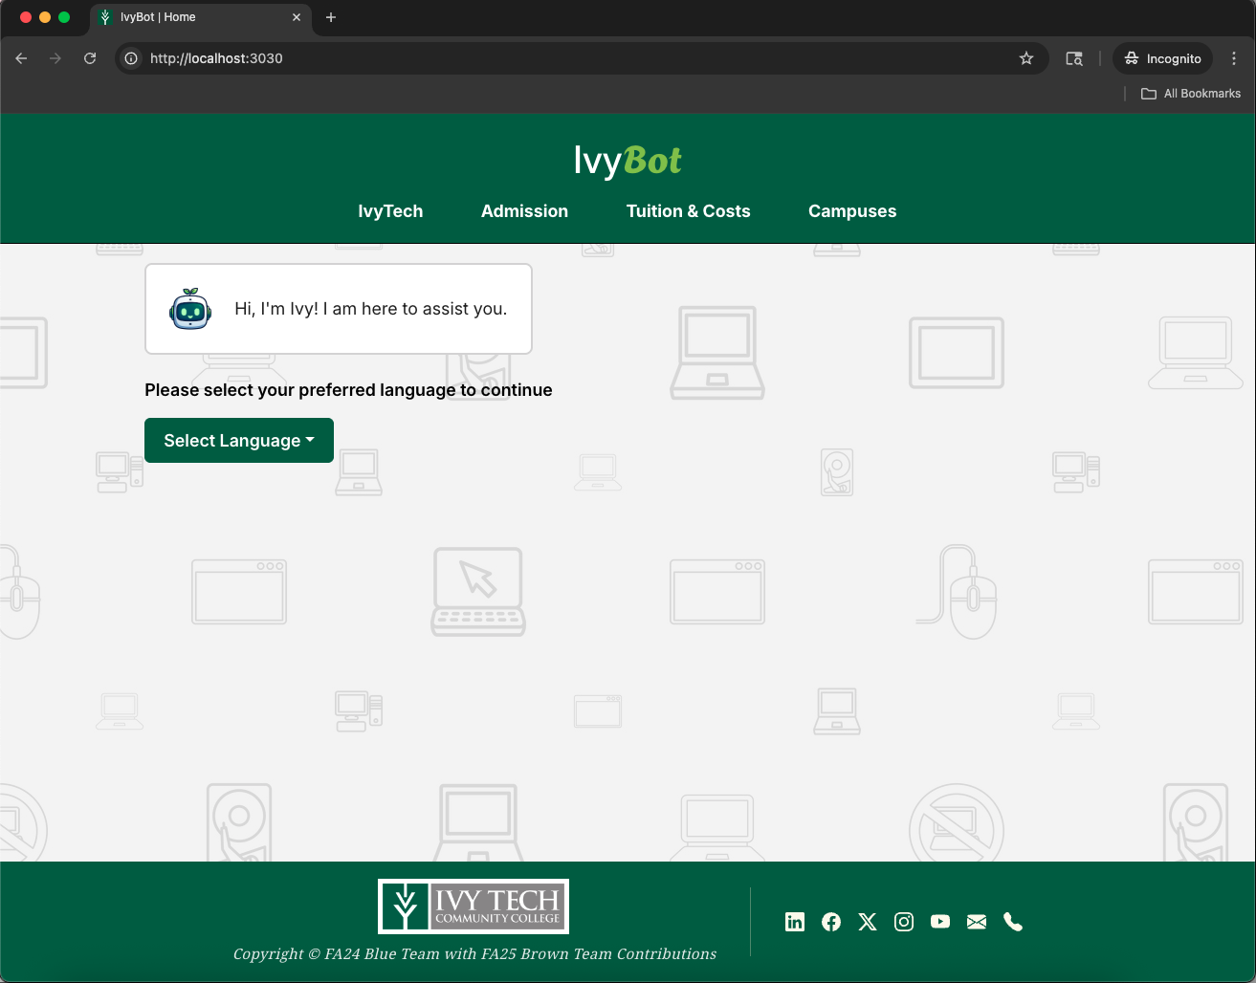
- Start Interacting with the Chatbot (IvyBot)
  - Select a ‘Language’ to use to interact with IvyBot
  - Select a ‘Role’ to continue. If you’re a Student, Staff, or Faculty, please use your school email address (@ivytech.edu). Remember, you can always click ‘Back’ if you accidentally chose the wrong ‘Role’.
  - Use the text entry box to start interacting with IvyBot!

Interaction with IvyBot

Initial User Guidelines from SDEV 265 FA24 Blue Team
- Start the Conversation
  - Type your message in the text input field at the bottom of the chat window
  - Press the ‘Enter’ key to send your message
- Receive Responses
  - The chatbot will process your message and display a response in the chat window
  - If the chatbot’s response indicates a lack of understanding on its part, try to rephrase the question for better results.
- Continue interacting with the chatbot

Language Selection
The Chatbot has two language preferences that a user can choose to interact with: English and Filipino. In either language, the chatbot can smoothly respond unless your inquiry is not in the database. NOTE: The chatbot’s current version is strict in extracting its responses. For example, if the user chose English in the beginning, the chatbot would only respond in English and vice versa unless the user chose to change the language.
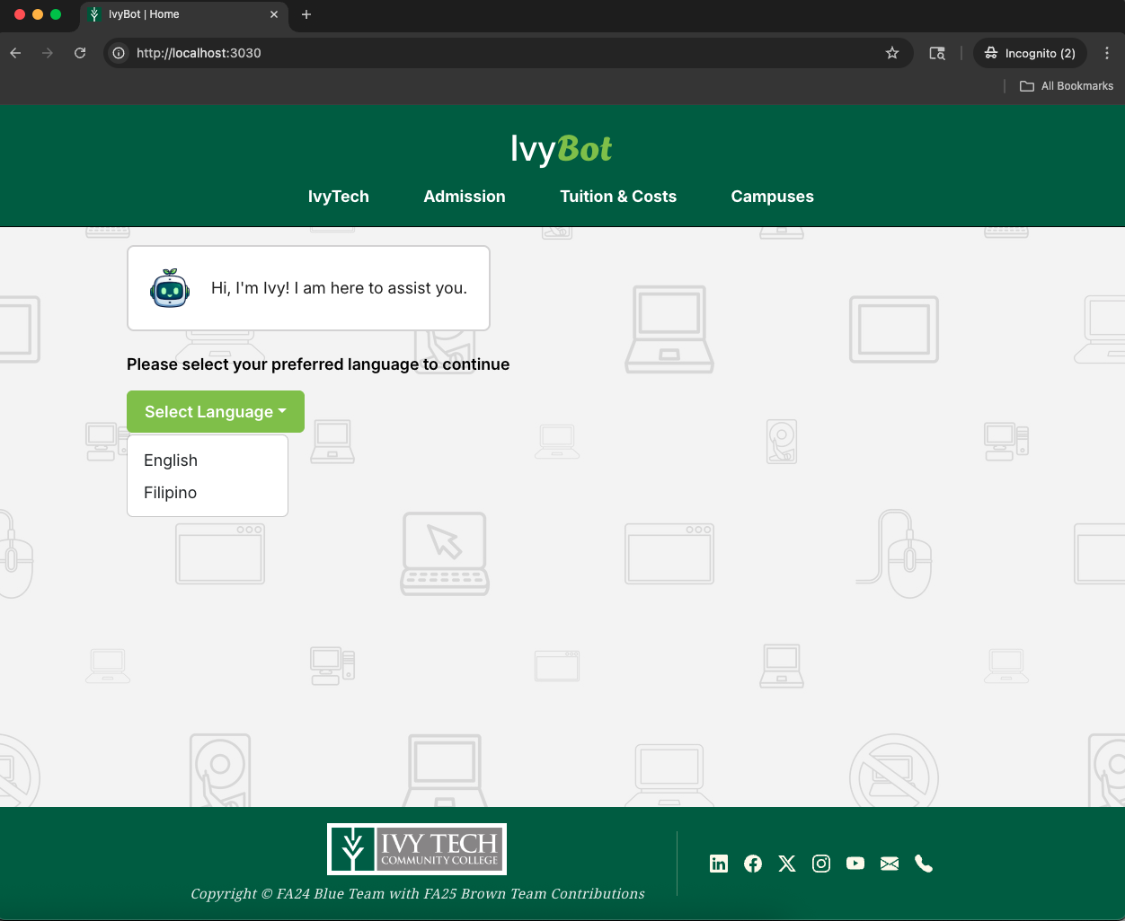

After a few minutes, the language modal will appear and ask you if you still want to continue your selected language. Either way, you can still interact with the chatbot smoothly.
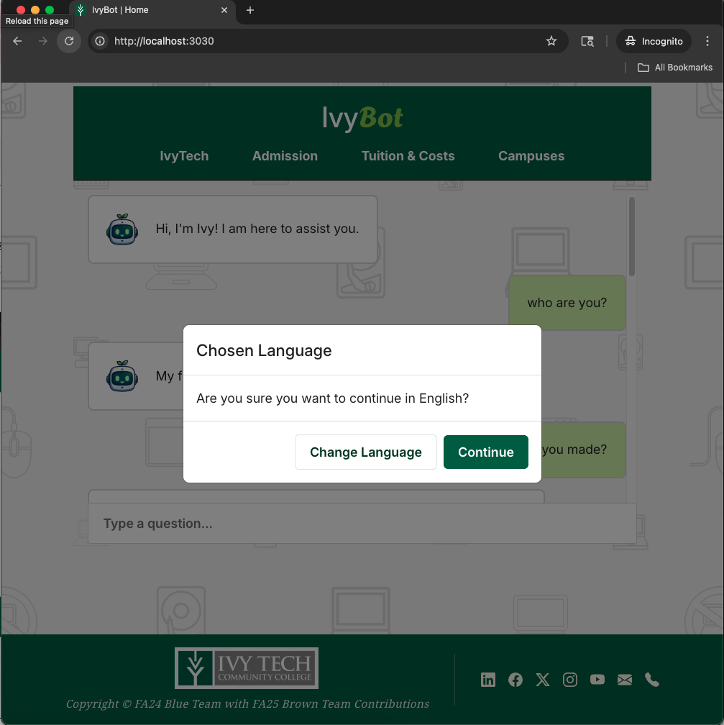
Figure: Modal Language Confirmation (English)
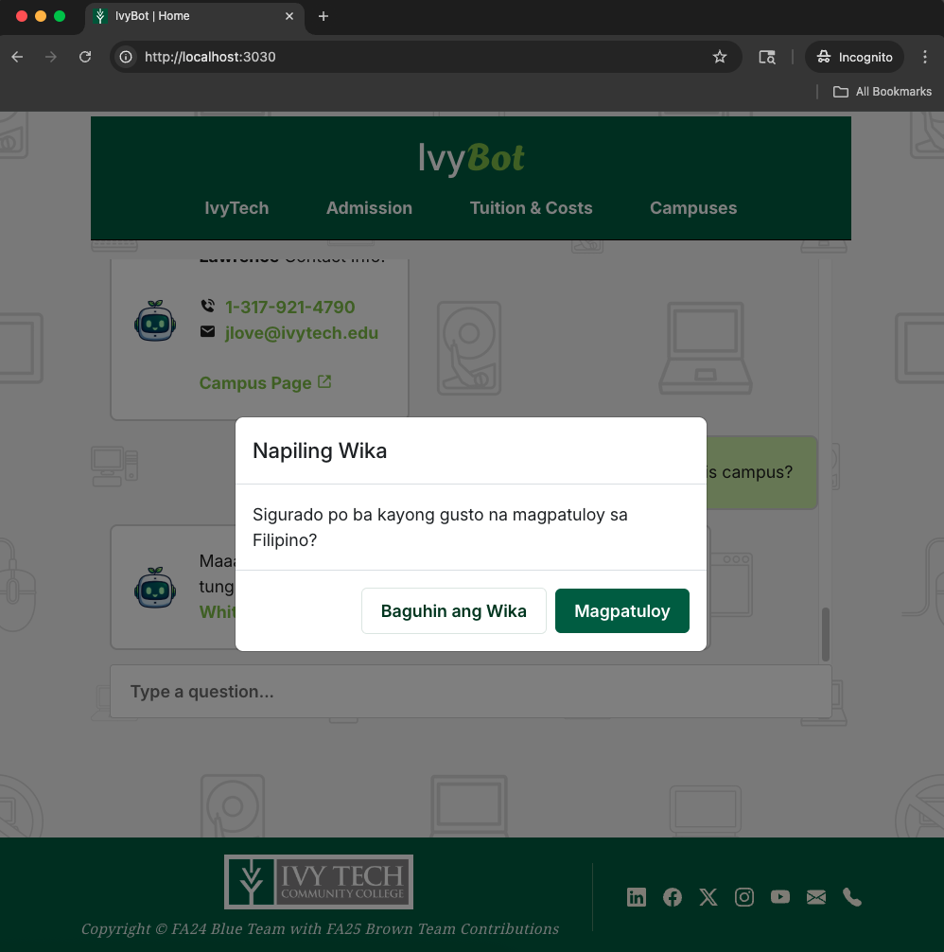
Figure: Modal Language Confirmation (Filipino)
* Please note that the Filipino language used in the chatbot is a mix of Filipino and English in its sentence structure.
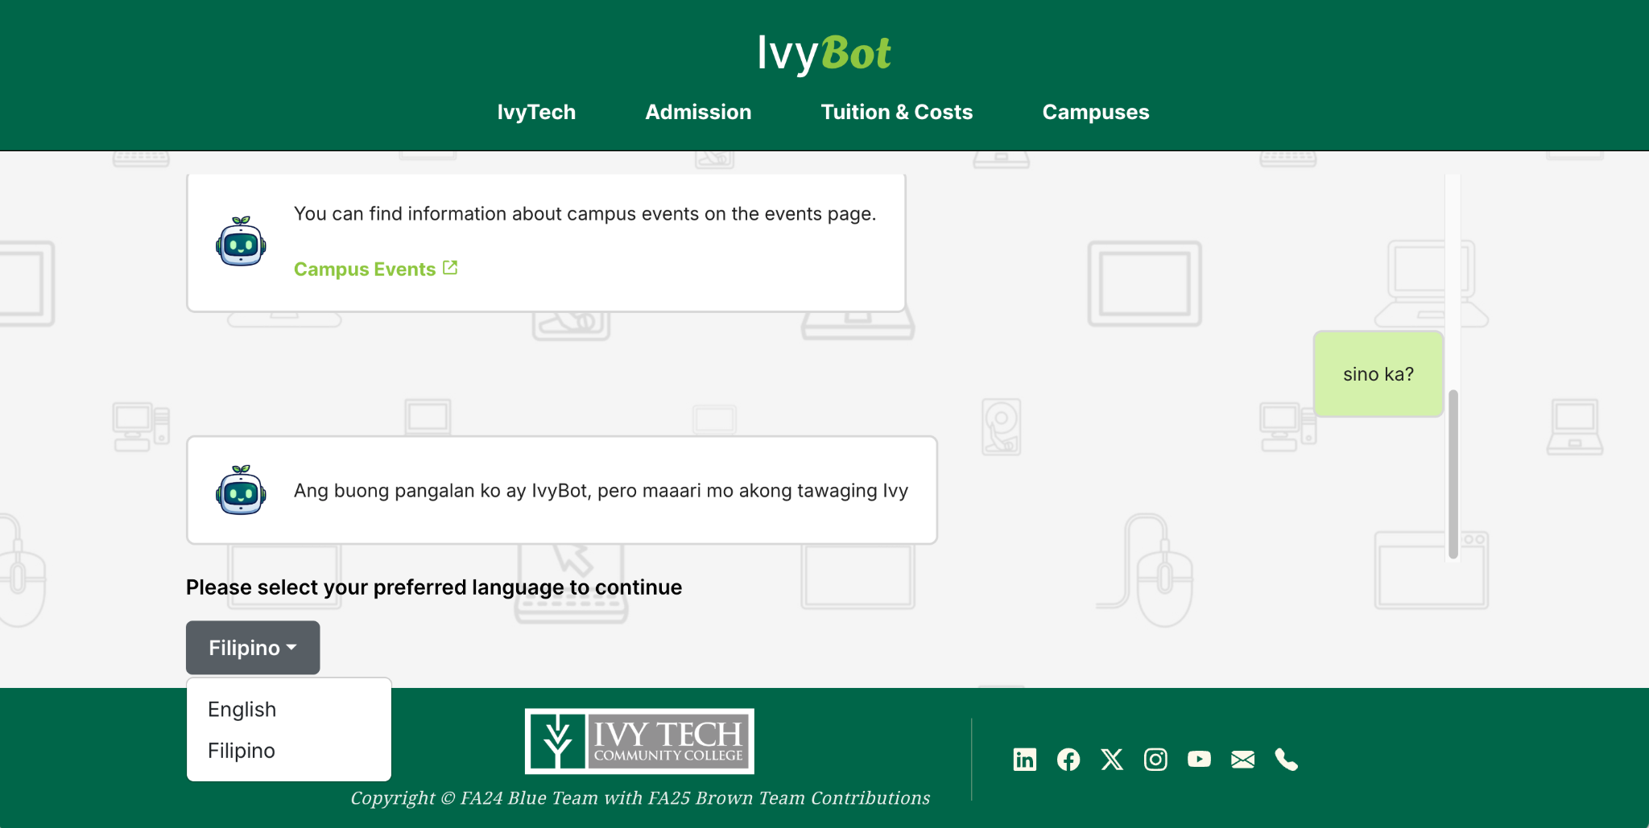
Figure: Display when the user decides to change the current language preference

Input Validation
- If you choose the wrong ‘Role’, you can always click the ‘back’ button to bring you to the main prompt. Note: You need to select a ‘role’ and enter an email if you wish to interact with the chatbot.
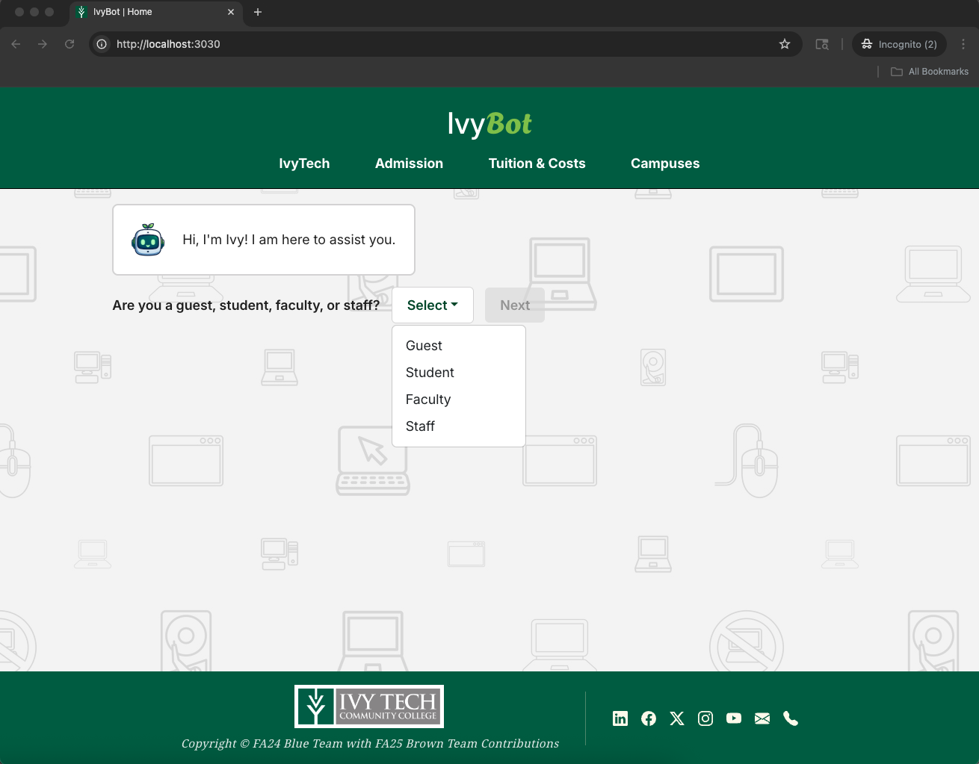
Figure: Role Input Validation

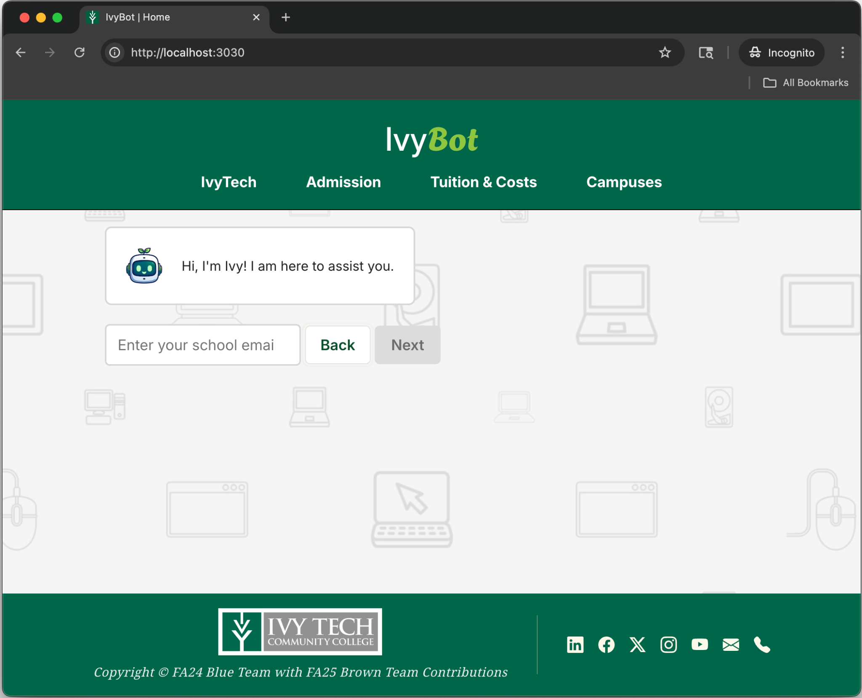
Figure: Email Input Validation

- Users identifying as Student, Faculty, or Staff must enter their school email to interact with the chatbot. Note: Only emails ending with “@ivytech.edu” are allowed.
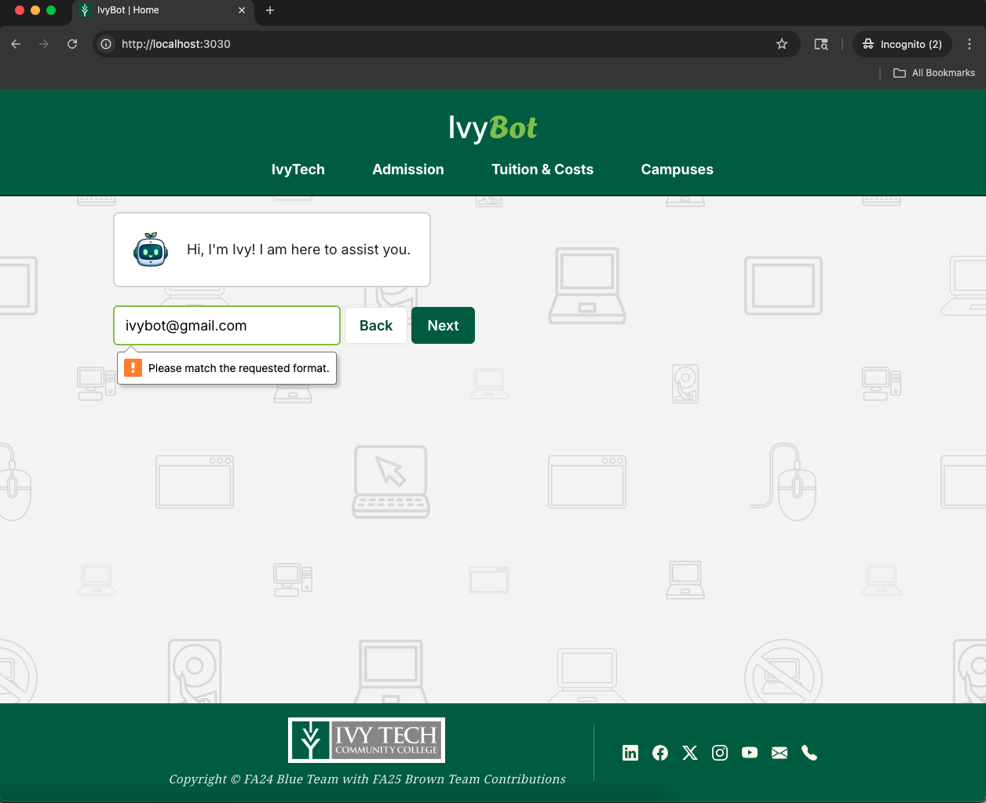

System Structure
Below is the expected folder structure for the ChatBot.
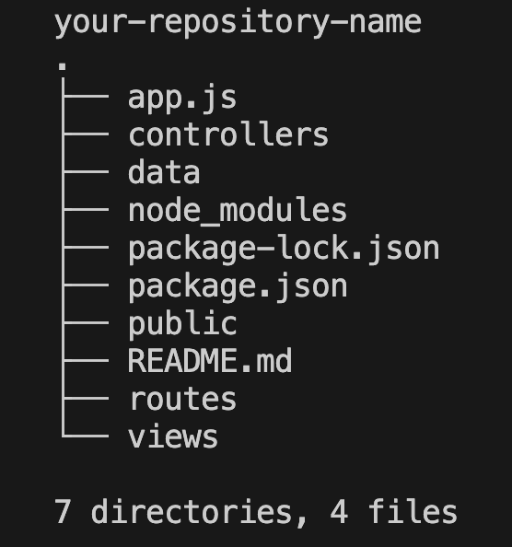
Below is the expected folder structure with the important supplemental documents for the ChatBot, excluding ‘node_modules’ folder due to its extensive content, but make sure that the said folder is still included in the directory.
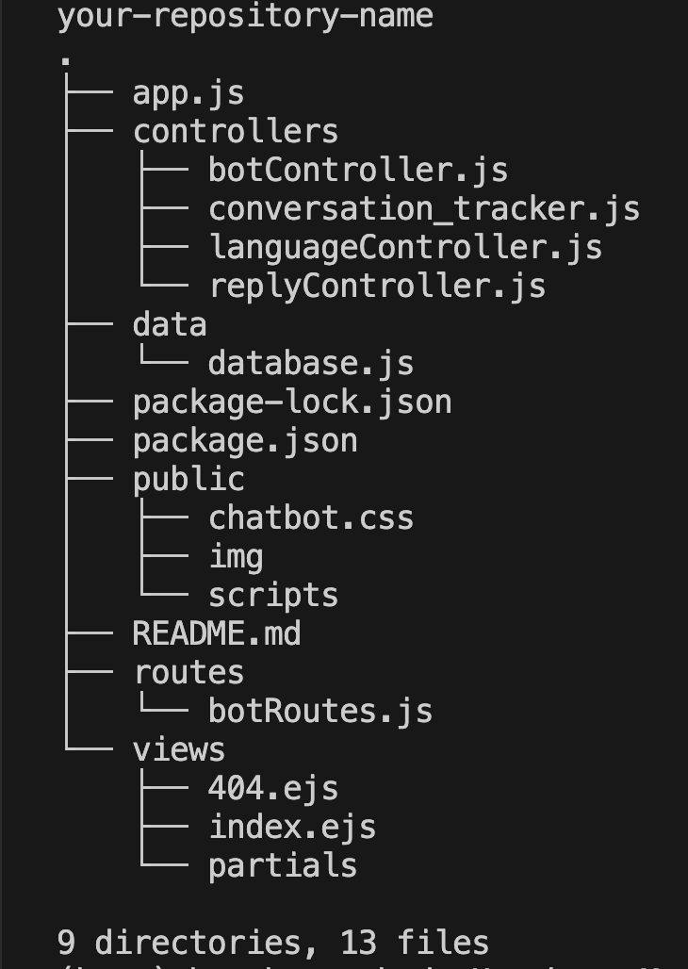

System Structure: Folder Information

Folder Name | Detailed Information
controllers | The documents inside it contain the files that show how the chatbot behaves. This is where the chatbot would extract its responses from.
data | The stand-in database for storing responses. Later on, this directory is also responsible for storing the unanswered_inquiries.json and chat_session_logging.json
public | Contains the JavaScript and CSS codes that are responsible for making the HTML formats responsive
views | Contains the HTML files that you can see on the front-end

More Breakdown of Information
File Name | Information
database.js | This file is the stand-in database. You will notice that the information is categorized (called ‘intent’).  - Intent is short for intentions  In this way, it would be easier to track or rank which is the best response to give to the user.
botContoller.js | This is the main controller that is responsible for ranking the responses from the database.  - Fuzzball  - More information: https://www.npmjs.com/package/fuzzball
unanswered_inquiries.json | This file is responsible for storing all the inquiries that are not covered by the current version of the database.  - The format is NoSQL  - It would also store the ‘question’, ‘userType’, ’schoolEmail’, ‘date’, and ‘ticket’.
chat_session_logging.json | This file is responsible for tracking the conversation between the bot and the user  - It includes the following information:  - Ticket, userType, schoolEmail, and the whole conversation with intent, and language (if other than English).  - Format is also using NoSQL

Important Notes For the Filipino Language
From Hershey Beatrice Marbeda:
I am a native in speaking Tagalog, and I think of Filipino as the ‘formal’ way of speaking Tagalog. Just like English, there are multiple ways of asking or addressing in Filipino, though it may differ in how it relates to others, such as relationship, context, and respect.
In my use of the Filipino language, I used different styles of response, such as adding hyphens, expanding “ng” to “nang,” and expanding more Filipino words and incorporating English terms within Filipino sentence structures. As someone who grew up in the Philippines, I believe that my generation rarely speaks in straight Filipino unless necessary; we often mix Tagalog and English, which is commonly referred to as "Taglish." I also ensure that the more formal ways of asking questions in Filipino are included, such as using “po” and “opo” to convey respect. I also made the fallback response in Filipino to use ‘po’ and ‘opo’.
This is why many people from various regions of the Philippines find it easier to learn English compared to Filipino.
You can think of the responses I added as “broken” Filipino, but feel free to revise them since it’s been a while since I’ve written in straight Filipino sentence structure. (I also apologized in advance huhuhuhu)

Summary
The original chatbot was created by the SDEV 265 FA24 Blue Team for the SoIT at Ivy Tech Community College. Building upon this foundation, the SDEV 265 FA25 Brown Team has decided to significantly enhance its capabilities. The Brown Team’s goals are broadening the chatbot’s database, improving its context-awareness features, and refining the overall user experience.
In the latest update, the Brown Team has introduced bilingual support for English and Filipino, allowing for seamless communication with a diverse user base. They have significantly expanded the database to include essential information such as upcoming campus events, student life details, campus addresses, contact information, and many more. Additionally, the chatbot's context-awareness has been improved to be more friendly and accommodating of spelling errors. To enhance the overall user experience, modern icons have also been integrated into the interface, making it more visually appealing and user-friendly; they have also added mobile views.
Looking ahead, the Brown Team recommends several improvements for further enhancements. They suggest the implementation of an Application Programming Interface (API) to streamline the communication and facilitate more dynamic functionality. This would not only enhance user experience but also allow for the inclusion of real-time data, making responses more relevant and timely. A potential API integration with Google Translate has been considered, although the Brown Team acknowledges that cost factors could pose a challenge. Overall, these recommendations aim to facilitate ongoing improvements, ensuring the chatbot remains an effective and engaging application for the SoIT.

Resources Used
- Figma | Designing the mockup
- Google Fonts | Fonts used in the chatbot
- Bootstrap | Responsive layout with its grid system and its icons
- VS Code | Coding the chatbot
- Google Chrome | Interacting with the chatbot
- Git | Version Control
- GitHub | Remote Git Repository
- SDEV 265 FA25 Blue Team | Original Creators & To-be Forked GitHub Repository
- VS Code extension: Go Live | Previewing HTML & CSS Changes
- VS Code extension: Tree | Visualizing Folder Structure

Example of Interaction
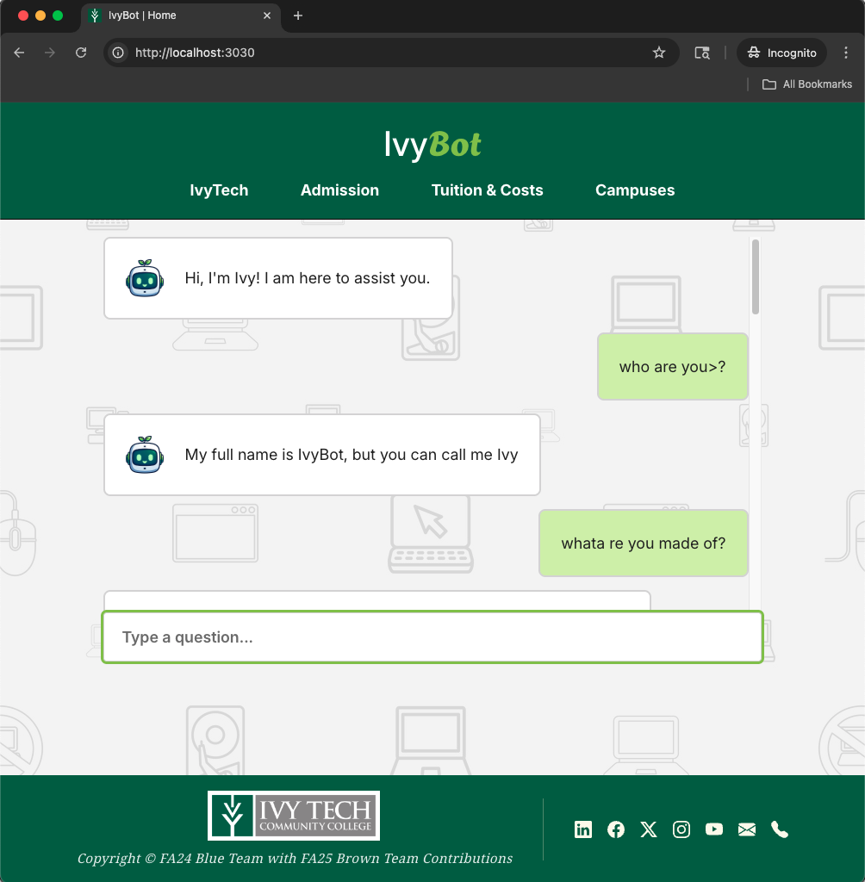
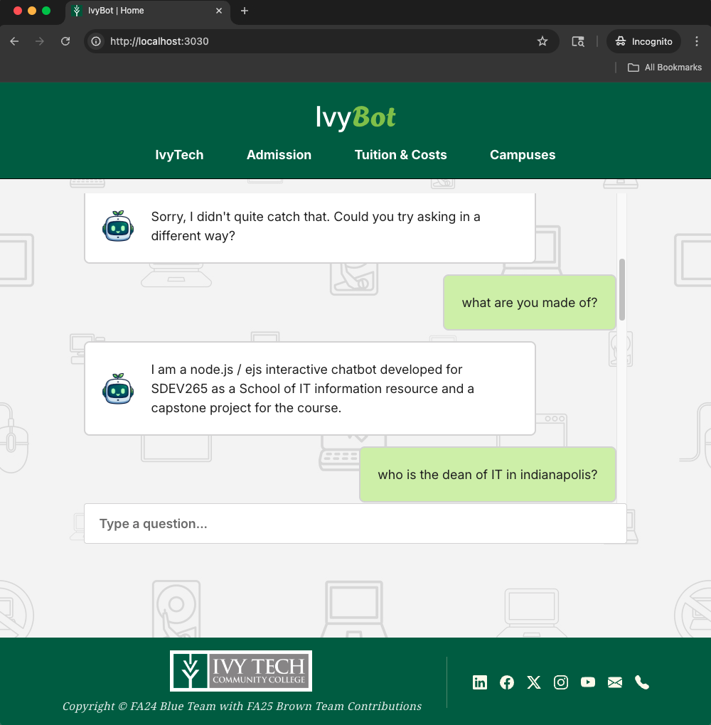
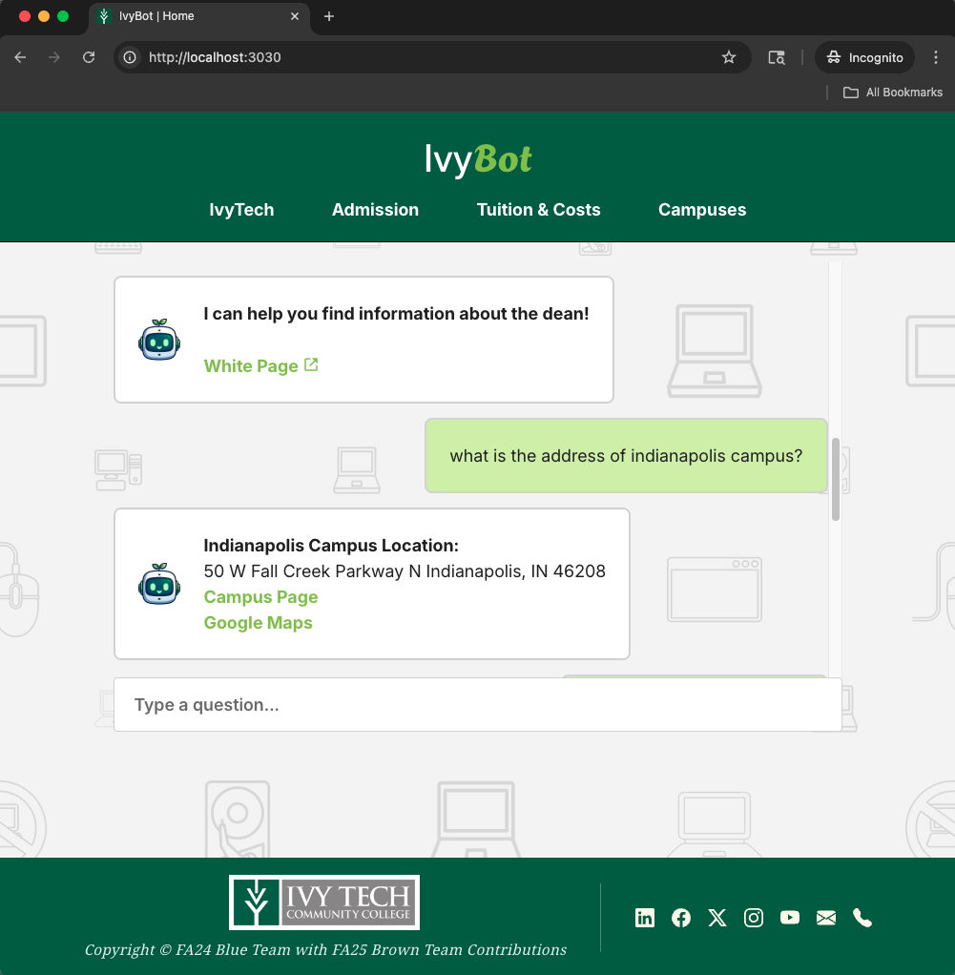

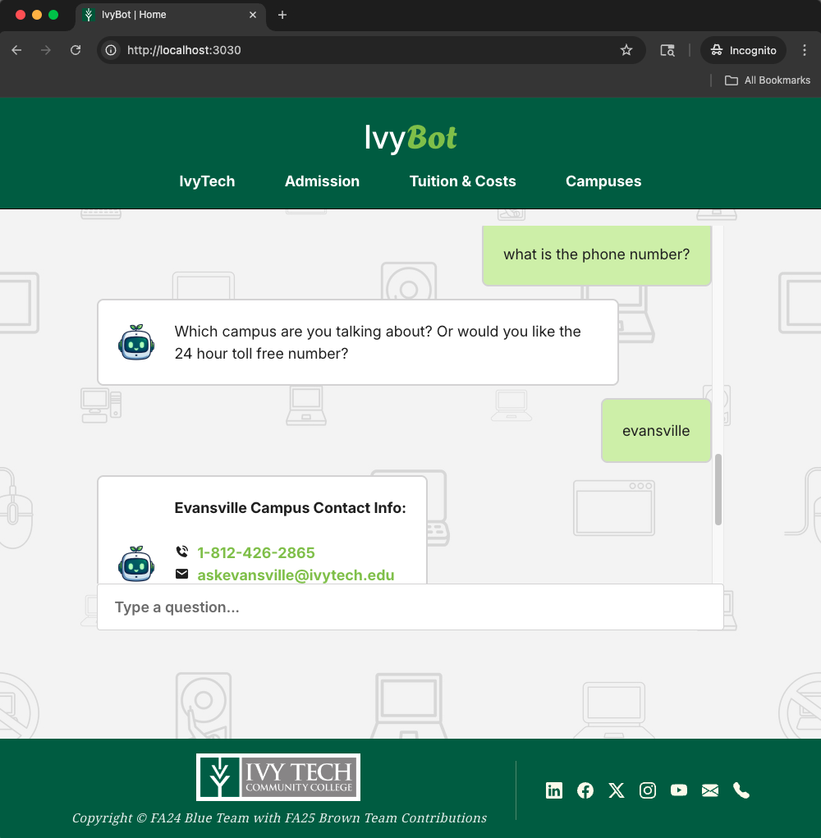
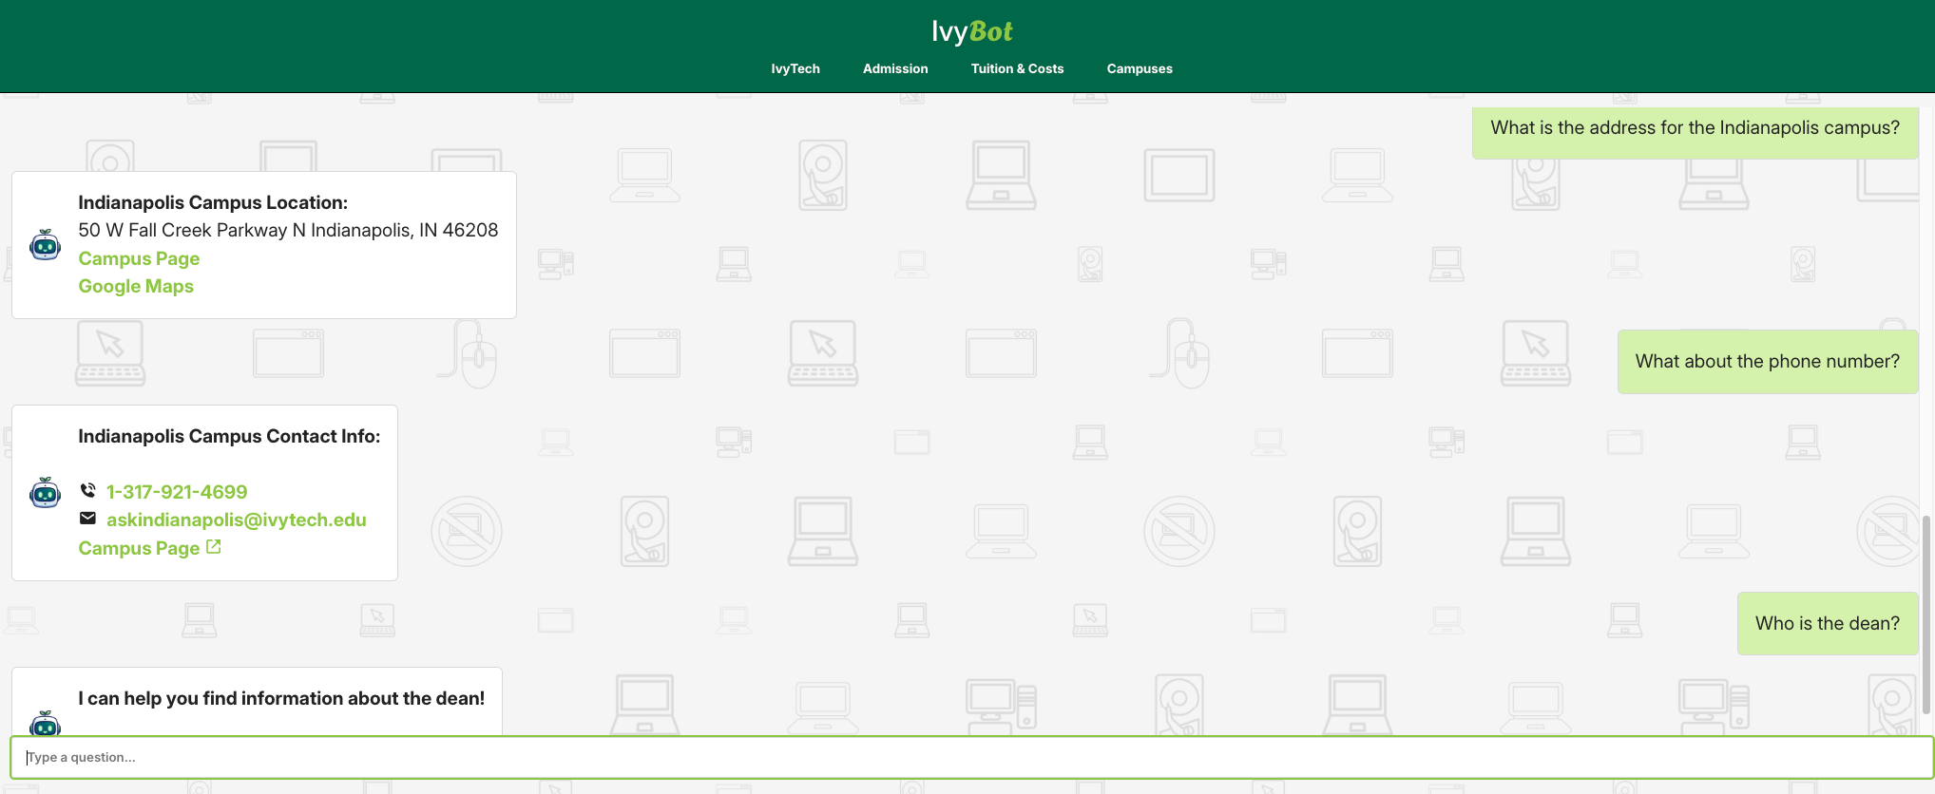

NOTE: If the user has provided specifics, the chatbot would then can also provide other information regarding the inquiry.
