Trae Toelle

Professor Michael Oetken

DIGME137

12/12/22

**Toyota Final Project**

The main goal of the website is to promote and sell the vehicles listed by Toyota. A main portion of Toyota’s branding is to have a sleek design which is evident by their current website and the design of their vehicles. The goal of the mobile app is for users to interact with their car, schedule maintenance with the dealership and authorized service centers.

The target audience of Toyota’s website is potential buyers. Toyota wants to sell cars, and their website is an outlet for that. It gives the user the ability to customize, compare and build the Toyota of their dreams. The customer uses the website to shop for their next or first vehicle, every specification chosen by the user.

As far as the content of the page is concerned, it will remain similar in many respects. The same media placement and cake layer design. However, some changes need to be made such as: removing the “Discover Toyota” carousel at the bottom of the homepage. Another change is adding “My Toyota” to the navigation bar, this way users of the website who are existing owners can easily get to the portal in less clicks. Changes to the build a car side need an overhaul, giving bigger buttons and a better design. The vehicles page gets a more familiar design, akin to Amazon or any other online marketplace. The ToyotaCare information page gets scaled up and fluff content removed. Also, just moving around some of the icons and general layout changes as detailed by the layout thumbnails on the next page.

**

**Vehicles Page**

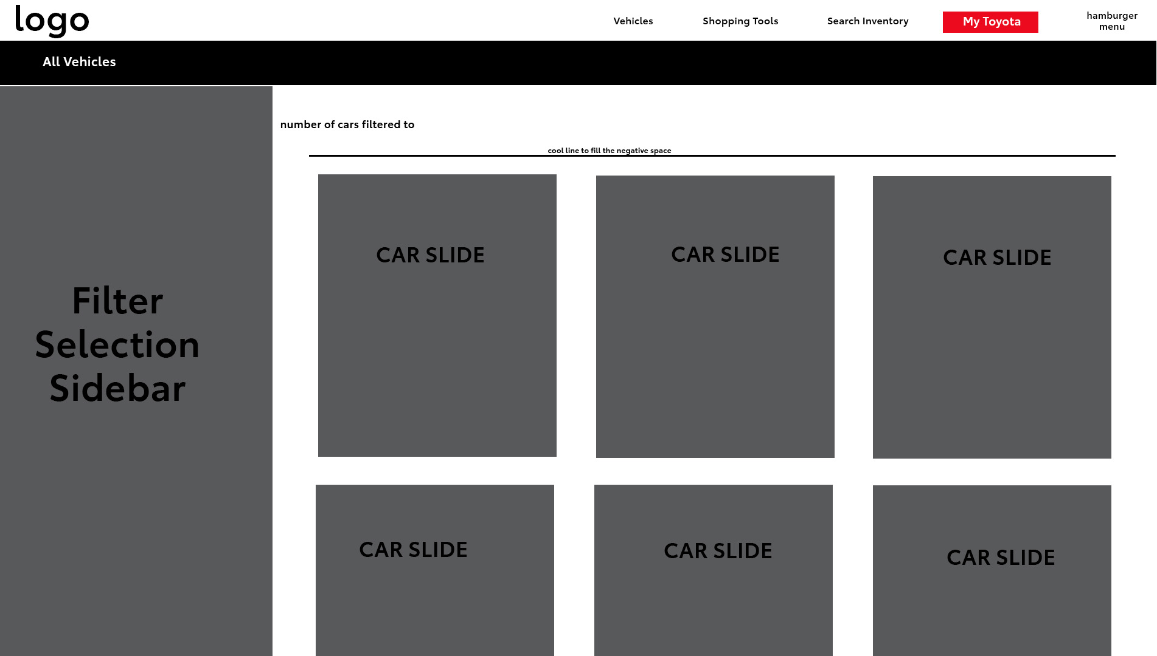

**ToyotaCare**

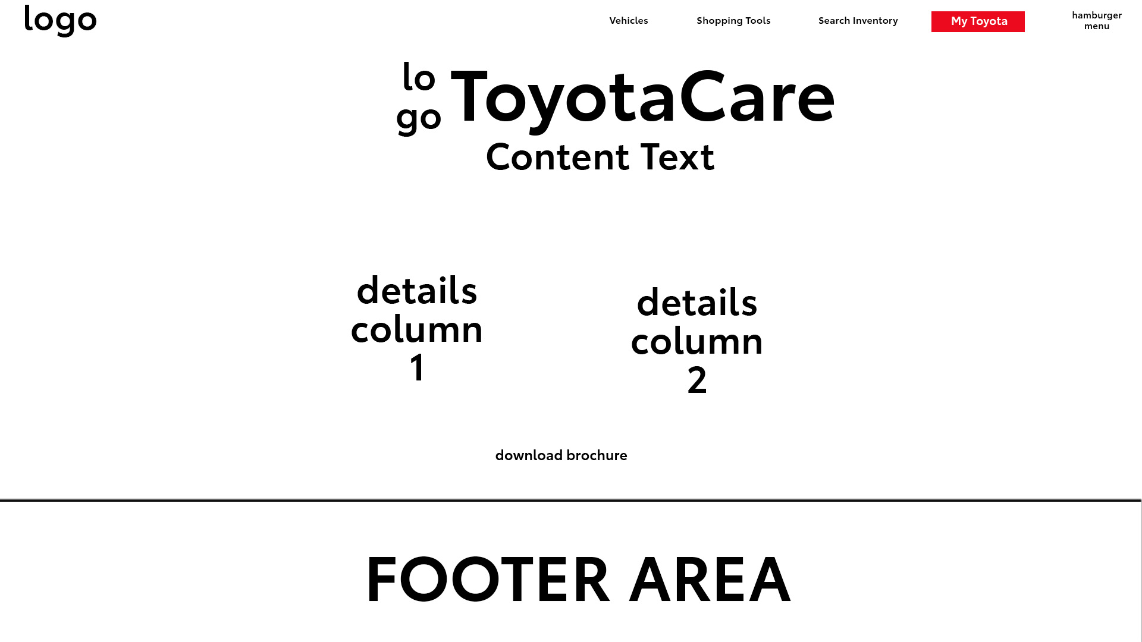

**Mobile App**

With their mobile app, Toyota’s goal is to give their owners a way to control, view and interact with their car from their phone. Whether that is locking their car or starting it from their bedroom on a cold winters’ day. The mobile app is designed to be as sleek and simple as their cars. White backgrounds, and Toyota’s colors, this keeps with the design of their website. The main point of the app is to use as a remote for the car and keeping track of the health and status of their car. While also being able to shop for accessories, schedule service and get roadside assistance when needed.

Note: For the planning I really didn’t do any, I just started doing it and the ideas came to me.