DATA WRANGLING USING PANDAS

Balerite, Roi Benedick S.

2ECE-E

Problem 1

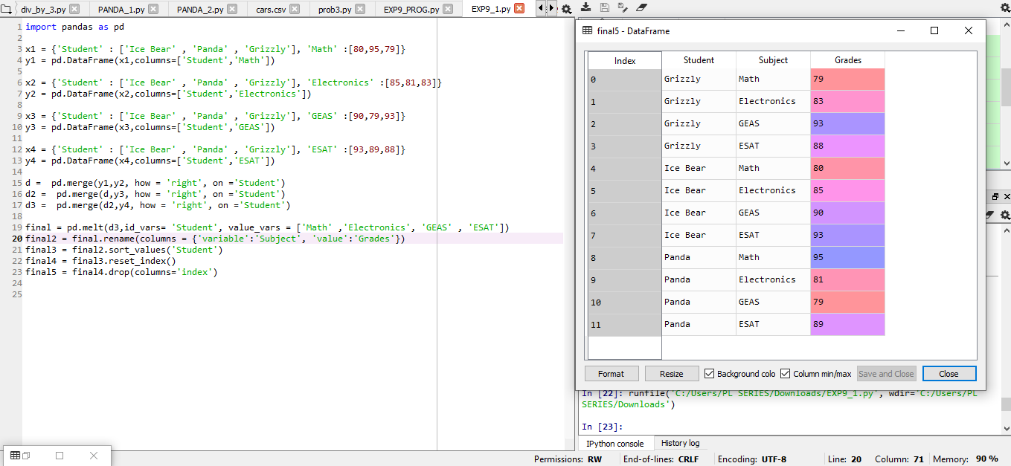

Problem 2

