Baremetal Programming using Raspberry Pi
International University Liaison Indonesia
Authors: Roid Maulana and Victor Hugo

Operating System
An operating system is simply a set of programs designed to run in the background on a computer system, giving an environment in which application software can be executed. It is a set of software designed to run in the background on a computer system, giving an environment in which application software can be executed.

Most OS consist of a large set of programs, only some of which are stored in the processor memory all of the time. Many of the subroutines available in the OS are stored on the hard drive so that they can be accessed when needed. This not only saves space in the processor memory but also means that the OS can be easily replaced when needed.

When you are using an applications package you are not communicating with the computer hardware, you are communicating with the OS. Without the OS, no matter how many programs there are, the computer would be completely useless. The OS sits between the hardware and application program/ the user.

Responsibilities of an OS includes:
- Hiding the complexities of hardware from the user.
- Managing between the hardware’s resources which include the processors, memory,data storage and I/O devices.
- Handling Interrupts generated by the I/O controllers.
- Sharing of I/O between many programs controlled by the CPU.

Generally, there are two types of software that usually reside on an OS
- System Software are programs that manage the operation of a computer.
- Application Software are programs that help the user perform a particular task.

Von Neumann Architecture
The phrase Von Neumann architecture derives from a paper written by computer scientist John Von Neumann in 1945. Describing design architecture for a computer with subdivisions of a central arithmetic part, central control, a memory to store both data and instructions, external storage and the management of input/output devices. The meaning of the phrase has evolved to mean a stored program computer. A stored program computer is one that keeps its programmed instructions, includes data, in random access memory (RAM). Since previously designed computer were to have its data and programs stored in separate memories. Von Neumann realized that data and programs are indistinguishable and can use the same memory.

On a large scale, the ability to treat instructions as data is what makes compilers, assemblers and other automated tools possible. One can “Write programs which write programs”. This led to the introduction of compilers which accepted high level languages as input and binaries as output.

The Von Neumann architecture uses a single processor which follows a linear sequence of Fetch-Decode-Execute. The processor has to use some special registers, these registers are mapped discretely in memory locations with special purposes attached, such as PC and ACC. The central processor contains Arithmetic Logic Unit (ALU) and Control Unit (CU). The data processing occurs in the ALU which involves logical operations whereas the CU fetches instructions from memory,decodes and synchronizes the operations before sending signals to other hardware parts or registers.

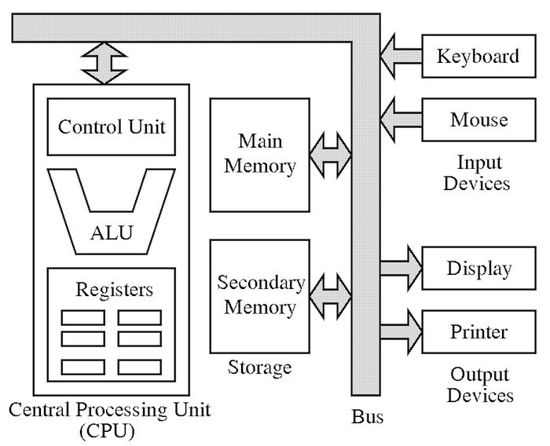

Figure 1. Typical Layout of Von Neumann Architecture
source: https://thecustomizewindows.com/wp-content/uploads/2013/07/Von-Neumann-Architecture.jpg

Memory Management
In order for a processor to execute a job, this job must be stored in the computer’s main memory. Suppose jobs A,B,C and D require 50k,20k,10k and 30k of memory respectively and the computer has a total of 130kB available of free space (keep in mind that the OS will take up some space).
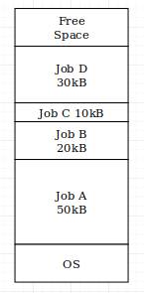

Figure 2. possible arrangements of the supposed jobs

When jobs are loaded into memory, they may not always occupy the same locations. Supposing, instead of the A,B,C and D jobs are located in a consecutive order, another job E is required to load right after. Now job D occupies different locations in the memory to those shown in Figure 1. Another problem to be solved is when to move jobs. Possible solutions are:
- Whenever a job terminates.
- When a new job is too large for any existing space.
- At regular given intervals.
- When the user decides.

This system is known as variable partitioning with compaction. Imagine that each job needs a space to fit into, this space is called the partition. Each of the jobs requires a different size of space, hence “variable partitions”. These variable partitions are normally called segments and the method of dividing memory up into pieces is called segmentation. We also say that sometimes it is necessary to move jobs around so that they fill the spaces left by jobs that left, this is called “compaction”.

An alternative method to divide both the memory and the jobs into fixed size units is called paging. As an example, suppose jobs A,B,C,D and E consist of 6,4,1,3 and 2 pages respectively. Also suppose that the availability in main memory for jobs consists of 12 pages and jobs A,B and C have been loaded into main memory.

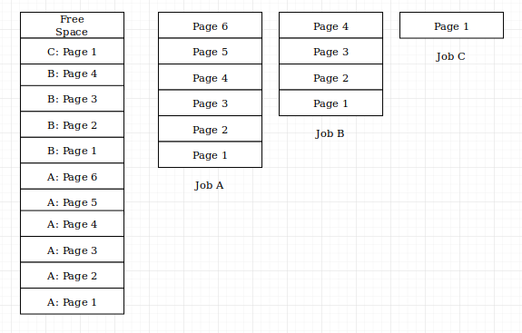

Figure 3. Dividing jobs into pages

Now suppose job B terminates, releasing four pages, and jobs D and E are ready to be loaded into main memory. Clearly there’s a similar problem caused by segmentation. The free space now consists of four extra pages into which job D (three pages) will fit, leaving a single page with an addition from the original one page free of memory. Job E consists of two pages, even though there is enough memory for job E the pages are not in contiguous order meaning they are not joined together which leaves a messy situation.
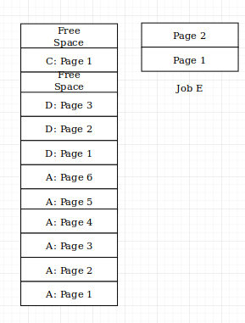

Figure 4. Problem with segmentation

The big difference between partitioning and paging is that jobs won’t need to occupy space in a contiguous manner. Therefore the solution goes something like this:
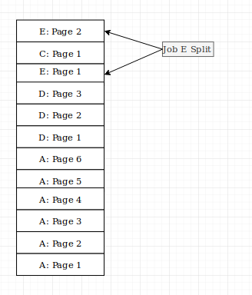

Figure 5. Problem fixed by paging and partitioning
The problem can be overcome by keeping a lookup table that indexes which memory pages are pointed to. Then, if each address used in a job consists of of a page index and the range required is from the start to the end of that page, a suitable conversion is possible.

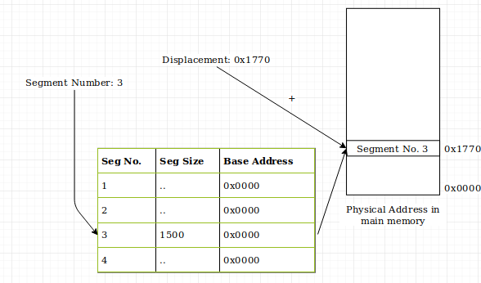
Figure 6. Lookup segmentation table

RISC and CISC
The Instruction Set Architecture (ISA) is the set of basic instructions that a processor understands. The instruction set is a portion of what makes up architecture. Historically, the first two philosophies to Instruction Sets were RISC and CISC. The merits and argued performance gains by each philosophy are and have been thoroughly debated.

Complex Instruction Set Computer (CISC) is rooted in the history of computing. Earlier developments were based around the idea of benefiting the CPU to a more complex structure able to support larger number of potential instructions which would lead to increased performance.
This idea is at the root of CISC processors, like the Intel x86 Family, which have very large instruction sets and increased complexity in other areas, with many more specialized addressing modes and registers implementation. The complexity of the processor’s architecture that was built for CISC is meant to be difficult to understand and program, it also meant that they were very expensive to produce.

Reduced Instruction Set Computer (RISC) was realized in the mid-1980s by IBM. The idea here was that the best way to improve performance would be to simplify the processor workings as much as possible. RISC processors, like the ARM Family, have greatly simplified and reduced the Instruction Set, numbering to a hundred instructions or less and addressing modes are simplified back to four or less. Fewer transistors are used to produce the processors meaning that RISC processors are much cheaper to produce. To an extent, the reduced instruction set means that the processor can execute instructions quicker potentially allowing for greater speeds, but at the same time places a greater burden upon the software itself. Less instructions means a greater emphasis on the efficient writing of software with the available instructions.

Interrupts
The simplest way of executing instructions goes somewhat like this diagram
Of course this is satisfactory as long as it goes with the flow, unfortunately things do go wrong more often and sometimes changes need to be configured in order to keep the flow going.

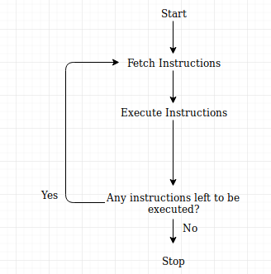

Figure 7. Generic execution of instructions

For example, a user has used up all the time allocated to his use of the processor. This change in order is instigated by messages to the processor, also known as interrupts. There are four nature of the type of interrupts, these are:
- I/O Interrupts
  - Generated by an I/O device that a job is complete or an error has occurred. Example may be printer running out of paper or not connected. In some cases, drivers may need to be installed in order for the computer to understand who it is communicating with.
- Timer Interrupts
  - Generated by an internal clock indicating that the processor must attend to time critical activities.
- Hardware Interrupts
  - Mistreatment in the hardware may result an interrupt indicating that the OS must power off in safe manner, example may be power failure.
- Program Interrupts
  - Generated due to an error in a program such as the violation of memory usage or an attempt to execute an invalid instruction.

If the OS is to manage interrupts, the sequence from Figure 7 needs to be modified further.
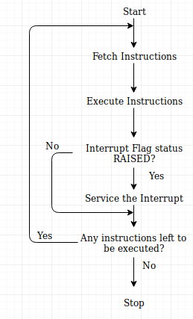

Figure 8. Generic execution of instructions with interrupts enabled
Figure 8 shows that after the execution of an instruction, the OS must see if an interrupt flag has been raised. If the flag happens to be raised, the OS must service the interrupt in the case that it is more important than the task already being processed to be executed. This involves obeying to a new set of instructions. The real problem is “how would the OS arrange the interrupted program to resume from exactly where it was left before and how does the OS deal with multiple interrupts all at once?”

In fact, the answer to how the OS resumes back to where it was left off is to reserve the contents of all the registers in the processors so that the OS can use them to service the interrupted program. And the answer to the second problem is by simply placing the interrupts in a queue. This only allows the processor to return to the originally interrupted program when the interrupt queue is empty. A First In First Out (FIFO) procedure can be implemented which holds the indications to then next interrupts that will have to be dealt with.

Device Management
Responsible for detecting and managing devices and exposing devices to userspace.
- Device Drivers – Allow user applications to communicate with system’s devices.
- Device Detection – Starts with root bus driver, organized in a tree structure, it detects buses present on the system as well as devices directly connected to motherboard.
- Exposure to userspace – Most Unix based OS exposes through filesystem tree, a directory containing special case files that represent devices (usually /dev). Advantage of this is that devices can be treated as files, easy to read and write into.

Bare Metal Programming
Bare metal programming is a term used when a program is run without any hosted environment, and run directly on the machine's hardware.
The program is run in Ring 0, and have a full access to the entire machine hardware without restriction. The processor will execute the instruction as is, which is important for some time critical hardware that requires real time computation.
The simplest way to write a bare metal program is by write it in the machine's assembly language, while programming with higher level language such as C requires a special compiler suite for every target architecture.

The Raspberry Pi
Raspberry Pi is a brand of low cost single board computer, powered with ARM based processor supplied by Broadcom. Every model has General Purpose I/O pin bank, that allows the machine to be used as a micro-controller.

Raspberry Pi 3 Model B Boot Process
On receiving power, Raspberry Pi 3B will perform the hardware reset and initialization, and execute a small program from the ROM to be able to read the boot media, partition table, and the file system format, which is FAT32. Then it began searching for some files named bootcode.bin, fixup.dat, and start.elf on the bootable partition of the SD card. The file bootcode.bin, fixup.dat, and start.elf contains the required bootloader instruction to read and load the kernel image file before points the program counter register to the entry point of the kernel to start executing it.

Raspberry Pi 3 Model B Bare Metal Programmings
Raspberry Pi 3 Model B has BCM2837 chipset, which has identical addressing with the BCM2835 chipset in Raspberry Pi 1, Raspberry Pi 1 Model B, and Raspberry Pi Zero. Generating the kernel image file for Raspberry Pi 3 Model B requires the ARM Embedded Application Binary Interface for bare metal version of GCC toolchain. If required, another toolchain from different vendor might be a better option for the purpose.
Generating the kernel image file for Raspberry Pi 3 Model B requires the ARM Embedded Application Binary Interface for bare metal version of GCC toolchain. If required, another toolchain from different vendor might be a better option for the purpose. The toolchain provides arm-none-eabi-as as the assembler, and arm-none-eabi-gcc as the C compiler. The generated object file is wrapped in the ELF file format to position and link the instructions properly with the provided arm-none-eabi-ld, and then dump it back to a raw image file with arm-none-eabi-objcopy with -O binary flag.

BCM2837 Chipset GPIO Addressing
Raspberry Pi 3 Model B with BCM2837 chipset maps their GPIO module from address 0x3F20 0000 to 0x3F20 00B0. The mapped address is divided to multiple banks to control the behavior of the GPIO module. Each bank is 32-bits or 4-Bytes wide, and operation is expected to be performed on 32-bits aligned word size. Some functionalities require multiple banks to perform, therefore the banks is grouped together in a sequential manner. The functionality banks cluster is separated with a reserved bank, that either should not be manipulated by the processor, or has no effect at all.

The first 6 banks is reserved to control the operation mode of the GPIO pins with the GPIO Function Select Registers (GPFSEL) cluster. Each GPIO pin is managed by modifying 3-bit bitmask field on the bank to select the mode and behavior of the pin. 0b000 denotes that the pin is used as digital input, 0b001 denotes output pin, while the rest is used for specific pin alternate functionality such as PWN, I2C, and interrupt. The bitmask is ordered sequentially from GPIO pin 0, until GPIO pin 53, and tightly packed aligned to the 32-bits bank width instead of the 8-bit character boundary.

A reserved bank separates the GPIO control cluster with the GPIO Pin Output Set Registers (GPFSET) cluster. The GPIO Pin Output Set Registers consists of 2 bank which resides in 0x3F20 001C and 0x3F20 0020, and control the state of the GPIO pin with digital output mode selected in the GPFSEL register. The states of the Output pin is represented with 1-bit bitmask, where a bit with value 1 denotes HIGH state of the output pin, and a value of 0 denotes LOW state of the output pin. The bitmask is tightly packed, and ordered sequentially from GPIO pin 0 until GPIO pin 31 in the 0x3F20 001C bank, and GPIO pin 32 until GPIO pin 53 in the 0x3F20 0020 bank.

Another reserved bank separates the GPSET with GPIO Pin Output Clear Registers (GPCLR) cluster. GPIO Pin Output Clear Registers consists of 2 banks in address 0x3F20 0028 and 0x3F20 002C. It clears the state of the GPIO pin with digital output mode selected in the GPCLR register to LOW level. The states of the Output pin is represented with 1-bit bitmask, where a bit with value 1 denotes HIGH state of the output pin, and a value of 0 denotes LOW state of the output pin. The bitmask is tightly packed, and ordered sequentially from GPIO pin 0 until GPIO pin 31 in the 0x3F20 0028 bank, and GPIO pin 32 until GPIO pin 53 in the 0x3F20 002C bank.

Bare Metal Blinking Light in Raspberry Pi 3 Model B
The LED is connected to pin 21 in the Raspberry Pi 3 Model B GPIO pin, and to blink it requires a working compiler toolchain, and the bootloader.
The flow of the program to blink the LED is as follows:

- GPIO pin 21 needs to be initialized as output by changing the bitmask to 0b001 in the GPFSEL bank. The mask for the GPIO pin 21 is the second triple bits located in the second bank of the GPFSEL register, therefore the address of 0x3F20 0008 or an offset of 0x8 from the base class of 0x3F20 0000 needs to be assigned with the value of 0x8.
- To turn on the LED, the 21-st bit of the address 0x3F20 001c should be set to 1
- Add a delay by busy looping
- To turn off the LED, the 21-th bit of the address 0x3F20 0028 should be set to 1
- Add another delay
- Goto 2nd instruction
The final source code in C is as follows:
#define GPFSEL2 0x02UL //GPFSEL-2 register offset
#define GPSET0 0x07UL //GPSET0 register offset
#define GPCLR0 0x0AUL //GPCLR0 register offset
#define BASE 0x3f200000UL //Base address

//BITFIELD macro
#define SET_BIT3 0x08UL
#define SET_BIT21 0x200000UL
int main(void) __attribute__((naked));
int main(void)
{
unsigned int * gpio = (unsigned int*)BASE;
gpio[GPFSEL2] = SET_BIT3;
gpio[GPSET0] = SET_BIT21;
unsigned int i = 0;
while(1){
i = 0;
gpio[GPSET0] = SET_BIT21;
while(i++ < 100000){}
gpio[GPSET0] = 0;
i = 0;
while(i++ < 100000){}
}
}

To assist with generating the kernel image file, the following Makefile is used:
bin := kernel.img
elf := kernel.elf
obj := kernel.o
code:= # Insert the name of the .c file here
CFLAGS := -nostartfiles -mfloat-abi=hard -mfpu=crypto-neon-fp-armv8 -march=armv8-a+crc -mcpu=cortex-a53 -c
CC := arm-none-eabi-gcc
$(bin) : $(elf)
arm-none-eabi-objcopy $^ -O binary $@
$(elf) : $(obj)
arm-none-eabi-ld $^ -o $@
$(obj) : $(code)
$(CC) $(CFLAGS) -o $@ $^
Note : This Makefile is only for Raspberry Pi 3 Model B, as different compilation flag is required for another model

Conclusion
To try to generalize our conclusion of this we would start by saying that bare metal programming means talking to the hardware directly, bypassing an operating system. Processors/computers do not require operating systems to run. Operating systems are just programs anyway themselves perhaps being considered bare metal programming. With baremetal programming, it’s often dealing with registers and memory for peripherals directly. For example a simple approach to read items from and to an SD card using file-systems. Even for programmers, creating all the code from scratch would end up with some sort of layering abstraction, at one end is the baremetal talking to registers and the other end dealing with some sort of open file, create file, read file, etc.

