SQL 2 – question 2

a:
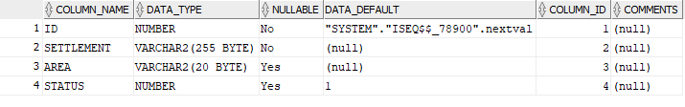
c:



d:
