SQL 2 – question 1

a:

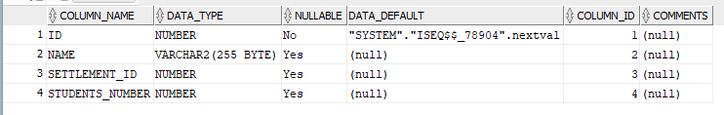
b:

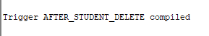

c:
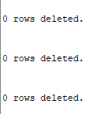
d:
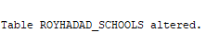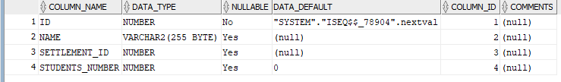

e:
after inserting :
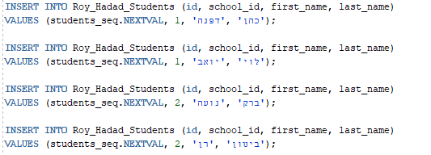
We got:
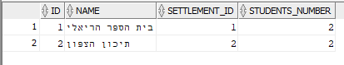
After updating :

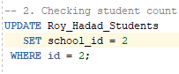
We got
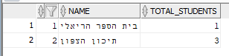

After delete :

We got
