SQL 1 – question 3

a.
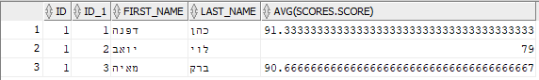
b.
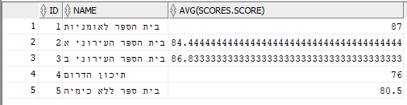
c.
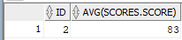
d:
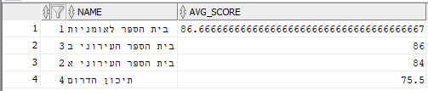
e:
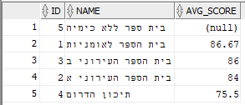
f:
g:
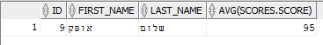

h:
