**Installing Service Mesh on OCP 4.2**

**Installing bookinfo example application**

oc apply -n bookinfo -f https://raw.githubusercontent.com/Maistra/bookinfo/maistra-1.0/bookinfo.yaml

oc apply -n bookinfo -f https://raw.githubusercontent.com/Maistra/bookinfo/maistra-1.0/bookinfo-gateway.yaml

export GATEWAY_URL=$(oc -n istio-system get route istio-ingressgateway -o jsonpath='{.spec.host}')

oc apply -n bookinfo -f <https://raw.githubusercontent.com/istio/istio/release-1.1/samples/bookinfo/networking/destination-rule-all.yaml>

Expose Gateway

#export GATEWAY_URL=$(oc -n istio-system get route istio-ingressgateway -o jsonpath='{.spec.host}')

#curl -o /dev/null -s -w "%{http_code}\n" http://$GATEWAY_URL/productpage

#echo $GATEWAY_URL

istio-ingressgateway-istio-system.apps.ocp.tmrnd.com.my

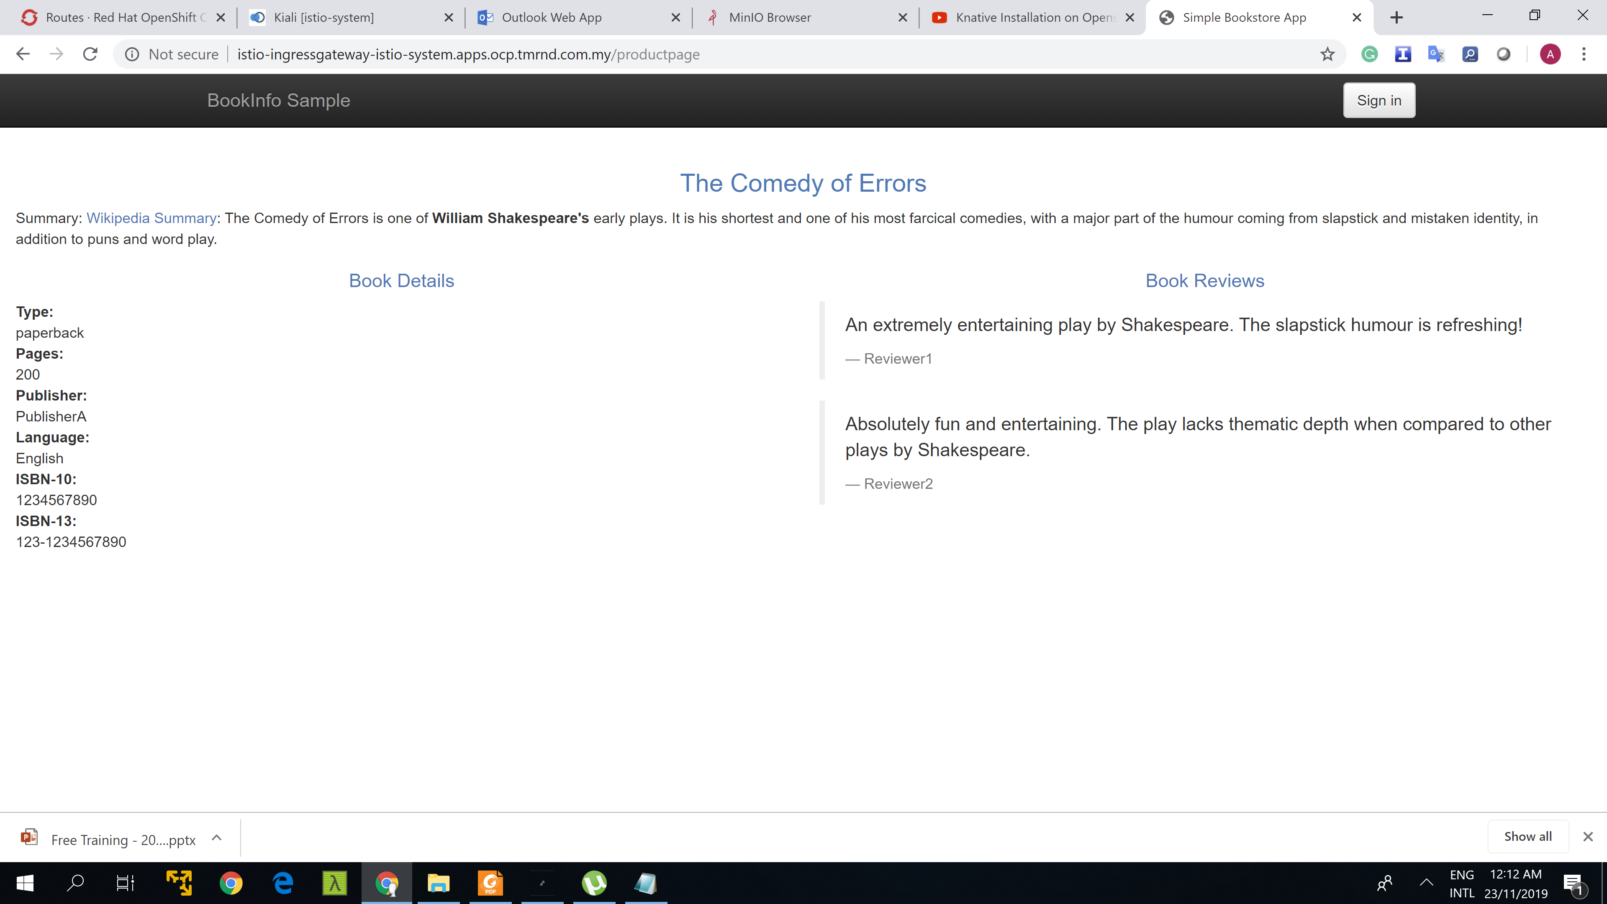

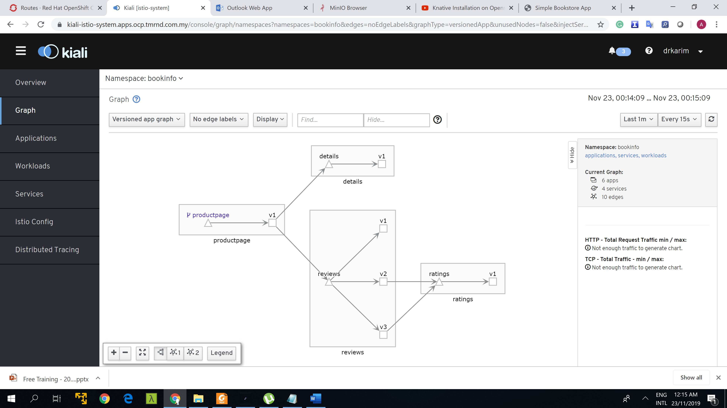

After refreshing many times

