**Sql Database – Tables & Commands**

* Staff Table Description
* Populating Table with staff details

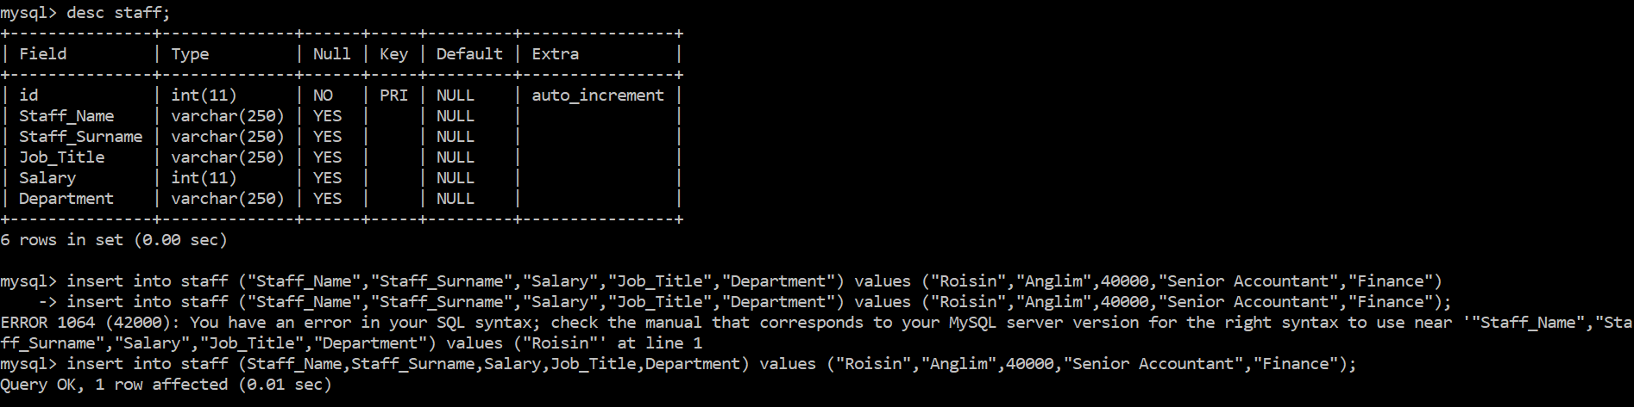

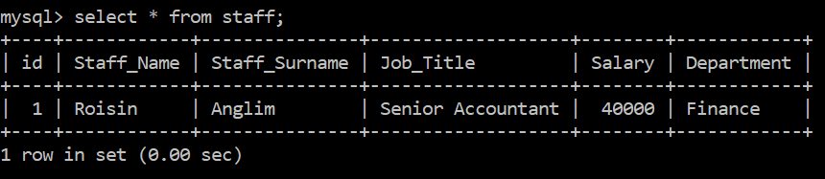

Check Id has been amended from web application

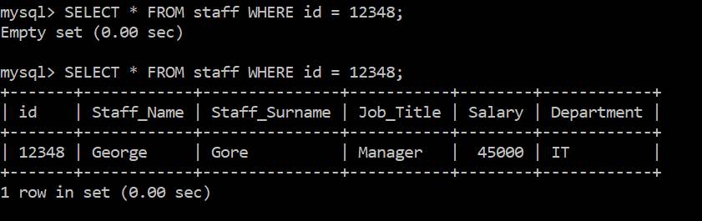

Inserts informaton into store table

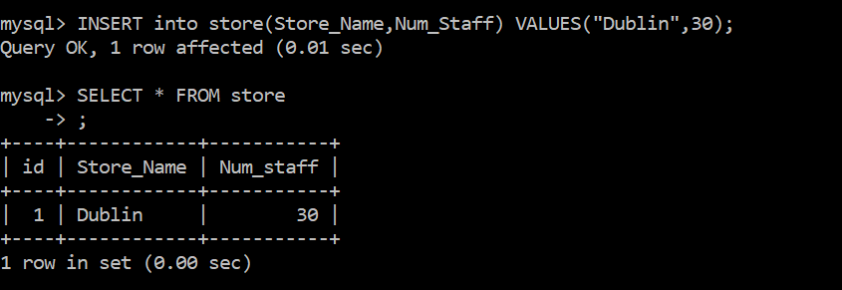

Returns information from store table & show table descriptions