Course 811M

Python for Data Scientists

Exercise Manual

|  |
| --- |
| **The following course materials are copyright protected materials. They may not be reproduced or distributed and may only be used by students attending the *Python for Data Scientists* course.** |

**Table of Contents**

Exercise 2.1: Array Creation 1

Exercise 2.2: Array Basic Operations 3

Exercise 3.1: Pandas Series 5

Exercise 3.2: Pandas DataFrame 7

Exercise 3.3: Working with DataFrame and Series 9

Exercise 5.1: Working with Matplotlib 11

This page intentionally left blank.

# Exercise 2.1: Array Creation

The aim of this exercise is to gain some experience of working with NumPy arrays.

1. Start IPython.
2. Define an ndarray containing the integer numbers 0 to 9.
3. Print the type of the array to the console.
4. Print the following properties of the array (they are accessible in the same way as ntype):
   1. ndim
   2. shape
   3. size
   4. itemsize
5. Define a 3 x 3 NumPy array containing all 1’s and display it to the console.
6. Print the four properties of Step 4 on the array defined in Step 5.

This page intentionally left blank.

# Exercise 2.2: Array Basic Operations

The aim of this exercise is to gain some experience of working with basic operations on NumPy arrays.

1. Define a 3 x 3 array with the integers 1 through 9 named array1.
2. Define a second 3 x 3 array with the number 2 in each cell named array2.
3. Now, perform the following operations using the two arrays:
   1. array1+array2
   2. array1-array2
   3. array1/array2
   4. array1*5
4. Print elements 4 to 6 of array 1 using a slice operation.
5. Create a new single-dimensioned array named array3 with the numbers 0 through 19 in it.
6. Take a slice of elements 5 to 15 of array 3 and assign the slice to a variable named aslice and print the variable.
7. Modify the contents of the first and last elements of the slice by writing the value 99 into these elements.
8. Print the contents of the slice aslice and the array array3. Are the contents what you expect of both arrays?

____________________________________________________________

This page intentionally left blank.

# Exercise 3.1: Pandas Series

The aim of this exercise is to gain some experience of working with the NumPy Series data structure.

1. Define a Series object holding the values 1 to 10.
2. Display the data values of the Series object defined in Step 1.
3. Display the index values of the Series object defined in Step 1.
4. Define a new Series object holding the values 1 to 10, with the corresponding index values set ‘a’ through to ‘j’.
5. Display the data values and index of the Series object of Step 4.
6. Access the third and fifth elements of the Series object using their index.
7. Define the following dictionary: {'Dublin': 200000, 'Athlone': 15000, 'Galway': 700000}.
8. Define the following array: ['Dublin', 'Athlone', 'Waterford'].
9. Now, construct a Series object using the dictionary in Step 7 and the index in Step 8.
10. Display the Series object defined in Step 9.
11. Use the Series notnull() and isnull() methods to display which elements are not null and null, respectively, for the Series object defined in Step 9.

This page intentionally left blank.

# Exercise 3.2: Pandas DataFrame

The aim of this exercise is to gain some experience of working with NumPy DataFrame data structure.

1. Use the following dictionary to create a DataFrame:
   1. {'team':['Leicester', 'Manchester City', 'Arsenal'], player':['Vardy', 'Aguero', 'Sanchez'],'goals':[24,22,19]}
2. Display the above DataFrame to the console.
3. What values are assigned for the index and columns?

____________________________________________________________

1. Use the dictionary from Step 1 and create a second DataFrame with index values 'one', 'two', 'three', respectively, and columns team, player, goals, played. Display the DataFrame to the console.

This page intentionally left blank.

# Exercise 3.3: Working with DataFrame and Series

The aim of this exercise is to gain some more experience of working with NumPy Series and DataFrame data structures.

1. Define and display a Series object with the following data: [1.1,2.2,3.3,4.4] and index=['d','b','c','a'].
2. Reindex the data with the index index=['a','b','c','d','e','f'] and display the Series object. Are there any missing values? ______________  
   If so, reindex again and zero-fill the missing values.
3. Display only those values in the series that have a data value >2.
4. Define a 3 x 3 DataFrame with columns A, B, C and index a, b, c. You choose the integer values of the data for each cell. Display the DataFrame.
5. Reindex the DataFrame of Step 3 with the index a, b, c, d, e. Display the DataFrame. Is it as you expect? What order are the rows?

____________________________________________________________

1. For your DataFrame, display the data but only include those rows whose data in Column B is >2.
2. Define a 4 x 4 DataFrame of integer numbers. Define a 3 x 3 DataFrame of integer numbers. Add the two DataFrame’s together. What is the result?

____________________________________________________________

1. Repeat Step 7, but in a way that any missing values in the result are zero-filled.
2. Define the following DataFrame: DataFrame(np.random.randn(4,4)).
3. Now, define a Python Lambda function of the following form: f = lambda x: x.max() - x.min().
4. Apply the function in Step 7 to each row in the DataFrame defined in Step 9.
5. Repeat Step 11, but for each column.
6. Sort the DataFrame in Step 7 firstly by column index, then repeat by row index.
7. On the DataFrame defined in Step 7, apply the following functions:
   1. describe()
   2. sum() – do this for each axis

This page intentionally left blank.

# Exercise 5.1: Working with Matplotlib

The aim of this exercise is to gain some experience of plotting data using matplotlib.

1. Your task is to plot a chart similar to the following:

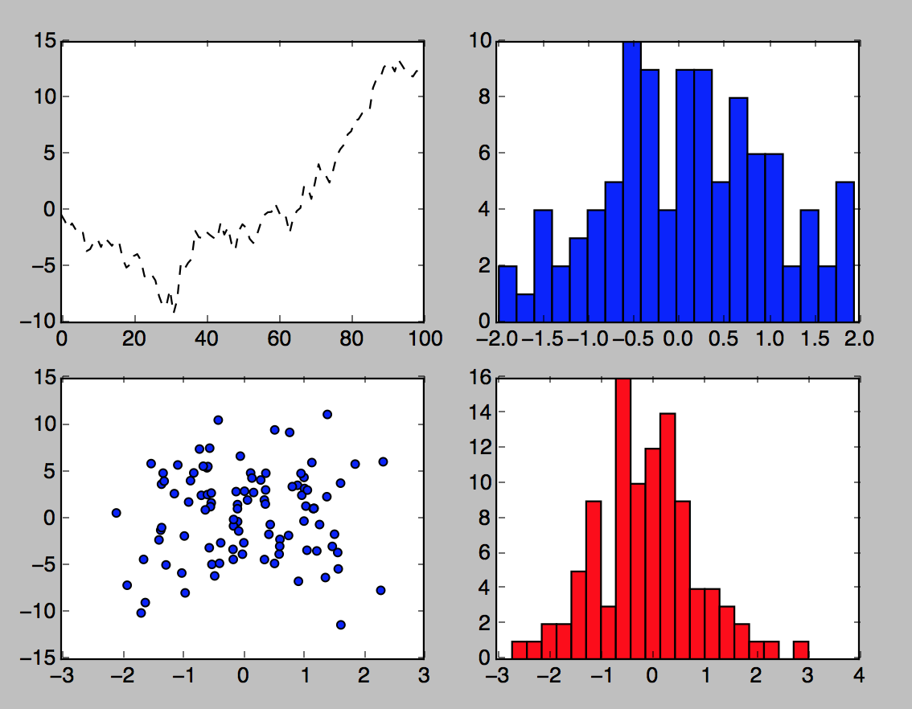

1. The data for the above can be generated as follows:
   1. For the plot: randn(x).cumsum()
   2. For the histogram: randn(x), bins=y
   3. For the scatter plot: randn(x), randn(x)-y*randn(100)
2. Plot the result of the cumulative sum of 2000 random numbers. The chart should have a title, x axis ticks set at 1, 500, 1000, 1500, and 2000 intervals, and x and y labels.
3. Define the following DataFrame:
   1. DataFrame({'A': np.random.randn(1000) + 1,'B': np.random.randn(1000), 'C': np.random.randn(1000)-1})
4. Plot the DataFrame from Step 4 as a histogram.
5. For the DataFrame of Step 4, plot a scatter plot for the following:
   1. Column A vs. Column B
   2. Column B vs. Column C
6. Add labels and a title to the plots in Step 6.