STUDENT NAME | R.ROJA
STUDENT REGISTRATION NUMBER | 251U1R2064 | CLASS: AIML-IC
PROGRAM | UG | YEAR and TERM:  1st year & 1st term
SUBJECT NAME | HTML
NAME OF THE ASSESSMENT | _{Reflective} lab journal-8
DATE OF SUBMISSION | 16.11.25


1. bootstrap working in offline mode
<!DOCTYPE html>
<html>
<head>
<meta charset="UTF-8">
<title>Offline Bootstrap Example</title>

<!-- Local Bootstrap CSS -->
<link rel="stylesheet" href="bootstrap/css/bootstrap.min.css">
</head>
<body>

<div class="container mt-5">
<h1 class="text-primary">Bootstrap Offline Test</h1>
<button class="btn btn-success">Click Me</button>
</div>

<!-- Local Bootstrap JS -->
<script src="bootstrap/js/bootstrap.bundle.min.js"></script>
</body>
</html>

Output:
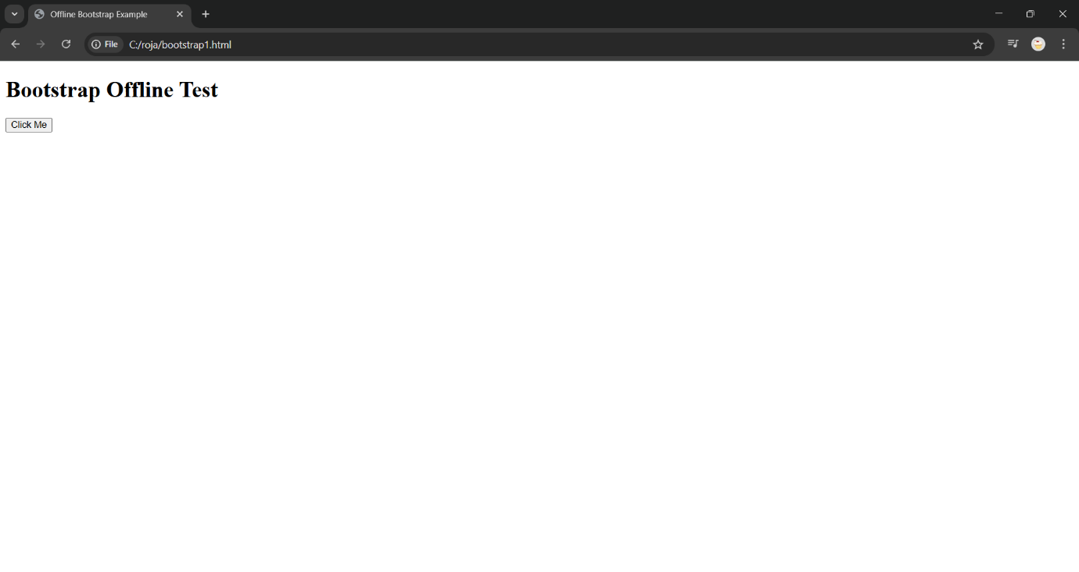

2.develop programs referring to previous boot strap programs

<!DOCTYPE html>
<html>
<head>
<meta charset="UTF-8">
<title>Registration</title>
<link rel="stylesheet" href="bootstrap/css/bootstrap.min.css">
</head>
<body>

<nav class="navbar navbar-dark bg-dark mb-4">
<a class="navbar-brand ms-3" href="#">My App</a>
</nav>

<div class="container">
<div class="card p-4 shadow">
<h3 class="mb-3">Student Registration</h3>

<div class="mb-3">
<label class="form-label">Full Name</label>
<input type="text" class="form-control">
</div>

<div class="mb-3">
<label class="form-label">Email</label>
<input type="email" class="form-control">
</div>

<button class="btn btn-success">Register</button>
<button class="btn btn-secondary">Cancel</button>
</div>
</div>

<script src="bootstrap/js/bootstrap.bundle.min.js"></script>
</body>
</html>

Output:

