STUDENT NAME | R.ROJA
STUDENT REGISTRATION NUMBER | 251U1R2064 | CLASS: CSE(AIML)
PROGRAM | UG | YEAR and TERM:  1st year & 1st term
SUBJECT NAME | HTML
NAME OF THE ASSESSMENT | Reflective lab journal-5
DATE OF SUBMISSION | 25.10.25

1.write a program on Responsive web design:
html lang="en">
<head>
<meta charset="UTF-8">
<meta name="viewport" content="width=device-width, initial-scale=1.0">
<title>Responsive Flexbox Layout</title>
<style>
.container {
display: flex;
flex-wrap: wrap;
}
.box {
flex: 1 1 300px; /* Shrinks or grows as needed */
margin: 10px;
padding: 20px;
background-color: lightblue;
text-align: center;
}
</style>
</head>
<body>
<h2>Responsive Flexbox Layout</h2>
<div class="container">
<div class="box">Box 1</div>
<div class="box">Box 2</div>
<div class="box">Box 3</div>
</div>
</body>
</html>

Output:
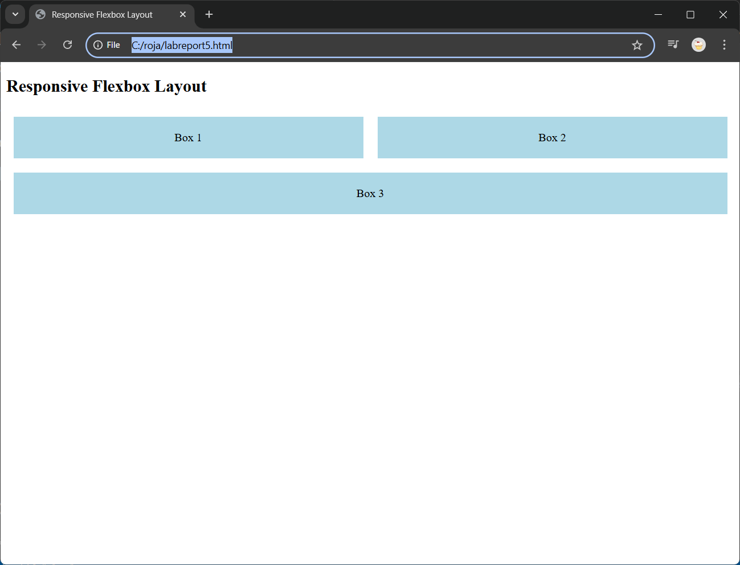

Explanation:
- The flex-wrap property allows boxes to wrap onto new lines on smaller screens.
- Each box adjusts its size automatically (flex: 1 1 300px).
- The <!DOCTYPE html> declaration defines the document as an HTML5 webpage.
- The <meta name="viewport" content="width=device-width, initial-scale=1.0"> tag ensures the page scales properly on mobile devices.
- The .container class is styled with display: flex, which turns it into a flex container, allowing flexible layout of its child elements.
- The flex-wrap: wrap property makes the boxes move to the next line if there isn’t enough space horizontally.
- Each .box inside the container acts as a flex item, which can grow or shrink depending on the available space.
- The flex: 1 1 300px rule means each box will take up equal space but will not shrink smaller than 300px in width.
- The margin: 10px adds spacing around each box to prevent them from touching.
- The padding: 20px adds inner spacing, making the box content look neat and readable.
- The background-color: lightblue visually distinguishes each box and makes them easier to see.
- This design is responsive because when the screen is resized, the boxes automatically rearrange to fit the available width, maintaining a clean and flexible layout across devices.
2.wite a program on bootstrap grid:
<html lang="en">
<head>
<meta charset="UTF-8">
<meta name="viewport" content="width=device-width, initial-scale=1">
<title>Bootstrap Grid Example</title>
<link href="https://cdn.jsdelivr.net/npm/bootstrap@5.3.3/dist/css/bootstrap.min.css" rel="stylesheet">
</head>
<body>
<div class="container text-center">
<h2>Bootstrap Grid Layout</h2>
<div class="row">
<div class="col-md-4 bg-primary text-white p-3">Column 1</div>
<div class="col-md-4 bg-success text-white p-3">Column 2</div>
<div class="col-md-4 bg-warning text-white p-3">Column 3</div>
</div>
</div>
</body>
</html>

Output:
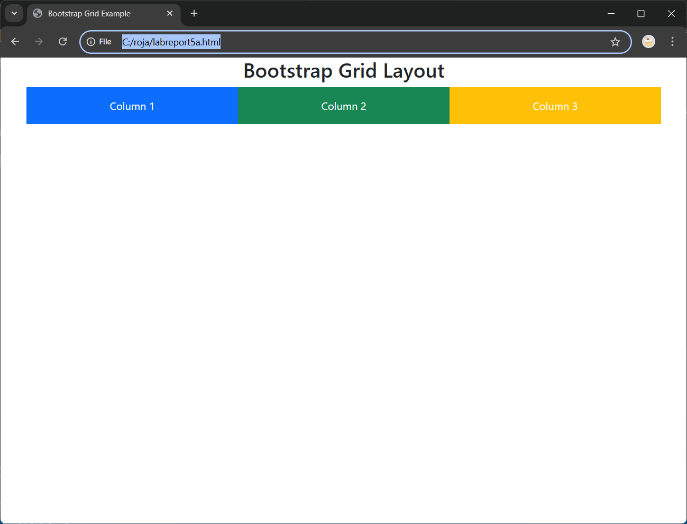

Explanation:
- The <!DOCTYPE html> declaration defines the page as an HTML5 document.
- The <meta name="viewport" content="width=device-width, initial-scale=1"> tag ensures the layout adapts to different screen sizes and devices.
- The Bootstrap CSS file is linked via CDN to use its built-in responsive classes and components.
- The <div class="container"> class provides a fixed-width, responsive container that centers the content on the page.
- Inside the container, the <div class="row"> acts as a horizontal wrapper that holds the columns.
- Each <div class="col-md-4"> defines one column that occupies 4 out of 12 grid spaces on medium and larger screens.
- Because 4 + 4 + 4 = 12, all three columns fit perfectly in one row.
- The color classes like bg-primary, bg-success, and bg-warning apply Bootstrap’s predefined background colors.
- The text-white class makes the text color white for better contrast against the background.
- The layout is responsive, so when viewed on smaller devices (below “md” size), the three columns automatically stack vertically for a clean mobile-friendly design.

3.write a program on container:
<html lang="en">
<head>
<meta charset="UTF-8">
<meta name="viewport" content="width=device-width, initial-scale=1">
<title>Fixed Container</title>
<link href="https://cdn.jsdelivr.net/npm/bootstrap@5.3.3/dist/css/bootstrap.min.css" rel="stylesheet">
</head>
<body>
<div class="container bg-light border mt-4 p-4">
<h3>Fixed Container Example</h3>
<p>This is a <code>.container</code> class that provides a fixed-width layout. It adjusts width based on the screen size but stays centered on the page.</p>
</div>
</body>
</html>

Output:
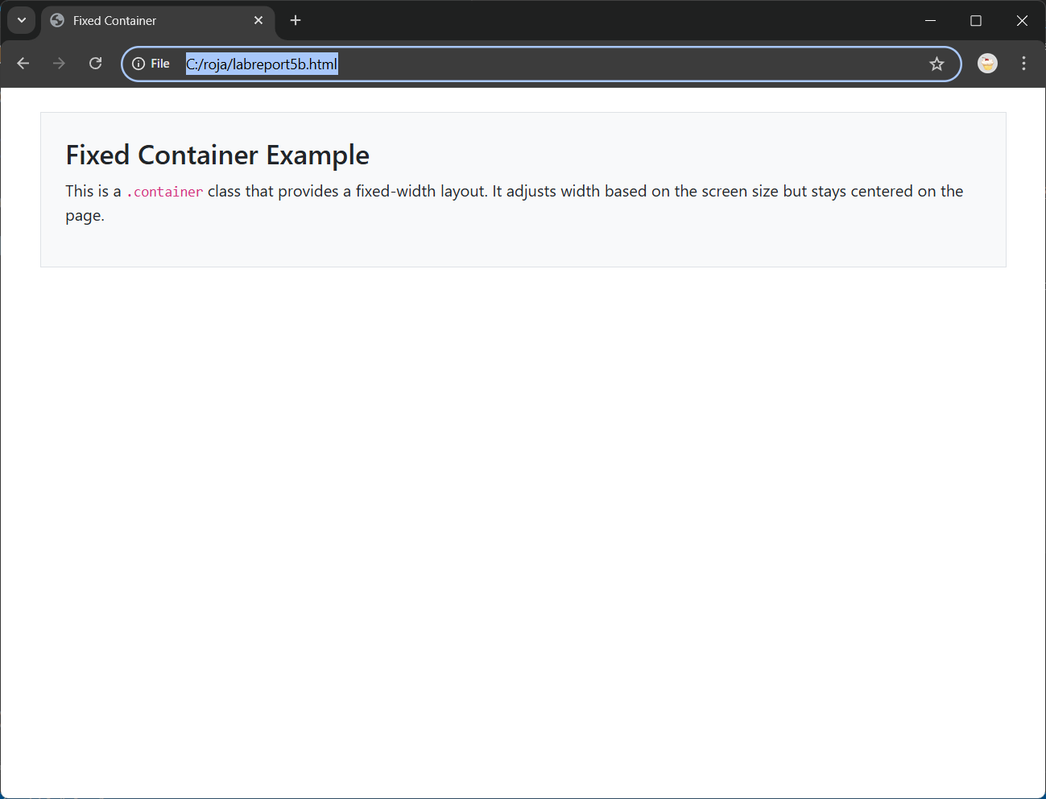
Explanation:
- The <!DOCTYPE html> declaration defines the document as HTML5.
- The Bootstrap stylesheet is linked using the official CDN to apply Bootstrap classes.
- The <div class="container"> creates a fixed-width container that adjusts based on screen size but has maximum width limits.
- The <div class="container-fluid"> creates a full-width container that always spans the entire viewport width.
- The <div class="container-sm"> is a responsive container, full-width until the screen reaches the small (sm) breakpoint.
- Each container has a bg-* class (like bg-light, bg-info, bg-warning) to add background color.
- The p-4 and my-4 classes add padding and margin spacing for better visual separation.
- The border class outlines each container, making the boundaries visible.
- The text classes like text-white improve readability on colored backgrounds.
- This program shows how Bootstrap containers manage layout widths across different devices, forming the base structure for responsive web pages.

4.wwrite a program on typography:
<html lang="en">
<head>
<meta charset="UTF-8">
<meta name="viewport" content="width=device-width, initial-scale=1">
<title>Bootstrap Headings</title>
<link href="https://cdn.jsdelivr.net/npm/bootstrap@5.3.3/dist/css/bootstrap.min.css" rel="stylesheet">
</head>
<body class="p-4">
<h2 class="text-center mb-3">Bootstrap Headings and Display Classes</h2>

<h1>h1. Bootstrap heading</h1>
<h2>h2. Bootstrap heading</h2>
<h3>h3. Bootstrap heading</h3>
<h4>h4. Bootstrap heading</h4>
<h5>h5. Bootstrap heading</h5>
<h6>h6. Bootstrap heading</h6>

<hr>
<h1 class="display-1">Display 1</h1>
<h2 class="display-2">Display 2</h2>
<h3 class="display-3">Display 3</h3>
</body>
</html>

Output:
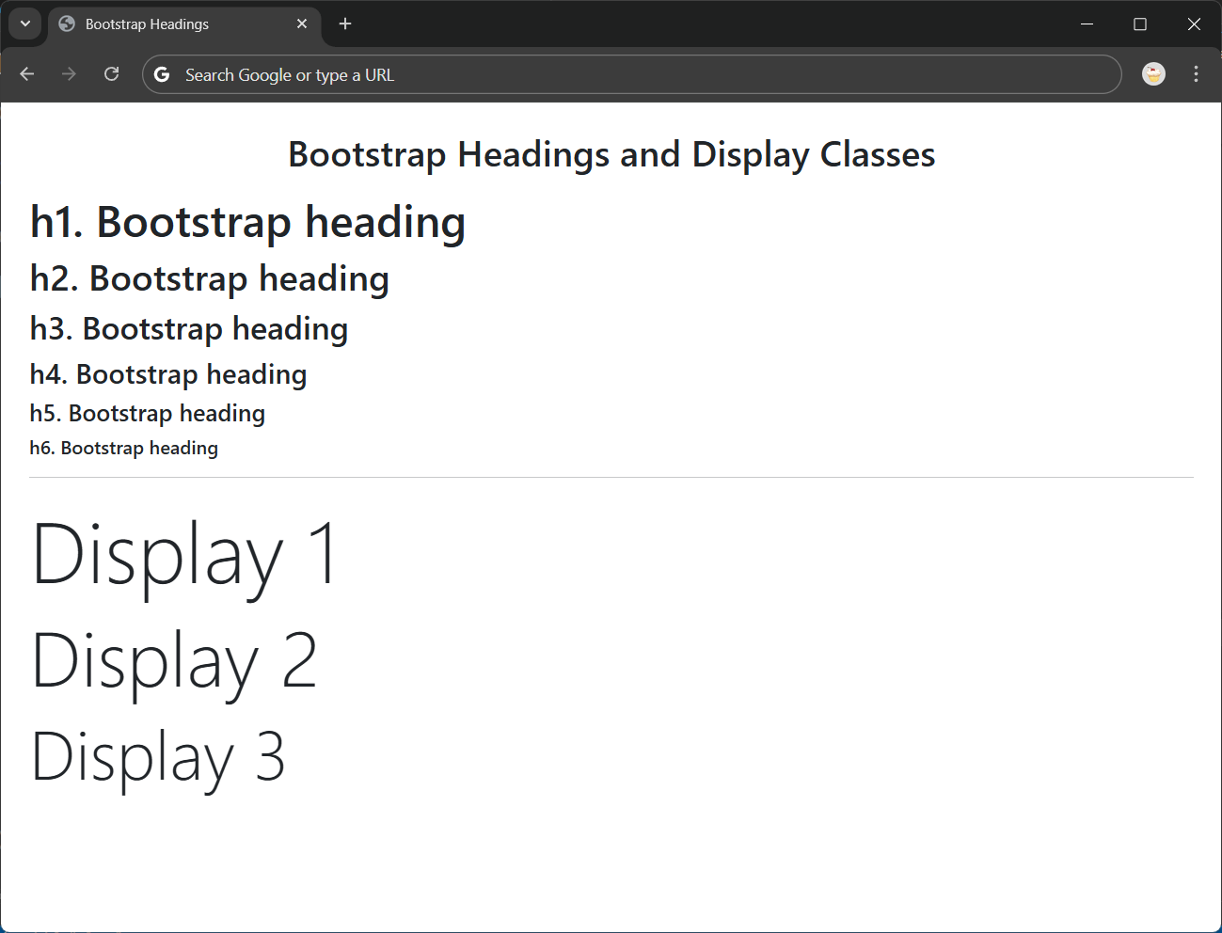

Explanation:
- Bootstrap provides default styles for HTML headings (h1–h6).
- The .display-* classes (from .display-1 to .display-6) create larger, more prominent text.
- These are commonly used for titles or hero text in web pages.

5.write a program on bootstrap-navbar:
html lang="en">
<head>
<meta charset="UTF-8">
<meta name="viewport" content="width=device-width, initial-scale=1">
<title>Basic Navbar</title>
<link href="https://cdn.jsdelivr.net/npm/bootstrap@5.3.3/dist/css/bootstrap.min.css" rel="stylesheet">
</head>
<body>
<nav class="navbar navbar-expand-lg navbar-light bg-light">
<div class="container-fluid">
<a class="navbar-brand" href="#">MyWebsite</a>
<div class="collapse navbar-collapse">
<ul class="navbar-nav">
<li class="nav-item"><a class="nav-link active" href="#">Home</a></li>
<li class="nav-item"><a class="nav-link" href="#">About</a></li>
<li class="nav-item"><a class="nav-link" href="#">Contact</a></li>
</ul>
</div>
</div>
</nav>
</body>
</html>

Output:
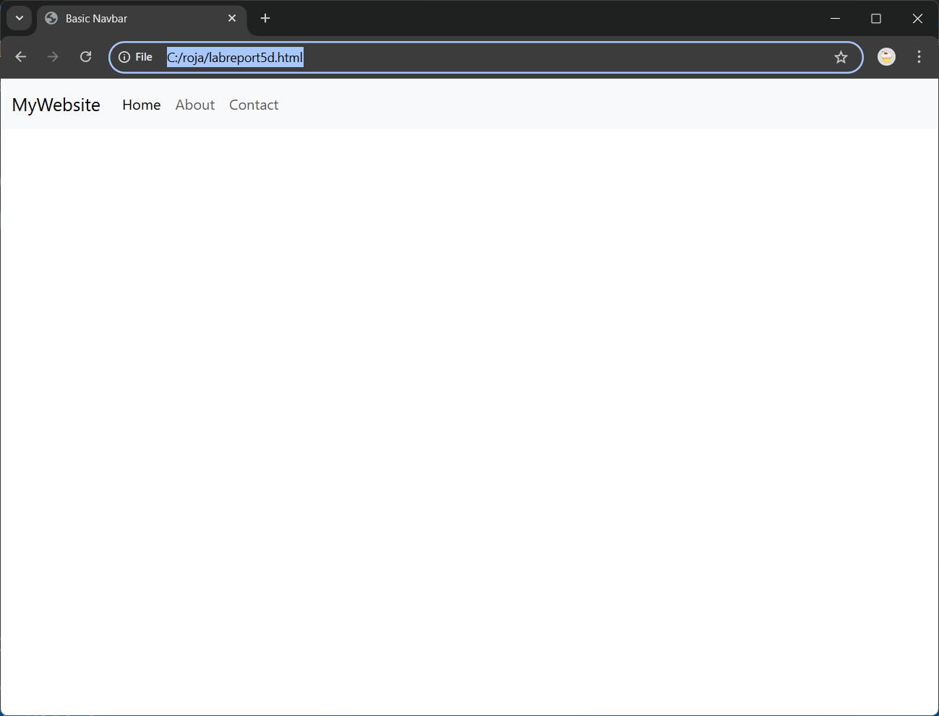

Explanation:
The .navbar class creates a navigation bar.
.navbar-light bg-light gives a light background with dark text.
navbar-brand shows the site name or logo.
.navbar-nav and .nav-item define the navigation links
The <!DOCTYPE html> tag defines the document as an HTML5 web page.
The <meta name="viewport" content="width=device-width, initial-scale=1"> ensures the page is responsive and adapts to all screen sizes.
The Bootstrap CSS file is linked through a CDN, allowing use of built-in Bootstrap styles.
The <nav> element with class navbar creates a responsive navigation bar section.
The class navbar-expand-lg allows the navbar to expand horizontally on large screens and stack vertically on smaller devices.
The class navbar-light bg-light sets a light background color with dark text for good contrast.
The <div class="container-fluid"> ensures the navbar spans the full width of the screen.
The <a class="navbar-brand"> defines the website name or logo displayed on the left side.
The unordered list <ul class="navbar-nav"> contains the navigation links, each inside a <li class="nav-item">.

