**Task 1**

Given a list of strings - List[String] (“alpha”, “gamma”, “omega”, “zeta”, “beta”)

- Find count of all strings with length 4.

- Convert the list of string to a list of integers, where each string is mapped to its corresponding length.

- Find count of all strings which contain alphabet ‘m’.

- Find the count of all strings which start with the alphabet ‘a’.

Following commands are used to get the desired output and screen shot of the executing results:

**val** stringList = List("alpha", "gamma", "omega", "zeta", "beta")

println("Count of all strings with length 4 -> "+ **stringList.count(c => c.length == 4)**)

**val** intList = **stringList.map(c => c.length)**

println("\nConverting the list of stringList to a list of intList, where each string is mapped to its corresponding length:")

println(intList)

println("\nCount of all strings which contain alphabet ‘m’ -> "+ **stringList.count(c => c contains 'm')**)

println("\nCount of all strings which start with the alphabet ‘a’ -> "+ **stringList.count(c => c.startsWith("a"))**)

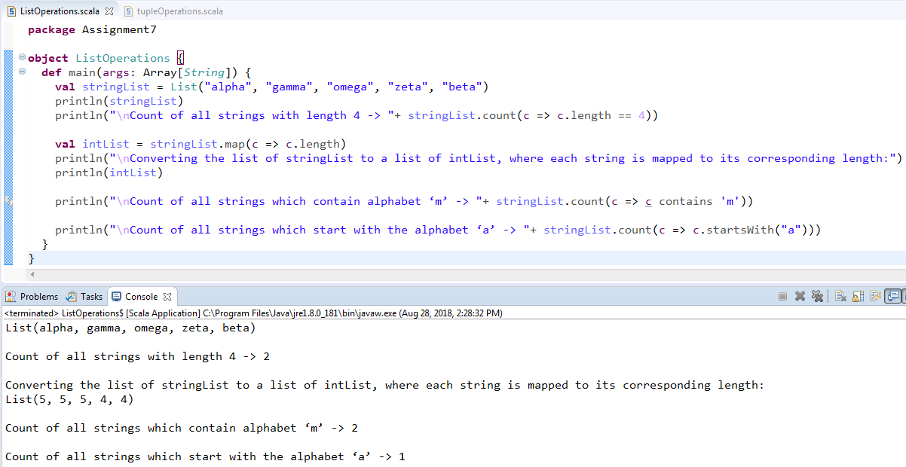

**Task 2**

Create a list of tuples, where the 1st element of the tuple is an int and the second element is a string.

Example - ((1, ‘alpha’), (2, ‘beta’), (3, ‘gamma’), (4, ‘zeta’), (5, ‘omega’))

- For the above list, print the numbers where the corresponding string length is 4.

- find the average of all numbers, where the corresponding string contains alphabet ‘m’ or alphabet ‘z’.

Following commands are used to get the desired output and screen shot of the executing results:

**val** tupleList = List((1, "alpha"),(2, "beta"),(3, "gamma"),(4, "zeta"),(5, "omega"))

**tupleList.filter(_._2.length == 4 ).foreach(x** => println("Number "+ x._1 +" has the string with the length of 4 and that string is "+x._2))

**val** outputTuple = **tupleList.filter(c => (c._2.count(_=='m')!=0 || c._2.count(_=='z')!=0))**

println("\nList of strings contains alphabet ‘m’ or alphabet ‘z’ are: "+outputTuple)

print("\nThe average of all numbers, where the corresponding string contains alphabet ‘m’ or alphabet ‘z’ is --> ")

println(**outputTuple.map(_._1).sum/outputTuple.size**)

