**Task 1**

Create a Scala application to find the GCD of two numbers

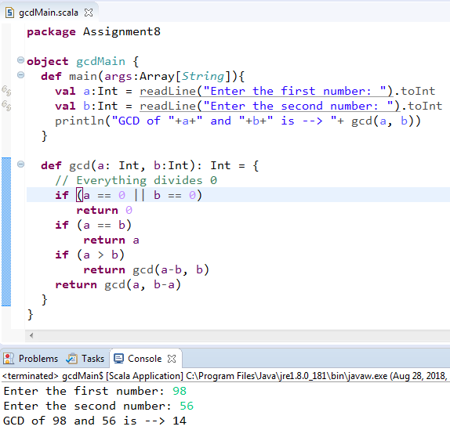

**Task 2**

Fibonacci series (starting from 1) written in order without any spaces in between, thus producing a sequence of digits.

Write a Scala application to find the Nth digit in the sequence.

➢ Write the function using standard for loop

➢ Write the function using recursion

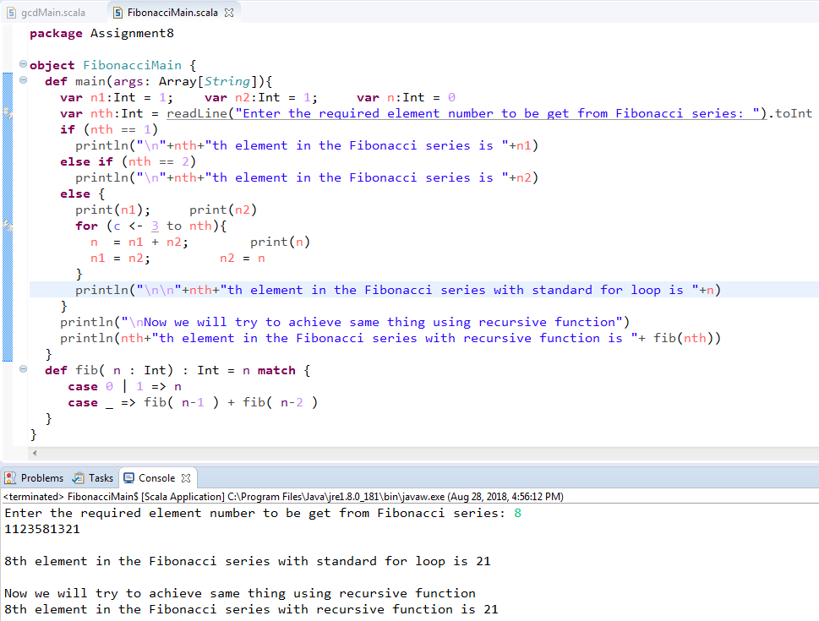

**Task 3**

Find square root of number using Babylonian method.

1. Start with an arbitrary positive start value x (the closer to the root, the better).

2. Initialize y = 1.

3. Do following until desired approximation is achieved.

a) Get the next approximation for root using average of x and y

b) Set y = n/x

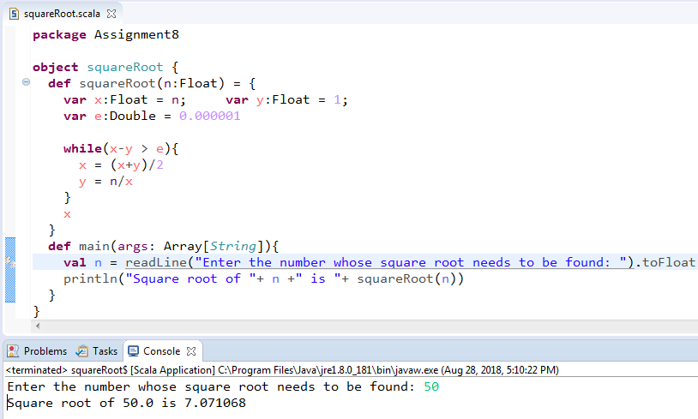

**Task 4**

Create a calculator to work with rational numbers.

Requirements:

➢ It should provide capability to add, subtract, divide and multiply rational Numbers

➢ Create a method to compute GCD (this will come in handy during operations on rational)

Add option to work with whole numbers which are also rational numbers i.e. (n/1)

➢ achieve the above using auxiliary constructors

➢ enable method overloading to enable each function to work with numbers and rational.

