Ontology Engineering Notes
A running set of notes on ontology engineering, based on "An Introduction to Ontology Engineering" by C. Maria Keet.
★ Key Points
- Ontologies sit in the knowledge layer.
- UML class diagrams are good at describing what a single application stores, but they weren't built to answer cross-model questions.
- An ontology sits one level of abstraction above individual conceptual data models.
- Ontology is application-independent, unlike UML diagrams.
- Ontologies can involve: the same word with different data types (e.g. pipe depth as float vs int), the same word with different meanings (e.g. 'bank' as riverbank or financial bank), and the same meaning with different names (e.g. 'customer' vs 'client').

Overview
This document collects key concepts, definitions, and reference points on ontology engineering as they come up. New entries are appended below as they are added.

Source Reference
Primary text: An Introduction to Ontology Engineering, C. Maria Keet.
First edition: v1.5, 2020 (open access, CC BY 4.0).
Second edition: College Publications, 2025 (updated with LLM/knowledge graph context, ~30% more content).

Glossary: Entity, Attribute, Relationship, Fact
Entity — a distinct 'thing' in the real world with its own identity, e.g. Patient, Flower. Called a class in UML, an object type in ORM. Each instance is independently identifiable.
Attribute — a property or characteristic of an entity, usually a single simple value, e.g. Patient.dateOfBirth. In EER and UML, attributes 'belong to' the entity and have no independent identity of their own.
Relationship — a connection between two or more entities, e.g. Patient — treatedBy — Doctor. Unlike an attribute, it links two independently identifiable things.
Fact / fact type — ORM's term, which reframes the other three: don't distinguish 'attribute' from 'relationship' at all — treat everything as a fact connecting two things. What EER/UML call an attribute (blood pressure) is, in ORM, just a relationship to a value type that happens to only take numbers. A fact (instance) is a specific true statement following that pattern, e.g. 'Patient #001 has BloodPressure 152.'
How the terms map across notations:
Concept | EER | UML | ORM
A 'thing' with identity | Entity | Class | Object type
A simple property of a thing | Attribute (ellipse) | Attribute (inside class box) | Treated the same as a relationship — a fact type to a value type
A link between two things | Relationship (diamond/line) | Association | Fact type

In short: entity = a thing, attribute = a property of a thing, relationship = a link between two things. ORM's design philosophy is to collapse attribute and relationship into one unified concept, fact, on the view that the attribute/relationship split is an artificial distinction rather than a real one.

Top-Level (Foundational) Ontology Examples
A top-level (or upper/foundational) ontology is a small set of very general categories and relations, not specific to any one domain, that domain ontologies can be built on top of. Several independently-developed ones exist, spanning philosophy, linguistics, industrial standards, and commercial AI:
Name | What it is | Origin / angle
BFO — Basic Formal Ontology | Minimal upper ontology (object, process, quality, etc.), no domain content. Foundation for nearly all OBO Foundry biomedical ontologies, including the Gene Ontology. | University at Buffalo; scientific realism
DOLCE | Upper ontology oriented toward how humans cognitively and linguistically categorise the world. Its quality/quale machinery closely resembles the qt/ql pattern. | Laboratory for Applied Ontology, Trento, Italy
GUM — Generalized Upper Model | Linguistically-oriented upper ontology modelling semantic relationships (agent, patient, purpose) consistent across human languages. | Natural language generation / processing research
ISO 15926 | Industrial ISO standard for representing process-plant information (oil & gas, chemical, power) across its full lifecycle. | Engineering industry standard, not academic
ISO 18629 | Industrial ISO standard specifying PSL (Process Specification Language) for representing manufacturing processes, vendor-neutral. | Manufacturing industry standard, not academic
OpenCyc | Open-source release of Cyc, a long-running AI project encoding vast common-sense knowledge, not just upper categories. | Cycorp / Douglas Lenat, started 1984
SUMO — Suggested Upper Merged Ontology | Broad upper ontology merging several public-domain sources, designed for wide 'surface area' so many domain ontologies can attach easily. | IEEE Standard Upper Ontology lineage

These represent different, not always philosophically compatible, schools of thought. A group representing BFO, DOLCE, GUM, ISO 15926, ISO 18629, OpenCyc, and SUMO agreed at a 2006 summit to act as 'upper ontology custodians' — notable precisely because these camps had largely developed in isolation, with genuinely different commitments about how to carve up reality. BFO and DOLCE are now both formally codified in the ISO/IEC 21838 standard for top-level ontologies, making them the most standards-recognised starting points to browse.

Notes

The DIKW Pyramid and Where Ontologies Sit
The Data-Information-Knowledge-Wisdom (DIKW) pyramid is a common way to think about levels of abstraction in computing and IT. It has four layers, built bottom-up:
- Data — raw facts and measurements (e.g. a timestamp, a name, a number). No structure or context yet.
- Information — data that has been structured or calculated (e.g. a database record with named fields like Name and Date).
- Knowledge — patterns and meaning synthesised from information (e.g. recognising that a 'Workshop' is a kind of 'Event', or inferring a relationship that wasn't explicitly stated).
- Wisdom — judgements, reasons, and principles built on that knowledge (e.g. deciding why you personally should attend a given event).
Ontologies sit at the knowledge layer. They don't just store raw facts (that's the data layer) or structured records (information layer) — they capture the concepts, categories, and relationships that let a system derive new, implicit facts. For example, if an ontology defines that a Workshop is a subclass of Event, then software can automatically deduce that any specific workshop (e.g. a workshop called 'DHS') is also an event, even though nothing ever explicitly stated that fact.
This is also why an ontology-backed system can behave like an 'intelligent' layer on top of ordinary data: it doesn't just retrieve stored facts, it can reason over them to surface things that were never directly written down.

Ontologies and Data Integration
A recurring use of ontologies is solving data integration problems. Different systems often use different names for the same real-world concept, and there is nothing built into the software that tells it those different names refer to the same thing. An ontology provides a shared, agreed-upon vocabulary — a common set of concepts and constraints — that every system can be mapped to. Once each system is linked to the same ontology concept, tools can automatically recognise that two differently-labelled things are really the same, and exchange data between the systems accordingly.
Rather than needing a custom translation between every pair of systems, each system only needs one mapping — to the ontology — and interoperability with all the other connected systems follows from that shared reference point.

Why UML Can't Solve Cross-Database Mismatches
Three concrete puzzles show why merging databases is hard:
- db1:customer vs db2:client — possibly the same real-world thing under different names, but nothing in either schema confirms it.
- db1:bank vs db2:bank — same name doesn't guarantee same meaning; one could be a financial institution, the other a riverbank.
- db1:pipe.depth.float vs db2:pipe.depth.int — same meaning (sewer pipe depth), different representation (precision). A naming match isn't even the issue here — it's a granularity mismatch.
UML class diagrams can't resolve any of this, for two structural reasons: (1) UML forces one datatype per attribute, so it can't express that a float field and an integer field mean the same thing; and (2) UML has no built-in notion of cross-model equivalence — it can say 'class X is a subtype of class Y' within one diagram, but not 'concept X in model 1 equals concept Y in model 2.'
Where the ontology fits — three stacked levels:
Level | Example | Scope
Implementation | db1:pipe.depth.float, db2:pipe.depth.int | Raw, inconsistent reality
Conceptual data model | UML / EER / ORM diagrams | Tied to one application; diagrams don't know about each other
Ontology | e.g. a PipeDepth concept | Application-independent; sits above both, describes the domain itself
Because the ontology doesn't belong to db1 or db2 specifically, it can act as a neutral hub: db1's field maps up to PipeDepth, and db2's field maps up to the same PipeDepth — the same mechanism as the Patient/Client and Footwear/Shoes examples. Critically, an ontology language like OWL can formally assert that two differently-typed fields refer to the same real-world quantity — a kind of cross-model equivalence statement that UML's vocabulary simply has no way to express.

Real-World Examples
Hospital merger
Two merging hospitals each store patient data differently: Hospital A calls a person a 'Patient' with a field 'DOB'; Hospital B calls the same kind of person a 'Client' with a field 'BirthDate'. Rather than writing a custom translation between every pair of merging systems, both are mapped to one ontology concept, e.g. Patient with a dateOfBirth property. Any connected system can then exchange data with any other, because they all map to the same shared vocabulary.
The Gene Ontology (real, widely-used case)
Two major biology databases, KEGG and InterPro, each store records about the same gene product under their own separate identifiers. Neither database has any inherent way of knowing the records refer to the same biological function. What connects them is that both annotate their entries with the same term from the Gene Ontology, a standardised vocabulary of over 40,000 biological concepts. Because both databases tag their data with the same Gene Ontology term, software can automatically recognise that two entries from unrelated databases in different countries describe the same underlying thing.
Retail catalog merge
A retailer acquiring another company needs to merge product catalogs. One system categorises items as 'Footwear', the other as 'Shoes'. A shared product ontology defines one canonical concept, and both catalogs map their local term to it, so search, recommendations, and inventory systems can treat products consistently without custom translation logic scattered across the codebase.

Same Knowledge, Different Renderings
An ontology is a concrete artefact — a file you can create, open, and manipulate — not just an abstract idea. The same underlying knowledge can be expressed in several different formats depending on the intended audience. Using the classic African Wildlife Ontology example ('lions eat only herbivores, and eat at least some impalas'), the same fact can appear as:
- First-order logic — the precise mathematical form, using quantifiers such as 'for all' and 'there exists'. Rigorous, but unwieldy for everyday use.
- Description Logic — a more compact, ontology-specific notation expressing the same constraint.
- Controlled natural language — an auto-generated, near-English sentence, aimed at domain experts who aren't logicians.
- Graphical notation — visual diagrams, useful for people who think in pictures rather than logic symbols.
- RDF/XML (OWL) — the actual machine-processable format that computers read and reason over.
All five are the same knowledge, just tailored to different audiences: mathematicians, ontology engineers, domain experts, visual thinkers, and machines respectively. What makes it an ontology, rather than just a diagram or sentence, is that underneath all these human-friendly views sits a rigorous logic-based representation a computer can process.
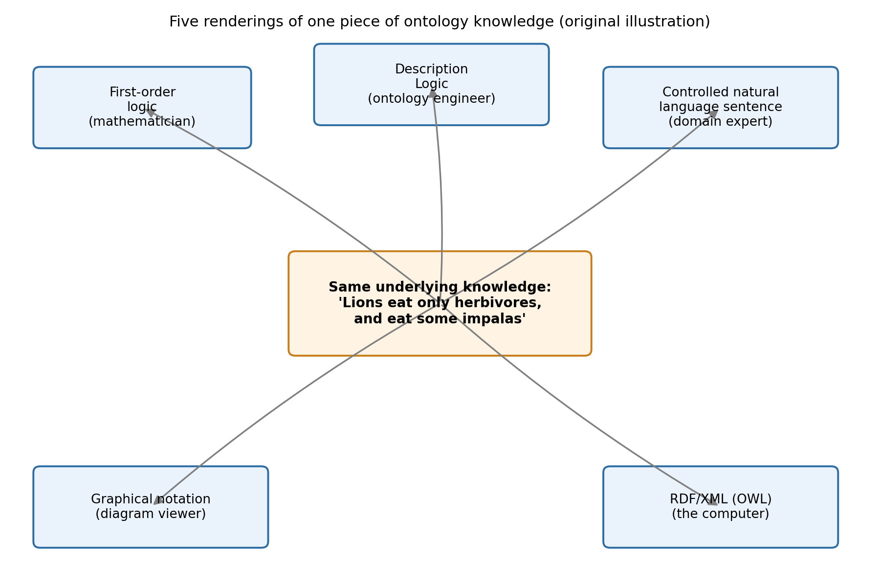
Original illustration — five renderings of the same knowledge.
The Lion / Herbivore / Impala relationship itself — the actual modelled fact underneath all five renderings above — looks like this:
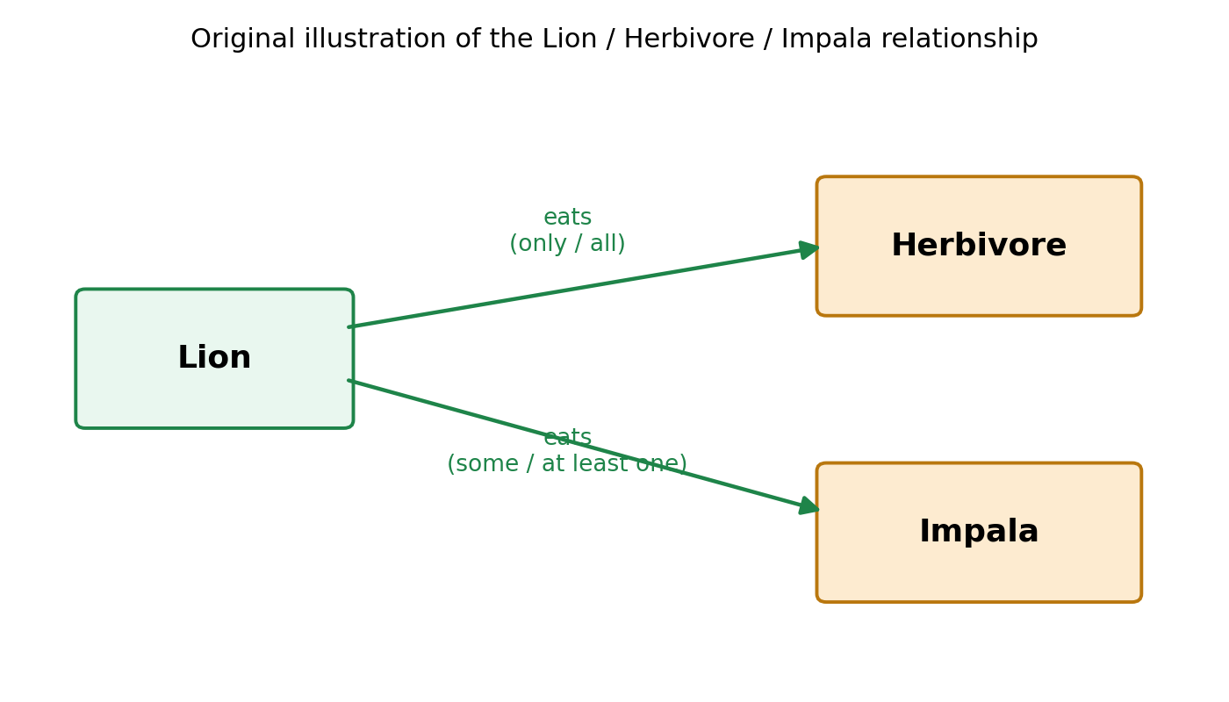
Original illustration — a lion eats only herbivores, and eats at least some impalas.
Note: these are original diagrams created to illustrate the same concept, not reproductions of the textbook's own figures (which remain under the publisher's copyright).

EER, ORM, and UML Compared — and How an Ontology Differs
All three conceptual modelling notations can express the same fact (e.g. 'a patient has a systolic and diastolic blood pressure reading') but structure it differently:
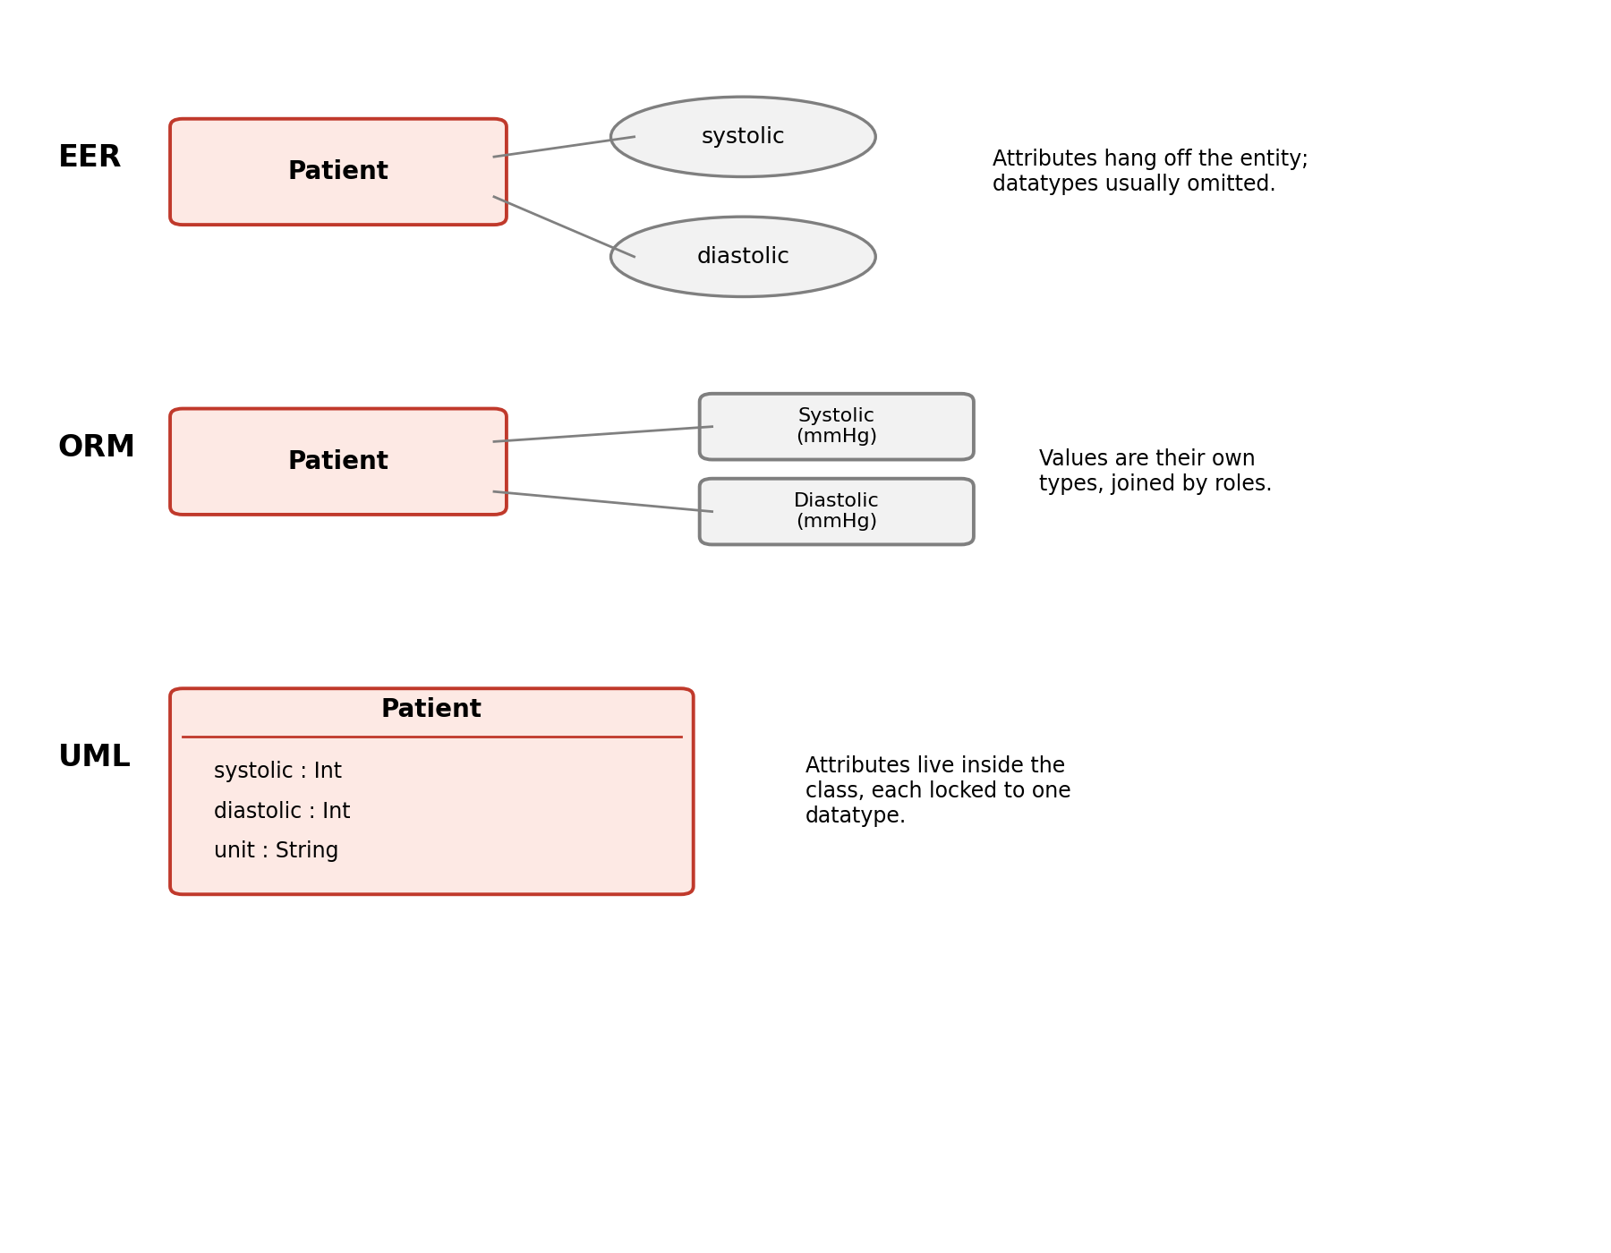
Original illustration — the same fact modelled in EER, ORM, and UML.
 | EER | ORM | UML
Where the value lives | Attribute bubble attached to entity | Its own value type, connected by an explicit role | Attribute line inside the class box
Datatypes | Usually omitted at conceptual level | Attached to the value type | Mandatory — one per attribute
Attribute vs. relationship | Attributes are second-class | No attributes at all — everything is a fact type between objects | Attributes are second-class
Natural-language grounding | No | Yes — reads as verbalised sentences | No
Typical use | Relational database design | Fact-oriented analysis with domain experts | Object-oriented software design

ORM's core idea is that 'attribute' is not a special category — a value is a relationship (fact type) between an object and a value type, just as much as any other relationship. EER and UML instead treat attributes as second-class citizens, baked into the entity/class itself. That philosophical difference is why the same fact looks so structurally different across the three.

How the Ontology Is Different — Four Concrete Reasons
- Application-independent: EER, ORM, and UML each describe what one application stores. An ontology describes the subject domain itself, so it can be reused across every application built on it, including future ones.
- Can assert equivalence across models: none of EER, ORM, or UML has vocabulary to say 'my value type is the same thing as your attribute in a different model.' An ontology can state that equivalence formally — this is what makes cross-system mapping possible at all.
- It's a logical theory, so machines can reason over it: EER/ORM/UML diagrams are documentation — they don't compute anything. An ontology is written in a logic (Description Logic, serialised as OWL), so a reasoner can derive facts nobody explicitly stored (e.g. classifying a reading as hypertensive from a threshold rule).
- It represents the nature of a relationship, not just its existence: a foundational-ontology pattern (the qt / ql relations) distinguishes a quality that depends on its bearer (blood pressure depends on the patient) from a value region that doesn't (152 mmHg exists on the scale regardless of who is measured). EER, ORM, and UML have no way to draw that distinction — they can only say a value is 'attached.'
The qt / ql pattern, applied to the Patient / BloodPressure example:
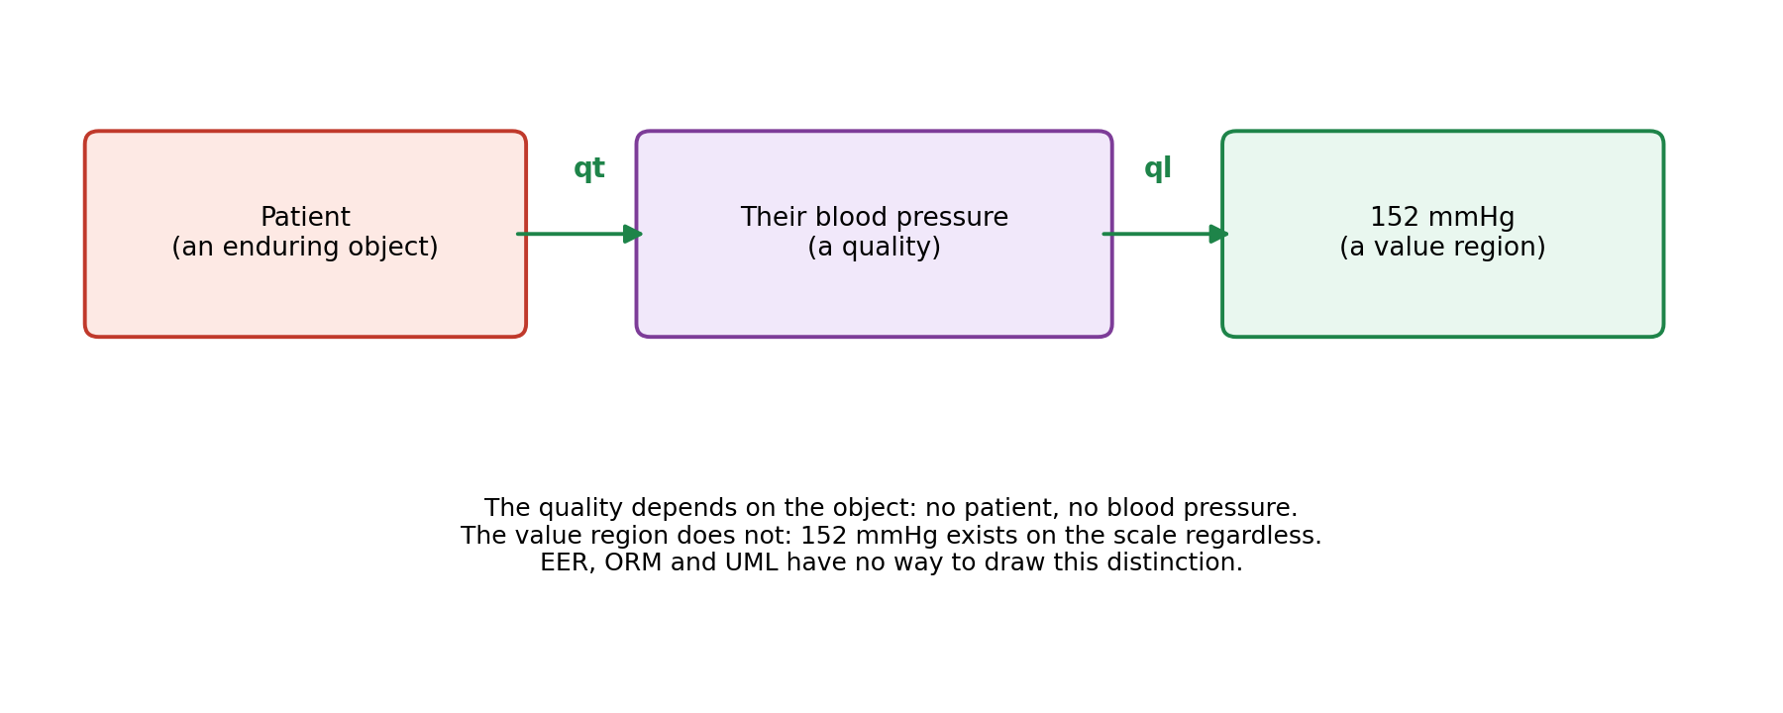
Original illustration — qt links an object to its quality, ql links the quality to its value region.
Honest caveat: the ontology isn't 'better' at what EER, ORM, and UML are for. If you're designing one database schema, EER is the right tool and an ontology would be overkill. The ontology wins specifically when there are multiple systems, changing meaning, or a need for machine reasoning — which is why the layered figure keeps the conceptual models and stacks the ontology above them, rather than replacing them.

Schema-Level vs Data-Level Integration
These are two different ways an ontology can be used to integrate separate data sources, operating at different granularities.
Schema-level integration — maps entire structures (classes, fields) to shared ontology concepts, once, at design time. E.g. EER's Flower, ORM's Bloem, and UML's Flower all map to one ontology concept Flower. This needs a formal ontology with axioms and equivalence assertions, and suits a handful of systems within one organisation (e.g. merging a few RDBMSs).
Data-level integration — skips structure entirely and tags individual records with a shared vocabulary term, one tuple (or even one cell) at a time. E.g. a KEGG database row and a separate InterPro database row are both tagged with the same Gene Ontology code, GO:0004619, so software can recognise they describe the same thing — even though the two databases have completely different schemas, identifier systems, and are maintained on different continents. This only needs a lightweight controlled vocabulary, not a full formal ontology, and suits large numbers of independent databases across the open internet.
Comparison:
 | Schema-level (e.g. flower shop) | Data-level (e.g. Gene Ontology)
What gets mapped | Classes / fields / structures | Individual records / tuples
Who does the mapping | Ontology engineers, once, at design time | Data curators, tagging each record as created
What's needed | A formal ontology with axioms, equivalence assertions | A lightweight controlled vocabulary — shared labels
Effort | Heavy — deep modelling (qt/ql, DL axioms, etc.) | Light — everyone just agrees to use the same tags
Scale it suits | A handful of systems within one organisation | Thousands of independent databases on the internet
What connects things | 'This class in system A equals that class in system B' | 'This row and that row happen to carry the same tag'

Why biology needed the lighter approach: schema-level mapping assumes you can formally reconcile a handful of known systems' structures — realistic for an organisation's own few databases. Biology instead had thousands of independent databases worldwide with no coordination on schema design, so formal schema-mapping wasn't feasible at that scale. What was feasible: get everyone to tag their data with the same shared vocabulary term. Both approaches use an ontology (or vocabulary) as the shared reference point — they just apply it at different granularities: structure vs. individual fact.

More Real-Life Examples
Schema-level examples
- Bank merger — Bank A's Account.balance (decimal, dollars) and Bank B's Ledger.amount (integer, cents) are formally mapped once, by engineers, to one shared concept AccountBalance, accounting for the unit difference. That single mapping then applies to every account in both systems.
- Airline codeshare — two airlines' booking systems model 'passenger' and 'seat class' differently (e.g. Y/J/F vs Economy/Business/First). One formal mapping is built between the two schemas' concepts, once, so every shared-flight reservation passed between systems is automatically translated correctly.
Data-level examples
- Wikipedia / Wikidata — French and English Wikipedia are separate, independently-edited systems with no shared schema. Articles about the same person (e.g. Marie Curie) are linked because each language's article is individually tagged with the same Wikidata identifier (e.g. Q7186) — record-by-record tagging, not a schema-wide mapping.
- ORCID in academic publishing — Scopus, Google Scholar, PubMed, and a university repository are unrelated databases with different schemas. A researcher's papers are tied together across all of them because each paper record is tagged with the same ORCID identifier (e.g. 0000-0002-1825-0097), not because the databases agreed on structure.
- Barcodes / GTINs in retail — Walmart, Amazon, and a corner store run unrelated inventory systems. The same physical product is linked across all three because each system tags its own row with the same GTIN/barcode (e.g. 049000028911), with no schema reconciliation between them.
The pattern: schema-level examples (bank merger, airline codeshare) involve a small, known set of systems where someone can afford to formally reconcile the structures once. Data-level examples (Wikidata, ORCID, barcodes) involve many independent, uncoordinated systems where the only realistic option is agreeing on a shared tag and applying it record-by-record — the same trade-off as the Gene Ontology case above.

Worked Example: Choosing Between Them (Claims / Client / Provider)
The choice depends on how many systems are involved and how coordinated they are, not on the table names themselves.
Points to schema-level: if Claims, Client, and Provider live within one company's own database(s) — even across two or three internal systems (e.g. a legacy claims system plus a newer client-management system after an acquisition) — that is the small, known, coordinable scenario.
Points to data-level: if claims data arrives from many external providers and partners who each submit in their own format (hundreds of hospitals, clinics, other insurers), that is the many-uncoordinated-systems scenario.
Why schema-level fits the internal Claims/Client/Provider case: these tables aren't independent, disconnected records — they have relationships and business rules that need to be formally modelled, not just tagged. A Claim must reference exactly one Client and one or more Providers; a claim can't be approved without a valid provider licence status; a client can't file overlapping claims for the same incident. Data-level tagging can say 'this Provider row and that Provider row are the same provider,' but it can't express 'a Claim requires a Provider with an active licence' or enforce that a Client only links to Claims within their policy period. Those are structural, relational constraints — schema-level territory.
Where data-level still earns its place, even here: providers are usually tagged with an NPI (National Provider Identifier), a nationally standardised code — storing NPIs on the Provider table gives free data-level interoperability with every other insurer, clearinghouse, and government system, without aligning schemas. Similarly, diagnosis/procedure codes on Claims (ICD-10, CPT) are the same 'lightweight controlled vocabulary' pattern as the Gene Ontology example — tagging claim line-items with these codes lets you compare and aggregate claims data across unrelated external systems without a shared schema.
Recommendation: build a schema-level ontology as the backbone for the three internal tables — it gives the relationship modelling (Claim ↔ Client ↔ Provider) and business-rule enforcement needed internally. Then layer in data-level standard codes (NPI for providers, ICD-10/CPT for claims) wherever the system needs to talk to the outside world — other insurers, government reporting, provider networks. This mirrors how real healthcare/insurance systems are built: a formal internal data model, referencing already-standardised external vocabularies at the boundaries rather than reinventing them.

SME Engagement: Competency Questions, Decision Support Questions, and Avoiding Silos
Working note (own view, refined through discussion and grounded against an Ontology 101 training session on this exact topic): the best way to design an ontology is not to closely train subject matter experts (SMEs) to become ontologists themselves. Instead, interact with them to seek/take information, then go build the ontology separately — no need to teach them the formal mechanics. One SME's mental model of a domain doesn't have to be exactly how the ontology gets built, because various SMEs may not even agree with each other. The goal is to find a logical way of interpreting the data across those perspectives; that is how silos get avoided.

Terminology: CQ = DSQ = Research Question
Competency Question (CQ), Decision Support Question (DSQ), and Research Question are essentially the same underlying concept, just named differently by different practitioner communities (academic ontology engineering tends to say CQ; aerospace/defence and other applied engineering communities often say DSQ; some research-heavy communities say research question). All three mean: a natural-language question that the ontology must be able to answer, used as a requirement that guides modelling and can later be tested automatically.

Three Strategies for Building an Ontology
Strategy | How it works | Main failure mode
Pure top-down | Ontologist thinks hard about the domain alone, builds it, hopes it answers the right questions. | No SME buy-in — nobody asked to be involved
Pure SME-led | Train the SMEs to build the ontology themselves. | Doesn't scale; non-experts confidently build formal models without the training to do it well
Competency-question-driven | Treat SMEs as informants, not co-engineers. Ask what they need answered; don't teach them ontology engineering; don't show them the ontology, show them an interface. | Silo-prone — modelling strictly per one SME's questions can conflict with another SME's questions on the same domain

The third strategy is standard practice, but has a known failure mode worth naming directly: it is inherently silo-prone. Modelling strictly according to one SME's competency questions risks conflicting with another SME's questions about the same domain, with no principled way to reconcile them.

The Fix: Logical Disambiguation, Not a Privileged Interpretation
The refinement beyond plain competency-question-driven design: don't just model according to the competency questions collected — use the logic of an upper-level ontology (e.g. BFO) to systematically disambiguate the different ways data could be interpreted, even where a given SME isn't themselves aware they're interpreting it a particular way. The goal is explicitly not to find one privileged interpretation of the data. The goal is to find the logical space of interpretations, so that different perspectives can be precisely encoded and connected rather than forced into artificial agreement. A real example of this in practice: several ontologies within the OBO Foundry hold different, valid perspectives on the same domain, because different experts legitimately think about that domain differently — the aim is to encode that precisely enough to flip between perspectives, rather than privilege one.
This connects to, but is more practically grounded than, the ontological realism debate covered earlier (Smith & Ceusters vs. Merrill): rather than arguing philosophically for one true interpretation, the working method is to formally represent the space of interpretations and use logic to keep them connected and internally consistent — sidestepping the need to declare any one SME 'correct.'

The DSQ Progression: Entities → Problems → Space/Time Correlation
In practice, decision support questions are elicited in iterative rounds of increasing precision, not gathered all at once:
- Round 1 — Account for entities: what are all the things I care about? (E.g. aircraft, engines, the engine's major component parts.) Entities are not decided upfront by the ontology engineer — they fall out of the questions the SME asks.
- Round 2 — Identify problems: what is actually going wrong? What makes the job harder than it needs to be?
- Round 3 — Correlate across space and time: can these entities and problems be connected by location, sequence, site, or time, to answer more sophisticated questions?
Practical mechanics that make this work: open with a deliberately broad question ('what makes your job harder than it needs to be?') so the SME fills in the shape of their own domain. If stuck, it is completely fine to ask directly: 'what question would you want answered from your data?' — SMEs often already have a specific cross-system question in mind. Aim for 3–5 strong DSQs per round rather than dozens; quality and SME engagement matter more than volume.

Worked Example: Aircraft Engine Maintenance
This example is grounded directly in an Ontology 101 training session transcript (SME role-play on aircraft engine maintenance), and pulls together every point above into one concrete case.
1. Terminology confirmed in practice — the training instructor confirms directly that competency questions, decision support questions, and research questions are essentially interchangeable terms depending on practitioner community (academic ontology engineering says CQ; aerospace/defence often says DSQ; some research communities say research question). All three mean the same thing: a natural-language question the ontology must be able to answer.
2. Why the standard strategy still needed a fix — competency-question-driven design (treat SMEs as informants, not co-engineers; don't teach them ontology engineering; don't show them the ontology, show them an interface) is the traditional strategy, but the instructor flags its real failure mode directly: it is inherently silo-prone, since modelling strictly per one SME's questions can conflict with a different SME's questions on the same domain. The fix is not to find one privileged interpretation of the data, but to find the logical space of interpretations, using an upper-level ontology (BFO) to systematically disambiguate — so different perspectives can be precisely encoded and connected rather than forced into artificial agreement.
3. The DSQ progression, confirmed as a three-level structure — Round 1: account for entities — what are all the things I care about (aircraft, engines, the engine's major component parts)? Entities are not decided upfront by the ontology engineer; they fall out of the questions the SME asks. Round 2: identify problems — what is actually going wrong? Round 3: correlate across space and time — location, sequencing, sites — to answer more sophisticated questions.
4. The real numbers, clarified — confirmed directly by the SME role-play: 80 aircraft, 8 engines per aircraft (640 engine-position pairs that can change), and separately, each engine has 8 major component parts. These are two different '8's, not the same number reused — worth correcting carefully, since it's an easy detail to conflate.
5. The value-of-connection story — a maintenance team tracked only engine startup events (the highest-strain event for an engine), with no idea which aircraft or engine each startup belonged to. Once startup data was connected into a fuller ontology — linking startups to the airport they occurred at, and airports to flight routes — the ontology could infer which aircraft a given startup must have belonged to, purely from which two airports the flight connected. Nobody manually solved that; the connected model derived it. This is a clean, concrete illustration of why connecting data beats cleaning data in isolation: the value came from relationships between datasets, not from any single dataset being cleaner.
6. Practical interview mechanics worth keeping — open broad: 'what makes your job harder than it needs to be?' — deliberately vague so the SME fills in the shape of their own domain. If stuck, it's completely fine to ask directly: 'what question would you want answered from your data?' — SMEs often already have a specific cross-system question in mind. Aim for 3–5 strong DSQs per round, not dozens — quality and SME engagement over volume. The workflow closes the loop formally: competency/decision-support questions get encoded as SPARQL queries run against the OWL ontology, functioning like automated unit tests, so you can mechanically check whether the model actually answers the questions it was built for.

Enhanced Interview Question Bank (Aircraft → Engine → Part)
Two question types from question-theory research map onto this drill-down: constraint-seeking questions (broad — eliminate unlikely options by identifying a shared feature across many possibilities) and hypothesis-scanning questions (narrow — test one specific fact directly). Good interviews move from constraint-seeking toward hypothesis-scanning as they progress.
Level 1 — Aircraft (broad, constraint-seeking): 'Across the fleet, what's the thing you're least confident is accurate right now?' / 'When an aircraft's status changes, how many systems need updating for that to be true everywhere?'
Level 2 — Engine (narrowing): 'When an engine moves from one aircraft to another, is that event recorded anywhere, or only the current position?' (hypothesis-scanning: tests one specific fact — is history tracked, yes or no) / 'How do you currently confirm which 8 engines are on a given aircraft right now?'
Level 3 — The 8 major engine parts (most precise, hypothesis-scanning): 'For each of the 8 major parts, is there a serial number tracked individually, or just a part type/model?' / 'Which of these 8 parts, if mis-tracked, causes the worst downstream consequence — safety, compliance, cost?' / 'Has a part ever been swapped between engines without the paper trail catching up?'

Closing the Loop: From DSQs to Automated Testing
The workflow does not end at collecting questions. Competency/decision-support questions are later encoded as SPARQL queries run against the OWL-encoded ontology, functioning as automated unit tests — a query either does or does not return the expected answer, giving a mechanical check on whether the ontology actually answers the questions it was built to answer. This can be wired into a CI-style pipeline (e.g. triggered on GitHub) for ongoing quality control as the ontology evolves.

Lessons From a Live SME Interview (Round 2 of the Same Case)
A second, in-progress interview session on the same aircraft engine maintenance case surfaced several practical lessons worth capturing directly, beyond the structural framework above.
Steer, don't just receive — an interview will naturally drift toward interesting-but-tangential territory (who audits documentation, what logging looks like). The interviewer has to actively redirect back toward the pain point with sharper, metrics-oriented questions, e.g. 'how long does a given maintenance task typically take?' — the input actually needed for an optimisation model. Passive elicitation is not enough; the interviewer must keep steering toward the target.
'Book time' vs. 'actual time' — a genuinely sharp, well-formed pain point — the strongest example to emerge: engines cost roughly $13 million each across a fleet of ~500 aircraft. The maintenance manual specifies a fixed ('book') repair time for each task, but the actual mechanic time never matches it. The SME cannot tell whether the discrepancy is a mechanic performance problem or a manufacturer defect problem, because the data needed to distinguish the two explanations lives in different, unconnected databases, and there is no staff capacity to manually cross-reference it. This surfaces a concrete modelling need: book time and actual time should be modelled as two separate, comparable attributes of a maintenance task, so the gap between them becomes a queryable signal rather than something buried in separate paper trails.
A third kind of silo — legal/IP, not just technical — contracted-out maintenance (for aircraft at airports without an in-house hub) creates a data gap that cannot be fixed by better engineering alone: manufacturers such as Boeing restrict sharing proprietary drawings and designs, so some data is legally walled off, not merely technically disconnected. Worth adding as a third category alongside the schema-level/data-level distinction covered earlier: some silos are structural, some are simply uncoordinated, and some are legally mandated and cannot be integrated away.
Tacit domain logic worth modelling explicitly — the 'service reset' pattern — if a mechanic performs unscheduled repair work and the engine is already disassembled, they will sometimes opportunistically complete an upcoming scheduled service early, since the marginal extra time is small. This effectively resets that service's clock. Nobody would have volunteered this as a stated 'requirement' — it only surfaced through continued drilling into the maintenance workflow. The general pattern worth capturing: an unscheduled repair task can subsume or trigger an overlapping scheduled service task within some tolerance window.
Vocabulary tip — avoid the word 'data' — explicit advice given mid-session: don't ask SMEs about 'data,' since people hold wildly different interpretations of that word. Use concrete domain terms instead — 'tasks,' 'repairs,' 'routine maintenance.'
Meeting close-out pattern — always end by asking practical next-step questions (who is the point of contact for data access?) and offer to send a summarised write-up back to the SME for validation — a lightweight way to confirm nothing was misunderstood before modelling begins.
Confirmed Round 3 (space/time correlation) example — 'do failures cluster at a particular airport?' is a clean, real instance of the third DSQ round from the framework above — independent confirmation the three-round structure holds up in a live interview, not just in theory.

References (Tacit Knowledge Elicitation)
"Tacit Knowledge Elicitation Process for Industry 4.0" — framework for capturing tacit operational best practices via ontologies and role-play — https://link.springer.com/article/10.1007/s44163-022-00020-w
"Tacit Knowledge Extraction via Logic Augmented Generation and Active Inference" — neuro-symbolic approach to formalising implicit, experience-based judgement in procedural domains — https://arxiv.org/html/2605.07639
"Procedural Knowledge Ontology (PKO)" — guided elicitation tooling to help domain experts turn tacit procedural knowledge into explicit, structured form — https://arxiv.org/html/2503.20634v1
"A Knowledge Engineering Method for New Product Development" — classic elicitation/analysis/structuring breakdown of the knowledge capture process — https://arxiv.org/pdf/1201.5009

References
Uschold & Grüninger (1996), "Ontologies: Principles, Methods and Applications" — the original elicitation methodology paper — https://www.aiai.ed.ac.uk/publications/documents/1996/96-ker-intro-ontologies.pdf
"Use of Competency Questions in Ontology Engineering: A Survey" — overview of the CQ elicitation field — https://www.researchgate.net/publication/375064996_Use_of_Competency_Questions_in_Ontology_Engineering_A_Survey
"A Review and Comparison of Competency Question Engineering Approaches" (EKAW 2024) — covers the 20-questions technique and card-sorting — https://livrepository.liverpool.ac.uk/3184940/1/EKAW2024-2.pdf
"Knowledge Elicitation Techniques for Deriving Competency Questions for Ontologies" — https://www.academia.edu/89642055/Knowledge_Elicitation_Techniques_for_Deriving_Competency_Questions_for_Ontologies
Nutrigenomics concept-map case study — worked example of eliciting SME knowledge without teaching formal ontology — https://pmc.ncbi.nlm.nih.gov/articles/PMC1524992/
"On the Roles of Competency Questions in Ontology Engineering" — source of the hypothesis-scanning / constraint-seeking question typology — http://www.meteck.org/files/EKAW24positionPaperCQs.pdf
"Characterising Competency Questions for Ontologies" — purposes/motivations behind asking a CQ — https://ceur-ws.org/Vol-4176/caos-9.pdf
Barry Smith, "Introduction to Biomedical Ontology" course materials — includes 'Ontological realism and multiple perspectives' — https://ontology.buffalo.edu/smith/courses08/Introduction-to-Biomedical-Ontology/BioOntology_Course.html
Smith & Ceusters, "Ontological realism: A methodology for coordinated evolution of scientific ontologies" — the realist position — https://philarchive.org/rec/SMIORA-2
Merrill, "Ontological realism: Methodology or misdirection?" (Applied Ontology, 2010) — the critical counter-paper — https://www.researchgate.net/publication/220438681_Ontological_realism_Methodology_or_misdirection
Merrill, "Realism and Reference Ontologies: Considerations, Reflections, and Problems" — Merrill's earlier, more detailed critique — https://www.researchgate.net/publication/220438632_Realism_and_reference_ontologies_Considerations_reflections_and_problems
Basic Formal Ontology overview (Wikipedia) — quick refresher on continuant/occurrent structure — https://en.wikipedia.org/wiki/Basic_Formal_Ontology

Design Patterns: From Competency Questions to a Modelled Graph
This is the middle stage of the ontology development cycle: SME engagement produces competency questions, those questions are converted into design patterns (visual representations of ontological structure), and the design patterns are then encoded as OWL files that can be opened in Protégé and run through a reasoner.

The DSQ Worksheet: Four Columns
In practice the elicitation output is captured in a simple four-column worksheet, working left to right:
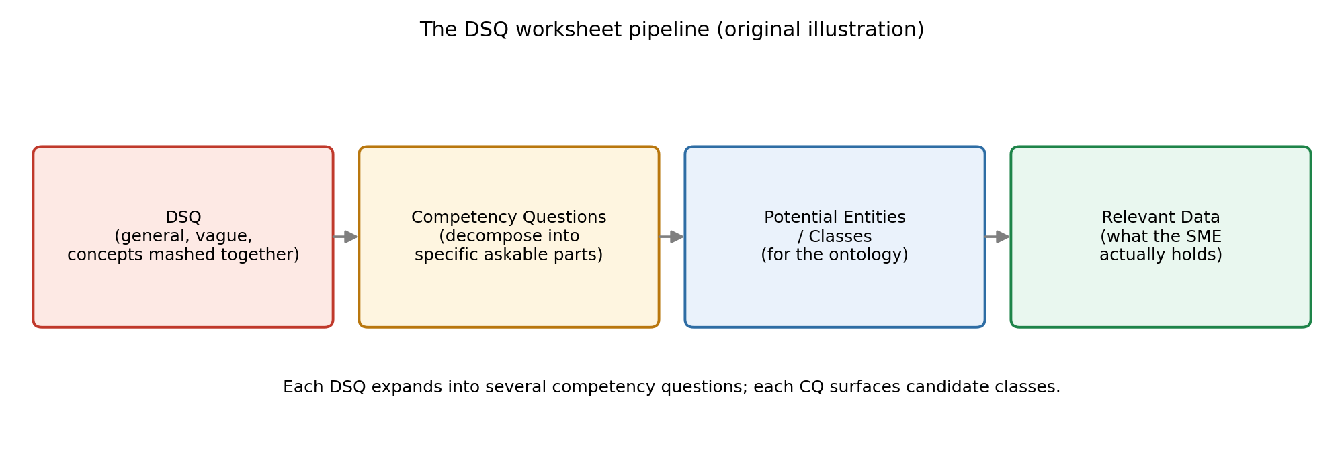
Original illustration — the DSQ worksheet pipeline.
Worked columns from the aircraft engine case: DSQ 1 'What types of Aircraft make up the Fleet?' expands into competency questions 'What is a Fleet of Aircraft?' and 'What are the types of Aircraft that make up this Fleet?', which surface candidate classes Fleet, Aircraft, Jet Aircraft. DSQ 2 'Does the Fleet overlap with another Fleet?' (a real aerospace problem — an engine moved to an aircraft that sits in a different fleet) yields Fleet Overlap and Fleet Membership. DSQ 4 'Where do the aircraft in my fleet operate?' yields Airport, Flight, Flight Phase, plus the phase taxonomy Taxi, Take Off, Climb, Cruise, Descent, Approach, Landing. DSQ 5 'What are the most common maintenance issues with jet engines?' decomposes the engine into its major parts — Compressor, Combustion Chamber, Turbine Section, Bearings, Lubrication System, Fan, Inlet Section, Exhaust Section, Afterburner. DSQ 8 'Are Maintenance Issues more frequent in some places?' yields Altitude, Particulate Level, Pollution Level, Heat, Humidity — the space/time correlation round.

Resolving SME Disagreement: Lean on Published Standards
Experts will disagree on terminology on every project — 'we don't call it that, we call it this.' A practical technique: don't invent the taxonomy yourself, and don't try to referee the dispute. Anchor the candidate classes to an already-published standard, so the terms aren't the ontologist's invention. In the maintenance case, the activity taxonomy (Adjust, Calibrate, Check, Component Cleaning, Component Replacement, Engine Overhaul, Inspect, Lubrication, Maintain, Modify, Overhaul, Refit, Renew, Repair, Replace, Routine Inspection, Service, Test, Troubleshoot, Tune Up) came from a study of roughly 800,000 maintenance work orders, and the definitions trace to ISO 14224 and ISO 15926.
If someone still objects, they need to bring good reasons. Often this is a leadership question, not an ontologist's question — the right move is to record a primary label, alternate labels, primary and secondary definitions, and definition sources, then put a pin in the dispute and escalate it. Every decision should carry an annotation: why this decision was made, on what date, and who was involved. That provenance goes into the ontology's annotation properties.

Disambiguation: Four Confusions to Design Against
These four confusions are described as surprisingly common in real projects. They are obvious once stated — and precisely because they are so obvious, they get overlooked in actual data. An upper-level ontology like BFO provides guard rails that make them hard to miss.
Confusion to avoid | Example
Information vs. what the information is about | An occupation code vs. the person who holds that occupation. A tail number is not the aircraft; a serial number is not the engine.
Material vs. immaterial things | A given river (the water) vs. the site where the river used to flow. You can't find an old riverbed by looking for water.
Bearing properties vs. bearers of properties | An apple's redness vs. the apple itself.
Processes vs. products | Ontology engineering vs. the ontology produced; baking a cake vs. the cake.

The BFO Hierarchy Used for DSQ Analysis
The class buckets below map onto BFO's own taxonomy. The full hierarchy, with the branches most used in DSQ analysis highlighted:
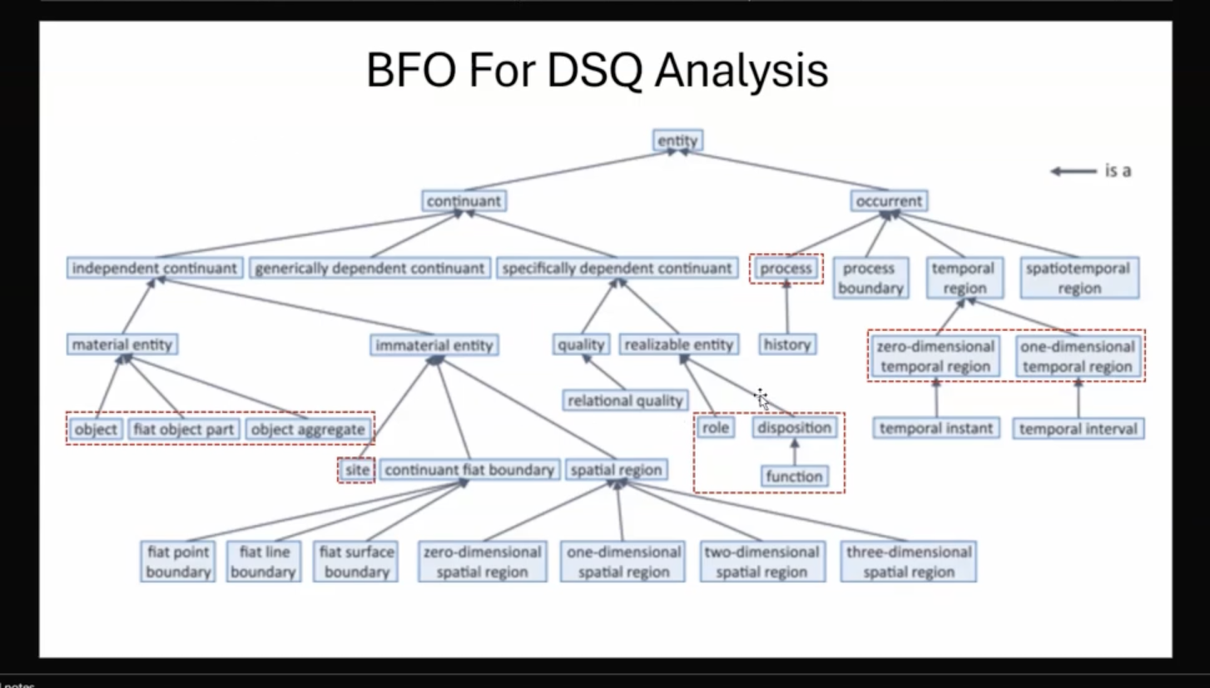
BFO class hierarchy as presented for DSQ analysis (arrows read 'is a'). Red-dashed boxes mark the branches most frequently needed.
The single most important split is at the top: continuant vs. occurrent. A continuant persists and is wholly present at every moment it exists (an engine is entirely there right now). An occurrent unfolds and has temporal parts (a flight is only partly present at any instant). Every other branch hangs off that distinction.
BFO term | What it means | Example
entity | The root of BFO. Anything that exists at all. | Everything below
continuant | Something that persists through time and is wholly present whenever it exists. | An aircraft, a runway, a colour
occurrent | Something that unfolds over time and has temporal parts — only partly present at any instant. | A flight, a repair, a lifetime
independent continuant | A continuant that does not depend on another thing to exist. | An engine, an airport
specifically dependent continuant | A continuant that depends on one particular bearer to exist. | This engine's temperature
generically dependent continuant | Information-like content that can be copied across many bearers. | A maintenance manual, a tail number
material entity | An independent continuant that has matter as a part — something you could touch. | A turbine blade, an aircraft
immaterial entity | An independent continuant with no matter — places, boundaries, regions. | The airspace above a runway
object | A material entity that is a single, maximally connected whole. | One jet engine
fiat object part | A part of an object carved out by human convention, not by a real physical discontinuity. | The 'forward section' of a fuselage
object aggregate | A collection of objects treated as one entity. | A fleet of aircraft
site | An immaterial entity that is a place or cavity, typically bounded by material things. | A hangar's interior, an airport site
continuant fiat boundary | A boundary drawn by convention rather than by physical discontinuity. | A state line, a zone boundary
fiat point / line / surface boundary | Zero-, one-, and two-dimensional kinds of fiat boundary. | A survey marker; an equator; a map face
spatial region | Pure space itself, independent of what occupies it. | The volume a container encloses
zero/one/two/three-dimensional spatial region | Points, lines, surfaces, and volumes of space. | A coordinate; a flight corridor; a volume
quality | A property that is fully exhibited whenever its bearer exists — no trigger needed. | An apple's redness, an engine's mass
relational quality | A quality that depends on more than one bearer at once. | The distance between two airports
realizable entity | A property that is only manifested when something happens — a potential. | Solubility, a pilot's licence
role | A realizable entity a thing has contingently, by social or contextual assignment; it can be lost without the bearer changing. | Being the designated backup engine
disposition | A realizable entity grounded in the bearer's physical make-up; realised under the right conditions. | Salt's solubility; a blade's brittleness
function | A disposition a thing has because of how it was designed or selected to behave. | A fuel pump's function to pump fuel
process | An occurrent that unfolds in time and has material participants. | An act of motion, a repair, a takeoff
process boundary | The instantaneous start or end of a process. | The moment of wheels-up
history | The total process comprising everything that happens to a given material entity. | One engine's full service life
temporal region | Time itself, independent of what happens in it. | The interval 09:00–10:30
zero-dimensional temporal region / temporal instant | A single point in time. | 09:00:00 exactly
one-dimensional temporal region / temporal interval | A stretch of time with duration. | 1.5 hours
spatiotemporal region | A region of space-time combined — where and when together. | The path a flight traces through space over time

Three distinctions worth pinning down, since they're the ones most often blurred: (1) quality vs. realizable entity — a quality is always on display (mass, redness), whereas a realizable entity only shows up when triggered (solubility needs water). (2) role vs. disposition vs. function — a role is assigned contextually and can be dropped without changing the thing; a disposition is grounded in what the thing is physically made of; a function is a disposition the thing was designed or selected to have. (3) temporal instant vs. temporal interval — a point in time vs. a stretch with duration; datatype values like '1.5 hours' attach to the latter.

The Same Hierarchy as Seen in Protégé
Opening the BFO core file in Protégé shows the same taxonomy as an indented asserted class hierarchy:
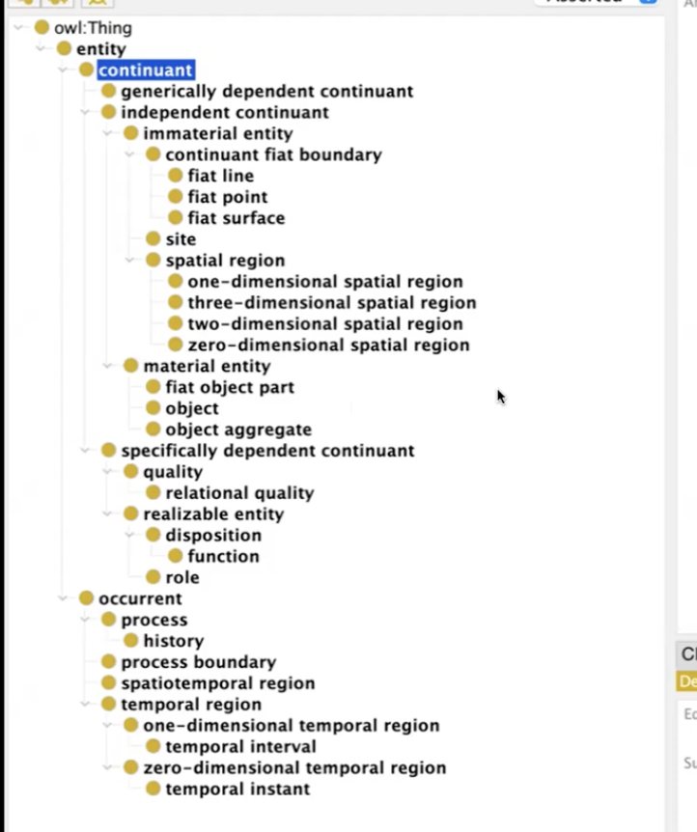
BFO's asserted class hierarchy in Protégé.
Reading notes: owl:Thing at the top is not BFO — it's OWL's own universal root, present in every OWL ontology; BFO plugs in beneath it. Indentation means subClassOf. And Protégé sorts siblings alphabetically rather than by significance, which is why 'one-dimensional' appears above 'three-dimensional' above 'two-dimensional' — don't read meaning into the order.
Every node in that tree, with an aircraft-domain example:
BFO class | What it means | Aircraft example
owl:Thing | OWL's universal root — not BFO itself. Every OWL ontology has it. | (everything)
entity | BFO's actual root. Anything that exists. | (everything below)
continuant | Persists through time, wholly present whenever it exists. | An engine, a runway, a tail number
— generically dependent continuant | Information-like content, copyable across many bearers. | Tail number N12345; the maintenance manual; airport code JFK
— independent continuant | Doesn't depend on another thing to exist. | An aircraft, an airport
—— immaterial entity | No matter — places, boundaries, pure space. | The airspace above an airport
——— continuant fiat boundary | A boundary set by convention, not physical discontinuity. | The edge of a controlled airspace sector
———— fiat line | 1-D conventional boundary. | A published airway centreline
———— fiat point | 0-D conventional boundary. | A named waypoint on a flight plan
———— fiat surface | 2-D conventional boundary. | The ceiling of a restricted altitude block
——— site | A place or cavity, usually bounded by material things. | A maintenance bay; a hangar interior; the airport site
——— spatial region | Pure space itself, independent of occupants. | The volume a parked aircraft occupies
———— zero-dimensional spatial region | A point in space. | The exact GPS coordinate of a gate
———— one-dimensional spatial region | A line in space. | The centreline of runway 27L
———— two-dimensional spatial region | A surface in space. | The runway's paved surface area
———— three-dimensional spatial region | A volume of space. | The volume of a hangar
—— material entity | Has matter — you could touch it. | A turbine blade, an aircraft
——— fiat object part | A part carved out by convention, not a real physical break. | The 'forward section' of a fuselage
——— object | A single, maximally connected whole. | One jet engine; one aircraft
——— object aggregate | A collection treated as one entity (use 'has member'). | A fleet of 80 aircraft; a fleet of engines
— specifically dependent continuant | Depends on one particular bearer to exist. | This engine's temperature
—— quality | Always exhibited whenever the bearer exists — no trigger. | An engine's mass; an airport's altitude
——— relational quality | A quality depending on more than one bearer at once. | The distance between two airports
—— realizable entity | A potential — only manifests when something happens. | Flight capability
——— disposition | Grounded in the bearer's physical make-up. | A turbine blade's brittleness; lift capability
———— function | A disposition the thing was designed/selected to have. | A fuel pump's function to pump fuel
——— role | Contextually or socially assigned; droppable without changing the thing. | Being the designated backup engine; pilot in command
occurrent | Unfolds through time, has temporal parts, only partly present at any instant. | A flight, a repair
— process | Unfolds in time with material participants. | A flight; an engine startup; a takeoff
—— history | The total process of everything that happens to one material entity. | One engine's entire service life
— process boundary | The instantaneous start or end of a process. | The moment of wheels-up
— spatiotemporal region | Space and time combined. | The 4-D path a flight traces from JFK to LAX
— temporal region | Time itself, independent of what happens in it. | The window 09:00–10:30
—— one-dimensional temporal region | A stretch of time with duration. | The 6-minute climb phase
——— temporal interval | A specific bounded stretch. | 1.5 hours of cruise
—— zero-dimensional temporal region | A single point in time. | The instant of touchdown
——— temporal instant | A specific point in time. | 09:00:00 UTC

Two structural points the indentation encodes: function sits under disposition — a function is a special kind of disposition (designed-for, rather than merely physically grounded). But role is a sibling of disposition, not a child: dispositions come from physics, roles from social assignment, and a backup engine is physically identical to a primary one. Likewise quality and realizable entity are siblings rather than parent/child — an engine's mass is a quality (always there), while its capability to produce thrust is realizable (only shown when running).

Rules of Thumb: Seven Buckets for Identifying Classes
Walk through the competency question, pick out each noun and verb, and sort them into these seven buckets in order. Start with material entities because they are easiest for humans to think about; leave information until last, because if you don't, you will invariably confuse information for what it's about.
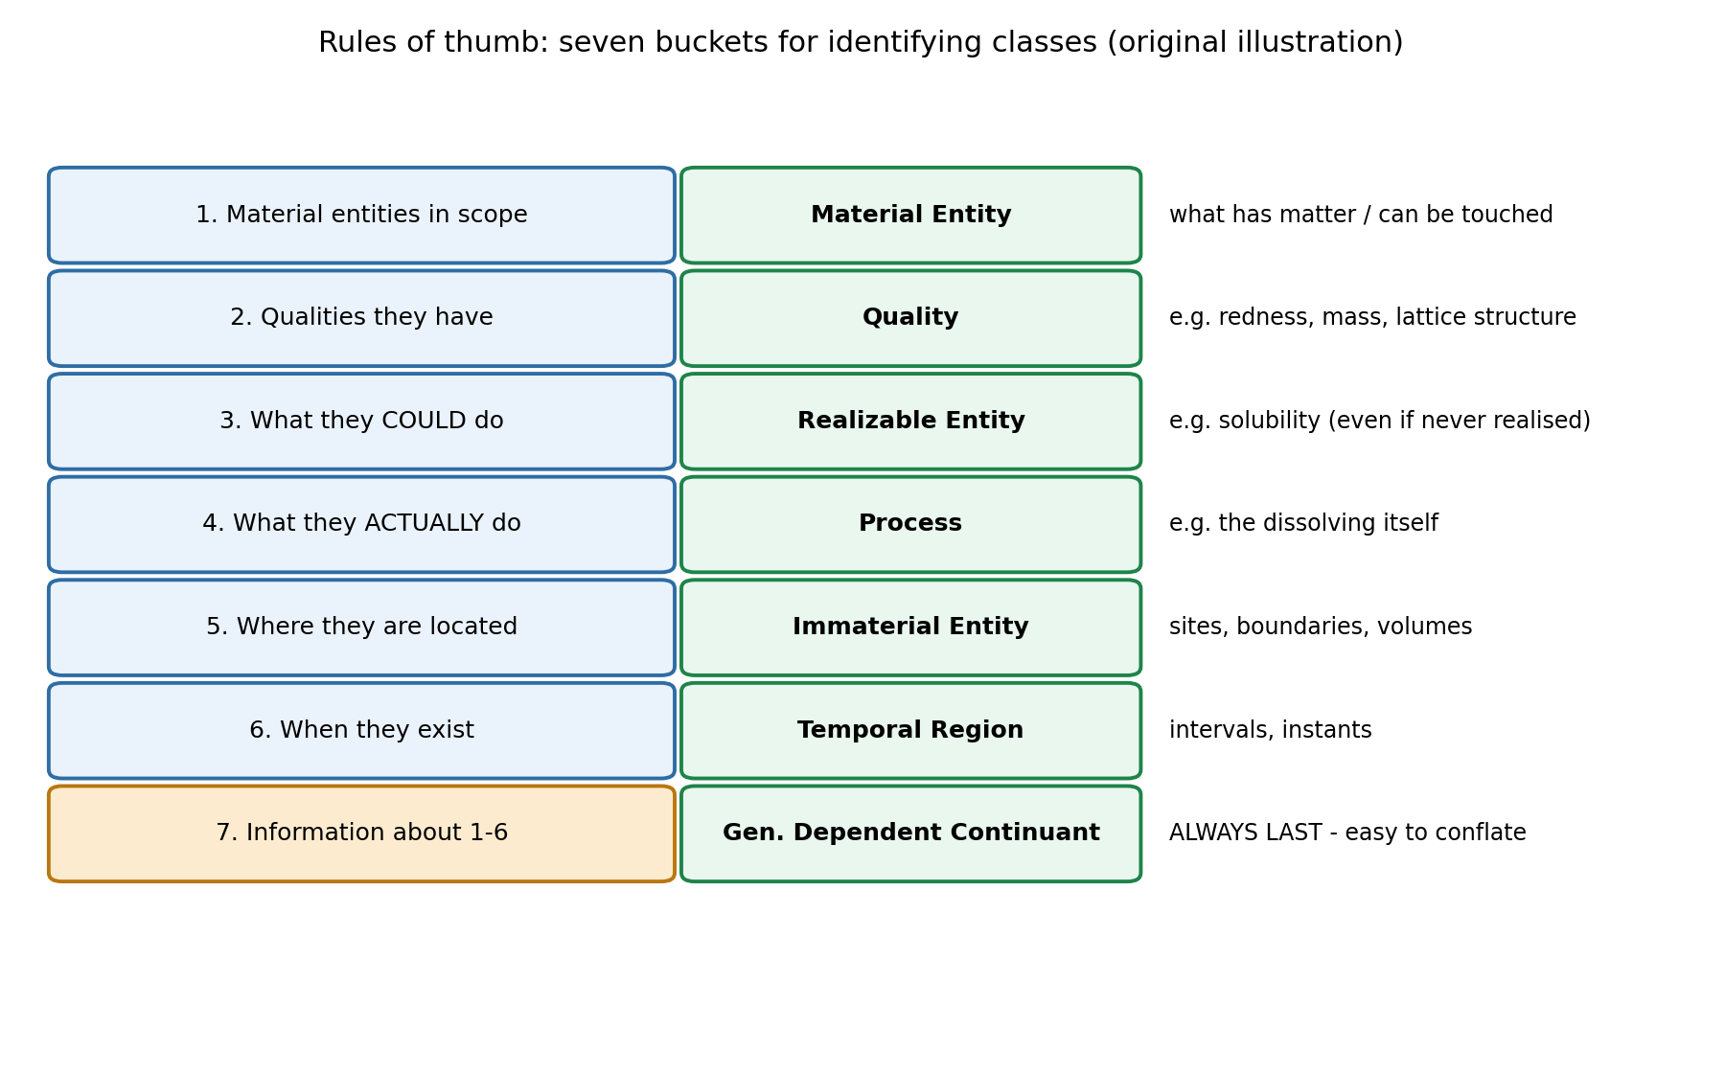
Original illustration — the seven class buckets and their BFO categories.
The salt example ties buckets 1–4 together: a piece of sodium chloride is a material entity (you can touch it); its lattice structure is a quality; its solubility is a realizable entity (what it could do — it stays soluble even if it never touches water); and the dissolving itself is a process (what it actually does). Four genuinely different things, all worth representing separately, because machines do exactly what you tell them and nothing more.
You do not have to fill every bucket. If the competency question contains nothing that calls for a quality, skip that bucket — track the question, not an urge to model everything.

Handling Ambiguity: Asterisk It and Move On
Natural-language terms are often ambiguous across buckets. Take the competency question 'At what speed does a patrol boat move in knots over an hour?' — 'speed' could mean the actual changing of position over time (a process) or the magnitude of that change as it would appear in a physics textbook or dataset (information). Similarly, 'hour' could be a temporal region or information about a temporal region.
The working rule: when you spot an ambiguity, mark it with an asterisk, list it in both buckets, and keep going. If you stop to argue about which reading is correct, you will never finish the list. Come back once the whole question has been processed.
Crucially, representing both readings is not a failure — it is the point. Disambiguation does not mean finding a privileged interpretation of the data; it means fleshing out the logical space of interpretations and letting the user tell you which one they meant. As the instructor puts it: we are describing, they are prescribing. This is the same principle as the systematic disambiguation strategy in the SME engagement section above, now applied at the level of a single word in a single question.

Rules of Thumb: Connecting the Classes with Relations
Once the class list is settled, the logical strength of the ontology comes from wiring those classes together — a spiderweb of relations, using BFO's object properties. This is where semantic enrichment actually happens, and it's also why the relationships often aren't visible in the competency question itself: you supply them.
Connect... | ...using BFO relation
Qualities to material entities | inheres in
Realizables to material entities | inheres in, has material basis
Processes to material entities | participates in
Realizables to processes | has realization
Immaterial location of a material entity | located in
When entities exist | exists at, or a datatype property
When entities carry information | generically depends on (or 'is about' in CCO)

The Resulting Design Pattern
Putting it together for 'At what speed does a patrol boat move in knots over an hour?', with speed modelled as a process (rather than as information) for this pass:
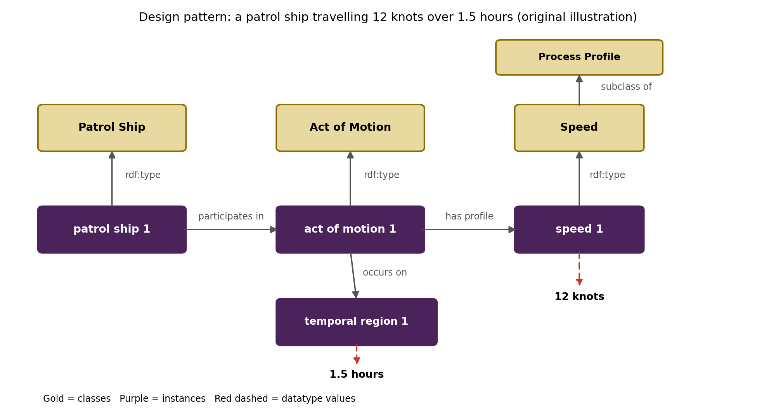
Original illustration — design pattern for a patrol ship travelling 12 knots over 1.5 hours.
Reading the pattern: gold boxes are classes, purple boxes are instances, and rdf:type links each instance to its class (RDF's way of relating instances to classes). The instance-level relations are the substance: patrol ship 1 participates in act of motion 1; that act of motion has profile speed 1 and occurs on temporal region 1. The red dashed arrows are datatype properties attaching literal values — 12 knots to the speed, 1.5 hours to the temporal region — often following an ISO standard that already carries its own built-in logic worth reusing.

Thinking Axiomatically: The Best Trick in the Bag
'Axiom' here is meant in the dictionary sense — self-evident — not the mathematical sense of an unproven starting assumption. If a flight exists, certain things necessarily follow. You don't need to ask an SME and you don't need data to confirm them; they're true by the nature of what a flight is. Every class can have default axioms, and the habit worth building is to jot them down every time.
Why it matters practically: an SME hands you one word — Flight — which looks like one class. Axiomatic thinking explodes it into a whole connected structure, and the structure comes out of BFO's own shape. This is where the upper ontology does real work rather than serving as philosophical decoration.
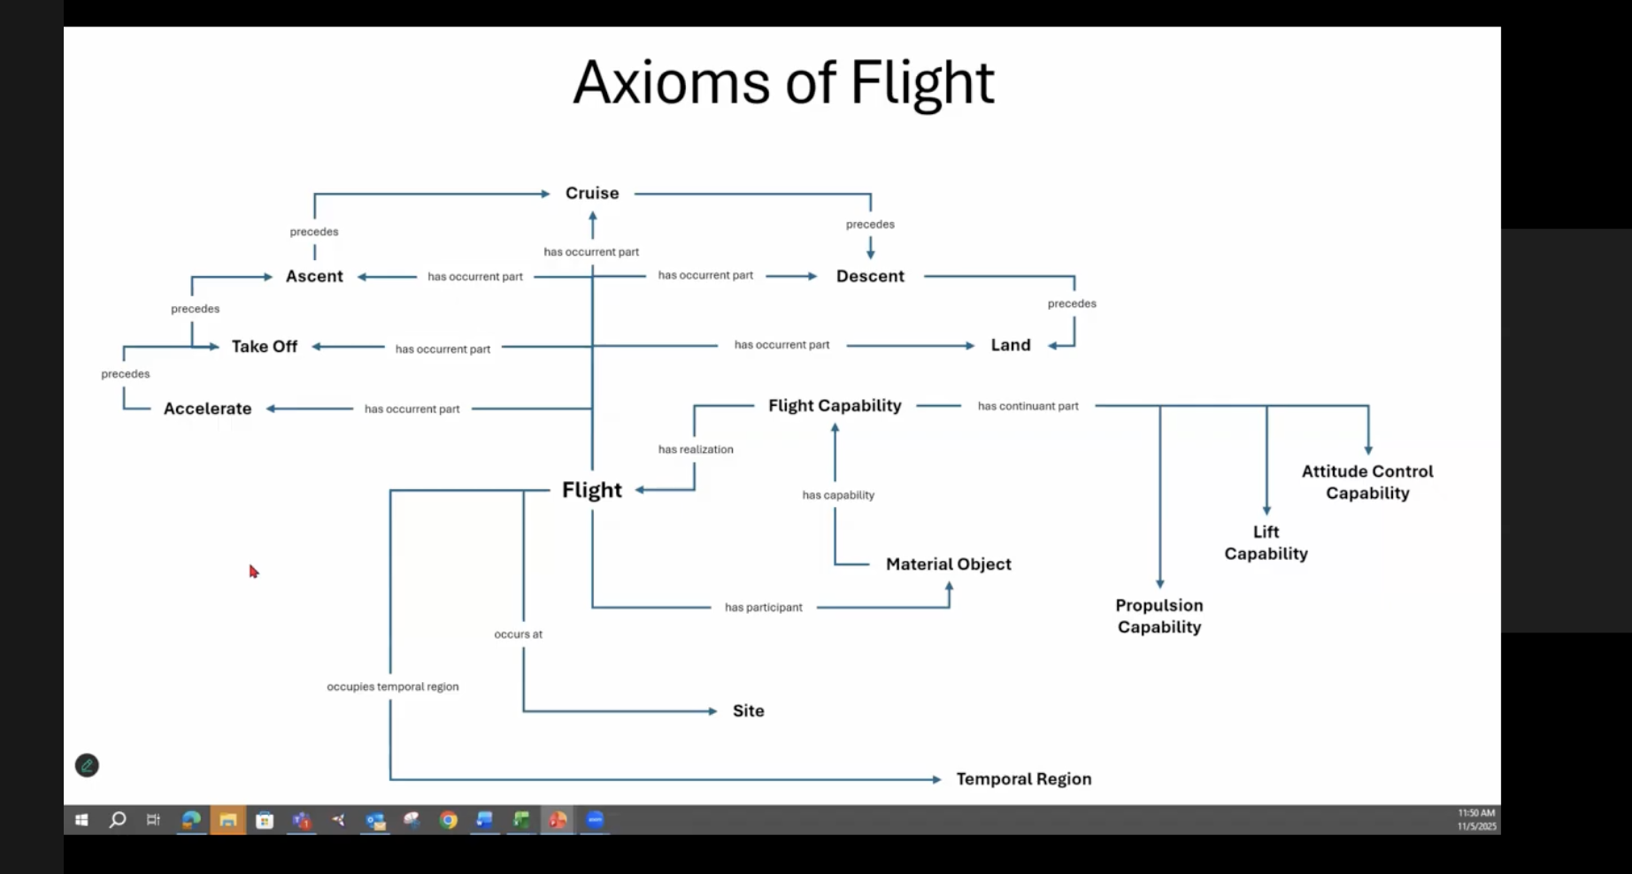
Axioms of Flight — the structure that falls out of a single class, derived by asking BFO's structural questions in order.
The checklist to run against any new class:
Ask of any class | BFO relation to reach for | Flight example
If it's a process, what participates in it? | has participant | Flight has participant Material Object
What capability must that participant have? | has capability / inheres in | Material Object has capability Flight Capability
What does that capability decompose into? | has continuant part | Propulsion, Lift, Attitude Control Capability
How does the capability connect back to the process? | has realization / realizes | Flight Capability is realised in Flight
What are the process's parts? | has occurrent part | Accelerate, Take Off, Ascent, Cruise, Descent, Land
How are those parts ordered in time? | precedes / preceded by | Accelerate precedes Take Off precedes Ascent...
Where does it happen? | occurs at / located in | Flight occurs at Site
When does it happen? | occupies temporal region | Flight occupies Temporal Region

Note the deliberate generality: the participant is modelled as Material Object, not Aircraft — it could be a bird or a cannonball. Note also that the capability exists even when the aircraft is parked in a hangar; it's a potential, not an activity. You can't point at a bird's flight capability directly, but you can point at the flight and say that's what the capability was for.
Two payoffs. First, the definition almost writes itself from the graph: 'a flight is a process that has a material entity participant with propulsion, lift, and attitude control capabilities, and that includes acceleration, takeoff, ascent, cruise, descent, and landing as ordered parts, occurring at a site over a temporal region.' That's derived structurally rather than improvised. Second, queries get richer for free — a reasoner can answer questions nobody stored, because the precedes chain and has-occurrent-part relations are logical, not just documentation. You cannot land before you accelerate, and the ontology knows it.

Honest Caveats: Where the Axioms Break
Two objections raised in the same session show the technique's limits, and both are worth keeping alongside it:
- Gliders break the propulsion axiom — a glider has no propulsion capability of its own; propulsion is external. So 'has continuant part Propulsion Capability' is not actually axiomatic for flight in general.
- Landing isn't necessary either — a flight that gets shot down never lands. Landing enables the next flight; it isn't constitutive of this one.
The prescribed response is telling: discuss it for about ten minutes so the SMEs can see you're being rigorous, then put a pin in it and take the debate offline with other ontologists. If the customer's aircraft always land, leave Land in. The scoping test is blunt and non-philosophical — what they support, how much funding they have, and whether it answers their maintenance questions. A philosopher won't like that answer, but it's the one that keeps the project funded.

Modelling Correction: Object vs. Object Aggregate
A common error surfaced in the same discussion: a car is NOT an object aggregate just because it has an engine, a drive train, and brakes. A car is an object, and the right relation is 'has part'. Reserve object aggregate (and 'has member') for genuine collections — all the pens in a cup, all the people in a meeting, a fleet of aircraft, a fleet of engines.
Aggregates do not require physical proximity, though. A fleet spread between Shanghai and Seattle is still one object aggregate — membership works like set theory, not like spatial clustering. The same reasoning extends beyond physical things: AI systems composed of other systems have been modelled as object aggregates precisely because the aggregation isn't physical in nature.

Scoping Discipline: Don't Boil the Ocean
A live example from the session: working the competency question 'What airports do the aircraft take off or land at?', someone proposed adding airport altitude. It's a reasonable idea — altitude genuinely affects engine wear. But it isn't in scope for this question, which asks only which airports, not tell me more about the airports.
The discipline: if something feels important but doesn't fit the question you're currently modelling, that's a signal there should be a separate competency question for it — not a reason to stretch this one. (In the real project, altitude did appear later, in DSQ 8: 'Which Airports are at High Altitudes?') Questions should be treated as a modular set; each one keeps its own scope, and together they cover the ground.
The justification test is practical, not academic: if you model a large amount of content about altitude and the sponsor didn't ask for it, you need a documented reason — 'your subject matter experts said this mattered, and here's the question it answers.' 'Seemed cool' is not a defensible answer to whoever is paying for the work.
A related judgement call from the same discussion: distinguishing 'material airport' (hangars, runway, tower, maintenance facility) from 'site airport' (the immaterial place) is legitimate disambiguation, not a rabbit hole — that labelling helps the modeller think clearly, even if those exact labels would never be shown to a sponsor. And when a class already has good published coverage (world airports, ISO country codes), reuse it rather than rebuilding it in-house.

References (Design Patterns & BFO)
BFO-2020 repository — the BFO core file (Turtle/RDF serialisation), class taxonomy, and object properties — https://github.com/BFO-ontology/BFO-2020
ISO 14224 — petroleum/petrochemical equipment reliability and maintenance data standard, source of maintenance activity definitions — https://www.iso.org/standard/64076.html
Basic Formal Ontology overview — continuant/occurrent structure refresher — https://en.wikipedia.org/wiki/Basic_Formal_Ontology

Encoding in OWL: From Design Pattern to Protégé
The final stage of the cycle: taking the design pattern off paper and building it as an OWL file that a reasoner can actually operate on.

Why OWL Specifically — Decidability
OWL captures a fragment of description logic that is decidable, and that is the entire point. It represents binary relations over a finite domain, and the guarantee it buys you is this: ask the system whether some proposition is true or false, and you will get an answer within a finite amount of time. You never end up in the position of not knowing whether the machine is still working or has hit a question it fundamentally cannot answer. Anything more expressive than that fragment becomes undecidable — which is exactly why OWL is deliberately a fairly weak language.
Layer | What it gives you | Example
RDF | Subject–predicate–object triples — the base data structure of any turtle file. | descent phase 1 / occurrent part of / flight process 1
RDFS (subclass) | Type hierarchies — how one class relates to another. | Descent Phase subClassOf Process
OWL (logic) | Real logical constraints on top of the hierarchy. | Continuant disjointWith Occurrent; class-level restrictions

Disjointness, Demonstrated by Breaking It
Continuant and Occurrent are asserted disjoint in BFO — no instance can be both. The instructive demo is to deliberately create an individual typed as both, run the HermiT reasoner, and watch Protégé report the ontology as inconsistent, with an explanation naming the exact conflicting axiom. Drop one type, re-synchronise the reasoner, and the ontology is consistent again.
Worth knowing where reasoning actually happens: the description pane in Protégé (subclass axioms, equivalences, disjointness) is what reasoners and SPARQL operate on. The annotations pane — textual definitions, comments, elucidations — is ignored by reasoners entirely. A beautifully worded definition does no logical work; it's for humans.

Axioms Are Inherited Downstream
Subclass anything under BFO and you inherit every axiom from every ancestor class for free. Assert something at a high level and it propagates down the tree. This matters practically: new domain classes created under BFO arrive pre-loaded with constraints, so run the reasoner intermittently while building rather than only at the end — otherwise you discover late that something you asserted conflicts with an inherited axiom.

Modelling Decisions and the Reasoning Behind Them
Class | Placed under | Reasoning
Aircraft | object | Passes the causal unity test: move one proper part and the rest must move too, or you break it. Move a wing and the rest had better follow.
Fleet of Aircraft | object aggregate | Many discrete objects summed into one collection.
Airport (labelled 'airport material entity') | material entity — deliberately no further | 'Airport' is genuinely ambiguous — buildings, tarmac, runways, parking lots, all legitimate uses. Committing to object or object aggregate would be provably wrong for some usage, so the label itself encodes the hedge.
Airport Site | site (immaterial entity) | The ground area plus the airspace above it. Note: the site is NOT the air molecules — air moves through it.
Flight | process | A processy thing existing over time.
Flight Phase (taxi, take off, ascent, cruise, descent, landing) | process | Occurrent parts of a flight process.

On fiat object parts, for contrast: these are named parts demarcated by a surface rather than a real physical break — the Western Hemisphere of Earth, the upper and lower lobes of a lung, or the front versus the back of an aircraft cabin. They're worth naming (people fight wars over some of them) but they aren't objects in their own right.
The airport decision is the one worth remembering. The stated motivation: having watched intelligence-community teams burn time arguing over what counts as a 'facility' or a 'target,' the aim was to avoid manufacturing that fight at all. Say nothing so strong that it's false, describe as much as is true, and put the hedge in the label so other ontologists see it. Specific components (tarmac, buildings, runways) can still be created as their own classes and connected via parthood or location relations. This is the same 'describe, don't prescribe' principle from the SME engagement section, applied to a single class name.

Class-Level vs. Individual-Level Assertions
This is the core technical lesson of the session. The same relation between the same two classes carries very different weight — and very different risk — depending on how and in which direction you assert it.
Assertion level | What it says | Strength / risk
Individual → individual | descent phase 1 is occurrent part of flight process 1. | Weak — holds only for that one triple. Low risk.
Class-level (safe direction) | Every Descent Phase is occurrent part of SOME Flight Process. | Strong — entails the individual triple. Defensible.
Class-level (risky direction) | Every Flight Process has occurrent part SOME Descent Phase. | Strong but exposed — a craft that ascends and never returns, or a flight aborted during taxi, breaks it.

Note also that BFO has separate parthood relations for each side of the hierarchy: 'continuant part of' for continuants and 'occurrent part of' for occurrents. Use the wrong one across the continuant/occurrent divide and the reasoner will flag an inconsistency, because those two classes are disjoint.
Mechanically, in OWL everything ultimately reduces to subclass relationships — class-to-class and instance-to-class. Adding a class-level axiom in Protégé is done through the 'subclass of' button and the class expression editor, written as: occurrent part of some Flight Process. The 'some' is a required logical connective; the object property always has to be connected through logic to the class it targets. Behind the scenes OWL introduces anonymous classes to make this work — they're mostly invisible in the editor and in turtle serialisations, but they're there.

Temporal Ordering and an Instructive Counterexample
BFO provides 'precedes' and 'preceded by' for ordering occurrents. Asserting that a Descent Phase is preceded by some Ascending Phase looks safe — until someone raises drones released mid-air from a carrier aircraft, which descend without ever having ascended themselves.
The escape hatch, and why it's uncomfortable: the axiom only says 'some' ascending phase — it never requires it to be the same aircraft's ascent. So the drone case technically satisfies it (the carrier aircraft's ascent counts). The axiom survives. But the better question is whether that's what you actually meant. An axiom that's technically true because it's underspecified may not be capturing your intent at all.

The Central Trade-Off
More axioms asserted → fewer counterexamples allowed → more implicit information becomes inferable → more precision about how the machine interprets your model. Leaving things open → you get out only what you put in.
There is no universally correct setting on that dial. It's a balancing act, and where you land depends on how specific the use case is. For an aircraft maintenance ontology that will be queried across thousands of descent events, more specificity pays off — leave it loose and the numbers won't reconcile. The same reasoning that governs scoping decisions governs axiom strength.

Postscript: 'History' Made Concrete
A neat illustration of BFO's history class from the hierarchy table above. The oldest active USAF B-52H — from a fleet of 77 aircraft with tail numbers dating to the 1950s–60s, one tracing back to the end of the Korean War era — has a full history assembled from open sources: missions it participated in (Red Flag, Enduring Freedom), a 2015 radar upgrade, a 2020 maintenance event, its station at Barksdale, and its eight engines. Every one of those is an occurrent part of the history of that tail number — which is exactly what BFO's history class exists to hold.

References (OWL & Reasoners)
OWL 2 Web Ontology Language Document Overview (W3C) — the standard itself, including the semantics of disjointness — https://www.w3.org/TR/owl2-overview/
Protégé — the desktop ontology editor used for class hierarchies, individuals, and running reasoners — https://protege.stanford.edu/
HermiT reasoner — the OWL reasoner used in the consistency demonstration — http://www.hermit-reasoner.com/
RDF 1.1 Primer (W3C) — the triple structure OWL is built on — https://www.w3.org/TR/rdf11-primer/

Ontology Engineering Using Large Language Models (LLMs)
Source: Lippolis et al. (2025), 'Ontology Generation using Large Language Models', arXiv:2503.05388.

Why This Matters
Building a good ontology requires three skills at once: domain knowledge, formal logic, and the ability to bridge between how humans speak and how a machine needs things encoded. These three skills rarely exist in one person — that's the fundamental bottleneck that makes ontology engineering slow, expensive, and inaccessible to most practitioners.
Even when all three skills are available, the work is mostly manual. Methodologies exist to help (Methontology, NeOn, eXtreme Design, Linked Open Terms) but they provide structure and guidance, not automation. Creating, curating, and validating ontological elements is still cognitively costly and largely hand-done.
The question this paper investigates: can a Large Language Model take requirements (user stories and competency questions) as input and produce a usable OWL ontology draft as output, without requiring the model to be fine-tuned or retrained?

The Programming Co-Pilot Analogy
The framing throughout the paper is co-pilot, not replacement. GitHub Copilot doesn't replace software engineers — it drafts boilerplate, completes routine patterns, and catches common mistakes while the human reviews and corrects. This paper positions ontology engineering as analogous: LLMs can generate a draft, flag obvious errors, and reduce the cost of getting started, while a human ontologist remains responsible for the hard judgement calls.
Two separate value propositions are claimed and tested:
- For experienced ontology engineers: reduce manual labour on routine modelling, freeing them to focus on the difficult disambiguation decisions.
- For novices: lower the barrier enough that someone without deep description-logic expertise can get a usable starting draft, which they then review and correct.

What LLMs Don't Replace: the SME Elicitation Step
The LLM pipeline in this paper starts downstream of everything in the SME engagement section of these notes. Competency questions and user stories are still inputs produced by humans through the elicitation process described earlier. The LLM is being asked to automate the step after DSQ elicitation — the conversion of CQs into a modelled OWL artefact. This is important to be clear about: the parts of ontology engineering that involve talking to subject matter experts, surfacing tacit knowledge, and making scoping decisions are not being automated.

Key Terms the Paper Uses (Plain-English Definitions)
Term | Plain-English meaning | Example
Modelled CQ | An ontology models a CQ if it contains everything needed to write a SPARQL validation query — regardless of whether the modelling is good or bad practice. | If the CQ is 'Who wrote this book?', the ontology must have Author, Book, and a property connecting them.
Superfluous element | A class or property that appears in no SPARQL query for any CQ. Dead weight. | 'Person' class included but not needed to answer any of the CQs.
Minimal ontology module | The ontology with all superfluous elements stripped out, relative to one CQ. This is the gold standard. | Just Author → authorOf → Book, nothing else.
Minor issue | Missing exactly one object or data property. Adding it would make the CQ modelled. Treated as forgivable. | Author and Book classes present, but the 'authorOf' link missing.

The Four Ontology Engineering Methodologies Mentioned
Methodology | Era | Core idea
Methontology | 1997 | Systematic from scratch: define scope, build glossary, classify concepts, define relations, document.
NeOn | 2012 | Network-centric: reuse and re-engineer existing ontologies rather than building from scratch.
eXtreme Design (XD) | 2009– | Agile, pattern-based. Uses competency questions and user stories as core input — directly relevant to these notes' SME workflow.
Linked Open Terms (LOT) | 2022 | Pragmatic and industry-oriented, compiled from lessons across many real projects.

The one most relevant to this research and to these notes is eXtreme Design (XD), because it explicitly centres competency questions and user stories as its core inputs — the same inputs the LLM pipeline uses.

The Two Prompting Techniques
Both techniques work CQ-by-CQ — they never ask the LLM to build the whole ontology at once. This is decomposed prompting: one large, complex task is broken into many smaller, well-scoped sub-tasks. The key insight is that a poorly modelled single CQ is a manageable failure; an entirely wrong ontology is a catastrophic one.
Memoryless CQbyCQ — process each CQ in complete isolation. Give the LLM the user story and that one CQ. Generate a fragment. Repeat for every CQ, then merge at the end. The key innovation: unlike the earlier CQbyCQ baseline, the model is NOT shown the growing ontology between iterations, cutting input context by roughly 60%.
Why cut the context? Long context distracts LLMs. Slight overlaps between independently-generated fragments are easier for a human engineer to reconcile than completely inconsistent output from a distracted model. Better to have redundancy than incoherence.
Ontogenia — also one CQ at a time, but incremental: each iteration merges the new fragment into the growing ontology and carries it forward in context. Adds two things on top of the basic CQbyCQ idea: (1) Metacognitive Prompting in five steps — interpret requirements → break CQs into logical elements → reflect and extend with rules and restrictions → confirm the decision with explicit reasoning → self-evaluate by generating test instances; and (2) injection of published Ontology Design Patterns from the ODP repository.
Feature | Memoryless CQbyCQ | Ontogenia
Memory of prior output | None — each CQ is fully isolated | Yes — carries growing ontology forward in context
Context size | ~60% smaller than CQbyCQ baseline | Larger — grows with each iteration
Prompting technique | Decomposed prompting with pitfall warnings | Metacognitive Prompting (5-step self-evaluation)
Ontology Design Patterns | Not injected | Injected from ODP repository
Explicit labels, comments, inverses | Not required | Explicitly requested
Common pitfall warnings | Included | Not included
Best suited for | Independent modelling where fragments can be merged | History-dependent, richer multi-CQ modelling

The Benchmark and Baseline
Ten ontologies, 100 competency questions, 29 user stories, from four real-world projects (Polifonia, Onto-DESIDE, WHOW, IKS) and three educational ones. CQs are divided by difficulty: Simple (data property, object property) and Complex (reification, restrictions). Note that reification CQs dominate at 62 out of 100 — the hard case is well-represented.
The baseline is the clever part. They compare against master's students with CS backgrounds but no prior ontology design experience, who submitted twice — an initial attempt and a revised version after expert feedback. So the comparison is: LLM vs. novice-without-feedback, AND LLM vs. novice-with-feedback. Three LLMs are tested: GPT-4, OpenAI o1-preview, and Llama-3.1-405B.

Four-Dimensional Evaluation (Why One Metric Is Never Enough)
A key contribution of the paper is the argument that single-metric evaluation of LLM-generated ontologies is misleading. They use four together:
Evaluation dimension | What it measures | Tool / method
Standard metrics (OOPS!) | Common structural mistakes and best-practice violations, e.g. multiple domains/ranges, wrong inverse axioms. | Automated — OOPS! Pitfall Scanner
Proportion of modelled CQs | What percentage of CQs the ontology covers — with and without forgiving minor issues. | Manual — two ontology engineers cross-checking
Superfluous element rate | How much dead weight is in the ontology — classes and properties not needed by any CQ. | Manual — divide superfluous count by total count per type
Expert qualitative analysis | Holistic usability, completeness, accuracy, naming consistency — as if grading a student submission. | Two experienced knowledge engineers, independent and then reconciled (Cohen's kappa 0.61)

Why four? Because Llama shows exactly why one is insufficient: it modelled many simple CQs correctly (good coverage score) BECAUSE it generated large numbers of superfluous elements — with enough random classes and properties, some happened to cover the CQ. Penalising superfluous elements reveals that the apparent coverage was partly noise. No single metric catches all dimensions of quality.

What the Results Actually Showed
The headline number: Ontogenia + o1-preview scored 1.0 adequacy (both expert evaluators agreed every CQ was adequately modelled) on the Theatre and Hospital stories. That is better than the students' final revised submissions.
The most surprising result: Memoryless (without memory) outperformed the old CQbyCQ (with memory). Less context genuinely improved output. The model performed better when it couldn't see its own prior work than when it could.
Where all techniques failed: complex CQs, especially reification (Memoryless scored 0 for reification in independent generation). Reification — modelling a relationship as a class so you can attach properties to it, e.g. modelling 'John was employed by Company X from 2010 to 2015' as a reified Employment event — is consistently where LLMs struggle.

The Persistent Technical Bug: Multiple Domains and Ranges
The most common structural flaw across all LLMs and all techniques was assigning multiple rdfs:domain or rdfs:range axioms to a single property. This is an easy mistake to make because it looks reasonable — 'this property can connect to either a Doctor or a Nurse, so I'll put both as the domain'. But OWL interprets multiple domain/range axioms as a CONJUNCTION, not a disjunction. So 'domain: Doctor AND Nurse' means only an entity that is both a Doctor and a Nurse can be the subject — which is almost certainly not what was intended, and can generate contradictions that make the whole ontology inconsistent.
The practical implication: any LLM-generated ontology needs a mandatory pass through OOPS! (the pitfall scanner) and a human check for multi-domain and multi-range properties before the draft is used.

Trade-offs Worth Knowing
What you gain | What you give up | When it matters
More CQs modelled (Ontogenia > Memoryless) | More superfluous elements generated | When coverage is the priority and cleanup is feasible
Smaller context (Memoryless) | No history — can't model history-dependent CQs well | When cost and speed matter more than coherence across CQs
o1-preview quality | Higher API cost, proprietary/black-box model | When quality cannot be compromised
Open-source model (Llama) | More structural flaws, lower expert ratings | When cost or data privacy prevents commercial APIs
More axioms asserted | More risk of unintended consequences, harder to fix errors | When precision and inferencing are the goal

What This Means in Practice
- If you have commercial API access to o1 or GPT-4, an LLM draft is worth generating before building by hand — it will outperform a novice's first attempt on most standard CQ types.
- Treat it as a first draft, not a final product. Always run OOPS!, always check multi-domain/range properties, always have a human review the taxonomy for circular references and naming consistency.
- Reification CQs should not be trusted from an LLM without careful review — this is consistently the hardest case.
- Superfluous elements are acceptable in small numbers; unmodelled CQs and broken axioms are not.
- Llama (open-source) currently produces too many structural flaws for reliable production use — this may change as open-source models improve.

Prompting Techniques: Why They Work and How They Differ
The paper makes a deliberate choice to use prompt engineering rather than fine-tuning — and that choice is worth understanding because it shapes everything about how the techniques work.

Fine-Tuning vs. Prompt Engineering
 | Fine-tuning | Prompt engineering
What it does | Updates the model's internal weights by training further on labelled domain data. | Leaves weights untouched; crafts the input text to unlock the model's existing knowledge.
Requires | Large labelled datasets, significant compute, dedicated infrastructure. | No labelled data, no compute beyond normal API usage.
Updating requirements | Retrain the model — expensive and slow. | Edit the prompt — instant.
Best when | The model genuinely lacks domain knowledge and labelled data is available. | The model already has domain knowledge (e.g. OWL, ontologies) from training.

For ontology generation, prompt engineering is the smarter choice because the LLM already has substantial knowledge about OWL, ontologies, SPARQL, and description logic from its training data. The model just needs to be unlocked correctly, not retrained. And if requirements change, you update the prompt, not the entire model. This is the same philosophy behind the competency-question-driven SME interview: elicit, do not train.

Three Prompting Techniques, Each Building on the Previous
1. Subtask-Decomposed Prompting (CQbyCQ) — rather than asking the model to build a whole ontology, decompose the task into the smallest possible units — one CQ at a time. Failure in one unit does not contaminate others. A human can review and fix individual units rather than the whole thing. This is directly analogous to the DSQ to CQ to class pipeline in the design pattern section of these notes.
2. Chain of Thought (CoT) Prompting — ask the LLM to show its reasoning step by step rather than jumping to an answer. This forces the model to make its reasoning explicit, which catches errors and significantly reduces hallucinations. When the model has to justify each step it is harder for it to confidently assert something wrong. Empirical foundation: Brown et al. (GPT-3 few-shot paper), Wei et al. (who named and formalised CoT), and Wang et al. all demonstrated substantial performance improvements across many task types using this approach.
3. Metacognitive Prompting (MP) — a specific improved form of CoT, inspired by human introspection. MP applies a structured five-step self-evaluation loop: (1) interpret the requirement; (2) reflect on what is relevant; (3) evaluate the planned approach; (4) generate the output; (5) verify that the output satisfies the original requirement. MP consistently outperforms plain CoT because it does not just ask for step-by-step reasoning — it asks the model to actively catch its own mistakes. The decision-confirmation and self-evaluation phases in Ontogenia are directly this five-step loop.

The Research Comparison the Techniques Set Up
These are genuinely different bets about what makes LLMs fail at ontology generation:
Technique / diagnosis | The bet being made | Ontology application
Plain prompting | Give the model the task and let it figure it out. | One-shot 'generate an ontology' — performs poorly.
Subtask decomposition (CQbyCQ / Memoryless) | The problem is scope — the model cannot handle the whole task at once, so shrink each unit. | One CQ at a time; merge at the end.
Chain of Thought (CoT) | The problem is shallow reasoning — the model reaches for a quick answer when it needs to think more carefully. | Step-by-step axiom construction with explicit reasoning.
Metacognitive Prompting (Ontogenia) | The problem is lack of self-correction — the model needs to evaluate its own output, not just produce it. | Five-step reflect-verify loop per CQ, with growing ontology in context.

The results confirm both diagnoses are partly right. Ontogenia (metacognitive, keeps context) wins overall; but Memoryless (decomposed, drops context) beats the original memory-carrying CQbyCQ. The model performs better when its scope is tightly constrained AND when it is asked to reason carefully — the two improvements are orthogonal, not competing.

Precise Terminology and Experimental Setup
Before running any experiments, the paper locks down the exact meaning of every key term — because small differences in definition can completely change what results mean. Here is each definition in plain English.

The Six Key Definitions
Ontology (O) — four components: classes, object properties, data properties, and axioms. Intentionally minimal — no requirement to use BFO or any specific methodology. Just those four components.
Validation Competency Question (CQ) — a question that can be used to verify whether the ontology represents what it is supposed to represent. Specifically: it must be possible to write a SPARQL query for it, and running that query tells you whether the ontology has the right content. Not all CQs are validation CQs — some are scope questions or exploration questions. This paper uses them purely as test cases the ontology must satisfy.
Modelled CQ — the most important definition, binary and quality-blind — an ontology models a CQ if it contains all classes and properties needed to write a SPARQL query that verifies it. Two critical points: (1) it is binary — either the ontology has everything for the query or it does not, no partial credit; (2) quality of modelling does not matter — even if class names are bad, the hierarchy is wrong, or axioms follow poor practice, it still counts as modelled as long as the SPARQL query can be written. The paper is measuring coverage, not elegance.
Superfluous Element — any class or property in the ontology that is not needed by any SPARQL query for any CQ. Dead weight. The LLM added it thinking it might be relevant, but the actual questions being modelled never require it. Example: a Person class and name/wrote properties that appear in the ontology but never in any query. Does not break anything but makes the ontology larger, harder to read, and harder to maintain.
Minimal Ontology Module — the ontology with all superfluous elements removed, relative to one specific CQ. This is the gold standard. If you are evaluating whether an LLM modelled CQ number three correctly, you compare against the minimal module for CQ three — the smallest possible correct ontology for that one question — not against the whole ontology covering all CQs.
Minor Issue — if the ontology has everything needed for a CQ except exactly one property, and adding that single property would make it fully modelled, that is a minor issue rather than a failure. The kind of thing a human reviewer catches and fixes in five minutes. Results are reported with and without forgiving minor issues so you can see how much they affect the scores.

Why These Definitions Are Set Up This Way
The quality-blind definition of 'modelled CQ' is deliberate and worth understanding. An ontology engineer cares deeply about naming conventions, hierarchy soundness, and axiom correctness. But if the goal is to measure whether an LLM covered the right concepts — independently of how it arranged them — then quality judgements need to be separated from coverage judgements. This is why the paper uses four evaluation dimensions: coverage (modelled CQ proportion) catches one thing, structural analysis (superfluous elements) catches another, OOPS! catches a third, and expert qualitative analysis catches quality in the round. No single metric is sufficient.

The Experimental Setup
Two ontology generation methods were tested:
- Independent Ontology Generation — each CQ fed in isolation to the LLM; each output evaluated individually. Clean per-question assessment. Tests: can the model handle one well-defined question at a time?
- Incremental Ontology Generation — all CQs for one story fed to the model at once; one cohesive OWL ontology expected as output. Tests: can the model build something that covers a whole scenario coherently?
Three LLMs compared:
GPT-4 (1106 version) — identified as the strongest performer in earlier work; used as the main model and baseline for comparison.
OpenAI o1-preview — compared independently; represents the state of the art in commercial reasoning models at the time of the study.
Llama-3.1-405B-instruct-16b — best available open-source model; included to test whether open-source alternatives are viable as an ontology co-pilot without proprietary API costs.
Testing all three against the same benchmark allows the paper to answer not just 'can LLMs do ontology generation' but 'which LLMs, how differently do they perform, and is open-source currently good enough?' — three separate questions with three different practical implications.

How the Benchmark Dataset Was Built
Before testing whether LLMs can generate ontologies, you need a gold standard to compare the outputs against. This section explains how that gold standard was built, why it was built the way it was, and what safeguards were put in place.

Why a New Dataset Had to Be Built
No suitable benchmark existed at the right granularity. The Rebboud et al. benchmark (covered in the Related Work section below) used whole ontologies rather than minimal modules — too coarse for per-CQ evaluation. So the authors built their own, combining two types of sources:
Source type | What it is | Why it was included
Extracted datasets | Ontologies already existing in the wild, with CQs and user stories attached. Superfluous elements stripped to isolate minimal modules. Four real-world semantic web projects: Polifonia, Onto-DESIDE, WHOW, IKS. | Tests generalisation to real-world use — the key weakness of prior work that used only educational examples.
Manually created datasets (SemanticWebCourse) | Ontologies built by master's students with CS backgrounds but no ontology experience, submitted twice: once before feedback and once after expert feedback. | Provides the human novice baseline — two calibration points (without and with expert coaching) to compare LLM performance against.

Why Real-World Sources Were Prioritised
Prior work had been criticised for using only educational ontologies — the concern being that results might not generalise to real-world use. This paper deliberately prioritised four real semantic web projects (Polifonia, Onto-DESIDE, WHOW, IKS) to address that. Educational sources (the SemanticWebCourse data) were kept because they provide the human baseline, but they do not dominate the benchmark.

The Two Inclusion Criteria and Why Both Are Required
An ontology could only enter the benchmark if it had BOTH a set of competency questions AND a corresponding set of user stories. One without the other was not enough. The reason is directly tied to the eXtreme Design (XD) methodology — which this paper's prompting pipeline is built on — and which treats CQs and user stories together as the fundamental building blocks of ontology development. If the LLMs are being prompted with both, the benchmark must reflect that same input structure.
This also explains why only ten ontologies qualified: most published ontologies do not have both attached. The ten that did yielded 100 distinct CQs and 29 user stories.

The Human Baseline
The SemanticWebCourse dataset provides the calibration point for 'what a human novice does.' Master's students with CS backgrounds but no prior ontology experience were given the same task the LLMs are given. Each group submitted twice: a first attempt before any feedback, and a revised version after receiving expert feedback. This gives two calibration points:
- Novice without coaching — the unrevised first submission
- Novice with coaching — the revised final submission after expert feedback
Both are used as baselines throughout the paper. Exceeding 'novice with coaching' is the bar that matters most, because that represents a human who has at least been corrected by an expert once.

How Minimal Modules Were Created (Four Steps)
The minimal module for each CQ is the gold standard the LLM output is compared against. Building it is careful, manual work:
- Step 1 — Deduplication: manually check for duplicate CQs and remove them. If two CQs ask the same thing in different words, keeping both would inflate scores artificially.
- Step 2 — Superfluous element removal: take each full ontology and strip every class and property not needed to answer that specific CQ. What remains is the minimal module — the smallest correct answer.
- Step 3 — Cross-checking: two authors independently reviewed every minimal module to confirm it contained the genuinely necessary and only necessary elements. Disagreements were discussed until resolved.
- Step 4 — The modules are the gold standard against which every LLM output is measured, and are also preserved for potential future use as fine-tuning training data.

Why independent cross-checking matters: if the gold standard itself has errors — things stripped that should have been kept, or kept that should have been stripped — every evaluation score built on it is meaningless. The cross-check is quality control on the benchmark, not on the LLM outputs.

Why Minimal Modules Beat Whole Ontologies as a Benchmark
Evaluating an LLM against a whole ontology has two problems: (1) a model that generates a sprawling ontology with hundreds of classes might accidentally cover every CQ through sheer volume — you cannot tell whether it understood the requirements or just generated a lot; (2) when the LLM misses a CQ, you cannot pinpoint which part of the whole ontology was supposed to cover it.
Minimal modules solve both: each module is the minimum necessary for exactly one CQ, so you can evaluate each question independently, identify precisely what is missing when the LLM fails, and avoid giving credit for accidentally-correct coverage. This is also why superfluous element rates are tracked separately — a model that generates a huge ontology but accidentally covers all CQs should not score the same as one that generates a lean, accurate ontology that covers all CQs intentionally.

Dataset Composition and the CQbyCQ Baseline
Understanding the dataset composition and how the baseline prompting technique works is essential context for reading the paper's results.

The 100 CQs: Four Categories by Type and Difficulty
Category | Count | What it requires | Plain-English example
Data Property Modelling (Simple) | 10 | A datatype attribute on a class. | 'What is the name of a patient?' — needs Patient class + name data property.
Object Property Modelling (Simple) | 25 | A relationship between two classes. | 'Which doctor treated which patient?' — needs Doctor, Patient, and a treated object property.
Reification (Complex) | 62 | Treating a relationship itself as an entity so you can attach properties to it. | 'Which doctor treated which patient, and when?' — needs a Treatment event class with a date property, not just a treated relation.
Restrictions (Complex) | 3 | Formal logical constraints expressed as OWL axioms. | 'Every flight must have at least one pilot.' — needs an OWL minCardinality restriction.

Why the reification number matters: 62 out of 100 CQs — nearly two-thirds of the benchmark — are reification CQs, the hardest category. This is why result scores look lower than you might expect, and why reification is called out separately throughout the paper. A model that handles simple CQs well but fails on reification will still score poorly overall.

The Five Sources and Why the Student Baseline Is the Right Comparison
Source | What it is | Role in the benchmark
Polifonia | Real EU project on musical heritage knowledge graphs. | Real-world CQs — tests generalisation beyond educational examples.
Onto-DESIDE | Real EU project on circular economy ontologies. | Real-world CQs — tests generalisation.
WHOW | Real EU project on water and health ontologies. | Real-world CQs — tests generalisation.
IKS | Earlier EU project on interactive knowledge stack. | Real-world CQs — tests generalisation.
SemanticWebCourse (Saeedizade & Blomqvist 2024) | Three educational stories (Music, Hospital, Theatre), 15 CQs each. Master's student submissions before and after expert feedback. | Provides the human novice baseline — two calibration points for comparison.

The comparison target is deliberately novice ontology engineers, not experts. The practical use case being argued for is LLMs as co-pilots for practitioners without deep expertise. The question is not 'can an LLM match a world-class expert?' but 'can an LLM match or exceed someone who has just learned this, even after being corrected once?' That's a meaningful, practically useful bar. Two student submission points give the full picture: unrevised first submission (the floor), revised final submission after expert feedback (the realistic ceiling for a supported novice).

CQbyCQ: The Prior State of the Art and Why the New Techniques Build On It
What CQbyCQ does: model one CQ at a time; merge each output into the growing ontology; give the LLM access to that growing ontology and previous CQs while modelling each new one. Performance: comparable to students — slightly better than an unrevised first submission, roughly matching the revised final submission. This established the key insight: sub-task decomposition works. One CQ at a time outperforms asking for the whole ontology at once.
What Metacognitive Prompting established: in the prior Lippolis et al. (2024) paper, metacognitive prompting proved effective especially when Ontology Design Patterns were injected — producing richer, more pattern-grounded ontologies. So the two new techniques are refinements: CQbyCQ + drop the memory = Memoryless; CQbyCQ + metacognitive self-evaluation + design pattern injection = Ontogenia.

Memoryless CQbyCQ: How It Works and Why Dropping Memory Helps
The key change: the LLM does not see the growing ontology or previous CQs while working on the current one. Each CQ is modelled in complete isolation. All fragments are merged at the end. This cuts input context by roughly 60%.
Why dropping memory helps: longer context does not just mean more information available — it means more things the model's attention is drawn to, more opportunities to get confused or produce inconsistent output. The key reasoning: if each fragment is generated independently, fragments may overlap slightly (two CQs independently generating similar class names), but overlaps are easy to merge. Inconsistencies — where the model tangles its own earlier decisions — are hard to detect and repair automatically. A novice engineer can merge overlapping fragments; repairing internal inconsistencies requires deeper understanding. Better to have redundancy than incoherence.
What the Memoryless CQbyCQ prompt contains:
- An ontologist persona given to the LLM — sets the role and expected output format
- Turtle syntax instructions for classes, properties, reification, and other OWL features
- The ontology story (the user story providing domain context)
- The specific CQ being modelled
- An explicit list of common LLM pitfalls to avoid — producing empty output (the model describes what it would do instead of actually outputting Turtle) and slipping into conversational mode (starting to chat instead of generating RDF)
The pitfall list is notable: the paper has empirical knowledge of how LLMs specifically fail at this task and proactively warns the model against its own known failure modes inside the prompt. This is in-prompt quality control — something the original CQbyCQ did not have.

Memoryless CQbyCQ vs. Ontogenia: Similarities, Differences, and a Worked Hospital Example

Reading Figure 1 (from the paper):
Top — Memoryless CQbyCQ: each CQ goes to its own independent Prompt-LLM call, producing its own OWL fragment. No connection exists between runs — they happen in parallel. At the end all fragments are merged into one final OWL file. The pipeline is a fan-out then a merge.
Bottom — Ontogenia: same fan-out structure, but with a Memory box between the individual OWL files and the final output. Each CQ run feeds its result into Memory, and the next CQ run reads from that Memory before generating. Also, an ODP is injected at the start. The pipeline is iterative rather than parallel — each step builds on the last.
This visual explains why Ontogenia produces more coherent multi-CQ ontologies (the model sees what it already decided) and why Memoryless can outperform it on individual CQ coverage (no distracting prior context).

Five-Point Comparison
Feature | Memoryless CQbyCQ | Ontogenia
Labels, comments, inverses, instances | Not requested — minimal structural output | Explicitly requested — richer, more readable output
Ontology Design Pattern injection | None | Pulls relevant ODPs from the ODP repository before each CQ
Prompting technique | Straightforward decomposed prompting | Metacognitive Prompting — five-step self-evaluation loop
User story in prompt | Included | Included (added to this version; not in the original Lippolis 2024 version)
Pitfall warnings in prompt | Included — warns against empty output and conversational mode | Not included — relies on metacognitive self-evaluation instead

Worked Example: Hospital Patient Management (Three CQs)
User story: a hospital tracks patients, the doctors who treat them, and the medications prescribed during each treatment.
- CQ1: What is the name of a patient? — Data Property (simple)
- CQ2: Which doctor treated which patient? — Object Property (simple)
- CQ3: Which doctor prescribed which medication to which patient, and when? — Reification (complex)

MEMORYLESS CQbyCQ
Step 1 — CQ1 runs in isolation: model sees story + CQ1 only. Generates Patient class and hasName data property. Saves to OWL1. Then forgets everything.
Step 2 — CQ2 runs in isolation: model sees story + CQ2 only. Has no idea it already generated Patient. Independently generates Patient again, plus Doctor and a treated object property. Saves to OWL2. The Patient overlap is redundancy — easy to merge, not a problem.
Step 3 — CQ3 runs in isolation: model sees story + CQ3 only. Models reification — creates a Prescription event class with prescribedBy, prescribedTo, prescribedMedication, and prescribedOn. Saves to OWL3. May generate a redundant wasTreatedBy instead of reusing treated — it doesn't know treated exists.
Step 4 — Merge: all three OWL files combined. Duplicate Patient class deduplicated. Final ontology covers all three CQs. No labels, no comments, no test instances — structurally correct but minimal and harder to read.
ONTOGENIA
Step 0 — ODP injection: before any CQ runs, the pipeline selects relevant Ontology Design Patterns — the Participation pattern (for doctor-treats-patient) and the Event pattern (for prescription as a dated event). Pre-built, validated templates are ready to reuse.
Step 1 — CQ1 runs, result goes into Memory: model sees story + CQ1 + relevant ODP + no prior ontology (first run). Generates Patient class with rdfs:label 'Patient', rdfs:comment 'A person receiving medical care', hasName data property, AND a test instance: patient1 a :Patient; :hasName 'John Smith'. All three extras (label, comment, instance) were explicitly requested in the Ontogenia prompt.
Step 2 — CQ2 reads Memory, runs, updates Memory: model sees story + CQ2 + relevant ODP + the ontology from Step 1. It knows Patient exists. It reuses it, adds Doctor (with label and comment), adds treated object property, adds its inverse treatedBy, and extends the test instance: doctor1 a :Doctor; patient1 treatedBy doctor1. Memory now contains a coherent two-class ontology.
Step 3 — CQ3 reads Memory, runs, final output: model sees story + CQ3 + Event ODP + the two-class ontology so far. Builds Prescription event class (with label and comment), Medication class, prescribedBy/prescribedTo/prescribedMedication object properties, prescribedOn date property, and a complete test scenario: prescription1 a :Prescription; prescribedBy :doctor1; prescribedTo :patient1; prescribedMedication :med1; prescribedOn '2025-01-15'.

Side-by-Side: What Each Pipeline Produces for the Same Three CQs
 | Memoryless CQbyCQ | Ontogenia
Class names and labels | Structurally correct, no rdfs:label or rdfs:comment | Full labels and comments on every class and property
Inverse relationships | Not generated unless the CQ specifically requires them | Explicitly generated — treatedBy added alongside treated
Test instances | None | A complete linked test scenario: doctor1 treated patient1, prescription1 was prescribed on a date
Internal consistency | Risk of redundancy — Patient generated three times, merged | Risk of propagating an early error into later CQs
Reuse of prior decisions | None — each CQ generates independently | Guaranteed — CQ3 builds directly on CQ1 and CQ2 output
Output size | Lean — only what each CQ strictly requires | Richer but more superfluous elements possible

Independent vs. Incremental Generation — Using the Same Example
Independent: CQ3 is fed to the model completely standalone. The model's only job is to model the prescription question. The output is evaluated against the minimal module for CQ3 alone. Clean, focused test — success or failure tells you exactly about CQ3 with no confounding effects from CQ1 or CQ2.
Incremental: all three CQs are processed together (either via Memoryless merge or Ontogenia memory). The output is one ontology covering all three. You evaluate whether it covers CQ1, CQ2, and CQ3 coherently — does the Prescription class correctly reference the same Doctor and Patient classes used for CQ2? Can you write all three SPARQL queries against it?
Why both matter: independent tells you whether the technique handles the hard case (reification) in isolation. Incremental tells you whether the whole ontology hangs together. A model could ace independent generation but produce a mess in incremental — if its Prescription class uses a different Doctor name from the one generated for CQ2, the ontology is internally inconsistent even though each individual fragment was 'correct' in isolation.

Evaluation Setup: Everything in Tables
This section explains the experimental design, what was evaluated, how, and why — all in tabular format for easy reference.

Figure 2: Reading the Experimental Flow Diagram
Half | What it shows | Key visual
Top — Generation | How OWL files are produced from CQs and stories. | Independent = straight line; Incremental = loop with a decision diamond ('Finished modelling?')
Bottom — Evaluation | How OWL files are assessed once produced. | Three parallel tracks: SPARQL/CQ score, superfluous count, expert + OOPS!

Independent vs. Incremental Generation
 | Independent | Incremental
What goes in | One CQ + one Story | All CQs of a story + Story together
What comes out | One OWL fragment per CQ | One unified OWL ontology
Loop? | No — straight in, straight out | Yes — loops until all CQs modelled
Awareness of other CQs | None — completely isolated | Full — model builds on prior CQs
Implemented by | Both prompting techniques independently | Memoryless (merge at end) or Ontogenia (carry forward in context)
Best for measuring | Raw per-CQ capability — clean and isolated | Multi-CQ coherence — do the fragments combine correctly?

What Was Tested on What (The Scope Decision)
Experiment | LLMs used | Prompting techniques | Dataset
Independent generation | GPT-4 only | Both (Memoryless + Ontogenia) | All 10 ontologies — 100 CQs
Incremental generation | GPT-4, o1-preview, Llama-3.1-405B | Both (Memoryless + Ontogenia) | SemanticWebCourse only — 3 stories, 45 CQs

Why Incremental was not tested on all 100 CQs: most non-SemanticWebCourse stories have only ~2 CQs on average — too few to meaningfully test multi-CQ coherence. SemanticWebCourse stories have 15 CQs each, making them genuinely challenging for incremental approaches. Time and resource constraints were also a factor.

The Four Evaluation Steps
Step | What it measures | Run on | Method
1. Proportion of modelled CQs | Coverage — did the ontology contain everything needed for each CQ's SPARQL query? | Both Independent and Incremental | Two ontology engineers independently; discussed disagreements
2. OOPS! Pitfall Scanner | Automated structural mistakes — wrong inverses, multiple domains/ranges, missing namespaces | Incremental only | Automated — critical pitfalls only reported
3. Superfluous element rate | Dead weight — classes and properties not used in any SPARQL query | Incremental only | Manual count ÷ total elements of each type
4. Expert qualitative analysis | Holistic usability, completeness, accuracy, naming consistency | Incremental only, best open + closed-source LLMs | Two experienced KEs grading as if student submissions (Cohen's kappa 0.61)

Why Each Metric Is Needed — What You Would Miss Without the Others
If you only used... | You would miss... | Example
CQ proportion alone | Dead weight — a model generating 500 classes might accidentally cover all CQs through sheer volume. | Llama scores well on coverage but has ~40% superfluous elements.
OOPS! alone | Whether CQs are covered — OOPS! checks structure, not coverage. | An ontology can pass every OOPS! check but model zero CQs.
Superfluous rate alone | Coverage and quality — a minimal but wrong ontology scores perfectly. | An ontology with 0 superfluous elements but 0 modelled CQs.
Expert evaluation alone | Scalability — two experts reading every file takes weeks. | Cannot cover all 100 CQs across all three LLMs.

LLM Settings
LLM | Temperature setting | Why
GPT-4 (1106) | 0 — deterministic, no randomness | Empirically established as the best setting for ontology generation in the prior Saeedizade & Blomqvist paper. Makes results reproducible.
OpenAI o1-preview | Default — not exposed as a user parameter | The o1 architecture differs from standard GPT models; temperature is not adjustable by the user in the same way.
Llama-3.1-405B | Default — out-of-the-box settings | Tests the model without optimised conditions, for a fair comparison of what open-source provides by default.

Evaluation Coverage: What Got the Full Four Steps vs. Partial
Experiment | CQ proportion | OOPS! | Superfluous rate | Expert analysis
Independent (GPT-4, both techniques) | Yes | No | No | No
Incremental (all 3 LLMs, both techniques) | Yes | Yes | Yes | Yes (best LLMs only)

The full four-step evaluation was only feasible on the Incremental results set. Time and resource constraints prevented running OOPS!, superfluous element counting, and expert review across all 100 CQs and all LLMs. This is noted as a limitation in the paper.

Evaluation Criteria and OOPS! Results Explained
This section explains the three evaluation criteria in detail and then unpacks what the OOPS! pitfall results actually reveal.

The Three Evaluation Criteria in Plain English
Criterion | What it measures | How it works
Proportion of modelled CQs | Coverage — did the ontology contain everything needed for each CQ's SPARQL query? | Binary yes/no per CQ, averaged. Reported twice: strict (minor issues = failure) and relaxed (minor issues forgiven). Two engineers independently judge; discuss disagreements.
Structural analysis — superfluous element rate | Dead weight — three separate rates: superfluous classes ÷ total classes; superfluous object properties ÷ total; superfluous data properties ÷ total. | Manual count per OWL file. Kept separate because LLMs make different over-generation mistakes for classes vs. properties. Rate (not raw count) allows fair comparison across different-sized ontologies.
Expert qualitative analysis | Holistic quality: usability, completeness, accuracy, naming, specific errors found. Plus per-CQ adequacy judgement. | Two experienced KEs not involved in generation graded outputs as student assignments. Assessed (i) general quality with comments; (ii) adequacy of modelling per CQ. Cohen's kappa 0.61 — substantial agreement. Only best open and closed-source LLMs evaluated this way.

Why Two Scores (Strict and Relaxed) Are Reported for CQ Proportion
Every CQ proportion result is reported twice — strict (minor issues count as failures) and relaxed (minor issues are forgiven). The gap between the two scores tells you something useful: if strict is 0.75 and relaxed is 0.90, that means 15% of the CQs are one single property addition away from being correctly modelled. Close, but not quite — and fixable by a human engineer in minutes per CQ.

The Six OOPS! Pitfall Codes in Table 1
Code | Pitfall name | Why it matters
P05 | Wrong inverse relationships | If treated is the inverse of treatedBy, they must mirror each other exactly. If not, reasoning produces wrong inferences — e.g. inferring a patient treated a doctor.
P06 | Cycles in a class hierarchy | If A is a subclass of B and B is a subclass of A, nothing can be an instance of either class without a logical contradiction.
P19 | Multiple domains or ranges | THE most dangerous and most common bug. Writing two rdfs:domain values means OWL interprets them as a conjunction (AND), not a disjunction (OR). If the two classes are disjoint, the ontology becomes immediately inconsistent — see detailed explanation below.
P29 | Wrong transitive relationship | Applying transitivity where it does not hold produces false inferences — e.g. if hasPart is wrongly marked transitive, door handle could be inferred to be a part of a house.
P37 | Ontology not available | The file references a namespace, class, or import that cannot be found. Structurally broken but less semantically dangerous than P19.
P39 | Ambiguous namespace | The namespace declaration is unclear or missing, making the file harder to parse, validate, and reuse.

The P19 Bug Explained: Why Multiple Domains/Ranges Is Dangerous
What the LLM does: assigns multiple rdfs:domain values to a property — e.g. both Doctor and Nurse as the domain of a treated property, thinking it means 'this property can be used by either a Doctor or a Nurse'.
What OWL actually does: interprets multiple rdfs:domain axioms as a CONJUNCTION — meaning the subject must be BOTH a Doctor AND a Nurse simultaneously. This is equivalent to owl:intersectionOf. If Doctor and Nurse are disjoint (nothing can be both), this makes the ontology immediately inconsistent — no instance can ever use the property without a contradiction.
Why LLMs make this mistake: the models have learned from training data that properties connect multiple things, but have not learned that OWL's domain/range semantics are conjunctive rather than disjunctive. The LLM writes it thinking OR; OWL reads it as AND.
The fix: use owl:unionOf for the domain/range, or restructure with a common superclass. Any LLM-generated ontology should be checked for this before use.

Reading Table 1: What the Numbers Reveal
Pitfall | CQbyCQ GPT-4 | Memoryless GPT-4 | Memoryless Llama | Memoryless o1 | Ontogenia GPT-4 | Ontogenia Llama | Ontogenia o1
P05 Wrong inverses | 0 | 1 | 25 | 0 | 2 | 7 | 5
P06 Cycles in hierarchy | 0 | 0 | 2 | 0 | 5 | 0 | 11
P19 Multiple domains/ranges | 0 | 23 | 32 | 1 | 4 | 15 | 0
P29 Wrong transitive | 0 | 0 | 0 | 1 | 0 | 0 | 0
P37 Ontology not available | 3 | 2 | 0 | 0 | 0 | 0 | 0
P39 Ambiguous namespace | 3 | 2 | 0 | 1 | 1 | 0 | 0

Three Headline Findings from the OOPS! Results
- o1-preview is the most structurally clean model — fewest critical pitfalls overall, and specifically avoids the most dangerous bug (P19 = 0 under Ontogenia). Its cycles count (P06 = 11 under Ontogenia) is high but cycles are less immediately destructive than the conjunction bug.
- Llama is the most structurally broken model — highest critical pitfalls in both techniques, dominated by wrong inverses (P05) and multiple domains/ranges (P19). This aligns with expert qualitative results showing Llama ontologies were often unusable. Open-source at this model size is not yet reliable for production ontology generation.
- Multiple domains/ranges (P19) is the dominant, systematic failure mode — it appears across every LLM and every technique to some degree. This is not a model-specific bug; it is a general weakness of LLM-generated OWL. Every LLM-generated ontology should be checked for it before use, regardless of which model or technique produced it.

What Came Before: The Related Work Landscape
Before explaining their new contribution, the paper maps the territory of what had already been tried with LLMs in ontology engineering — and what gap each prior approach left open.

Part 1: The Problem With Existing Methodologies
Methodologies like Methontology, NeOn, and the Linked Open Terms (LOT) provide structured frameworks for ontology engineering, and an agile trend of reusing proven Ontology Design Pattern templates has grown popular because it maximises logical correctness — you reuse patterns experts have already validated rather than building from scratch. But the key phrase is: most are still entirely manual. Even with the best methodology, an engineer still has to manually match modelling problems to requirements, which is complex and time-consuming. This is the gap the paper attacks.

Part 2: Five Prior Attempts at LLM-Assisted Ontology Work
Each of the following approached the problem but left a specific hole:
Prior work | What it did | What it left open
LLMs4OL | Used LLMs to extract relations between ontology entities from text. | Only entity-relation level — no class hierarchy, no axioms, no OWL file produced.
Fine-tuned GPT for DL axioms | Translated carefully-written restricted natural language sentences into Description Logic axioms. | Input sentences were artificial and highly constrained — nothing like real user stories or CQs.
DeepOnto | A tool for integrating OWL with LLMs — works with ontologies inside an LLM pipeline. | General-purpose tooling, not a system for generating ontologies from requirements.
NeOn-GPT pipeline | Full ontology generation pipeline using an LLM with the NeOn methodology. | Only one prompting technique tested, only one ontology as example — no generalisability.
LLMs4Life | Extended NeOn-GPT to the life sciences domain. | Implementation details and evaluation methodology unclear — cannot benchmark against it.
Rebboud et al. benchmark | Proposed multi-dimensional evaluation criteria and the only existing benchmark for this task. | Benchmark uses whole ontologies (not minimal modules), often lacks user stories.

Part 3: The Closest Prior Work and What Was Still Missing
NeOn-GPT (Fathallah et al.) — a pipeline using an LLM with the NeOn methodology to generate ontologies. Closest in spirit to what this paper does. Two gaps: it only tested one prompting technique (no comparison possible) and only on one ontology generation example (no generalisability from a single case).
LLMs4Life — extends NeOn-GPT to the life sciences domain. Gap: implementation details are unclear, especially around evaluation methodology. You cannot benchmark against results whose evaluation is unspecified.
The authors' own prior work (Lippolis et al. 2024; Saeedizade & Blomqvist 2024) — the two papers this work directly builds on. They showed LLM results 'at least comparable to human novice modellers.' This establishes the starting point: prior work reached novice level; this paper asks whether it can exceed it.
Rebboud et al. — proposed the multi-dimensional evaluation framework (accuracy, completeness, conciseness, logical consistency) that this paper's evaluation design is based on, and proposed the only existing benchmark for this task. Two gaps: the benchmark uses whole ontologies rather than minimal modules (making fine-grained per-CQ evaluation harder), and it often lacks user stories (meaning the inputs don't reflect real ontology development practice).

The Gap This Paper Fills
Putting all the prior work together, the specific hole this paper addresses is:
- Two prompting techniques compared head-to-head (not just one)
- A richer benchmark with real-world ontologies, user stories, and minimal ontology modules (not whole ontologies)
- Multi-dimensional evaluation including superfluous element rates — a structural measure no prior benchmark used
- Human expert qualitative assessment grading outputs as if they were student submissions
- Three LLMs compared (GPT-4, o1-preview, Llama) against actual student submissions at two stages (before and after expert feedback)

References
Lippolis et al. (2025), 'Ontology Generation using Large Language Models' — the primary paper summarised above — https://arxiv.org/abs/2503.05388
Saeedizade & Blomqvist (2024), 'Navigating Ontology Development with Large Language Models' — the CQbyCQ baseline this paper extends — https://link.springer.com/chapter/10.1007/978-3-031-60626-7_9
OOPS! Pitfall Scanner — the automated tool used for structural evaluation — https://oops.linkeddata.es/
Ontology Design Patterns repository (ODP) — the source of patterns injected into the Ontogenia technique — http://ontologydesignpatterns.org/
eXtreme Design (XD) methodology — the CQ-and-user-story-centred methodology that underpins the benchmark — https://ceur-ws.org/Vol-516/pap21.pdf

Tabular Notes: Incremental Ontology Generation Results
The tables below summarize the passage on OOPS! pitfall scanning, prompting methods, model performance, CQ categories, and the main conclusions.
Overview of the Passage
Part | Meaning
Topic | The passage evaluates how well different LLM-based methods generate ontologies from competency questions, or CQs.
CQ | A competency question: a question the ontology should be able to answer, such as 'Which doctor treated which patient?'
Incremental ontology generation | Building an ontology step by step, adding knowledge for one CQ at a time.
Independent ontology generation | Modeling each CQ separately, without requiring the full ontology to remain coherent across many CQs.
OOPS! | A tool that scans ontologies for common modeling mistakes, called pitfalls.
Table 1 | Counts how many ontology pitfalls were found for each method and LLM. Lower numbers are better.

Methods and Models
Method / Model | What It Means | Main Observation
CQbyCQ | Earlier method from Saeedizade and Blomqvist. It models CQs one by one while using previous generated ontology context. | Performed worse than the newer memoryless approach.
Memoryless CQbyCQ | Models each CQ separately, without feeding previous ontology output into the prompt. | Surprisingly strong; smaller, cleaner prompts can help.
Ontogenia | The authors' proposed prompting technique for ontology generation. | Best overall when paired with OpenAI o1-preview.
GPT-4 | OpenAI model used in the experiments. | Good performance, especially for isolated CQs.
Llama* | Llama-3.1-405B-instruct-bf16. | Had many mistakes, especially with reification.
o1 | OpenAI o1-preview. | Best-performing model in the incremental setting.

OOPS! Pitfalls
Pitfall | Meaning | Simple Example | Why It Matters
P05 Wrong inverse relationships | An inverse property is defined incorrectly. | hasParent should be inverse of hasChild, not hasSibling. | Causes wrong logical inferences.
P06 Cycles in a class hierarchy | Classes are arranged in a circular inheritance chain. | Student subclassOf Person and Person subclassOf Student. | Makes the class hierarchy logically confused.
P19 Multiple domains or ranges | A property has multiple domains or ranges that may imply unintended class membership. | hasAuthor domain = Book and Article. | Can produce incorrect classifications.
P29 Wrong transitive relationship | A property is marked transitive when it should not be. | hasMother is not transitive. | Produces false inferred relationships.
P37 Ontology not available | The ontology file could not be accessed, parsed, or loaded. | Broken output file or invalid ontology syntax. | The ontology cannot be evaluated properly.
P39 Ambiguous namespace | Namespace or URI definitions are unclear or inconsistent. | Mixing ex:Person with another undefined person:Person. | Makes entities hard to identify consistently.

Result Areas
Result Area | Reported Result | Interpretation
Memoryless CQbyCQ with GPT-4, independent setting | 0.91 correctly modeled CQs | Very good performance when each CQ is handled separately.
Ontogenia with GPT-4, independent setting | 0.84 correctly modeled CQs | Also strong, but lower than Memoryless CQbyCQ for isolated CQs.
Memoryless CQbyCQ ignoring minor issues | 0.94 | Most mistakes were small.
Ontogenia ignoring minor issues | 0.89 | Performance improves when minor issues are ignored.
Complex CQs with Memoryless CQbyCQ | 0 | Struggled badly with complex modeling in the independent setting.
Complex CQs with Ontogenia | 0.66 | Ontogenia handled complex CQs better.
Incremental generation | Ontogenia + o1-preview performed best | Best combination for building a full ontology step by step.
Compared to students | LLM methods exceeded students' final submissions | The LLM methods modeled more CQs correctly than student ontologies.
Compared to prior state of the art | Ontogenia and Memoryless CQbyCQ surpassed prior CQbyCQ | New prompting strategies improved ontology generation.

CQ Types
CQ Type | Meaning | Example
DP: Datatype property | Links an entity to a literal value. | Patient hasAge 45.
OP: Object property | Links one entity to another entity. | Doctor treats Patient.
Reif.: Reification | Turns a relationship, event, or statement into its own entity so it can have properties. | Treatment has doctor, patient, date, and medication.
Rest.: Restrictions | Adds logical constraints. | Patient must have at least one diagnosis.

Key Takeaways
Key Finding | Explanation
Ontogenia + o1-preview was best overall | This combination generated the highest number of correctly modeled CQs in incremental ontology generation.
Memoryless prompting helped | Feeding previous generated ontology context into the model may add noise, increase prompt size, and carry forward earlier mistakes.
More context was not always better | The older CQbyCQ method used prior outputs as context, but that may have reduced performance.
Llama struggled with reification | Llama had difficulty recognizing when a relationship should become a separate class or entity.
Complex CQs are harder | CQs involving reification, restrictions, or multi-step relationships are much more difficult than simple datatype or object properties.

Tabular Notes: Structural Analysis and Superfluous Elements
The tables below explain Table 2 from the paper, which evaluates unnecessary ontology elements produced by different prompting techniques and models.
Core Meaning
Term / Idea | Explanation
Structural analysis | An evaluation of whether the generated ontology has a clean structure, beyond whether it answers the competency questions.
Superfluous elements | Unnecessary classes or properties added by the model that are not needed to represent the intended domain or answer the CQs.
Why this matters | An ontology can answer many CQs correctly but still be bloated, confusing, or harder to maintain because it contains unnecessary elements.
Lower percentage | Better structural quality because fewer elements are unnecessary.
Higher percentage | Worse structural quality because the model is overgenerating classes or properties.

How to Read Table 2
Column Group | What It Measures
Superflu. Classes | Percentage of unnecessary classes in the Theatre, Music, and Hospital ontologies.
Superflu. Obj. Properties | Percentage of unnecessary object properties, meaning unnecessary relationships between entities.
Superflu. Data Properties | Percentage of unnecessary data properties, meaning unnecessary literal-valued attributes.
Bold values under 15% | Best structural performance: few unnecessary elements.
Red values over 50% | Worst structural performance: many unnecessary elements.

Main Findings
Finding | Meaning
Good CQ performance is not enough | Memoryless CQbyCQ and Ontogenia can perform well on CQ modeling but still create many unnecessary ontology elements.
Additional evaluation criteria are needed | The authors argue that LLM-generated ontologies should be judged not only by CQ correctness, but also by structural quality.
CQbyCQ with GPT-4 is structurally cleaner | The older CQbyCQ method with GPT-4 produced the fewest superfluous elements overall, even though it had lower CQ coverage.
Memoryless CQbyCQ with GPT-4 is comparable in some places | It performs reasonably for some classes and object properties, but has high superfluous data-property rates.
Llama overgenerates | Llama-3.1-405B-instruct-bf16 produces many unnecessary classes and properties across both prompting techniques and all story domains.
o1 is mixed | o1 performs well in some object-property cases, but poorly in some class and data-property cases.

Examples of Superfluous Elements
CQ Example | Clean Ontology Elements | Possible Superfluous Elements
Which actor performs in which play? | Actor, Play, performsIn | PerformancePerson, TheatricalHuman, participatesInEventContext
Which patient received which treatment? | Patient, Treatment, receivesTreatment | MedicalCaseEntity, CareInteractionRecord, hasTreatmentLabel
Which song belongs to which album? | Song, Album, belongsToAlbum | MusicItemContainer, AudioCreativeObjectType, hasAlbumText

Interpretation of Selected Results
Technique / Model | What Table 2 Suggests
CQbyCQ (GPT-4) | Lowest or near-lowest superfluous rates in many categories, so it creates cleaner structures.
Ontogenia (GPT-4) | Strong in some class categories, but can produce many unnecessary object and data properties.
Ontogenia (Llama) | High superfluous class and object-property rates, plus a 100% superfluous data-property rate for Hospital.
Ontogenia (o1) | Mixed performance: some acceptable rates, but very high data-property rates in Music and Hospital.
Memoryless CQbyCQ (GPT-4) | Creates many unnecessary data properties, especially compared with CQbyCQ GPT-4.
Memoryless CQbyCQ (Llama) | Often high, including red-flag rates above 50% for Theatre and Music data properties.
Memoryless CQbyCQ (o1) | Good object-property rates in Music and Hospital, but still high in some class categories.

Simple Takeaway
Takeaway | Meaning
Best structural cleanliness | CQbyCQ with GPT-4 appears to produce the fewest unnecessary elements.
Best CQ modeling is not always structurally best | Ontogenia and Memoryless CQbyCQ may model more CQs correctly, but they can also add extra classes and properties.
Main problem with Llama | It tends to overgenerate ontology elements, creating bloated structures.
Overall conclusion | LLM-generated ontologies must be evaluated for both CQ correctness and structural cleanliness.

Tabular Notes: Discussion and Conclusion
The tables below summarize the paper's Discussion and Conclusion sections, including overall results, multidimensional evaluation, superfluous elements, research questions, strengths, and weaknesses.
Discussion and Conclusion Overview
Section | Main Idea | Simple Explanation
Discussion | The authors interpret the results. | They explain what the experiments mean, not just what the numbers were.
Conclusion | The authors summarize the contribution and answer the research questions. | They say LLMs are useful for ontology generation, but still need human review.

Overall Results
Topic | What the Paper Says | Meaning
LLMs are promising for ontology engineering | LLMs can support ontology generation. | They can help create draft ontologies faster, especially for non-experts.
Independent Ontology Generation | Memoryless CQbyCQ and Ontogenia perform well for simple CQs. | When each CQ is handled separately, the models do well with simple properties.
Simple Data Property CQs | Models perform well. | Example: Person hasAge 30. These are easier because they connect an entity to a value.
Simple Object Property CQs | Models perform well. | Example: Doctor treats Patient. These are also relatively straightforward.
Reifications | Models perform worse. | Harder because a relationship must become its own entity, such as Treatment with doctor, patient, date, and medicine.
Restrictions | Models perform worse. | Harder because they require logical constraints, such as every patient must have at least one diagnosis.
Incremental Ontology Generation | Ontogenia and Memoryless CQbyCQ outperformed previous methods and students. | When building an ontology step by step, the new prompting methods modeled more CQs correctly.
Best combination | Ontogenia + OpenAI o1-preview had the highest percentage of modeled CQs. | This was the strongest method/model combination for coverage.

Important Problems
Problem | Explanation | Example
Structural issues | Even when the ontology answers many CQs, it may contain unnecessary or incorrect structures. | Extra classes, duplicated properties, wrong domains or ranges.
Superfluous elements | The LLM creates more classes or properties than needed. | employedSince and employmentStartDate both mean the same thing, so only one is needed.
OOPS! pitfalls | Automated scanner found ontology modeling problems. | Multiple domains/ranges, wrong inverse relationships, ambiguous namespaces.
Expert evaluation found similar issues | Human ontology experts also noticed flaws. | This confirms that the automated metrics were meaningful.
Llama-generated ontologies had many flaws | Experts found Llama outputs harder to use and understand. | Llama often produced bloated or confusing ontology structures.
o1-generated ontologies were better | o1 outputs were comparable to or better than student work. | With Ontogenia, o1 performed especially well.

Multidimensional Evaluation
Evaluation Point | Meaning
Multiple evaluation methods were used | The paper did not rely on only one score.
Standard metrics | Checked whether CQs were modeled correctly.
Structural metrics | Checked whether the ontology had unnecessary elements or structural problems.
Expert evaluation | Human ontology experts judged usability, understandability, and modeling quality.
Why this matters | Ontology quality cannot be captured by a single number. You need both automated checks and human judgment.

Superfluous Elements
Aspect | Explanation
What they are | Extra classes or properties that are not necessary.
Why they appear | LLMs may generate synonyms, duplicate concepts, or overly detailed structures.
Example from the paper | employedSince and employmentStartDate may both be generated for the same CQ, even though they mean the same thing.
Why they are a problem | They make the ontology larger, harder to understand, and harder to maintain.
Why they may be acceptable in moderation | A few extra elements are easier to fix than missing CQs or serious logical errors.
How to fix them | Use tools like OOPS!, expert review, manual cleanup, or better prompts.

Research Questions
Research Question | Authors' Answer
1. To what extent can LLMs support ontology generation from predefined requirements? | Current commercial models, especially OpenAI o1 with good prompting, can perform on par with non-experts and help generate useful draft ontologies.
2. What evaluation criteria are suitable for LLM-generated ontologies? | One metric is not enough. Evaluation should include CQ coverage, structural quality, pitfalls, superfluous elements, and expert review.
3. What are the strengths and weaknesses of LLM-generated ontologies? | Strength: they can quickly produce useful draft ontologies and reduce modeling time. Weakness: they still make logical and structural mistakes.

Strengths of LLM-Generated Ontologies
Strength | Meaning
Good starting drafts | LLMs can help ontology engineers begin modeling faster.
Improved modeling quality for novices | Non-expert ontology engineers may benefit from LLM suggestions.
Reduced time and effort | The LLM can produce an initial ontology that humans refine.
Better CQ coverage with good prompts | Memoryless CQbyCQ and Ontogenia modeled more requirements than previous methods.

Weaknesses of LLM-Generated Ontologies
Weakness | Meaning
Wrong domain and range restrictions | The model may assign properties to the wrong classes.
Wrong inverse property axioms | The model may define relationships in the wrong direction.
Superfluous classes and properties | The model may create unnecessary or duplicate elements.
Overlapping concepts | The model may create two classes or properties that mean almost the same thing.
Weakness with reification and restrictions | The model struggles with more complex ontology patterns.
Need for human review | LLM output should assist ontology engineers, not replace them.

Final Takeaway
Takeaway | Explanation
LLMs are useful ontology co-pilots | They can help generate first drafts and improve productivity.
They are not fully reliable ontology engineers | They still make structural and logical mistakes.
Best use case | Use LLMs to kick-start ontology modeling, then have humans and tools review, clean, and correct the ontology.
Overall conclusion | LLM-generated ontologies are promising, especially with models like OpenAI o1, but high-quality evaluation must be multidimensional and include expert judgment.

Tabular Notes: Important Concepts to Understand
These tables summarize the key concepts needed to understand the research paper on ontology generation using large language models.
Foundational Ontology Concepts
Concept | What It Means | Why It Matters in the Paper
Ontology | A formal model of a domain using classes, properties, relations, and constraints. | The paper studies whether LLMs can generate useful ontologies automatically.
Ontology Engineering | The process of designing, building, evaluating, and maintaining ontologies. | The authors argue this process is complex and LLMs may help reduce effort.
OWL Ontology | An ontology written in the Web Ontology Language, OWL. | The generated outputs are OWL ontologies, so OWL modeling quality matters.
Class | A category of things, such as Patient, Doctor, Song, or TheatrePerformance. | Classes form the core vocabulary of the ontology.
Object Property | A relationship between two entities, such as Doctor treats Patient. | Many CQs require correct object-property modeling.
Data Property | A relationship between an entity and a literal value, such as Patient hasAge 45. | Simple data-property CQs were easier for the models.
Domain and Range | Domain says what kind of subject a property applies to; range says what kind of object or value it points to. | LLMs often make mistakes with domains and ranges.
Inverse Property | A property that reverses another property, such as hasParent and hasChild. | Wrong inverse relationships were common OOPS! pitfalls.
Transitive Property | A relation that carries over through chains, such as part-of relationships. | Some relations are incorrectly marked transitive by generated ontologies.
Taxonomy / Class Hierarchy | The subclass structure of an ontology. | Cycles or wrong hierarchy choices harm ontology quality.

Requirement and Validation Concepts
Concept | What It Means | Why It Matters
Competency Question, CQ | A question the ontology should be able to answer. | The paper uses CQs as the main requirements for ontology generation.
User Story | A short domain scenario or requirement description. | The LLM receives user stories and CQs to generate ontology modules.
Modeled CQ | A CQ is modeled if the ontology contains the needed classes and properties to answer it with SPARQL. | This is one main evaluation metric in the paper.
SPARQL Query | A query language for RDF/OWL knowledge graphs. | Used to check whether a CQ can be answered from the ontology.
Minimal Ontology Module | The smallest set of ontology elements needed to model a specific CQ. | Generated ontologies are compared against minimal reference modules.

Generation Methods
Concept | What It Means | Why It Matters
Independent Ontology Generation | Each CQ is modeled separately, in isolation. | Useful for testing whether the LLM can model one requirement at a time.
Incremental Ontology Generation | The ontology is built step by step across multiple CQs. | More realistic, because real ontologies must remain coherent as they grow.
CQbyCQ | Earlier prompting method that models CQs one by one while using prior generated context. | Baseline from previous work.
Memoryless CQbyCQ | A prompting method where each CQ is modeled without carrying previous generated ontology context. | Surprisingly effective; smaller prompts can sometimes help.
Ontogenia | The authors' new prompting technique for ontology generation. | Best-performing method when combined with OpenAI o1-preview.
Prompting Technique | The strategy used to instruct the LLM. | The paper compares how different prompts affect ontology quality.

Complex Modeling Concepts
Concept | What It Means | Why It Matters
Reification | Turning a relationship or event into its own entity. | LLMs struggle with this because it requires more advanced modeling.
Restriction | A logical constraint in OWL, such as every Patient must have at least one Diagnosis. | LLMs also struggle with restrictions.
Simple CQ | A CQ involving basic data or object properties. | LLMs perform well here.
Complex CQ | A CQ involving reification or restrictions. | LLMs perform worse here.

Evaluation Concepts
Evaluation Concept | What It Measures | Why It Matters
CQ Coverage | How many CQs the ontology successfully models. | Shows whether the ontology meets requirements.
OOPS! Pitfall Scanner | A tool that detects common ontology modeling problems. | Used to find issues like wrong inverse properties, cycles, and multiple domains/ranges.
Pitfall | A common ontology design mistake. | Helps assess structural correctness.
Superfluous Element | An unnecessary class or property. | LLMs often overgenerate extra elements.
Structural Analysis | Evaluation of unnecessary or problematic ontology structure. | Shows that high CQ coverage does not always mean a clean ontology.
Expert Evaluation | Human ontology experts review the generated ontologies. | Needed because automated metrics alone are not enough.
Multidimensional Evaluation | Using multiple evaluation criteria together. | The paper argues ontology quality cannot be judged by one metric only.

Models and Baselines
Model / Result Concept | Meaning
GPT-4 | Strong baseline model; often produced cleaner structures.
Llama-3.1-405B-instruct-bf16 | Often produced many superfluous elements and struggled with reification.
OpenAI o1-preview | Best overall when combined with Ontogenia, especially for modeled CQs.
Student Baseline | Student ontology submissions used as a comparison point.
State of the Art Baseline | Previous CQbyCQ method from earlier research.

Big Lessons
Big Lesson | Explanation
LLMs are useful ontology co-pilots | They can generate helpful first drafts and reduce ontology engineering effort.
LLMs should not fully replace ontology engineers | Their outputs still need review, cleanup, and correction.
More modeled CQs does not always mean better ontology | A model may answer many requirements but still create bloated or flawed structures.
Good ontology evaluation must be multidimensional | You need CQ coverage, pitfall scanning, structural analysis, and expert review.
Complex modeling remains difficult | Reification, restrictions, domains/ranges, inverse properties, and taxonomy design are still challenging for LLMs.

