Ansible-01
1. Setup one master and two worker nodes in ansible.

Step 1: Create three EC2 instances
Open the AWS Console → EC2 → Instances → Launch instances.
Use these settings for each instance:
Setting | Master | Worker 1 | Worker 2
Name | ansible-master | ansible-worker1 | ansible-worker2
OS image | Ubuntu Server 24.04 LTS | Ubuntu Server 24.04 LTS | Ubuntu Server 24.04 LTS
Instance type | t3.micro | t3.micro | t3.micro
Key pair | Create or select one | Same key pair | Same key pair
Storage | 8–10 GiB | 8–10 GiB | 8–10 GiB
Use the same VPC and preferably the same subnet for all three instances.
Security group: Allow SSH (TCP port 22) from your own public IP to the master. For worker access, allow SSH from the master's private IP or its security group. Avoid opening SSH to everyone (0.0.0.0/0) unless temporarily necessary.
Wait until all three instances show Running and their status checks pass.
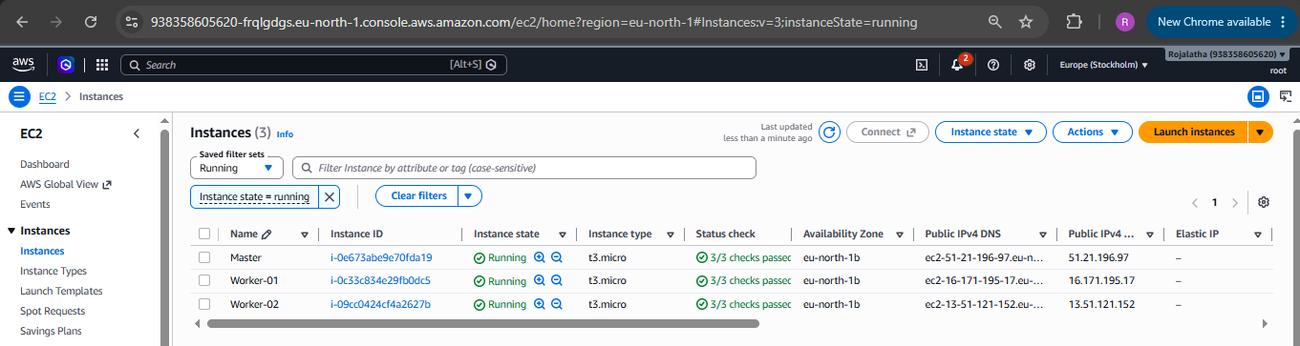

Step 2: Connect to the Ansible Master and Install Ansible on the Master
Updates the Ubuntu package lists.

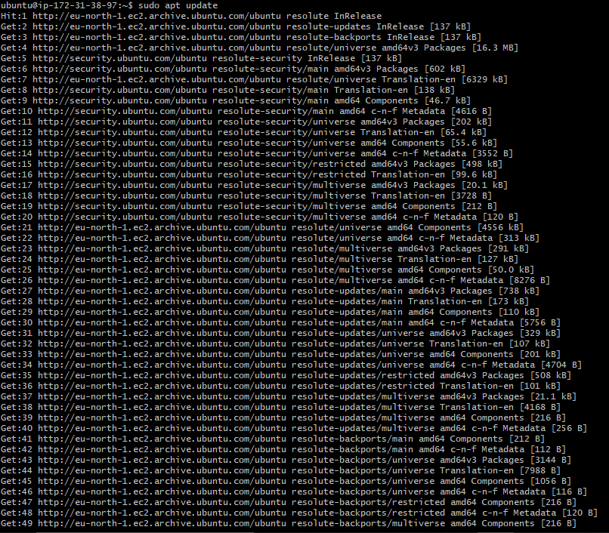
Install Ansible.
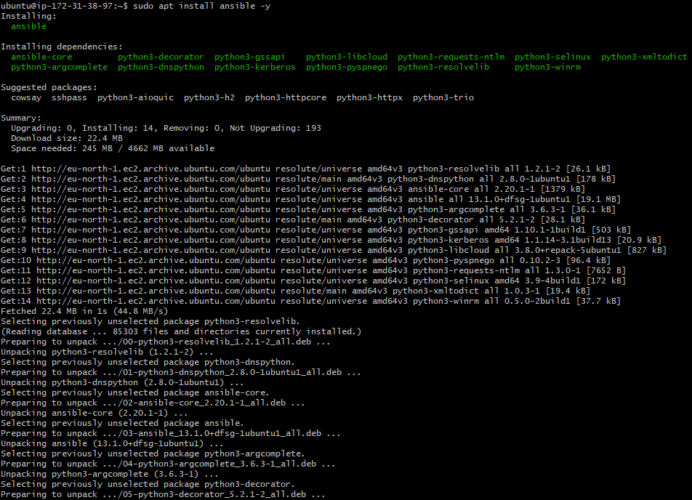
Verifies the installation.

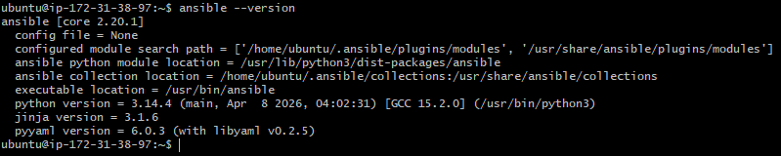

Step 3: Prepare the two worker nodes
Connect to each worker separately and update packages.
Ansible normally uses SSH and Python to manage Ubuntu workers.
On worker 1:
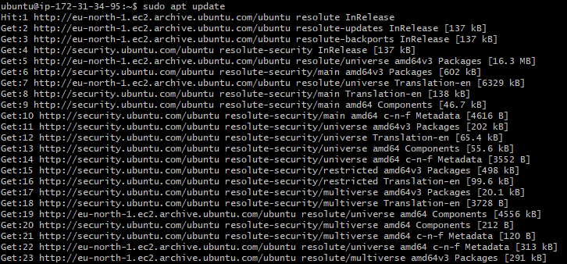
On worker 2:
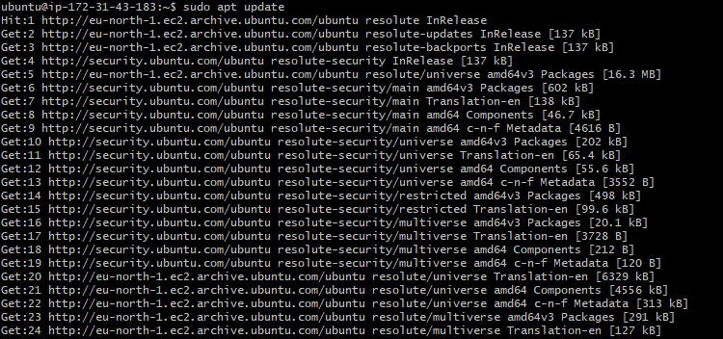
Install python:
On worker 1:
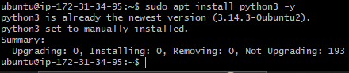
On worker 2:
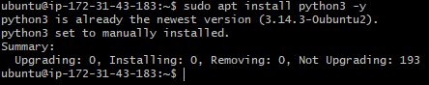

Step 4: Configure SSH from Master to Workers
Ansible must be able to SSH from the master to both workers without interactive password prompts.
On the master, create an SSH key:
Press Enter to accept the default file location. Leave the passphrase empty.
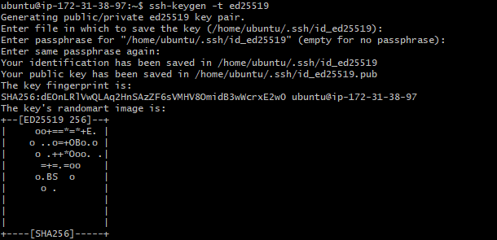
Then display the public key
Copy the displayed public key.
On each worker, add the master's public key to the ubuntu user's authorized keys:

On worker 1:
Create a directory, give permissions and add the public key to authorized keys file.
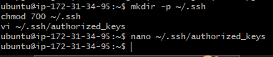
Added the public key to authorized keys file using nano editor.
To save press Ctrl+O, press Enter, and exit with Ctrl+X
On worker 2:
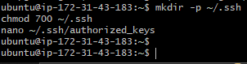
To save press Ctrl+O, press Enter, and exit with Ctrl+X
To avoid copying your private SSH key to the master set permissions to 600 on both workers.

Step 5: Configure the Ansible inventory

On master:

Create a directory to store Ansible configuration and inventory files.

Add Ansible-managed servers in the inventory file using nano editor

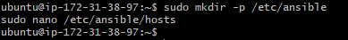

Added Ip addresses of the worker nodes in inventory file.

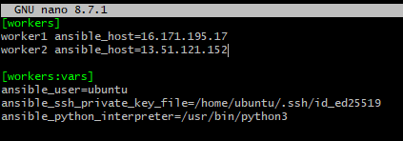
Now to save press Ctrl+O, press Enter, and exit with Ctrl+X

Step 6: Test connectivity

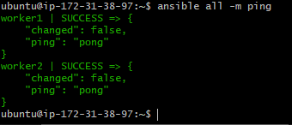
As both workers return pong, Ansible master-worker setup is working.

Step 7: Run your first playbook
Create a playbook on the master using nano editor:
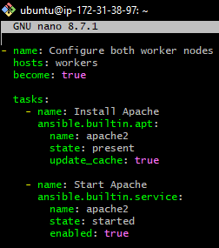
Save and exit.
Execute it:
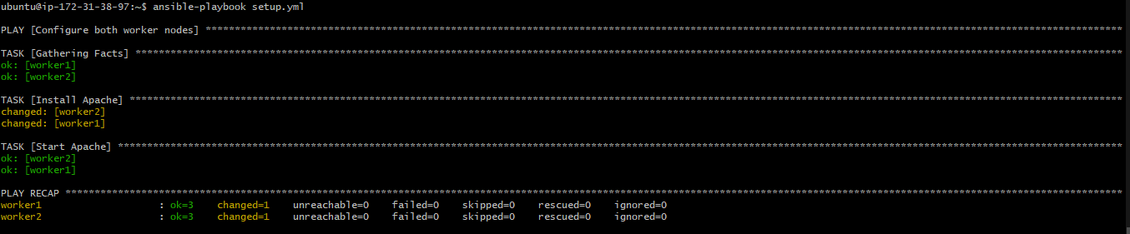
Verify the results:
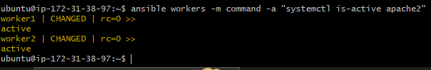
2. Execute the adhoc command shared in #dvps-cloud-documents-12 Channel.

1: Test connectivity
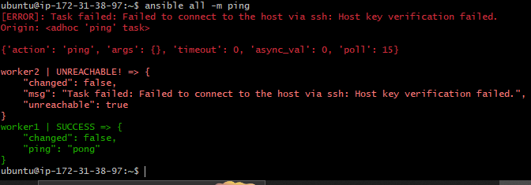
Target only worker 01:
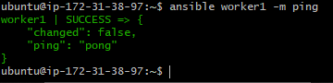
Target only worker 02:
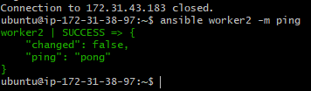

2: Gather server information

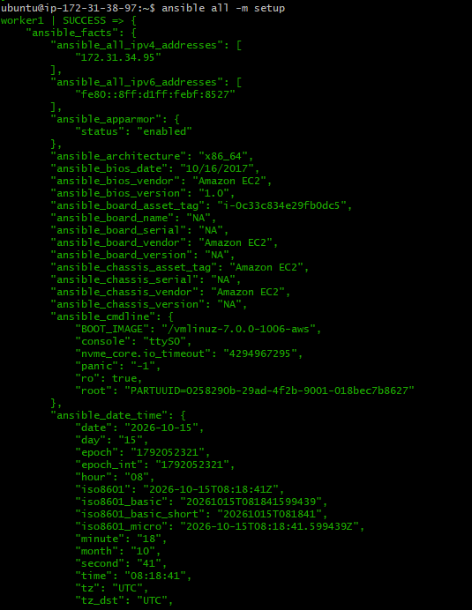

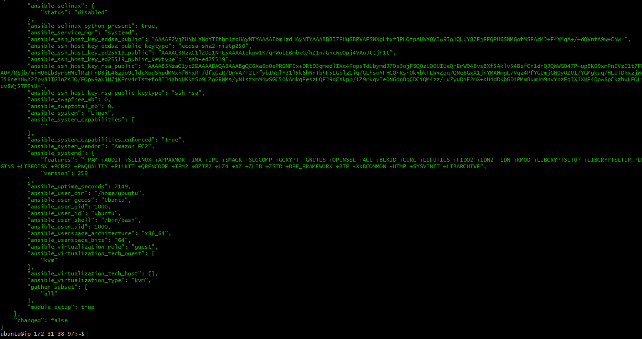
Display only operating system distribution information:

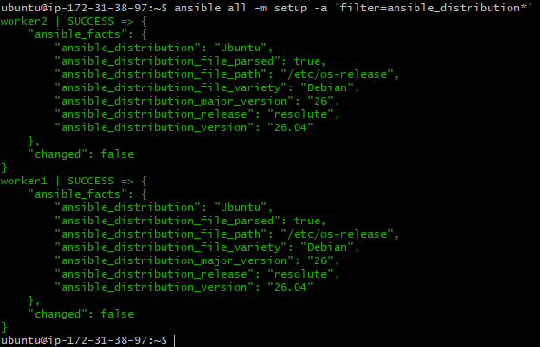
Display memory facts:
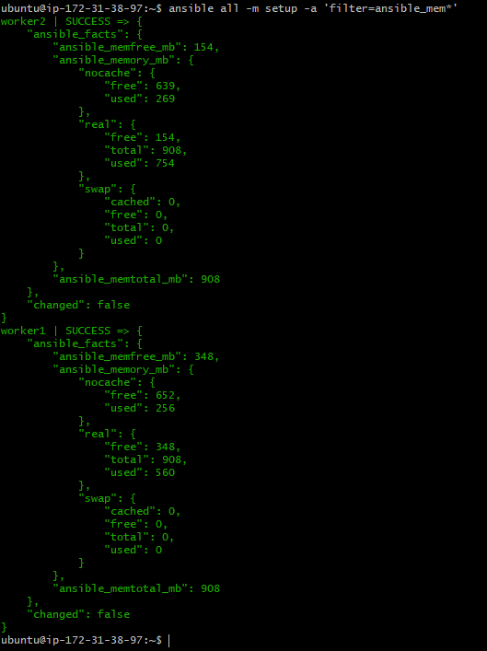
3. Check uptime
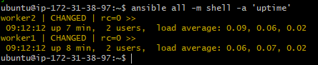

Target one worker:
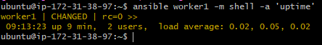

4. Check free memory

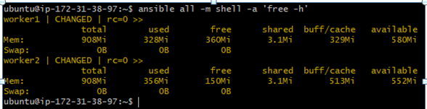

5. Check running processes

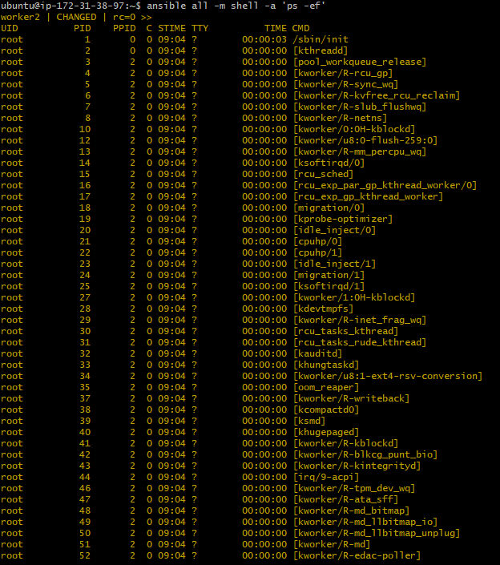

6. Create a directory
Below used Ansible command creates a directory named controller on all hosts listed your Ansible inventory.

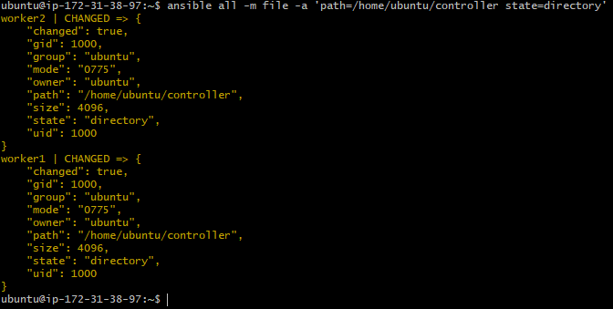
Verify it the directory exists:
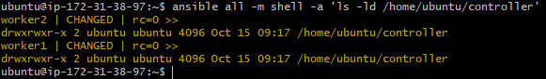

7. Install Apache on Ubuntu
Update package lists on both workers:
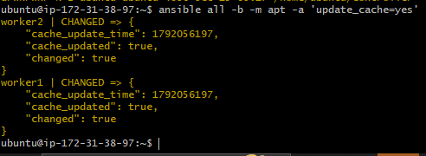
Install Apache:
This command installs Apache2 on all worker nodes using the Ubuntu package manager.
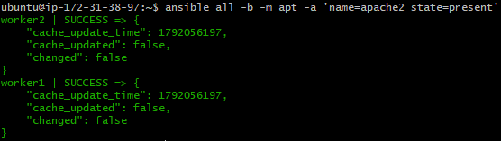

Start Apache and enable it at boot:
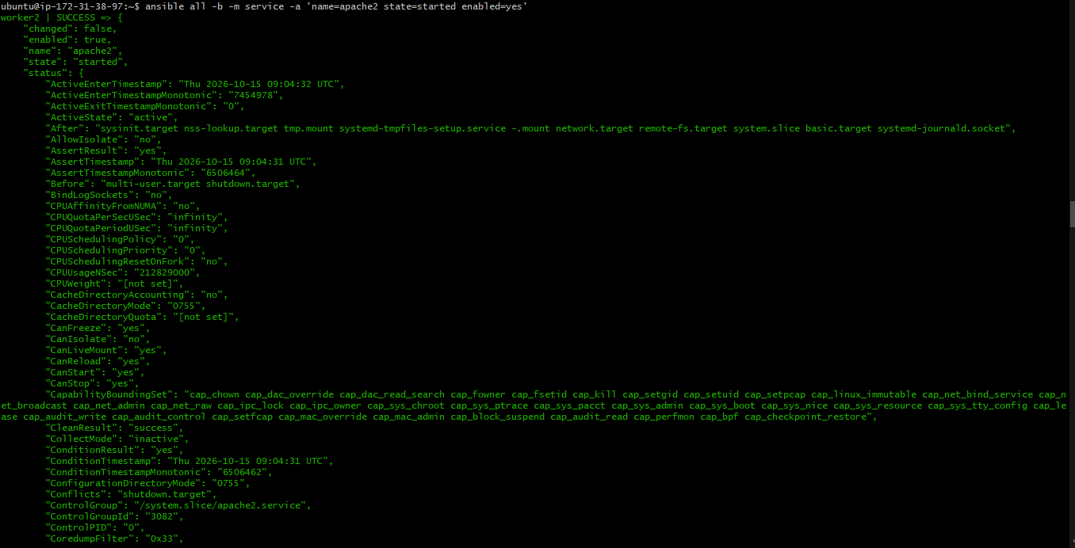
Check Apache's status:
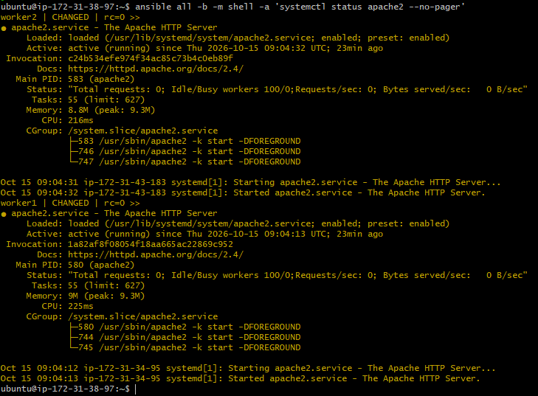
Here, -b in the command means become root using privilege escalation. SSH user must have permission to use sudo.

8. Stop Apache
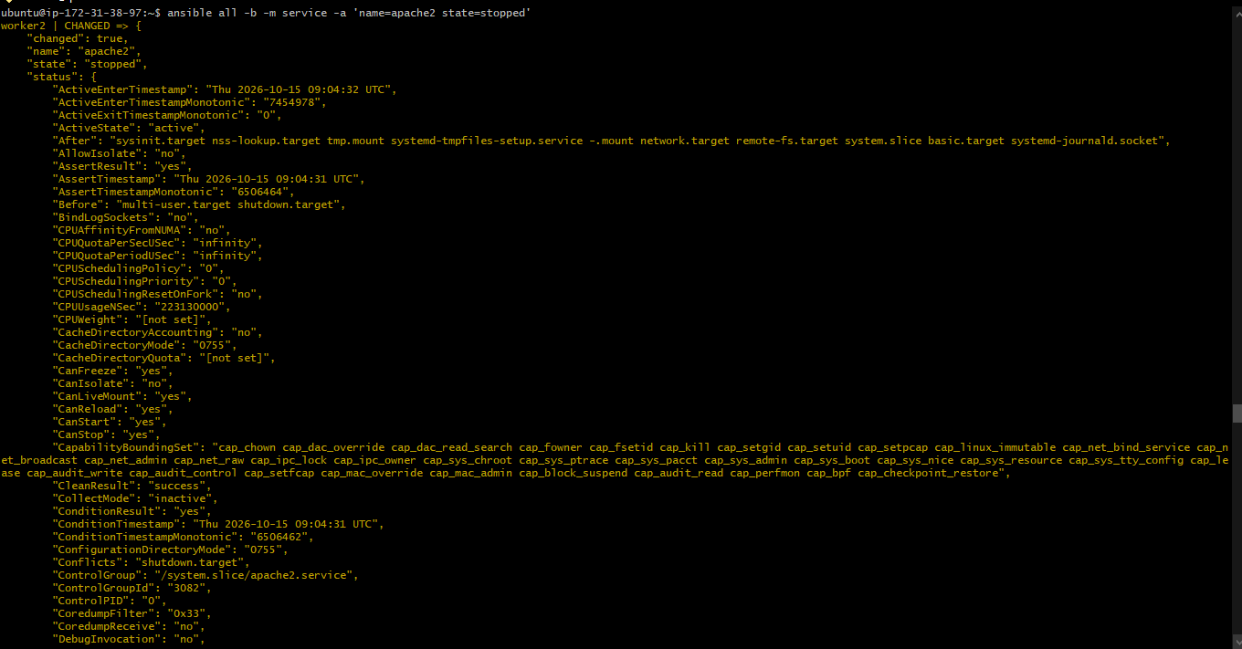

9. Uninstall Apache
This removes Apache from both workers.
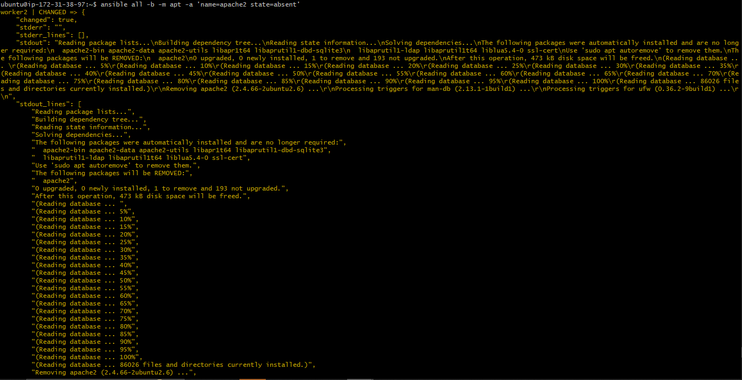

10. Display detailed execution logs
-vvvv displays detailed debugging information, useful when troubleshooting SSH or connectivity problems.

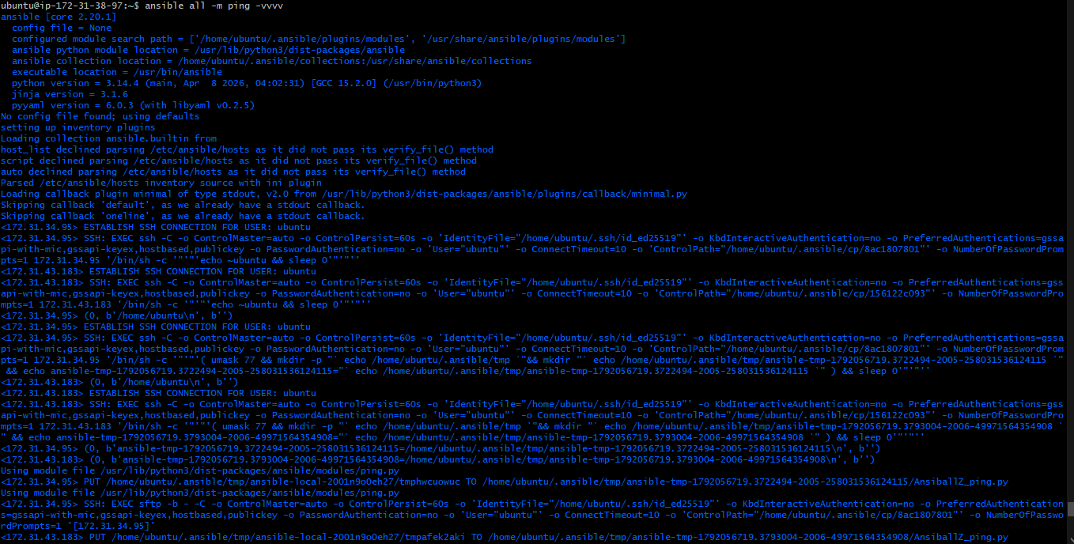

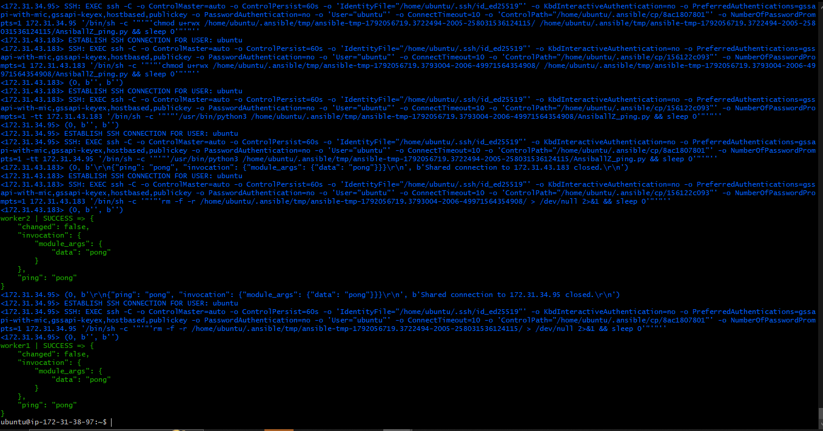

11. Use a custom inventory file
Create a separate inventory:
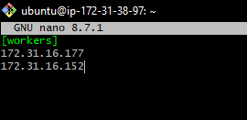
Test SSH connectivity between Ansible master and the hosts in the workers group using a specific inventory file that is newly created.
The -i option specifies the inventory file, while workers selects the group defined inside it.
It says unreachable as we there are no servers with those Ip’s created.
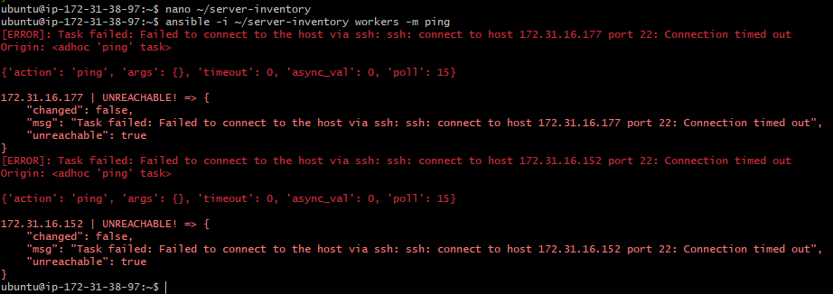

12. Use username and password authentication
If we have not configured SSH keys, you can ask Ansible to prompt for an SSH password:

