Ansible-02
- Install httpd using ansible playbook, use handlers,notifiers.

Step 1: Create the playbook
Create playbook using nano install_httpd.yml
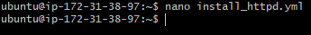
Write a playbook and add tasks in it.

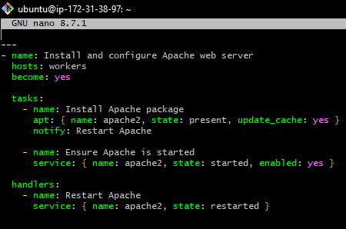
Save the file using Ctrl + O, press Enter, and exit with Ctrl + X.
Here notify: Restart Apache: Calls the handler named Restart Apache if the package installation task reports a change.
In this playbook, Ansible installs Apache, starts the service, and restarts Apache if the installation task makes a change. Handlers normally run at the end of the play.
If Apache is already installed and the package task makes no change, the handler will not run

Step 2: Run the playbook

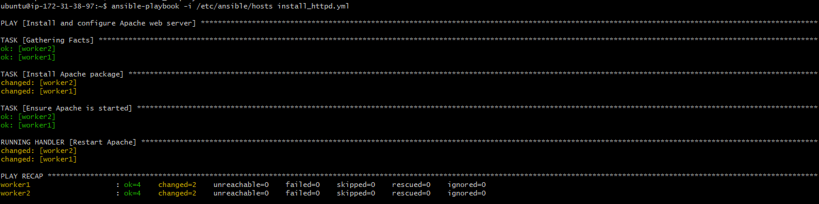

Step 3: Verify Apache installation
Check the package version:
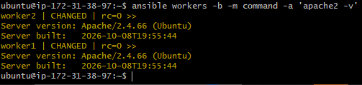
Check the service status:
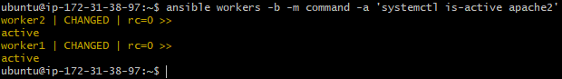
2. Write a ansible playbook to install apache tomcat.

Step 1: Create the playbook
Create a playbook using nano install_tomcat.yml

Write a playbook and add tasks in it.
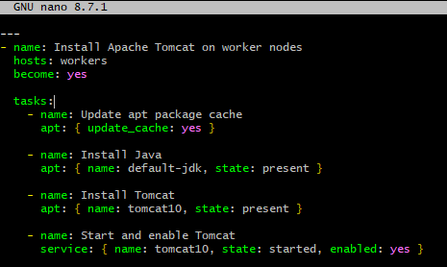
Save the file using Ctrl + O, press Enter, then press Ctrl + X.

Step 2: Run the playbook
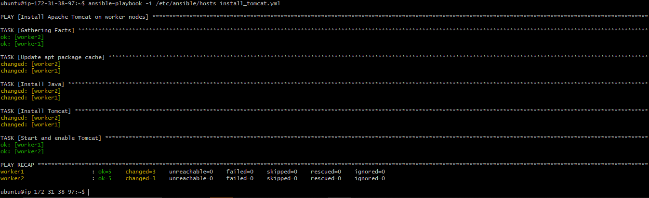

Step 4: Verify Tomcat installation
Check the Tomcat service status:
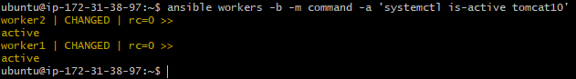
Check the installed package:
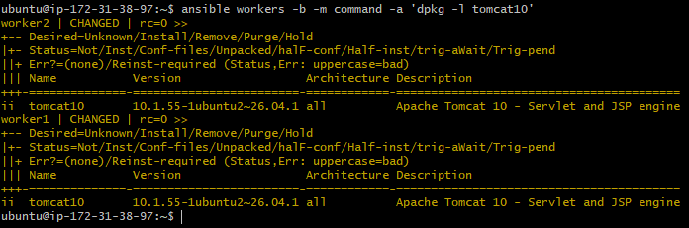

Step 5: Test Tomcat
Tomcat commonly listens on port 8080. Check whether it is listening on each worker:
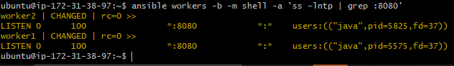
As port 8080 is listening, we’ll test access from the controller using the workers' private IP addresses:
This resulted in connection failure due to some network issue, so tested on worker node and was successful.
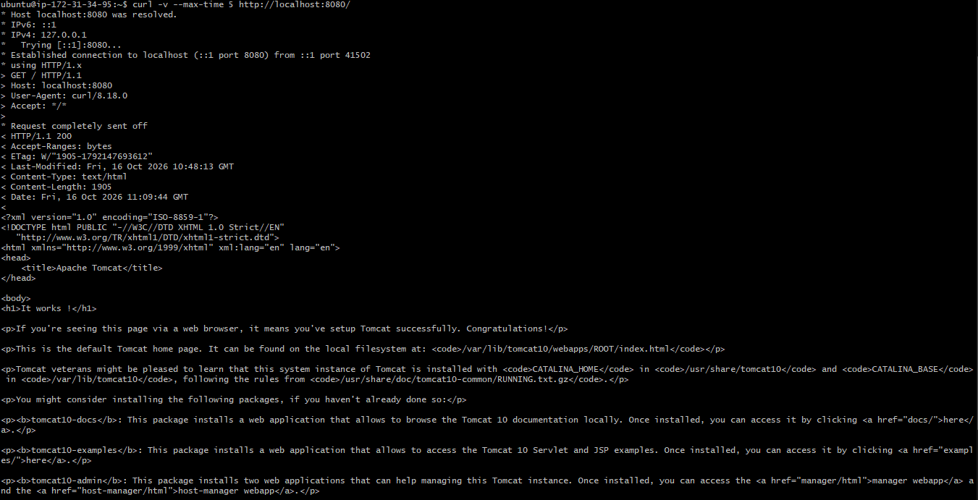
Access tomcat on browser:
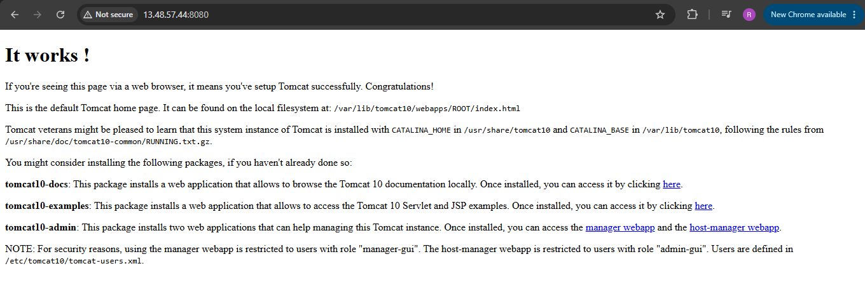
3. Write a ansible playbook to provision one ec2 on aws.

Step 1: Prerequisites
Before running the playbook, you need:
- An AWS account with permission to create EC2 instances.
- AWS credentials configured on your Ansible controller.
- Ansible installed on the controller.
- The amazon.aws Ansible collection installed.
- An existing AWS key pair, VPC, subnet, and security group.

Step 2: Install the required packages

Update packages
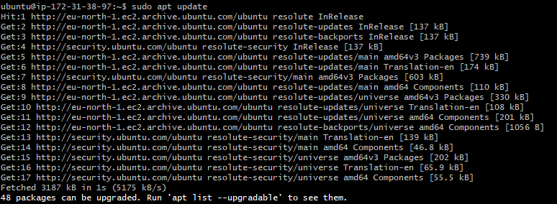
Install Python, pip, and Boto3 (the AWS SDK for Python):

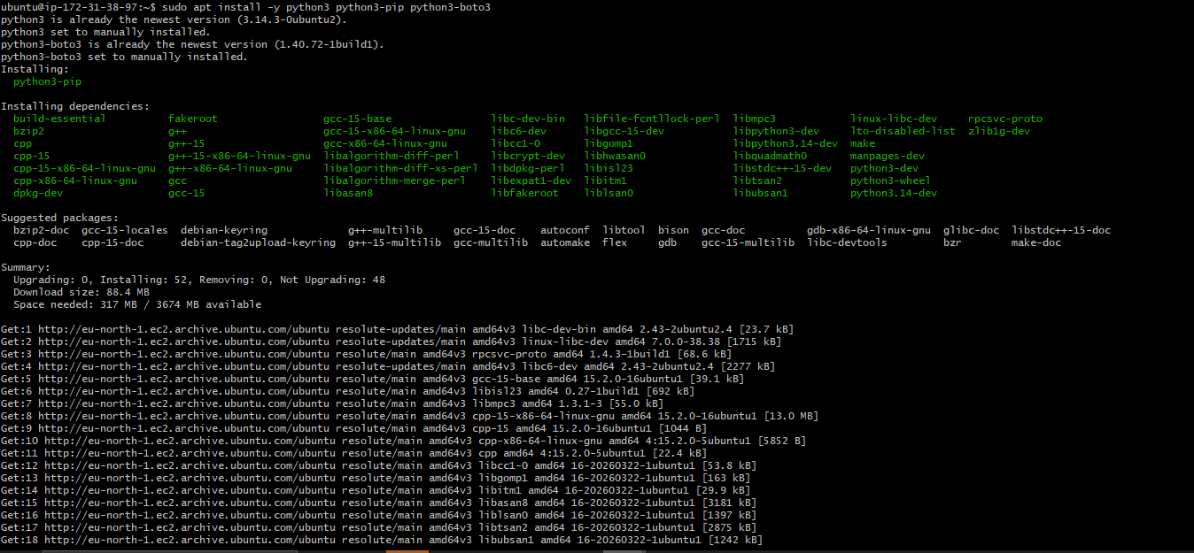

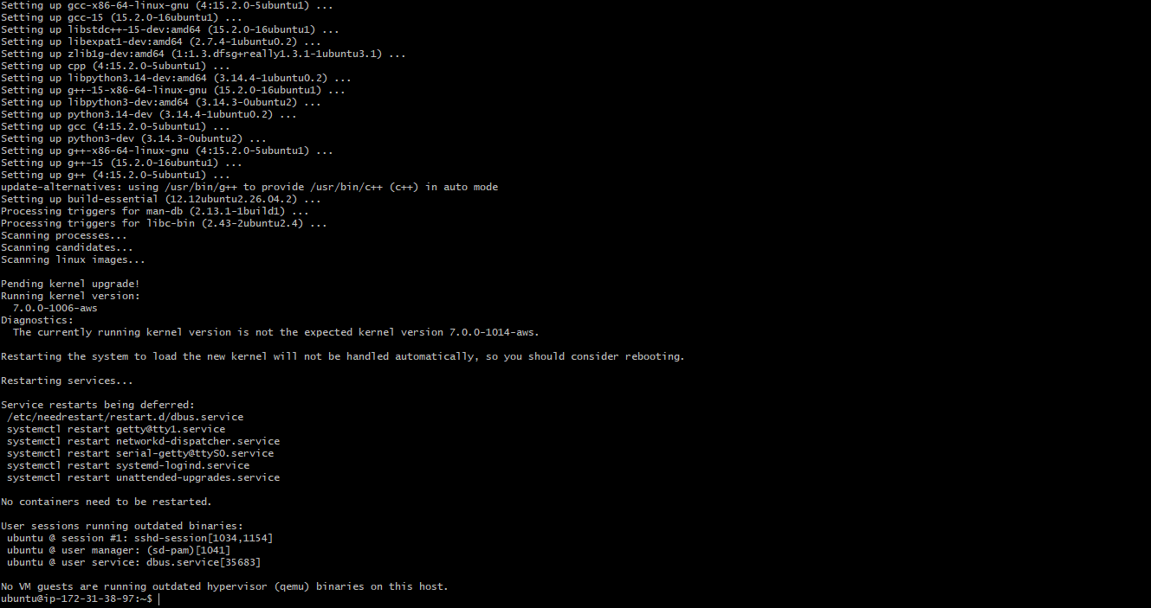
Install the AWS Ansible collection:
Verify Ansible is installed:

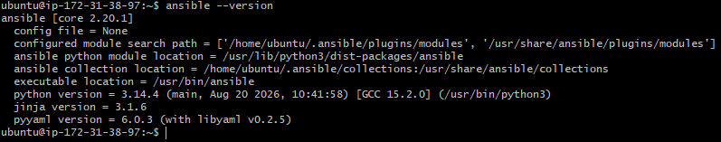
Check that the collection is available:

Step 3: Configure AWS access
Ansible needs permission to create EC2 instances in AWS account.
So, we need to attach an IAM role to controller EC2 instance with the required EC2 permissions. This avoids storing long-term AWS access keys on the server.
Check whether AWS CLI is installed:
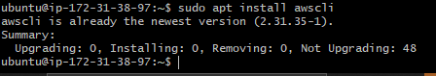
Check the AWS identity:
As we received credentials error, we need to attach a IAM role to the controller or configure AWS credentials securely.

1. Create a custom policy to launch an instance:
• Sign in to the AWS Management Console.
- Open IAM → Policies.
- Click Create policy.
- Select the JSON tab.
- Paste the following policy for basic EC2 instance provisioning.

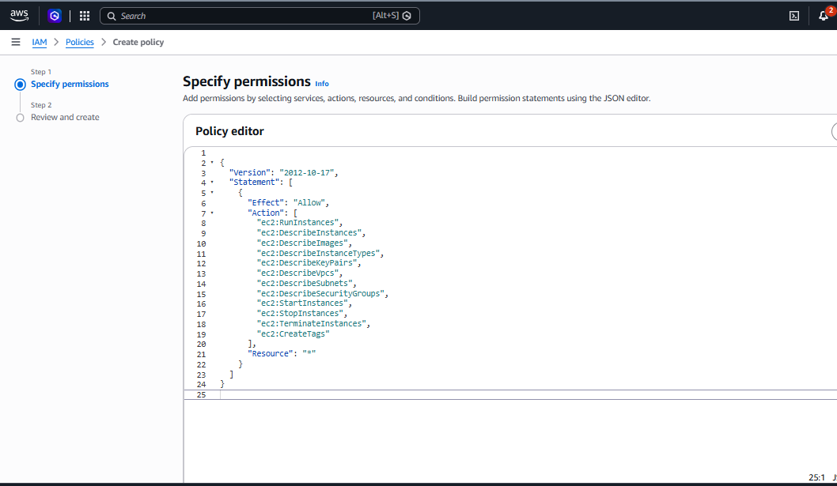

- Click Next.
- Enter the policy name AnsibleEC2LaunchPolicy.
- Click Create policy.

2. Attach the policy
- Go to IAM → Roles if Ansible is running on an EC2 controller, or IAM → Users if you're using an IAM user.
- Select the role or user that Ansible uses.
- Choose Add permissions → Attach policies.
- Search for AnsibleEC2LaunchPolicy.
- Select it and click Add permissions.

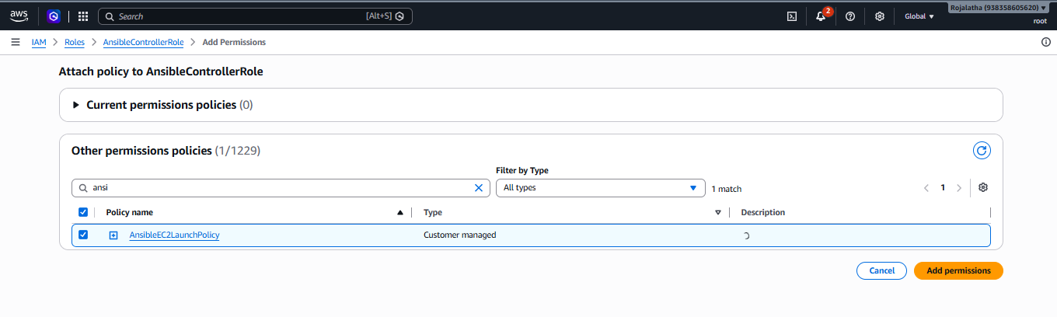
Now Check the AWS identity:
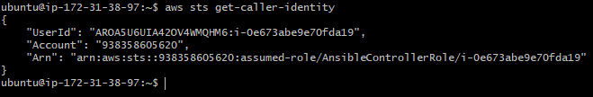
Step 4: Collect the AWS resource details
Get the latest Ubuntu 24.04 LTS AMI

Copy this AMI id: ami-02a9cdd4e98bc3c78
Check your AWS region and list the VPCs in your AWS account.
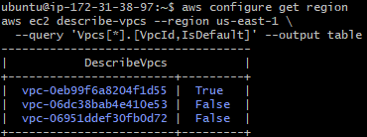
Find a suitable VPC and subnet:

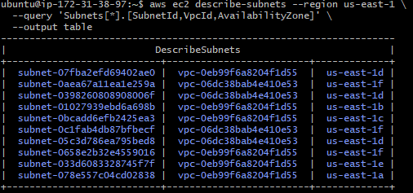
Find an existing EC2 key pair:

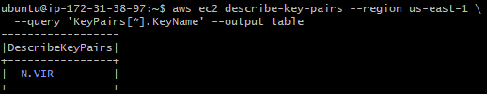

Step 5. Create the Ansible playbook
Create a project directory:
Create the playbook file:
Create playbook file with name nano provision-ec2.ymlusing nano editor:
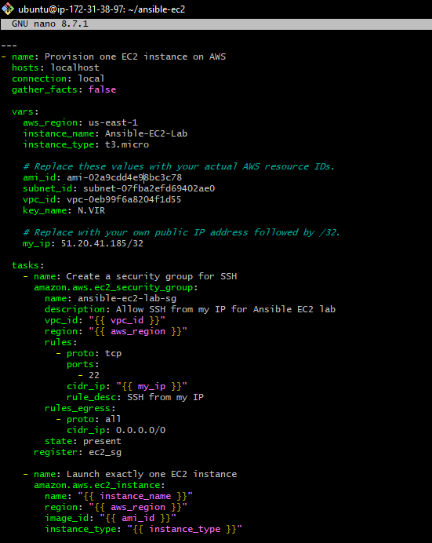
Save the file in nano using Ctrl+O, press Enter, then Ctrl+X.

Step 6. Validate and run the playbook
First, check the YAML syntax:
Next, run the playbook:
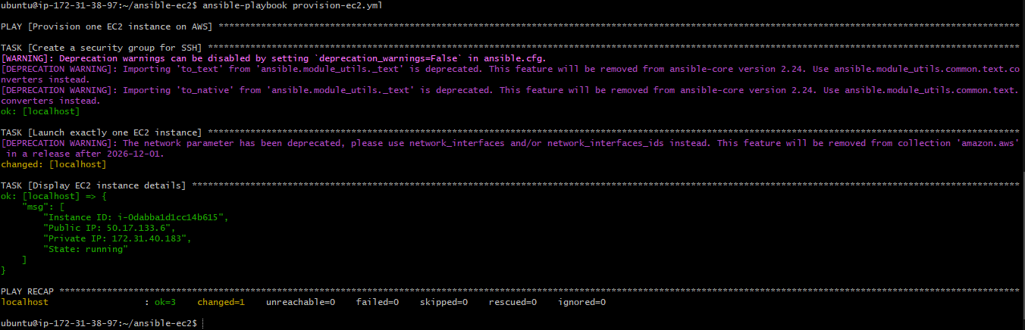
The playbook will:
- Create a security group allowing SSH from your IP.
- Launch one EC2 instance using the selected AMI, subnet and key pair.
- Wait for the instance to reach the running state.
- Display the instance ID, public IP, private IP and state.
Note: Each normal run with count: 1 can launch another instance.

Step 7. Verify the EC2 instance

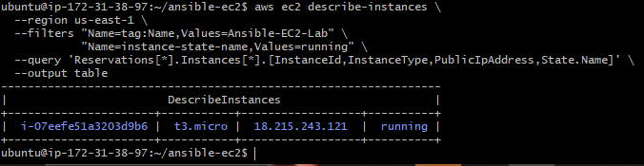
Verify the instance on Aws console:
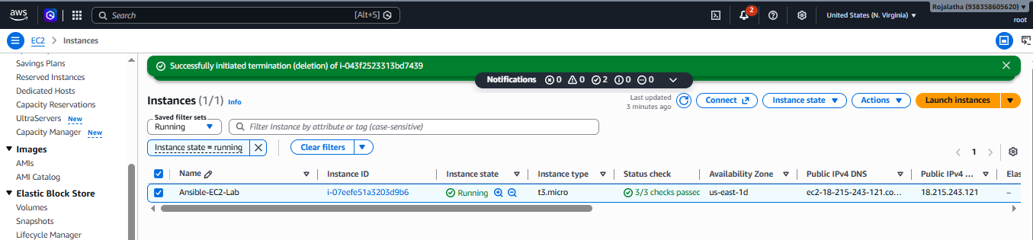
5. Write a ansible playbook to copy one file from node-1 to node-2.

Step 1: Configure the inventory
On Ansible controller, open the inventory file:
Make sure it contains the correct private IP addresses of two worker nodes:
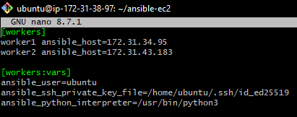
Save with Ctrl+O, Enter, then Ctrl+X

Step 2: Create a file on Node-1
Connect to Node-1:
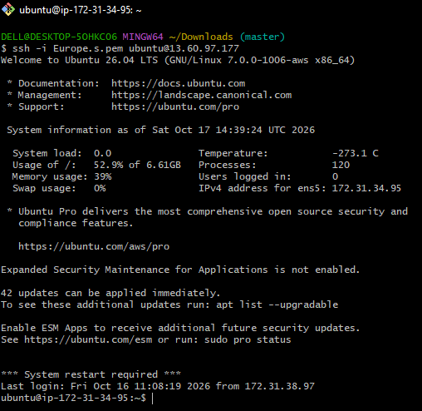
Create a sample file:
Verify it:
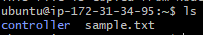
Cat the file
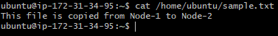
Return to the controller:

Step 3: Create the playbook on the controller
Create a project directory and playbook:
Write a playbook:
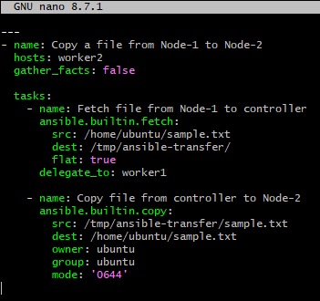
Save the file using Ctrl+O, Enter, then Ctrl+X.
Ansible's fetch module retrieves the file from Node-1 to the controller. The copy module then transfers that file from the controller to Node-2.
The controller acts as an intermediary because fetch and copy do not directly transfer files between two remote nodes.

Step 4: Test connectivity
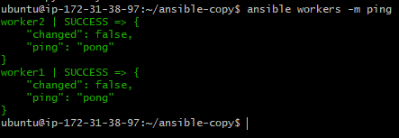

Step 5: Run the playbook
Check the YAML syntax:
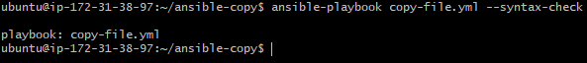
Execute it:
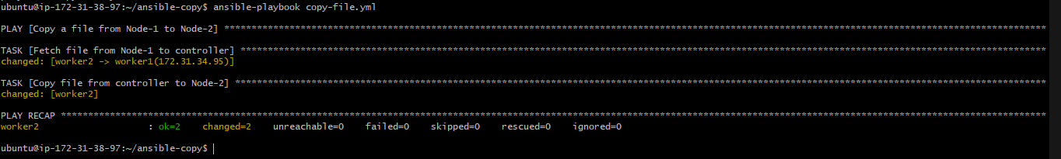

Step 6: Verify the copied file
Connect to Node-2 and check the file:
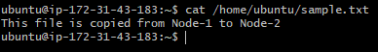
6. Write a ansible playbook to create different files with different names using single playbook.

Step 1: Create a project directory
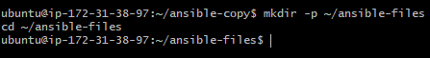

Step 2: Create the playbook

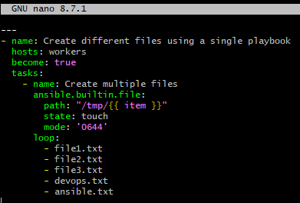
Save the file using Ctrl+O, press Enter, and then press Ctrl+X.

Step 4: Check the syntax

Step 5: Execute the playbook

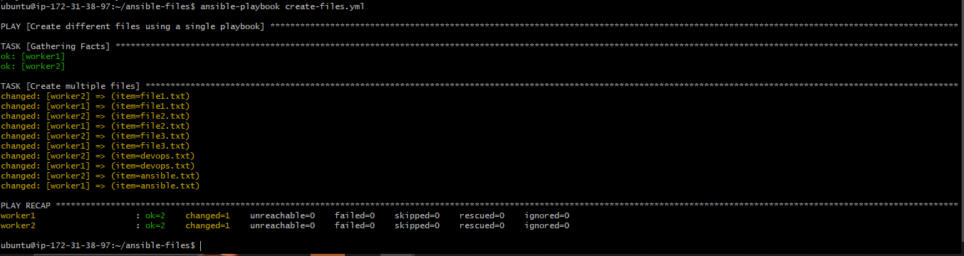

Step 6: Verify the files
Check Node-1:

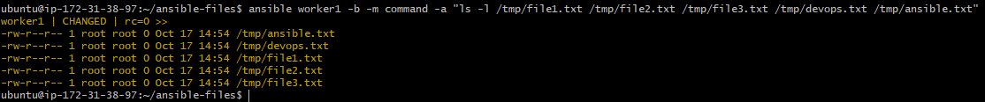

Check Node-2:
Successfully created five files with different names on two worker nodes using a single Ansible playbook and a loop.

