Ansible-03
- Write a single ansible playbook which will install apache and nginx. Note: Playbook should not be hardcoded and pass the variables from different file.

Step 1: Create the project directory on controller:

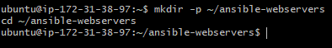
The project structure will look like this:
ansible-webservers/
├── install-webservers.yml
└── vars.yml

Step 2: Create the variables file
Create the file using nano editor:
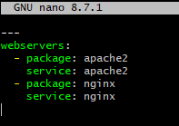
Save using Ctrl+O, press Enter, then Ctrl+X.
- package specifies the package to install.
- service specifies the service to start and enable.
- apache2 is the Apache package and service name on Ubuntu.
- nginx is the Nginx package and service name on Ubuntu.
Keeping these values in vars.yml means we can change them without editing the playbook.

Step 3: Create the Ansible playbook
Create the playbook:
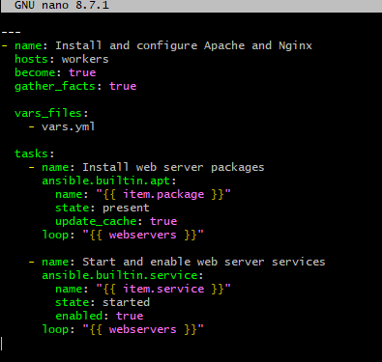
Save and exit Nano.
The playbook does not hardcode package or service names in its tasks. They are supplied by the external variables file.

Step 4: Verify your inventory
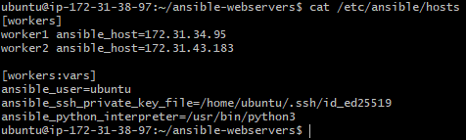

Step 5: Test connectivity
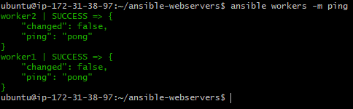

Step 6: Check playbook syntax

Step 7: Execute the playbook

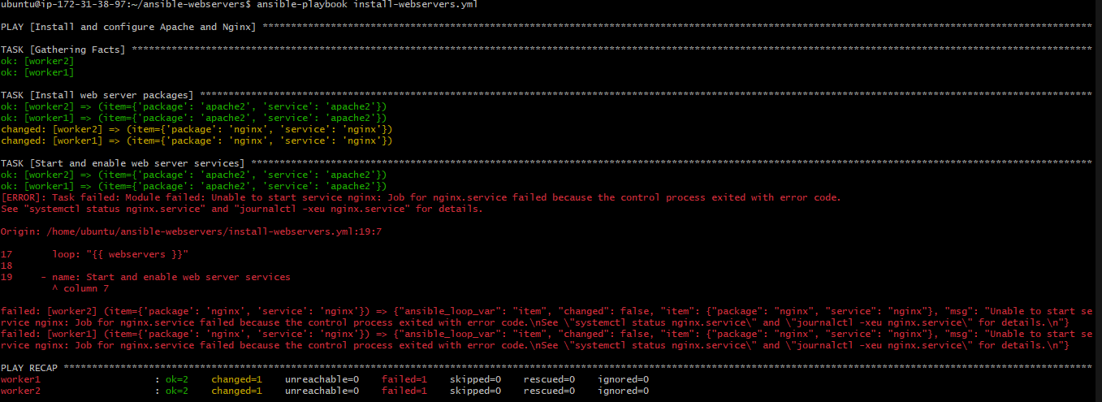

While executing it came up with a error saying unable to start service as:
• Port 80: Apache (apache2) is using it.
• Port 8080: A Java process is using it.
• Nginx: Cannot start because both ports we tried are occupied.

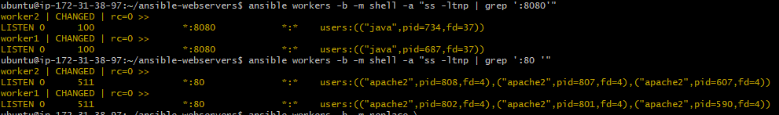

Let's configure Nginx to use port 8081 instead.

Step 8: Change Nginx to port 8081

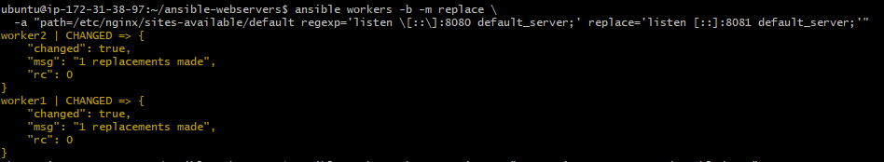
Change the IPv6 listener too:

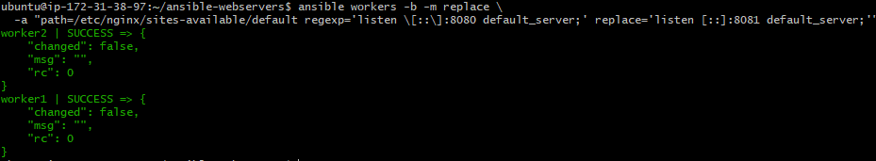
Ansible will install Apache and Nginx on both worker nodes and start their services.
Test the configuration
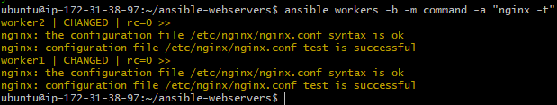

Now execute the playbook:

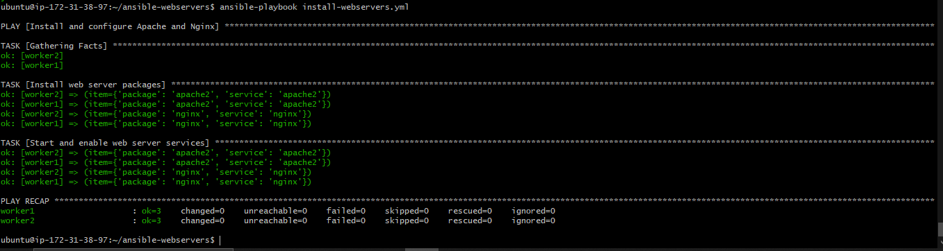

Step 9: Verify the services

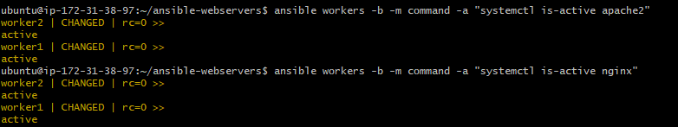
Also check installed packages:
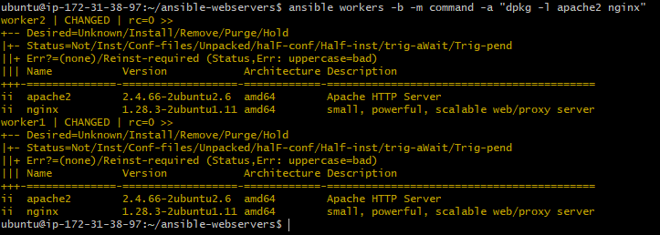

2. Ansible playbook to create 10 different directories with minimal code and directory names should be passed as variables.
Objective:
Create 10 directories using a single Ansible playbook, with all directory names passed through a separate variables file.

Step 1: Create the project directory

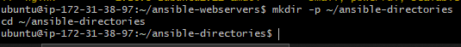

Step 2: Create the variables file
Add the 10 directory names:

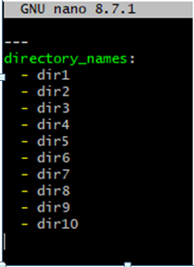
Save using Ctrl+O, press Enter, then Ctrl+X.

Step 3: Create the playbook

Write a playbook:
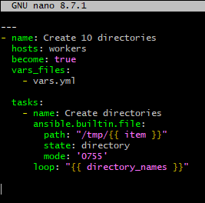
Save and exit Nano.

Step 4: Execute the playbook
Check syntax:
Run the playbook:
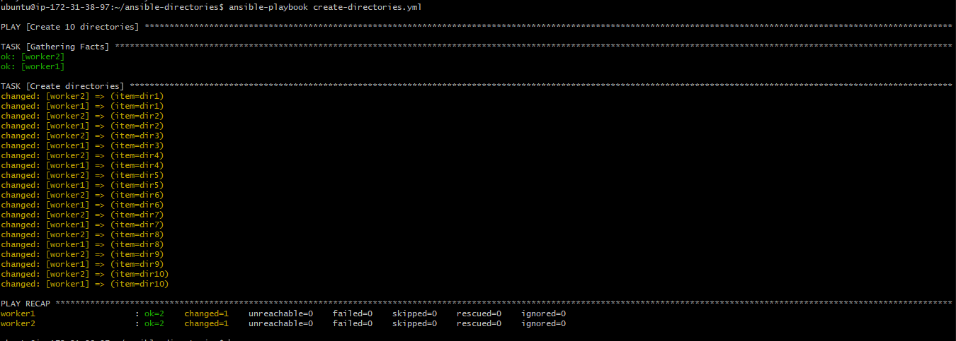

Step 5: Verify the directories

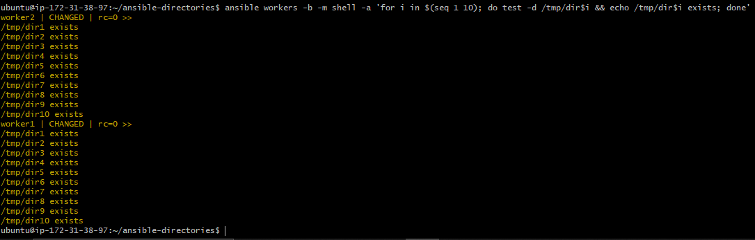
Ten directories are created on each worker using a single playbook with minimal code and externally defined variables.
3. Ansible playbook to copy ssh-keygen from master to worker nodes.
Note: a)Provision new 3 ec2 machines, one master and two worker nodes. b)Create common user called ansadm and provide sudo priviliges on 3 ec2 instances. c)Create ssh-keygen in master and your playbook should copy the keygen making it password less authentication.

Step 1: Configure the inventory on the master
Connect to the master using original Ubuntu SSH key, then verify Ansible is installed:
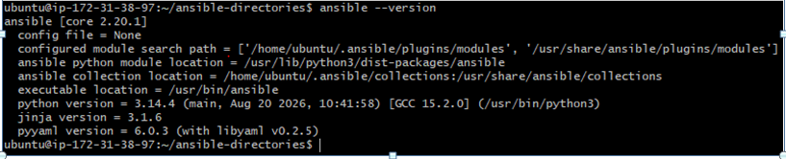
Create a project directory:
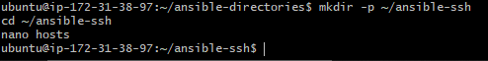
Add the inventory into file
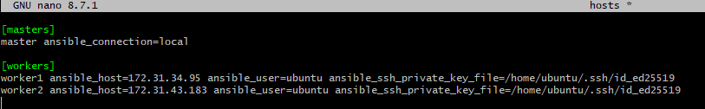
Save with Ctrl+O, press Enter, and exit with Ctrl+X.
Test the connections for all three hosts:

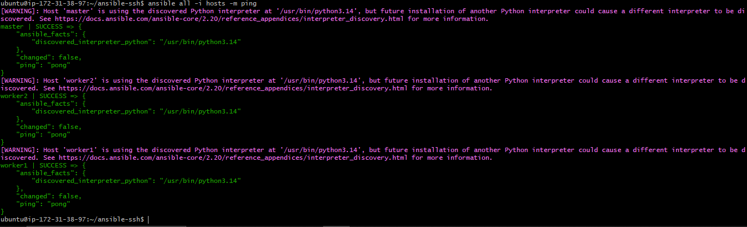
Step 3: Create the common user ansadm and grant sudo privileges
Create the playbook:
Write a playbook:
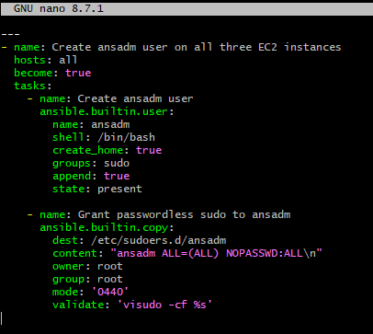
Save with Ctrl+O, press Enter, and exit with Ctrl+X.
Run the playbook:
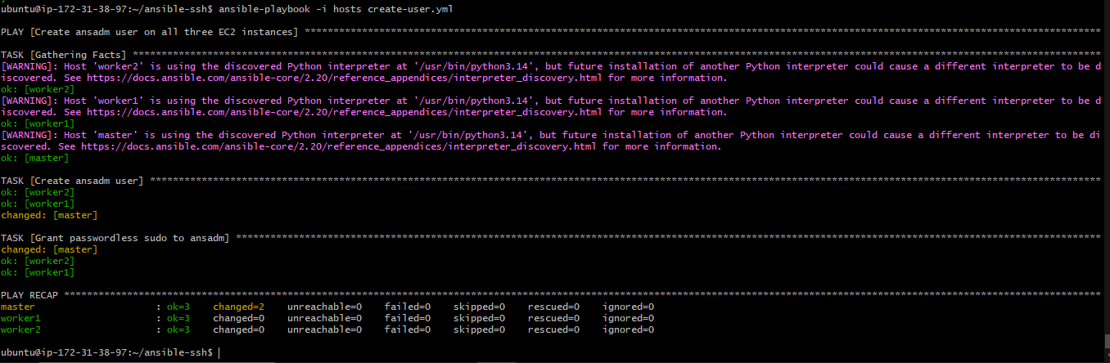
This creates ansadm on the master and both workers and adds it to the Ubuntu sudo group. The sudoers file also permits ansadm to use sudo without a password. Protect these administrator accounts and private keys carefully.

Step 4: Generate the SSH key on the master
Create another playbook:
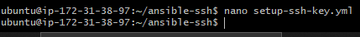
Write a playbook:
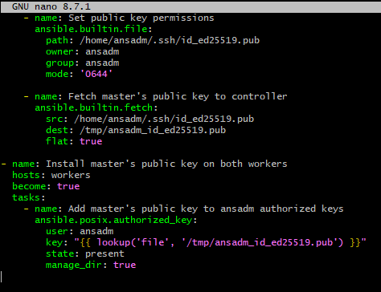
Save the file and install the required collection:

Step 5: Run the SSH-key playbook
First, check syntax:

Run the playbook:

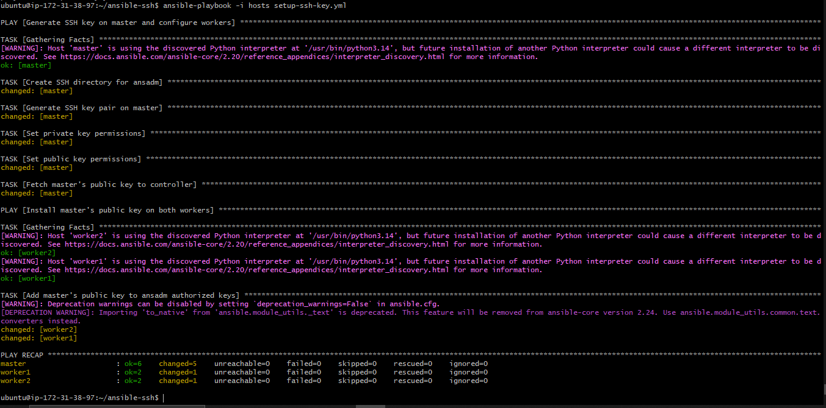

Step 6: Test passwordless SSH authentication
For worker1
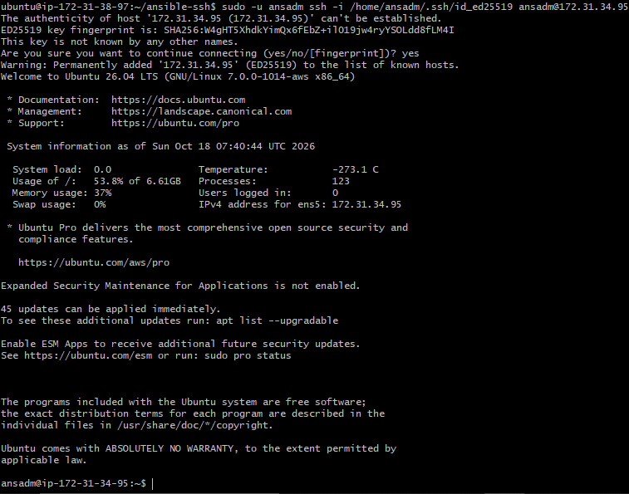
For worker 2:
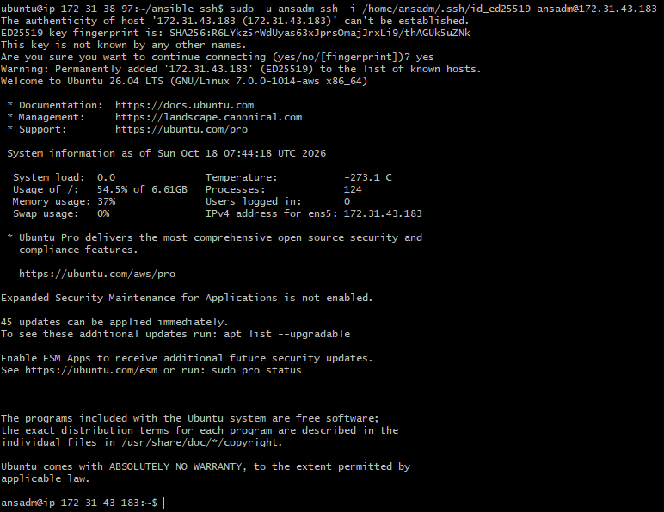
Succesfully logged into both worker nodes with any password.
You can also verify sudo on a worker:
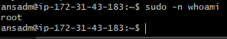

Step 7: Verify the user exists on all three machines

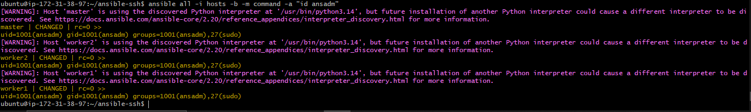

4. Ansible playbook to inject ansible vault variables.

Step 1: Create a project directory
Run on your Ansible master:
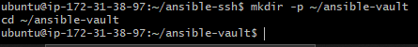

Step 2: Create a variables file
Create a file containing the sensitive variables:
Write a file
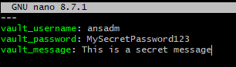
Save and exit Nano.

Step 3: Encrypt the variables file
Ansible prompts you to create and confirm a Vault password. Choose a strong password and store it securely.

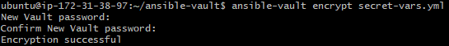
Check that the file is encrypted:
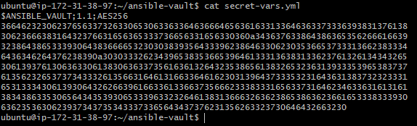

Step 4: Create the playbook
Create the playbook:
Write a playbook:
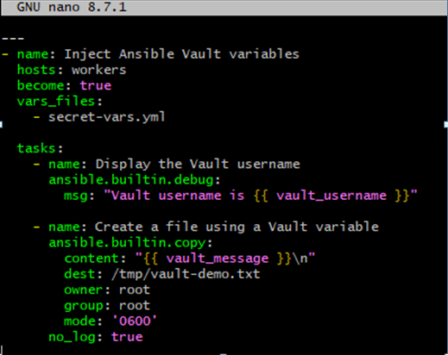
Save and exit.

Step 5: Run the playbook
Playbook asks for password when executing it. Enter your Vault password when prompted.
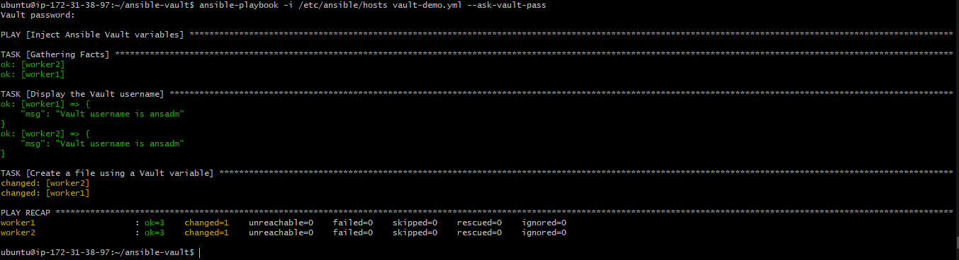

Step 6: Verify the result

