Ansible – 04
1. Create ansible playbook to create ansible vault.

Step 1: Create a project directory
Run on your Ansible master:
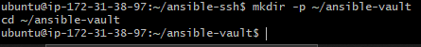

Step 2: Create a variables file
Create a file containing the sensitive variables:
Write a file
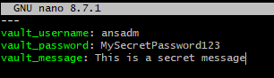
Save and exit Nano.

Step 3: Encrypt the variables file
Ansible prompts you to create and confirm a Vault password. Choose a strong password and store it securely.

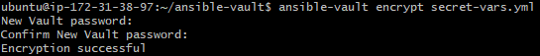
Check that the file is encrypted:
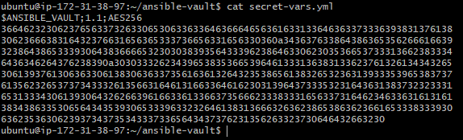

Step 4: Create the playbook
Create the playbook:
Write a playbook:
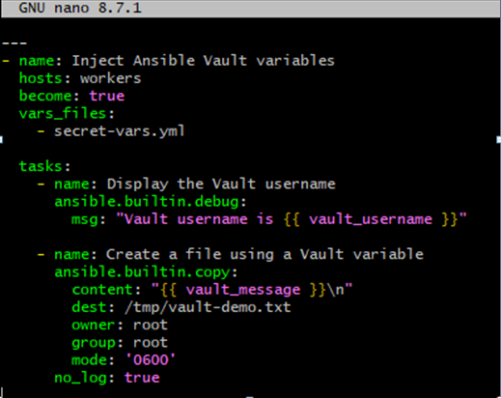
Save and exit.

Step 5: Run the playbook
Playbook asks for password when executing it. Enter your Vault password when prompted.
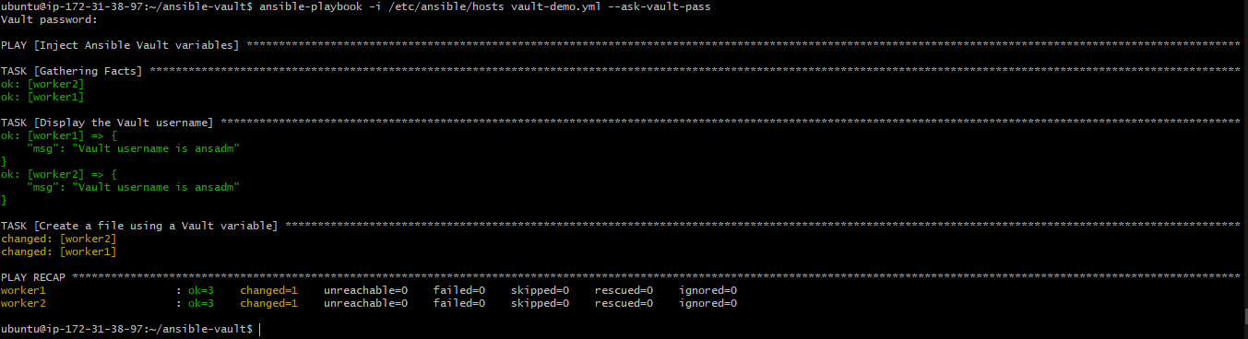

Step 6: Verify the result

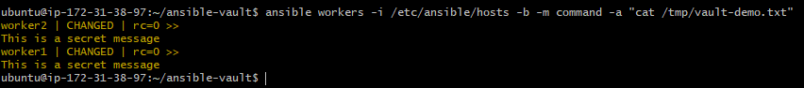
2. Write a ansible playbook to install apache in linux and ubuntu machine by using when condition.

Step 1: Create the playbook
On Ansible master, create a file named install-apache.yml:
Write a playbook:
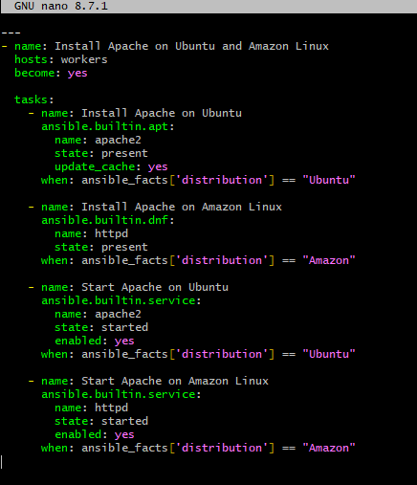
Save the file with Ctrl+O, press Enter, and exit with Ctrl+X.

Step 2: Check your inventory
Confirm that your inventory file contains the target machines:
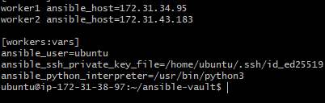

Step 3: Run the playbook

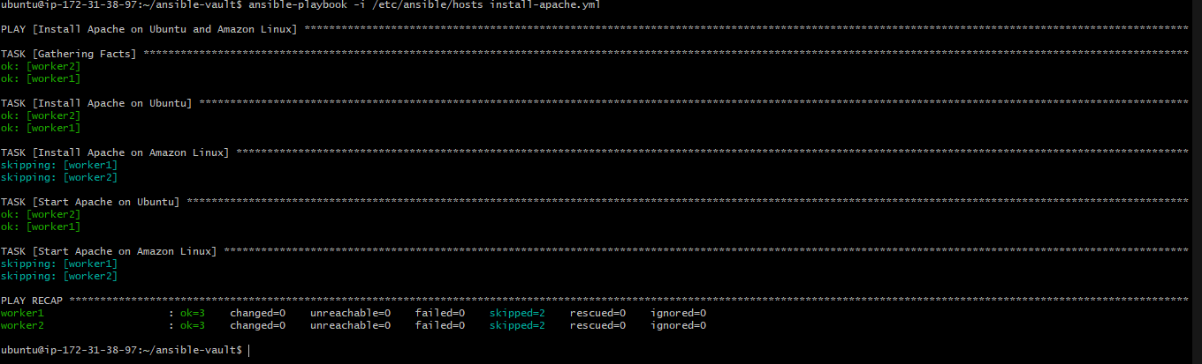

Step 4: Verify Apache is running

On ubuntu machine:

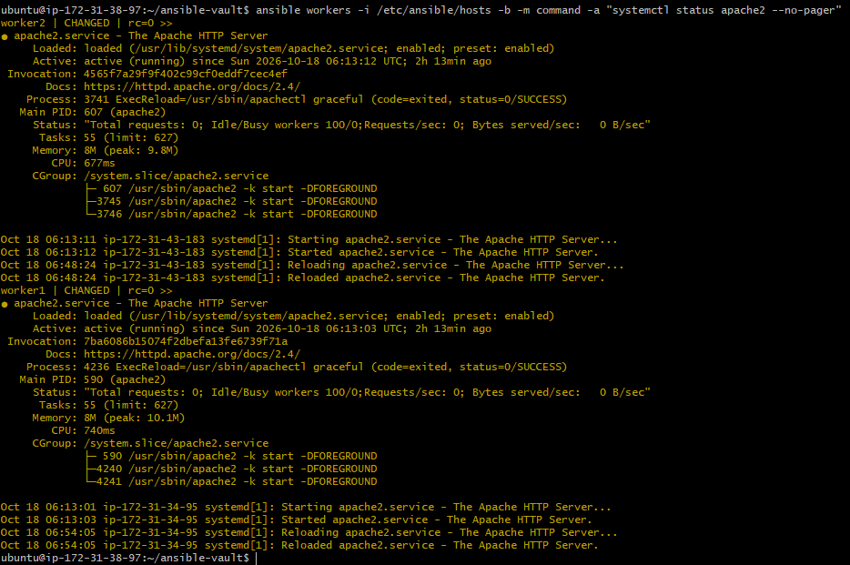

On linux machine:

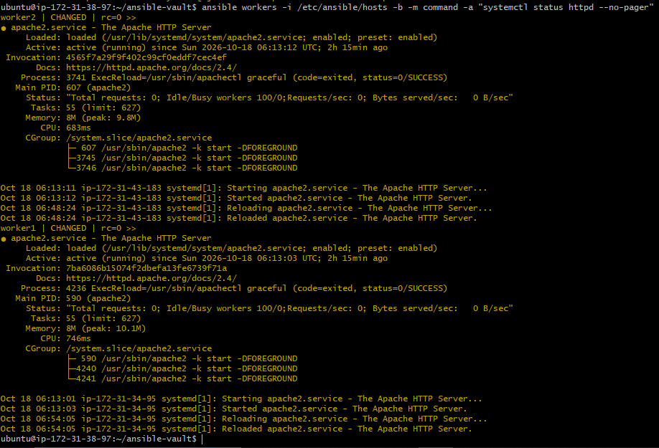
These verification commands assume the respective operating systems are present in your inventory.
3. Create ansible playbook using roles to configure LAMP stack

Step 1: Create the project directory
This creates separate roles for Apache, MySQL, and PHP.

Step 2: Create the Apache role

Write a playbook:
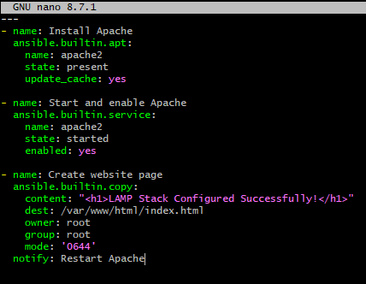
Save and exit.
Now create the Apache handler:
Write a playbook:
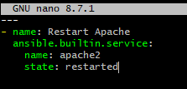
Save and exit.
A handler runs only when a task notifies it and makes a change.

Step 3: Create the MySQL role

Write a playbook:

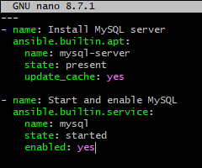
Save and exit.

Step 4: Create the PHP role

Write a playbook:
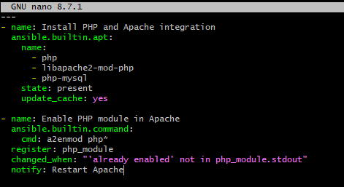
Save and exit.

Step 5: Create the main playbook
From ~/ansible-lamp, create:
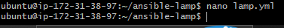
Write a playbook:
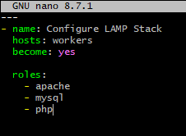
Save and exit.
This playbook applies all three roles to the hosts in your existing workers inventory group.

Step 6: Run the playbook

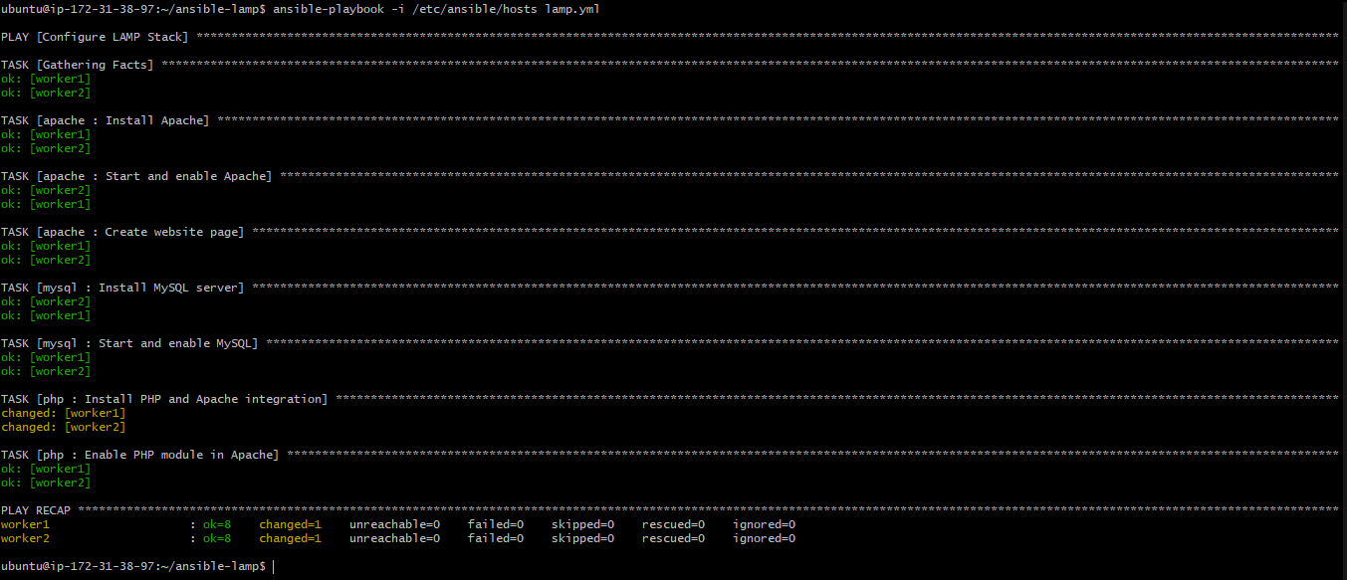
Ansible will execute the Apache, MySQL, and PHP roles on both workers.

Step 7: Verify the LAMP stack
Check Apache:
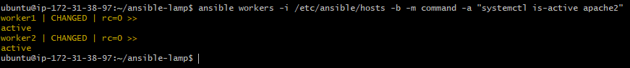
Check MySQL:
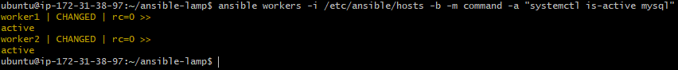
Check PHP:
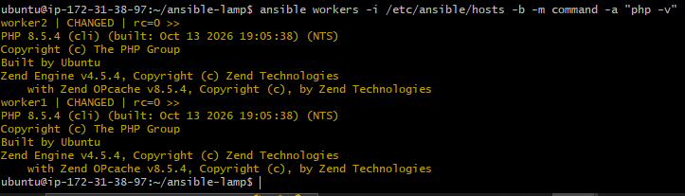
Check the installed packages:
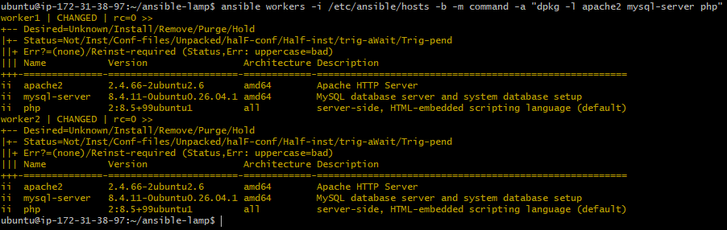

To test the website, run this on the controller:
For worker 1:
For worker 2:

4. Setup ansible AWX and explore the options.

Prerequisites:

• A Linux machine or VM with sufficient CPU, RAM, and disk space i.e 8gb RAM
• Docker or another supported container runtime, Git, and kubectl.
• A working Kubernetes cluster with available CPU and memory.
• Network access to download container images.
• Your worker EC2 instances and SSH credentials, for the later automation exercise.

Step 1: Launch an instance:
Select Amazon Linux 2023 · 2 vCPUs · 8 GiB RAM · 30–40 GiB disk

Connect to the server and verify the instance for basic details:

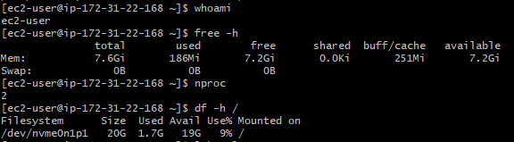

Step 2: Update Amazon Linux and install basic tools

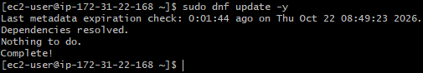

Check git version and curl version

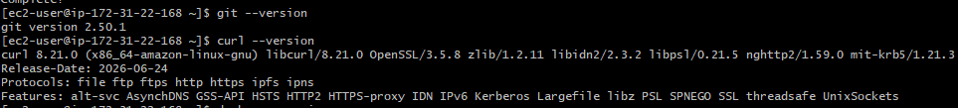
Step 3: Install Docker:
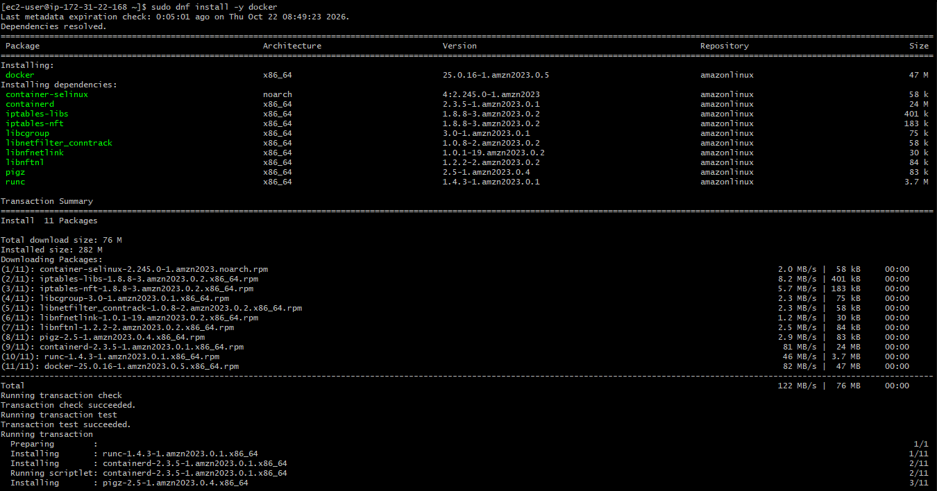

Start Docker:
Allow your user to run Docker commands:
Apply the group change in your current session and test docker:
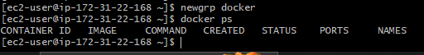
From the above output, Docker setup is working correctly. The output confirms that ec2-user can run Docker commands without a permission error.

Step 4: Install Minikube and kubectl
Install minikube and verify the version:

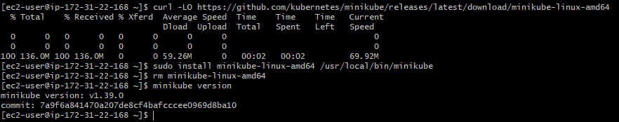

Install kubectl and verify it

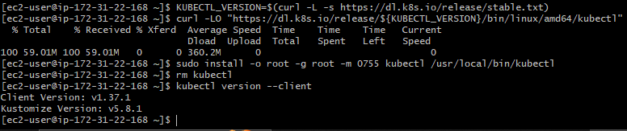

Start Kubernetes
Before starting, check available disk space:
If at least several GB remain available, start a small cluster:
This allocates 2 CPUs and approximately 4 GiB of RAM to Minikube. It leaves some memory for Amazon Linux and Docker, although the instance may still become resource-constrained when AWX starts. Minikube's documented baseline is 2 CPUs, 2 GB RAM, and 20 GB free disk.

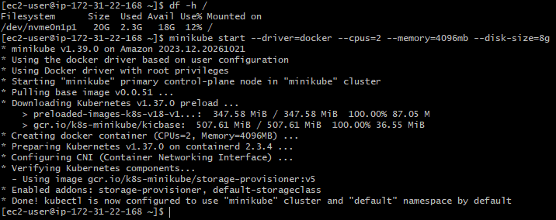
Verify the cluster:
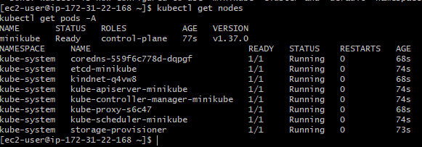

Check minikube status:

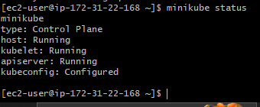

Step 5: Install AWX Operator
The official AWX installation method uses AWX Operator with Kubernetes Kustomize.
First, install a version-pinned operator
Set the operator version:
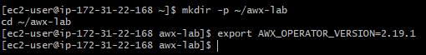
Create the installation configuration:
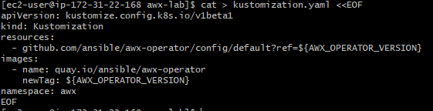
Before applying it, verify the selected release is available:
If it returns the matching tag, deploy the operator:
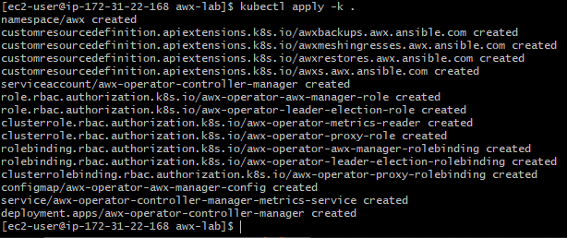
This downloads the required manifests and creates the operator resources in the awx namespace.

Verify the operator
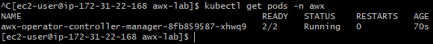

Step 6: Create the AWX application
Move to your lab directory and Create the AWX resource file:
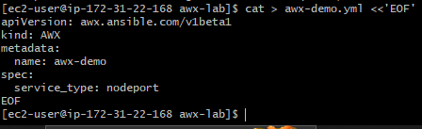
Add the file to your existing Kustomize configuration:
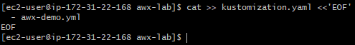
Apply the configuration:
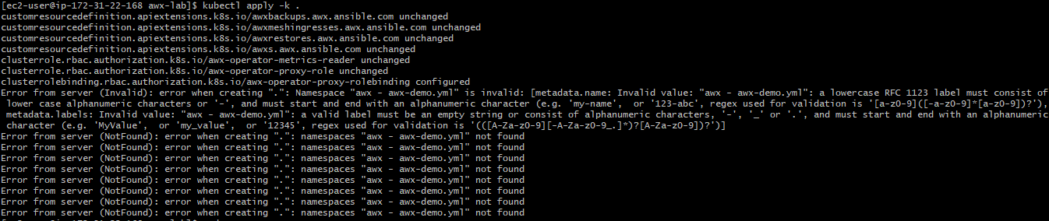
As configuration came up with error, check kustomization.yaml file.
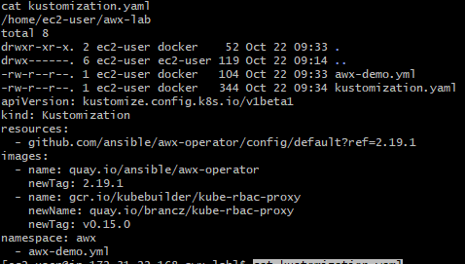
Here we see that awx-demo.yml is specified outside the resources, so correct it and add it inside the resources:
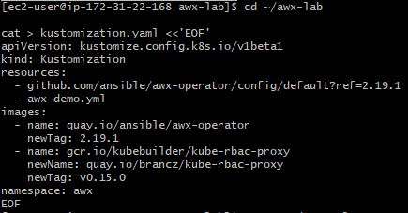
Verify it:
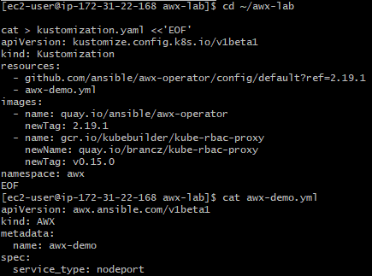
Verify the AWX custom resource
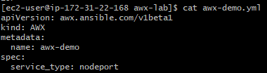
First create the namespace:

Apply the configuration

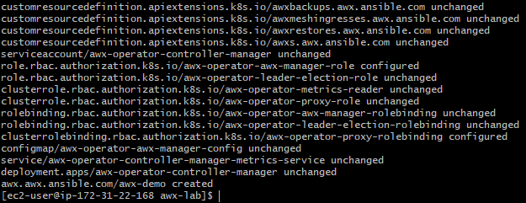

Step 7: Monitor the deployment

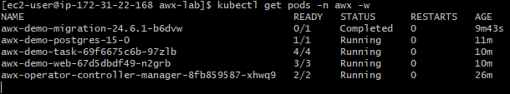
The application may take several minutes to start because AWX needs additional containers and a database.

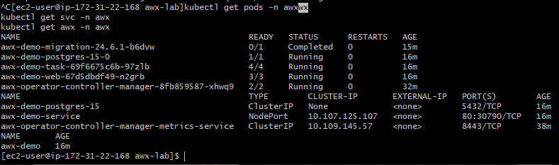
From the above output AWX service is exposed on NodePort 30790

Step 8: Retrieve your AWX admin password

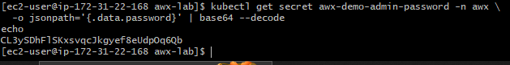

Open the AWX web interface
This returns a URL for accessing AWX. Since we're running Minikube on a remote EC2 instance, the URL may be accessible only from the EC2 host.

Now on powershell create an SSH tunnel:

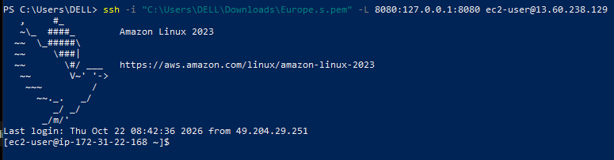
Back in the EC2 terminal, run:
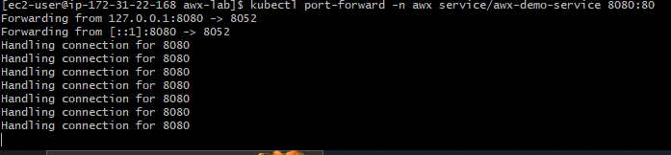
• kubectl port-forward forwards a local port to a Kubernetes service.
• -n awx selects the AWX namespace.
• service/awx-demo-service targets your AWX service.
• 8080:80 maps EC2's local port 8080 to AWX service port 80.
Now open this address in your Windows browser:
Open AWX at http://localhost:8080
Log in with:
- Username: admin
- Password: The password retrieved in Step 2
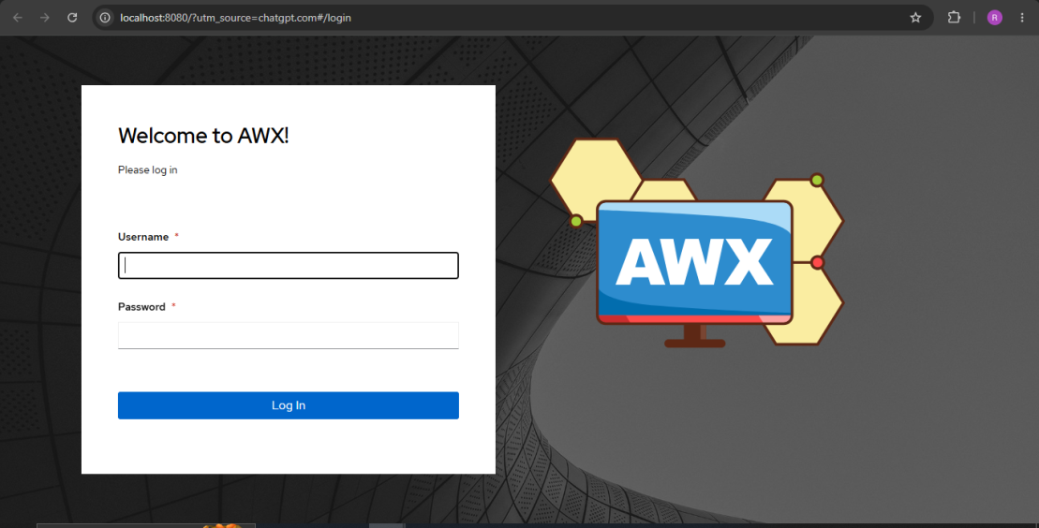
Once logged in, explore the areas:
AWX feature | What to do
Organizations | View the default organization
Users | View the admin account
Inventories | Create an inventory of your EC2 workers
Credentials | Configure SSH access to your workers
Projects | Connect an Ansible Git repository
Job Templates | Create a template using a playbook
Jobs | Launch the template and inspect its output
Schedules | Explore scheduled automation

