App and web servers Task

- Install nginx and run nginx on port number 81.

Installed Nginx using yum install nginx.

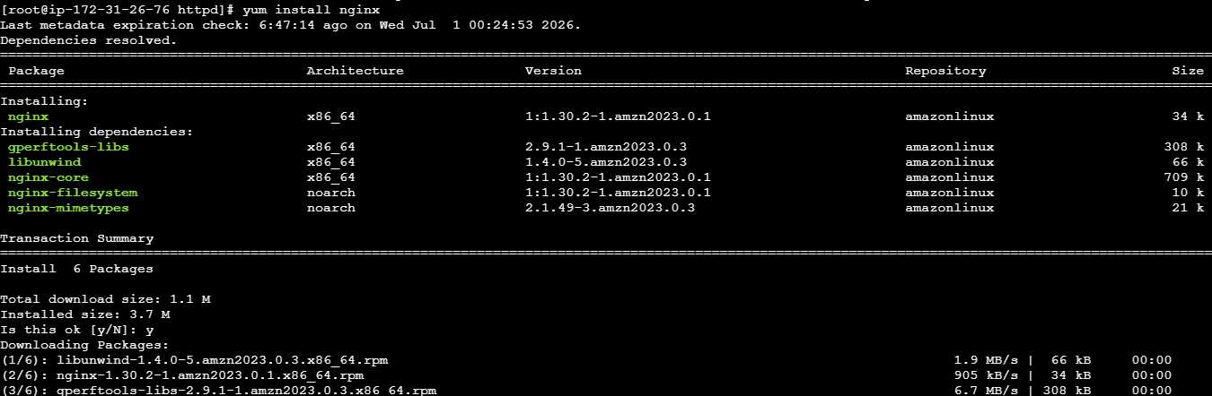

Used Systemctl start nginx to start and see that its running.

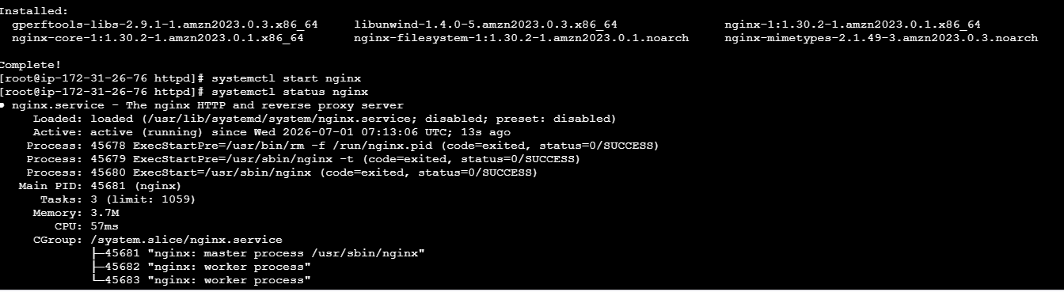

On web pageby giving http://<EC2-PUBLIC-IP> we can see the below page

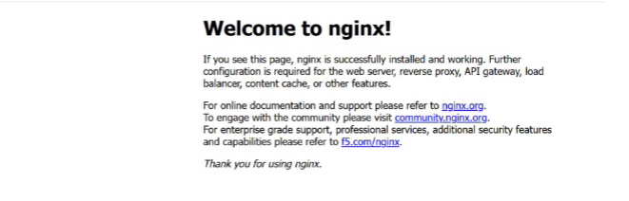

netstat -na | grep 80, checked if port is in use.
To customize our own port, copied the file from /etc/nginx/nginx.conf and pasted in Vi. Then edited port 80 to 81 and saved the file using Esc : wq!

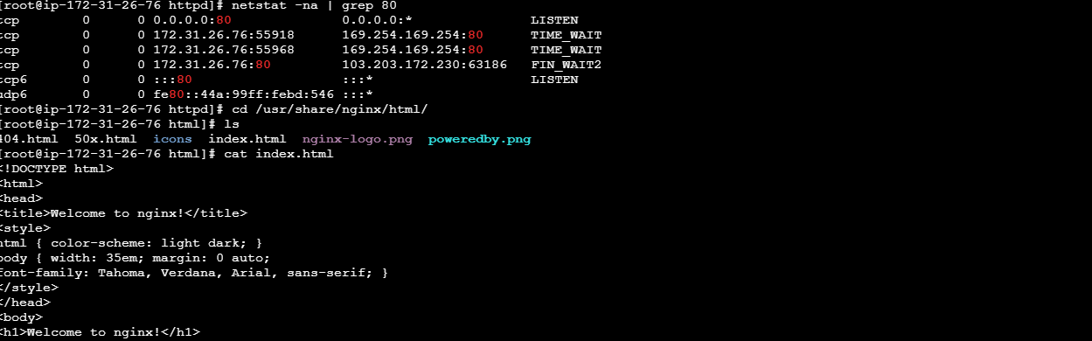

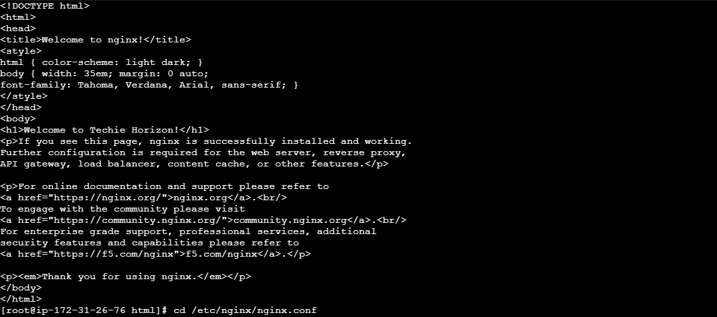
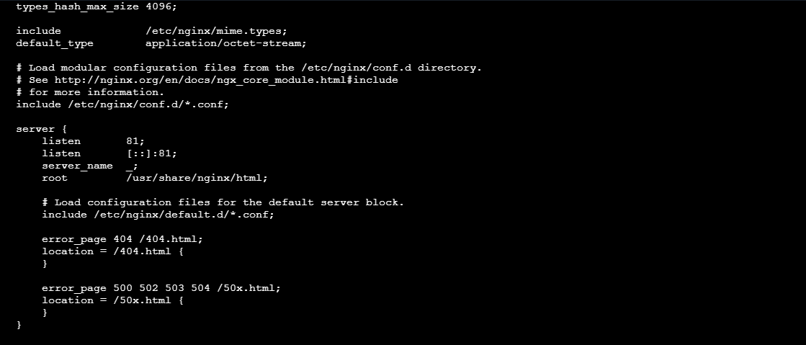
2. Deploy a sample index.html file on nginx.
Navigate to deployment path /usr/share/nginx/html open Vi file
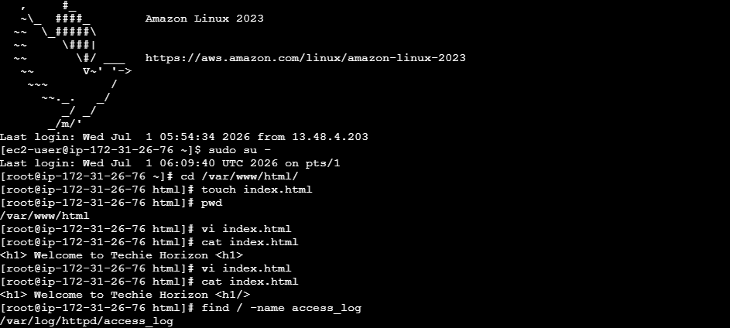

Entered Vi file and replaced Welcome to Nginx with Welcome to Techie Horizon!

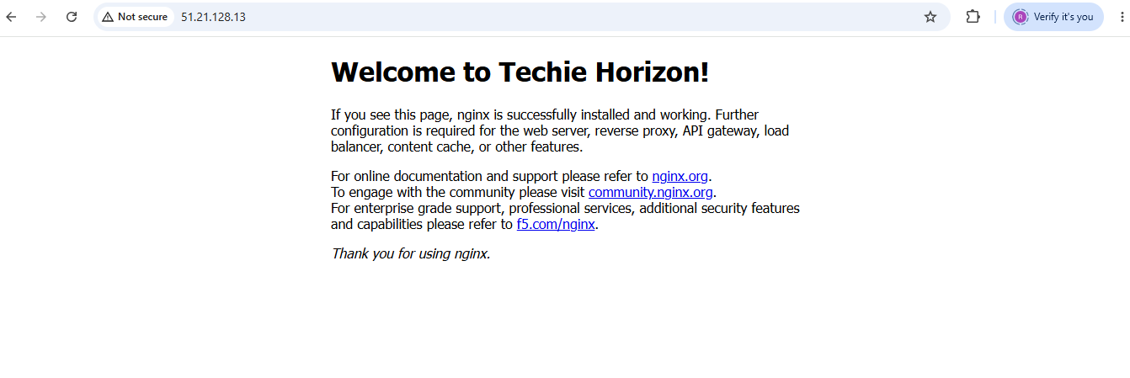

3. Install Apache and run Apache on port number 82
Isntall Apache using yum install httpd
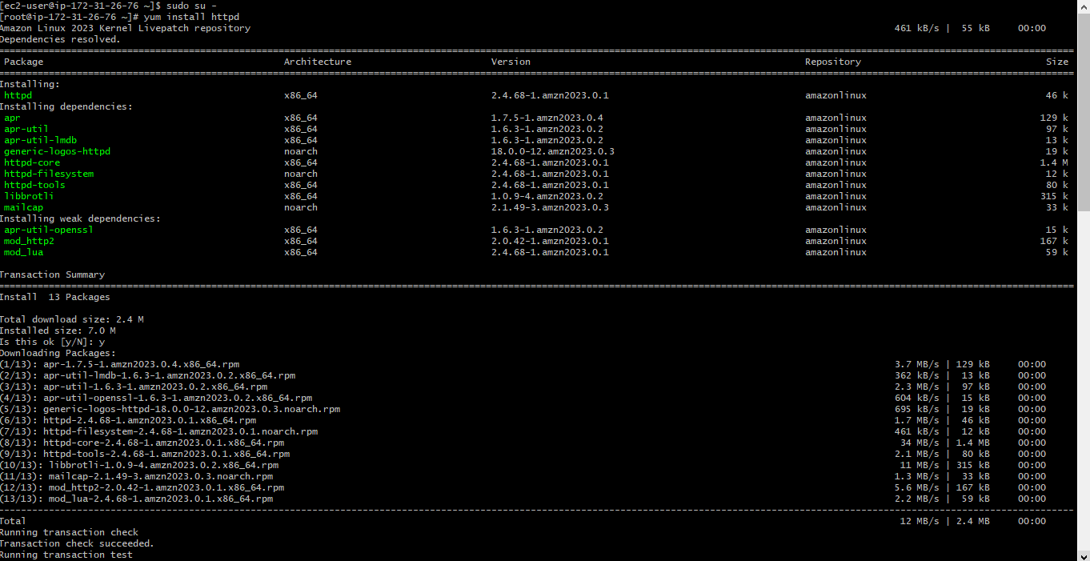
We see it is installed and checked if its running using systemctl status httpd
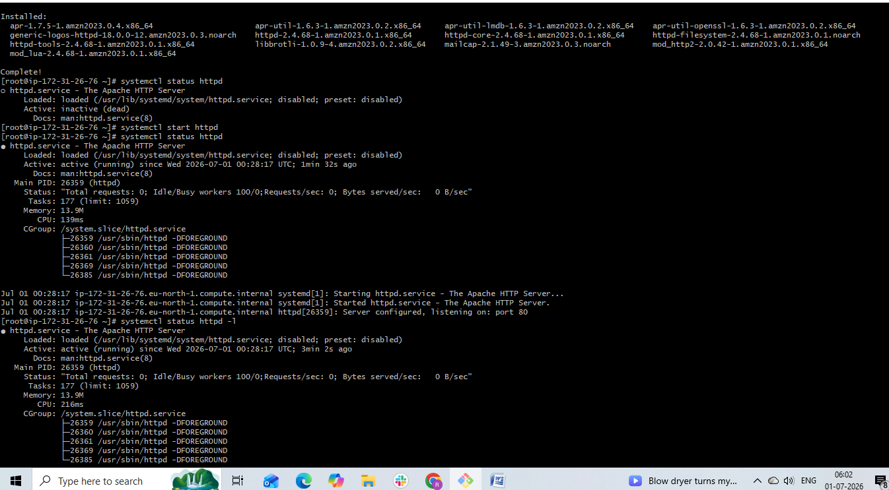
Also checked if port is in use by using netstat –na | grep 80
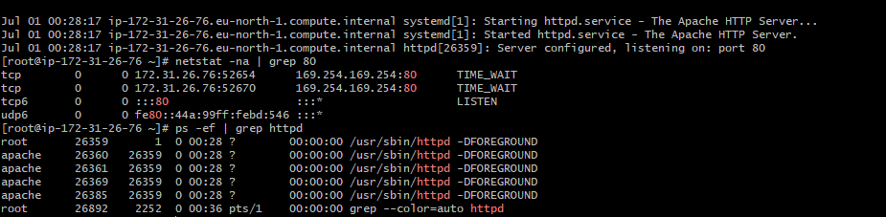
In browser simply gave Ip address to verify the page

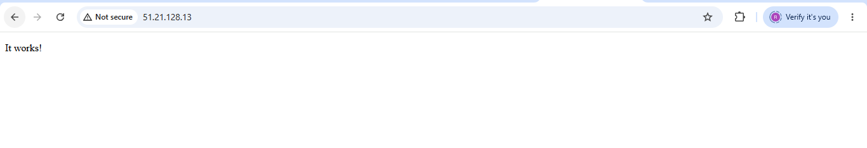
4. Deploy a sample index.html file on Apache.
Navigate to /var/www/html. Now to configure our own port used etc/httpd/conf/httpd.conf, copied the file to vi and edited the port number
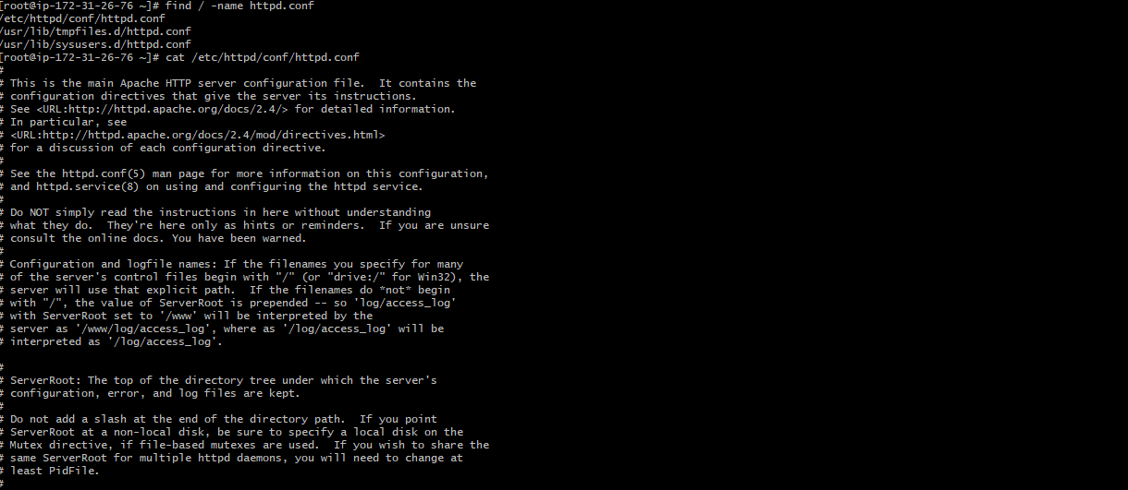

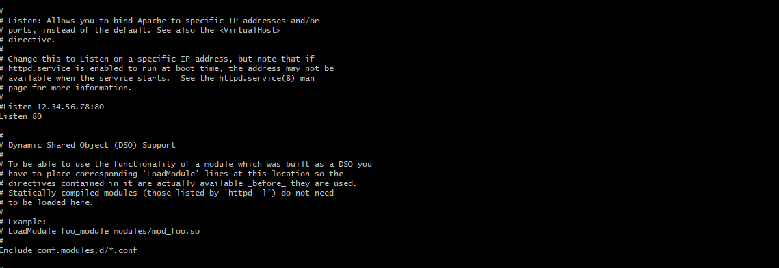

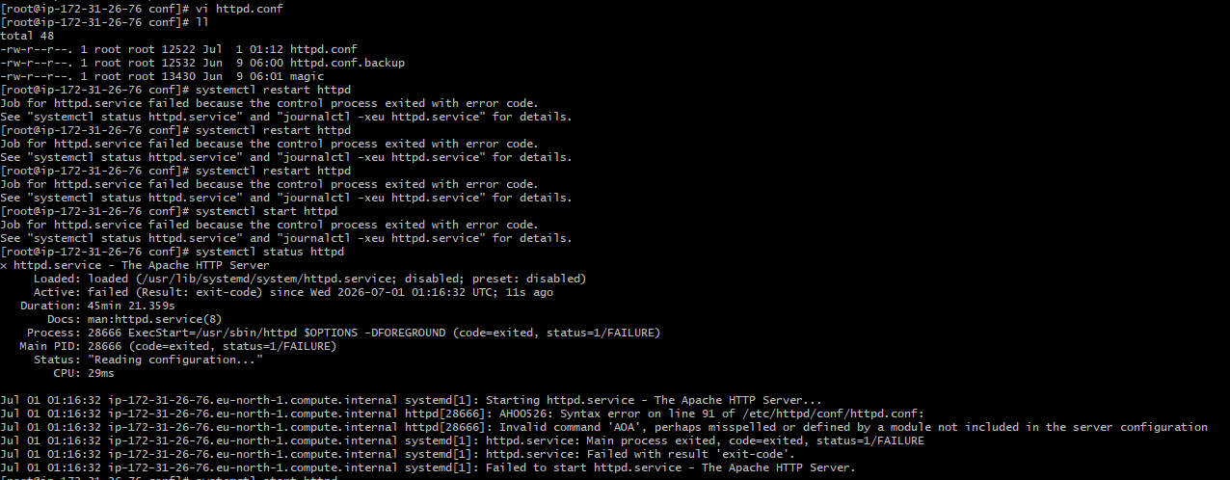

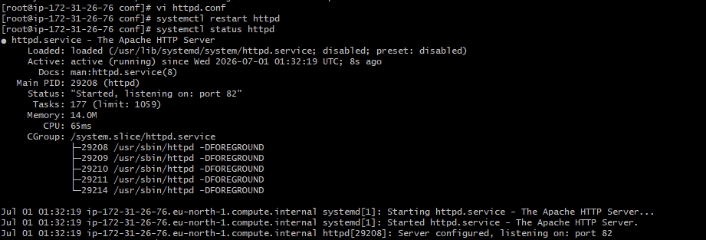

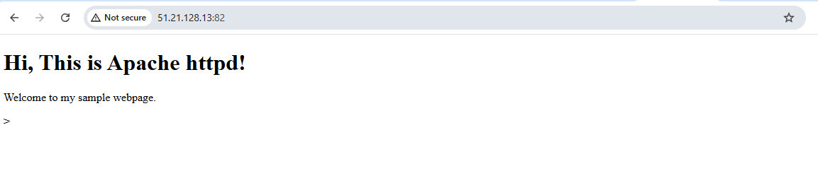
5. Install Apache tomcat on port number 8082
Apache Tomcat is a Java application server. It is written in Java, so it cannot run unless Java is installed.
Tried to installed Java using sudo dnf install java-17-amazon-corretto –y command.
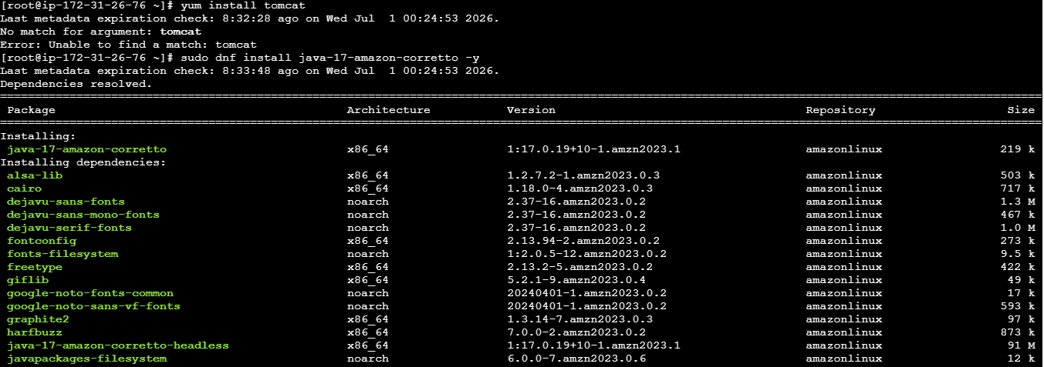
Used wget https://archive.apache.org/dist/tomcat/tomcat-10/v10.1.43/bin/apache-tomcat-10.1.43.tar.gz to download Tomcat manually.
It was downloaded as zip file apache-tomcat-10.1.43.tar.gz. Now extracting this file using sudo tar -xzf apache-tomcat-10.1.43.tar.gz
Save the extracted file with name using sudo mv apache-tomcat-10.1.43 tomcat
When we give command ll, it shows the extracted file saved as Tomcat.
Checked if port is running using netstat -na | grep 8080
Editing the port number 8080 in vi editor with command vi /opt/tomcat/conf/server.xml and changed port number to 8082
To read the content of the file used cat vi /opt/tomcat/conf/server.xml
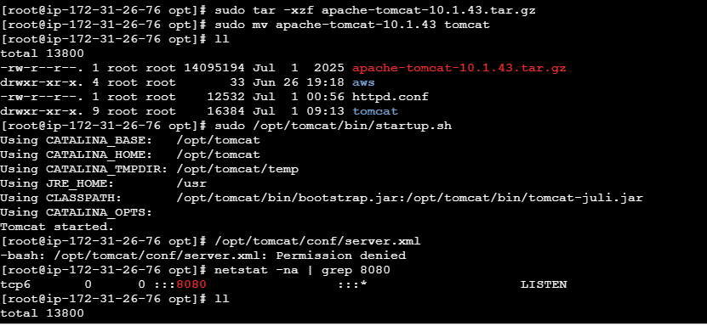
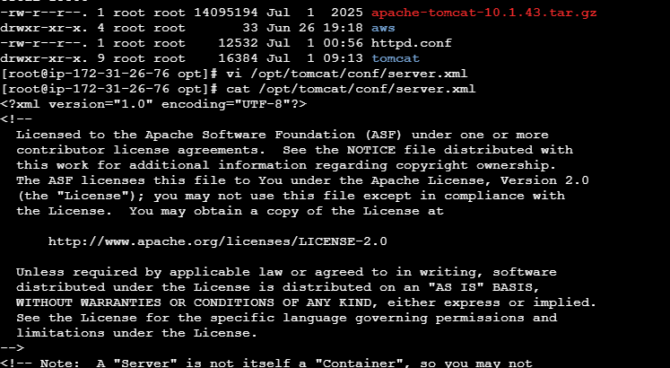
6. Deploy a sample app on webapps

Used path cd /opt/tomcat/webapps and created a directory sample apps.
Using vi index.jsp, Inserted basic html code and check the webpage and read the content of file using cat index.jsp
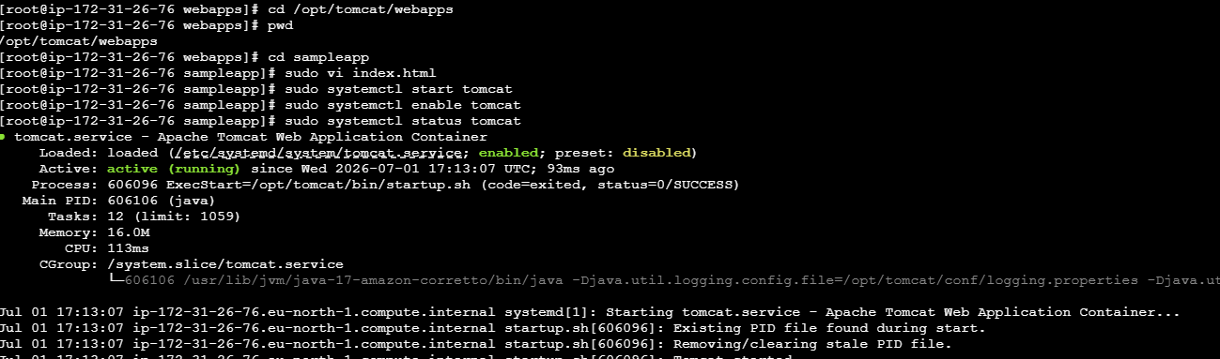
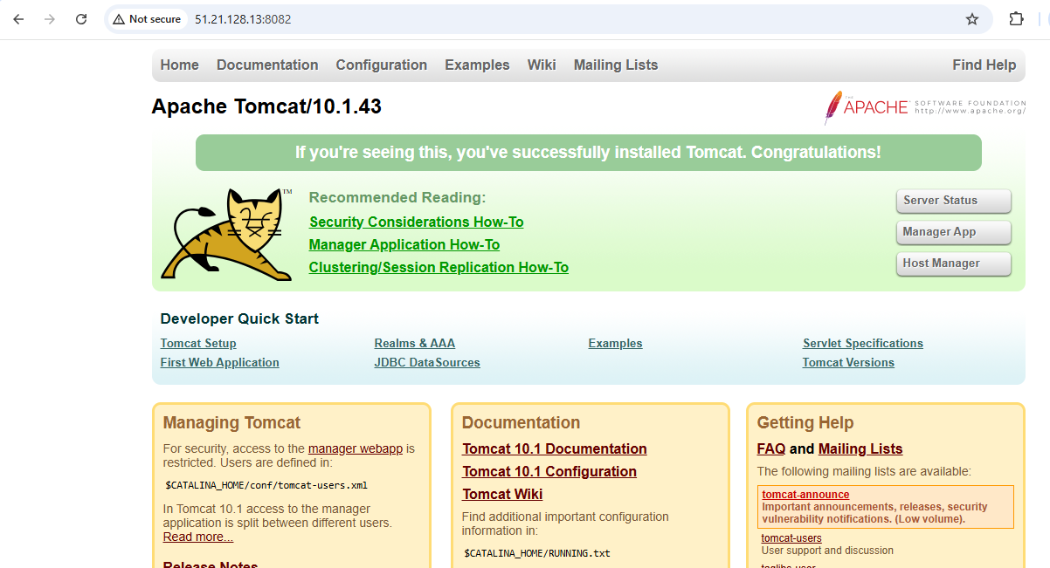

7. Create a tomcat.service file for tomcat
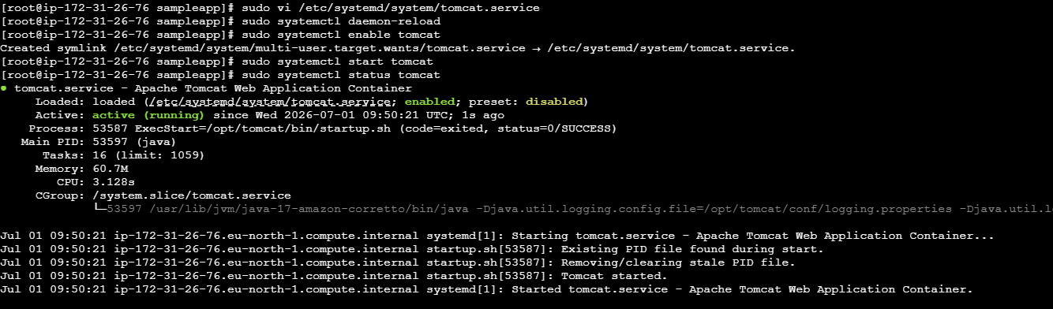
8.Configure HA Proxy server
