Step 7: Create a dashboard
- Go to Dashboards → New dashboard.
- Click Add visualization.
- Select the Prometheus data source.
- Enter the query up.
- Select Stat or Time series.
- Click Apply, then save the dashboard as EC2 Monitoring Dashboard.
Below is the Grafana Time Series Visualization for last 15 min

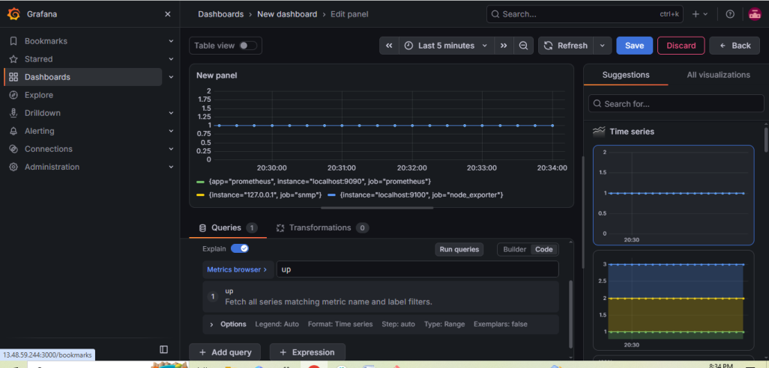

Below is the Grafana stat visualization

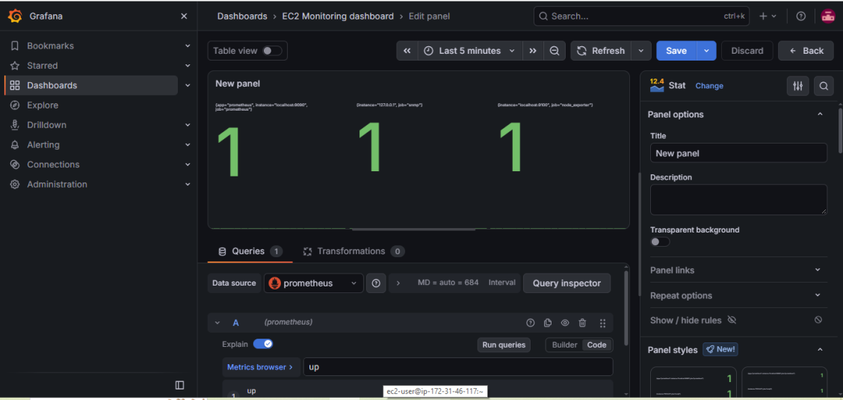
7. Configure Prometheus for service discovery of dynamic targets.

Step 1: Create a dynamic targets file
This file contains the target that Prometheus will discover. Later, we can add more targets without changing the Prometheus configuration.

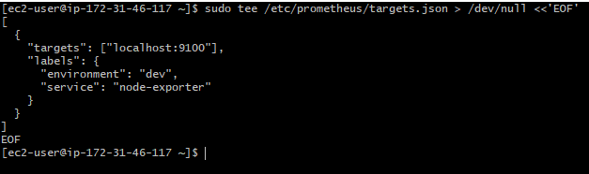
Set readable permissions:
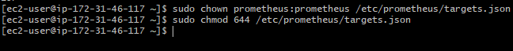

Step 2: Configure Prometheus
Open the configuration file and add the below job without changing other jobs:
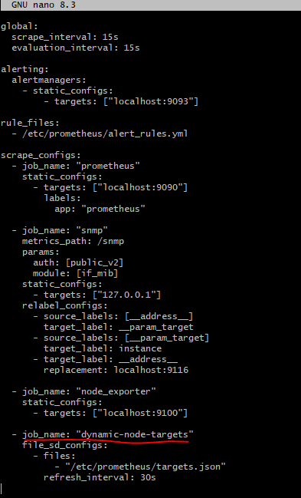
Save the file using Ctrl+O, press Enter, then Ctrl+X.

Step 3: Validate the configuration

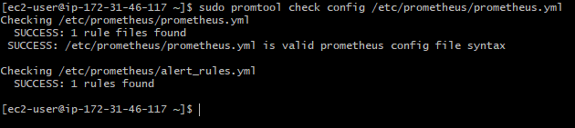

Step 4: Reload Prometheus

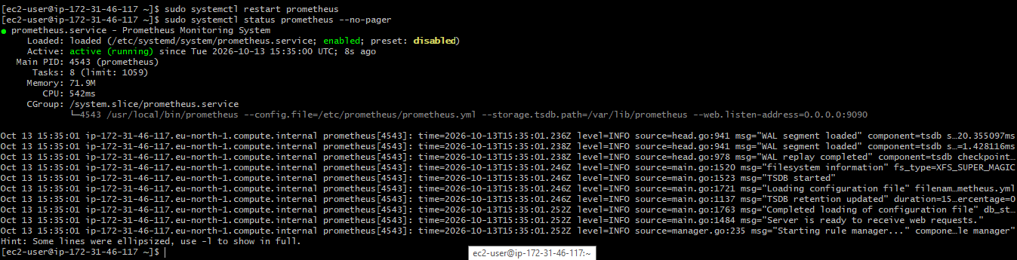

Step 5: Verify service discovery
Open this URL in your browser:
Find the job dynamic-node-targets. It should discover localhost:9100 and show as UP.

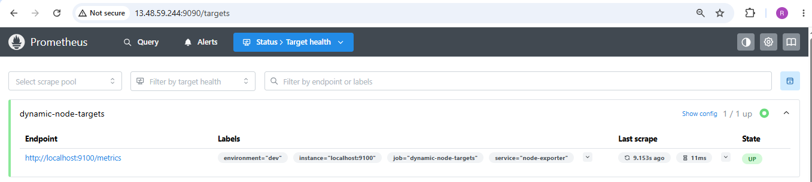
Test using the Prometheus query:

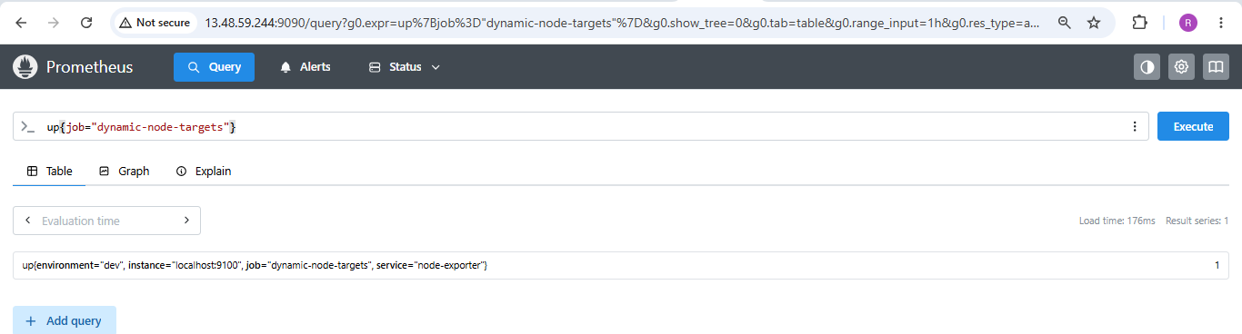

Step 6: Test that discovery is dynamic
Add a second target to the JSON file.

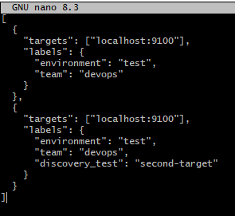
Save file using Ctrl+O, Enter, then Ctrl+X.
Save the file and wait approximately 30 seconds. Refresh the Prometheus Targets page. The second target should appear without restarting Prometheus.
Both entries intentionally use the same endpoint to demonstrate file discovery; they are not two separate servers.

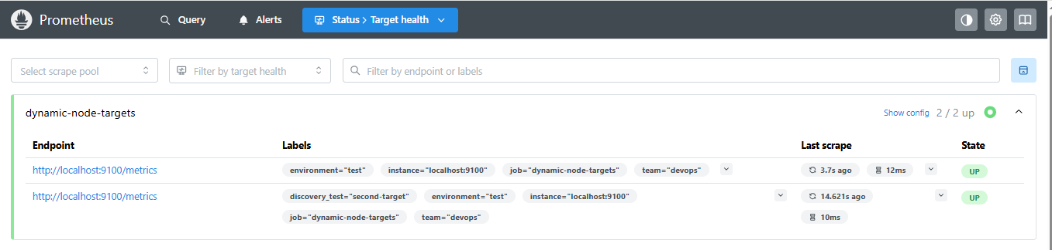

The dynamic-node-targets job appears in Prometheus, the target file is read successfully, and target changes are detected automatically.

8. Create alerting rules for monitoring disk space.

Step 1: Verify Node Exporter disk metrics
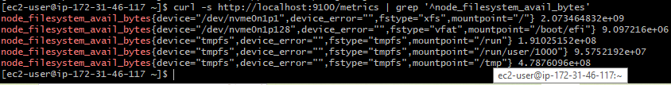
In above screenshot see metrics for mounted filesystems, including available disk space in bytes.
Check the filesystem mount points:
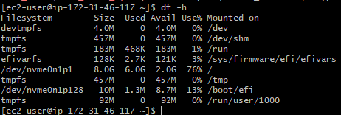

Step 2: Create the disk alert rules file
Create or edit the rules file:
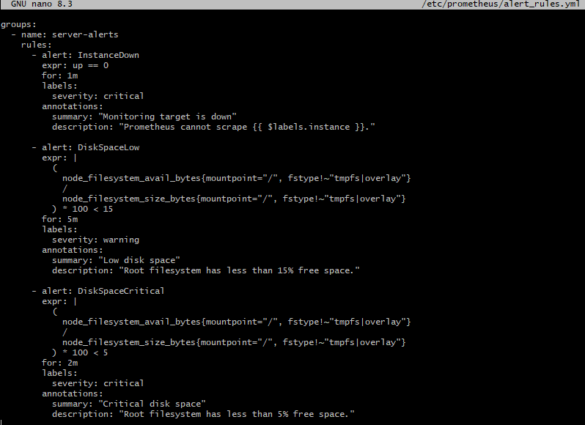
Save file using Ctrl+O, Enter, then Ctrl+X.

Step 3: Validate the rules

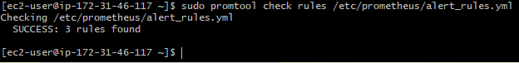
Then validate the full configuration:
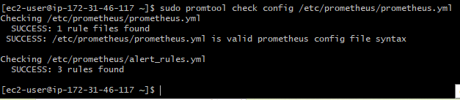

Step 4: Restart Prometheus
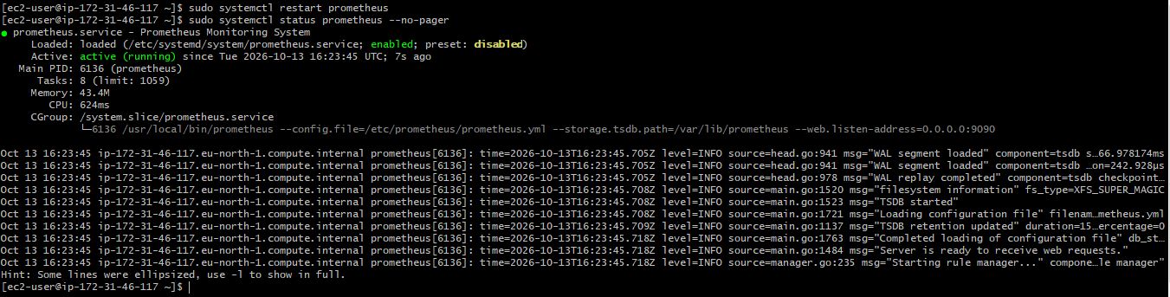

Step 5: Verify alerts in the browser

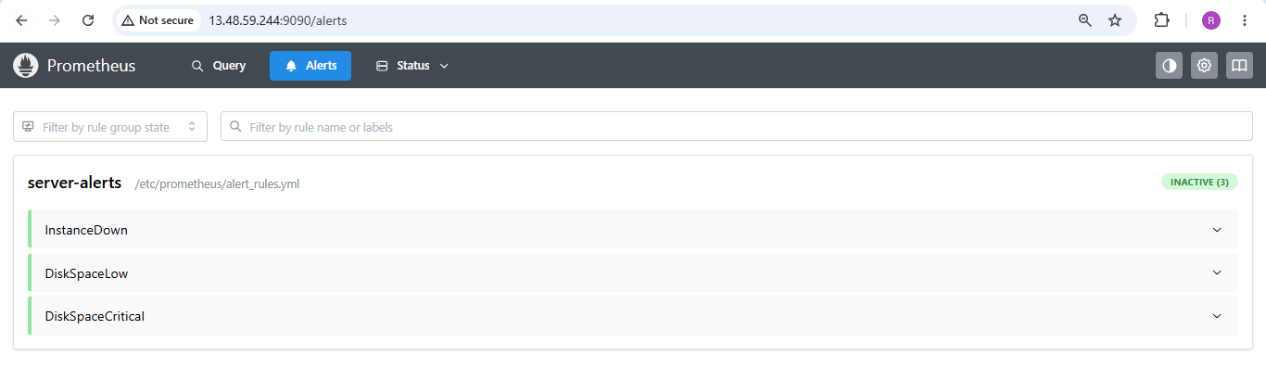
9. Create a custom Grafana dashboard using Prometheus metrics for specific insights.

Step 1 — Check Grafana on your EC2 instance

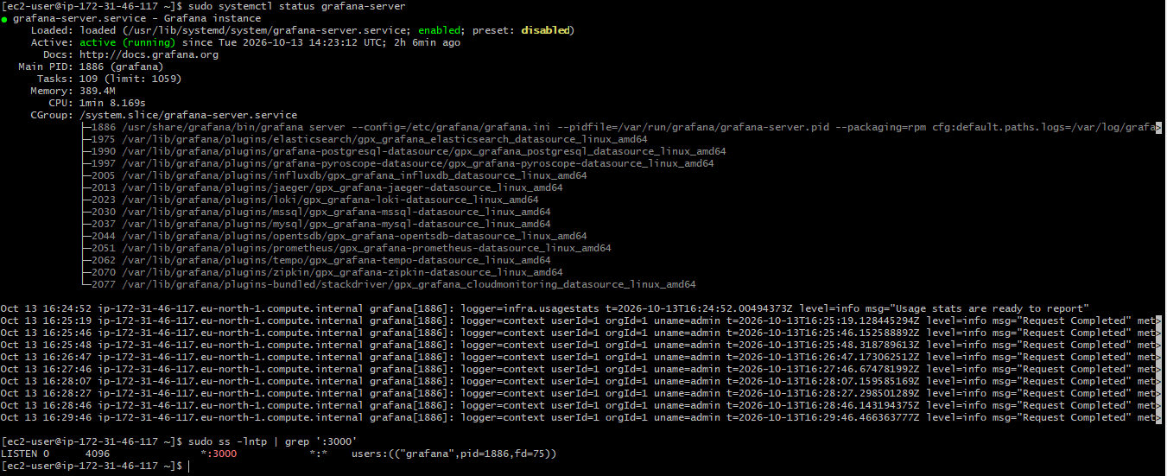

Step 2 — Create the custom dashboard
Go to Dashboards → New → New dashboard → Add visualization. Select Prometheus data source.
Create these six panels. For each one, enter its PromQL query in the query editor and select the recommended visualization.

Panel 1 — CPU Usage

Panel 2 — Memory Usage

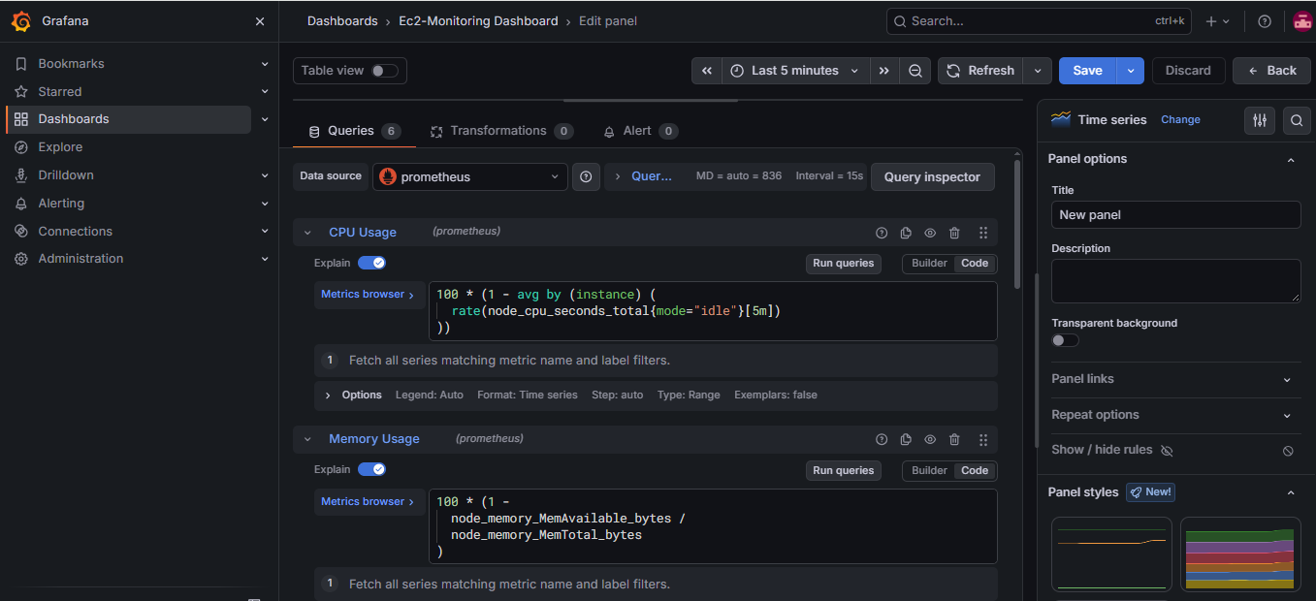

Panel 3 — Root Disk Usage

Panel 4 — Server Availability

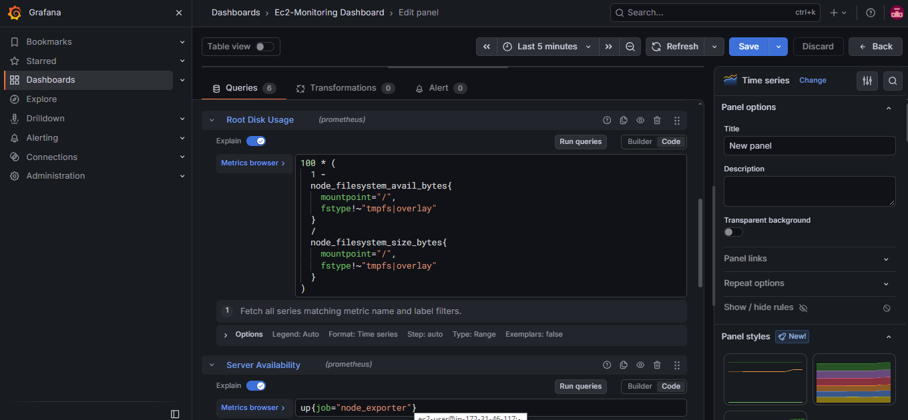

Panel 5 — Network Traffic

Panel 6 — System Load

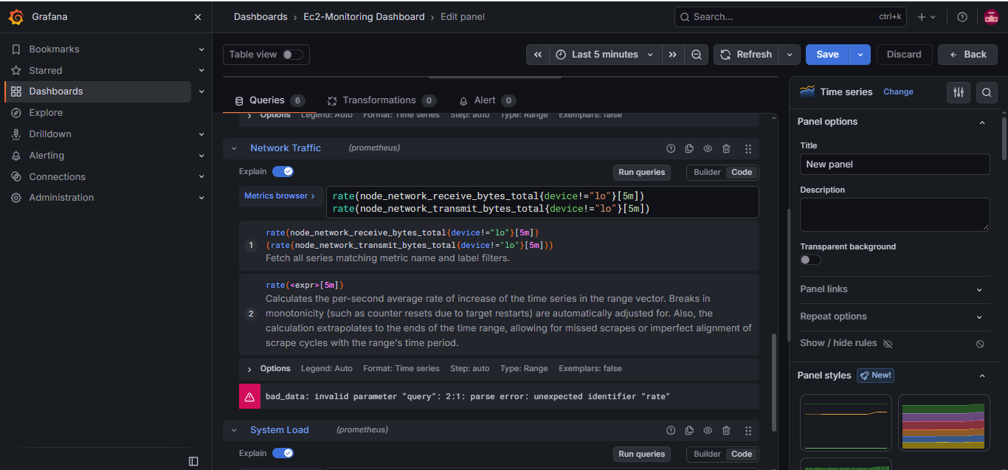
For each panel, click Apply to add it to the dashboard. When all six are present, save the dashboard as EC2 Monitoring Dashboard.

Step 4 — Test the dashboard data
Before troubleshooting Grafana, confirm that the metrics are available. On the EC2 instance:
Check the Node Exporter target in Prometheus in browser:
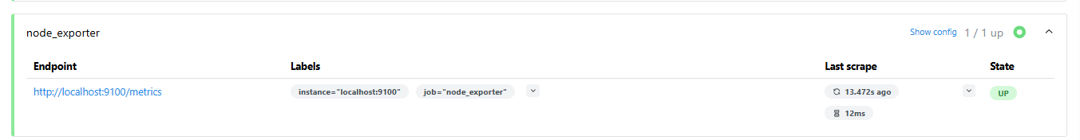
Grafana visualization for above 6 panels
