Devsecops

1) Setup DevSecOps pipeline using freestyle project.
Source Code: https://github.com/betawins/spring-petclinic.git
Prerequisites:
1. Jenkins
2. Docker
3. Sonarqube
4. Aws cli, eksctl, kubectl
5. IAM role
6. Eks Cluster.
Step 1: Check the installed software:
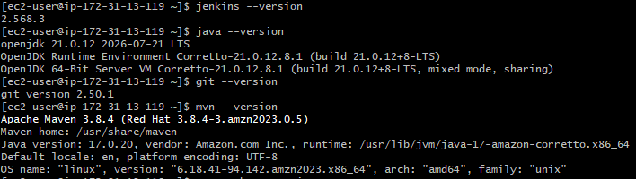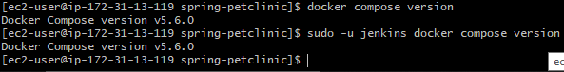

Step 2 — Verify the application builds
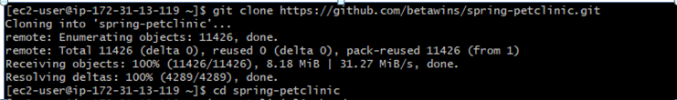

Verify the files in this directory and search for mvnw (Maven wrapper):
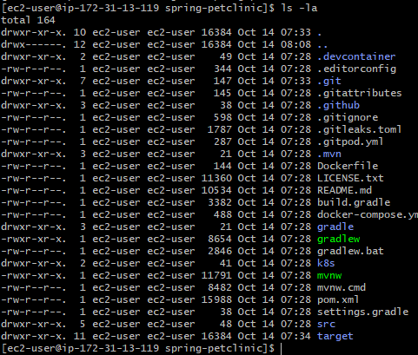

Step 3. Verify the Maven Wrapper
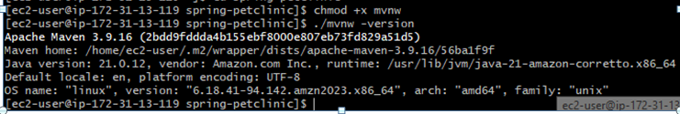
The wrapper downloads the Maven distribution specified by the project when needed.
Now Build and test the application:
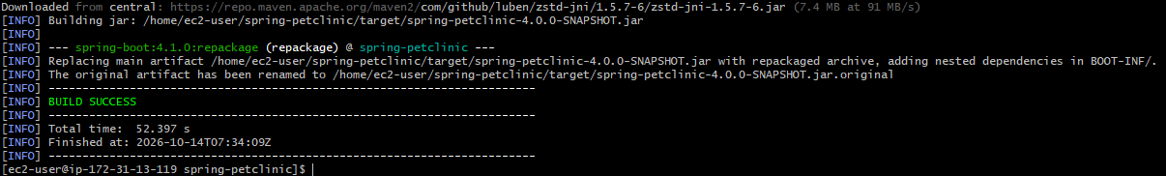
Step 4: Install SonarQube on the same EC2 instance
First, install Docker:
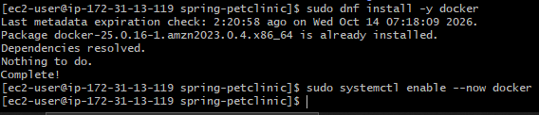
Check Docker:
Configure the required Linux kernel setting:
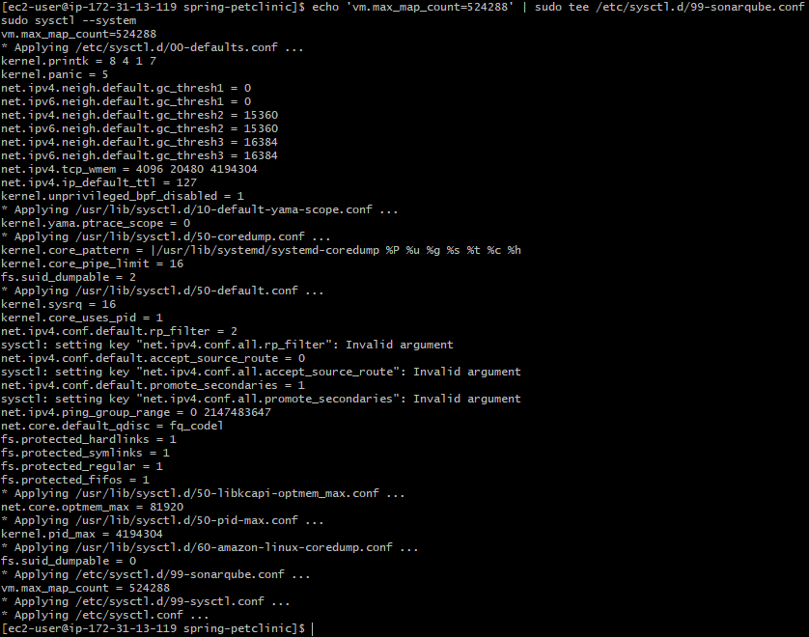
Verify:
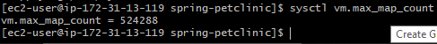
As Docker works and we have sufficient resources, start SonarQube:
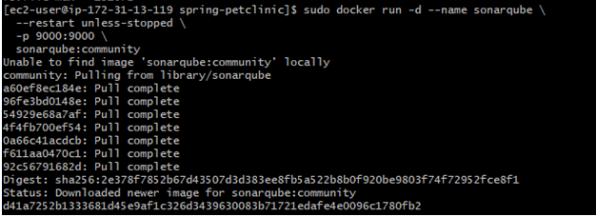
Check startup:
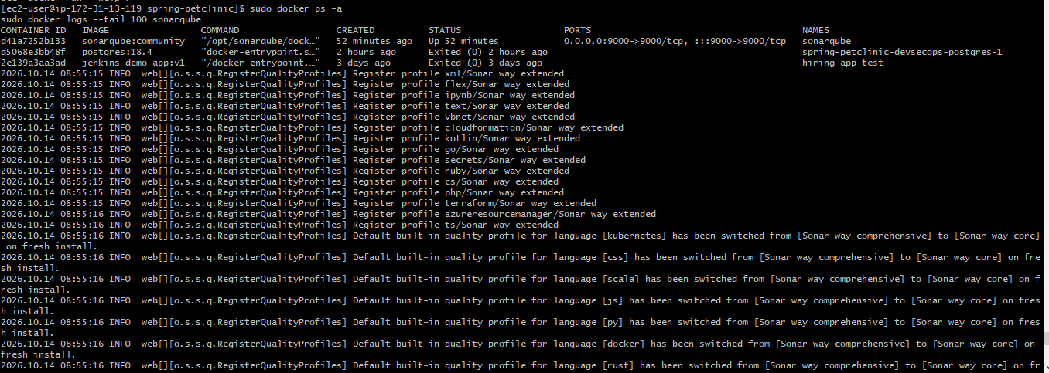
Open this address in your browser:
http://YOUR-EC2-PUBLIC-IP:9000
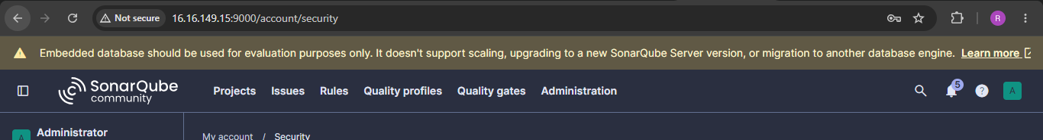
Allow inbound TCP port 9000 in your EC2 security group from your own IP only. Log in using the initial credentials shown by the fresh installation, usually admin / admin, and change the password when prompted.

Step 5: Install the Jenkins plugins
Open Jenkins in your browser.
Go to Manage Jenkins → Plugins → Available plugins and install:
- Git plugin
- SonarQube Scanner
- OWASP Dependency-Check
- Credentials Binding Plugin
Git plugin:

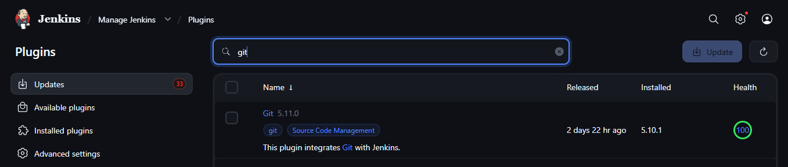

Sonarqube scanner plugin

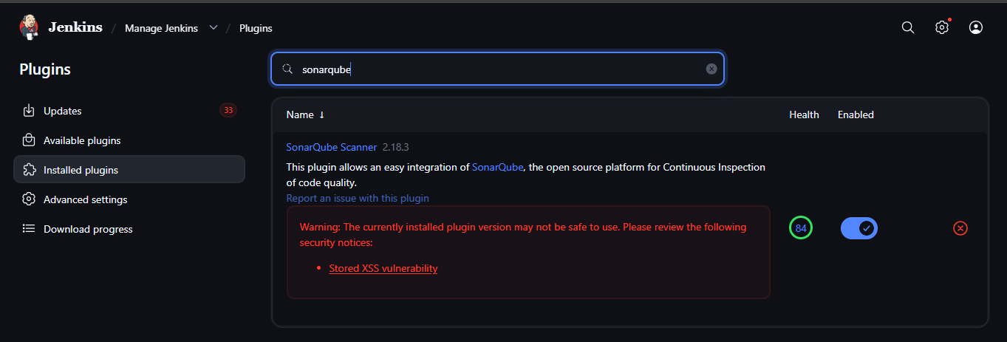

Owasp dependency check plugin:

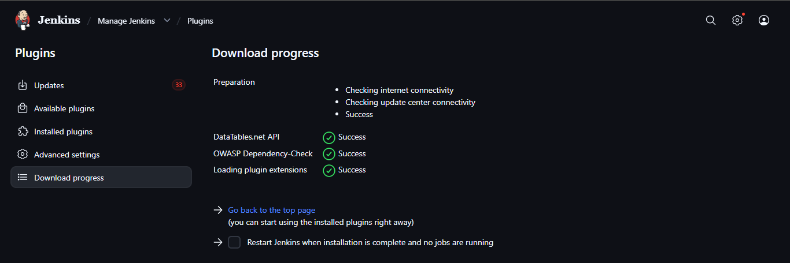

Credentials Binding plugin:

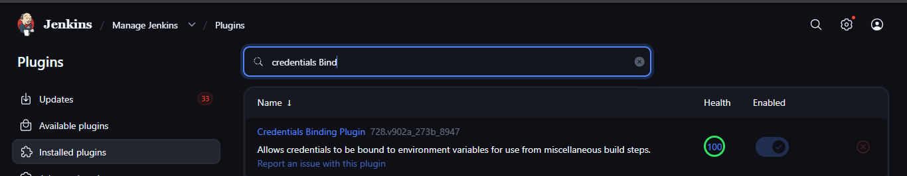

Step 6: Configure SonarQube in Jenkins
In SonarQube:
- Create a project named spring-petclinic.
- Use spring-petclinic as its project key.
- Generate a project analysis token.

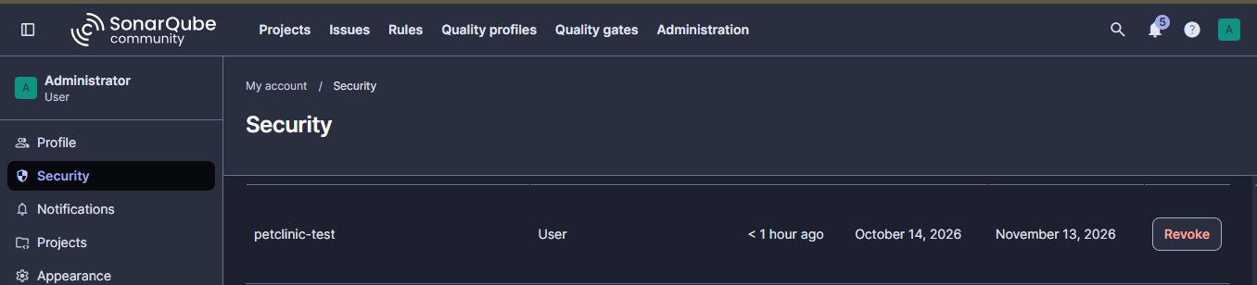
In Jenkins:
- Open Manage Jenkins → Credentials.
- Add a credential of type Secret text.
- Paste the SonarQube token.
- Set the ID to sonarqube-token.
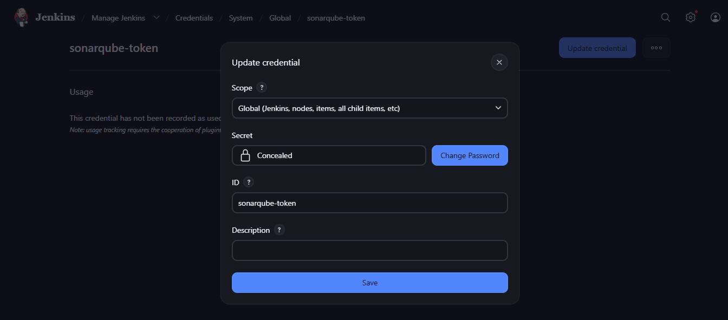
Next, go to Manage Jenkins → System → SonarQube servers.
Add a server configuration:
- Name: SonarQube
- Server URL: http://localhost:9000 if Jenkins and SonarQube run on the same EC2 host.
- Server authentication token: select the appropriate Jenkins credential.
Save the configuration.
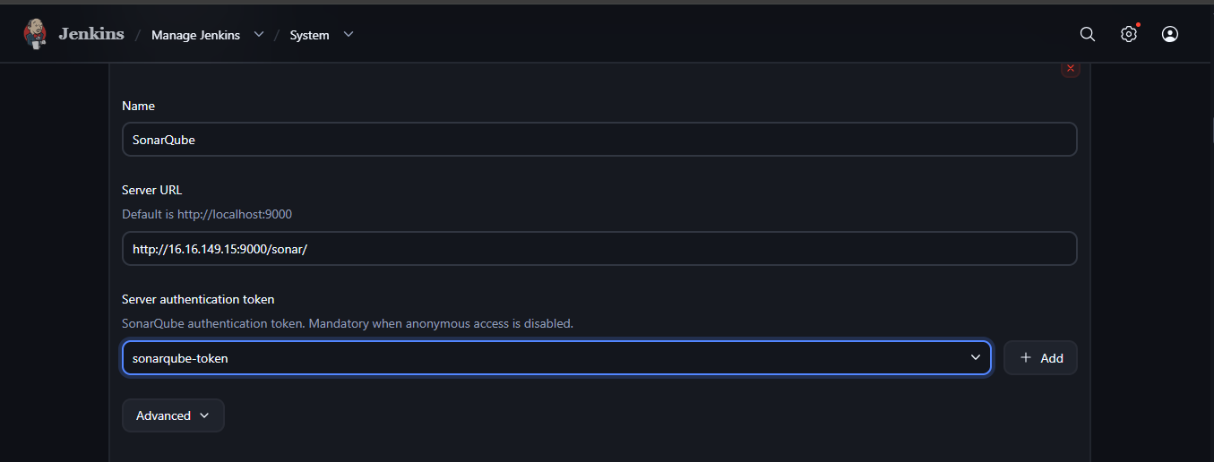

Step 7: Get an NVD API key
- Open the official NVD website: Request an NVD API Key.
- Follow the instructions to request a key.
- Check your email and complete any required verification.
- Copy the API key when it is provided.
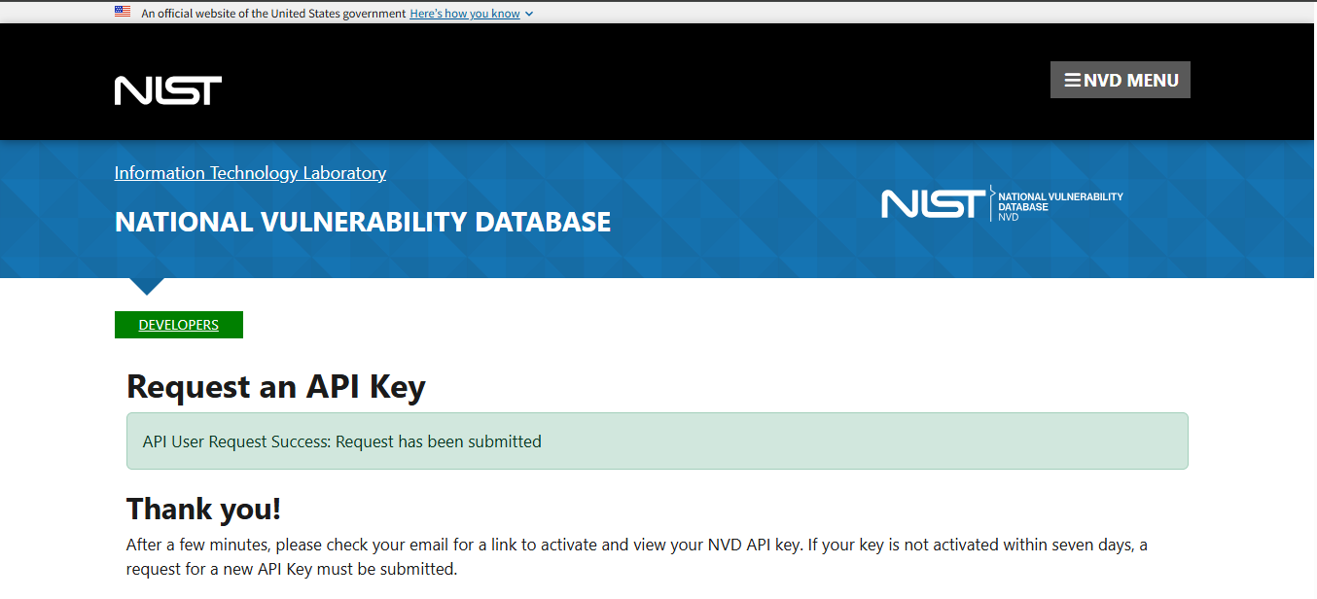
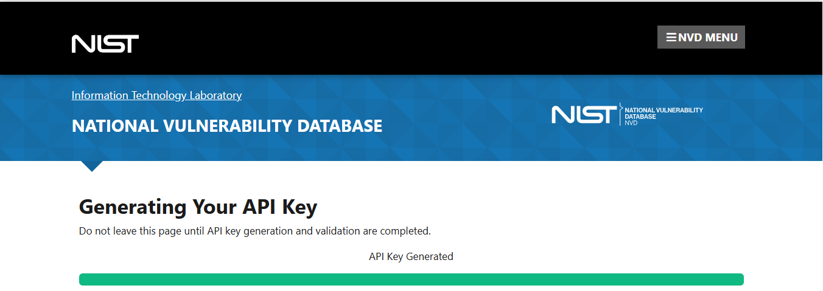

Step 8: Set the NVD API key on your EC2 server
After you receive the key, run this in your EC2 terminal:
read -s -p "Enter NVD API key: " NVD_API_KEY
Then Verify that the variable is set without displaying the secret:
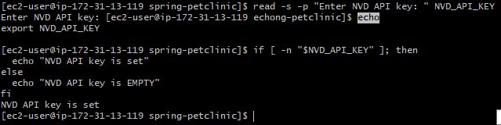

Step 9: Add or verify the NVD API key credential
- Open your Jenkins dashboard.
- Go to Manage Jenkins → Credentials.
- Open System → Global credentials (unrestricted), or the credential store used by your pipeline.
- Click Add Credentials.
Kind: Secret text
Secret : actual NVD API key
ID : nvd-api-key
Description : NVD API Key for OWASP Dependency Check
Click Create.
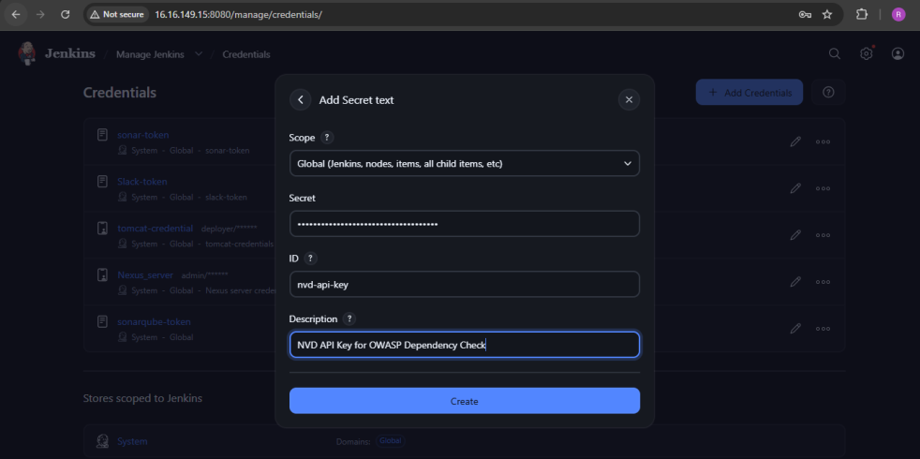

Step 10. Create the Freestyle project in Jenkins
Open your Jenkins dashboard in the browser.
- Click New Item.
- Enter the item name: spring-petclinic-devsecops.
- Select Freestyle project.
- Click OK.
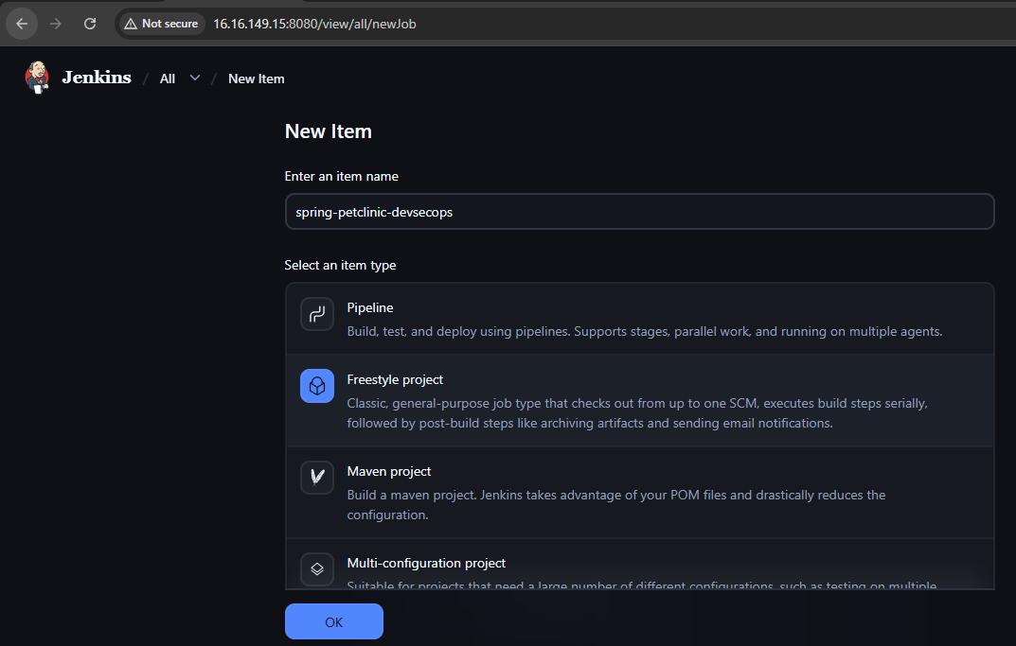
Under Source Code Management, select Git and configure:
- Repository URL: https://github.com/betawins/spring-petclinic.git
- Branch Specifier: */main
- Credentials: None for a public repository.
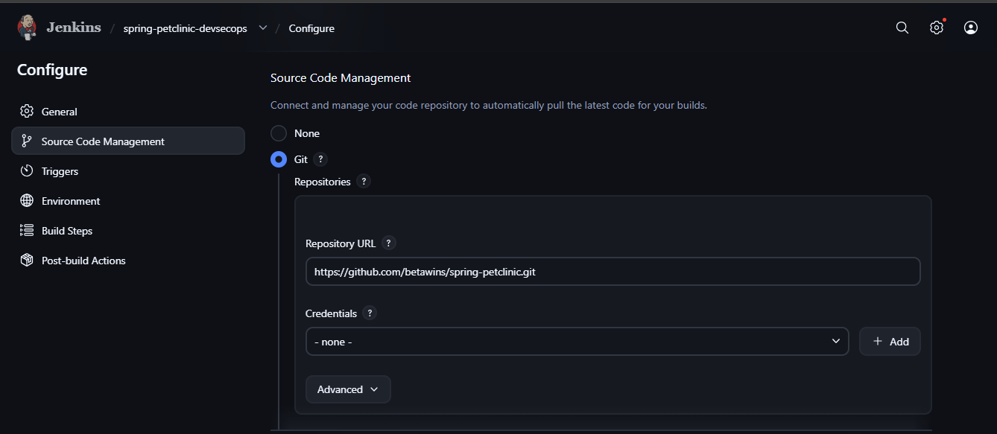

Build step 1— Compile and test
Under Build Steps, select Add build step → Execute shell and enter:
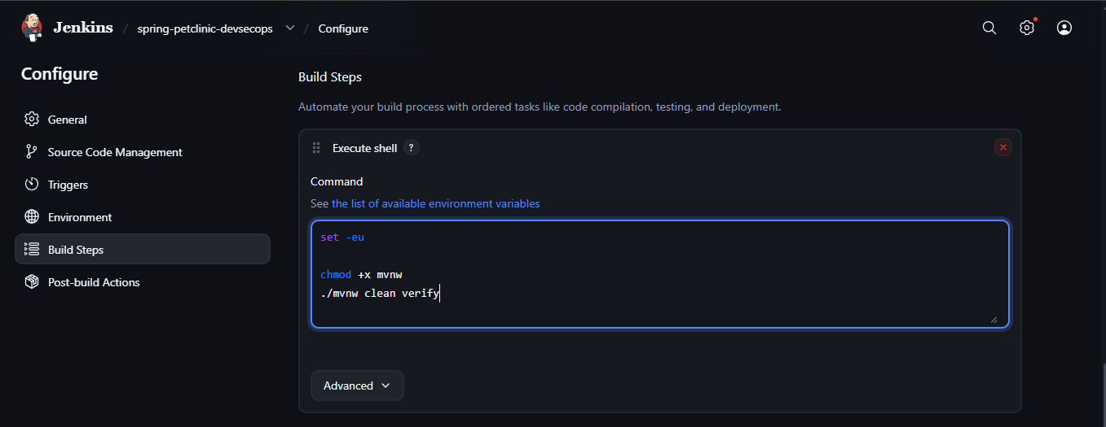
Click Save → Build Now → Console Output.
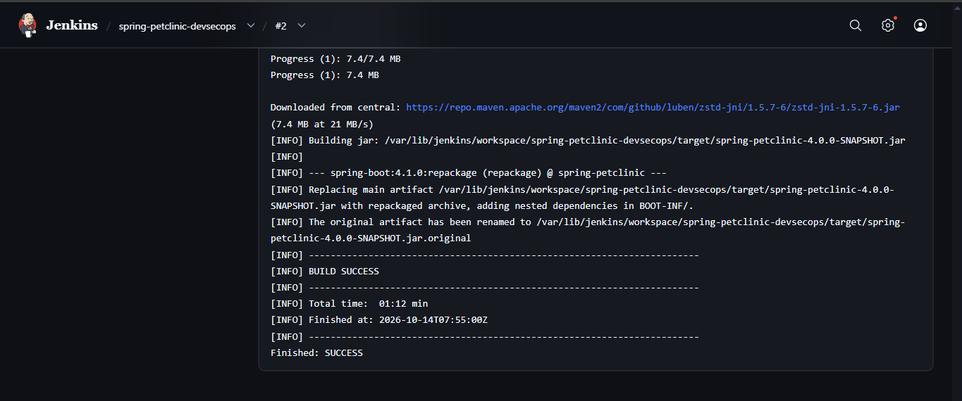

Build step 2 — Run OWASP Dependency-Check
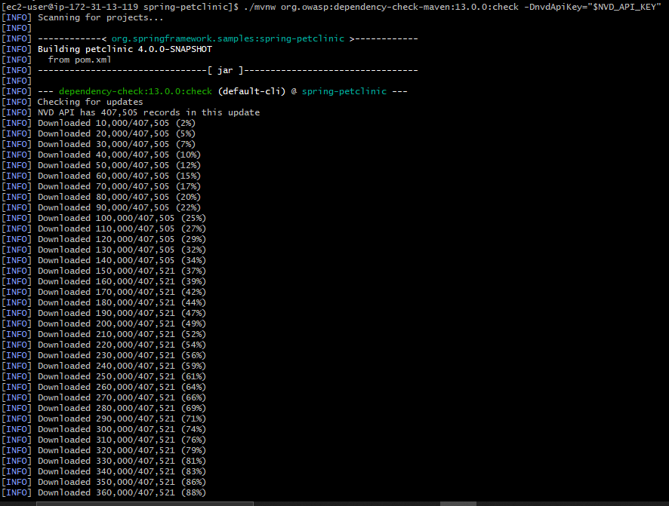

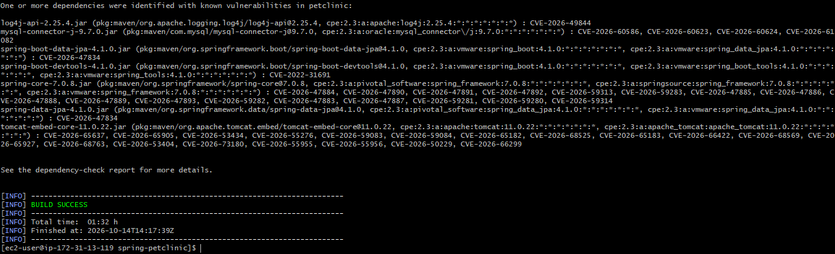

Build step 3 — Analyze source code
In the Freestyle job configuration, enable the Credentials Binding option to expose your Jenkins secret-text credential as the environment variable SONAR_TOKEN.

1: Update Jenkins credentials binding
- Open Jenkins → spring-petclinic-devsecops → Configure.
- Under Build Environment, enable Use secret text(s) or file(s).
- Add a Secret text binding with these values:
- Variable: SONAR_TOKEN
- Credentials: sonarqube_token
4. Click Save.
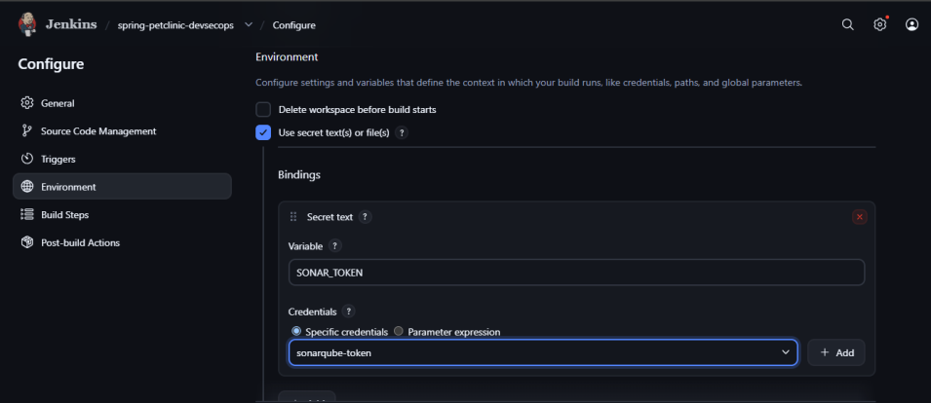
2. Then add another Execute shell step:
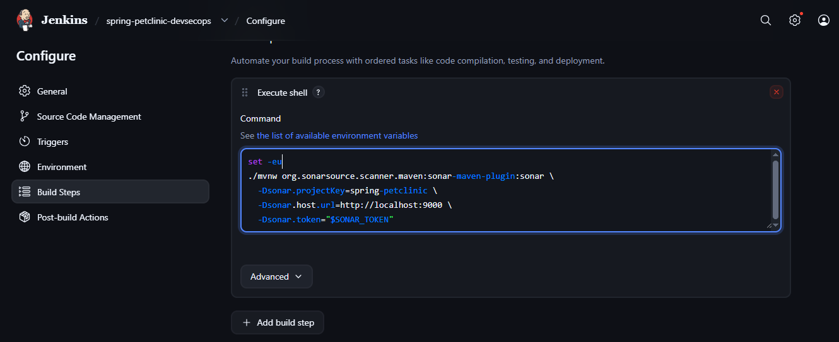

Step 10. Run and verify the pipeline
- Click Build Now.
- Open Console Output.
- Check whether the SonarQube analysis succeeds.
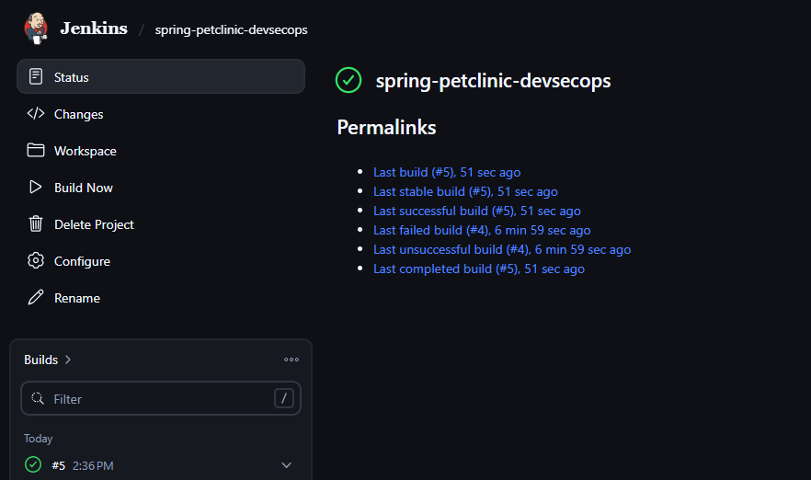

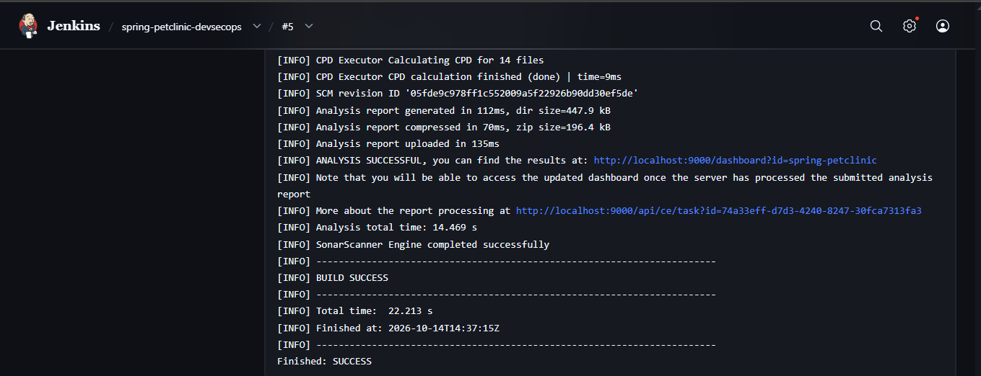

Below stages executed successfully:
Stage | Success criteria
Git checkout |  | Repository downloaded
Maven build | BUILD SUCCESS
Dependency scan | Vulnerability scan completes
SonarQube | Analysis submitted successfully
Final verification | Jenkins status reflects build and scan failures
Open SonarQube and confirm that spring-petclinic has analysis results.

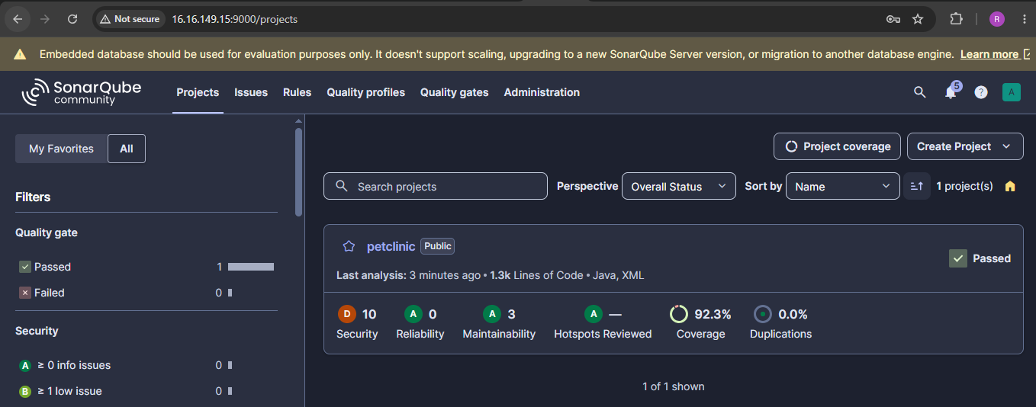

2) Setup SevSecOps pipeline using Declarative pipeline.
Source Code: https://github.com/betawins/spring-petclinic.git
Step 1 – Step 9 are configurations are similar as Freestyle job and the below continues the Declarative pipeline job steps.
Step 10: Create the Declarative Pipeline job
In Jenkins:
- Click New Item.
- Enter the name spring-petclinic-devsecops-pipeline.
- Select Pipeline.
- Click OK.
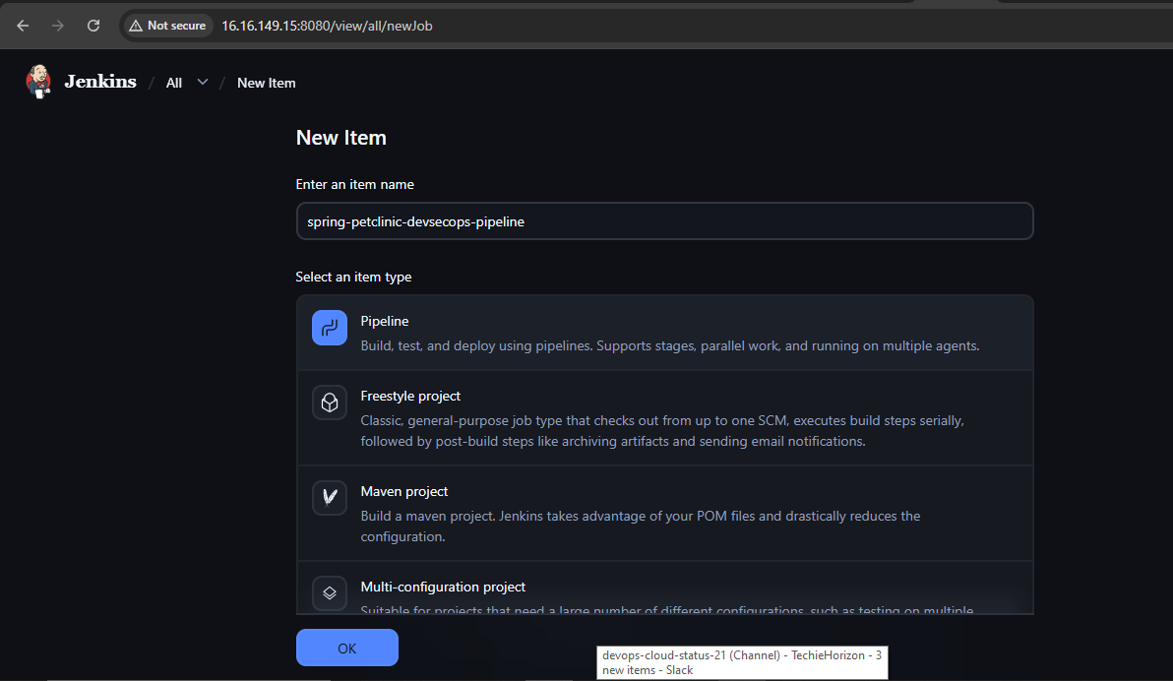
- Scroll down to the Pipeline section.
- For Definition, select Pipeline script.
- Write the Declarative Pipeline script.
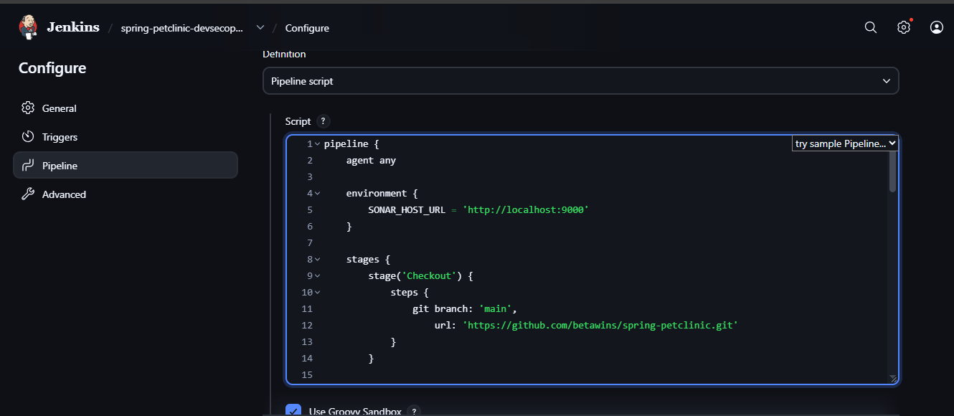
Click save.

Step 11: Run the pipeline
- Open spring-petclinic-devsecops-pipeline.
- Click Build Now.
- Under Build History, click the new build number.
- Select Console Output.
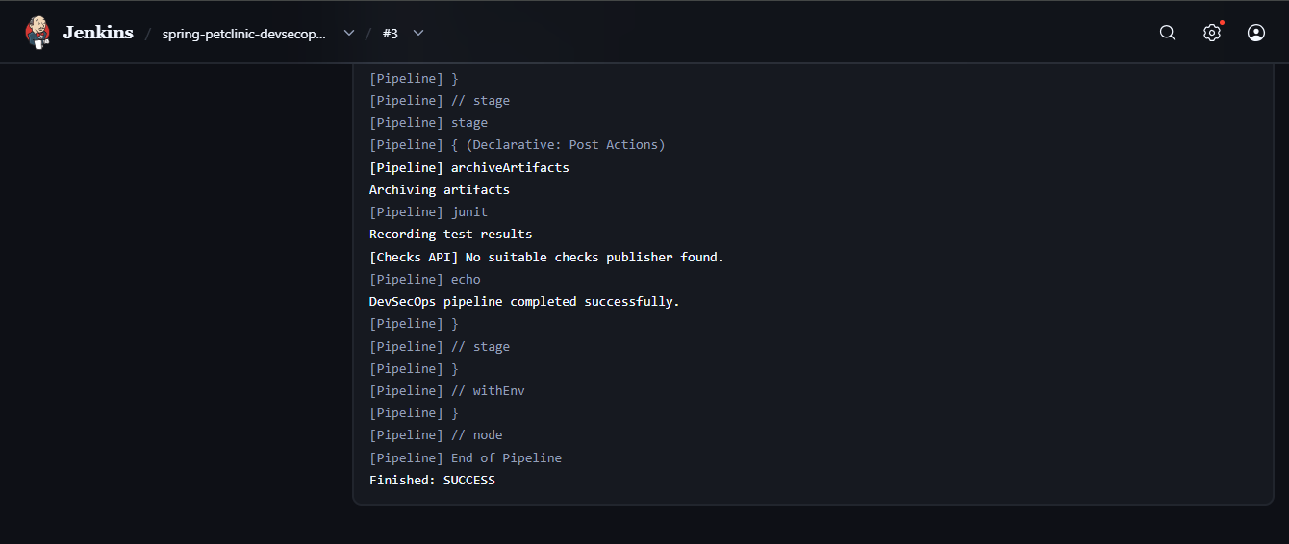
- Follow the output as each stage executes.
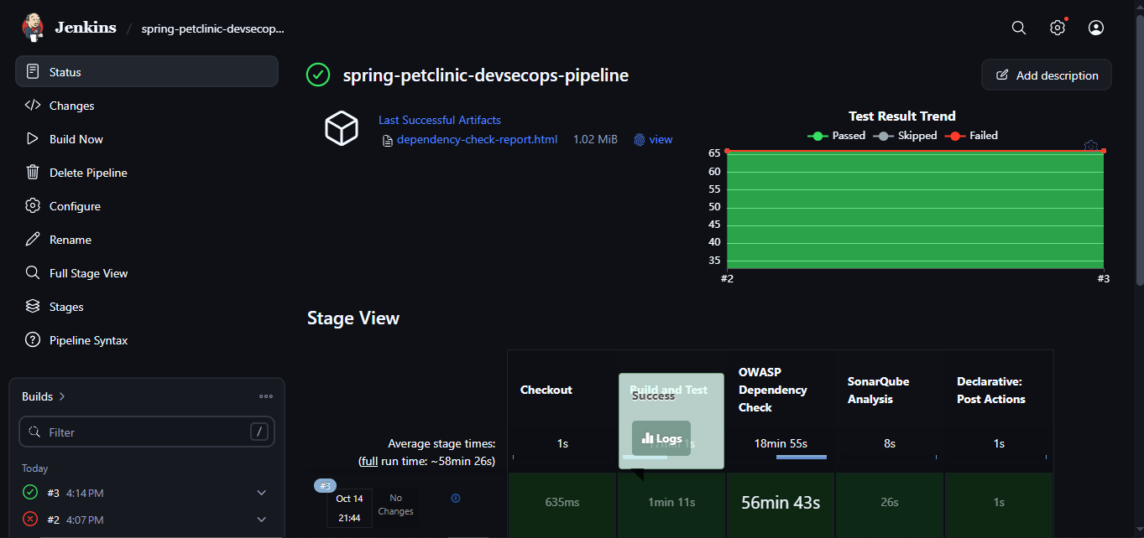
SonarQube: Open http://YOUR-EC2-PUBLIC-IP:9000, go to Projects, and open spring-petclinic to review bugs, vulnerabilities, security hotspots, and code-quality metrics.
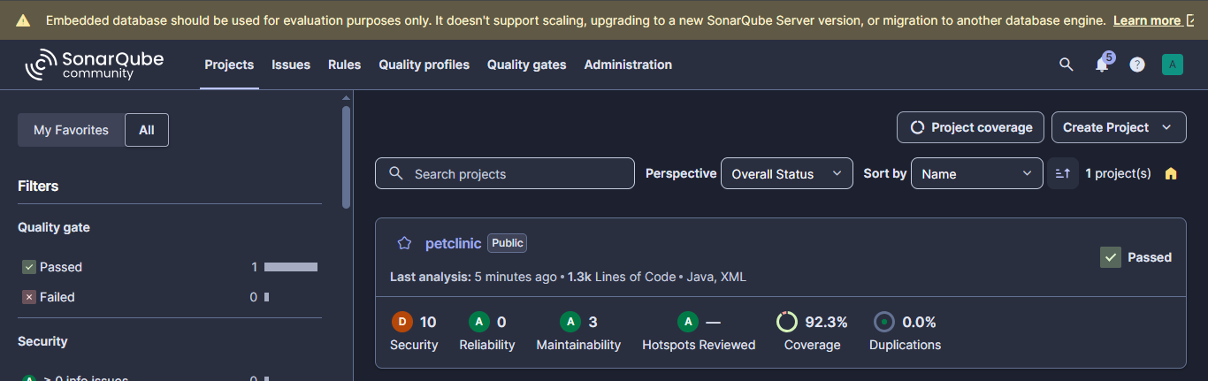

Step 12: Check whether the application is running

1. As Jenkins is already using port 8080, we’ll try to Start PetClinic on port 8082 using below command:
cd /home/ec2-user/spring-petclinic

./mvnw spring-boot:run -Dspring-boot.run.arguments=--server.port=8082
2. Wait until the application starts. Look for a message indicating that Tomcat started on port 8082.
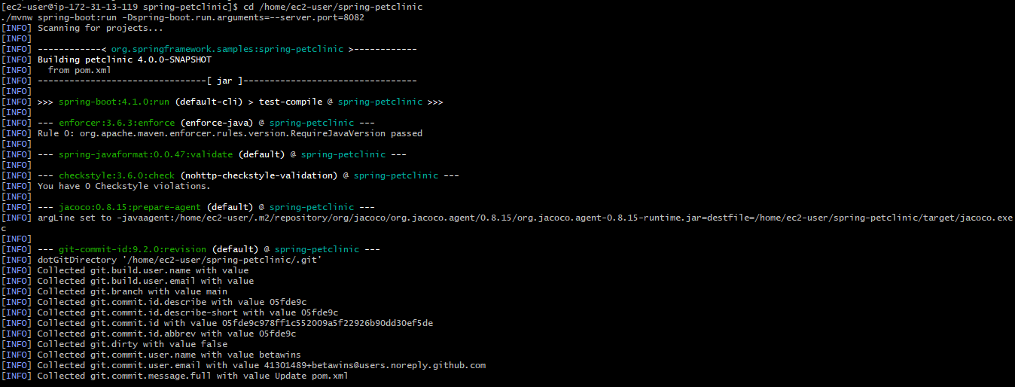
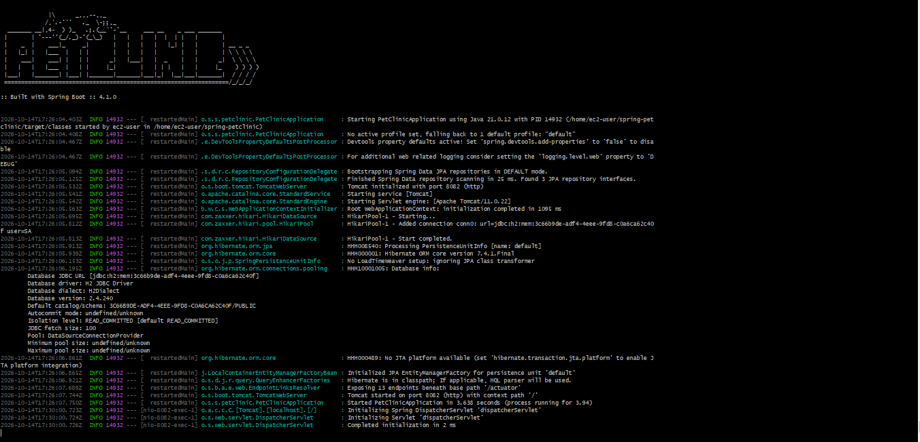
Keep this terminal open.

Access PetClinic application in browser
Open: http://YOUR-EC2-PUBLIC-IP:8082

