

Course: Master of Data Analytics

Unit Code: MDA692

Unit Name: Data Analytics Capstone Project

Assessment Title: Assessment 1 – Project Detailed Design
Unit Coordinator: | Dr Osamah A. Mahdi
Lecturer: | Dr Osamah A. Mahdi
Industry Partner: | Arif System
Project Supervisor: | Dr Osamah A. Mahdi

Student ID | Name
MIT242438 | Rojan Dhimal
MIT242481 | Sher Bahadur Baral
MIT242414 | Yuvrajsinh Vaghela
MIT243573 | Althaf Ali Mohammad
MIT251007 | Vineet Bhatia
MIT242025 | Mohammed Ibrahim Fawaz

Contents
1. Introduction to the Research Project 3
1.1 Introduction 3
1.2 Project Aim 4
1.3 Project Objectives 5
2. Detailed Project Design 5
2.1 Project Overview 5
2.2 Block Diagram of the Implementation 6
2.3 Implementation Workflow 7
2.4 Software Specifications 9
2.5 Hardware Specifications 9
2.6 Roles and Responsibilities of Team Members 10
2.7 Weekly Project Plan 11
3. Conclusion 12
References 13

Time Series Forecasting for Energy Demand Prediction

1. Introduction to the Research Project

1.1 Introduction
Energy is one of the most essential resources of modern society sort of; the demand for electricity constantly keeps on increasing with the growth of population, expansion of industry, urbanization, technology development and increased use of electrical devices etc. In fact, a power generator must constantly try to keep electricity demand equal to electricity supply – at the same time – to provide an acceptable level of power supply, at least to minimize costs. As a result, it is a vital requirement for energy providers, energy companies and the government to accurately forecast future energy requirements. Accurate forecasts can help to better schedule power generation, optimize resource use, minimize wasted energy, aid in incorporating renewable energy and prevent a lack of electricity during peak demand if forecasts are accurate.
In history, there are three most popular statistical forecasting techniques which are widely used for electricity demand forecasting; these are called Moving Average, Autoregressive Integrated Moving Average (ARIMA), and Seasonal Autoregressive Integrated Moving Average (SARIMA). These models are generally simple and can reasonably simulate tendencies and seasonal patterns of the past and are often used due to their simplicity. However, traditional forecasting techniques have difficulty to sustain high forecasting accuracy in the modern era where consumption is increasingly driven by nonlinear factors like weather, renewable energy generation, consumer choices and economic activities. Therefore, in recent times machine learning and deep learning techniques have been getting increasingly popular as they can analyze complex relationships within large datasets and then generate more accurate predictions.
This capstone project aims to design and implement a Time Series Forecasting for Energy Demand Prediction system with the application of AI. The proposed system will try to analyze electricity consumption in the past and also other factors such as temperature, seasonal variation, generation of solar power, wind power generation etc., and estimate the future demand for electricity. Several forecasting methods will be explored, such as statistical models, machine learning models and deep learning models. They will evaluate and compare using popular performance indicators such as Mean Absolute Error (MAE), Root Mean Square Error (RMSE), and Mean Absolute Percentage Error (MAPE). The forecasting model that has the most accurate and stable predictions will be recommended as the best forecasting model. [1]
This project takes an integrated approach of forecast interpretability, which is not done by traditional forecasting systems. Deep learning models, like Long Short-Term Memory (LSTM) networks, have been shown to have excellent prediction capabilities, but they are also black box models with limited explanations to the predictions. Hence the aim of this project is to add Explainable Artificial Intelligence (XAI) techniques to make the energy demand prediction understandable and to give the stakeholders important insights into the factors affecting energy demand prediction. This extra feature helps to promote trust and aid in informed decision-making, whether by technical or non-technical users.
The project's data analytics methodology is broken down into several structured parts starting with the collection of the datasets, followed by preprocessing the data, exploration data analysis, feature engineering, building a forecasting model, evaluating the model, and visualizing the results. Energy datasets available to the public, including electricity consumption and weather-related data, will be used throughout the project. Preprocessing the data will be done before building forecasting models, such as handling missing values, removing duplicates, scaling features, and time-series transformation.
This project will help advance energy management by delivering accurate and reliable electricity demand forecasts if successful in its implementation. The suggested forecasting model is expected to facilitate effective resource planning, minimize the needless operational expenses, enhance electricity distribution, and help in sustainable management of electricity. In addition, this project will be the culmination of the knowledge students have acquired during the entire Master of Data Analytics program by combining statistical analysis, machine learning, deep learning and explainable AI into a real-life forecasting solution.

1.2 Project Aim
The goal of this capstone project is to design and develop a robust time series forecasting system that can predict future electricity demand in a reasonably accurate way, using historical energy consumption info plus weather linked variables. The whole project will put side by side statistical forecasting models , machine learning algorithms and deep learning techniques, to see which one is really the most effective forecasting approach. At the same time, it will try to make the results a bit more transparent and easier to interpret, not just output numbers, by applying explainable artificial intelligence methods.

1.3 Project Objectives
The objectives of this project are:
- For collecting and preprocessing the historical dataset of electricity demand and weather that can be used for time series forecasting.
- For performing the exploratory data analysis of energy consumption patterns and trends.
- For building forecasting models based on ARIMA, SARIMA, Random Forest, and LSTM.
- For comparing forecasting models with the help of metrics like MAE, RMSE, and MAPE.
- For enhancing the predictability of forecasting models by using the explainable AI approaches.
- For recommending an optimal forecasting model for energy demand forecasting.

2. Detailed Project Design

2.1 Project Overview
The proposed Energy Demand Forecasting System is meant to help electricity providers predict future electricity demand in a more accurate way, using historical energy consumption data plus environmental variables. Overall, the forecasting framework brings together traditional statistical forecasting methods and newer machine learning and deep learning approaches, so the predictions stay strong even when operating conditions change a bit. The project uses a kind of data analytics workflow, starting with data collection and finishing with performance evaluation and result visualization, not just a quick run then done.
Historical electricity demand data will be gathered from publicly available energy datasets, and also from additional factors like temperature, humidity, solar radiation, wind energy production, and seasonal indicators. These factors are expected to enhance forecasting, because they reflect outside influences that affect electricity usage. Before building any model, the dataset will go through heavy preprocessing, such as handling missing values, removing duplicates, doing feature scaling, converting datetime formats, and doing feature engineering which is basically making the inputs smarter. Some extra inputs will also be created like hour of day, day of week, month, holidays, and those seasonal indicators again, to boost forecasting capability, even if the setup seems repetitive.
The forecasting framework will sort through a bunch of prediction techniques, kind of like compare them. Traditional statistical models, including ARIMA and SARIMA, will be used for baseline forecasting performance. Random Forest will show up as the machine learning style option. Long Short-Term Memory (LSTM) neural networks will be put in place as the main deep learning forecasting model , because they can really learn long-term temporal dependencies across sequential data. Model performance will be checked using well-known forecasting evaluation metrics such as MAE , RMSE, and MAPE. The forecasting model that ends up giving the best prediction accuracy as well as consistent stability will be picked as the final forecasting solution. [2]
The proposed forecasting system is expected to deliver dependable demand predictions, make energy planning smoother, help with renewable energy integration. It should also cut operational costs and assist decision-makers to manage electricity resources more efficiently, in practice.

2.2 Block Diagram of the Implementation
In particular, the Energy Demand Forecasting System follows a structured approach in generating future demand forecasts from historical data on electricity usage. First of all, it gathers historical energy data as well as weather data . Secondly, it pre-processes the data through data cleaning, which makes the data more appropriate for analysis. Feature engineering is done to create additional variables, thus ensuring the accuracy of the forecasting process. In the modelling stage, different models for forecasting are trained and tested, including the ARIMA, SARIMA, Random Forest, and LSTM methods, which are evaluated based on MAE, RMSE, and MAPE measures. Thirdly, the best model is selected, and lastly, the results are presented in visualisation form. [3]
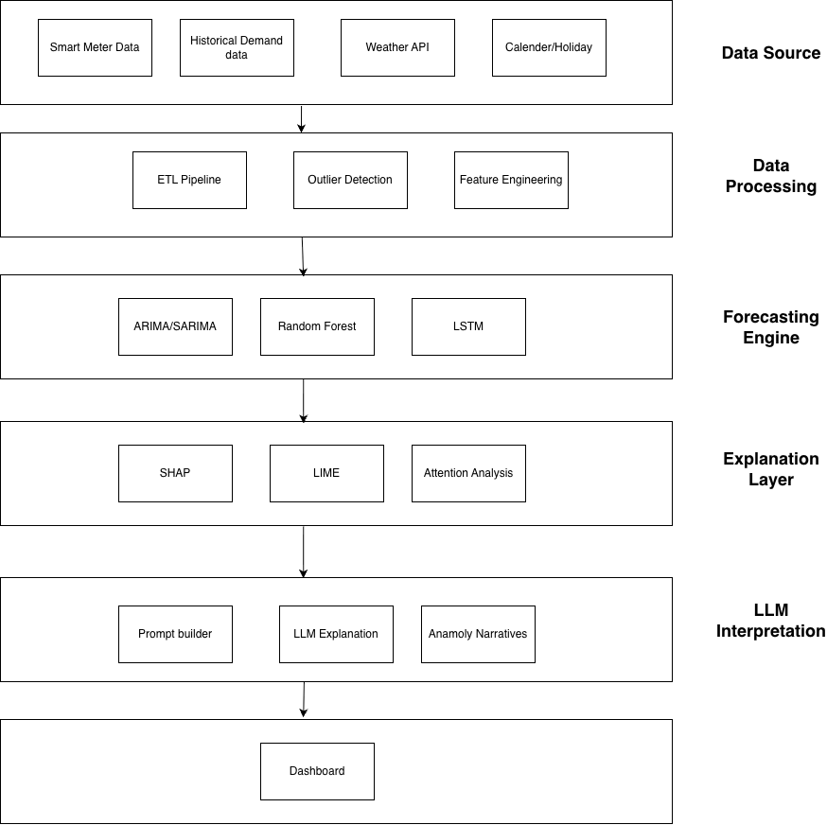
Figure 1 Block Diagram of the Proposed Energy Demand Forecasting System

2.3 Implementation Workflow
The project entails a series of steps including data acquisition, pre-processing, feature engineering, model training, evaluation, and visualization. The historical electricity demand and weather data is acquired and pre-processed to generate additional features based on time. The pre-processed data is then utilized to train and compare ARIMA, SARIMA, Random Forest, and LSTM models. The best-performing model is determined through an evaluation of its performance metrics such as MAE, RMSE, and MAPE. [4]
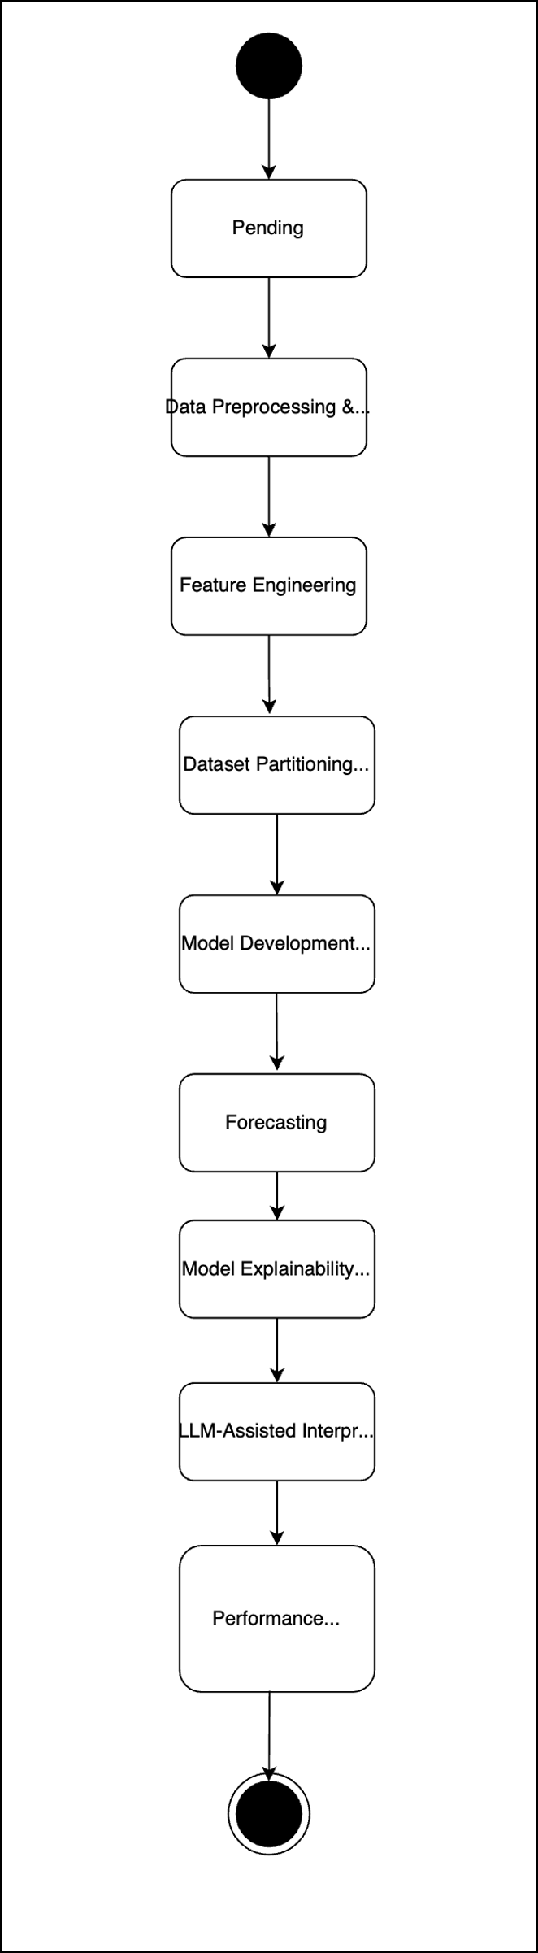
Figure 2 Forecasting Workflow

2.4 Software Specifications
Development of the project will be done via the use of Python as the programming language. Coding and testing of codes will be done via Jupyter Notebook and Google Colab, while data pre-processing will be done via Pandas and NumPy. Forecasting models will be done using Scikit-learn, TensorFlow/Keras, and Statsmodels. Plotting results will be done using Matplotlib and Plotly.

Software | Purpose
Python, Javascript | Programming
Jupyter Notebook / Google Colab | Development
Pandas & NumPy | Data processing
Scikit-learn | Machine learning
TensorFlow / Keras | LSTM model
Statsmodels | ARIMA & SARIMA
Matplotlib / Plotly | Visualisation
GitHub | Version control
Table 1 Software Requirements

2.5 Hardware Specifications
A computer that is equipped with an Intel Core i5 processor or better, 16 GB of RAM, and SSD will be needed. Google Colab can be used to train complex models. A stable internet connection will also be required to access datasets and work with other team members. [5]

Component | Specification
Processor | Intel Core i5 or higher
RAM | Minimum 16 GB
Storage | SSD (100 GB+)
Operating System | Windows 11
Internet | Broadband
Table 2 Hardware Requirements

2.6 Roles and Responsibilities of Team Members
It is only through proper collaboration by all team members that this capstone project will be accomplished successfully. Every team member has been entrusted with different tasks in line with their areas of specialization as well as the goals of the entire project. Proper communication will enable the activities of the project to be accomplished in time.
Team Member | Responsibilities
Rojan Dhimal | Planning for the project, forecasting model development, and systems architecture.
Sher Bahadur Baral | Literature review, statistical forecasting models, and documentation assistance.
Yuvrajsinh Vaghela | Data acquisition, preprocessing, data integration, feature extraction, and report documentation.
Altaf Ali | Implementation, testing, and evaluation of the machine learning model.
Vineet Bhatia | Project scheduling, creation of timeline, and project management.
Mohammed Ibrahum Fawaz | Selection of the dataset, validation, and comparison of forecasting models.
Table 3 Team Roles and Responsibilities

2.7 Weekly Project Plan
Project Implementation and Management The project will be implemented through the systematic weekly plan where the tasks in the project will be accomplished within the given time frame. Meetings with the project supervisor on a weekly basis will be organized to monitor the task accomplishment.
Week | Planned Activity
Week 1 | Re-affirm the project topic, aims and requirements.
Week 2 | Datasets collection and set up the development environment.
Week 3 | Data preprocessing and exploratory data analysis.
Week 4 | Completion and submission of the Project Detailed Design (Assignment 1).
Week 5 | Development of forecasting models and feature engineering.
Week 6 | ARIMA and SARIMA model development.
Week 7 | Random Forest model development and project progress report.
Week 8 | Development of the LSTM forecasting model.
Week 9 | Model tuning and testing.
Week 10 | Comparison of forecasting models and visualizations.
Week 11 | Implementation and evaluation completion and submission of Assignment 2.
Week 12 | Project presentation and reflection report.
Table 4 Weekly Project Plan

3. Conclusion
The current report gives the design of the Time Series Forecasting for Energy Demand Prediction capstone project. The designed architecture is supposed to outline the necessary architecture of the system, process flow of implementation, software and hardware requirement, roles of team members, and schedule necessary to successfully implement the project. The planning that was done in the current stage is aimed at giving a roadmap to work on the development and evaluation of forecasting models in the next stage of the project.

References

[1] | R. Hyndman and G. Athanasopoulos, Forecasting: Principles and Practice, 3rd Edition ed., OTexts, 2021.
[2] | S. Makridakis, E. Spiliotis and V. Assimakopoulos, "The M4 Competition: Results, Findings, Conclusion and Way Forward," International Journal of Forecasting, vol. 34, no. 4, p. 802–808, 2018.
[3] | I. Goodfellow, Y. Bengio and A. Courville, Deep Learning, MIT Press, 2016.
[4] | S. Hochreiter and S. Schmidhuber, "Long Short-Term Memory," Neural Computation, vol. 9, no. 8, p. 1735–1780, 1997.
[5] | G. Box, G. Jenkins, G. Reinsel and G. Ljung, Time Series Analysis: Forecasting and Control, 5th Edition ed., John Wiley & Sons, 2015.

