LibSpace

Project Documentation

1. Introduction:
Project Title: LibSpace
Team Leader: Roja sri B – rojasrinkr@gmail.com
Team Members:
1. Jeevitha S – nkrcsjeevitha@gmail.com
2. Preethi R – preethi568@gmail.com
3. Sona J – sonasaritha5102006@gmail.com
2. Project Overview:
LibSpace is a micro web-based library management system that provides secure user authentication and basic book management features. The application allows users to register, log in, log out, and delete their accounts. Once authenticated, users can perform CRUD (Create, Read, Update, Delete) operations on books, including adding new books, viewing the list of books, updating book details, and deleting books.
Features:
• User Authentication
• Book Management (CRUD Operations)
• User–Book Relationship
• Security & Validation
• RESTful API Design
3. Architecture:
- API Layer (Routes)
- Business Logic Layer (Controllers)
- Data Access Layer (Models / Database)
4. Setup Instructions:
- Prerequisites: Node.js and npm installed
- Database setup (MongoDB / MySQL)
- Code editor ( VS Code)
- Web browser (Chrome)

Installation Steps:
- Install mongoose:
- Create a database connection file inside Config/db.js
- Connect using MongoDB URI
5. Folder Structure:
MY-LIBSPACE-MAIN/
│
├── Config/
│ └── db.js
│
├── controller/
│ ├── authController.js
│ └── bookController.js
│
├── middlewares/
│ └── verify_token.js
│
├── models/
│ ├── blackListerToken.js
│ ├── book.model.js
│ └── user.model.js
│
├── routes/
│ ├── book.route.js
│ └── user.route.js
│
├── node_modules/
│
├── .gitignore
├── index.js
├── package.json
├── package-lock.json
└── README.md
6. Running the Application:
Frontend: cd client → npm install
Backend: cd server → npm start
Access: http://localhost:5000
7. API Documentation:
- User Routes handle:
Registration
Login
Logout
Delete User
8. Authentication: Implementing password hashing (bcrypt).Generating JWT tokens for authentication.
9. User Interface: User Registration,User Login,Access Protected Routes,Book Operations (After Login),Logout,Delete User (Optional).
10. Testing: Testing APIs using Postman.
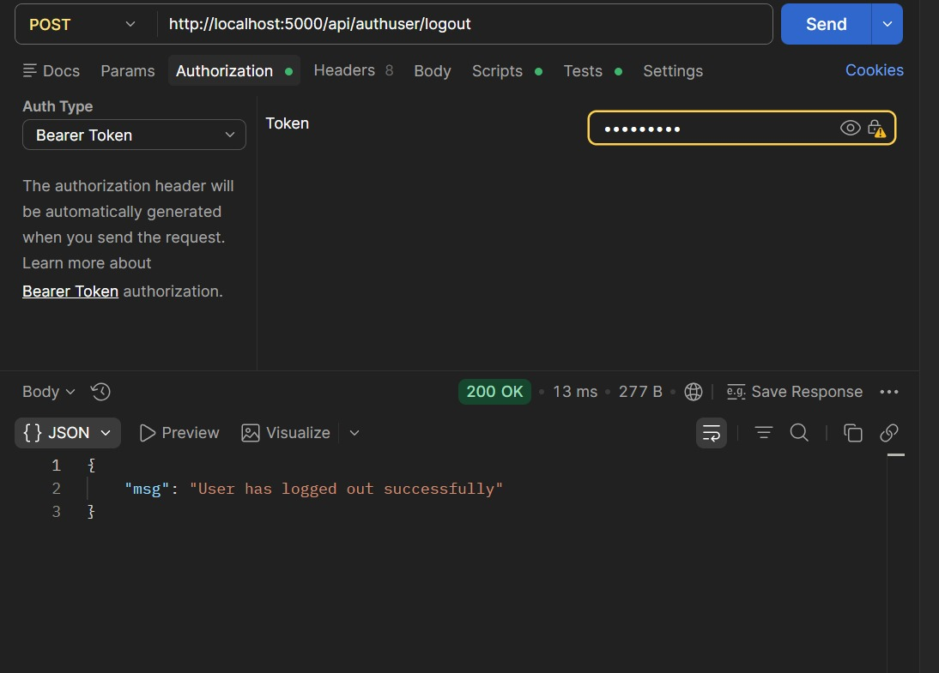
11. Screenshots or Demo:

12. Known Issues: Slow loading when many products exist. No barcode scanning feature.
13. Future Enhancements: Barcode scanning for products, AI-based stock prediction, Mobile application support, Cloud database integration
Sample Backend Code (Node.js + Express):
import express from "express";
import dotenv from "dotenv";
import connectDb from "./Config/db.js";
import userRouter from "./routes/user.route.js";
import bookRouter from "./routes/book.route.js";
dotenv.config();

const app = express();

app.use(express.json());

const PORT = process.env.PORT || 5000;

app.listen(PORT, () => {
connectDb();
console.log(`Our server is working at PORT :${PORT}`);
});

app.use("/api/authuser", userRouter);
app.use("/api/book", bookRouter);

