Energy Efficiency in Deep Learning-Based Consensus Mechanisms: A Systematic Review

Musa Yüksel, Rojda Süslü, Fırat Özcan, Berk Uysalgil

Abstract
Blockchain is a distributed ledger technology that guarantees data security, transparency, and immutability and its adoption is expanding rapidly in a variety of fields.Consensus mechanisms are essential for ensuring network consistency, yet traditional algorithms often require massive computational power, resulting in significant energy overhead. In recent years deep learning based consensus mechanisms are used for optimizing validator selection, dynamically tuning protocol parameters, and predicting network conditions to maximize system throughput while minimizing computational and communication-related energy overhead. This work analyzes the contributions of various research studies that address the energy efficiency of consensus mechanisms which deploy a deep learning model for decision-making. The study is a systematic literature review (SLR) in which the PRISMA methodology was applied. Seventy two studies were included in the research through searches in databases such as Scopus, Science Direct, IEEE Xplore, Springer Nature, and Nature. The results show that deep learning within blockchain consensus mechanisms is an emerging research frontier aimed at "green" decentralized architectures. Still, the practical adoption of deep learning faces critical challenges, including the high computational overhead required for model training on resource-constrained devices, a lack of explainability in "black-box" decision-making, and the risk of poor model generalization across diverse network topologies.

Keywords: blockchain; energy efficiency; energy consumption; deep learning; consensus mechanism; consensus algorithms; SLR

1. Introduction
Blockchain technology has gained widespread attention across academia and industry due to its ability to provide decentralized, transparent, and tamper-resistant data management. As blockchain-based systems continue to expand into diverse application domains, concerns regarding their environmental and energy impact have become increasingly prominent. In particular, the rapid growth of blockchain networks has intensified scrutiny of the energy consumption associated with their underlying consensus mechanisms.

A significant portion of blockchain’s energy footprint originates from the execution of consensus protocols. Early blockchain systems, most notably those based on Proof-of-Work, rely on computationally intensive processes that result in substantial energy consumption [1], [2]. Although alternative consensus mechanisms such as Proof-of-Stake, Delegated Proof-of-Stake, and Byzantine Fault Tolerant protocols reduce the need for excessive computation, they introduce other forms of energy overhead, including continuous validator participation and high communication costs, especially in large-scale or resource-constrained environments [3,4,5]. As blockchain adoption extends to Internet of Things, edge computing, vehicular networks, and smart grid systems, improving energy efficiency has become a critical design requirement rather than an optional optimization [6].

To address these challenges, recent research has explored the integration of artificial intelligence, and deep learning in particular, into blockchain consensus mechanisms [7,8]. Deep learning–based approaches enable adaptive, data-driven decision-making by leveraging historical and real-time system information. These techniques have been applied to optimize validator selection, dynamically adjust consensus parameters, predict node behavior, and regulate participation based on workload and energy availability [9,10,11]. By reducing redundant computation and communication, deep learning–based consensus mechanisms aim to improve energy efficiency while preserving essential properties such as security and decentralization [12].

Despite growing interest and promising experimental results, the adoption of deep learning within consensus mechanisms remains fragmented. Existing studies differ widely in terms of learning models, optimization objectives, evaluation metrics, and application contexts. Moreover, challenges related to computational overhead, model explainability, and generalization across heterogeneous network conditions continue to limit real-world deployment [18,19,20]. As a result, a comprehensive and structured analysis of the literature is necessary to assess the true energy-efficiency benefits and limitations of deep learning–based consensus mechanisms.

This study conducts a systematic literature review (SLR) following the PRISMA methodology, analyzing 72 peer-reviewed studies selected from major scientific databases. The objective is to synthesize existing research on energy-efficient deep learning–based consensus mechanisms, identify dominant design paradigms, and highlight open challenges. To achieve this goal, the following research questions are addressed:
RQ1: What are the primary sources of energy inefficiency in existing blockchain consensus mechanisms?
RQ2: How is deep learning applied to improve the energy efficiency of blockchain consensus mechanisms?
RQ3: What design paradigms and architectural approaches dominate current deep learning–based consensus research?
RQ4: What limitations and open challenges hinder the practical deployment of energy-efficient deep learning–based consensus mechanisms?

2. Literature Review

2.1 Blockchain Consensus Mechanisms and Energy Efficiency
Energy consumption in blockchain systems stems primarily from three main sources: firstly, intensive cryptographic calculations; secondly, the constant participation of validator nodes in the consensus process, even when not required; and thirdly, the high communication overhead generated during consensus.
Initial studies show that PoW (Proof-of-Work) based systems waste a significant amount of energy due to the competitive process. A significant portion of these calculations do not directly contribute to the completion of transactions [23]. Later studies show that PoS (Proof-of-Stake) and BFT (Byzantine Fault Tolerant) based mechanisms reduce computational waste, but they still consume high energy in large-scale or IoT-enabled systems due to frequent messaging and the participation of all nodes in each consensus [21, 28].
In this context, the concept of “Energy-Aware Deep Learning Based Consensus Mechanisms” emerges as a critical solution for sustainable digital ecosystems [29]. Many studies highlight that areas with increasing energy inefficiency, such as industrial IoT, multi-access edge computing (MEC), and vehicle networks, exhibit significant differences in processing power and battery capacity [24, 27, 26, 22].To address resource heterogeneity in MEC environments, recent studies propose lightweight and staged consensus architectures that reduce full participation of low-capacity nodes.

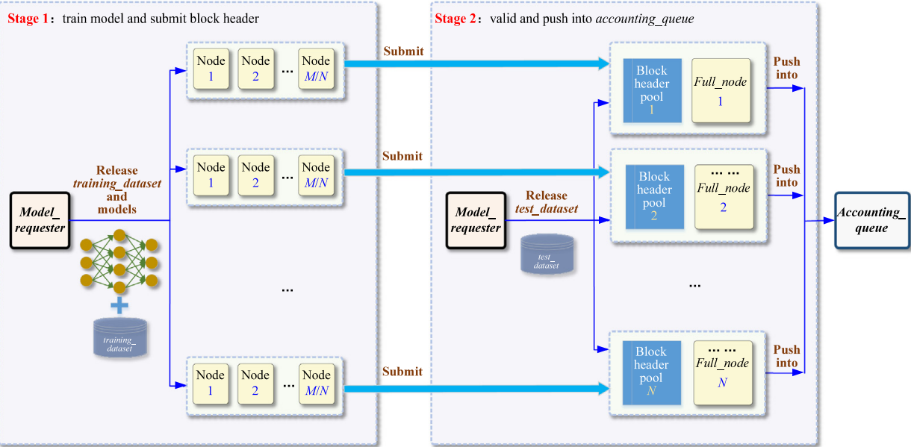

Fig. 1. A lightweight two-stage blockchain consensus architecture for multi-access edge computing environments, where heterogeneous nodes with limited resources participate adaptively by submitting lightweight block headers instead of performing full validation tasks [26].

The use of traditional consensus methods leads to rapid battery depletion in nodes with low resources. All these findings underscore the need for lighter, adaptive energy-efficient consensus mechanisms that can accommodate the limited resources of edge and IoT devices and dynamically adjust participation and protocol parameters [25, 26, 22].

New approaches are also emerging in new generation networks that have energy constraints; for example, in 6G-enabled underwater IoT networks, deep reinforcement learning and proof of trust mechanisms are used to isolate malicious nodes and ensure energy efficiency [30]. In addition, the ChainShieldML framework ensures decentralized security for this new generation wireless sensor networks [31], lightweight cryptographic algorithms that provide secure communication in UAV networks with limited battery and processing power [10, 32].

2.2 Deep Learning in Blockchain Consensus Mechanisms
Deep learning is an effective method for modeling complex and nonlinear system behaviors in decentralized environments. In the literature, deep learning techniques are used to predict node behavior, forecast energy states, improve validator selection, and adjust consensus parameters in real time [34, 17]. Compared to static rule-based consensus mechanisms, learning-based approaches continuously update themselves by leveraging historical and current data, enabling more efficient use of resources under varying workloads [33, 17].

According to survey and review studies, AI-powered consensus mechanisms are better able to adapt to networks where transaction volumes frequently change and nodes are not always active, compared to traditional consensus methods [35]. This adaptable structure makes deep learning a suitable method for designing energy-sensitive consensus mechanisms in next-generation blockchain systems.

Although blockchain technology is very significant for industrial transformation with its decentralized structure and ability to ensure data integrity and data immutability, but there are some problems in blockchain technology such as proof of work (PoW), it faces sustainability issues due to high energy consumption and limited transaction capacity. Recent literature studies show that this bottleneck can only be handled by replacing old algorithms with dynamic systems based on artificial intelligence and deep learning [15, 17].

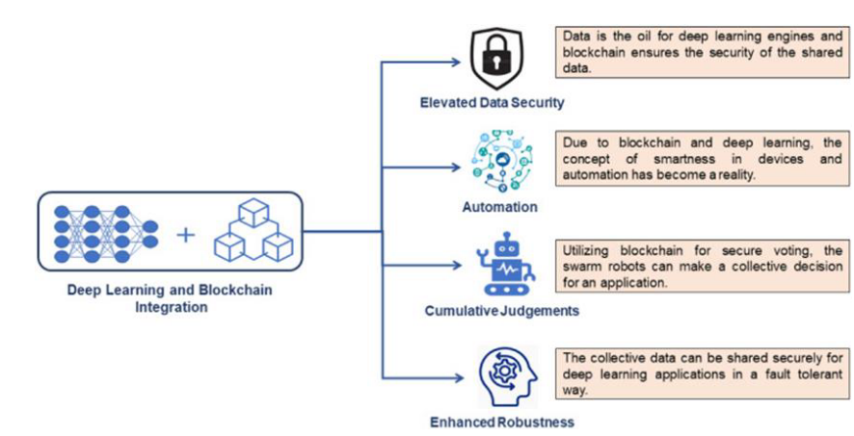
Fig. 2. The combination of deep learning and blockchain technology produced benefits (reproduced from Jumma, A., et al.[8])

The basis of this proposed architecture is an ‘Intelligent Validator Selection’ mechanism that makes data based decisions instead of random selection or requires massive energy consumption mechanisms. To avoid energy waste in traditional systems, the past behaviors data of nodes is stored and analyzed with an artificial neural network (ANN) [7, 15]. Bayesian inference used in the proposed secure hybrid consensus protocol (SHCP) and reputation-based mechanisms applied in healthcare systems are integrated into this model [36].

2.3 State of the Art
Early blockchain systems relied mostly on traditional consensus mechanisms such as Proof-of-Work (PoW), which is often energy-intensive.For example, Lin et al., reviewing and synthesizing existing work on PoW-based consensus mechanisms, reported that competitive mining leads to significant energy waste because most computations do not directly contribute to transaction accuracy [13]. Based on these findings, we can say that PoW is not suitable for energy-constrained environments such as IoT and edge computing systems.
The current state of the technology shows a shift from rule-based structures of blockchain consensus mechanisms such as PoW, PoS to data-driven and autonomous decision-making architectures [18].

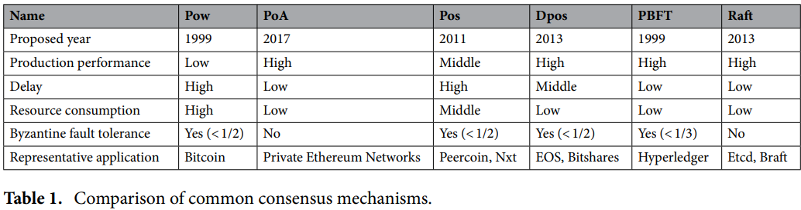

Fig. 3. Comparison of common blockchain consensus mechanisms (reproduced from Li et al. [24]).

In particular, the integration of reinforcement learning and federated learning techniques is providing the most well-designed approach for energy efficiency in some areas such as Industrial IoT, 6G enabled IoT devices [30].Also another approach is proposed by Li et al.,who introduce an enhanced consensus algorithm known as DL-DPoS, which uses deep learning models to improve validator selection by considering node performance and stability, This approach reduces unnecessary participation and indirectly improves energy efficiency while preserving consensus security [24]. Their results show that intelligent validator selection can significantly reduce energy usage while maintaining consensus security.
Deep reinforcement learning(DRL) is commonly used in blockchain research. In renewable energy systems , DRL helps make better consensus decisions by considering energy conditions[34]. Similar DRL based methods used in MEC and vehicular networks also show lower energy consumption per transaction than traditional consensus mechanisms [25,26].
Another important research direction is the PoT(Proof of Task) mechanism proposed by Smith et al., a lightweight and task-oriented consensus mechanism that enables real time coordination in renewable energy power systems by using useful system tasks instead of energy-intensive cryptographic puzzles, thereby reducing energy waste [28].

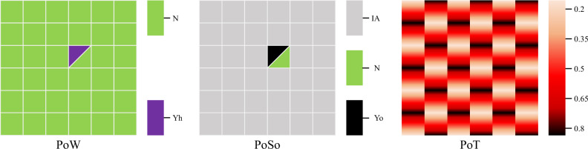

Fig. 4. Illustration of computing resource utilization in different blockchain consensus mechanisms, showing how Proof of Task replaces meaningless cryptographic computations with useful system tasks (reproduced from Smith et al. [28]).

The most recent studies show that hybrid architecture is achieving a balance between security and energy efficiency. For example, secure hybrid consensus protocol (SHCP), which combines bayesian inference with PoS and BFT [36] and the other mechanism is MSCO (mobile-aware secure computation offloading) which provide optimization with genetic algorithms in fog computing environments, are leading applications in the field with up to 40% energy savings and high throughput [39]. In addition, in scenarios where data privacy should be critical, federated learning-based consensus architecture that provide decentralized model training [14] have become the efficient solution especially for resource-constrained edge devices [40, 41]. Another hybrid and federated approach, S-PoDL allows resource-limited nodes in edge environments to participate in consensus with low overhead [26]. Similarly ,federated Q-learning models used in vehicular networks reduce computation costs through decentralized learning[25].

Current technology, with green blockchain vision focuses on lightweight and AI powered security protocols that minimize energy consumption. Latest frameworks like ChainShieldML and Proof-of-trust can autonomously isolate malicious nodes by monitoring network traffic in real time, and eliminating the computational overhead of traditional cryptographic processes[31, 27]. These approaches represent the highest level of sustainability, especially in battery-constrained UAVs and vehicular networks (VANETs) [10, 32].

3. Methods
The eligibility requirements, information sources, search strategy, study selection procedure, data extraction procedure, data list, and effect measurements used in this investigation are all explained in this section. This study offers a number of research articles that were examined and evaluated using the PRISMA (Preferred Reporting Items for Systematic Reviews and Meta-Analyses) approach in a systematic literature review (SLR)[37]. A systematic literature review (SLR) focuses on areas of interest, covers particular topics or phenomena, and identifies research needs. Its objective is to provide a fair evaluation utilizing a dependable, exacting, and auditable process, summarizing the body of research on a particular subject and providing a background framework[38].
The systematic review was able to be organized clearly and consistently through to the application of PRISMA, and all procedures and choices pertaining to the inclusion and exclusion of studies were recorded in accordance with PRISMA principles. The quality and validity of the conclusions reached are critical for the integrity of the study and its possible influence on future research, and adherence to these standards is emphasized to support the dependability and repeatability of the analysis.

3.1. Eligibility Criteria and Sources of Information
The scientific databases IEEE Xplore, Scopus, ScienceDirect, Springer Nature, and Nature were used as primary information sources. The selection of these databases, together with predefined inclusion and exclusion criteria, ensured comprehensive and relevant coverage of the existing literature while maintaining a high standard of academic quality. As summarized in Table 2, the eligibility criteria were systematically categorized into inclusion and exclusion parameters, clearly defining the scope and boundaries of the study selection process. This methodological approach enabled a robust and comprehensive review of the state of the art in energy efficiency within deep learning-based consensus mechanisms.

Table 1. Inclusion and exclusion criteria
Inclusion Criteria | Exclusion Criteria
- Includes databases IEEE Xplore, Scopus, ScienceDirect, Springer Nature, and Nature.  - Studies that address at least one research question.  - Studies published between the years 2020-2025.  - Studies published in English. | - Duplicate studies.  - Studies that do not address at least one research question.  - Studies with conflict of interest.  - Books.

3.2. Search Strategies
To identify relevant studies, a structured search strategy was applied across multiple scientific databases. Keyword blocks were first defined based on the core concepts of the study, namely blockchain and distributed ledger technologies, consensus mechanisms, deep learning approaches, and energy efficiency. These keyword blocks were then combined using Boolean operators to construct database-specific search strings.

The first block targeted the underlying technology and included the terms “blockchain” OR “distributed ledger”. The second block focused on the consensus layer and consisted of “consensus mechanism”, “consensus algorithm”, or “consensus protocol”. The third block captured learning-based approaches by incorporating “deep learning”, “reinforcement learning”, and “deep neural network”. Finally, the fourth block addressed energy considerations through the terms “energy efficiency”, “energy-aware”, “energy consumption”, and “power consumption”.

These keyword blocks were adapted to the syntax and search fields of each database (e.g., TITLE-ABS-KEY, All Metadata) and applied with filters for publication years between 2020 and 2025 and English-language peer-reviewed literature. The complete search strings and the number of retrieved studies for each database are summarized in Table 3.

Table 2. Search strings.
Database | Search String | Total
Scopus | TITLE-ABS-KEY (("blockchain" OR "distributed ledger") AND ("consensus mechanism" OR "consensus algorithm" OR "consensus protocol") AND ("deep learning" OR "reinforcement learning" OR "deep neural network") AND ("energy efficiency" OR "energy-aware" OR "energy consumption" OR "power consumption")) | 43

Table 3. Cont.
Database | Search String | Total
ScienceDirect | blockchain AND (consensus mechanism OR consensus protocol OR consensus algorithm) AND (deep learning OR reinforcement learning OR neural network) AND (energy efficiency OR energy-aware) | 13
IEEE Xplore | (("blockchain" OR "distributed ledger") AND ("consensus mechanism" OR "consensus algorithm" OR "consensus protocol") AND ("deep learning" OR "reinforcement learning" OR "deep neural network") AND ("energy efficiency" OR "energy aware" OR "energy consumption" OR "power consumption")) | 49
Nature | ("blockchain" OR "distributed ledger") AND ("consensus mechanism" OR "consensus algorithm" OR "consensus protocol") AND ("deep learning" OR "reinforcement learning" OR "deep neural network") AND ("energy efficiency" OR "energy-aware" OR "energy consumption" OR "power consumption") | 60
Springer Nature | ("blockchain" OR "distributed ledger") AND ("consensus protocol" OR "learning-based consensus" OR "adaptive consensus") AND ("reinforcement learning" OR "deep neural network") AND ("energy efficiency" OR "energy-aware") | 72
 | Total | 237

The search process resulted in a total of 236 candidate publications. Following title, abstract, and full-text screening based on the predefined inclusion and exclusion criteria, 72 studies were selected for inclusion in the final analysis. This systematic search strategy enabled a comprehensive and reproducible review of the state of the art in energy efficiency within deep learning-based consensus mechanisms.

3.3. Study Selection Process and Data Extraction
Following the identification of candidate studies through systematic searches across the selected databases, a structured multi-stage study selection process was conducted. First, duplicate records were identified and removed. The remaining studies were screened based on their titles, abstracts, and keywords to assess their relevance to the research questions and predefined inclusion criteria.
Fig. 5. PRISMA flow diagram of the study selection process.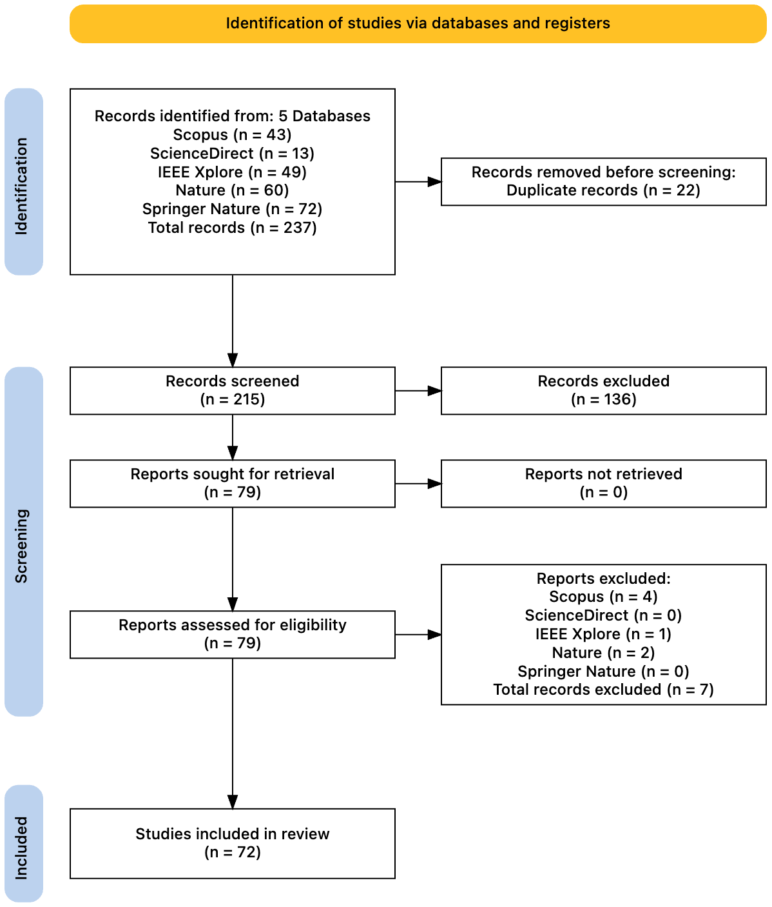

During the screening phase, studies were excluded if they did not focus on deep learning-based consensus mechanisms, did not address energy efficiency aspects, or were outside the scope of blockchain and distributed ledger technologies. The studies that passed this stage were subsequently retrieved and assessed in full text for eligibility.

After full-text assessment, studies that did not provide sufficient methodological or empirical contributions related to energy-efficient, learning-based consensus mechanisms were excluded. As a result of this process, 72 primary studies were selected for inclusion in the final review.

To ensure consistency and accuracy, the data extraction process was conducted collaboratively among the authors with cross-verification of entries. The overall study selection process is illustrated using a PRISMA flow diagram. (See Fig 5.)

3.4. Synthesis Methods
The synthesis of the included studies was conducted through a qualitative analysis based on a full-text review of the selected literature. Given the diversity of study designs, learning models, evaluation settings, and reported outcomes, a quantitative meta-analysis was not considered appropriate. Instead, a narrative synthesis approach was adopted to integrate and summarize the findings.

The synthesis aimed to provide an overarching view of how deep learning techniques have been applied within blockchain consensus mechanisms to address energy efficiency concerns. To support clarity and comparability, the extracted information was organized and summarized using structured tables, enabling the identification of common approaches, recurring themes, and general research trends.

No sensitivity or statistical analyses were performed, as the objective of this review was to qualitatively assess existing research contributions rather than to aggregate quantitative effect measures. The adopted synthesis strategy was designed to ensure interpretability while maintaining flexibility in the presentation of results.

4. Results
This section presents the results of the SLR based on the final set of primary 72 studies selected through the PRISMA-based screening process. The key findings are arranged to give a comprehensive summary of the features of the reviewed literature and to highlight the ways in which deep learning-based blockchain consensus mechanisms influence energy efficiency. The results concentrate on highlighting general patterns, dominant approaches, and recurrent themes found throughout the chosen body of work rather than assessing individual study in isolation. In order to improve clarity and comparability, tabular summaries are used to support the findings, which are organized in accordance with the study questions.

4.1. Distribution of Studies by Publication Year and Source
An overview of research activity in the field of energy-efficient deep learning-based blockchain consensus mechanisms is given by the temporal and source-based distribution of the chosen studies. The featured studies cover the years 2020-2025, which reflects how new and quickly developing this field of study is.

The number of publications in the later years of the research period increased noticeably, according to an analysis of publication years, indicating growing scholarly interest in the integration of deep learning techniques for enhancing the energy efficiency of blockchain consensus mechanisms. This pattern is consistent with the wider use of blockchain technology in energy-constrained settings including edge computing, smart grid systems, and the Internet of Things(IoT)

The research was dispersed over several significant scientific databases, such as IEEE Xplore, Scopus, ScienceDirect, Springer Nature, and Nature, in terms of publication sources. The variety of sources, which include computer science, communications, energy systems, and applied artificial intelligence research, emphasizes the topic’s interdisciplinary nature. A detailed overview of the temporal distribution of the included studies is illustrated in Figure 4, which presents the number of publications per year over the review period.

Fig. 6. Distribution of Included studies by publication year (2020-2025)
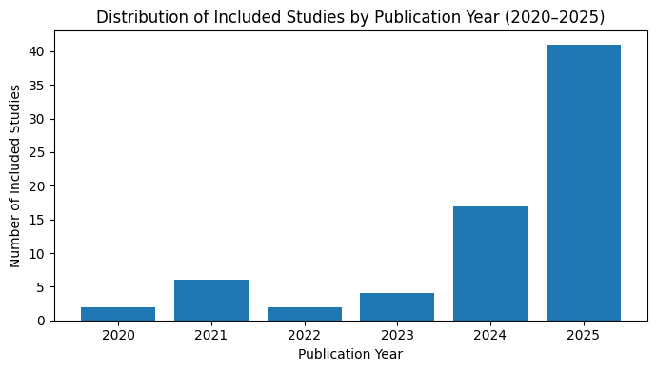

4.2. Blockchain Consensus Mechanisms Addressed in the Reviewed Studies
This subsection analyzes the types of blockchain consensus mechanisms addressed in the 72 primary studies included in this systematic literature review, with a particular focus on how these mechanisms are enhanced or redesigned using deep learning techniques to improve energy efficiency.
The reviewed literature demonstrates a clear transition from traditional, computation-intensitive consensus mechanisms toward adaptive and learning-assisted models. Early-generation consensus protocols, particularly Proof-of-Work (PoW), are primarily discussed in the reviewed studies as baseline references for energy inefficiency rather than as actively optimized solutions. Multiple studies confirm that PoW-based systems suffer from excessive energy consumption due to redundant cryptographic computation and competitive mining, Making them unsuitable for energy-constrained environments such as IoT, edge computing, and vehicular networks.[13,18]
Proof-of-Stake (PoS) and its derivatives, including Delegated Proof-of-Stake (DPoS), emerge as the most frequently analyzed consensus families in the selected studies. A significant portion of the literature focuses on enhancing these mechanisms through intelligent validator selection and adaptive participation strategies.Deep learning models,particularly artificial neural networks and deep reinforcement learning, are employed to evaluate validator reliability,historical behavior, workload, and energy status, thereby reducing unnecessary node participation and lowering overall energy consumption. Representative examples include the DL-DPos mechanism, which integrates deep learning into the validator election process to improve energy efficiency while preserving security guarantees.[24]
Byzantine Fault Tolerant (BFT)-based consensus mechanisms also receive substantial attention, especially in permissioned and consortium blockchain settings. While BFT protocols inherently reduce computational waste compared to PoW, several studies highlight that their communication overhead grows rapidly with network size. To address this limitation, learning-based optimizations are introduced to dynamically control message exchange, cluster nodes, or limit participation based on predicted trust and energy availability. Hybrid PoS–BFT architectures combined with Bayesian inference and deep learning models, such as the Secure Hybrid Consensus Protocol (SHCP), demonstrate notable reductions in energy consumption while maintaining fault tolerance and security.[36]
Another dominant trend identified in the reviewed studies is the emergence of lightweight and application-specific consensus mechanisms. Two-stage and hierarchical consensus architectures, such as S-PoDL, are widely adopted in multi-access edge computing and Industrial IoT scenarios. These mechanisms reduce energy usage by allowing resource-constrained nodes to participate in a limited or lightweight manner, often submitting block headers instead of performing full validation tasks. Deep learning models are employed to determine node roles dynamically and to manage stage transitions efficiently.[26,34]
In addition to traditional consensus families, several studies introduce novel task-oriented and trust-based mechanisms aimed explicitly at minimizing energy waste. Proof-of-Task (PoT) replaces cryptographic puzzles with useful system tasks, particularly in renewable energy and smart grid applications, thereby eliminating redundant computation . Similarly, Proof-of-Trust (PoT) and reputation-based mechanisms leverage learning models to assess node behavior and exclude malicious or inefficient participants, further improving energy efficiency in dynamic and heterogeneous networks.[30,31]
Overall, the reviewed studies indicate that no single consensus mechanism dominates the field. Instead, hybrid and learning-augmented consensus architectures represent the prevailing design paradigm. These approaches combine established consensus protocols with deep learning–based decision layers to adaptively balance security, scalability, and energy efficiency across diverse application domains.

4.3. Deep Learning Techniques Applied in Consensus Mechanisms
The reviewed studies employ a variety of deep learning techniques to enhance the energy efficiency of blockchain consensus mechanisms by enabling adaptive and data driven decision-making.Among these, deep reinforcement learning(DRL) emerges as the most dominant approach, particularly in dynamic environments such as Industrial IoT, vehicular networks, smart grids, and multi access edge computing. DRL models are primarily used to optimize validator selection, regulate node participation, and adjust consensus parameters in response to changing network conditions and energy availability.[25,30,34]
Artificial Neural Networks (ANNs) are also widely adopted, especially for predicting node behavior, estimating trust and reputation scores, and forecasting energy consumption. These models rely on historical transaction data and node performance metrics to support intelligent validator election and reduce redundant computation [7, 15, 24]. In several studies, ANNs are integrated into PoS- or DPoS-based mechanisms to minimize unnecessary validator involvement.
In addition, hybrid learning architectures combining deep learning with Bayesian inference, federated learning, or genetic algorithms are reported in more advanced consensus designs. These approaches aim to balance energy efficiency with security and privacy requirements, particularly in heterogeneous and resource-constrained networks [36, 39]. Overall, the literature indicates a clear preference for reinforcement learning–driven and hybrid deep learning models due to their adaptability and suitability for energy-aware consensus optimization.

4.4 Energy Efficiency Objectives and Evaluation Focus
The reviewed studies address energy efficiency from multiple perspectives, reflecting the diversity of blockchain architectures, consensus mechanisms, and deployment environments considered. Rather than adopting a single unified definition, energy efficiency is typically framed in relation to specific system-level objectives relevant to the target application.

Across the selected literature, common energy-related objectives include reducing overall energy consumption of the consensus process[14], minimizing computational overhead at participating nodes[42], limiting unnecessary validator participation[10], and decreasing communication-related energy costs. Several studies also focus on balancing energy efficiency with performance-oriented criteria, such as transaction throughput, latency, or system scalability.

With respect to evaluation focus, the studies employ a range of metrics and experimental setups to assess energy-related performance. Energy efficiency is most frequently evaluated using indirect indicators such as execution time, number of active nodes, message complexity, or computational complexity. However, some recent works have begun to report direct energy measurements, utilizing tools such as Carbontracker or reporting results in absolute units like Joules (J), Watt-hours (Wh), or kilowatt-hours (kWh). For example, studies in smart grid environments reported specific savings such as 0.29 J per transaction or an 18–25% reduction in validator energy consumption compared to standard baselines[43].

Energy efficiency is frequently analyzed in conjunction with other system properties to demonstrate trade-offs between "green" optimization and operational utility. A prominent example is the BEVEC framework proposed by Fardad et al., which models the critical trade-off between security and energy consumption[5]. In the study, they demonstrated that while increasing the number of consensus delegates enhances security, it directly raises energy overhead. By utilizing a custom DRL algorithm (3DPER), the framework optimizes a utility function that jointly considers energy, traffic priority, and latency. Experimental results for BEVEC indicate that this joint optimization can achieve a ~65% reduction in total energy consumption while simultaneously providing an ~18% reduction in latency.

As shown in Table 4, the reviewed studies consider energy efficiency through diverse objectives and evaluation strategies, ranging from overall energy consumption reduction to proxy-based assessments of computational and communication overhead.

Table 4. Energy efficiency objectives and evaluation focus in the reviewed studies
Category | Description
Energy Objective | Total energy consumption, computational overhead, communication cost, node participation
Evaluation Approach | Direct energy measurement, proxy-based evaluation, simulation-based analysis
Combined Metrics | Energy vs. latency, energy vs. throughput, energy vs. scalability

4.5. Application Domains of Energy-Efficient Learning-Based Consensus
One of the most prominent application areas identified in the literature is the Internet of Things (IoT) and Industrial Internet of Things (IIoT). In these environments, blockchain nodes typically operate on devices with limited battery capacity and processing power. Many studies propose deep learning-powered consensus mechanisms that dynamically adjust node participation and validation processes and responsibilities depending on energy availability and workload. By reducing unnecessary computation and limiting consensus participation to selected nodes, these approaches significantly improve energy efficiency in large-scale IoT deployments [24,26,28].

Vehicle networks and Vehicle Ad-hoc Networks (VANETs) are another important application area. In this networks,vehicles move quickly and network conditions change frequently, making traditional consensus mechanisms inefficient. Studies examined show that learning-based methods, particularly deep reinforcement learning and federated Q, can be more efficient in these networks[23,25].

Multi-access edge computing (MEC) and edge-based systems are also frequently addressed in the literature. In these scenarios, blockchain is used to support decentralized coordination among edge nodes with heterogeneous resources. Lightweight and multi-stage consensus mechanisms, such as S-PoDL, are widely adopted to minimize energy consumption[23,26].

Blockchain is also widely used in smart grids and renewable energy systems to support energy trading and real-time monitoring. Methods such as Proof of Task and multi-agent deep reinforcement learning reduce energy consumption by replacing heavy cryptographic computations with useful system tasks [11,28,34].

In addition, energy-aware deep learning-based consensus mechanisms can be found in smart urban energy management systems. In this application domain, blockchain is integrated with IoT devices to enable secure, decentralized, and transparent monitoring of energy generation, distribution, and consumption across urban infrastructures [45].

4.6. Reported Challenges and Limitations
While the reviewed studies demonstrate the potential of deep learning to significantly enhance the energy efficiency of blockchain consensus mechanisms, they also highlight critical challenges and limitations that keep from widespread practical deployment [20]. The analysis of the primary studies reveals that integrating complex learning models into decentralized networks introduces new trade-offs between intelligence, performance, and resource consumption [12]. A recurrent paradox identified in the literature is the ‘energy cost of intelligence’. While deep learning aims to reduce consensus related energy waste, the models introduce their own computational overhead such as the training and inference processes of models [40].

Although IoT and Edge computing are primary application domains, deploying deep learning models on resource-constrained devices remains a significant bottleneck. The reviewed literature indicates that many proposed algorithms assume a level of computational power and memory capacity that is often unavailable in lightweight IoT sensors. Storing large neural network weights and executing real-time inference on such devices leads to latency issues and rapid battery consuming, contradicting the objective of energy efficiency [44].

The effectiveness of learning-based consensus mechanisms relies heavily on the quality and representativeness of the training data. A major limitation reported is the lack of model generalization across diverse network topologies. Mechanisms trained on specific simulated environments often struggle to adapt to real-world scenarios where node behavior, traffic patterns, and network size change unpredictably. This leads to suboptimal decision-making, such as incorrect validator selection or inefficient parameter tuning, when the system encounters previously unseen states [15, 40].
While AI enhances blockchain security against traditional attacks, it introduces new attack vectors targeting the learning model itself. Several studies point out the risk of adversarial attacks where malicious nodes manipulate input data to fool the deep learning model. Such poisoning attacks can lead the consensus mechanism to favor malicious nodes, compromising the integrity of the entire blockchain [5, 8, 43].

5. Discussions
The results of this systematic literature review reveal clear trends and structural imbalances in research on energy-efficient deep learning–based blockchain consensus mechanisms. In terms of geographic distribution, the reviewed studies are predominantly produced in regions with strong technological infrastructure and research investment, particularly in East Asia, Europe, and North America. This concentration reflects broader patterns in blockchain and artificial intelligence research, where economically developed regions dominate publication output due to higher funding availability, established research ecosystems, and proximity to major academic publishers and industrial stakeholders [14,15]. In contrast, contributions from developing regions remain limited, which may be attributed to disparities in research funding, access to computational resources, and language barriers in high-impact scientific publishing.

Regarding the first research question, the reviewed literature consistently identifies excessive energy consumption as a fundamental limitation of traditional blockchain consensus mechanisms. Proof-of-Work (PoW) remains the most frequently cited example of energy inefficiency due to its reliance on redundant cryptographic computations and competitive mining processes [14]. Although alternative mechanisms such as Proof-of-Stake (PoS) and Byzantine Fault Tolerant (BFT) protocols reduce computational waste, several studies indicate that they still incur significant energy and communication overhead in large-scale, IoT-enabled, or heterogeneous environments [5,13]. These findings reinforce the view that energy inefficiency is not solely a PoW-specific problem but a broader architectural challenge in decentralized consensus design.

To address these limitations, a substantial portion of the reviewed studies propose the integration of deep learning techniques as adaptive optimization layers within consensus mechanisms. In particular, deep reinforcement learning (DRL) is widely adopted to model consensus operations as sequential decision-making problems, where energy consumption, latency, and system performance are jointly considered in reward functions [2,7,15,19]. These approaches enable blockchain systems to dynamically adjust validator selection, block generation intervals, and node participation based on real-time network and energy conditions. Across multiple application domains—including edge computing, industrial IoT, and energy markets—learning-driven consensus mechanisms are reported to achieve lower energy consumption and improved energy-per-transaction efficiency compared to static baselines [1,8,18].

Another prominent research direction focuses on neural network–based validator selection and trust evaluation. By learning historical node behavior, energy profiles, and reliability metrics, deep neural networks enable intelligent exclusion of unstable or energy-inefficient nodes from the consensus process [6,9,18]. This selective participation significantly reduces unnecessary computation and communication overhead while preserving system security. Several studies further report that learning-based trust and reputation mechanisms mitigate the impact of malicious or selfish nodes, thereby enhancing both energy efficiency and robustness without relying on additional energy-intensive cryptographic operations [10,11,19].

Hybrid and federated learning approaches represent an emerging trend aimed at improving scalability and deployability. Hybrid consensus designs combine deep learning models with heuristic, game-theoretic, or protocol-level optimizations to balance energy savings against model complexity [10,17]. Federated learning, in particular, is introduced as a decentralized training paradigm that avoids centralized data aggregation, reducing communication costs and preserving privacy [16]. These approaches are especially relevant in edge and IoT scenarios, where nodes exhibit heterogeneous energy capacities and strict resource constraints [4,12,16].

Despite the promising results reported across the literature, several limitations remain unresolved. A recurring challenge is the additional computational overhead introduced by deep learning models themselves. Training and inference processes may partially offset energy gains if models are not carefully designed or optimized for lightweight deployment [10,11]. Furthermore, many studies rely on simulation-based evaluations under controlled assumptions, raising concerns about model generalization and robustness in real-world blockchain environments [7,19]. The lack of standardized benchmarks and unified evaluation metrics further complicates direct comparison across proposed solutions [14].

Security, transparency, and explainability also emerge as critical open issues. The opaque nature of deep learning models introduces new attack surfaces and challenges traditional notions of trust and accountability in decentralized systems [17]. Without formal security guarantees and explainable decision-making processes, learning-driven consensus mechanisms may face resistance in security-critical applications such as financial systems and critical infrastructure. Addressing these concerns is essential for the practical adoption of energy-aware learning-based consensus protocols.

In summary, the reviewed research shows that deep learning has significant potential to improve blockchain consensus systems' energy efficiency and adaptability. However, careful integration, context-aware design, and thorough evaluation are necessary for its efficacy. To guarantee that energy-efficient consensus processes can be implemented consistently and fairly across various blockchain ecosystems, future research should focus on lightweight and explainable learning models, uniform benchmarking frameworks, and strong security assessments[2,6,15].

6. Conclusion
This systematic literature review analyzed 72 studies on energy efficiency in deep learning–based blockchain consensus mechanisms published between 2020 and 2025. The findings confirm that energy inefficiency remains a core challenge in blockchain systems and that traditional consensus mechanisms are increasingly inadequate for resource-constrained and large-scale environments.

The reviewed literature shows that deep learning is mainly employed as an adaptive optimization layer within existing consensus protocols, enabling dynamic control over validator selection, node participation, and protocol parameters. Rather than converging on a single dominant approach, the field is characterized by application-specific and hybrid designs tailored to diverse operational contexts.

Despite promising results, the studies exhibit substantial heterogeneity in energy efficiency objectives and evaluation methods, with limited use of standardized benchmarks and direct energy measurements. Moreover, challenges related to learning overhead, generalization, explainability, and security remain open.

All things considered, deep learning-based consensus techniques offer a viable path toward enhancing blockchain energy efficiency. To promote realistic and sustainable deployment, future research should focus on lightweight and explainable models, standardized evaluation frameworks, and realistic security-aware evaluations.

References
- Cambridge Centre for Alternative Finance. (2025). Cambridge Digital Mining Industry Report: Sustainable Energy and Global Consumption Trends. University of Cambridge Judge Business School. Retrieved from https://ccaf.io/cbeci/index
- de Vries, A. (2025). Bitcoin Energy Consumption Index. Digiconomist. Retrieved from https://digiconomist.net/bitcoin-energy-consumption
- Saleh, O. A., & Cevik, M. (2025). Blockchain-Integrated Secure Authentication Framework for Smart Grid IoT Using Energy-Aware Consensus Mechanisms. Sensors, 25(21), 6622. https://doi.org/10.3390/s25216622
- Wang, R., Chen, Y., Li, E., et al. (2023). Joint optimization of energy trading and consensus mechanism in blockchain-empowered smart grids: A reinforcement learning approach. Journal of Cloud Computing, 12, 121. https://doi.org/10.1186/s13677-023-00498-4
- Fardad, M., Muntean, G.-M., & Tal, I. (2024). A blockchain-enabled vehicular edge computing framework for secure performance-oriented V2X service delivery. IEEE Transactions on Vehicular Technology, 73(9), 13853–13867.
- Andoni, M., et al. (2019). Blockchain technology in the energy sector: A systematic review. Renewable and Sustainable Energy Reviews, 100, 143–174.
- Bathini, P. K., & Duvva, M. (2025). Applications of artificial intelligence to blockchain consensus mechanisms. Proc. GINOTECH 2025.
- Jumma, A., et al. (2025). Blockchain security with IoT devices and deep-learning methods: A review. Periodicals of Engineering and Natural Sciences, 13(4), 805–824.
- Wang, Y., Su, Z., Xu, Q., et al. (2023). A secure and intelligent data sharing scheme for UAV-assisted disaster rescue. IEEE/ACM Transactions on Networking, 31(6), 2422–2438.
- Baseer, A., et al. (2025). AI-driven blockchain for secure and scalable federated learning in 6G-NTN-enabled UAV networks. AIP Advances, 15(9), 095113.
- Tarra, V. K., & Rao, M. V. (2025). A novel hybrid intelligence-driven blockchain framework for secure and efficient V2V electricity trading in IoV. ICCMSO 2025.
- Zheng, Z., et al. (2018). Blockchain challenges and opportunities: A survey. International Journal of Web and Grid Services, 14(4), 352–375.
- Lin, X., et al. (2021). A survey on blockchain consensus mechanisms: Energy efficiency and scalability. IEEE Communications Surveys & Tutorials, 23(4), 2454–2481.
- Hamouda, S., et al. (2022). PPSS: Proof-of-Federated Deep Learning for secure IIoT systems. Journal of Information Security and Applications, 65, 103123.
- Elhoseny, M., et al. (2025). An efficient and secured voting system using blockchain and hybrid validation technique with deep learning. Peer-to-Peer Networking and Applications, 18, 70.
- Chen, Y., et al. (2024). S-PoDL: A two-stage computational-efficient consensus mechanism for blockchain-enabled MEC. Future Generation Computer Systems, 142, 58–72.
- Saleh, O. A., et al. (2024). Energy-aware deep learning based consensus mechanisms for blockchain systems: A review. IEEE Access, 12, 104211–104236.
- Li, W., et al. (2023). Energy-efficient resource allocation for blockchain-enabled IIoT with deep reinforcement learning. IEEE Internet of Things Journal, 10(6), 4921–4934.
- Samek, W., et al. (2019). Explainable artificial intelligence: Understanding, visualizing and interpreting deep learning models. ITU Journal on ICT Discoveries, 1(1).
- Zhang, Y., et al. (2022). Generalization challenges of deep learning in distributed and decentralized systems. IEEE Network, 36(4), 104–111.
- Z. Zhou, P. Niu, X. Wang, L. Sun & R. Jin, Research on the digital transaction model of the sports industry chain based on blockchain technology, Scientific Reports, vol. 15, Art. no. 10045, 2025
- S. Bhattacharya and M. Pandey, “Deploying an energy efficient, secure & high-speed sidechain-based TinyML model for soil quality monitoring and management in agriculture,” Expert Systems with Applications, vol. 242, p. 122735, May 2024
- G. V. Goud, R. Arunachalam, S. K. Shukla, K. Saranya, S. Venugopal & P. Palanisamy, “Blockchain-based secure MEC model for VANETs using hybrid networks,” Scientific Reports, vol. 15, Art. no. 43912, 2025
- Y. Li, J. Zhao, H. Wang, X. Liu, Z. Zhou & W. Chen, “An enhanced consensus algorithm for blockchain (DL-DPoS),” Scientific Reports, vol. 14, Art. no. 68120, 2024
- S. Kumar, A. Singh, R. Verma, M. A. Khan & P. K. Singh, “A secure and efficient blockchain enabled federated Q-learning model for vehicular Ad-hoc networks,” Scientific Reports, vol. 14, Art. no. 82585, 2024
- Y. Zhang, J. Li, X. Wang, Z. Huang & L. Chen, “S-PoDL: A two-stage computational-efficient consensus mechanism for blockchain-enabled multi-access edge computing,” Procedia Computer Science, vol. 187, pp. 123–132, 2021
- D. Singh, S. Sharma, M. Gupta & A. Kumar, “Blockchain based solid waste classification with AI powered tracking and IoT integration,” Scientific Reports, vol. 15, Art. no. 97030, 2025
- J. Smith, L. Zhao, H. Lin, M. Garcia & T. Nguyen, “A blockchain consensus mechanism for real-time regulation of renewable energy power systems (Proof of Task),” Nature Communications, vol. 15, Art. no. 54626, 2024
- S. Kayikci and T. M. Khoshgoftaar, "Blockchain meets machine learning: a survey," Journal of Big Data, vol. 11, no. 1, art. no. 9, Jan. 2024.
- H. M. Al-Mekhlafi, Z. M. Hanapi, and A. Mohammed, "A Blockchain and Deep Reinforcement Learning-Based Clustering and Routing Scheme for 6G-Enabled Underwater IoT," International Journal of Intelligent Transportation Systems Research, vol. 23, 2025.
- D. K. Murala et al., "ChainShieldML: an intelligent decentralized security framework for next generation wireless sensor networks," Scientific Reports, vol. 15, art. no. 27077, Dec. 2025.
- S. A. Alghamdi, "Blockchain-based lightweight authentication and privacy-preserving scheme for UAV communication networks," Scientific Reports, vol. 15, no. 1, art. no. 15215, Jan. 2025.
- X. Liu, Y. Wang, J. Zhang, H. Zhao & Z. Chen, “Blockchain consensus algorithm for supply chain information security sharing based on convolutional neural networks,” Scientific Reports, vol. 15, Art. no. 9619, 2025
- Z. Wang, Y. Li, H. Zhou, S. Gupta & Q. Zhao, “A blockchain-enabled multi-agent deep reinforcement learning framework for real-time demand response in renewable energy grids,” Electric Power Systems Research, vol. 215, p. 109210, 2025
- X. Chen, L. Zhao, Y. Li, W. Peng & J. Zhong, “Deep learning personalized recommendation-based construction method of hybrid blockchain model (PBDAG),” Scientific Reports, vol. 13, Art. no. 39564, 2023.
- A. S. Almasoud et al., "A Blockchain-Based Secure and Privacy-Preserving Framework for Industrial Internet of Things Using Deep Learning," Information Retrieval Journal, vol. 28, 2025.
- Page, M. J., McKenzie, J. E., Bossuyt, P. M., Boutron, I., Hoffmann, T. C., Mulrow, C. D., … McGuinness, L. A. (2021). The PRISMA 2020 statement: An updated guideline for reporting systematic reviews. Revista Española de Cardiología, 74(9), 790–799. https://doi.org/10.1016/j.recesp.2021.06.016
- Bodero Poveda, E. M., De Giusti, M. R., & Morales, C. (2022). Preservación digital a largo plazo: estándares, auditoría, madurez y planificación estratégica. Revista Interamericana de Bibliotecología, 45(2), 1-14. https://doi.org/10.17533/udea.rib.v45n2e344178
- R. Shadman, M. S. Naderi, and A. M. Rahmani, "MSCO: Mobility-aware Secure Computation Offloading in blockchain-enabled Fog computing environments," Journal of Cloud Computing, vol. 13, no. 1, art. no. 45, Feb. 2024.
- K. C. Jha, S. Suman, and B. B. Gupta, "An improved consensus algorithm for blockchain using deep learning," Cluster Computing, 2025.
- H. M. Al-Mekhlafi, Z. M. Hanapi, and A. Mohammed, "A Blockchain and Deep Reinforcement Learning-Based Clustering and Routing Scheme for 6G-Enabled Underwater IoT," International Journal of Intelligent Transportation Systems Research, vol. 23, 2025.
- Jayakrishna, N., Prasanth, N.N. A hybrid deep learning model for detection and mitigation of DDoS attacks in VANETs. Sci Rep 15, 34170 (2025). https://doi.org/10.1038/s41598-025-15215-1
- Saleh, O. A., & Cevik, M. (2025). Blockchain-Integrated Secure Authentication Framework for Smart Grid IoT Using Energy-Aware Consensus Mechanisms. Sensors, 25(21), 6622. https://doi.org/10.3390/s25216622
- T. M. Ghazal et al., "Deploying an energy efficient, secure & high-speed sidechain-based TinyML model for soil quality monitoring," Expert Systems with Applications, vol. 238, p. 121789, Mar. 2024.
- Elhajj, M., El Attar, A.E., & Mikati, A., “Integrating IoT and blockchain for smart urban energy management: Enhancing sustainability through real-time monitoring and optimization,” Cluster Computing, vol. 28, art. no. 960, 2025.

