TASK1
In the generate_maze_street procedure, the saved registers $s0, $s1, $s3, $s4, and $s5 are used. According to MIPS calling convention, $s registers must be preserved by the callee if they are modified inside a procedure. Therefore, the procedure first allocates 20 bytes on the stack using addi $sp, $sp, -20. Each modified $s register is then saved to the stack using sw instructions. At the end of the procedure, the same registers must be restored using lw instructions, and the stack pointer must be returned to its original value using addi $sp, $sp, 20. This ensures that the caller’s saved register values are not corrupted after the procedure call.

BEFORE
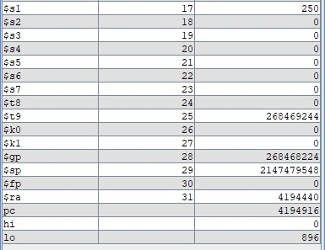

AFTER
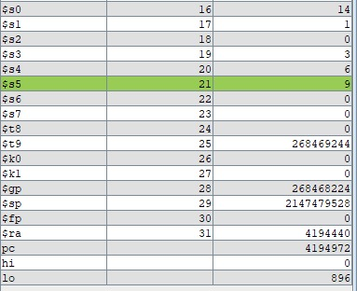

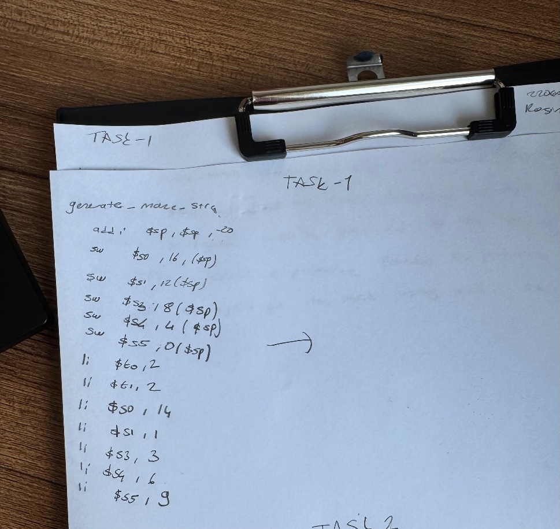

TASK2
The draw_maze procedure correctly preserves the $s0 register. Since $s0 is modified inside the procedure, it is saved on the stack at the beginning and restored before returning. The $ra register is also preserved because the procedure calls draw_pixel using jal. The stack pointer is restored to its original value before jr $ra, so the procedure follows the MIPS calling convention.

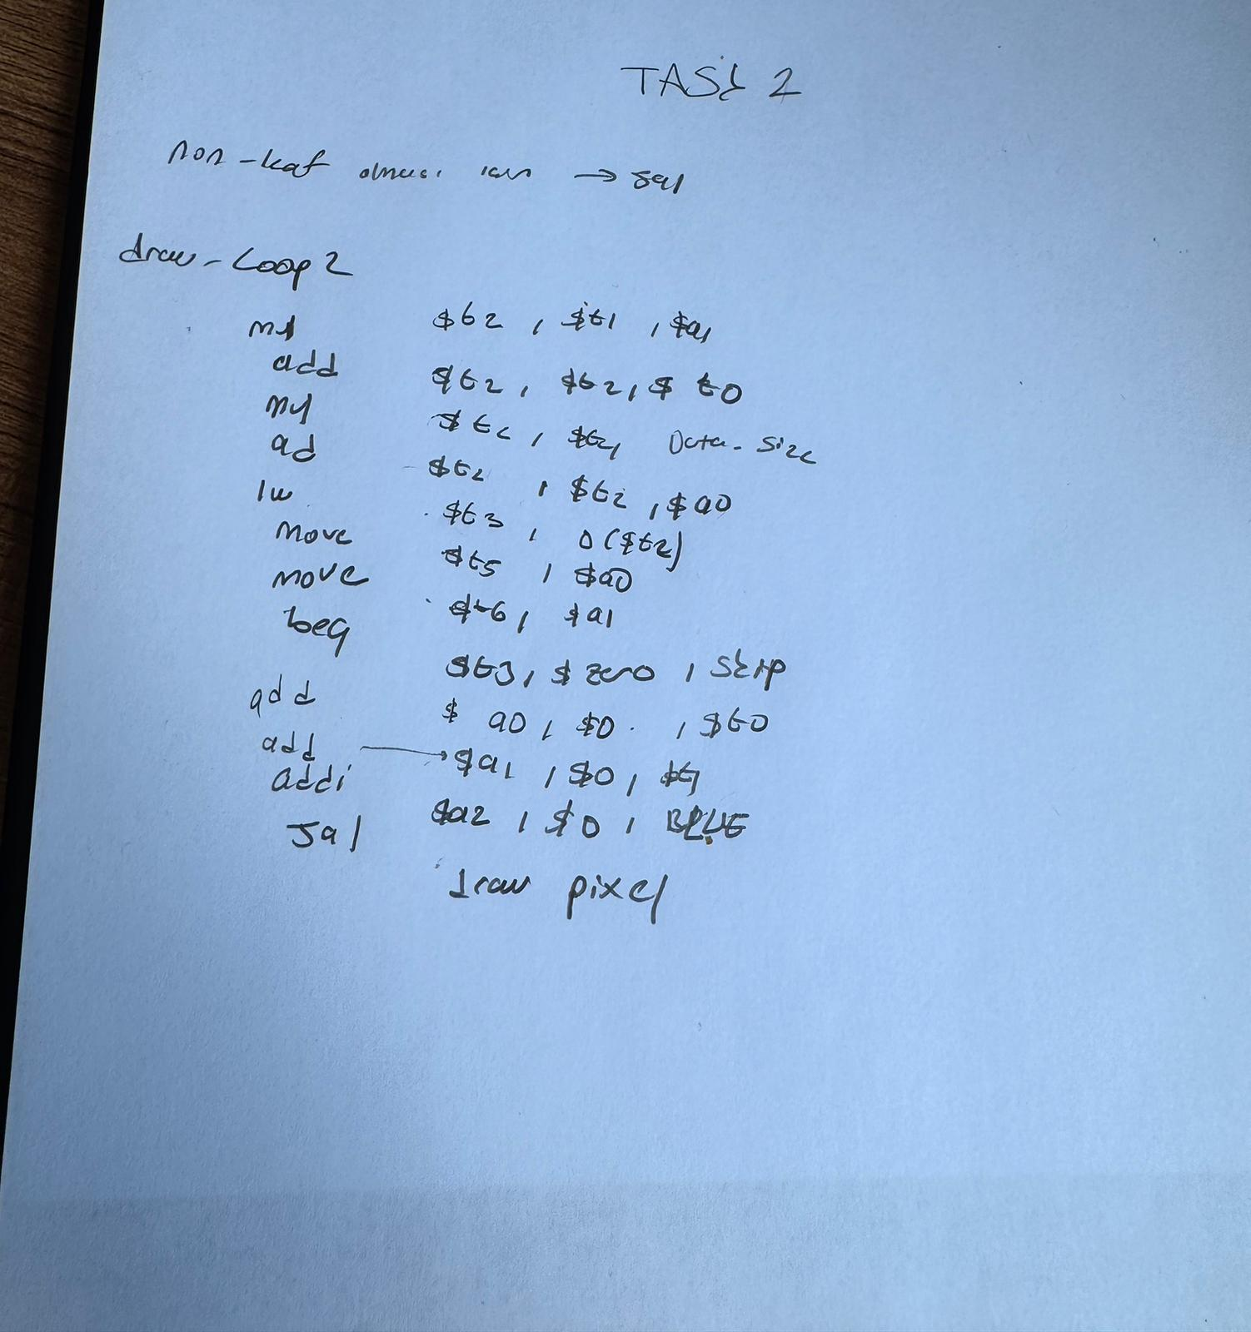
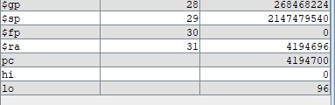

TASK3

In this task, a short instruction sequence from the draw_maze procedure was selected. The original sequence calculates the memory address of a 2D array element. The instructions have RAW data hazards because each instruction depends on the value of $t2 produced by the previous instruction. In a 5-stage MIPS pipeline without forwarding, these dependencies cause stall cycles because the result cannot be used until the WB stage.

In the improved version, the address calculation is reorganized by calculating the row byte offset and column byte offset separately. This allows an independent instruction to be placed between dependent instructions. As a result, the number of stall cycles is reduced. The original CPI is 4.0, while the improved CPI is 3.0. Therefore, the instruction scheduling improves pipeline performance.

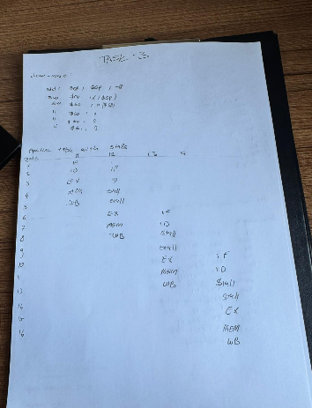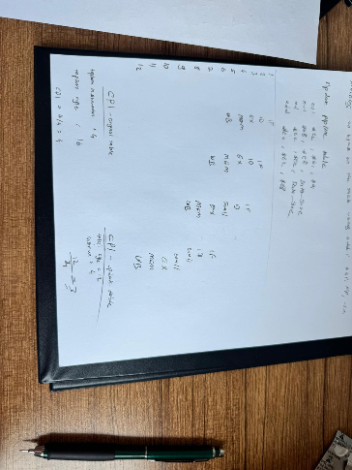

TASK4

Prompt : I have a MIPS Assembly maze game that uses a 15×15 integer array (mdArray) stored in row-major order. The generate_maze_outer_moat function iterates column-by-column to fill the left and right borders, causing stride-60-byte memory accesses that hurt cache performance. The draw_maze function recomputes array addresses from scratch (4 instructions) every inner loop iteration. Please optimize these two routines for better spatial locality by: (1) replacing the full address recomputation with a running pointer that increments by DATA_SIZE (4 bytes) in the inner loop and by arrSize×DATA_SIZE (60 bytes) for row transitions, and (2) splitting the left/right column loop into a single sequential scan using two pointer variables instead of interleaved stride accesses

cache-performance
Before
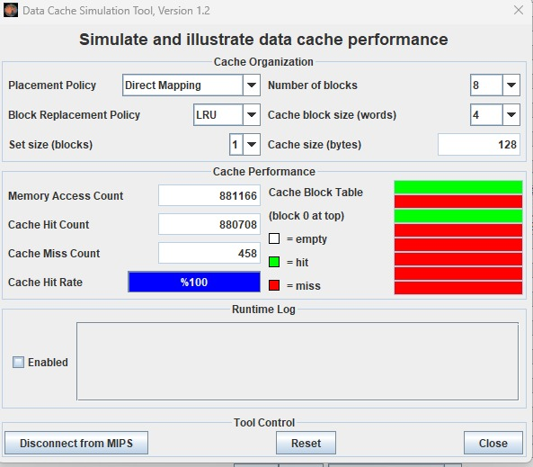
AFTER