Output
5 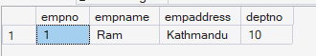
6 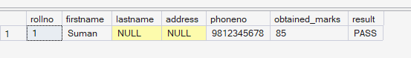
9 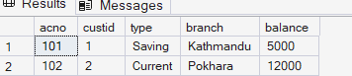
10 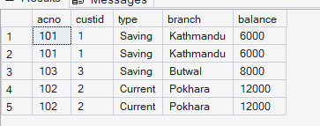 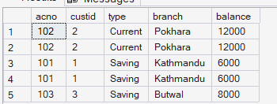
11 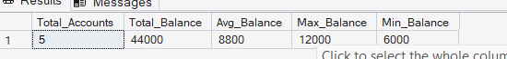
12 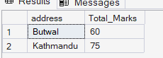 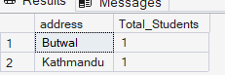 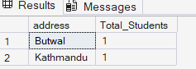
13 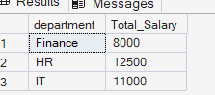
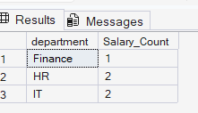
15 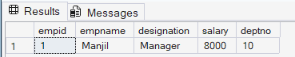
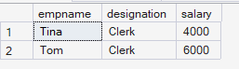
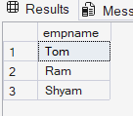
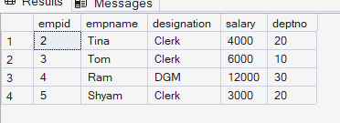
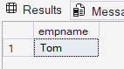
16 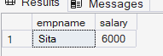 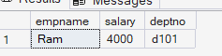 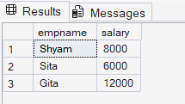 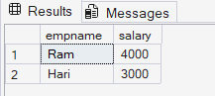
21 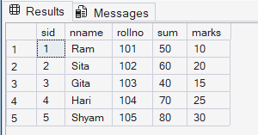

A Lab Report On
Database management system
Faculty of Humanities and Social Science
Tribhuvan University

Submitted by:
Rojip Chhantyal
Roll Number: 53002157
Southwestern State College

Submitted to:
Teksan Gharti Magar

Department of Bachelor of Computer Application (BCA 4th Semester)
Southwestern State College
In the partial fulfilment of the requirements of the degree of Bachelor of Computer Application (BCA 4th Semester)

Basundhara, Kathmandu
Table of content
Database Fundamentals
1 – Create database "collage"
2 – Create schemas BCA and BIM
3 – Create table Student in default, BIM, and BCA schemas
4 – DDL Operations (Create, Drop, Alter, Rename, Truncate) on Employee table
5 – DML Operations (Insert, Select, Update, Delete) on Employee table
6 – Create Student table with constraints (NOT NULL, UNIQUE, CHECK, DEFAULT)
7 – Create Employee and Department tables with PRIMARY KEY and FOREIGN KEY
8 – Advanced Table Operations (Drop table/database/constraint, Add/Drop/Alter columns, Modify datatype)

Advanced Queries and Joins
9 – Create "Account" table and perform DML operations
10 – Order data using ORDER BY clause
11 – Aggregate functions
12 – Student table: Group By and Filtering queries
13 – Employee table: Group By and Conditional queries
14 – Joins (Inner, Outer, Cross)
15 – Nested Queries (Subqueries) on employee_detail table
16 – Set Comparison between employee_detail and department tables
17 – VIEW: Create and use views on Employee table

Stored Procedures, Triggers, and Indexes
18 – Stored Procedures on STUDENT table (Create, Display, Delete, Update, Modify, List, Encryption, Parameters)
19 – Return data from stored procedures (Result sets, Output parameters, Return codes)
20 – Triggers (DDL and DML Triggers)
21 – Trigger to auto-update sum on insert (Enable/Disable trigger)
22 – Multirow Enabled Row Trigger
23 – Indexes (Clustered, Non-clustered, Filtered, Alter/Drop)

