Data Analytics Internship

A Project Report submitted to the Global Next Consulting India Private Limited (GNCIPL)

By Name of Group members
PRAJNA MONDAL
ROJINA KHATUN

Under the Supervision of Ms. Anuradha Gupta (Project Director)

GLOBAL NEXT CONSULTING INDIA PVT LED

December, 2025

Project Title : Employment Data Analysis and Skill Gap Identification

Summary
This report presents a comprehensive study on Employment Data Analysis and Skill Gap Identification. The objective of the project is to analyze employment trends and current skill demands using structured datasets and to recommend suitable training and upskilling programs. The analysis uses Excel, SQL, and Power BI to process data, identify gaps between existing workforce skills and market requirements, and present insights through interactive dashboards. The outcomes support workforce development and policy-level decision-making.
Objectives
- Analyze employment and unemployment trends across sectors and regions.
- Identify in-demand skills and emerging job roles.
- Detect skill gaps between workforce capabilities and industry needs.
- Recommend training and development programs based on data insights.
- Visualize findings using interactive dashboards.
Application Area
- Field: Human Resource Analytics / Workforce Planning
- Use cases:
  - Skill gap analysis for students and professionals
  - Workforce development planning
  - Policy and labor market analysis
  - Educational curriculum alignment
Data Sources
- Employment datasets
  - Industry-wise employment reports
- Job market data
  - Job portals and skill demand surveys
- Training and education data
  - Existing training programs and certifications
Tools and Technologies
- Excel: Data cleaning , Preprocessing
- SQL: Querying large datasets, joining multiple data sources
- Power BI: Dashboard creation and interactive visualization
Data Processing Workflow
- Collect employment and skill-related data from multiple sources.
- Clean and standardize datasets using Excel.
- Load structured data into SQL tables.
- Perform queries to identify trends and skill demand patterns.
- Export processed data to Power BI for visualization.
Key Analyses
- Employment growth and decline by industry
- Skill demand vs skill availability comparison
- Salary trends for high-demand skills
- Regional distribution of skill gaps
- Workforce demographics analysis
Sample SQL Query
- Region-wise Employee Count
- Department wise Avg(Skill Score)
- Job Demand (Vacancy) in Industry
- Job Title vs. Employee Skill Score
- Training Effectiveness (Skill Improvement Score Average)

Power BI Dashboard
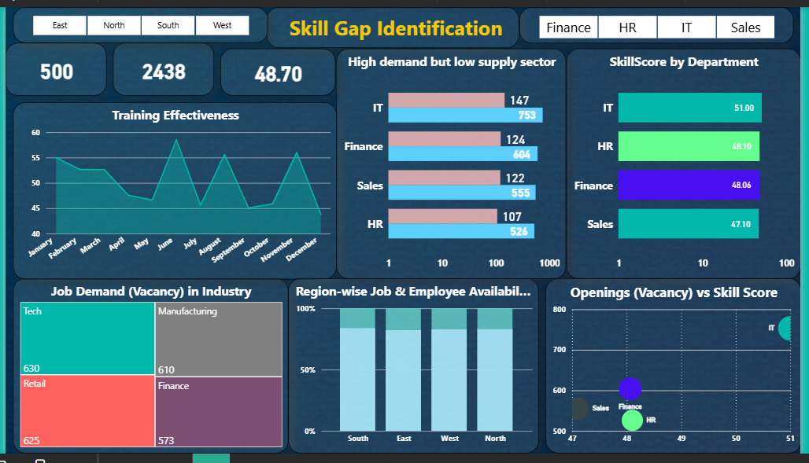
Conclusion
Employment Data Analysis and Skill Gap Identification provides valuable insights into labor market dynamics. By leveraging Excel, SQL, and Power BI, this project delivers data-driven recommendations for workforce development and training initiatives. The approach supports strategic planning for education providers, organizations, and policymakers.

