1. **Write a query to display the Customer_Name and Customer Segment using alias name “Customer Name", "Customer Segment" from table Cust_dimen.**

select Customer_Name as `Customer Name`,

Customer_Segment as `Customer Segment`

from superstore.cust_dimen;

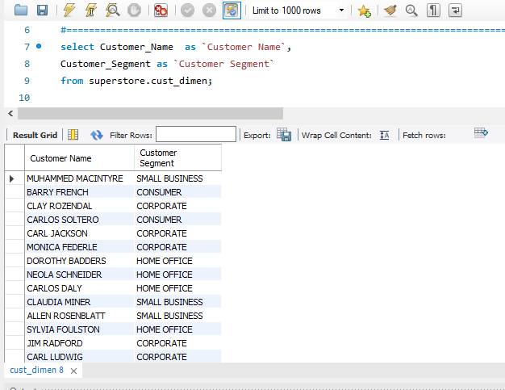

1. **Write a query to find all the details of the customer from the table cust_dimen order by desc.**

select * from superstore.cust_dimen order by 1 desc;

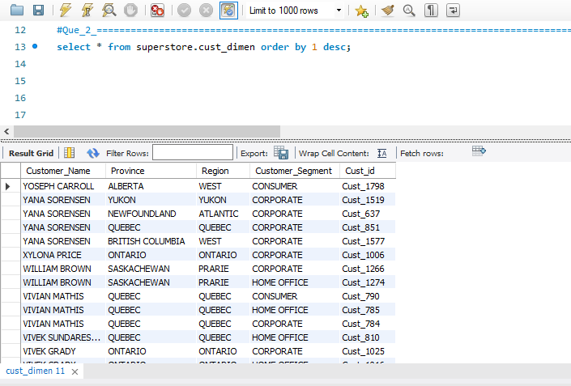

1. **Write a query to get the Order ID, Order date from table orders_dimen where ‘Order Priority’ is high.**

select Order_ID , Order_Date from superstore.orders_dimen where Order_Priority = 'HIGH';

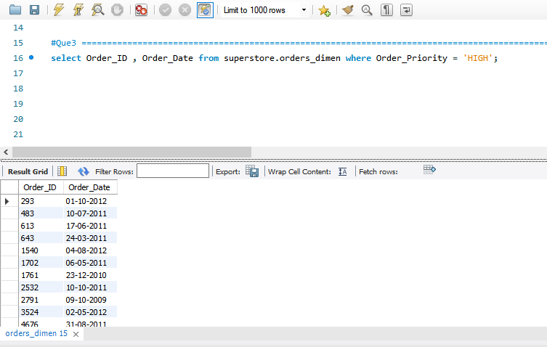

1. **Find the total and the average sales (display total_sales and avg_sales)**

select sum(Sales) as total_sales,avg(Sales) as avg_sales from superstore.market_fact;

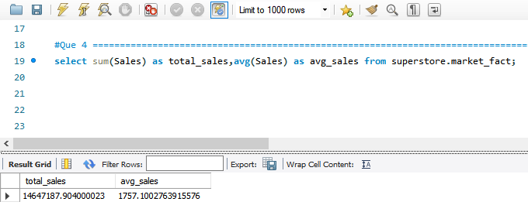

1. **Write a query to get the maximum and minimum sales from maket_fact table**

select max(Sales) as max_sale,min(Sales) as min_sale from superstore.market_fact;

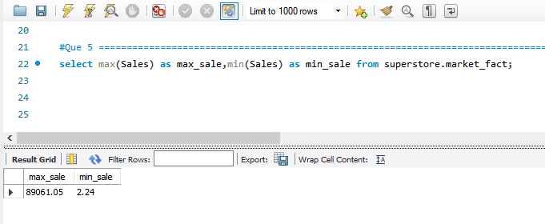

1. **Display the number of customers in each region in decreasing order of no_of_customers. The result should contain columns Region, no_of_customers.**

select Region,count(Customer_Name) as 'Number_of_Customers' from superstore.cust_dimen group by Region order by count(Customer_Name) desc;

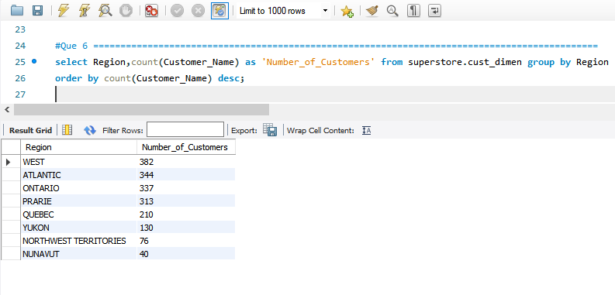

1. **Find the region having maximum customers (display the region name and max(no_of_customers)**

select Region,count(customer_name) as 'Number_of_Customers' from superstore.cust_dimen group by Region

order by count(Customer_Name) desc limit 1 ;

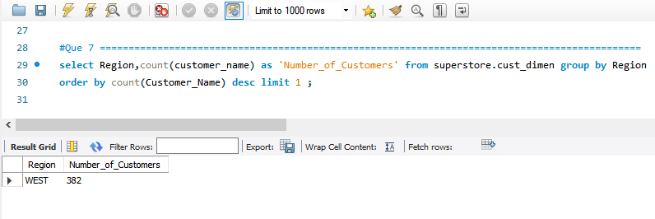

1. **Find all the customers from Atlantic region who have ever purchased ‘TABLES’ and the number of tables purchased (display the customer name, no_of_tables purchased)**

select Customer_Name, count(*) as num_tables from

superstore.market_fact s, superstore.cust_dimen c, superstore.prod_dimen p

where s.Cust_id = c.Cust_id and s.Prod_id = p.Prod_id and

p.Product_Sub_Category = 'TABLES' and c.Region = 'ATLANTIC'

group by Customer_Name;

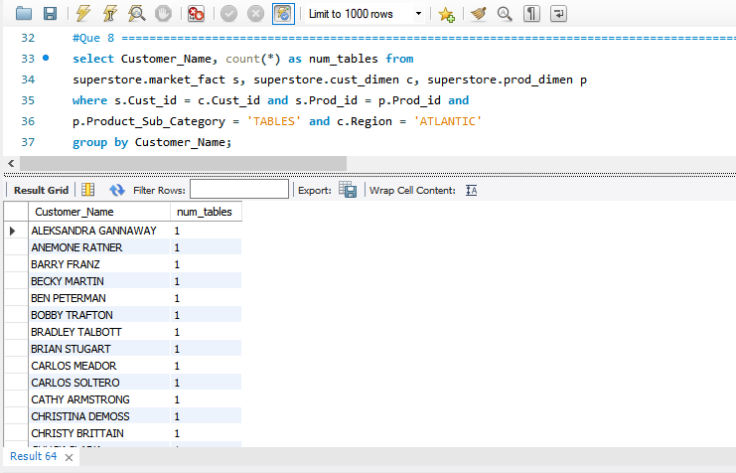

1. **Find all the customers from Ontario province who own Small Business. (display the customer name, no of small business owners)**

select Customer_Name,count(*) as `no of small business owners` from superstore.cust_dimen

where Customer_Segment = 'SMALL BUSINESS' and Province = 'ONTARIO'

group by Customer_Name;

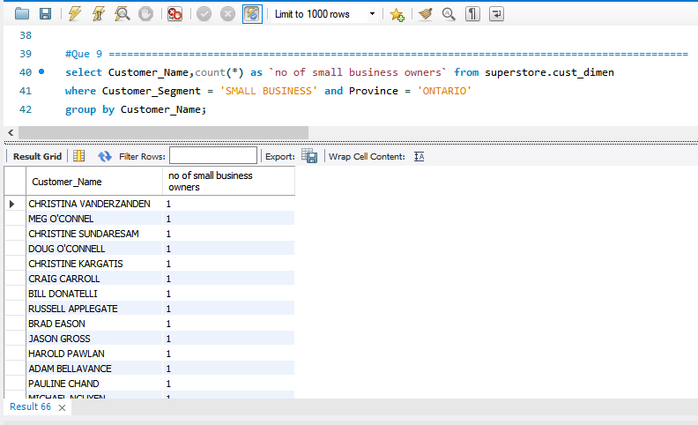

1. **Find the number and id of products sold in decreasing order of products sold (display product id, no_of_products sold)**

select Prod_id,count(*) as `no_of_products sold` from superstore.market_fact group by Prod_id

order by count(`no_of_products sold`) desc;

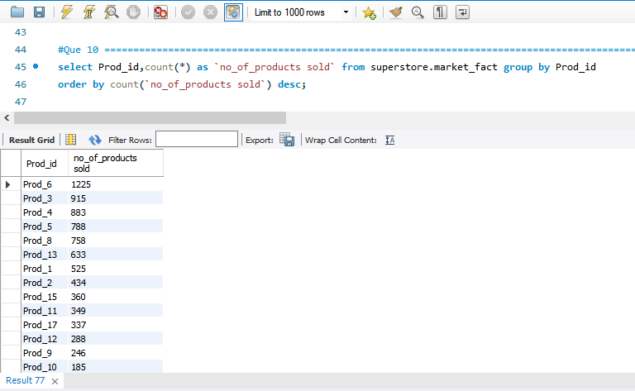

1. **Display product Id and product sub category whose produt category belongs to Furniture and Technlogy. The result should contain columns product id, product sub category.**

select Prod_id,Product_Sub_Category from superstore.prod_dimen

where Product_Category='FURNITURE' or Product_Category='TECHNOLOGY'

group by Prod_id;

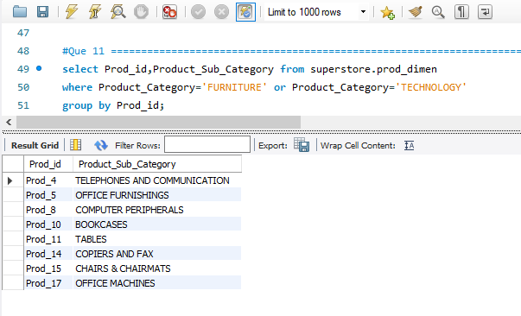

1. **Display the product categories in descending order of profits (display the product category wise profits i.e. product_category, profits)?**

select Product_Category,Profit from superstore.market_fact s,superstore.prod_dimen p

where s.Prod_id = p.Prod_id

group by Product_Category order by Profit desc;

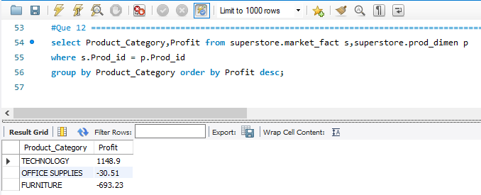

1. **Display the product category, product sub-category and the profit within each subcategory in three columns.**

select Product_Category,Product_Sub_Category,Profit from superstore.market_fact s,superstore.prod_dimen p

where s.Prod_id = p.Prod_id;

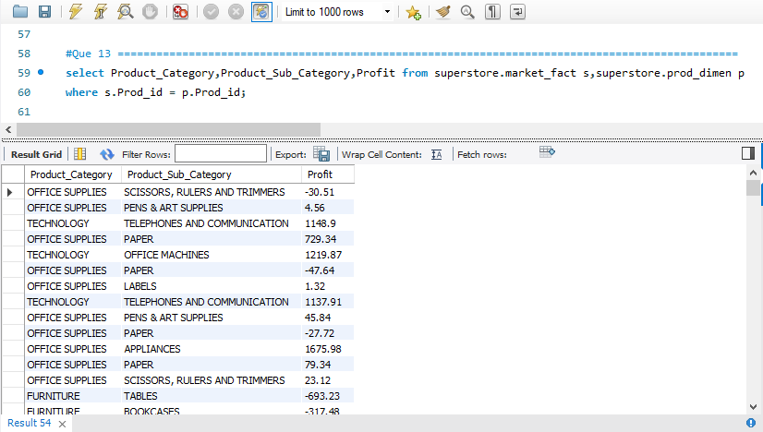

1. **Display the order date, order quantity and the sales for the order.**

select Order_Date,Order_Quantity,Sales from superstore.market_fact s, superstore.orders_dimen c

where s.Ord_id = c.Ord_id;

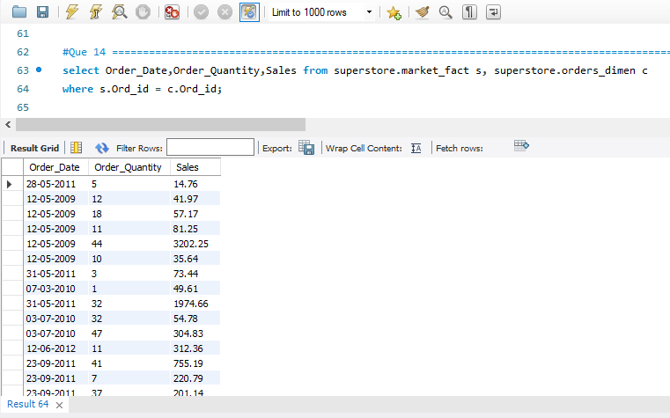

1. **Display the names of the customers whose name contains the**

**i) Second letter as ‘R’**

**ii) Fourth letter as ‘D’**

select Customer_Name from superstore.cust_dimen

where Customer_Name like '_R%' and Customer_Name like '___D%';

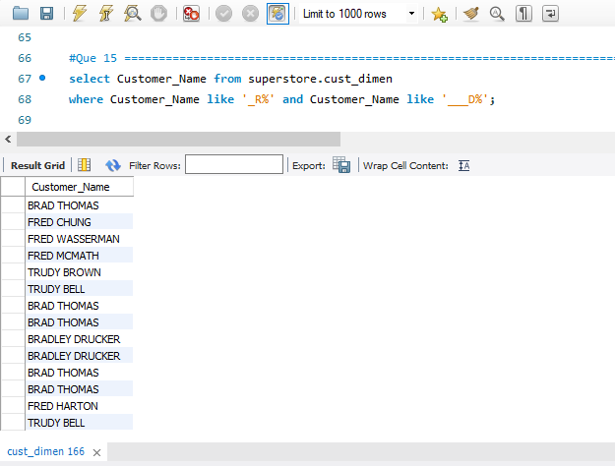

1. **Write a SQL query to to make a list with Cust_Id, Sales, Customer Name and their region where sales are between 1000 and 5000.**

select c.Cust_id,s.Sales,c.Customer_Name,c.Region from superstore.market_fact s,superstore.cust_dimen c

where s.Cust_id = c.Cust_id and Sales between 1000 and 5000;

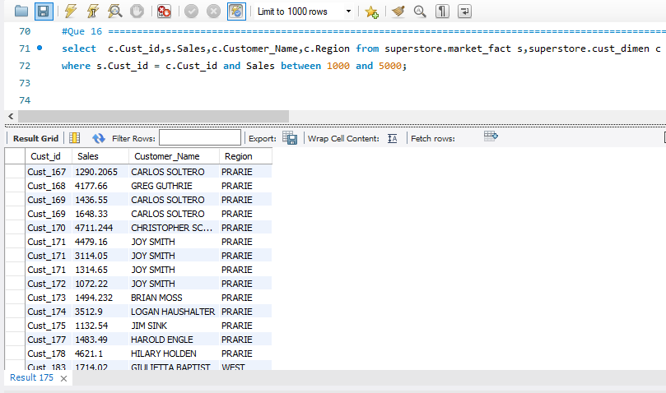

1. **Write a SQL query to find the 3rd highest sales.**

select min(Sales) as `3rd highest salary`

FROM (

select Sales from superstore.market_fact order by Sales desc limit 3

) as a

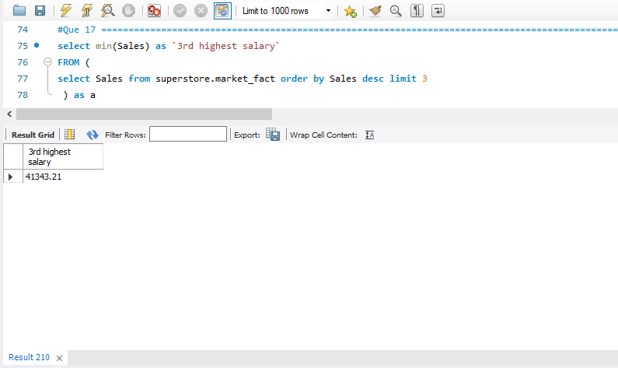

1. **Where is the least profitable product subcategory shipped the most? For the least profitable product sub-category, display the region-wise no_of_shipments and the profit made in each region in decreasing order of profits (i.e. region, no_of_shipments, profit_in_each_region) → Note: You can hardcode the name of the least profitable product subcategory**

select Region,count(Ship_id) as no_of_shipment,sum(Profit) as profit_in_each_region from

superstore.cust_dimen c,superstore.market_fact s,superstore.prod_dimen p

where c.Cust_id = s.Cust_id and s.Prod_id = p.Prod_id

group by Region

order by profit_in_each_region asc;

